Advancing mountainscape diversity, functioning, and disturbance dynamics studies with hyperspectral imaging requires a focus on plant traits, soil-rock attributes, and landsliding

Ana Kilgore ^{1, *} and Carla Restrepo ¹

¹ Department of Biology, University of Puerto Rico at Rio Piedras, San Juan, PR, 00931, US

Supplementary Material: Table S1, Figure S1

Table S1. Landslide studies characterizing Vegetation Recovery Rates (VRR) over time.
Figure S1. Functional and Spectral Traits in Landslide-Impacted areas in the Sierra de las Minas in Guatemala.

Table S1. Landslide studies characterizing Vegetation Recovery Rates (VRR) over time (T0 = year of image prior to triggering event , T1=year of first image, T2=year of last image) based on the Normalized Vegetation Index (NDVI). VRR = NDVI2 - NDV1 / NDVI0 - NDVI 1, where NDVI0 is the NDVI prior to a landslide triggering event, NDVI1 is the NDVI of sites affected by landslides immediately after the triggering event, and NDVI2 is like NDVI1 but after years of the triggering event. In () standard deviations if available. In [] revised value resulting from compound effect of a second triggering event after the original one. An alternative metric is the Landslide Restoration Rate (LRR), LRR = 1 - (LAt/Lt0), where LAt is the area than remains denuded at time t and LA0 is the landslide area at the time that it was triggered.
Country | Event | Site | Dominant ecosystems | Sensor | T0 (year) | T1 - T2 (year) |  | T2-T0 (years) |  | Overall method |  | ET Initial - Final NDVI |  | ET VRR (%) |  | ET VRR (%) yr-1 |  | RT Initial - Final NDVI |  | RT VRR (%) |  | RT VRR (%) yr-1 |  | Comment (elevation, slope) |  | Reference
Taiwan | 1999 Chi-Chi Mw 7.3 Earthquake | Jou-Jou Mountains | Forests and Grasslands | SPOT (20 m) | 1999 | 1999 - 2001 | 1.5 |  | NDVI; Classification; Change detection |  | 0.40 (0.07) - 0.30 (0.11) [0.17 (0.10)] |  | 59 [36] |  | 39 [24] |  |  |  |  |  |  |  | VRR down to 36% after Typhoon Toraji; VRR by elevation, slope, and landscape position |  | 1
 | 1999 Chi-Chi Mw 7.3 Earthquake | Jijiu Peaks | Forests and Grasslands | SPOT (20 m) | 1999 | 1999 - 2020 | 20 |  |  |  |  |  |  |  |  |  |  |  |  |  |  |  | Uses LRR: Slopes (93%) > Ridges (86% > Rivers (79%) |  | 2
 | 2001 Toraji, 2004 Mindulle, 2008 Sinlaku, 2009 Morakot | Ta-Chia, Wu, and Chuo-Shuei catchments, Central Taiwan |  | SPOT (20 m; PAN ) | 2001 | 2001 - 2009 | 8 |  | NDVI; Classification, Change detection |  |  |  |  |  |  |  |  |  |  |  |  |  | Images before and after major typhoon events after the 1999 Chi-Chi Earthquake. Cumulative area of reactivated and newly formed landslides was 14,386 ha and 26,757 ha, respectively |  | 3
China | 2008 Wenchuan Mw 7.9 Earthquake | All extent | Forests and Shrubs | Landsat TM (30 m), Airborne sensor ADS (0.3 - 0.7 m) | 1982 | 2008 - 2011 | 3 |  | FVC (NDVI); Classification, Extraction landslides |  |  |  | 73 |  | 24 |  |  |  |  |  |  |  |  |  | 4
 | 2008 Wenchuan Mw 7.9 Earthquake | Baisha and Longxi watersheds |  | Landsat (30 m) | 1994 | 2008 - 2014 | 6 |  |  |  |  |  |  |  |  |  |  |  |  |  |  |  |  |  | 5
 | 2008 Wenchuan Mw 7.9 Earthquake |  | Diverse vegetation types | MODIS (250 m) | 2005 | 2008 - 2013 | 5 |  | FVC (NDVI) |  |  |  | 41 |  | 8 |  |  |  |  |  |  |  |  |  | 6
 | 2008 Wenchuan Mw 7.9 Earthquake | Epidentral area round Yingxiu |  | MODIS (250 m) | 2001 | 2008 - 2015 | 7 |  | NDVI |  | 0.84 - 0.69 |  |  |  |  |  |  |  |  |  |  |  |  |  | 7
 | 2008 Wenchuan Mw 7.9 Earthquake | All extent |  | MODIS (250 m), Landsat (30 m) | 2000 | 2009 - 2018 | 9 |  | NDVI; Landslide inventory |  | 0.67 (0.13) - 0.60 (0.15) |  | 72 |  | 8 |  |  |  |  |  |  |  | Based on landslides that did not reactivate |  | 8
 | 2008 Wenchuan Mw 7.9 Earthquake | Wenchuan region, Beichuan region, and Qingping region | Forest vegetation | Landsat (30 m) | 2006 | 2008 - 2018 | 10 |  | FVC(NDVI); Automatic identification landslides |  | 0.82 (0.01) - 0.75 (0.06) |  | 77 (12) |  | 8 |  |  |  |  |  |  |  |  |  | 9
 | 2008 Wenchuan Mw 7.9 Earthquake |  |  | Landsat (30 m), HJ-1 (x m), Sentinel 2 (x m) | 2007 | 2008 - 2018 | 10 |  | NDVI; Landslide inventory |  | 0.65 (0.13) - 0.49 (0.09) |  | 67 |  | 6.7 |  |  |  |  |  |  |  | Elevation, aspect, slope |  | 10
Japan | 2012 Storm and 2016 Kumamoto Mw 7.1 Earthquake | Aso Volcano | Semi-natural grassland vegetation | Rapid Eye (2010-2019; 5 m) and Planet Scope (2016-2020; 3 m), UAV |  |  |  |  | NDVI; Landslide inventory |  | 0.86 (0.03) - 0.67 (0.05) |  | 64 |  | 12 |  | 0.86 (0.03) -0.72 (0.05) |  | 69 |  | 23 |  |  |  | 11
 | 2004 Chuetsu Mw 6.6 Earthquake |  | Forests and Grasslands | Landsat (30 m) | 2003 | 2004 - 2021 | 18 |  | NDVI; Landslide inventory |  | 0.41 - 0.47 |  | 154 |  | 10 |  |  |  |  |  |  |  |  |  | 12
 | 2015 Sennindani Landslide |  |  | Landsat (30 m) SPOT (20 m), QuickBird (2.44), WorldView (1.8) |  |  |  |  |  |  |  |  |  |  |  |  |  |  |  |  |  |  | Single landslide; Restoration through air-seeding methods |  | 13
Rusia |  | Central Yamal | Tundra (shrubs and grasslands) | Landsat (30 m), SPOT (20 m), QuickBird (2.44), WorldView (1.8) | 1988 | 1990 - 2017 | 27 |  | NDVI: Landslide inventory |  |  |  |  |  |  |  |  |  | 72 |  | 3 |  |  |  | 14
Nepal | 2015 Gorkha Mw 7.8 Earthquake | Central Nepal |  | Sentinel 1C | 2015 | 2017 - 2019 | 4 |  | NDVI |  | 0.51-0.49 |  | 19 |  |  |  |  |  |  |  |  |  | VRR based on median values |  | 15
Mexico | 2013 Hurricane Ingrid and Tropical Storm Daniel | Estado Guerrero |  | Landsat (30 m) |  | 1984 - 2021 | 34 |  | NDVI; Continuous Change Detection and Classification algorithm |  |  |  |  |  |  |  |  |  | 93 |  | 3 |  | Corresponds to one of 448 pixels |  | 16

Figure S1. Functional and Spectral Traits in Landslide-Impacted areas in the Sierra de las Minas in Guatemala. Three principal components (PCs) and three vegetation indices (normalized difference water index (NDWI), Anthocyanin Content Index (ACI), and Vogelman Index 2 (VOG) derived from PRISMA for two small regions of the SLM.
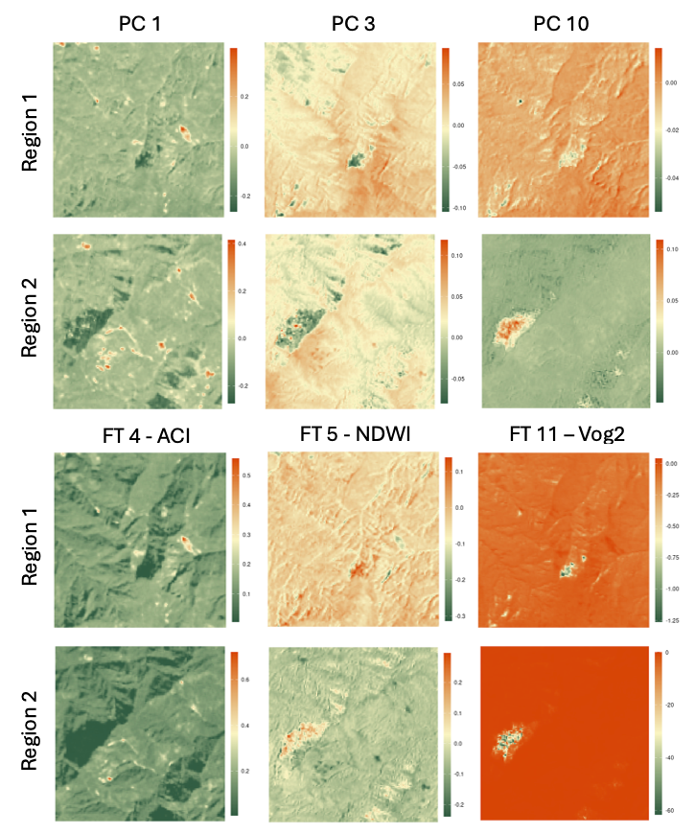
Literature Cited

1. Lin, W.-T.; Chou, W.-C.; Lin, C.-Y.; Huang, P.-H.; Tsai, J.-S. Vegetation recovery monitoring and assessment at landslides caused by earthquake in Central Taiwan. Forest Ecol. Manag. 2005, 210, 55-66.
2. Lin, W.-T.; Huang, P.-H.; Chou, T.-Y. Mechanisms of vegetation restoration at landslides caused by a catastrophic earthquake in Central Taiwan. Ecol. Eng. 2023, 190, 106929.
3. Shou, K.J.; Hong, C.Y.; Wu, C.C.; Hsu, H.Y.; Fei, L.Y.; Lee, J.F.; Wei, C.Y. Spatial and temporal analysis of landslides in Central Taiwan after 1999 Chi-Chi earthquake. Eng. Geol. 2011, 123, 122-128.
4. Jiao, Q.; Zhang, B.; Liu, L.; Li, Z.; Yue, Y.; Hu, Y. Assessment of spatio-temporal variations in vegetation recovery after the Wenchuan earthquake using Landsat data. Nat. Hazards 2014, 70, 1309-1326.
5. Zhang, H.; Wang, X.; Fan, J.; Chi, T.; Yang, S.; Peng, L. Monitoring earthquake-damaged vegetation after the 2008 Wenchuan Earthquake in the Mountainous River Basins, Dujiangyan County. In Remote Sens., 2015; Vol. 7, pp 6808-6827.
6. Jiang, W.-G.; Jia, K.; Wu, J.-J.; Tang, Z.-H.; Wang, W.-J.; Liu, X.-F. Evaluating the Vegetation Recovery in the Damage Area of Wenchuan Earthquake Using MODIS Data. In Remote Sens., 2015; Vol. 7, pp 8757-8778.
7. Yang, W.; Qi, W.; Zhou, J. Decreased post-seismic landslides linked to vegetation recovery after the 2008 Wenchuan earthquake. Ecol. Indic. 2018, 89, 438-444.
8. Yunus, A.P.; Fan, X.; Tang, X.; Jie, D.; Xu, Q.; Huang, R. Decadal vegetation succession from MODIS reveals the spatio-temporal evolution of post-seismic landsliding after the 2008 Wenchuan earthquake. Remote Sens. Environ. 2020, 236, 111476.
9. Chen, M.; Tang, C.; Wang, X.; Xiong, J.; Shi, Q.; Zhang, X.; Li, M.; Luo, Y.; Tie, Y.; Feng, Q. Temporal and spatial differentiation in the surface recovery of post-seismic landslides in Wenchuan earthquake-affected areas. Ecol. Inform. 2021, 64, 101356.
10. Zhong, C.; Li, C.A.-O.; Gao, P.A.-O.X.; Li, H. Discovering vegetation recovery and landslide activities in the Wenchuan Earthquake area with Landsat imagery. Sensors 2021, 21, 5243.
11. Saito, H.; Uchiyama, S.; Teshirogi, K. Rapid vegetation recovery at landslide scars detected by multitemporal high-resolution satellite imagery at Aso volcano, Japan. Geomorphology 2022, 398.
12. Xiang, Z.; Dou, J.; Yunus, A.P.; Zhang, L.; Wang, X.; Luo, W. Vegetation-landslide nexus and topographic changes post the 2004 Mw 6.6 Chuetsu earthquake. CATENA 2023, 223, 106946.
13. Thapa, P.S.; Daimaru, H.; Yanai, S. Analyzing vegetation recovery and erosion status after a large Landslide at Mt. Hakusan, Central Japan. Ecol. Eng. 2024, 198, 107144.
14. Verdonen, M.; Berner, L.T.; Forbes, B.C.; Kumpula, T. Periglacial vegetation dynamics in Arctic Russia: Decadal analysis of tundra regeneration on landslides with time series satellite imagery. Env. Res. Lett. 2020, 15, 105020.
15. Pandey, H.P.; Gnyawali, K.; Dahal, K.; Pokhrel, N.P.; Maraseni, T.N. Vegetation loss and recovery analysis from the 2015 Gorkha earthquake (7.8 Mw) triggered landslides. Land Use Policy 2022, 119, S0264837722002125.
16. Arrogante-Funes, P.; Bruzón, A.G.; Álvarez-Ripado, A.; Arrogante-Funes, F.; Martín-González, F.; Novillo, C.J. Assessment of the regeneration of landslides areas using unsupervised and supervised methods and explainable machine learning models. Landslides 2024, 21, 275-290.

