Supplementary information for article “Digital PCR validation for characterization of quantitative reference material of Escherichia coli O157:H7 genomic DNA”

Method validation
Table S1. Primers and probes of target genes used for E. coli ddPCR study.
Microorganism | Gene | Sequences | Reference
Escherichia coli  Shigella spp. | uidA | GCAAGGTGCACGGGAATATT | [1]
Escherichia coli  Shigella spp. | uidA | CAGGTGATCGGACGCGT | [1]
Escherichia coli  Shigella spp. | uidA | [HEX] CGC CAC TGG CGG AAG CAA CG [BHQ1] | [1]
Escherichia coli | lacY | TGCTGGCTGGCACTATTATG | Adapted from ([2], [3])
Escherichia coli | lacY | GCACTTCAAACTGGCTGGTA | Adapted from ([2], [3])
Escherichia coli | lacY | [FAM] CCG TTC CTG CTG GTG GGC TGC TT [BHQ1] | Adapted from ([2], [3])
Diarrheogenic Escherichia coli | eaeA | CATTGATCAGGATTTTTCTGGTGATA | [4]
Diarrheogenic Escherichia coli | eaeA | CTCATGCGGAAATAGCCGTTA | [4]
Diarrheogenic Escherichia coli | eaeA | [FAM] ATA GTC TCG CCA GTA TTC GCC ACC AAT ACC [BHQ1] | [4]
Enteropathogenic Escherichia coli O157  (EPEC) | rfbE | TTTCACACTTATTGGATGGTCTCAA | [5]
Enteropathogenic Escherichia coli O157  (EPEC) | rfbE | CGATGAGTTTATCTGCAAGGTGAT | [5]
Enteropathogenic Escherichia coli O157  (EPEC) | rfbE | [HEX] AGG ACC GCA GAG GAA AGA GAG GAA TTA AGG [BHQ1] | [5]
Escherichia coli producing Shiga toxins (STEC) | stx1 | TTTGTTACTGTGACAGCTGAAGCTTTACG | [5]
Escherichia coli producing Shiga toxins (STEC) | stx1 | CCCCAGTTCAATGTAAGATCAACATC | [5]
Escherichia coli producing Shiga toxins (STEC) | stx1 | [FAM] CTG GAT GAT CTC AGT GGG CGT TCT TAT GTA A [BHQ1] | [5]
Escherichia coli producing Shiga toxins (STEC) | stx2 | TTTGTCACTGTCACAGCAGAAGCCTTACG | [5]
Escherichia coli producing Shiga toxins (STEC) | stx2 | CCCCAGTTCAGAGTGAGGTCCACGTC | [5]
Escherichia coli producing Shiga toxins (STEC) | stx2 | [HEX] TCG TCA GGC ACT GTC TGA AAC TGC TCC [BHQ1] | [5]
Escherichia coli O157:H7 | Z3276 | CGGGGGATACATTTACGCTT | [6], [7]
Escherichia coli O157:H7 | Z3276 | TTTCTGAGCTGGAACAAGGC | [6], [7]
Escherichia coli O157:H7 | Z3276 | [FAM] ACGGTGTTTTCAGGCTTACAGGTCGT [BHQ1] | [6], [7]

Figure S1. 2% agarose electrophoresis of amplification products of E. coli O157:H7 gene targets.
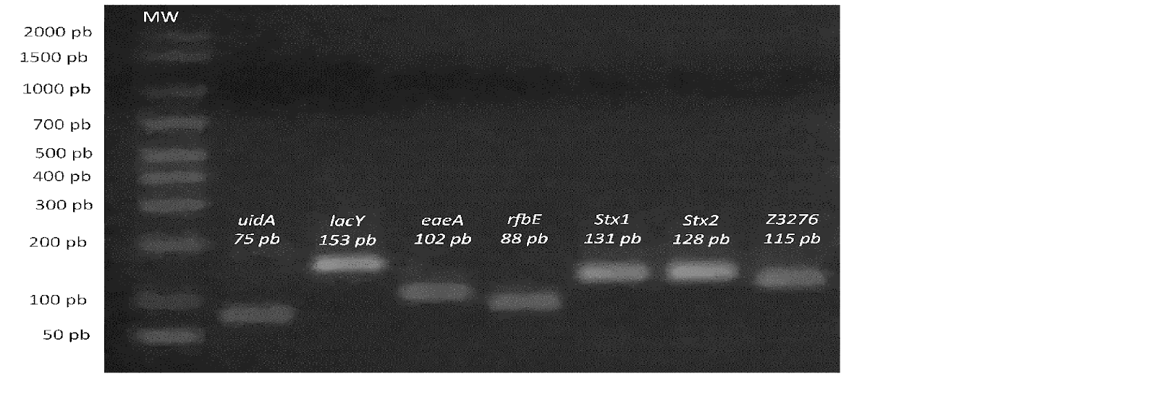
Figure S2. Linear interval for DNA targets in E. coli O157:H7 gene quantification by ddPCR
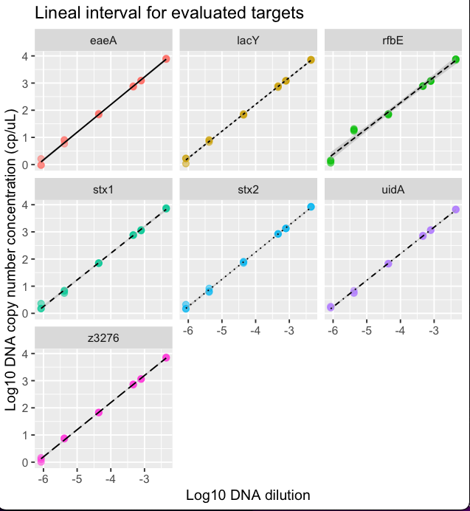
Amplification curves and linearity graphs of the amplification cycle depending on the logarithm of the MRC IRMM 449 DNA dilution by qPCR.

Tables S2-S8. Data of precision experiments performed in three different days at five sample concentration levels with three replicas for each sequence target.

Table S2. uidA measurement results in ddPCR reaction
Level | Day | Replicate 1 | Replicate 2 | Replicate 3 | Dilution
1 | 1 | 6540,13 | 6697,62 | 6794,56 | 8,66E-02
1 | 2 | 6794,82 | 7533,69 | 7062,06 | 9,28E-02
1 | 3 | 6530,17 | 6545,06 | 6896,68 | 8,92E-02
2 | 1 | 683,96 | 712,77 | 740,21 | 9.12E-02
2 | 2 | 639,56 | 660,39 | 614,79 | 7,83E-02
2 | 3 | 681,27 | 652,63 | 672,99 | 8,24E-02
3 | 1 | 67,10 | 68,38 | 66,68 | 8,75E-02
3 | 2 | 59,70 | 68,85 | 56,71 | 8,08E-02
3 | 3 | 61,40 | 62,90 | 59,34 | 8,10E-02
4 | 1 | 5,75 | 5,53 | 6,85 | 8,47E-02
4 | 2 | 6,85 | 7,16 | 6,16 | 8,03E-02
4 | 3 | 5,06 | 6,12 | 5,13 | 8,04E-02
5 | 1 | 1,69 | 1,60 | 1,80 | 8,55E-02
5 | 2 | 1,68 | 1,33 | 1,33 | 8,35E-02
5 | 3 | 1,05 | 2,02 | 1,48 | 8,03E-02

Table S3. lacY measurement results in ddPCR reaction.
Level | Day | Replicate 1 | Replicate 2 | Replicate 3 | Dilution
1 | 1 | 6898,69 | 7222,34 | 7401,78 | 8,54E-02
1 | 2 | 7678,82 | 8255,54 | 7688,78 | 9,30E-02
1 | 3 | 8031,36 | 7980,63 | 8355,61 | 9,10E-02
2 | 1 | 696,06 | 779,84 | 759,19 | 9.12E-02
2 | 2 | 691,99 | 672,64 | 662,83 | 7,83E-02
2 | 3 | 725,92 | 685,97 | 687,31 | 8,24E-02
3 | 1 | 67,25 | 67,67 | 73,66 | 8,75E-02
3 | 2 | 63,28 | 66,85 | 65,71 | 8,08E-02
3 | 3 | 61,33 | 60,74 | 63,80 | 8,10E-02
4 | 1 | 6,73 | 8,12 | 7,71 | 8,47E-02
4 | 2 | 7,28 | 5,77 | 6,43 | 8,03E-02
4 | 3 | 5,99 | 5,29 | 5,67 | 8,04E-02
5 | 1 | 1,69 | 1,67 | 1,08 | 8,55E-02
5 | 2 | 1,17 | 0,99 | 1,72 | 8,35E-02
5 | 3 | 1,48 | 1,59 | 1,48 | 8,03E-02

Table S4. eaeA measurement results in ddPCR reaction
Level | Day | Replicate 1 | Replicate 2 | Replicate 3 | Dilution
1 | 1 | 7536,62 | 7786,61 | 8102,18 | 8,87E-02
1 | 2 | 8969,36 | 8174,37 | 8417,44 | 9,47E-02
1 | 3 | 9724,67 | 9159,13 | 10300,70 | 8,57E-02
2 | 1 | 753,44 | 780,90 | 720,52 | 8,97E-02
2 | 2 | 719,06 | 714,51 | 595,67 | 8,04E-02
2 | 3 | 741,42 | 739,41 | 749,84 | 8,08E-02
3 | 1 | 68,36 | 75,74 | 70,42 | 8,54E-02
3 | 2 | 67,24 | 57,72 | 66,29 | 7,85E-02
3 | 3 | 71,56 | 71,60 | 55,37 | 7,72E-02
4 | 1 | 7,73 | 5,81 | 8,16 | 8,45E-02
4 | 2 | 6,60 | 6,54 | 6,79 | 7,96E-02
4 | 3 | 6,96 | 6,27 | 6,75 | 7,85E-02
5 | 1 | 0,96 | 0,95 | 1,63 | 8,52E-02
5 | 2 | 1,06 | 1,25 | 0,82 | 8,40E-02
5 | 3 | 1,07 | 1,59 | 1,20 | 7,93E-02

Table S5. rfbE measurement results in ddPCR reaction
Level | Day | Replicate 1 | Replicate 2 | Replicate 3 | Dilution
1 | 1 | 7025,54 | 7612,30 | 7633,26 | 8,64E-02
1 | 2 | 7859,07 | 8008,88 | 7753,30 | 9,16E-02
1 | 3 | 8026,80 | 8103,37 | 7509,71 | 9,11E-02
2 | 1 | 769,02 | 766,27 | 787,97 | 9,02E-02
2 | 2 | 715,78 | 705,07 | 716,13 | 7,87E-02
2 | 3 | 694,99 | 692,05 | 699,02 | 7,92E-02
3 | 1 | 67,04 | 71,84 | 73,73 | 8,60E-02
3 | 2 | 63,97 | 64,42 | 68,45 | 7,71E-02
3 | 3 | 66,54 | 63,37 | 65,73 | 8,14E-02
4 | 1 | 20,54 | 17,23 | 18,89 | 8,48E-02
4 | 2 | 18,76 | 17,07 | 18,36 | 7,92E-02
4 | 3 | 18,82 | 18,20 | 17,02 | 7,90E-02
5 | 1 | 1,33 | 1,44 | 1,15 | 8,43E-02
5 | 2 | 1,41 | 1,55 | 1,24 | 8,47E-02
5 | 3 | 0,96 | 1,40 | 0,85 | 8,08E-02

Table S6. stx1 measurement results in ddPCR reaction
Level | Day | Replicate 1 | Replicate 2 | Replicate 3 | Dilution
1 | 1 | 7005,08 | 7281,22 | 7673,33 | 8,56E-02
1 | 2 | 7648,85 | 7814,37 | 7899,21 | 9,24E-02
1 | 3 | 7569,11 | 6978,06 | 7019,57 | 8,77E-02
2 | 1 | 758,91 | 749,29 | 781,04 | 9,02E-02
2 | 2 | 695,38 | 698,07 | 686,75 | 7,87E-02
2 | 3 | 699,22 | 683,37 | 700,67 | 7,92E-02
3 | 1 | 70,58 | 72,01 | 69,02 | 8,60E-02
3 | 2 | 63,97 | 64,42 | 68,45 | 7,71E-02
3 | 3 | 67,98 | 67,26 | 63,87 | 8,14E-02
4 | 1 | 6,98 | 5,53 | 6,46 | 8,48E-02
4 | 2 | 7,11 | 6,39 | 6,07 | 7,92E-02
4 | 3 | 6,56 | 5,13 | 5,43 | 7,90E-02
5 | 1 | 1,48 | 1,52 | 2,30 | 8,43E-02
5 | 2 | 0,74 | 1,23 | 1,77 | 8,47E-02
5 | 3 | 1,84 | 1,48 | 1,08 | 8,08E-02

Table S7. stx2 measurement results in ddPCR reaction
Level | Day | Replicate 1 | Replicate 2 | Replicate 3 | Dilution
1 | 1 | 8553,49 | 8414,37 | 8198,42 | 8,71E-02
1 | 2 | 11086,21 | 9778,56 |  | 9,14E-02
1 | 3 | 11193,89 | 11182,05 |  | 8,76E-02
2 | 1 | 832,77 | 853,86 | 835,48 | 8,79E-02
2 | 2 | 775,25 | 771,97 | 749,30 | 7,91E-02
2 | 3 | 805,62 | 775,25 | 736,90 | 8,05E-02
3 | 1 | 71,06 | 80,93 | 77,32 | 8,43E-02
3 | 2 | 72,67 | 68,24 | 71,31 | 7,93E-02
3 | 3 | 80,04 | 67,43 | 49,44 | 7,81E-02
4 | 1 | 6,50 | 6,06 | 8,28 | 8,49E-02
4 | 2 | 6,25 | 7,15 | 6,72 | 7,68E-02
4 | 3 | 6,73 | 8,26 | 6,59 | 7,76E-02
5 | 1 | 2,10 | 1,50 | 1,45 | 8,52E-02
5 | 2 | 0,93 | 1,45 | 1,08 | 8,54E-02
5 | 3 | 1,60 | 0,91 | 1,03 | 7,86E-02

Table S8. Z3276 measurement results in ddPCR reaction
Level | Day | Replicate 1 | Replicate 2 | Replicate 3 | Dilution
1 | 1 | 6873,09 | 7322,71 | 7001,59 | 8,62E-02
1 | 2 | 7188,09 | 7373,52 | 7241,81 | 8,66E-02
1 | 3 | 7419,37 | 7572,51 | 7556,88 | 9,28E-02
2 | 1 | 702,38 | 732,91 | 740,48 | 8,87E-02
2 | 2 | 689,01 | 653,75 | 615,59 | 8,04E-02
2 | 3 | 686,06 | 671,08 | 693,41 | 7,96E-02
3 | 1 | 67,64 | 66,15 | 67,71 | 8,64E-02
3 | 2 | 64,09 | 63,35 | 58,65 | 7,85E-02
3 | 3 | 60,03 | 61,54 | 63,66 | 7,84E-02
4 | 1 | 7,56 | 7,63 | 7,18 | 8,69E-02
4 | 2 | 6,06 | 6,04 | 6,91 | 7,96E-02
4 | 3 | 6,11 | 6,81 | 6,89 | 7,96E-02
5 | 1 | 1,45 | 1,25 | 1,01 | 8,55E-02
5 | 2 | 0,94 | 1,36 | 0,65 | 8,40E-02
5 | 3 | 1,00 | 0,82 | 1,78 | 7,70E-02

Reference material production

Table S9. Analysis of variance of homogeneity between bottles of pilot batches
Origin of variations | Sum of squares | Degrees of freedom | Average of squares | F_{cal} | P_{(0,05)} | F_{crit}
Low level concentration batch100 copies/μL
Between groups | 501 | 7 | 71.6 | 1.16 | 0.34 | 2.25
Within groups | 2465 | 40 | 61.6
Total | 2966 | 47
High level concentration Batch 100.000 copies/μL
Between groups | 91965676 | 7 | 13137953 | 1.17 | 0.37 | 2.66
Within groups | 179023138 | 16 | 11188946
Total | 270988815 | 23

Table S10. Regression analysis results for short and long term stability study for high (HL) and low (LL) concentration level materials at 4ºC and -20ºC.

Study | Material/condition | Slope | Intercept | R2 | p-value
STS | LL-4ºC | 0.000244 | 0.9902 | 0.003526 | 0.9406
STS | LL -20ºC | 0.00200 | 0.9499 | 0.07817 | 0.7204
STS | HL-4ºC | 0.00108 | 0.9768 | 0.5628 | 0.2498
STS | HL -20ºC | -0.00096 | 0.9637 | 0.3217 | 0.4328
LTS | LL-4ºC | 0.00085 | 0.9792 | 0.3537 | 0.2131
LTS | LL -20ºC | -0.00041 | 0.9614 | 0.09906 | 0.5435
LTS | HL-4ºC | 0.00150 | 0.9613 | 0.4255 | 0.1603
LTS | HL -20ºC | 0.00013 | 0.9587 | 0.1200 | 0.5012

Table S11. Regression analysis results for short and long term stability study for high (HL) and low (LL) concentration level materials at 4ºC and -20ºC.
Condition | Slope | Standard error | relative uncertainty | u absolut uncertainty
LTS 4 HL | 0,00150 | 0,0008727 | 0,052362 | 8632
LTS-20 HL | 0,00013 | 0,0001843 | 0,011058 | 1823
LTS 4 LL | 0,00085 | 0,000577 | 0,03462 | 5,95
LTS-20 LL | -0,00041 | 0,0006171 | 0,037026 | 6,37

Supplementary Information SI 1
T.test (performed with R Version 4.4.3)
Low concentration level  Two Sample t-test  data: LL_Z3276 and LL_rfbE  t = -3.3751, df = 52, p-value = 0.001402  alternative hypothesis: true difference in means is not equal to 0  95 percent confidence interval:  -11.218848 -2.852748  sample estimates:  mean of x mean of y  168.1533 175.1891 | High Concentration level  Two Sample t-test  data: HL_Z3276 and HL_rfbE  t = -7.0148, df = 46, p-value = 8.658e-09  alternative hypothesis: true difference in means is not equal to 0  95 percent confidence interval:  -9619.664 -5329.899  sample estimates:  mean of x mean of y  161032.7 168507.5

Table S12. Characterization results of batch 100.000 copies/μL with Z3276
Day | Sample | Result by days |  |  |  |  | Total result
Day | Sample | Value | u _{comb.} | u _{rel} | Average | u _{comb.} Day | Average | u _{comb.}
1 | 190401-08P-26 | 133250 | 2203 | 1,7% | 161795 | 1806 | 161117 | 3975
1 | 190401-08P-42 | 161762 | 2619 | 1,6%
1 | 190401-08P-66 | 161827 | 2486 | 1,5%
2 | 190401-08P-10 | 162900 | 2894 | 1,8% | 162945 | 1775 | 161117 | 3975
2 | 190401-08P-50 | 164668 | 2462 | 1,5%
2 | 190401-08P-58 | 161266 | 2288 | 1,4%
3 | 190401-08P-18 | 154070 | 2568 | 1,7% | 158613 | 2777 | 161117 | 3975
3 | 190401-08P-34 | 159595 | 2354 | 1,5%
3 | 190401-08P-75 | 162174 | 2415 | 1,5%

Table S13. Characterization results of batch 100.000 copies/μL with rfbE
Day | Sample | Result by days |  |  |  |  | Total result
Day | Sample | Value | u _{comb.} | u _{rel} | Average | u _{comb.} Day | Average | u _{comb.}
1 | 190401-08P-26 | 141085 | 2166 | 1,5% | 169427 | 2879 | 168610 | 3858
1 | 190401-08P-42 | 171661 | 2526 | 1,5%
1 | 190401-08P-66 | 167194 | 2610 | 1,6%
2 | 190401-08P-10 | 169707 | 2522 | 1,5% | 170103 | 1526 | 168610 | 3858
2 | 190401-08P-50 | 171153 | 2450 | 1,4%
2 | 190401-08P-58 | 169449 | 2463 | 1,5%
3 | 190401-08P-18 | 164628 | 2404 | 1,5% | 166299 | 1702 | 168610 | 3858
3 | 190401-08P-34 | 159595 | 2354 | 1,5%
3 | 190401-08P-75 | 162174 | 2415 | 1,5%

Table S14. Characterization results of batch 100 copies/μL with Z3276
Day | Sample | Result by days |  |  |  |  | Total result
Day | Sample | Value | u _{comb.} | u _{rel} | Average | u _{comb.} Day | Average | u _{comb.}
1 | 190401-10P-24 | 160,18 | 6,52 | 4,1% | 164 | 4 | 168 | 8
1 | 190401-10P-51 | 163,79 | 6,29 | 3,8%
1 | 190401-10P-59 | 167,05 | 6,29 | 3,8%
2 | 190401-10P-16 | 170,29 | 6,44 | 3,8% | 169 | 4 | 168 | 8
2 | 190401-10P-67 | 171,42 | 6,55 | 3,8%
2 | 190401-10P-76 | 166,29 | 6,25 | 3,8%
3 | 190401-10P-08 | 167,32 | 6,48 | 3,9% | 171 | 4 | 168 | 8
3 | 190401-10P-32 | 171,96 | 6,44 | 3,7%
3 | 190401-10P-40 | 175,08 | 6,41 | 3,7%

Table S15. Characterization results of batch 100 copies/μL with rfbE
Day | Sample | Result by days |  |  |  |  | Total result
Day | Sample | Value | u _{comb.} | u _{rel} | Average | u _{comb.} Day | Average | u _{comb.}
1 | 190401-10P-24 | 177 | 6,44 | 3,6% | 177 | 4 | 175 | 8
1 | 190401-10P-51 | 181 | 6,74 | 3,7%
1 | 190401-10P-59 | 175 | 7,81 | 4,5%
2 | 190401-10P-16 | 183 | 7,24 | 4,0% | 177 | 6 | 175 | 8
2 | 190401-10P-67 | 170 | 6,32 | 3,7%
2 | 190401-10P-76 | 179 | 6,63 | 3,7%
3 | 190401-10P-08 | 171 | 6,82 | 4,0% | 171 | 4 | 175 | 8
3 | 190401-10P-32 | 171 | 6,46 | 3,8%
3 | 190401-10P-40 | 172 | 6,67 | 3,9%

Figure S3
Short term stability study results (relative to controls) for High and low level copy number concentration batches.
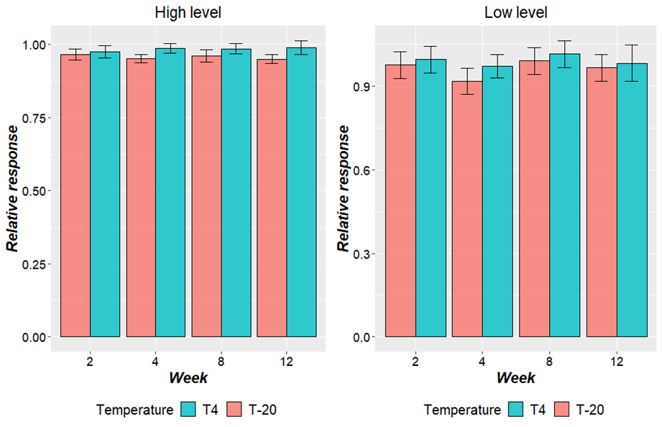

Figure S4. Uncertainty estimation candidate for reference material

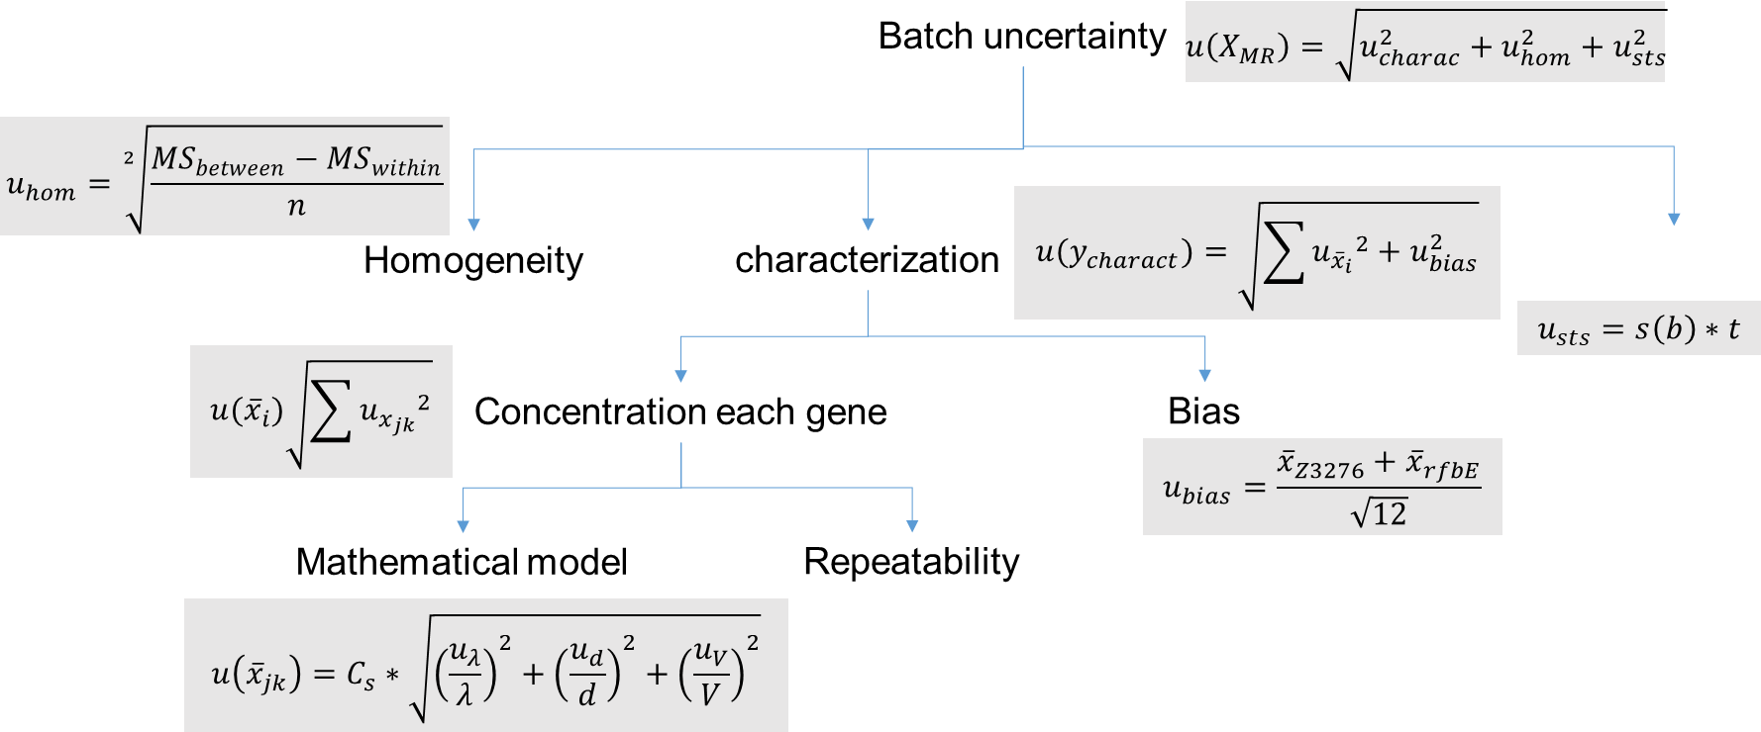

Table S16. dMIQE checklist

ITEM TO CHECK | IMPORTANCE | Comments
EXPERIMENTAL DESIGN
Definition of experimental and control groups | E | Not applicable
Number within each group | E | Not applicable
Assay carried out by core lab or investigator's lab? | D | Investigator’s lab
Power analysis | D | Not applicable
SAMPLE
Description | E | Included in manuscript
Volume or mass of sample processed | E | Included in manuscript
Microdissection or macrodissection | E | Not applicable
Processing procedure | E | Not applicable
If frozen - how and how quickly? | E | Not applicable
If fixed - with what, how quickly? | E | Not applicable
Sample storage conditions and duration (especially for FFPE samples) | E | Included in manuscript
NUCLEIC ACID EXTRACTION
Quantification - instrument/method | E | Included in the manuscript
Storage conditions: temperature, concentration, duration, buffer | E | Included in the manuscript
DNA or RNA quantification | E | Included in the manuscript
Quality/integrity-instrument/method; e.g. RIN/RQI and trace or 3’:5’ | E | Included in the manuscript
Template structural information | E | Not applicable
Template modification (digestion, sonication, pre-amplification etc.) | E | Not applicable
Template treatment (initial heating or chemical denaturation) | E | Not applicable
Inhibition dilution or spike; | E | Not applicable
DNA contamination assessment of RNA sample | E | Included in the manuscript
Details of DNase treatment where performed | E | Included in the manuscript
Manufacturer of reagents used and catalogue number | D | Not applicable
Storage of nucleic acid: temperature, concentration, duration, buffer | E | Included in the manuscript
REVERSE TRANSCRIPTION (If necessary)
cDNA priming method + concentration | E | Not applicable
One or two step protocol | E | Not applicable
Amount of RNA used per reaction | E | Not applicable
Detailed reaction components and conditions | E | Not applicable
RT efficiency | D | Not applicable
Estimated copies measured with and without addition of RT | D | Not applicable
Manufacturer of reagents used and catalogue number | D | Not applicable
Reaction volume (for two step reverse transcription reaction) | D | Not applicable
Storage of cDNA: temperature, concentration, duration, buffer | D | Not applicable
dPCR TARGET INFORMATION
Sequence accession number | E | Included in manuscript
Location of amplicon | D | uidA: 2369650 - 2396742  lacY: 418928 - 419080  eaeA: 4667314 - 4667415  rfbE: 2852517 - 2852604  stx1: 2996304 - 2996434  stx2: 1352836 - 1352963  Z3276: 2933746 - 2933860  Reference location in Escherichia coli O157:H7 str. EDL933, complete sequence.  GenBank NC_002655
Amplicon length | E | Included in manuscript
In silico specificity screen (BLAST, etc) | E | Included in supplementary information
Pseudogenes, retropseudogenes or other homologs? | D | Not applicable
Sequence alignment | D | Included in supplementary information
Secondary structure analysis of amplicon and GC content | D | Included in supplementary information
Location of each primer by exon or intron (if applicable) | E | Not applicable
Where appropriate, which splice variants are targeted? | E | Not applicable
dPCR OLIGONUCLEOTIDES
Primer sequences and/or amplicon context sequence | E | Included in manuscript
RTPrimerDB Identification Number | D | Not included
Probe sequences | D | Included in manuscript
Location and identity of any modifications | E | Not applicable
Manufacturer of oligonucleotides | D | Included in manuscript
Purification method | D | RPC for primers and RP HPLC/dual HPLC for probes
dPCR PROTOCOL
Complete reaction conditions | E | Included in manuscript
Reaction volume and amount of RNA/cDNA/DNA | E | Included in manuscript
Primer, (probe), Mg++ and dNTP concentrations | E | Included in manuscript
Polymerase identity and concentration | E | Included in manuscript
Buffer/kit Catalogue No and manufacturer | E | Included in manuscript
Exact chemical constitution of the buffer | D | Not applicable
Additives (SYBR Green I, DMSO, etc.) | E | Not applicable
Plates/tubes Catalogue No and manufacturer | D | Included in manuscript
Complete thermocycling parameters | E | Included in manuscript
Reaction setup | D | Included in manuscript
Gravimetric or volumetric dilutions (manual/robotic) | D | Manual
Total PCR reaction volume prepared | D | Included in manuscript
Partition number | E | 13000 - 19000
Individual partition volume | E | Included in manuscript
Total volume of the partitions measured (effective reaction size) | E | 10.6 – 15.6 uL
Partition volume variance/standard deviation | D | Not applicable
Comprehensive details and appropriate use of controls | E | Included in manuscript
Manufacturer of dPCR instrument | E | Included in manuscript
dPCR VALIDATION
Optimisation data for the assay | D | Not included in manuscript
Specificity (when measuring rare mutations, pathogen sequences etc.) | E | Included in manuscript
Limit of detection of calibration control | D | Included in manuscript
If multiplexing, comparison with singleplex assays | E | Not included in manuscript
DATA ANALYSIS
Average copies per partition (λ or equivalent) | E | L1: 7,920 cp/uL  L2: 718 cp/uL  L3: 66 cp/uL  L4: 6.6 cp/uL  L5: 1.3 cp/uL
dPCR analysis program (source, version) | E | Included in manuscript
Outlier identification and disposition | E | Included in manuscript
Results of NTCs | E | Included in manuscript
Examples of positive(s) and negative experimental results as supplemental data | E | Included in supplementary information
Where appropriate, justification of number and choice of reference genes | E | Included in manuscript
Where appropriate, description of normalization method | E | Not applicable
Number and concordance of biological replicates | D | Not applicable
Number and stage (RT or qPCR) of technical replicates | E | Included in manuscript
Repeatability (intra-assay variation) | E | Included in manuscript
Reproducibility (inter-assay/user/lab etc. variation) | D | Included in manuscript
Experimental variance or confidence interval | E | Included in manuscript
Statistical methods used for analysis | E | Included in manuscript
Data submission using RDML | D | Not included in manuscript
E: Essential information, D: Desirable information

References

[1] E. Theres, M. Polt, M. Konrad-k, P. Kinner, A. Sessitsch, and T. Kosti, “Evaluation of quantitative PCR combined with PMA treatment for molecular assessment of microbial water quality,” vol. 7, no. 0, pp. 367–376, 2014, doi: 10.1016/j.watres.2014.09.022.
[2] S. Das Mitrai et al., “Duplex PCR for specific detection of Escherichia coli and its differentiation from other Enterobacteriaceae,” Indian J. Anim. Sci., vol. 85, no. 8, pp. 16–19, 2015.
[3] K. Horakova, H. Mlejnkova, and P. Mlejnek, “Specific detection of Escherichia coli isolated from water samples using polymerase chain reaction targeting four genes: Cytochrome bd complex, lactose permease, ??-d-glucuronidase, and ??-d-galactosidase,” J. Appl. Microbiol., vol. 105, no. 4, pp. 970–976, 2008, doi: 10.1111/j.1365-2672.2008.03838.x.
[4] E. M. Nielsen and M. T. Andersen, “Detection and Characterization of Verocytotoxin-Producing Escherichia coli by Automated 5 ′ Nuclease PCR Assay Detection and Characterization of Verocytotoxin-Producing Escherichia coli by Automated 5Ј Nuclease PCR Assay,” J. Clin. Microbiol., vol. 41, no. 7, pp. 2884–2893, 2003, doi: 10.1128/JCM.41.7.2884.
[5] I. O. for S. ISO, “ISO/TS 13136:2012 - Microbiology of food and animal feed -- Real-time polymerase chain reaction (PCR)-based method for the detection of food-borne pathogens -- Horizontal method for the detection of Shiga toxin-producing Escherichia coli (STEC) and the determination of O157, O111, O26, O103 and O145 serogroups,” 2012. https://www.iso.org/standard/53328.html (accessed Mar. 21, 2019).
[6] B. Li and J. Chen, “Real-Time PCR Methodology for Selective Detection of Viable Escherichia coli O157 : H7 Cells by Targeting Z3276 as a Genetic,” vol. 78, no. 15, pp. 5297–5304, 2012, doi: 10.1128/AEM.00794-12.
[7] B. Li, H. Liu, and W. Wang, “Multiplex real-time PCR assay for detection of Escherichia coli O157 : H7 and screening for non-O157 Shiga toxin-producing E . coli,” pp. 1–13, 2017, doi: 10.1186/s12866-017-1123-2.

