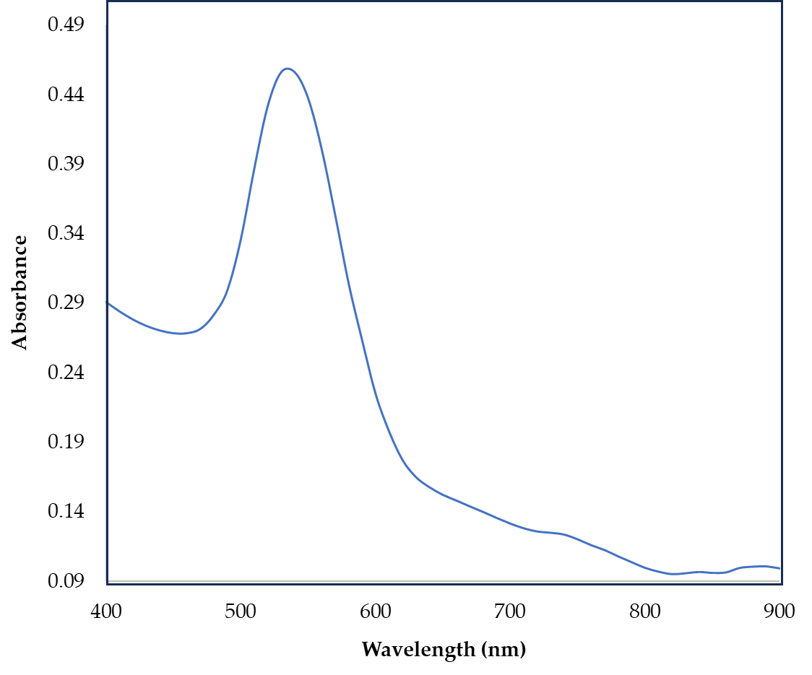

Figure S1. Average UV-visible spectra of AuNPs with average maximum absorbance at 540nm.

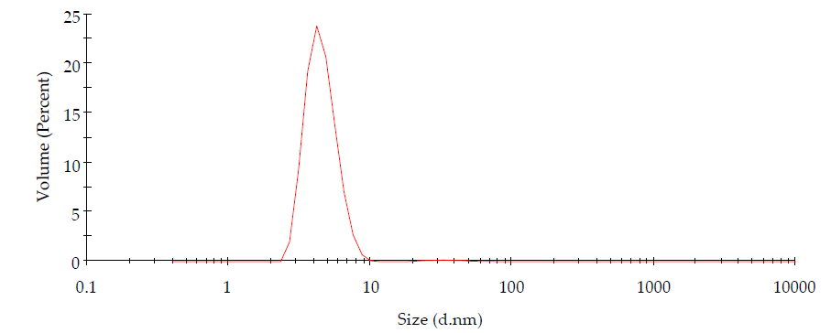

Figure S2. AuNPs (water and acetonitrile, 1:1) size distribution.

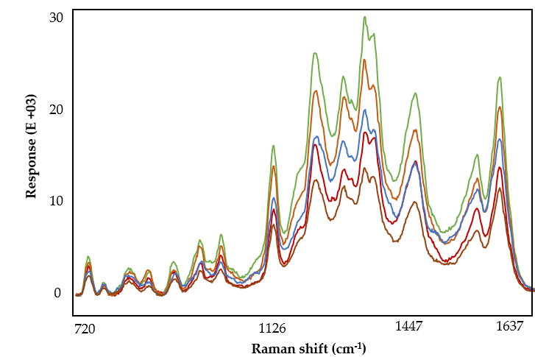
Figure S3. VAMS measurements illustrating spectral pattern consistency in FM sample regardless of signal intensity.

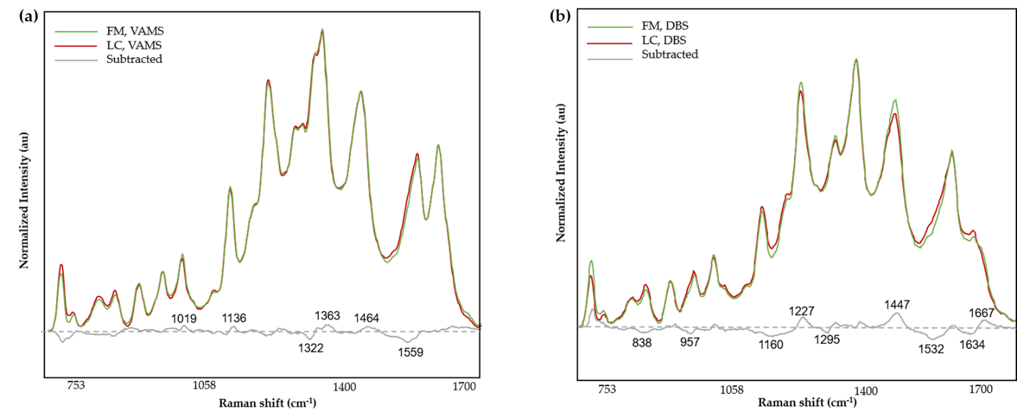
Figure S4. The subtracted mean spectra of LC from FM group, obtained from, (a) VAMS tips and (b) DBS cards.

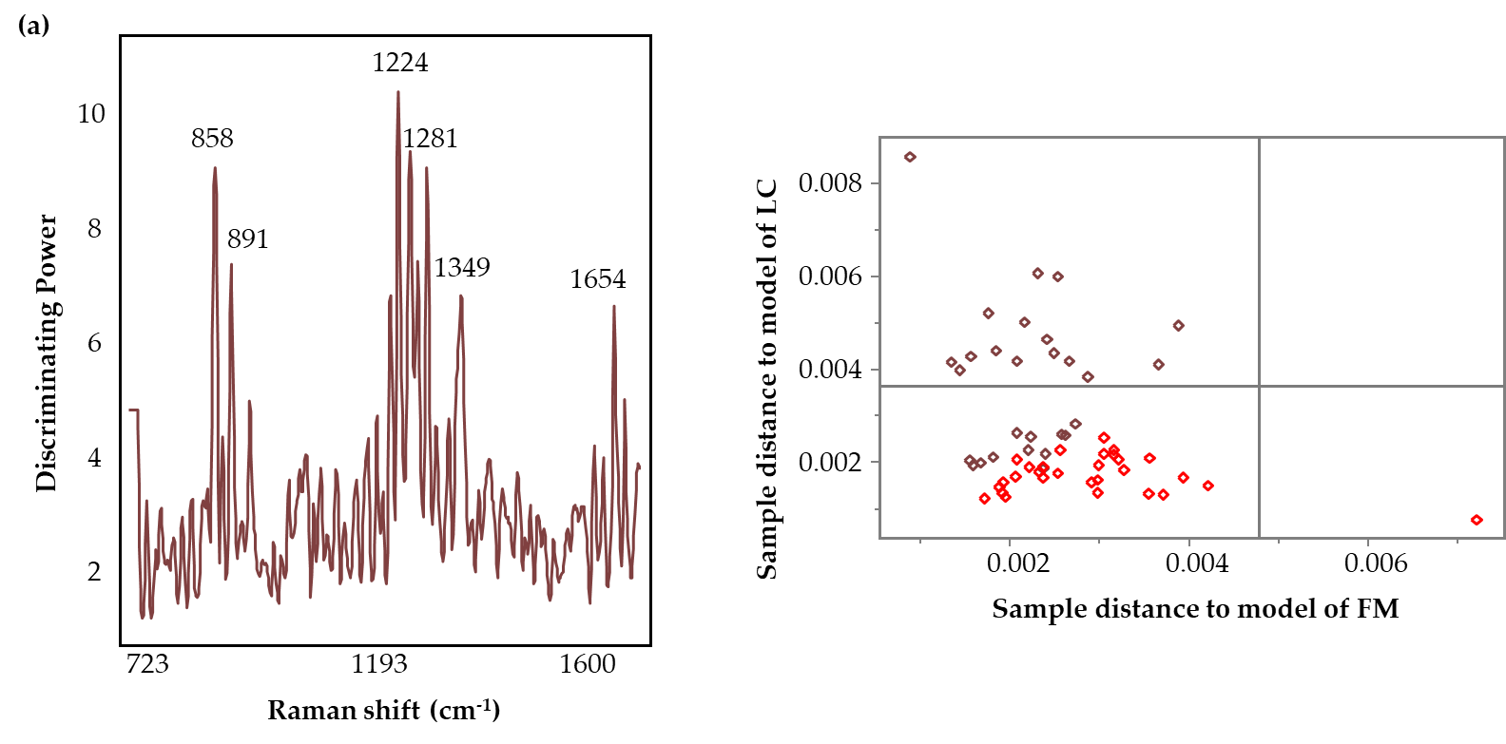
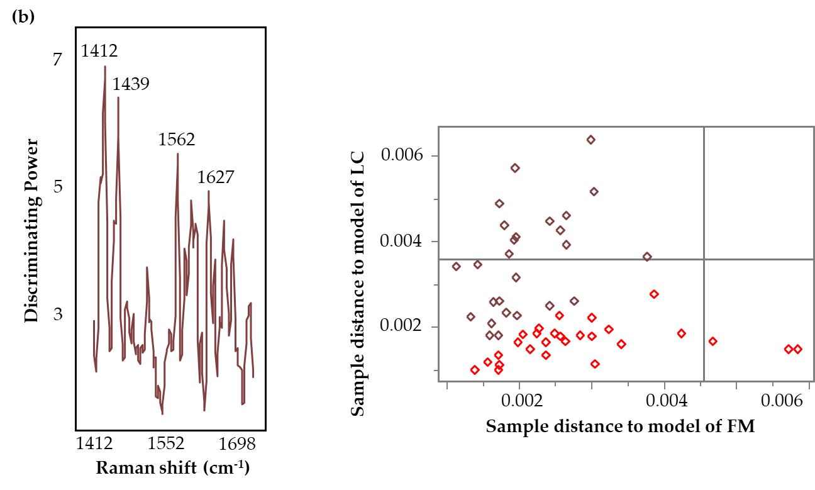
Figure S5. Discrimination power and Coomans plots (brown squares denote FM and red squares represent LC samples) of the SIMCA model for the full region (700-1700 cm⁻¹) (a) and the amide region (1400-1700 cm⁻¹) (b), for the classification of FM and LC samples collected using VAMS tips.

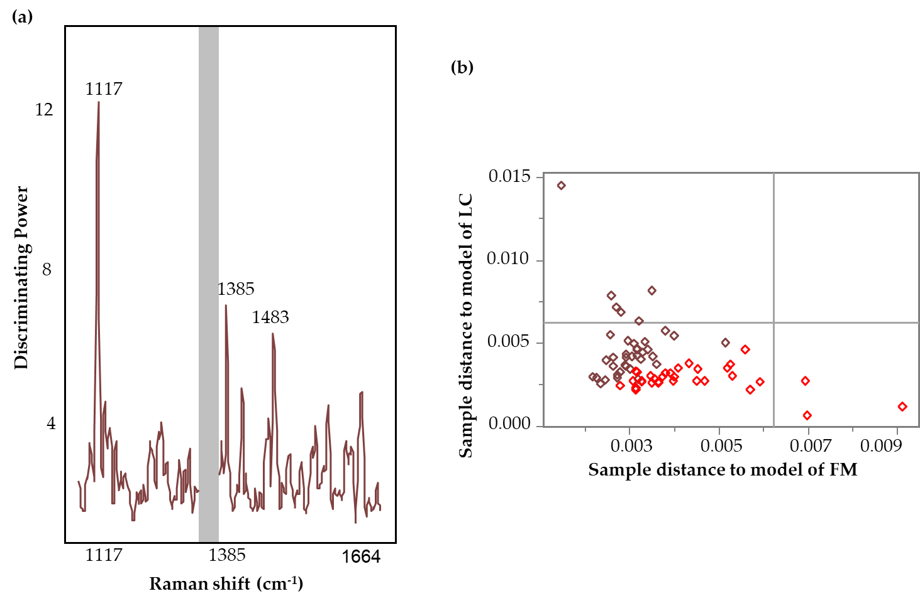
Figure S6. Discrimination power (a) and Coomans plots (b) (brown squares denote FM and red squares represent LC samples) of the SIMCA model for the central region (1100-1330 cm⁻¹ and 1400-1700 cm⁻¹), for the classification of FM and LC samples collected on DBS cards.

