Supplementary Materials
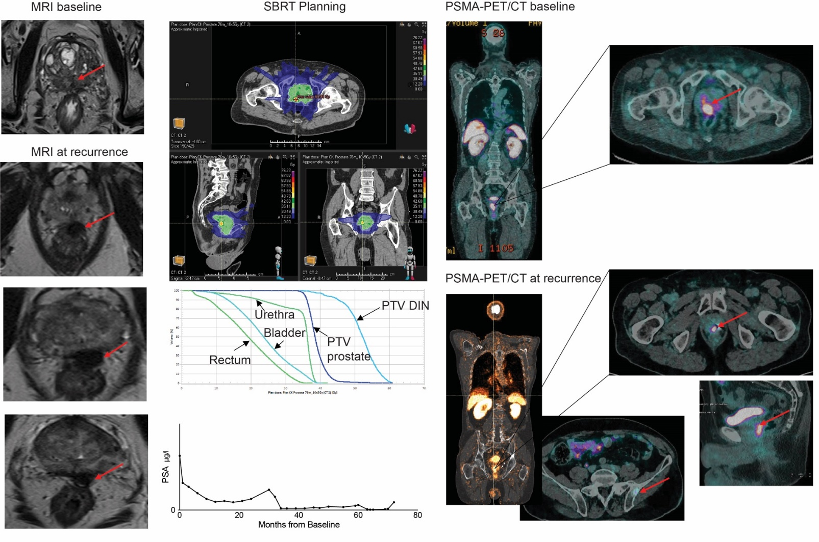
Figure S1. legend: Description of a patient’s case (T3a, GS 4+3, PSA baseline 12.6 μg/l) with mpMRI and ⁶⁸Ga-PSMA-PET/CT at baseline and at recurrence. SBRT histograms. Evolution of PSA values.
