Support information

Thermal Surface Properties, London Dispersive and Polar Surface Energy of Graphene and Carbon Materials by Inverse Gas Chromatography at Infinite Dilution

Tayssir Hamieh^{1,2}

¹Faculty of Science and Engineering, Maastricht University, P.O. Box 616, 6200 MD Maastricht, Netherlands, E-mail: t.hamieh@maastrichtuniversity.nl
²Laboratory of Materials, Catalysis, Environment and Analytical Methods (MCEMA), Faculty of Sciences, Lebanese University, 1533, Hadath, Lebanon

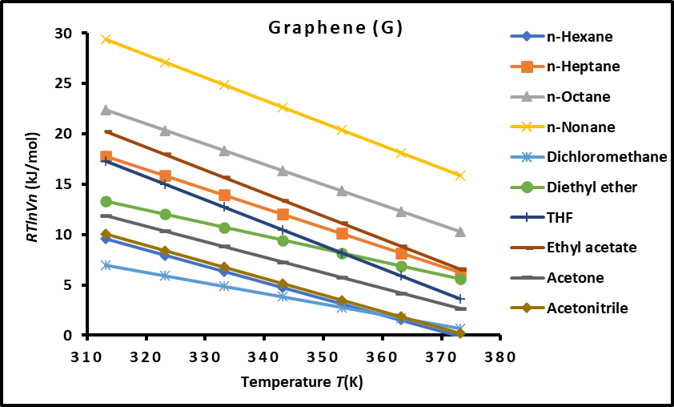
(a)

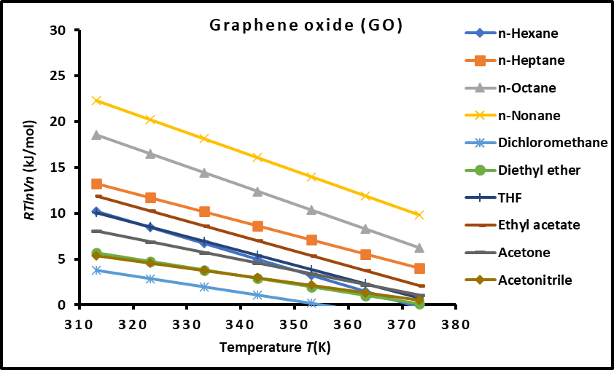
(b)

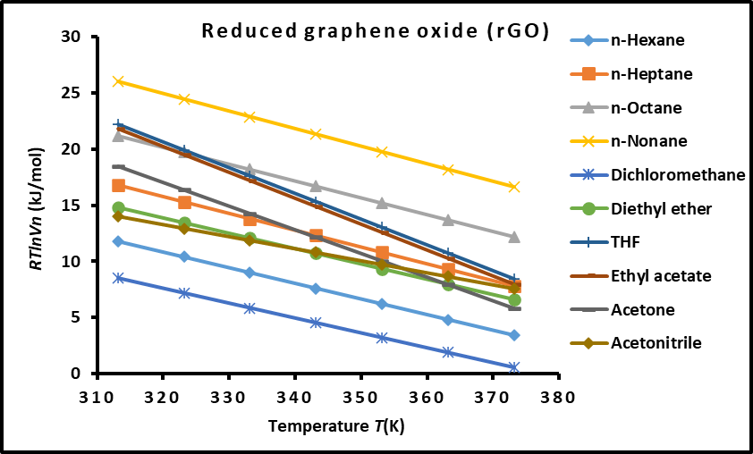
(c)

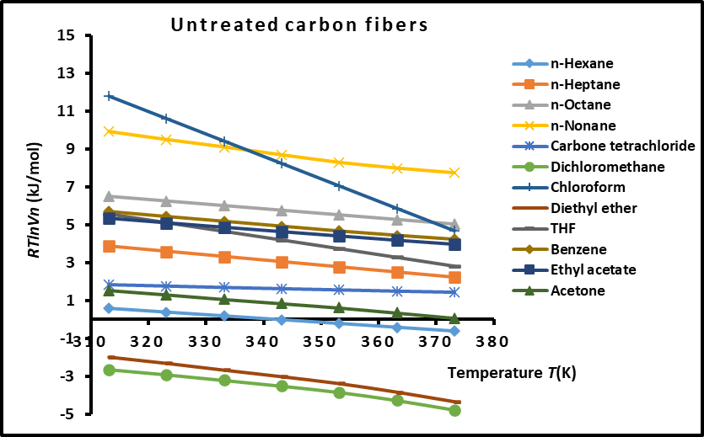
(d)

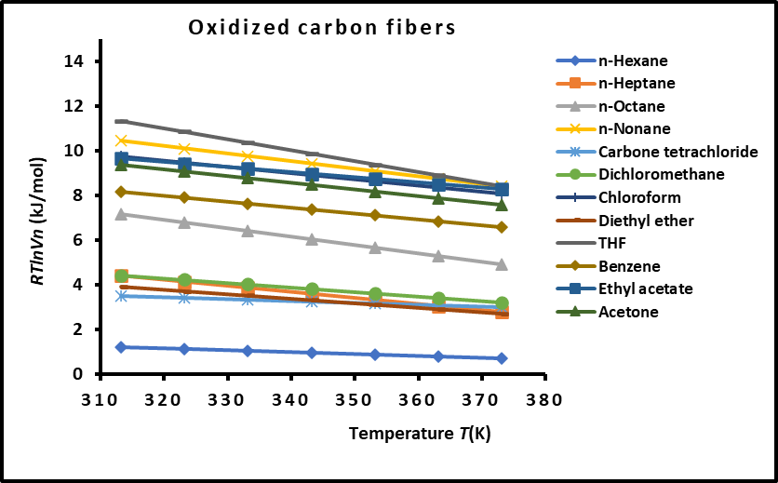
(e)
Figure S1. Variations of $RTlnV_{n}(T)$ of n-alkanes and polar molecules adsorbed on the various solid materials against the temperature. (a): Graphene, (b): Graphene oxide, (c): Reduced graphene oxide, (d) Untreated carbon fibers, and (e): Oxidized carbon fibers.

Table S1. Values of $-∆G_{a}^{p}\left(T\right)$ (in kJ/mol) of polar molecules adsorbed on the various solid materials against the temperature. Graphene, Graphene oxide, Reduced graphene oxide, Untreated carbon fibers, and Oxidized carbon fibers.
$-∆G_{a}^{p}\left(T\right)$ (in kJ/mol) |  | Graphene
T(K) | Dichloromethane |  | Diethyl ether | THF | Ethyl acetate | Acetone | Acetonitrile
313.15 | 12.938 |  | 21.537 | 20.104 | 22.191 | 25.247 | 32.890
323.15 | 12.993 |  | 20.456 | 19.156 | 21.658 | 24.461 | 33.199
333.15 | 13.048 |  | 19.376 | 18.207 | 21.125 | 23.676 | 33.508
343.15 | 13.102 |  | 18.294 | 17.258 | 20.591 | 22.889 | 33.816
353.15 | 13.157 |  | 17.214 | 16.310 | 20.057 | 22.104 | 34.125
363.15 | 13.211 |  | 16.134 | 15.362 | 19.524 | 21.318 | 34.434
373.15 | 13.265 |  | 15.052 | 14.412 | 18.990 | 20.531 | 34.742
$-∆G_{a}^{p}\left(T\right)$ (in kJ/mol) |  | Graphene oxide
T(K) | Dichloromethane |  | Diethyl ether | THF | Ethyl acetate | Acetone | Acetonitrile
313.15 | 2.309 |  | 9.736 | 8.668 | 11.657 | 12.238 | 18.469
323.15 | 2.749 |  | 9.445 | 8.404 | 11.603 | 12.414 | 19.019
333.15 | 3.192 |  | 9.157 | 8.143 | 11.552 | 12.592 | 19.571
343.15 | 3.639 |  | 8.873 | 7.887 | 11.504 | 12.772 | 20.122
353.15 | 4.082 |  | 8.584 | 7.626 | 11.452 | 12.950 | 20.674
363.15 | 4.523 |  | 8.294 | 7.363 | 11.400 | 13.127 | 21.225
373.15 | 4.964 |  | 8.003 | 7.100 | 11.347 | 13.304 | 21.775
$-∆G_{a}^{p}\left(T\right)$ (in kJ/mol) |  | Reduced graphene oxide
T(K) | Dichloromethane |  | Diethyl ether | THF | Ethyl acetate | Acetone | Acetonitrile
313.15 | 10.175 |  | 20.953 | 17.327 | 21.696 | 20.831 | 19.905
323.15 | 10.148 |  | 19.968 | 16.364 | 20.849 | 20.987 | 20.995
333.15 | 10.123 |  | 18.983 | 15.403 | 20.000 | 21.141 | 22.080
343.15 | 10.095 |  | 17.995 | 14.438 | 19.151 | 21.296 | 23.168
353.15 | 10.068 |  | 17.009 | 13.474 | 18.302 | 21.451 | 24.257
363.15 | 10.042 |  | 16.023 | 12.512 | 17.453 | 21.604 | 25.341
373.15 | 10.013 |  | 15.035 | 11.547 | 16.604 | 21.758 | 26.429
$-∆G_{a}^{p}\left(T\right)$ (in kJ/mol) |  | Untreated carbon fibers
T(K) | Dichloromethane |  | Diethyl ether | THF | Ethyl acetate | Acetone | Chloroform
313.15 | 4.130 |  | 2.133 | 11.809 | 9.471 | 10.681 | 15.339
323.15 | 3.872 |  | 1.873 | 11.455 | 9.381 | 10.499 | 14.255
333.15 | 3.614 |  | 1.613 | 11.101 | 9.291 | 10.317 | 13.171
343.15 | 3.356 |  | 1.353 | 10.747 | 9.201 | 10.135 | 12.087
353.15 | 3.098 |  | 1.093 | 10.393 | 9.111 | 9.953 | 11.003
363.15 | 2.840 |  | 0.833 | 10.039 | 9.021 | 9.771 | 9.919
373.15 | 2.582 |  | 0.573 | 9.685 | 8.931 | 9.589 | 8.835
$-∆G_{a}^{p}\left(T\right)$ (in kJ/mol) |  | Oxidized carbon fibers
T(K) | Dichloromethane |  | Diethyl ether | THF | Ethyl acetate | Acetone | Chloroform
313.15 | 10.526 |  | 7.399 | 17.009 | 13.204 | 17.919 | 12.794
323.15 | 10.235 |  | 7.187 | 16.443 | 12.962 | 17.462 | 12.519
333.15 | 9.944 |  | 6.975 | 15.877 | 12.720 | 17.005 | 12.244
343.15 | 9.653 |  | 6.763 | 15.311 | 12.478 | 16.548 | 11.969
353.15 | 9.362 |  | 6.551 | 14.745 | 12.236 | 16.091 | 11.694
363.15 | 9.071 |  | 6.339 | 14.179 | 11.994 | 15.634 | 11.419
373.15 | 8.780 |  | 6.127 | 13.613 | 11.752 | 15.177 | 11.144

Table S2. Values of ($-∆H_{a}^{p} in kJ {mol}^{-1}$) of polar molecules adsorbed on the different graphene and carbon materials
Materials | Dichloromethane | Diethyl ether | THF | Ethyl acetate | Acetone | Acetonitrile
Graphene | 11.234 | 55.379 | 49.808 | 38.894 | 49.855 | 23.224
Graphene oxide | -11.565 | 18.765 | 16.833 | 13.261 | 6.6652 | 1.2085
Reduced graphene oxide | 11.017 | 51.84 | 47.496 | 48.277 | 21.295 | 23.168
Untreated carbon fibers | 12.209 | 49.284 | 10.275 | 22.895 | 12.289 | -
Oxidized carbon fibers | 19.639 | 21.406 | 14.038 | 34.733 | 20.782 | -

Table S3. Values of ($-∆S_{a}^{p} in J {K^{-1}mol}^{-1}$) of polar molecules adsorbed on the different graphene and carbon materials
Materials | Dichloromethane | Diethyl ether | THF | Ethyl acetate | Acetone | Acetonitrile
Graphene | -5.4 | -44.3 | 2.7 | 25.8 | 29.1 | -5.4
Graphene oxide | 108.1 | 28.8 | 98.6 | 108.4 | 27.5 | 108.1
Reduced graphene oxide | 94.9 | 26.1 | 96.3 | 26.0 | 21.2 | 94.9
Untreated carbon fibers | 53.3 | 5.1 | 84.9 | 35.4 | 56.6 | -
Oxidized carbon fibers | 78.6 | -17.8 | -15.4 | 9.0 | 24.2 | -

Table S4. Values of polar acid-base energies $γ_{s}^{+}$, $γ_{s}^{-}$, $γ_{s}^{p}$, and total surface energy $γ_{s}^{tot.}$ ($in mJ/m^{2}$) of the different graphenes and carbon materials at various temperatures.

Materials | T(K) | 313.15 | 323.15 | 333.15 | 343.15 | 353.15 | 363.15 | 373.15
Graphene | $$γ_{s}^{-}$$ | 167.08 | 162.07 | 157.32 | 152.79 | 148.51 | 144.41 | 140.52
 | $$γ_{s}^{+}$$ | 73.55 | 68.61 | 63.95 | 59.53 | 55.36 | 51.42 | 47.70
 | $$γ_{s}^{p}$$ | 221.71 | 210.91 | 200.61 | 190.75 | 181.34 | 172.35 | 163.73
 | $$γ_{s}^{tot.}$$ | 500.90 | 472.02 | 443.90 | 416.53 | 389.88 | 363.98 | 338.77
Graphene oxide | $$γ_{s}^{-}$$ | 5.32 | 7.25 | 9.41 | 11.79 | 14.29 | 16.93 | 19.68
 | $$γ_{s}^{+}$$ | 20.29 | 19.69 | 19.12 | 18.58 | 18.05 | 17.53 | 17.03
 | $$γ_{s}^{p}$$ | 20.78 | 23.91 | 26.84 | 29.60 | 32.12 | 34.45 | 36.61
 | $$γ_{s}^{tot.}$$ | 139.0 | 133.2 | 127.4 | 121.7 | 116.1 | 110.5 | 105.0
Reduced graphene oxide | $$γ_{s}^{-}$$ | 103.34 | 98.87 | 94.69 | 90.70 | 86.96 | 83.44 | 80.07
 | $$γ_{s}^{+}$$ | 70.30 | 63.58 | 57.32 | 51.50 | 46.10 | 41.09 | 36.46
 | $$γ_{s}^{p}$$ | 170.47 | 158.57 | 147.35 | 136.69 | 126.62 | 117.11 | 108.06
 | $$γ_{s}^{tot.}$$ | 321.4 | 305.8 | 290.7 | 275.9 | 261.6 | 247.4 | 233.5
Untreated carbon fibers | $$γ_{s}^{-}$$ | 17.03 | 14.39 | 12.07 | 10.02 | 8.23 | 6.67 | 5.32
 | $$γ_{s}^{+}$$ | 13.40 | 12.87 | 12.37 | 11.89 | 11.42 | 10.98 | 10.55
 | $$γ_{s}^{p}$$ | 30.20 | 27.22 | 24.44 | 21.83 | 19.40 | 17.12 | 14.99
 | $$γ_{s}^{tot.}$$ | 86.5 | 80.2 | 74.4 | 68.5 | 62.9 | 58.2 | 53.9
Oxide carbon fibers | $$γ_{s}^{-}$$ | 110.59 | 100.57 | 91.37 | 82.93 | 75.19 | 68.08 | 61.56
 | $$γ_{s}^{+}$$ | 26.04 | 24.58 | 23.19 | 21.86 | 20.60 | 19.41 | 18.27
 | $$γ_{s}^{p}$$ | 107.33 | 99.43 | 92.06 | 85.16 | 78.72 | 72.70 | 67.07
 | $$γ_{s}^{tot.}$$ | 163.2 | 151.0 | 139.4 | 128.4 | 117.9 | 107.9 | 98.4

