Superlattices Reveal Electronic Topological Transition in CaC₆ with Pressure
Bruce Wang^{1,2}, Antonio Bianconi³, Ian D. R. Mackinnon⁴ and Jose A. Alarco^{1,2,4} *
¹School of Chemistry and Physics,²Centre for Materials Science, and ⁴Centre for Clean Energy Technologies and Practices, Queensland University of Technology: 2 George Street, Gardens Point, Brisbane, Queensland, 4000, Australia

³ Rome International Center for Materials Science Superstripes (RICMASS), Via dei Sabelli 119A, 00185 Roma, Italy
* Corresponding author: jose.alarco@qut.edu.au

Supplemental Material
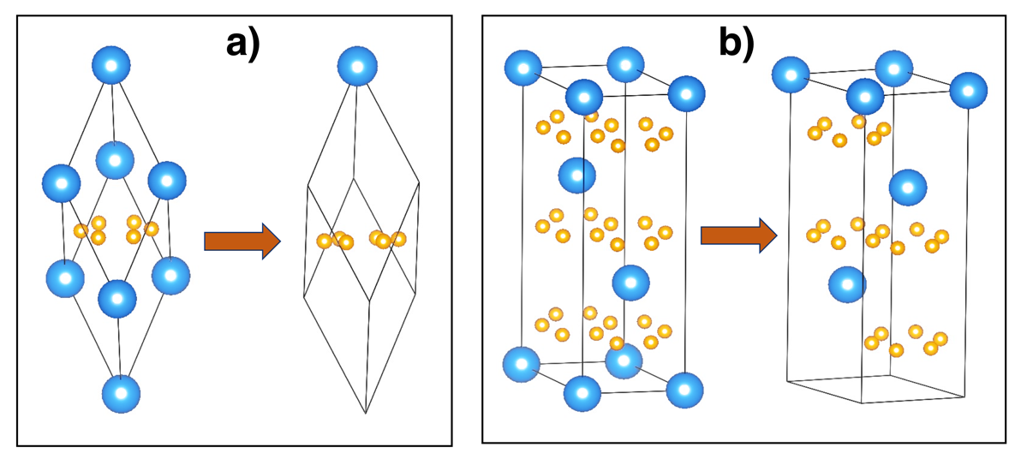
Figure S1: Displays of the aomic structures of the CaC₆ unit cells before and after relaxation. A) Primitive Rhobohedral unit cell. B) Equivalent hexagonal unit cell. Notice that after relaxation, some atoms undergo minimal, sub-decimal dsiplacements resulting in the “disappearance” from the highly symmetric input structures.
Figure S1 illustrates the atomic structures of CaC₆ before and after unit cell relaxations. Atoms located at the boundaries of the unit cell have all shifted from the boundaries post-relaxation. The symmetry applied for the atomic structures of CaC₆ may not adequately represent its most stable atomic arrangements. The directly optimised rhombohedral unit cell using GGA results in lattice parameters a = 5.1607Å and 𝛼 = 49.74°. On the other hand, geometry optimisation of the hexagonal cell results in a = 4.34Å and c = 13.53Å, which is equivalent to a rhombohedral cell with lattice parameters a = 5.159Å and 𝛼 = 49.744°. Furthermore, geometry optimisation slightly shifts the Ca and C atoms from their original symmetrical positions in both rhombohedral and hexagonal cells, resulting in the output unit cell outside the original input cell (see display in Fig. S1). Note that geometry optimisations using the same code and computational parameter setup for the rhombohedral and hexagonal unit cells calculate highly precise equivalent cells (within 0.033%), although small sub-decimal deviations in atomic positions have to be allowed for overall crystal symmetry to be considered fullfiled.

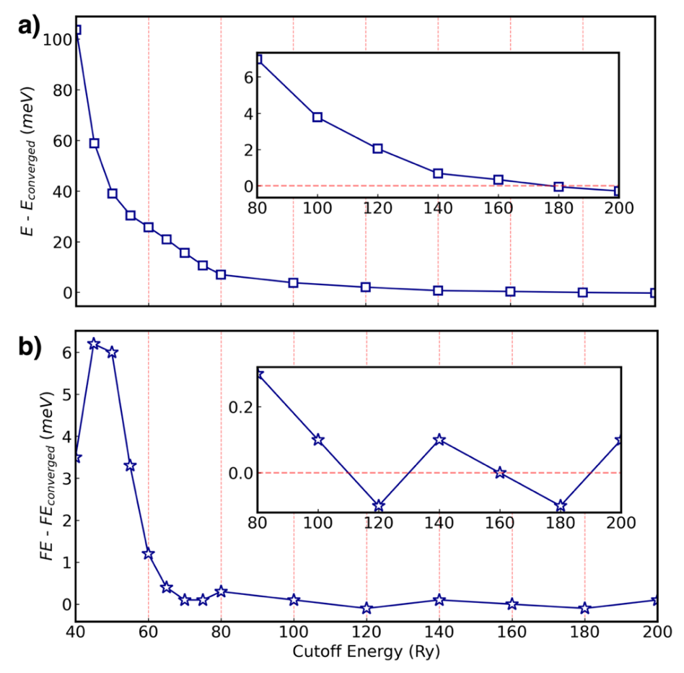

Figure S2: Plane-wave cut-off energies vs. total system energy and Fermi energy for CaC₆ (a) Illustrates the relationship between plane-wave cut-off energies and total energy. (b) Demonstrates the relationship between plane-wave cut-off energies and Fermi energy.
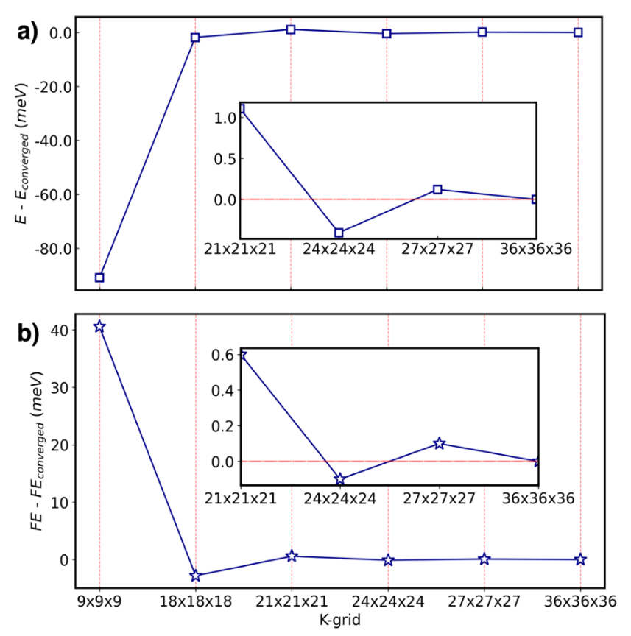
Figure S3: K-points mesh grid vs. total system energy and Fermi energy for CaC₆. (a) Illustrates the relationship between k-point mesh grid and total energy. (b) Demonstrates the relationship between k-point mesh grid and Fermi energy.

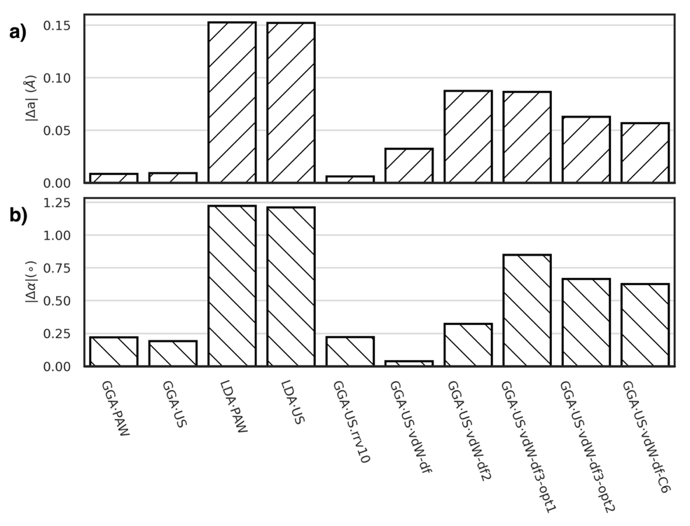
Figure S4: Pseudopotentials vs. change in lattice constants for CaC₆hR compared to experimental values.

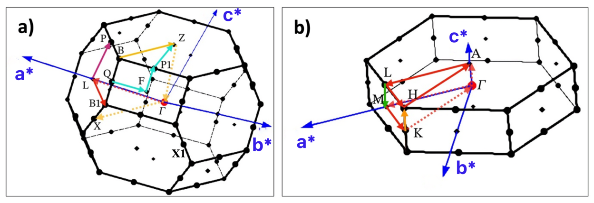
a₁*
a₂*
a₃*

Figure S5: (a) High-symmetry path for RHL1 (primitive rhombohedral unit cell). (b) High-symmetry path for HEX (hexagonal unit cell). The high-symmetry paths follows conventions given in reference¹ (with a few exceptions on the chosen labels).

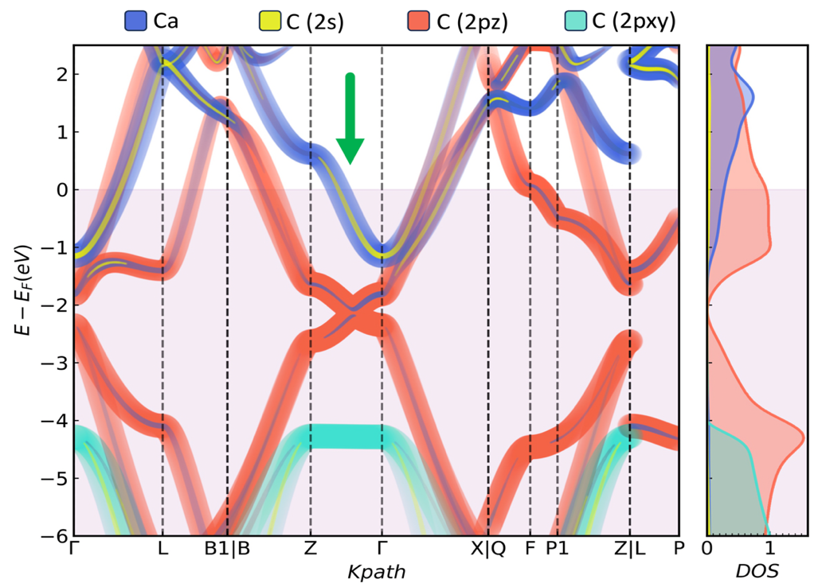

Figure S6: Projected energy band and density of states for the rhombohedral primitive cell. Notice the cosine shaped band along the GZ direction, crossing the Fermi level (arrowed). This cosine-shaped band (unfolded in this case) has dominant Ca 4s-orbital character and some C 2s-orbital character along the GZ line.

Figure S7 shows cross sections of the FS’s for 2GPa across a plane containing the high symmetry orientations $Γ-Z-L$.The cosine-shaped blue lines show schematically the position of the EBS in reciprocal space, relative to the FS’s. The dotted red line of cosine inflection points (where the amplitude of the cosine modulation is null) is where the bonding and antibonding characters transition relative to the FS and where folding is required. For illustration purposes only, we are superimposing an EBS (that is, an E vs k-point graph) onto a reciprocal space projection, which is a collection of k-points only, in order to highlight the link between an EBS and the corresponding FS.
When considering folding at the cosine midpoints line, the nearly spherical Ca-4s FS will develop arcs inside the original nearly spherical FS, as if new spheres were plotted at the Z points of the BZ boundaries, as schematically shown in Fig. 3b (see also Fig. S8). This effect of folding is further illustrated and discussed in section 3.3.
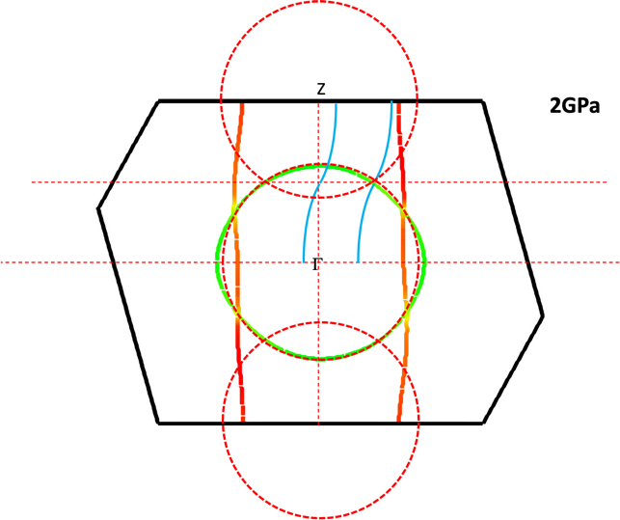
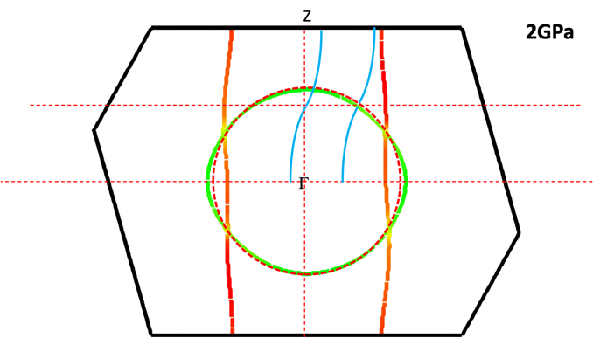
a
b

Figure S7. Schematic of the FS viewed on the cross section containing the $Γ-Z-L$ directions for the rhombohedral unit cell at 2 GPa. The relative position of the cosine band and the FS is schematically displayed in blue in Figures S7a and S7b. The colours of the FSs are proportional to the Fermi velocities (see scale bar in Figure 5).
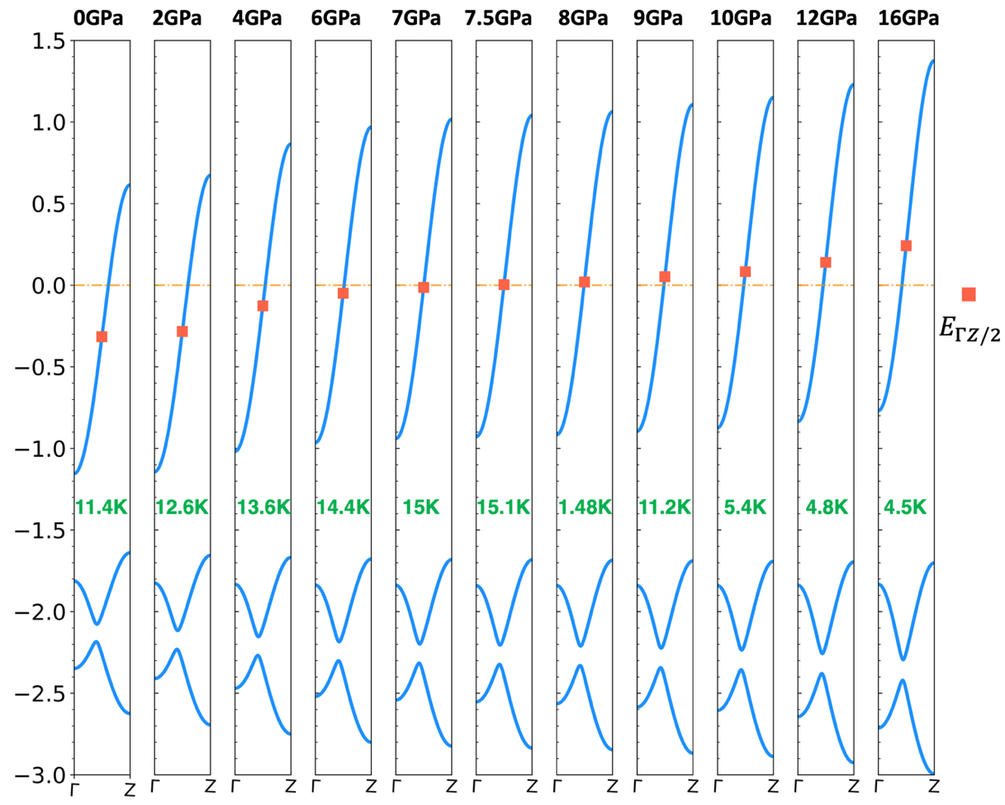

14.8K

Figure S8: Electronic band structures plotted along the GZ direction of primitive rhombohedral unit cell, presented as a function of pressure. The energy level at the middle point between $Γ$ and Z points is denoted as $E_{\frac{ΓZ}{2}}$. The experimentally determined superconducting transition temperatures for the different pressures are given in green below the corresponding cosine-modulated bands.
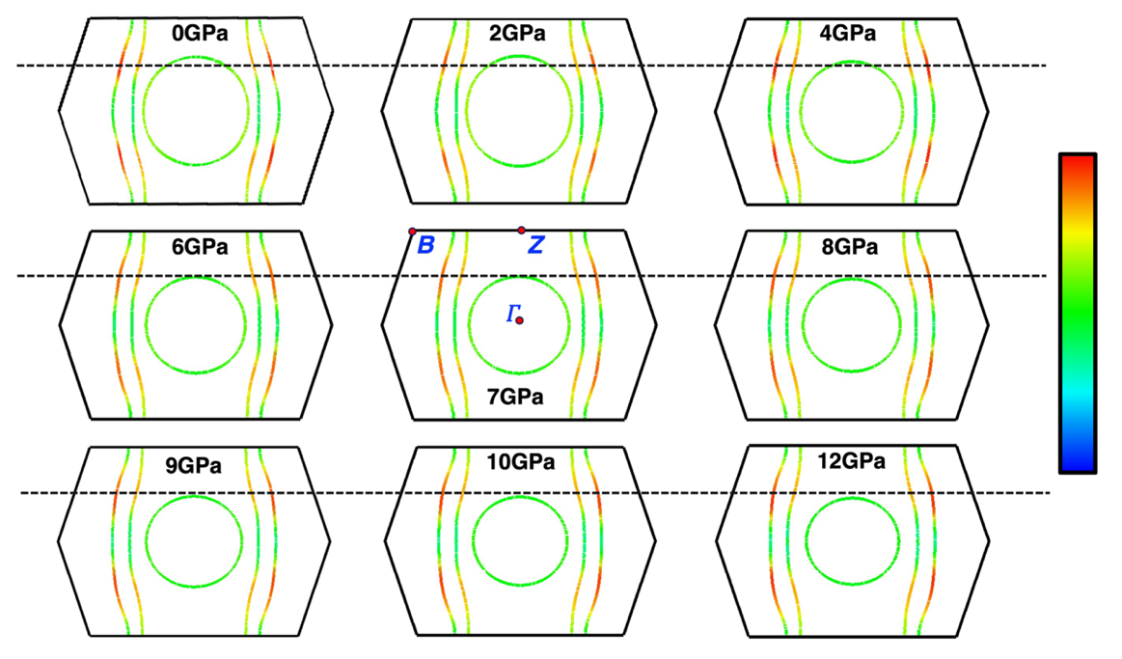

Figure S9: Fermi surfaces as a function of pressure for the rhombohedral unit cell viewed along the perpendicular to the plane containing 𝛤-B-Z high-symmetry path. The colour bar represents the value of Fermi velocity of electrons.
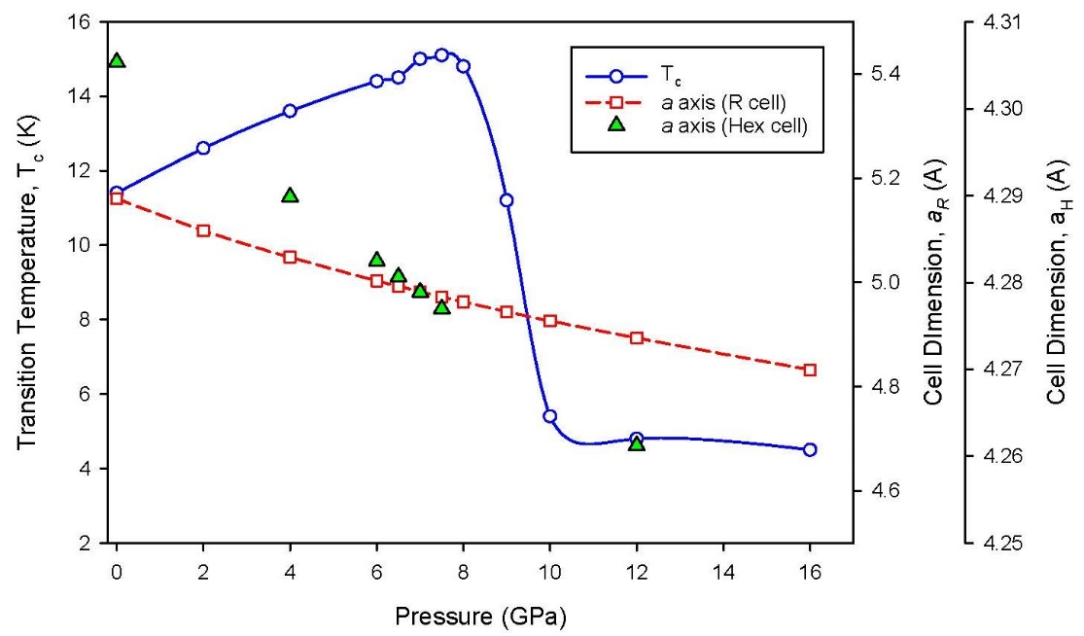
Figure S10. Graph of experimentally determined superconducting transition temperatures for CaC₆ as function of pressure (re-plotted and adapted from reference [6]) and calculated cell parameters for Rhombohedral and Hexagonal cells. .
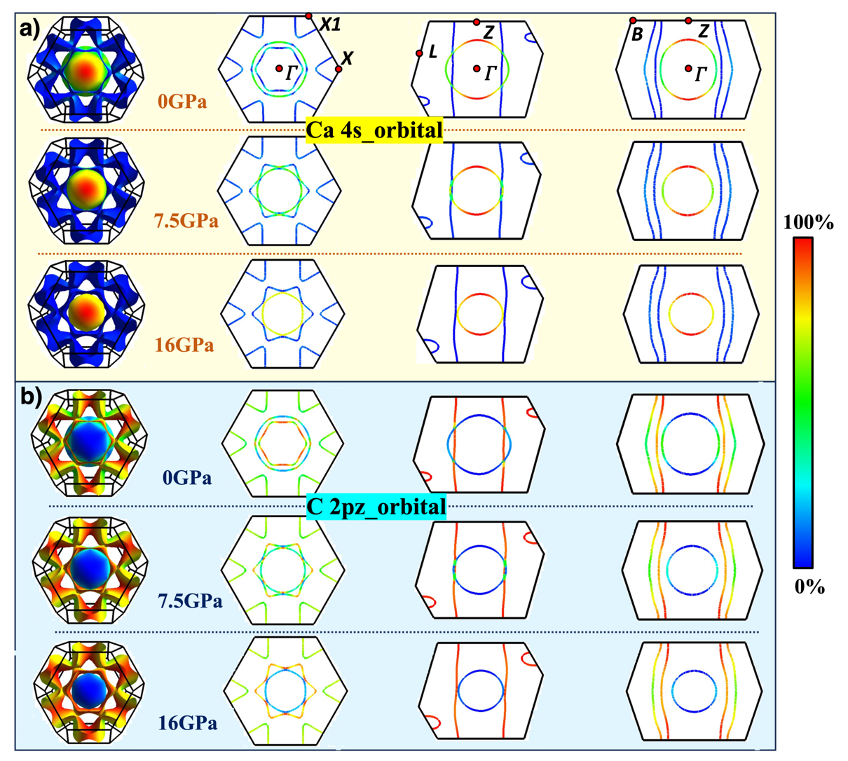

Figure S11: Orbital Characters of Fermi Surfaces for CaC₆. (a) Ca 4s-orbital characteristics of the Fermi surface for different pressures. (b) C 2pz-orbital characteristics of the Fermi surface for different pressures.

Figure S11 shows the orbital characters of Fermi surfaces under pressure. Pure 4s-orbital character of Ca is shown at the top and bottom of the spherical Fermi surface. The spherical Fermi surface is primarily shaped by the orbital of calcium.

The comprehensive properties of CaC₆, including lattice constants, Fermi energy, $E_{\frac{ΓZ}{2}}$ and charge transfer, are detailed in Table S1. In contrast to charge transfer, other properties of CaC₆ exhibit a more uniform trend.

TABLE S1. Properties of CaC₆ under pressure.
Pressure (GPa) | a (Å) | 𝛼, 𝛽, 𝛾 (∘) | $E_{\frac{ΓZ}{2}}$ (meV) | Fermi Energy (meV) | Charge Transferred from Ca to C | Tc ($k$)
0 | 5.1608 | 49.742 | -312.413 | 9.7412 | 1.307427 | 11.4
2 | 5.0997 | 50.287 | -279.467 | 10.0555 | 1.302507 | 12.6
4 | 5.0483 | 50.741 | -122.392 | 10.1288 | 1.314594 | 13.6
6 | 5.0031 | 51.138 | -45.043 | 10.295 | 1.315575 | 14.4
7 | 4.9823 | 51.321 | -9.683 | 10.3734 | 1.314397 | 15
7.5 | 4.9724 | 51.408 | 7.662 | 10.4116 | 1.314443 | 15.1
8 | 4.9627 | 51.492 | 24.126 | 10.4489 | 1.314156 | 14.8
9 | 4.9439 | 51.656 | 129.716 | 10.5223 | 1.313847 | 11.2
10 | 4.9260 | 51.812 | 86.883 | 10.5933 | 1.313196 | 5.4
12 | 4.8930 | 52.105 | 144.067 | 10.7297 | 1.310696 | 4.8
16 | 4.8319 | 52.627 | 246.311 | 10.9836 | 1.306175 | 4.5

ªa, 𝛼, 𝛽, 𝛾 are the lattice constants of CaC6hR (Rhombohedral unit cell).
^{b}$E_{\frac{ΓZ}{2}}$ are energy levels at $\frac{ΓZ}{2}$ of interlayer bands.
^{c}The critical temperature Tc is adapted from ref[2]²

References

1 Setyawan, W. & Curtarolo, S. High-throughput electronic band structure calculations: Challenges and tools. Computational Materials Science 49, 299-312, doi:https://doi.org/10.1016/j.commatsci.2010.05.010 (2010).
2 Kim, J. S., Boeri, L., Kremer, R. K. & Razavi, F. S. Effect of pressure on superconducting Ca-intercalated graphite CaC₆. Physical Review B 74, 214513, doi:10.1103/PhysRevB.74.214513 (2006).

