SUPPLEMENTARY MATERIAL FOR

Facile Access to Solifenacin Impurity K: One-Step Synthesis and an HPLC-MS method for its determination

Raúl Xifra¹ and Andreea L. Turcu^{2,3}*

¹ Centro de investigación y desarrollo para la Química Orgánica S.L. (CIDQO, S. L.); Polígono Industrial “Can Verdalet”. Calle D; Nave 91, 08490 Tordera, Spain; rxifra@ewatts-tech.com
² Laboratori de Química Farmacèutica (Unitat Associada al CSIC), Facultat de Farmàcia i Ciències de l’Alimentació, Universitat de Barcelona, Av. Joan XXIII, 27-31, 08028 Barcelona, Spain; aturcu@ub.edu
³ Institute of Biomedicine of the University of Barcelona (IBUB), Universitat de Barcelona, Barcelona, Spain.

Table of contents

Figure S1: ¹H, ¹³C, DEPT, HSQC, COSY, IR GC/MS (EI),
and UV spectrum of Impurity K Page S3
Figure S2: HPLC/MS-MS of Solifenacin succinate tables Page S13
Figure S3: HPLC/MS-MS of Impurity I Page S15
Figure S4: HPLC/MS-MS of Impurity K Page S17

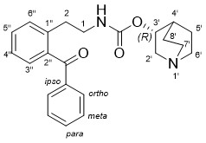
¹H, ¹³C, DEPT, HSQC, COSY, IR, GC/MS (EI) and UV spectrum of Impurity K
¹H (400 MHz, CDCl₃)
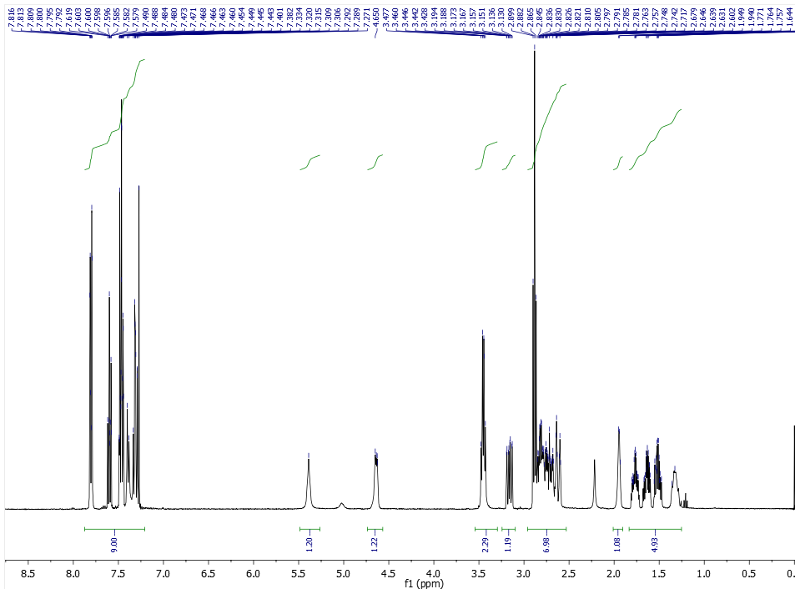
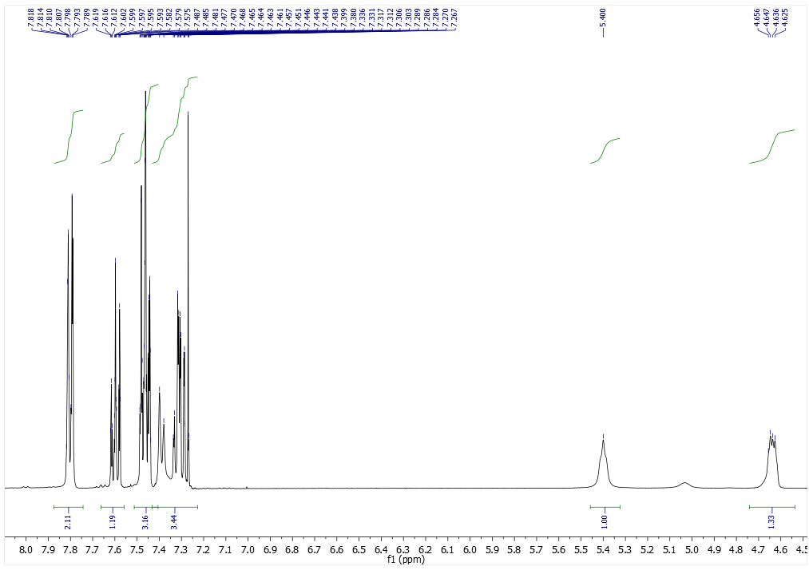
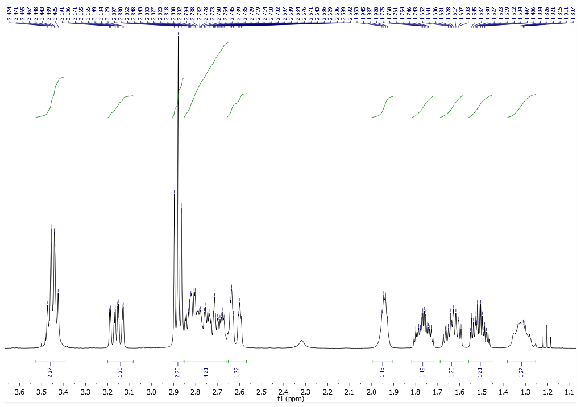
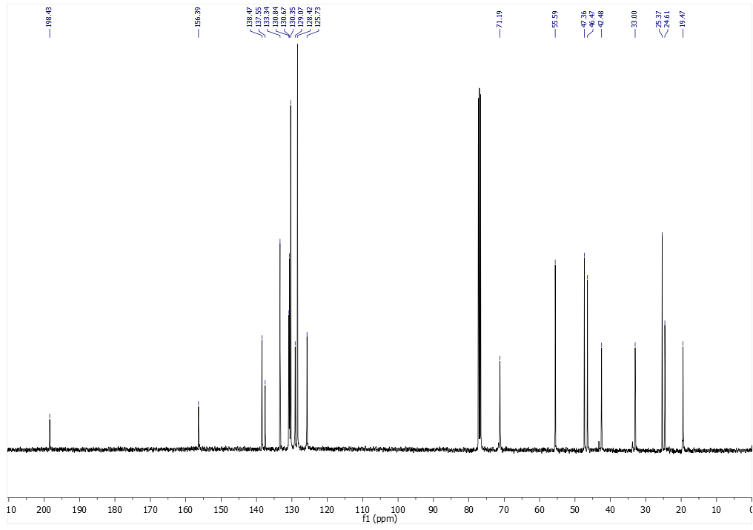
¹³C (100.16 MHz, CDCl₃)
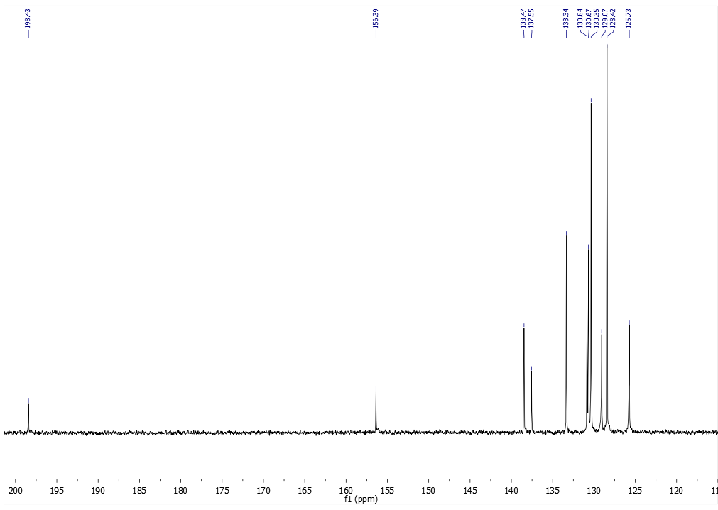
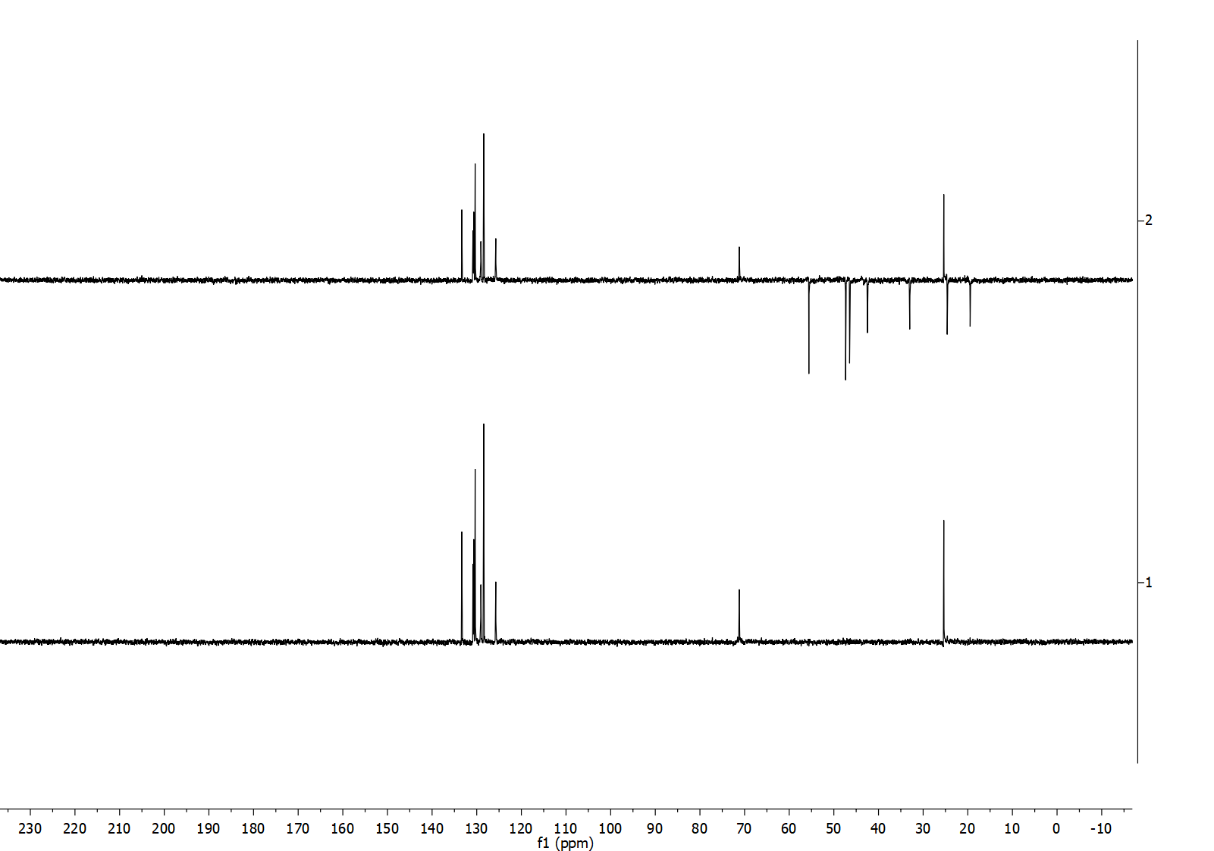
DEPT (400 MHz, CDCl₃)

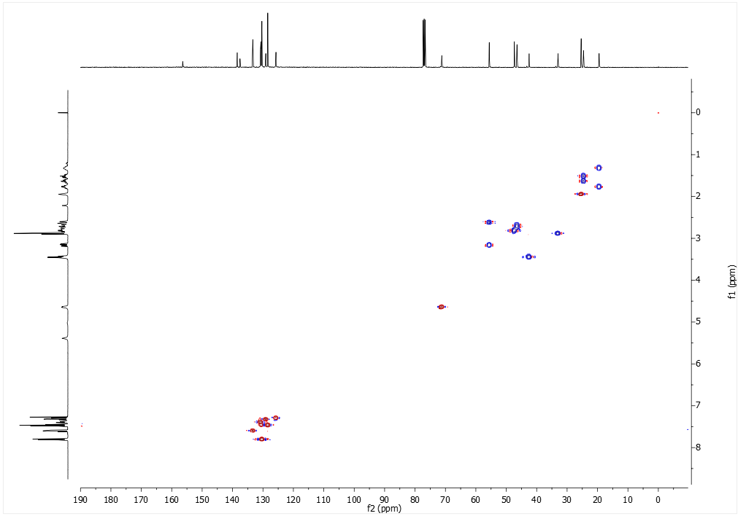
HSQC (400 MHz, CDCl₃)

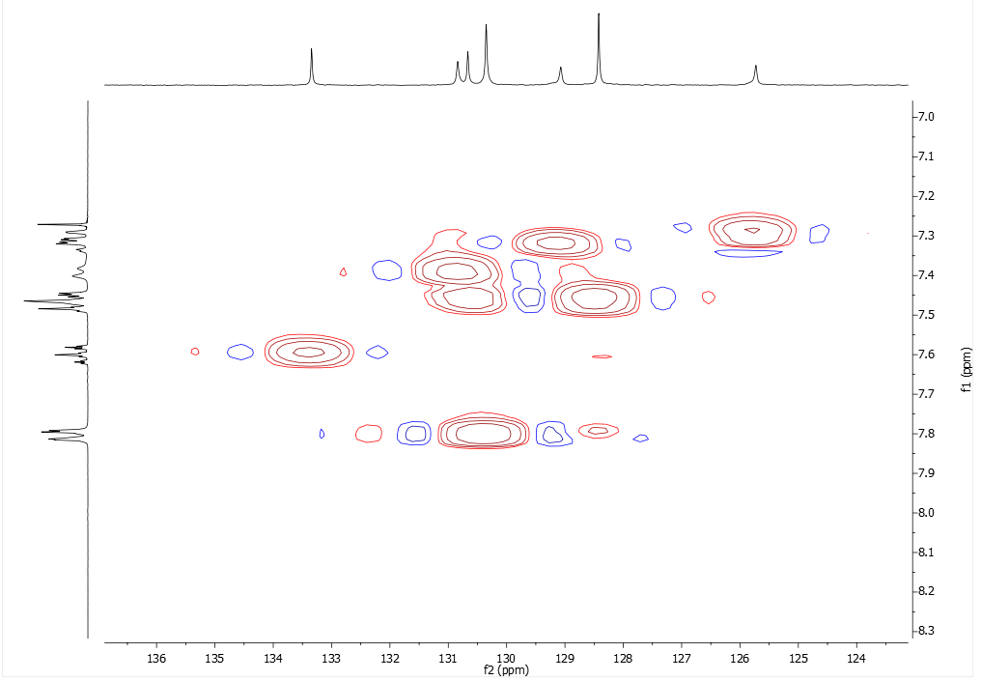

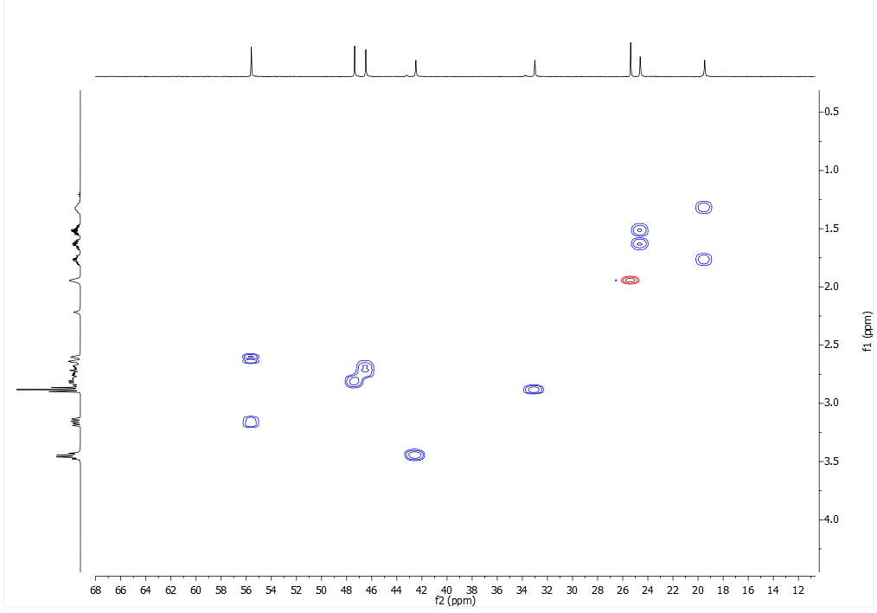

COSY (400 MHz, CDCl₃)
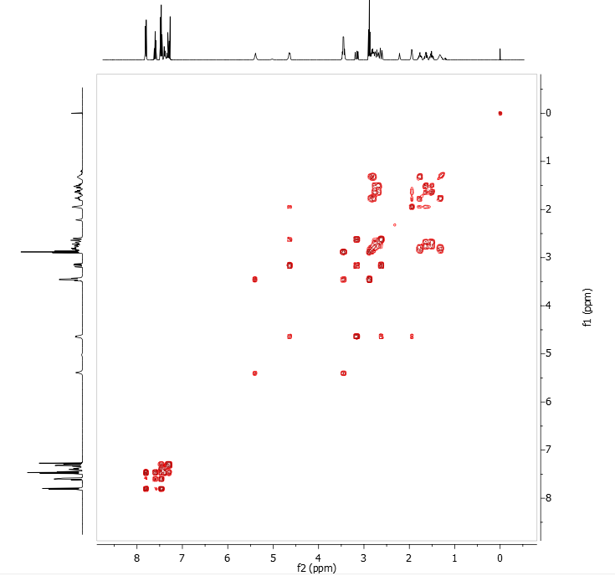

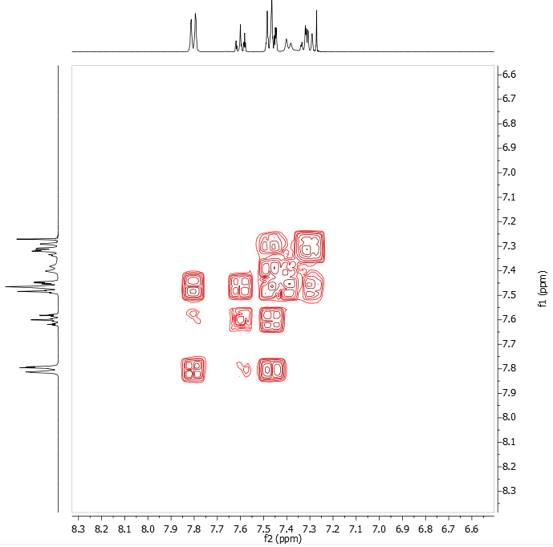
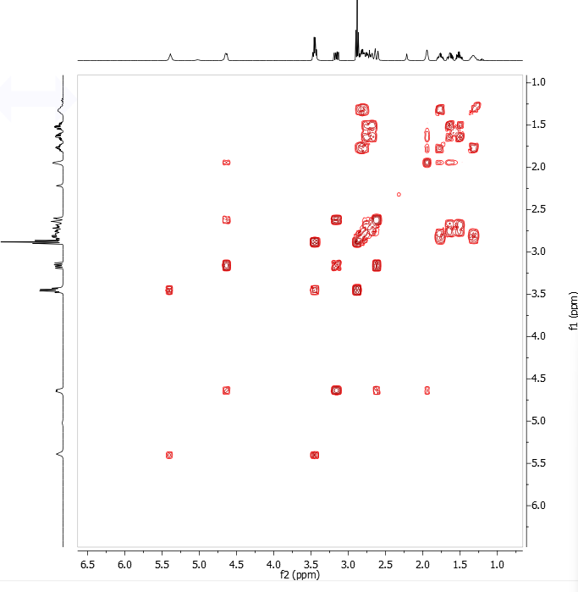

IR (KBr) spectrum of Impurity K
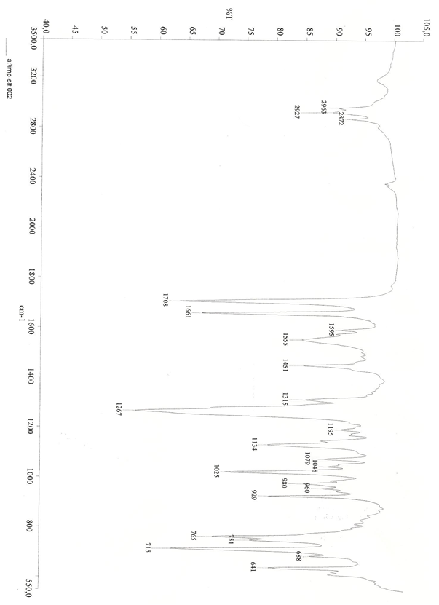

GC/MS (EI) of Impurity K
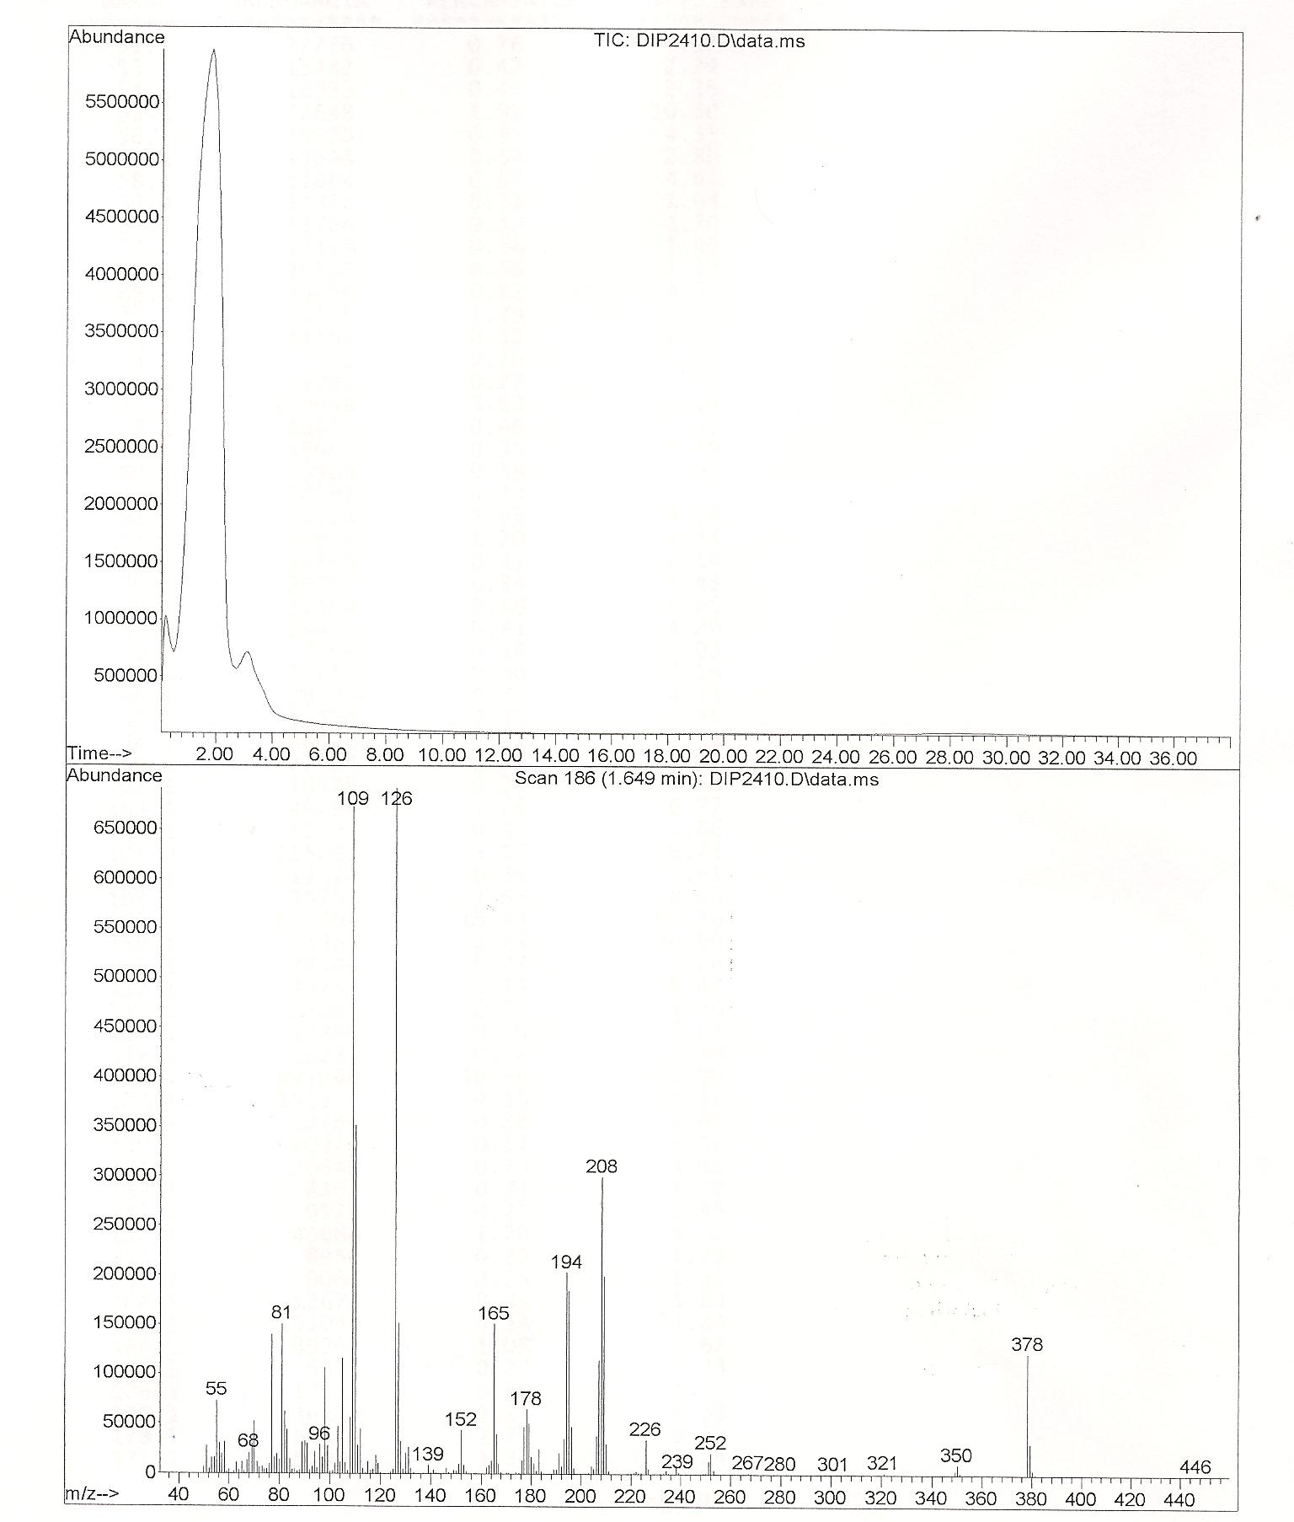
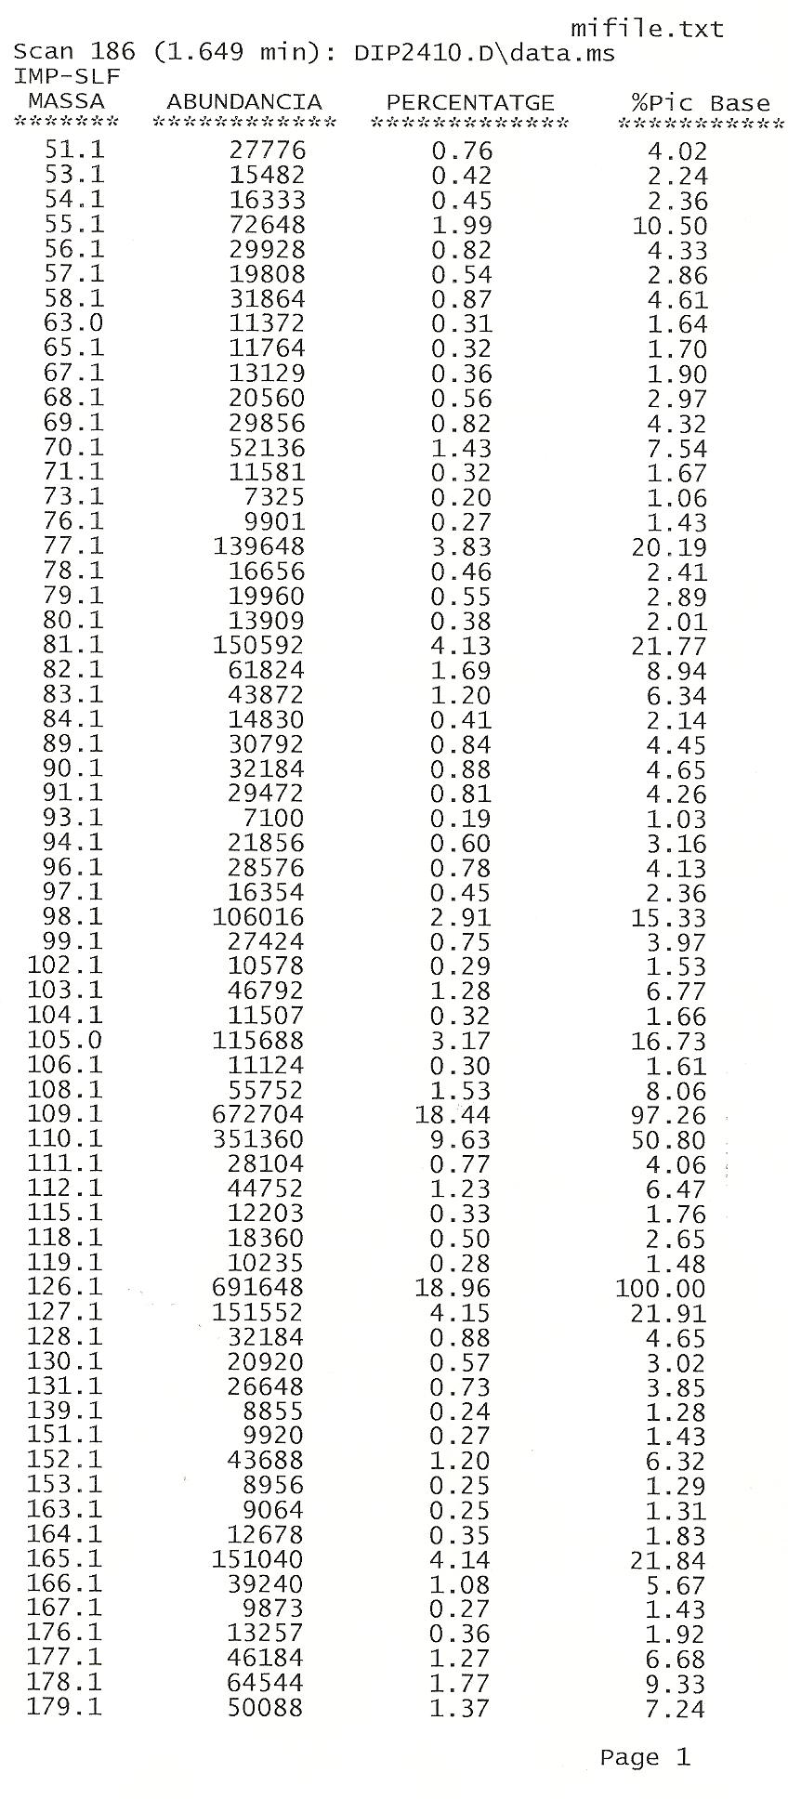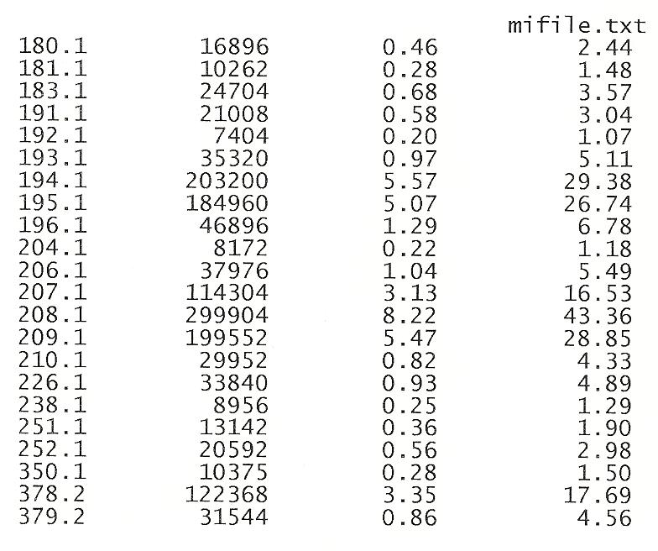

UV of Impurity K:

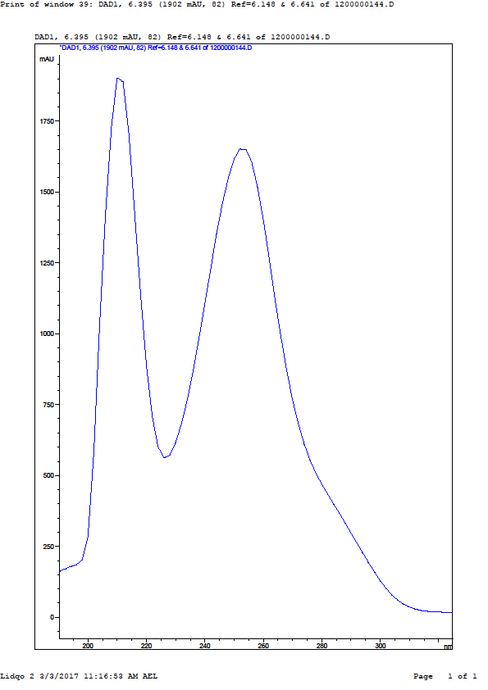

HPLC/MS-MS of Solifenacin succinate tablets
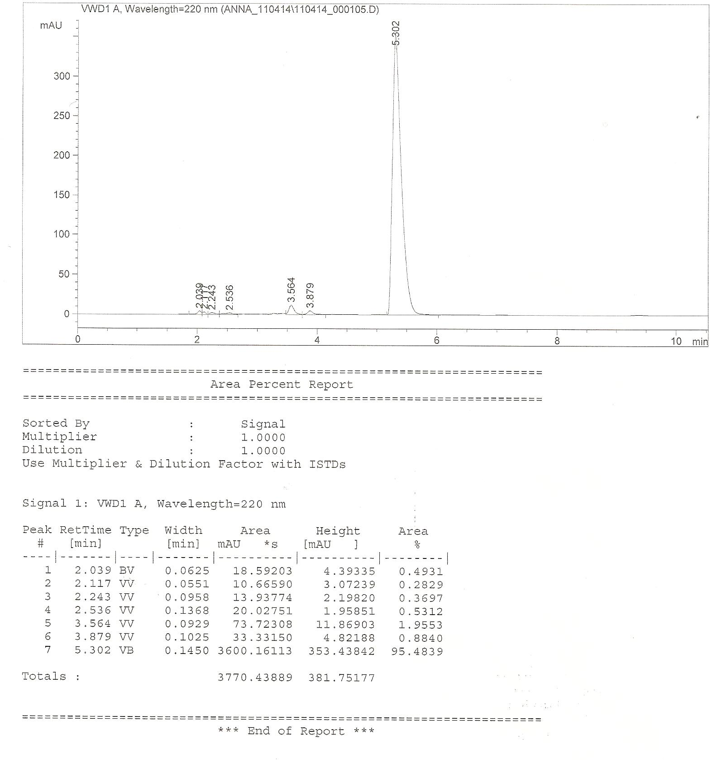
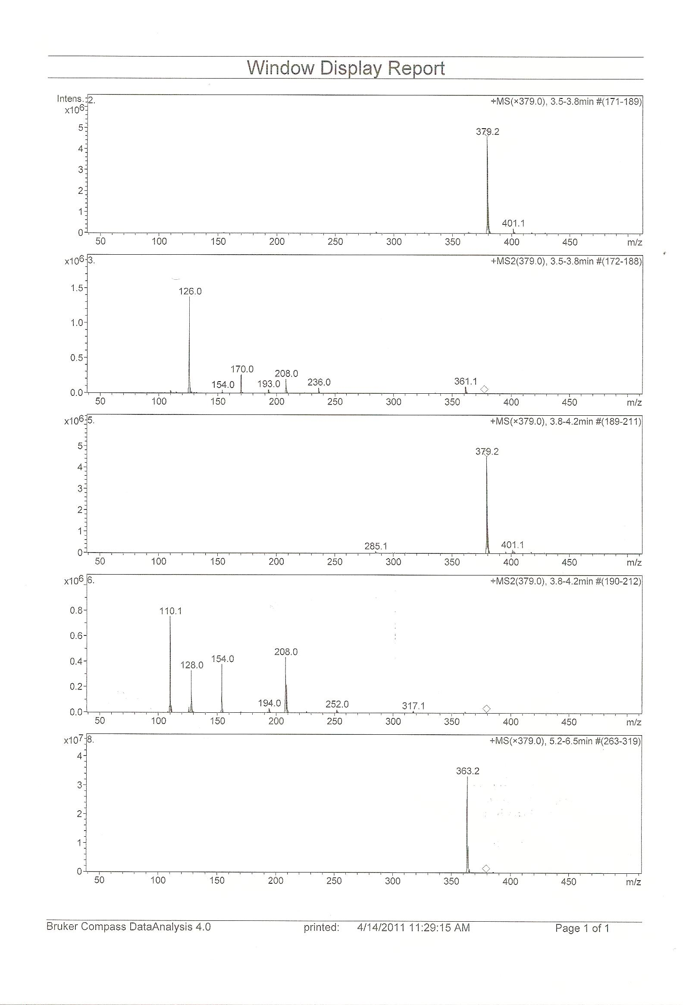

HPLC/MS-MS of Impurity I

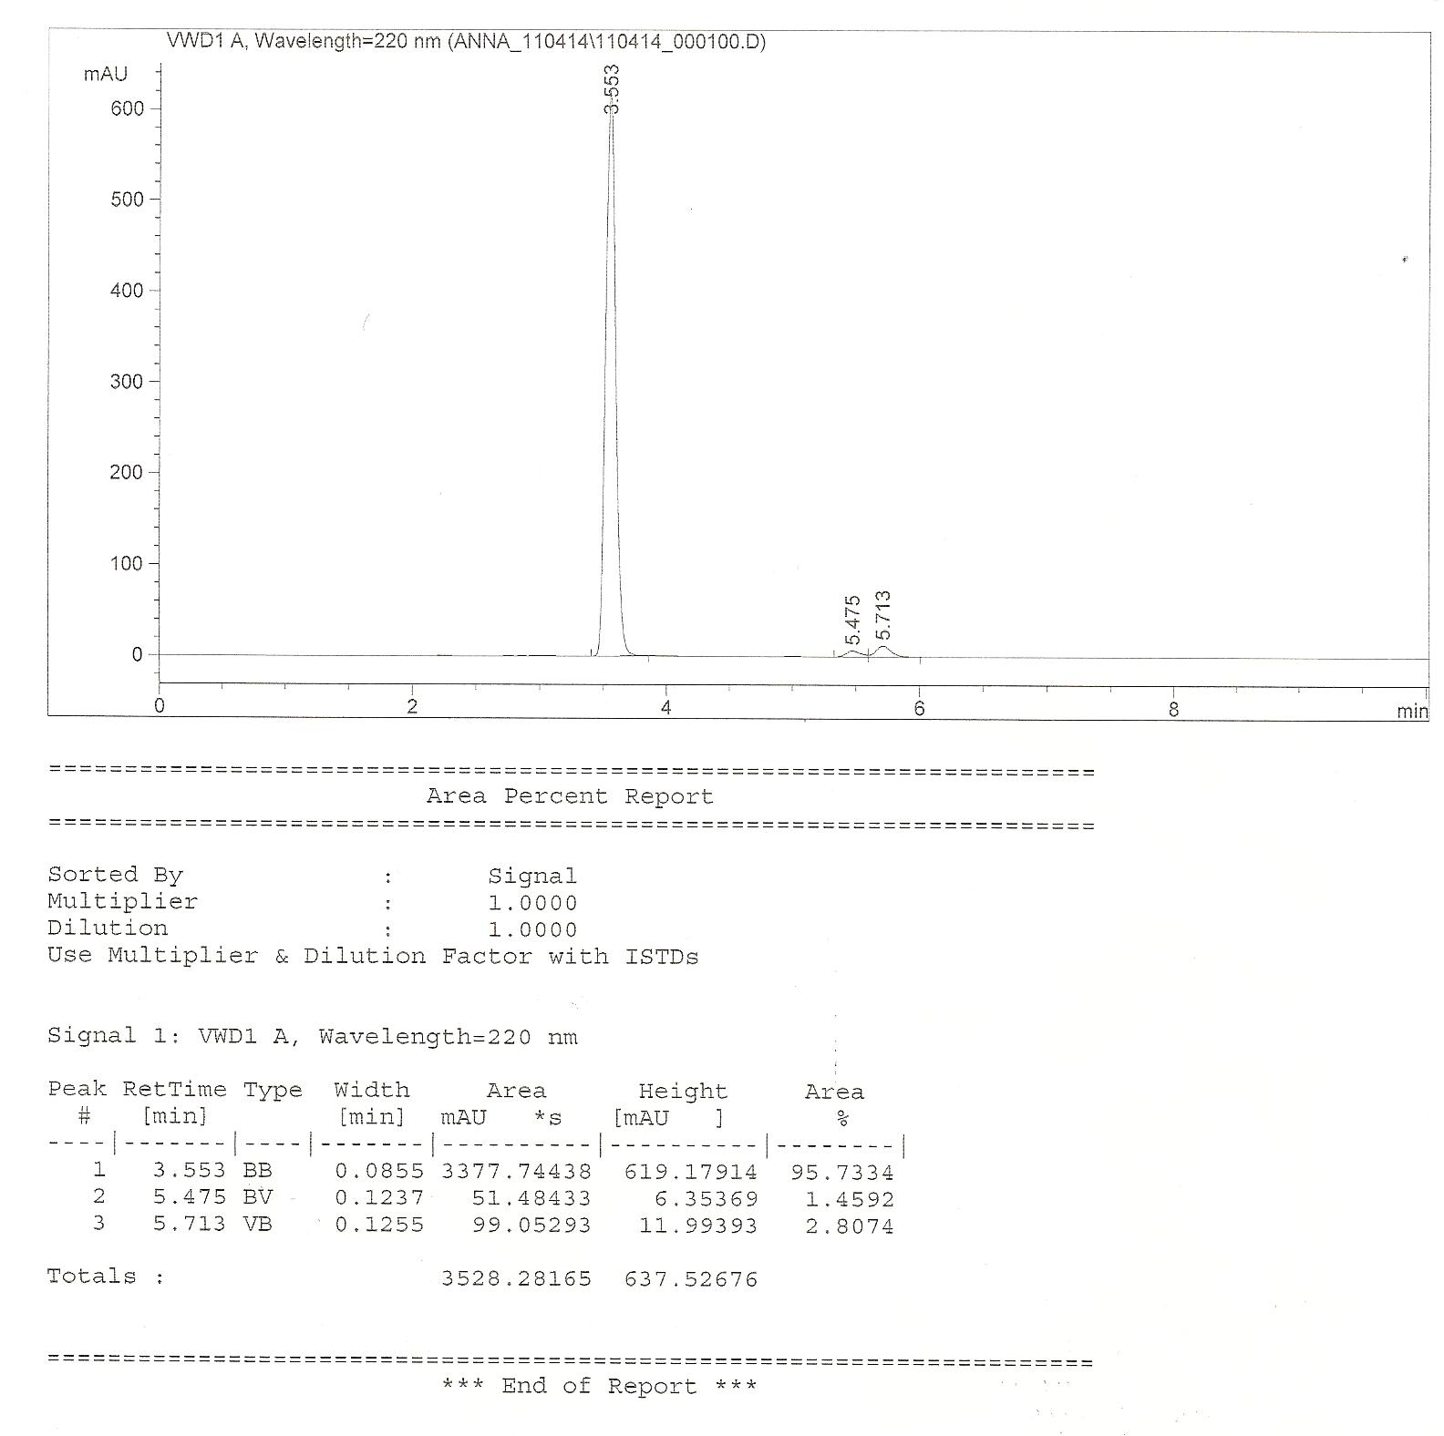

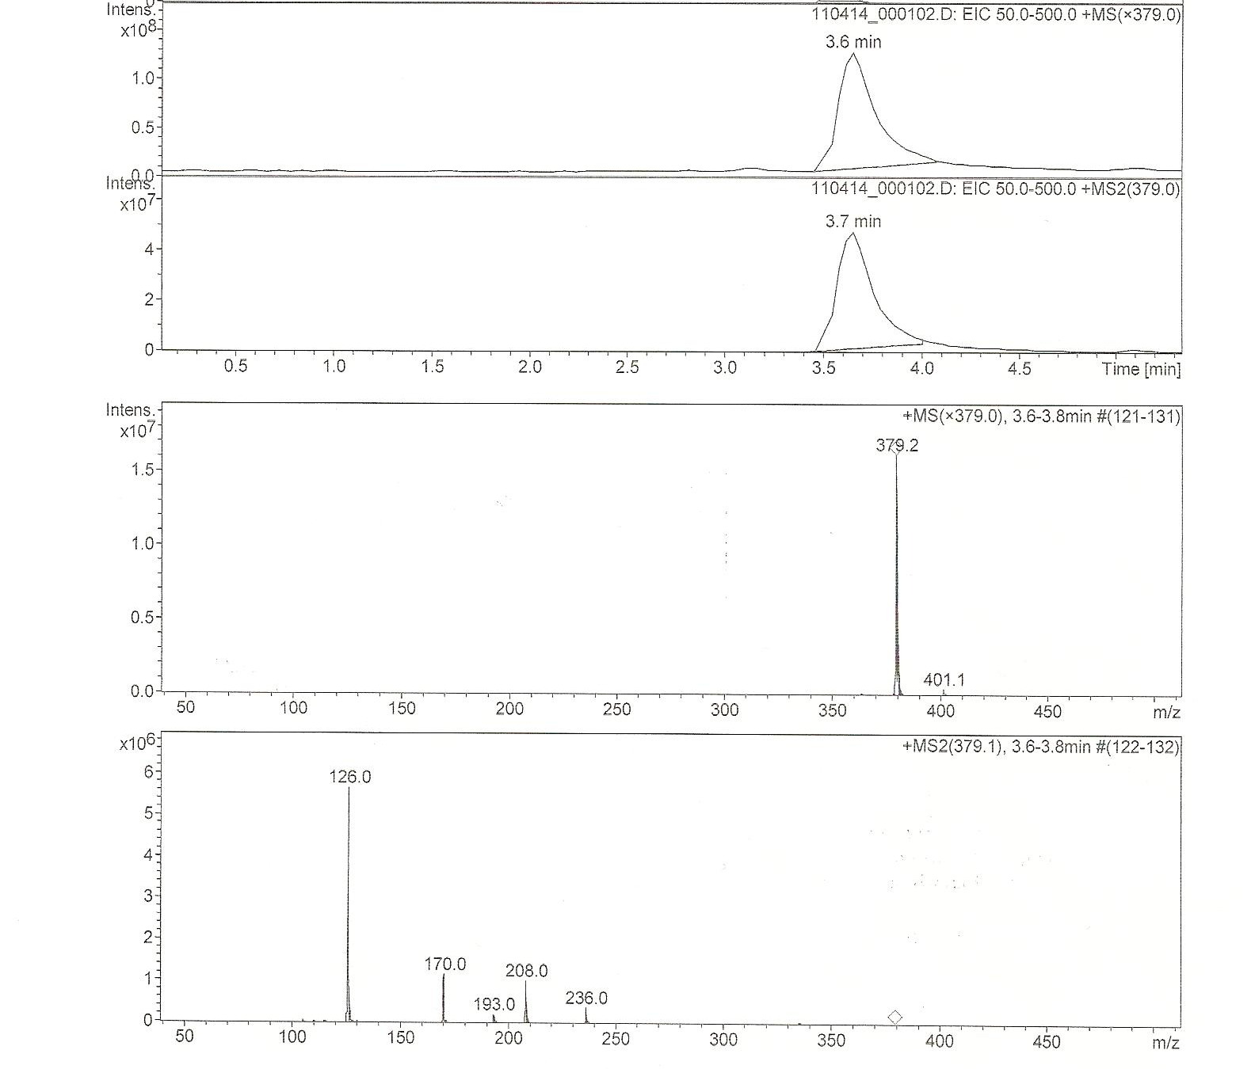

HPLC/MS-MS of Impurity K

