SUPPLEMENTARY MATERIAL

Theoretical Study of the Impact of Pore Size in TiO₂ Aerogels on Photocatalytic Formaldehyde Decomposition
College of Materials Science and Optoelectronics Engineering, University of Chinese Academy of Sciences, China;

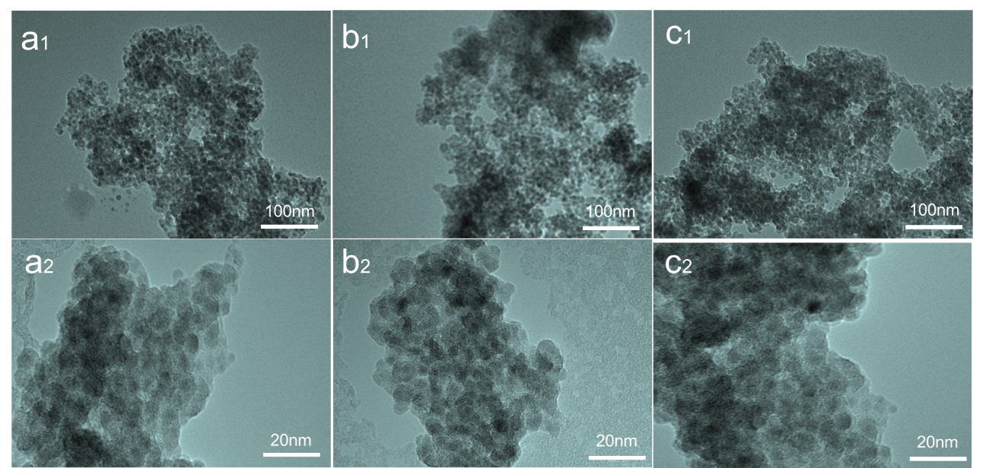
Figure S₁ TEM images of sample (a₁, a₁) Ti-1, (b₁, b₁) Ti-2 and (c₁, c₁) Ti-3.
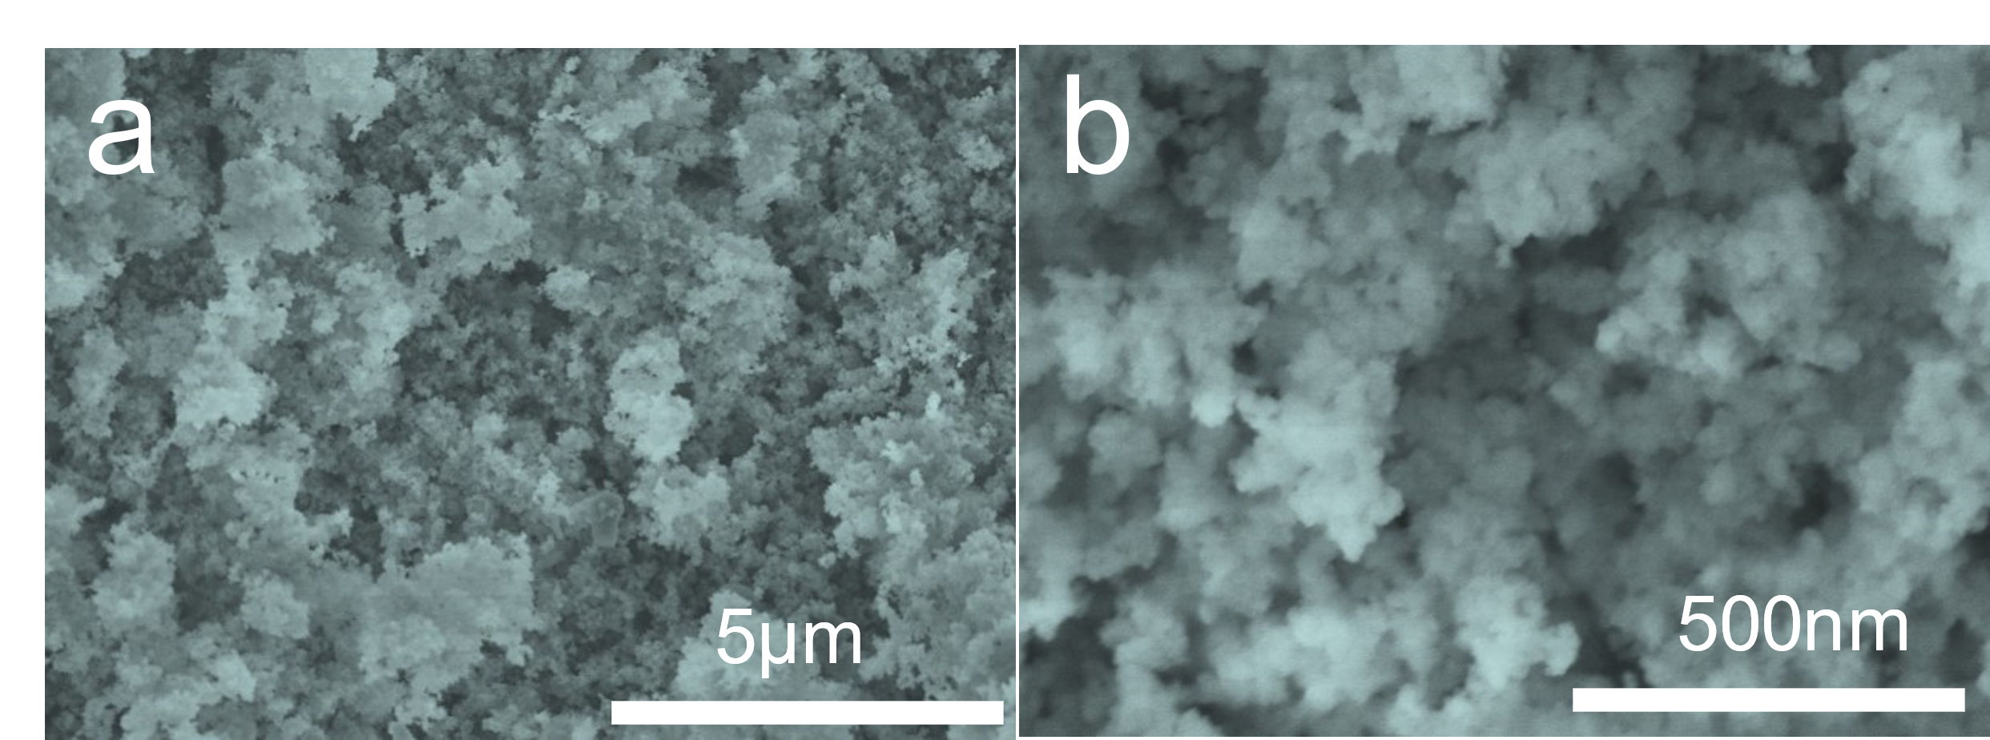
Figure S₂ SEM images of sample (a, b) Ti-0.
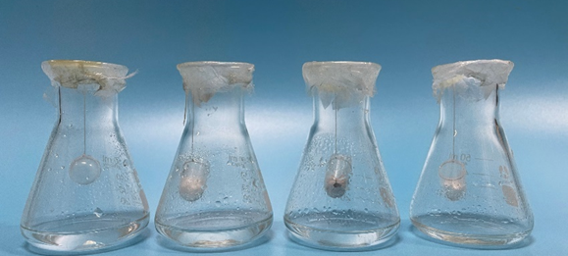
Figure S₃ Photocatalytic decomposition of HCHO by TiO₂ aerogel, from left to right are Ti-0, Ti-1, Ti-2 and Ti-3.

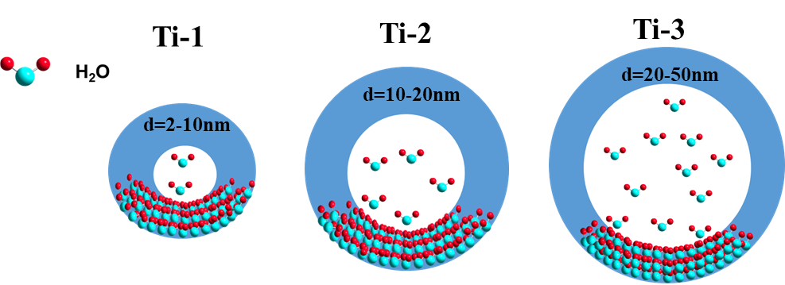
Figure S₄ Adsorption of water molecules by TiO₂ aerogel with different pore sizes.

Table S₁ Textural properties of TiO₂ aerogels.
Sample | BET surface area (m²/g) | Average pore size (nm) | Total pore volume (cm³/g)
Ti-0 | 79 | 64.6 | 0.821
Ti-1 | 282 | 7.3 | 0.515
Ti-2 | 241 | 12.9 | 0.414
Ti-3 | 268 | 48.6 | 0.386

Table S₂ Standard uncertainty introduced in the measurement process.
instrument | maximum permissible error (mg/ml) | standard uncertainty (mg/ml)
electronic balance | ±0.100 | 0.0580
volumetric flask (50ml) | ±0.050 | 0.0204
pipette (1ml) | ±0.007 | 0.0040
pipette (5ml) | ±0.015 | 0.0087

Table S₃ The values of formaldehyde concentration at different points in time.
Sample | 0h (mmol/L) | 1h (mmol/L) | 2h (mmol/L) | 3h (mmol/L) | 4h (mmol/L)
Ti-0 | 100.0 | 99.2 | 98.1 | 97.8 | 97.6
Ti-1 | 100.0 | 74.5 | 63.1 | 45.7 | 45.1
Ti-2 | 100.0 | 91.4 | 84.7 | 82.3 | 81.5
Ti-3 | 100.0 | 81.5 | 77.4 | 69.2 | 66.9

Table S₄ Multiple measurement data and standard uncertainty of experimental results.
Sample | 1st (mmol/L) | 2nd (mmol/L) | 3rd (mmol/L) | average (mmol/L) | standard uncertainty (mmol/L)
Ti-0 | 97.8 | 97.6 | 97.5 | 97.6 | 0.1581
Ti-1 | 45.3 | 45.1 | 45.1 | 45.1 | 0.1414
Ti-2 | 81.6 | 81.5 | 81.5 | 81.5 | 0.0707
Ti-3 | 67.0 | 67.0 | 66.7 | 66.9 | 0.2449

