Novel high-performance functionalized and grafted bio-based chitosan adsorbents for the efficient and selective removal of toxic heavy metals from contaminated water

Mohammad Monir^{1,a}, Rasha E. Elsayed^{2,a}, Rasha A. Azzam^{3,b}, Tarek M. Madkour^{4,a,*}
ªDepartment of Chemistry, School of Sciences and Engineering, The American University in Cairo, AUC Avenue, New Cairo, 11835, Cairo, Egypt
ªDepartment of Chemistry, Faculty of Science, Helwan University, Cairo, 11795, Egypt

1: mohammadmonir@aucegypt.edu; 2: r.essam@aucegypt.edu;
3: rasha_azzam@science.helwan.edu.eg; 4: tarekmadkour@aucegypt.edu
*Corresponding authors

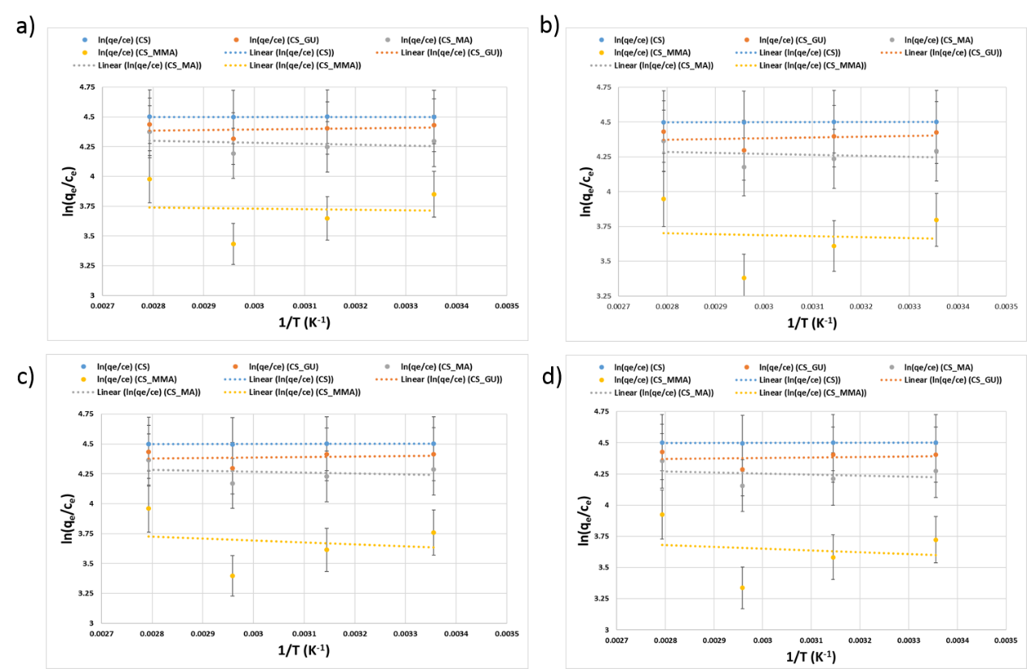
Figure S1. Van’t Hoff plots for nickel (a), lead (b), chromium (c), and cadmium (d).

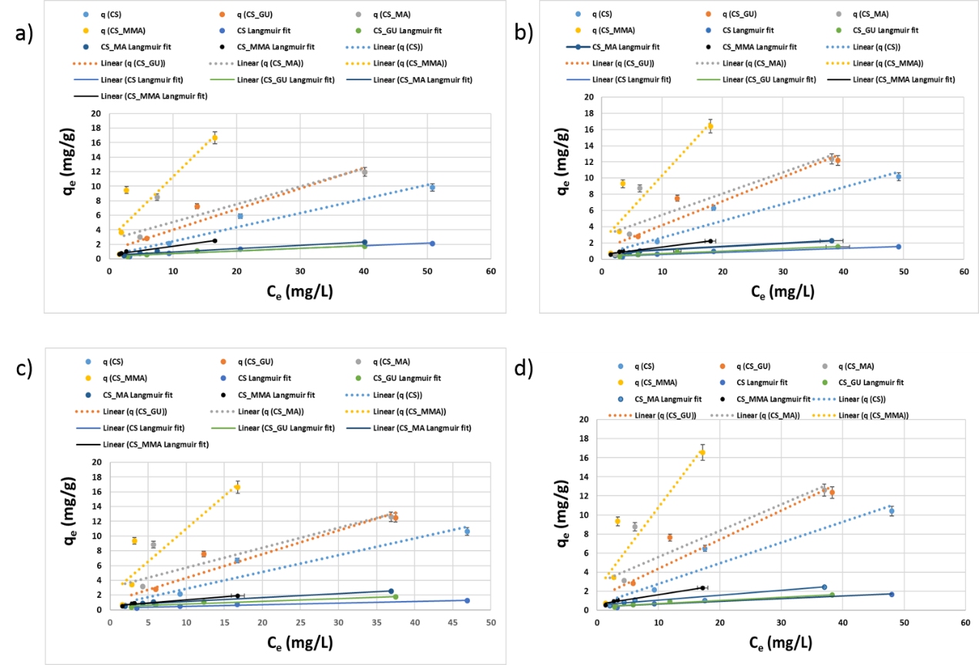
Figure S2. The equilibrium isotherms for the adsorption of nickel (e), lead (f), chromium (g), and cadmium (h).

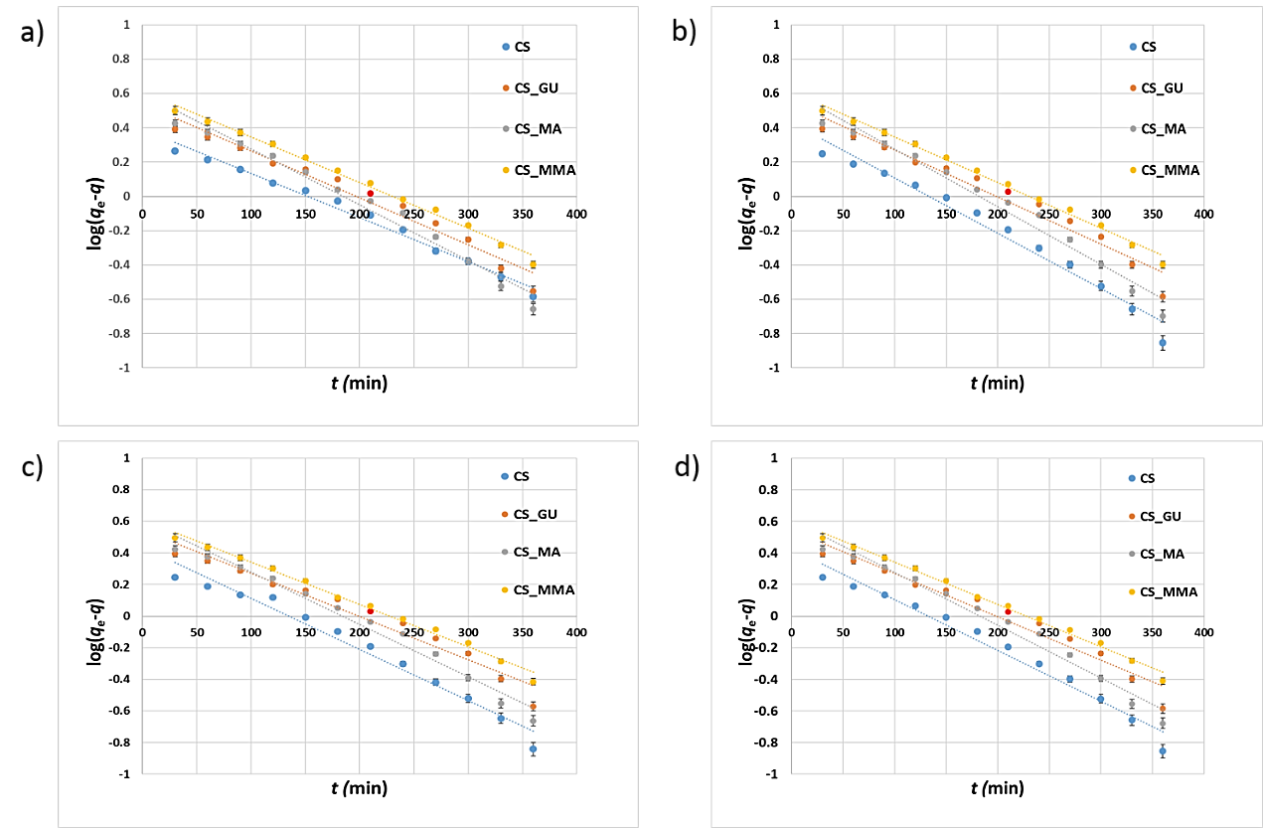
Figure S3. Linear plots of the kinetic profiles for the uptake of nickel (a), lead (b), chromium (c), and cadmium (d) estimated using pseudo-first-order.
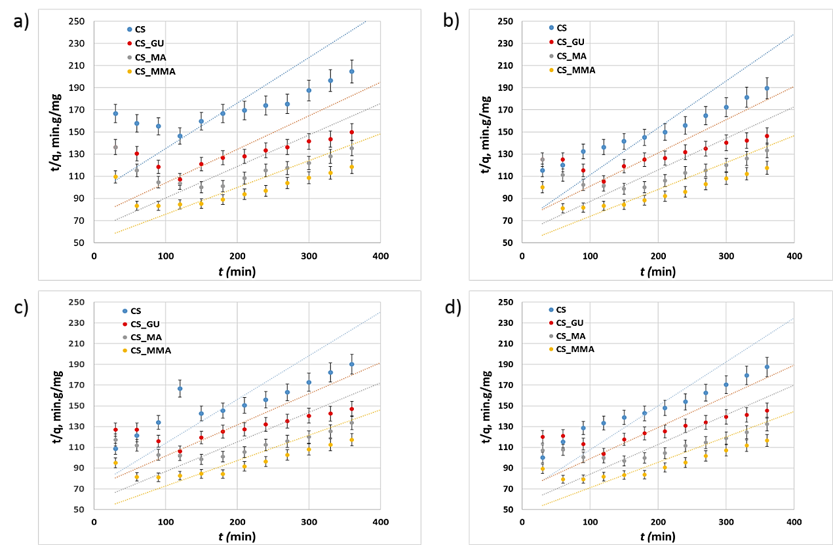
Figure S4. Linear plots of the kinetic profiles for the uptake of nickel (a), lead (b), chromium (c), and cadmium (d) estimated using the pseudo-second-order.

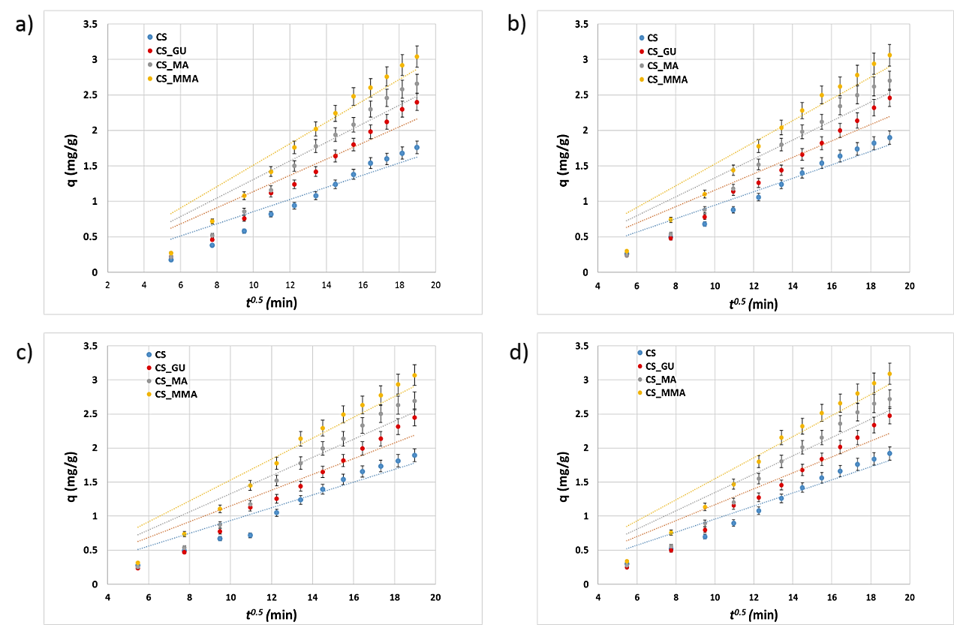
Figure S5. Linear plots of the kinetic profiles for the uptake of nickel (a), lead (b), chromium (c), and cadmium (d) estimated using the intra-particle diffusion model.

Table S1: The thermodynamic parameters for the adsorption of nickel, lead, chromium and cadmium ions on the surface of the different chitosan-based polymeric adsorbents
CS  System | Thermodynamic parameters for nickel ions adsorption |  |  |  |  | Thermodynamic parameters for lead ions adsorption
 | ΔH  (J/mol) | ΔS  (J/mol.K) | ΔG*  (kJ/mol) | K_{eq} | R² | ΔH  (J/mol) | ΔS  (J/mol.K) | ΔG*  (kJ/mol) | K_{eq} | R²
CS | -13.34 | 37.45 | -12.46 | 90.03 | 0.9423 | -46.72 | 37.27 | -12.46 | 90.01 | 0.9656
CS_GU | -365.66 | 35.44 | -12.17 | 81.01 | 0.9381 | -450.61 | 35.10 | -12.14 | 80.17 | 0.9444
CS  System | Thermodynamic parameters for chromium ions adsorption |  |  |  |  | Thermodynamic parameters for cadmium ions adsorption
 | ΔH  (J/mol) | ΔS  (J/mol.K) | ΔG*  (kJ/mol) | K_{eq} | R² | ΔH  (J/mol) | ΔS  (J/mol.K) | ΔG*  (kJ/mol) | K_{eq} | R²
CS | -41.60 | 37.29 | -12.46 | 90.01 | 0.9121 | -47.14 | 37.27 | -12.46 | 89.98 | 0.9013
CS_GU | -324.73 | 35.50 | -12.15 | 80.43 | 0.9232 | -309.06 | 35.48 | -12.12 | 79.72 | 0.9547

Table S2: Kinetic parameters for the adsorption of the metal ions onto the surface of the different chitosan-based polymeric adsorbents using different kinetic models
Kinetic model | Kinetic parameters | Nickel ions |  | Lead ions |  | Chromium ions |  | Cadmium ions
 |  | CS | CS_GU | CS | CS_GU | CS | CS_GU | CS | CS_GU
Pseudo-first order | k₁ (min⁻¹) | 0.0060 | 0.0062 | -0.0074 | -0.0064 | -0.0074 | -0.0076 | -0.0074 | -0.0076
 | q_{e (calc)} (mg/g) | 2.451 | 3.455 | 2.681 | 3.518 | 2.728 | 4.061 | 2.671 | 4.078
 | R² | 0.9868 | 0.9665 | 0.973 | 0.9567 | 0.9721 | 0.9772 | 0.9723 | 0.976
Pseudo-second order | k₂ (kg/mg.min⁻¹) | 21.499 | 17.868 | 11.216 | 16.701 | 12.247 | 17.145 | 10.041 | 15.805
 | q_{e (calc)} (mg/g) | 0.011 | 0.014 | 0.014 | 0.014 | 0.014 | 0.014 | 0.015 | 0.015
 | R² | 0.9628 | 0.9485 | 0.9628 | 0.9485 | 0.9741 | 0.9545 | 0.983 | 0.9605
Intra-particle diffusion | K_{id} (mg/(g.min^{0.5}) | 0.1511 | 0.131 | 0.1526 | 0.1332 | 0.1534 | 0.1332 | 0.1549 | 0.1348
 | R² | 0.9092 | 0.8849 | 0.9136 | 0.8877 | 0.9149 | 0.8878 | 0.9191 | 0.8934

