Supplemental Materials
Table S 1. Survey Questions
The purpose of this study is to understand your perceptions and expectations of the use of GEN-AI and other AI tools (e.g., ChatGPT and Grammarly) in academia. The insight from this study will help shape the university's AI usage guidance and policy.
Section 1
General Information
As the use of AI continues to permeate various aspects of our lives, there are overall mixed feelings about the advantages and implications, especially in academia. This survey aims to assess these feelings and expectations at the University of Bolton. Your response is totally confidential and will be used only for research to improve AI use in higher educations.
1.Do you agree to participate in this study?
Yes
No
Section 2
Demographic Information
2.Gender.
Man
Woman
Non-binary
Prefer not to say
3.Age Range.
18-24
25-34
35-44
45-54
55-64
65 and over
4.University level.
Undergraduate
Postgraduate
Doctoral
5.Field of study.
Agriculture and Environmental Sciences
Arts and Design
Business and Management
Education
Engineering and Technology
Health and Medicine
Humanities and Social Sciences
Law
Natural Sciences
Physical Sciences
Section 3
Understanding of Artificial Intelligence
6.How familiar are you with Generative Artificial Intelligence (GEN-AI)?
Extremely familiar
Moderately familiar
Somewhat familiar
Slightly familiar
Not at all familiar
7.How aware are you of GEN-AI use for academic purpose?
Extremely aware
Moderately aware
Somewhat aware
Slightly aware
Not at all aware
8.Have you used any GEN-AI such as ChatGPT or other AI tools such as Grammarly for academic purposes during your time at university?
Yes
No
9.Please specify the types of academic tasks for which you use GEN-AI and other AI tools?
Idea generation
Text generation
Paraphrasing and summarising
Grammar corrections
Data analysis and interpretation
Literature search
Question and answer
Language translation
10.How frequently do you use GEN-AI and other AI tools for your academic tasks?
Always
Often
Sometimes
Rarely
Never
Section 4
Impact of GEN-AI and AI
11.How has GEN-AI or other AI tools impacted your academic performance?
Significantly improved
improved
No significant impact
Hindered
Significantly hindered
12.GEN-AI and other AI tools provide academic advantage.
Strongly agree
Agree
Neutral
Disagree
Strongly disagree
Section 5
Perception of AI Use
13.What is your overall perception about the use of GEN-AI and other AI tools.
Positive
Neutral
Negative
14.What challenges have you encountered while using AI tools in your academic work?
Finance (Subscription fee)
Lack of clarity from the university
Plagiarism concern
Data privacy issues
Bias in algorithms
Section 6
Expectations and Prospects
15.The use of GEN-AI and other AI tools for academic purposes will significantly increase in the future.
Strongly agree
Agree
Neutral
Disagree
Strongly disagree
16.GEN-AI or other AI tools should be integrated into the university's curriculum.
Strongly agree
Agree
Neutral
Disagree
Strongly disagree
Section 7
General Feedback
17.Is there anything else you would like to share regarding your experience with AI tools in academia?
Enter your answer
18.Describe AI use in one word.
Enter your answer

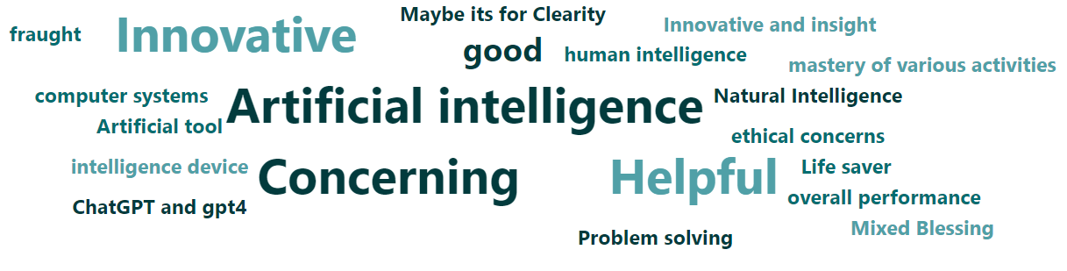
Figure S 1. Word cloud of respondents when asked to describe AI in one word..

