Supplementary Materials
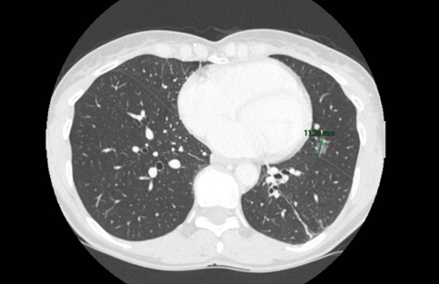
Figure S1. pre operative CT scan.
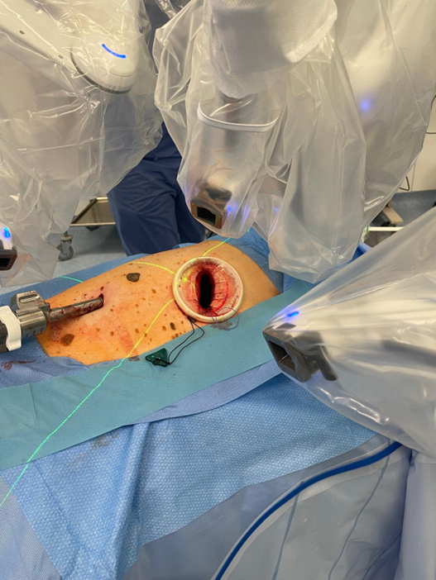
Figure S2. Incision and docking.

