SUPPLEMENTARY MATERIAL

Table S1. Statistical regression models linking crop yields to climatic parameters.

No. | Crop/ Region | Statistical model equation¹ | Model’s performance²
1 | Oranges/ Epirus | Y_{t} (kg/stremma) = 5561.44 + 1.973*P_{11,t-1} + 1104.42*ΤΜΙΝ_{1,t-1} – 1296.198*TMAX_{1,t-1} – 1161.537*Extr  Extr: dummy variable, with a value equal to 0 for all years except five (i.e., 1983, 1985, 1991, 2004, 2014) where it takes a value equal to 1 because of extreme events (e.g., hail, frost) in these years which are not sufficiently reflected in the climate data time series. | R²=0.75, SF=1.26⋅E⁻⁰⁸
2 | Oranges/ Peloponnese & Western Greece | Y_{t} (kg/stremma) = 407.21 + 22.11*P_{8,}t + 137.72*TMAX_{1,t} – 148.22*TMIN_{1,t} + 184.83*TMAX_{5,t} – 256.41*TMIN_{5,t} – 199.23*TMAX_{7,t} + 351.54*TAV_{8,t} – 89.02*TMAX_{9,t} – 1318.48*Extr  Extr: dummy variable, with a value equal to 0 for all years except the following where it takes a value equal to 1: a) 1987 because of an extreme event (e.g., hail, frost) in this year that is not sufficiently reflected in the climate data time series, and b) 2013 because there was a sharp increase of cultivated areas in this year (which then returned to normal levels) that resulted in a sharp reduction of crop yield. | R²=0.84, SF=4.32⋅E⁻⁰⁸
3 | Oranges/ Crete | Y_{t} (kg/tree) = 26.07– 7.04*TMIN_{11,t-1} + 7.65*TAV_{11,t-1} + 31.43*TMAX_{2,t} +27.07*TMIN_{2,t} – 60.08*TAV_{2,t} +13.9*TMAX_{4,t} – 17.4*TAV_{4,t} + 9.83*TMIN_{6,t} – 8.2*TAV_{6,t} – 18.69*Extr  Extr: dummy variable, with a value equal to 0 for all years except 2005 where it takes a value equal to 1 as in this year there was a sharp increase in the number of trees (which then returned to normal levels) that resulted in a sharp reduction of crop yield. | R²=0.71, SF=0.000186
4 | Lemons/ Peloponnese & Western Greece | Y_{t} (kg/stremma) = 3137.06 + 56.1*TMIN_{3,t} – 101.48*TMAX_{7,t} – 491.29*TMAX_{8,t} – 390.25*TMIN_{8,t} + 1007.33*TAV_{8,t} – 90.17*TMIN_{9,t} – 885.65*Extr  Extr: dummy variable, with a value equal to 0 for the period 1980-2003 and from 2015 onwards, and a value equal to 1 for the period 2004-2014 when there was a sharp decrease of the yield per tree and per unit area due to the frost of the year 2004 which damaged many lemon trees at the Achaia prefecture in the Peloponnese region. | R²=0.9, SF=1.1⋅E⁻¹¹
5 | Lemons/ Crete | Y_{t} (kg/tree) = 59.25 – 0.026*P_{2,t} + 10.91*TMIN_{4,t} – 12.16*TAV_{4,t} – 10.36*TMIN_{5,t} + 10.54*TAV_{5,t} – 0.15*dfyt + 0.17*t  t: dummy variable (year), with a value of 0 in the starting year 1980.  dfyt: planting density (number of trees/stremma) | R²=0.81, SF=2.51⋅E⁻⁰⁸
6 | Mandarins/ Epirus | Y_{t} (kg/stremma) = 5712.85 – 11.611*P_{6,t} – 3.1026*P_{11,t} – 223.3*TAV_{6,t} + 92.7*t  t: dummy variable (year), with a value of 0 in the starting year 1980. | R²=0.83, SF=1.16⋅E⁻¹¹
7 | Mandarins / Peloponnese & Western Greece | Y_{t} (kg/stremma) = – 19777.2 – 81.06*TAV_{2,t} + 161.23*TMIN_{3,t} + 253.79*TMAX_{4,t} – 233.01*TMIN_{4,t} + 1818.305*TMAX_{6,t} + 833.12*TMIN_{6,t} – 2805.63*TAV_{6,t} + 10.55*t  t: dummy variable (year), with a value of 0 in the starting year 1980. | R²=0.68, SF=4.03⋅E⁻⁰⁵
8 | Apples/ Central & Western Macedonia | Y_{t} (kg/stremma) = – 268.77 + 15.53*P_{1,t} + 1347.11*TMΑΧ_{1,t} + 1501.79*TMΙΝ_{1,t} – 3006.19*TAV_{1,t} + 261.64*TMIN_{4,t} + 3192.19*TMΑΧ_{5,t} + 2162.08*TMΙΝ_{5,t} – 5658.95*TAV_{5,t} + 1042.99*d  d: dummy variable, with a value equal to 0 for the period 1980-2010 and equal to 1 from 2011 onwards as there was a very large increase in the number of trees starting in 2011 without a consistent change in cultivated areas, which resulted in an increased production volume and a consequent very large increase of crop yields. | R²=0.77, SF=5.58⋅E⁻⁰⁶
9 | Apples/ Thessaly | Y_{t} (kg/stremma) = 3854.7 + 1.546*P_{2,t} – 7.25*P_{6,t} – 64.2*TMAX_{1,t} + 462.93*TMΑΧ_{4,t} – 588.77*TAV_{4,t} + 371.24*TMΑΧ_{5,t} – 490.47*TAV_{5,t} – 140.63*TMAX_{6,t} – 1033.46*TMAX_{8,t} – 458.96*TMIN_{8,t} + 1696.5*TAV_{8,t} + 869.78*dfyt  dfyt: dummy variable, with a value equal to 0 for the period 1980-2013 and equal to 1 from 2014 onwards as there was a very sharp increase of the planting density in this latter period. | R²=0.83, SF=5.474⋅E⁻⁰⁶
10 | Pears/ Central & Western Macedonia | Y_{t} (kg/tree) = 52.86 – 0.07*P_{5,t} + 2.53* TMIN_{1,t} – 3.24*TAV_{1,t} + 1.9*TMAX_{3,t} – 2.05*TAV_{3,t} + 6.58*TMIN_{5,t} – 5.59*TAV_{5,t} + 9.33*d – 12.055*Extr  d: dummy variable, with a value equal to 0 for the period 1980-2013 and equal to 1 from 2014 onwards as there was a very sharp decrease of the number of trees in this latter period which resulted in very large increase of the yield per tree.  Extr: dummy variable, with a value equal to 0 for all years except 2002 and 2003 where it takes a value equal to 1 as in these years there were extreme events (frost in April, hail) which are not sufficiently reflected in the climate data time series. | R²=0.78, SF=3.418⋅Ε⁻⁰⁶
11 | Pears/ Thessaly | Y_{t} (kg/tree) = 20.45 + 0.083*P_{3,t} + 0.125*P_{6,t} – 0.223*P_{7,t} – 1.3* TMAX_{1,t} – 1.19*TMAX_{2,t} + 2.12*TMAX_{3,t} + 9.64*TMAX_{6,t} – 12.41*TAV_{6,t} – 10.98*Extr  Extr: dummy variable, with a value equal to 0 for all years except 2002 and 2014 where it takes a value equal to 1 as in these years there were extreme events (fruit drop from high winds, frost in December) which are not sufficiently reflected in the climate data time series. | R²=0.81, SF=5.85⋅Ε⁻⁰⁷
12 | Pears/ Peloponnese & Western Greece | Y_{t} (kg/stremma) = 2626.68 + 419.103*TMIN_{12,t-1} – 431.07*TAV_{12,t-1} – 852.55* TMAX_{1,t} – 1022.7*TMIN_{1,t} + 1860.63*TAV_{1,t} + 166.54*TMIN_{4,t} + 1199.76*TMAX_{6,t} + 458.85*TMIN_{6,t} – 1840.6* TAV_{6,t} | R²=0.88, SF=2.26⋅Ε⁻⁰⁹
13 | Peaches/ Central Macedonia | Y_{t} (kg/tree) = 57.29 + 0.077*P_{1,t} + 0.1* P_{4,t} – 0.15* P_{6,t} + 3.93*TMAX_{8,t-1} + 3.89*TMAX_{9,t-1} – 4.68*TMAX_{1,t} – 1.89*TMIN_{2,t} + 3.4*TAV_{4,t} – 12.03*TMAX_{6,t} + 26.32*TMAX_{7,t} – 27.51*TAV_{7,t} + 28.12*TMIN_{8,t} – 23.33*TAV_{8,t} | R²=0.8, SF=6.77⋅Ε 05
14 | Peaches / Thessaly | Y_{t} (kg/stremma) = – 2845.7 + 8.07*P_{5,t} – 1103.15*TΜΑΧ_{12,t-1} + 2338.7*TAV_{12,t-1} – 1140.5*TΜΙΝ_{12,t-1} – 107.91*TΜΙΝ_{2,t} + 211.13*TMAX_{4,t} + 1063.5*TMAX_{5,t} – 1430*TAV_{5,t} + 37.69*t  t: dummy variable (year), with a value of 0 in the starting year 1980. | R²=0.73, SF=3.32⋅Ε⁻⁰⁵
15 | Apricots/ Central Macedonia | Y_{t} (kg/stremma) = 2625.96 – 60.74* TMAX_{2,t} – 158.81*TMAX_{3,t} + 265.4*TAV_{3,t} – 80.81*TMAX_{5,t} – 126.06*TMAX_{6,t} + 104.17*TMAX_{7,t} + 17.37*t  t: dummy variable (year), with a value of 0 in the starting year 1980. | R²=0.69, SF=3.11⋅Ε⁻⁰⁵
16 | Apricots / Thessaly | Y_{t} (kg/stremma) = 3372.4 + 194.9*TMAX_{6,t-1} – 479.4*TMIN_{6,t-1} – 177.2* TMAX_{2,t} + 121.71*TMIN_{2,t} + 103.93*TMAX_{3,t} + 172.39*TMAX_{4,t} – 232.9*TMIN_{4,t} – 180.0*TMIN_{5,t} + 35.737*t  t: dummy variable (year), with a value of 0 in the starting year 1980. | R²=0.78, SF=8.064⋅Ε⁻⁰⁶
17 | Apricots / Peloponnese | Y_{t} (kg/stremma) = -2559.58 + 1386.56*TMΑΧ_{9,t-1} + 858.24*TMΙΝ_{9,t-1} – 2330.88* TAV_{9,t-1} + 81.51*TMIN_{10,t-1} – 587.47*TMAX_{1,t} + 1184.39*TAV_{1,t} – 621.82*TMIN_{1,t} – 118.75*TMIN_{2,t} + 171.22*TMIN_{4,t} + 688.32*TMIN_{5,t} – 2145.4*TAV_{5,t} + 1302.67*TMAX_{5,t} | R²=0.77, SF=0.00023
18 | Cherries/ Central & Western Macedonia | Y_{t} (kg/stremma) = 173.12 – 161.72*TMAX_{11,t-1} – 127.73*TMIN_{11,t-1} + 296.5* TAV_{11,t-1} – 72.58*TAV_{12,t-1} + 68.28*TMAX_{12,t-1} + 49.51*TMAX_{5,t} – 62.42*TMIN_{5,t} – 117.34*Extr  Extr: dummy variable, with a value equal to 0 for all years except 1982, 1983 and 1991 where it takes a value equal to 1 as in these years crop yields were extremely low, which is indicative of extreme events not sufficiently reflected in the climate data time series. | R²=0.71, SF=0.0001
19 | Cherries / Thessaly | Y_{t} (kg/stremma) = 2325.88 + 468.45*TMAX_{11,t-1} – 1039.06*TAV_{11,t-1} + 560.17* TMIN_{11,t-1} – 33.11*TMAX_{1,t} + 62.34*TMAX_{5,t} + 308.59*TMAX_{6,t} – 677.9*TAV_{6,t} – 22.78*t – 494.48*Extr  t: dummy variable (year), with a value of 0 in the starting year 1980.  Extr: dummy variable, with a value equal to 0 for all years except 1991 where it takes a value equal to 1 as in this year there was a sharp decrease of crop yield, which is indicative of an extreme event that is not sufficiently reflected in the climate data time series. | R²=0.87, SF=4.572Ε⁻⁰⁸
20 | Almonds/Eastern Macedonia & Thrace | Y_{t} (kg/tree) = 70.88 + 0.027*P_{3,t} – 0.094*P_{8,t} – 0.953*TAV_{2,t} + 7.325*TMIN_{4,t} – 7.3* TAV_{4,t} – 2.515*TAV_{6,t} + 11.98*TMIN_{7,t} – 10.38*TAV_{7,t} – 12.82*TMAX_{9,t} + 23.79*TAV_{9,t} + 0.48*t  t: dummy variable (year), with a value of 0 in the starting year 1980. | R²=0.84, SF=3.99⋅Ε⁻⁰⁶
21 | Almonds / Central & Western Macedonia | Y_{t} (kg/tree) = 12.66 – 1.398*TMIN_{12,t-1} + 1.397*TAV_{12,t-1} + 0.96*TMΙΝ_{3,t} – 0.84*TAV_{3,t} – 0.54* TMIN_{6,t} + 0.14*t  t: dummy variable (year), with a value of 0 in the starting year 1980. | R²=0.82, SF=4.14⋅Ε⁻⁰⁹
22 | Almonds / Thessaly | Y_{t} (kg/tree) = 1.49 + 0.02*P_{6,t} + 4.087*TMAX_{5,t} – 6.69*TAV_{5,t} + 2.08*TMIN_{5,t} – 3.33*Extr + 0.11*t  Extr: dummy variable, with a value equal to 0 for all years except 1987 and 1998 where it takes a value equal to 1 as in these years crop yields were extremely low, which is indicative of extreme events not sufficiently reflected in the climate data time series.  t: dummy variable (year), with a value of 0 in the starting year 1980. | R²=0.76, SF=1.6⋅Ε⁻⁰⁷
23 | Almonds / Στερεά Ελλάδα | Y_{t} (kg/tree) = 1.78 + 0.008*P_{11,t-1} – 0.29*TMAX_{1,t} + 0.9*TMAX_{3,t} – 1.057* TAV_{3,t} + 0.065*t + 3.54*d  d: dummy variable, with a value equal to 0 for the period 1980-2014 and equal to 1 from 2015 onwards as there was a very large increase of the yield per tree in the latter period (average annual increase by 21-23%) which cannot be explained solely by climatic conditions.  t: dummy variable (year), with a value of 0 in the starting year 1980. | R²=0.86, SF=3.32⋅Ε⁻¹⁰
24 | Walnuts/ Eastern Macedonia & Thrace | Y_{t} (kg/stremma) = 1057.79 + 106.4*TMIN_{1,t} - 110.85*TAV_{1,t} – 53.537* TMIN_{4,t} + 51.6*TMAX_{4,t} – 50.815* TMIN_{8,t} + 37.02* TAV_{10,t} - 9.176*t  t: dummy variable (year), with a value of 0 in the starting year 1980. | R²=0.88, SF=4.63⋅Ε⁻¹¹
25 | Walnuts / Central & Western Macedonia | Y_{t} (kg/stremma) = 1671.24 – 0.903*P_{1,t} – 116.55* TMAX_{1,t} + 129.18* TAV_{1,t} – 43.718* TMINI_{2,t} + 32.578* TAV_{2,t} + 17.09* TMINI_{4,t} – 29.62* TMINI_{7,t} – 33.95* TAV_{8,t} + 15.44* TMIN_{10,t} | R²=0.82, SF=9.44⋅E⁻⁰⁸
26 | Walnuts / Στερεά Ελλάδα | Y_{t} (kg/tree) = –57.95 + 0.05*P_{5,t} + 0.12* P_{7,t} + 5.51* TMAX_{5,t} – 6.17* TAV_{5,t} + 1.66* TMIN_{6,t} + 6.77* TMAX_{7,t} – 7.67* TAV_{7,t} | R²=0.74, SF=1.121⋅E⁻⁰⁶
27 | Walnuts / Thessaly | Y_{t} (kg/stremma) = -218.47 + 0.515*P_{3,t} + 1.314*P_{6,t} – 9.62* TAV_{2,t} – 149.27* TAV_{6,t} + 130.18* TMAX_{6,t} + 90.64*d  d: dummy variable, with a value equal to 0 for the period 1980-2006 and a value equal to 1 from 2011 onwards as there was a very large increase of crop yield in the latter period (average annual increase by ~11%) which cannot be explained solely by climatic conditions. | R²=0.76, SF=1.37⋅E⁻⁰⁷
28 | Walnuts / Peloponnese & Western Greece | Y_{t} (kg/stremma) = 334.85 – 0.186*P_{1,t} – 0.449* P_{5,t} + 0.615* P_{8,t} – 5.242* TMAX_{2,t} + 58.91* TMAX_{5,t} + 55.07* TMIN_{5,t} – 113.86* TAV_{5,t} + 15.47* TMAX_{6,t} – 18.8* TAV_{7,t} | R²=0.81, SF=9.63⋅E⁻⁰⁷
29 | Chestnuts/ Central & Western Macedonia | Y_{t} (kg/tree) = 29.27 + 0.026*P_{4,t} + 0.037*P_{9,t} – 0.93*TMAX_{6,t} + 12.08*d  d: dummy variable, with a value equal to 0 for the period 1980-2015 and a value equal to 1 from 2016 onwards as there was a very large increase of the number of trees and a decrease of cultivated areas in the latter period which together resulted in a sharp increase of the yield per tree. | R²=0.79, SF=8.25⋅Ε⁻¹⁰
30 | Chestnuts / Thessaly | Y_{t} (kg/stremma) = 1963.93 + 1.49*P_{5,t} + 2.51*P_{8,t} – 63.04*TAV_{7,t} – 311.26*d  d: dummy variable, with a value equal to 0 for the period 1980-1989 and a value equal to 1 from 1990 onwards as there was a very large decrease of crop yields during the latter period which cannot be explained solely by climatic conditions. | R²=0.79, SF=1.57⋅Ε⁻⁹
31 | Chestnuts / Peloponnese & Western Greece | Y_{t} (kg/tree) = 14.2 – 0.7*TMIN_{7,t} + 0.46*t  t: dummy variable (year), with a value of 0 in the starting year 1980. | R²=0.91, SF=1.56⋅Ε⁻¹⁶
32 | Chestnuts / Crete | Y_{t} (kg/tree) = 54.28 – 1.936*TAV_{6,t} + 2.187*TAV_{8,t} – 2.642*TMIN_{9,t} + 8.8*d  d: dummy variable, with a value equal to 0 for the period 1980-2015 and a value equal to 1 from 2016 onwards as there was a very large decrease of the planting density from the year 2016 onwards. | R²=0.64, SF=1.67⋅Ε⁻⁰⁶
33 | Olives/ Eastern Macedonia & Thrace | Y_{t} (kg/stremma) = –413.55 + 2.44*P_{6,t} + 168.4* TMIN_{12,t-1} – 142.83* TAV_{12,t-1} – 50.83*TMAX_{5,t} + 449.11*TMAX_{6,t} – 419.66* TAV_{6,t} + 7.85*t  t: dummy variable (year), with a value of 0 in the starting year 1980. | R²=0.9, SF=4.13⋅E⁻¹²
34 | Olives / Central Macedonia | Y_{t} (kg/stremma) = –130.75 + 3.007*P_{8,t} + 0.91* P_{9,t} + 54.65*TMAX_{12,t-1} – 44.53*TAV_{12,t-1} + 87.39*TMIN_{6,t} – 87.17*TAV_{6,t} + 123.33*TAV_{8,t} – 104.99*TMIN_{8,t} – 22.36*TMAX_{9,t} – 92.88*Extr + 4.337*t  t: dummy variable (year), with a value of 0 in the starting year 1980.  Extr: dummy variable, with a value equal to 0 for all years except 1983, 1985, 2002 and 2013 where it takes a value equal to 1 as in these years there was a very low production without any significant changes in the areas cultivated or in the number of trees (which is indicative of extreme events not sufficiently reflected in the climate data series ). | R²=0.92, SF=4.67⋅E⁻¹⁰
35 | Ελιά / Thessaly | Y_{t} (kg/stremma) = –1022.25 + 1.55*P_{9,t-1} + 2.2* P_{3,t} – 55.81*TMIN_{3,t} + 77.58*TAV_{3,t} + 168.75*TMAX_{5,t} – 217.38*TAV_{5,t} + 88.03* TMIN_{6,t} – 54.59*TMIN_{7,t} – 15.5*TMIN_{12,t} | R²=0.84, SF=6.67⋅E⁻⁰⁸
36 | Olives / Central Greece | Y_{t} (kg/stremma) = 437.25 + 44.3*TMAX_{12,t-1} – 52.78*TAV_{12,t-1} – 9.2*TAV_{1,t} – 141.6*TMAX_{2,t} – 116.01*TMIN_{2,t} + 258.91*TAV_{2,t} – 10.39*TMAX_{4,t} + 33.94*TMIN_{9,t} – 29.07*TAV_{9,t} – 114.99*Extr + 3.22*t  t: dummy variable (year), with a value of 0 in the starting year 1980.  Extr: dummy variable, with a value equal to 0 for all years except 1981 and 1987 where it takes a value equal to 1 as in these years there was a very low production without any significant changes in the areas cultivated or in the number of trees (which is indicative of extreme events not sufficiently reflected in the climate data series ). | R²=0.78, SF=2.97⋅E⁻⁰⁵
37 | Olives / Ionian Islands | Y_{t} (kg/tree) = 87.62 + 0.04*P_{9,t} + 27.06*ΤΜΑΧ_{4,t} + 17.77*TMΙΝ_{4,t} – 49.016*TAV_{4,t} – 28.26*TMAX_{5,t} + 29.3*TAV_{5,t} + 2.36* TMIN_{9,t} – 2.46*TMIN_{10,t} + 23.24*TMAX_{11,t} + 21.07*TMIN_{11,t} – 44.2*TAV_{11,t} | R²=0.77, SF=4.57⋅E⁻⁰⁵
38 | Olives / Peloponnese & Western Greece | Y_{t} (kg/tree) = 10.17 – 0.024*P_{2,t} + 0.02* ∑P_{7-11,t} – 0.799*ΤΜΙΝ_{1,t} – 18.41*TAV_{5,t} + 8.97*ΤΜΙΝ_{5,t} +9.61*TMAX_{5,t} + 0.17*t  ∑P_{7-11,t} : sum of rainfall in the period July-November of year t.  t: dummy variable (year), with a value of 0 in the starting year 1980. | R²=0.67, SF=4.88⋅E⁻⁰⁵
39 | Olives / Crete | Y_{t} (kg/tree) = 14.18 + 0.033*P_{1,t} + 8.33*TMAX_{1,t} + 10.24*TMIN_{1,t} – 18.83*TAV_{1,t} + 12.12*TMAX_{6,t} + 10.003*TMIN_{6,t} – 22.07*TAV_{6,t} – 7.13*Extr  Extr: dummy variable, with a value equal to 0 for all years except 1981, 1983, 1990 and 2013 where it takes a value equal to 1 as in these years there was a very low production (a production level that was not recorded in any other year of the time series), which is indicative of extreme events not sufficiently reflected in the climate data series. | R²=0.74, SF=5.37⋅E⁻⁰⁶
40 | Oat/ Central & Western Macedonia | Y_{t} (kg/stremma) = 491.57 + 0.266*P_{11,t-1} + 0.173* P_{12,t-1} – 16.5*TMAX_{5,t} + 2.04*t  t: dummy variable (year), with a value of 0 in the starting year 1980. | R²=0.55, SF=5.16⋅E⁻⁰⁵
41 | Oat / Thessaly | Y_{t} (kg/stremma) = 449.48 + 7.48*TAV_{1,t} – 59.92*TMAX_{3,t} – 70.67*TΜΙΝ_{3,t} + 130.51*TAV_{3,t} – 82.2*TMAX_{4,t} + 149.52*TAV_{4,t} – 55.43*TMIN_{4,t} – 16.16*TAV_{5,t} – 57.76*Extr  Extr: dummy variable, with a value equal to 0 for all years of the period 1980-2019 except 1983 and 1990 where it takes a value equal to 1 as in these years there was a very large decrease of production not consistent with the recorded changes in cultivated areas, which led to a sharp decrease of crop yields (indicative of extreme events not sufficiently reflected in the climate data series ). | R²=0.74, SF=2.42⋅E⁻⁰⁵
42 | Oat / Central Greece | Y_{t} (kg/stremma) = 157.33 + 0.24*P_{6,t} + 1.32*t  t: dummy variable (year), with a value of 0 in the starting year 1980. | R²=0.59, SF=6.55⋅E⁻⁰⁷
43 | Oat / Peloponnese | Y_{t} (kg/stremma) = –59.83 + 0.47*P_{3,t} + 0.88*P_{6,t} + 33.44*TMAX_{3,t} – 28.77*TAV_{3,t} – 89.33*Extr  Extr: dummy variable, with a value equal to 0 for all years of the period 1980-2019 except 1990 where it takes a value equal to 1 as in this year there was a very large decrease of production not consistent with the recorded changes in cultivated areas, which led to a sharp decrease of crop yields (indicative of extreme events not sufficiently reflected in the climate data series ). | R²=0.64, SF=6.78⋅E⁻⁰⁶
44 | Oat / Western Greece | Y_{t} (kg/stremma) = 112.96 + 0.09*P_{3,t} + 6.74*TMAX_{11,t-1} – 7.87*TAV_{11,t-1} + 2.98*TMAX_{12,t-1} + 31.87*d  d: dummy variable, with a value equal to 0 for the period 1980-1988 and a value equal to 1 from 1989 onwards ascrop yields in almost all years of the latter period were 2-27% higher compared to the maximum yield of the former period (which indicates a systemic increase of crop yields because of non-climatic factors). | R²=0.81, SF=1.01⋅E⁻⁰⁹
45 | Oat / Ionian Islands | Y_{t} (kg/stremma) = 313.33 – 25.4*TMAX_{11,t-1} + 23.6*TMIN_{11,t-1} – 5.596*TMAX_{5,t} + 2.254*t  t: dummy variable (year), with a value of 0 in the starting year 1980. | R²=0.73, SF=3.67⋅E⁻⁰⁸
46 | Rye/ Eastern Macedonia & Thrace | Y_{t} (kg/stremma) = 169.9 + 0.453*P_{4,t} – 0.556*P_{6,t} + 9.84*TAV_{4,t} – 42.04*TMAX_{6,t} + 47.87*TΜΙΝ_{6,t} + 2.573*t  t: dummy variable (year), with a value of 0 in the starting year 1980. | R²=0.77, SF=3.36⋅E⁻⁰⁸
47 | Rye/ Central Macedonia | Y_{t} (kg/stremma) = 256.38 + 0.73*P_{5,t} + 0.76*P_{7,t} + 8.73*TMIN_{11,t-1} – 10.86*TMAX_{5,t} + 64.28*TMAX_{6,t} – 89.42*TAV_{6,t} + 18.43*TMIN_{7,t} – 65.42*Extr  Extr: dummy variable, with a value equal to 0 for all years except 1983 and 1985 where it takes a value equal to 1 as in these years there was a very sharp increase of cultivated areas with a much lower increase of production volumes, resulting to a sharp reduction of crop yields. | R²=0.72, SF=1.6⋅E⁻⁰⁵
48 | Rye/ Western Macedonia | Y_{t} (kg/stremma) = 287.98 + 0.43*P_{5,t} + 22.88*TMIN_{12,t-1} – 21.25*TAV_{12,t-1} – 10.59*TMIN_{2,t} + 12.25*TAV_{2,t} + 14.57*TMIN_{6,t} – 13.49*TAV_{6,t} – 123.81*Extr  Extr: dummy variable, with a value equal to 0 for all years except 2003 where it takes a value equal to 1 as in this year there was a very low production (a production level that was not recorded in another year of the time series), indicating the occurrence of an extreme event not sufficiently reflected in the climate data series. | R²=0.82, SF=702⋅E⁻⁰⁸
49 | Rye/ Thessaly | Y_{t} (kg/stremma) = 126.64 + 76*TMAX_{5,t} – 126.64*TAV_{5,t} + 43.18*TMIN_{5,t} + 1.427*t  t: dummy variable (year), with a value of 0 in the starting year 1980. | R²=0.53, SF=9.51⋅E⁻⁰⁵
50 | Tobacco/ Eastern Macedonia & Thrace | Y_{t} (kg/stremma) = 213.1 + 0.164*P_{3,t} + 0.238*P_{5,t} – 0.562*P_{6,t} + 0.333*P_{7,t} + 38.28*TMΙΝ_{6,t} – 38.31*TAV_{6,t} + 12.87*TΜΑΧ_{9,t} – 17.21*TΜΙΝ_{9,t} + 1.644*t  t: dummy variable (year), with a value of 0 in the starting year 1980. | R²=0.81, SF=1.97⋅E⁻⁰⁷
51 | Tobacco / Central Macedonia | Y_{t} (kg/stremma) = 119.57 + 0.15*P_{4,t} – 0.28*P_{7,t} + 4.54*TMAX_{6,t} + 22.55*TMIN_{8,t} – 75.68*d + 3.79*t  d: dummy variable, with a value equal to 0 for the period 1980-2013 a value equal to 1 from 2014 onwards as in the latter period there is a continuous decrease of cultivated areas and production volumes (with the rate of decrease in the latter much higher than that of the former), which is indicative of extreme events and other adverse non-climatic factors.  t: dummy variable (year), with a value of 0 in the starting year 1980. | R²=0.91, SF=3.83⋅E⁻¹³
52 | Tobacco / Thessaly | Y_{t} (kg/stremma) = 370.92 – 0.38*P_{7,t} – 10.68*TAV_{9,t} + 5.82*t  t: dummy variable (year), with a value of 0 in the starting year 1980. | R²=0.91, SF=7.68⋅E⁻¹⁷
53 | Lentils/ Central & Western Macedonia | Y_{t} (kg/stremma) = –28.8 + 0.17*P_{10,t-1} + 0.2*P_{11,t-1} + 0.244*P_{4,t} + 0.237*P_{5,t} – 0.232*P_{6,t} + 2.186*TMAX_{3,t} – 2.81*DTMAX_{56,t} + 14.98*TMAX_{7,t} – 15.65*TAV_{7,t}  DTMax_{56,t}: TMAX_{6,t} – TMAX_{5,t} | R²=0.75, SF=1.33⋅E⁻⁰⁵
54 | Lentils / Thessaly | Y_{t} (kg/stremma) = –221.12 + 0.42*P_{10,t-1} – 0.6*P_{5,t} + 38.14*TMAX_{10,t-1} – 40.27*TAV_{10,t-1} – 9.55*TMAX_{12,t-1} + 16.86*TMIN_{12,t-1} + 40.25*TAV_{4,t} – 37.22*TMIN_{4,t} – 34.44*TMIN_{5,t} + 13.66*TMAX_{6,t} – 56.78*Extr  Extr: dummy variable, with a value equal to 0 for all years of the period 1980-2019 except 1982 and 1990 where it takes a value equal to 1 as crop yields in these years were very low (a level not recorded in another year of the period) which is indicative of an extreme event not sufficiently reflected in the climate data series. | R²=0.77, SF=3.85⋅E⁻⁰⁵
55 | Lentils / Central Greece | Y_{t} (kg/stremma) = 88.39 + 0.15*P_{10,t-1} + 0.3*P_{3,t} + 38.56*TMAX_{2,t} + 44.22*TMIN_{2,t} – 90.01*TAV_{2,t} + 5.68*TAV_{3,t} | R²=0.64, SF=2.98⋅E⁻⁰⁵
56 | Watermelons/ Central Macedonia | Y_{t} (kg/stremma) = 1369.88 – 4.95*P_{7,t} – 489.15*TMAX_{7,t} + 642.59*TAV_{7,t} + 32.68*t  t: dummy variable (year), with a value of 0 in the starting year 1980. | R²=0.73, SF=3.53⋅E⁻⁰⁸
57 | Watermelons / Thessaly | Y_{t} (kg/stremma) = 828.37 + 3.31*P_{2,t} – 784.09*TMAX_{6,t} – 1030.6*TMIN_{6,t} + 1852.75*TAV_{6,t} + 41.13*t  t: dummy variable (year), with a value of 0 in the starting year 1980. | R²=0.77, SF=7.88⋅E⁻⁰⁹
58 | Watermelons / Central Greece | Y_{t} (kg/stremma) = –422.64 + 11.91*P_{4,t} + 21.72*P_{6,t} + 159.94*TMAX_{4,t} + 11.39*t  t: dummy variable (year), with a value of 0 in the starting year 1980. | R²=0.66, SF=5.64⋅E⁻⁰⁷
59 | Watermelons / Peloponnese & Western Greece | Y_{t} (kg/stremma) = 7152.98 – 666.61*ΤΜΑΧ_{5,t} + 757.17*TAV_{5,t} + 998.56*TMAX_{6,t} – 1056.29*TAV_{6,t} – 191.3*TΜΑΧ_{7,t} + 36.718*t  t: dummy variable (έτος), με τιμή 0 για το 1980 | R²=0.61, SF=5.66⋅E⁻⁰⁵
60 | Watermelons / South Aegean | Y_{t} (kg/stremma) = 369.53 + 332.38*P_{7,t} – 561.16*TMAX_{5,t} + 695.33*TMIN_{5,t} | R²=0.78, SF=9.94⋅E⁻¹¹
61 | Melons/ Eastern Macedonia & Thrace | Y_{t} (kg/stremma) = –2330.4 + 6.39*P_{7,t} – 857.17*TMIN_{6,t} + 889.94*TAV_{6,t} – 790.49*Extr  Extr: dummy variable, with a value equal to 0 for all years except 1983, 1985, 1986 and 1989 where it takes a value equal to 1 as in crop yields in these years were very low (a level not recorded in another year of the period) which is indicative of extreme events not sufficiently reflected in the climate data series. | R²=0.63, SF=2.26⋅E⁻⁰⁶
62 | Melons / Central & Western Macedonia | Y_{t} (kg/stremma) = 240.79 – 708.21*TMAX_{5,t} + 1320*TAV_{5,t} – 533.77*TMIN_{5,t} + 23.23*t  t: dummy variable (year), with a value of 0 in the starting year 1980. | R²=0.75, SF=7.74⋅E⁻⁰⁹
63 | Melons / Thessaly | Y_{t} (kg/stremma) = 4732.69 – 10.5*P_{6,t} – 696.26*TMAX_{6,t} + 797.35*TAV_{6,t} + 238.09*TMAX_{9,t} – 332.69*TAV_{9,t} – 675.88*Extr + 40.11*t  Extr: dummy variable, with a value equal to 0 for all years except 1983 where it takes a value equal to 1 as in this year the crop yield was very low (a level not recorded in another year of the period) which is indicative of an extreme event not sufficiently reflected in the climate data series.  t: dummy variable (year), with a value of 0 in the starting year 1980. | R²=0.86, SF=1.57⋅E⁻¹⁰
64 | Melons / Central Greece | Y_{t} (kg/stremma) = 1683.48 + 16.99*P_{6,t} + 7.15*t – 897.4*Extr  Extr: dummy variable, with a value equal to 0 for all years except 1987 where it takes a value equal to 1 as in this year the crop yield was very low (a level not recorded in another year of the period) which is indicative of an extreme event not sufficiently reflected in the climate data series.  t: dummy variable (έτος), με τιμή 0 για το 1980 | R²=0.66, SF=1.03⋅E⁻⁰⁷
65 | Melons / Peloponnese & Western Greece | Y_{t} (kg/stremma) = –167.11 + 5.59*P_{5,t} – 528.04*TMIN_{5,t} + 507.79*TAV_{5,t} + 14.55*t – 1075.24*Extr  t: dummy variable (year), with a value of 0 in the starting year 1980.  Extr: dummy variable, with a value equal to 0 for all years except 2018 where it takes a value equal to 1 as in this year there was a very large decrease of production volume, probably because of extreme events not sufficiently reflected in the climate data series , which led to a sharp decrease of crop yield. | R²=0.64, SF=6.46⋅E⁻⁰⁶
66 | Melons / Crete | Y_{t} (kg/stremma) = 488.09 + 8.72*P_{5,t} + 4.06*P_{9,t} + 1112.96*TMAX_{5,t} + 705.106*TMIN_{5,t} – 1826.29*TAV_{5,t} – 378.955*Extr  Extr: dummy variable, with a value equal to 0 for all years except 1980 and 1981 where it takes a value equal to 1 as in these years there was a very large decrease of production volume, probably because of extreme events not sufficiently reflected in the climate data series ,, which led to a sharp decrease of crop yields. | R²=0.66, SF=9.62⋅E⁻⁰⁶
67 | Cucumbers/ Thessaly | Y_{t} (kg/stremma) = 5839.85 – 779.04*TMAX_{8,t} + 1723.96*TAV_{8,t} – 1041.99*TMIN_{8,t} – 99.14*TMAX_{9,t} | R²=0.5, SF=0.0013
68 | Cucumbers / Central Greece | Y_{t} (kg/stremma) = 3523.34 + 17.08*P_{6,t} – 9.77*P_{9,t} – 112.99*TMAX_{6,t} – 1425.64*TMAX_{7,t} – 828.05*TMΙΝ_{7,t} + 2410.32*TAV_{7,t} – 197.18*TMAX_{9,t} + 231.89*TMΙΝ_{9,t} | R²=0.76, SF=1.39⋅E⁻⁰⁶
69 | Cucumbers / Peloponnese & Western Greece | Y_{t} (kg/stremma) = –93.94 + 2.59*P_{4,t} + 4.15*P_{5,t} + 12.39*P_{7,t} – 6.41*P_{8,t} – 2.2*P_{9,t} – 387.16*TΜΑΧ_{3,t} + 661.4*TAV_{3,t} – 363.68*TΜIN_{3,t} + 108.79*TΜAX_{5,t} – 44.899*TΜAX_{6,t} + 91.72*TΜAX_{7,t} – 75.24*TAV_{8,t} + 397.16*d  d: dummy variable, with a value equal to 0 for the period 1980-2006 and a value equal to 1 from 2011 onwards as in the latter period there is a sharp decrease of cultivated areas and to a much lower extent of production volumes, resulting to a significant increase of crop yields. | R²=0.89, SF=6.5⋅E⁻⁰⁶
70 | Cucumbers / Crete | Y_{t} (kg/stremma) = 189.6 + 22.33*P_{8,t} + 1878.15*TMAX_{8,t} – 2038.79*TAV_{8,t} + 2681.23*d  d: dummy variable, with a value equal to 0 for the period 1980-2013 and a value equal to 1 from 2014 onwards as in this latter period there was a sharp increase of cultivated areas and to a much larger extent of production volumes, resulting in a sharp increase of crop yields compared to the former period. | R²=0.82, SF=2.065⋅E⁻⁰⁹
71 | Cucumbers / Attica | Y_{t} (kg/stremma) = –782.22 + 1174.2*TMAX_{6,t} – 1287.09*TAV_{6,t} – 602.22*TMIN_{9,t} + 529.19*TAV_{9,t} + 1402.14*d  d: dummy variable, with a value equal to 0 for the period 1980-1994 and a value equal to 1 from 1995 onwards as in the latter period there is a significant improvement of crop yields (except in year 2002) by 9-90% compared to the average yield and by 5-84% compared to the median yield of the former period, which is probably due largely to non-climatic factors. | R²=0.73, SF=1.68⋅E⁻⁰⁶
72 | Cucumbers / Ionian Islands | Y_{t} (kg/stremma) = 608.7 + 1.53*P_{4,t} + 5.71*P_{6,t} + 6.86*P_{7,t} – 41.2*TMAX_{3,t} + 49.77*TAV_{5,t} – 374.19*TMAX_{7,t} – 309.47*TMIN_{7,t} + 703.11*TAV_{7,t} + 603.48*d  d: dummy variable, with a value equal to 0 for the period 1980-2014 and a value equal to 1 from 2015 onwards as in the latter period there is a significant improvement of crop yields which cannot be justified solely by changes in climatic conditions. | R²=0.93, SF=1.65⋅E⁻¹⁰
73 | Cucumbers / South Aegean | Y_{t} (kg/stremma) = 899.17 + 2.984*P_{3,t} + 928.37*TMΙΝ_{3,t} – 2130.99*TΜΑΧ_{6,t} – 2373.67*TΜΙΝ_{6,t} + 4542.31*TAV_{6,t} – 161.71*Extr  Extr: dummy variable, with a value equal to 0 for all years except 1994 and 2000 where it takes a value equal to 1 as in these years production volumes were very low (levels that were not recorded in another year of the period ), which is indicative of an extreme event not sufficiently reflected in the climate data series. | R²=0.6, SF=0.0017
74 | Alfafa/ Eastern Macedonia & Thrace | Yt (kg/stremma) = 1500.847 – 0.99*P7,t + 100.41*TMΙΝ6,t – 71.35*TΜΑΧ6,t – 24.00*TAV8,t + 182.74*d  d: dummy variable, with a value equal to 0 for the period 1980-2011 and a value equal to 1 from 2012 onwards as in the latter period there is a systematic increase of crop yields at levels much higher than those in the former period, which is indicative of the positive contribution of non-climatic factors (e.g. extension/improvement of irrigation). | R²=0.66, SF=2.71⋅E⁻⁰⁶
75 | Alfafa / Central & Western Macedonia | Y_{t} (kg/stremma) = 1387.09 + 0.63*P_{5,t} – 0.41*P_{6,t} – 0.57*P_{9,t} + 144.73*TMAX_{5,t} – 161.12*TAV_{5,t} – 211.25*TΜAX_{8,t} – 157.92*TΜIN_{8,t} + 394.82*TAV_{8,t} – 21.01*TAV_{9,t} + 25.92*TMIN_{10,t} + 43.06*TMAX_{11,t} – 46.4*TAV_{11,t} | R²=0.73, SF=0.00083
76 | Alfafa / Thessaly | Y_{t} (kg/stremma) = 867.93 + 0.8*P_{3,t} – 1.24*P_{5,t} – 1.29*P_{7,t} + 16.82*TMAX_{3,t} + 4.125*t – 223.57*Extr  t: dummy variable (year), with a value of 0 in the starting year 1980.  Extr: dummy variable, with a value equal to 0 for all years except 1988 where it takes a value equal to 1 as crop yields in this year were 11-30% lower than those on all other years, which is indicative of an extreme event not sufficiently reflected in the climate data series. | R²=0.81, SF=2.92⋅E⁻⁰⁹
77 | Alfafa / Central Greece | Y_{t} (kg/stremma) = 672.97 – 0.45*P_{10,t} + 13.42*TMΙΝ_{3,t} – 75.55*TΜIN_{5,t} + 42.87*TAV_{5,t} + 37.22*TMIN_{8,t} + 26.43*TMAX_{9,t} – 48.19*TMIN_{9,t} + 7.66*t – 90.99*Extr  t: dummy variable (year), with a value of 0 in the starting year 1980.  Extr: dummy variable, with a value equal to 0 for all years except 1980, 1982 and 1985 where it takes a value equal to 1 as crop yields in these years were much lower than in the all the rest, which is indicative of extreme events not sufficiently reflected in the climate data series. | R²=0.88, SF=5.24⋅E⁻¹⁰
78 | Alfafa / Western Greece | Y_{t} (kg/stremma) = 693.66 – 2.45*P_{5,t} + 41.25*TMAX_{3,t} – 130.75*TMIN_{4,t} + 101.5*TAV_{4,t} – 34.99*TΜAX_{5,t} + 38.07*TAV_{6,t} – 40.09*TMIN_{7,t} + 39.29*TMIN_{9,t} – 5.94*t – 149.82*Extr  t: dummy variable (year t), with a value of 0 in the starting year 1980.  Extr: dummy variable, with a value equal to 0 for all years except 1985 and 1989 1985 where it takes a value equal to 1 as crop yields in these years were much lower than in the all the rest, which is indicative of extreme events not sufficiently reflected in the climate data series. | R²=0.75, SF=8.04⋅E⁻⁰⁵
¹ 1 stremma = 0.1 Ha; t: year; TMAX_{i,t}: Mean maximum temperature (in ºC) of month i in year t; TMIN_{i,t}: Mean minimum temperature (in ºC) of month i in year t; TAV_{i,t}: Average temperature (in ºC) of month i in year t.
² SF: significance F

Table S2. Threshold values of climatic indicators associated with crop damage from extreme weather events.
Index No. | Threshold values of climatic indicators¹ | Time period of the year (day/month) | Crop
D1 | Number of days with a daily Fire Weather Index > 45 | 01/01 - 31/12 | All crops
D2 | Number of days with average daily wind speed > 10m/s | 01/01 - 31/12 | All crops
D3 | Daily (24-hour) rainfall > 30mm | 01/04 - 15/10 | Cotton
D4 | Daily (24-hour) rainfall > 30mm | 01/04 - 31/08 | Maize
D5 | Daily (24-hour) rainfall > 30mm | 01/02 - 31/10 | Olives
D6 | Daily (24-hour) rainfall > 30mm | 01/02 - 15/09 | Peaches, nectarines, apricots, cherries, plums, almonds, nuts
D7 | Daily (24-hour) rainfall > 30mm | 01/03 - 31/10 | Citrus fruits
D8 | Daily (24-hour) rainfall > 30mm | 15/02 - 31/08 | Apples, pears, grapes
D9 | Daily (24-hour) rainfall > 30mm | 15/03 - 15/06 | Melons, watermelons
D10 | Daily (24-hour) rainfall > 30mm | 01/05 - 15/10 | Kiwi
D11 | Daily (24-hour) rainfall > 30mm | 15/01 - 15/09 | Potatoes
D12 | Daily (24-hour) rainfall > 30mm | 01/03 - 30/09 | Tomatoes
D13 | Daily (24-hour) rainfall > 30mm | 15/04 - 15/08 | Tobacco
D14 | Daily (24-hour) rainfall > 30mm | 01/01 - 15/04 | Fodder plants
D15 | Daily (24-hour) rainfall > 30mm | 15/10 - 31/12 | Fodder plants
D16 | Daily (24-hour) rainfall > 30mm | 01/01 - 31/12 | Vegetables, cereals, legumes, wheat
D17 | Number of 3 consecutive days with T_{max} > 35°C | 01/04 - 15/10 | Cotton
D18 | Number of 3 consecutive days with T_{max} > 25°C | 15/01 - 28/02 | Almonds, nuts
D19 | Number of 3 consecutive days with T_{max} > 28°C | 15/03 - 15/05 | Kiwi
D20 | Number of 3 consecutive days with T_{max} > 28°C | 01/01 - 31/03 | Cereals
D21 | Number of 3 consecutive days with T_{max} > 28°C | 01/11 - 31/12 | Cereals
D22 | Number of 3 consecutive days with T_{max} > 30°C | 01/01 - 31/03 | Wheat
D23 | Number of 3 consecutive days with T_{max} > 30°C | 15/11 - 31/12 | Wheat
D24 | Number of 3 consecutive days with T_{max} > 30°C | 01/03 - 31/05 | Tomatoes
D25 | Number of 3 consecutive days with T_{max} > 32°C | 15/04 - 15/08 | Tobacco
D26 | Number of 3 consecutive days with T_{max} > 35°C | 01/04 - 30/06 | Wheat
D27 | Number of 3 consecutive days with T_{max} > 35°C | 01/04 - 30/08 | Maize
D28 | Number of 3 consecutive days with Tmax > 35°C | 01/01 - 31/12 | Olives
D29 | Number of 3 consecutive days with Tmax > 35°C | 01/05 - 31/12 | Peaches, nectarines, apricots, cherries, plums
D30 | Number of 3 consecutive days with Tmax > 35°C | 01/01 - 28/02 | Citrus fruits
D31 | Number of 3 consecutive days with T_{max} > 35°C | 16/05 - 31/12 | Citrus fruits
D32 | Number of 3 consecutive days with T_{max} > 35°C | 01/04 - 31/10 | Apples, pears, grapes, cereals
D33 | Number of 3 consecutive days with T_{max} > 35°C | 01/03 - 31/10 | Almonds, nuts
D34 | Number of 3 consecutive days with T_{max} > 35°C | 16/05 - 30/11 | Kiwi
D35 | Number of 3 consecutive days with T_{max} > 35°C | 16/09 - 31/12 | Vegetables
D36 | Number of 3 consecutive days with T_{max} > 35°C | 01/01 - 31/01 | Vegetables
D37 | Number of 3 consecutive days with T_{max} > 36°C | 01/01 - 15/04 | Fodder plants
D38 | Number of 3 consecutive days with T_{max} > 36°C | 15/10 - 31/12 | Fodder plants
D39 | Number of 3 consecutive days with T_{max} > 38°C | 01/06 - 30/09 | Tomatoes
D40 | Number of 3 consecutive days with T_{max} > 40°C | 01/04 - 15/09 | Vegetables
D41 | Number of 3 consecutive days with Tmax > 25°C | 01/01 - 30/04 | Peaches, nectarines, apricots, cherries, plums
D42 | Number of 3 consecutive days with Tmax > 25°C | 01/03 - 15/05 | Citrus fruits
D43 | Number of 3 consecutive days with Tmax > 25°C | 15/02 - 31/03 | Apples, pears, grapes
D44 | Number of 3 consecutive days with T_{max} > 25°C | 15/01 - 15/02 | Potatoes
D45 | Number of 3 consecutive days with T_{max} > 30°C | 16/02 - 30/04 | Potatoes
D46 | Number of 3 consecutive days with T_{max} > 30°C | 01/02 - 31/03 | Vegetables
D47 | Number of 3 consecutive days with T_{max} > 32°C | 01/01 - 31/12 | Legumes
D48 | Number of 3 consecutive days with T_{max} > 35°C | 15/03 - 15/09 | Melons, watermelons
D49 | Number of 3 consecutive days with Tmax > 35°C | 01/05 - 15/09 | Potatoes
D50 | Number of days with T_{min} < 0°C | 01/03 - 15/10 | Wheat
D51 | Number of days with T_{min} < 0°C | 01/01 - 31/12 | Olives
D52 | Number of days with T_{min} < 0°C | 01/03 - 30/06 | Citrus fruits
D53 | Number of days with T_{min} < -10°C | 15/11 - 31/12 | Wheat
D54 | Number of days with T_{min} < -10°C | 01/01 - 28/02 | Wheat
D55 | Number of days with T_{min} < 10°C | 15/03 - 15/05 | Melons, watermelons
D56 | Number of days with T_{min} < 10°C | 01/04 - 15/09 | Vegetables
D57 | Number of days with T_{min} < -10°C | 01/12 - 31/12 | Kiwi
D58 | Number of days with T_{min} < -10°C | 01/01 - 14/03 | Kiwi
D59 | Number of days with T_{min} < 15°C | 01/04 - 15/10 | Cotton
D60 | Number of days with T_{min} < 18°C | 16/05 - 15/09 | Melons, watermelons
D61 | Number of days with T_{min} < -2°C | 15/02 - 31/05 | Apples, pears, grapes
D62 | Number of days with T_{min} < -2°C | 15/03 - 30/06 | Kiwi
D63 | Number of days with T_{min} < -2°C | 01/01 - 31/03 | Vegetables
D64 | Number of days with T_{min} < -2°C | 16/09 - 31/12 | Vegetables
D65 | Number of days with T_{min} < -20°C | 01/11 - 31/12 | Grapes
D66 | Number of days with T_{min} < -20°C | 01/01 - 15/02 | Grapes
D67 | Number of days with T_{min} < -25°C | 01/01 - 31/01 | Peaches, nectarines, apricots, cherries, plums
D68 | Number of days with T_{min} < -25°C | 01/11 - 31/12 | Peaches, nectarines, apricots, cherries, plums
D69 | Number of days with T_{min} < -3°C | 01/02 - 30/06 | Peaches, nectarines, apricots, cherries, plums
D70 | Number of days with T_{min} < -3°C | 15/02 - 31/05 | Grapes
D71 | Number of days with T_{min} < -30°C | 01/01 - 14/02 | Apples, pears, grapes
D72 | Number of days with T_{min} < -30°C | 01/11 - 31/12 | Apples, pears, grapes
D73 | Number of days with T_{min} < -30°C | 01/11 - 31/12 | Almonds, nuts
D74 | Number of days with T_{min} < -30°C | 01/01 - 15/01 | Almonds, nuts
D75 | Number of days with T_{min} < -4°C | 15/01 - 30/06 | Almonds, nuts
D76 | Number of days with T_{min} < -5°C | 15/10 - 31/12 | Fodder plants
D77 | Number of days with T_{min} < -5°C | 01/01 - 15/04 | Fodder plants
D78 | Number of days with T_{min} < -5°C | 01/01 - 31/12 | Legumes
D79 | Number of days with T_{min} < 7°C | 15/04 - 15/08 | Tobacco
D80 | Number of days with T_{min} < 8°C | 01/04 - 30/08 | Maize

Table S3. Estimated changes (average of climate simulations) in crop yields due to long-term climate change, compared to those under the historical climate of 1986-2005.
Crop - Region | 2021-2040 |  |  |  | 2041-2060
 | RCP2.6 | RCP4.5 | RCP8.5 |  | RCP2.6 | RCP4.5 | RCP8.5
Chestnuts - Central & Western Macedonia | -4.4% | -6.4% | -6.6% |  | -5.4% | -8.6% | -9.9%
Chestnuts - Thessaly | -21.0% | -25.1% | -20.9% |  | -27.9% | -37.8% | -47.4%
Chestnuts - Peloponnese & Western Greece | -4.2% | -5.1% | -5.7% |  | -5.4% | -7.4% | -9.6%
Chestnuts - Crete | -13.1% | -14.2% | -15.2% |  | -16.4% | -17.6% | -26.0%
Walnuts – Eastern Macedonia & Thrace | -15.5% | -18.9% | -24.5% |  | -16.5% | -27.8% | -31.1%
Walnuts - Central & Western Macedonia | -16.3% | -22.5% | -21.3% |  | -17.7% | -25.7% | -32.4%
Walnuts - Thessaly | -11.6% | -12.7% | -12.8% |  | -13.4% | -17.0% | -22.5%
Walnuts - Peloponnese & Western Greece | -11.7% | -12.7% | -16.5% |  | -14.2% | -16.7% | -18.5%
Walnuts – Central Greece | -12.2% | -12.5% | -17.3% |  | -22.8% | -22.1% | -19.5%
Almonds - Eastern Macedonia & Thrace | -3.4% | -10.3% | -12.9% |  | -2.7% | -8.1% | -16.2%
Almonds - Central & Western Macedonia | -4.6% | -6.6% | -6.1% |  | -5.6% | -9.8% | -11.4%
Almonds - Thessaly | -4.8% | -6.2% | -5.6% |  | -5.8% | -10.0% | -11.5%
Almonds - Central Greece | -5.3% | -6.0% | -5.9% |  | -6.0% | -8.1% | -9.0%
Apricots – Central Macedonia | -14.7% | -14.9% | -12.0% |  | -13.1% | -17.3% | -22.2%
Apricots - Thessaly | -19.2% | -18.4% | -20.3% |  | -19.2% | -27.7% | -38.7%
Apricots - Peloponnese | -17.2% | -19.8% | -24.0% |  | -23.8% | -28.2% | -31.2%
Peaches - Central & Western Macedonia | -9.3% | -11.9% | -11.5% |  | -11.9% | -15.7% | -16.9%
Peaches - Thessaly | -15.5% | -17.9% | -16.6% |  | -15.1% | -18.6% | -21.0%
Cherries - Central & Western Macedonia | -1.0% | -1.9% | -5.1% |  | -5.0% | -3.8% | -5.7%
Cherries - Thessaly | -4.8% | -9.4% | -10.1% |  | -9.1% | -13.0% | -15.1%
Apples - Central & Western Macedonia | -4.4% | -6.3% | -12.0% |  | -5.2% | -7.2% | -9.0%
Apples - Thessaly | -3.4% | -7.3% | -5.6% |  | -7.2% | -9.2% | -12.0%
Pears - Central & Western Macedonia | -0.9% | 0.5% | 0.0% |  | 1.2% | 0.6% | 1.6%
Pears - Thessaly | -13.5% | -17.1% | -18.8% |  | -15.7% | -19.6% | -28.4%
Pears - Peloponnese & Western Greece | -7.5% | -9.1% | -7.1% |  | -5.9% | -9.1% | -12.9%
Mandarins - Epirus | -6.8% | -8.9% | -6.4% |  | -7.4% | -10.8% | -13.3%
Mandarins - Peloponnese & Western Greece | -5.6% | -3.6% | -5.9% |  | -4.9% | -6.6% | -7.3%
Oranges - Epirus | -4.2% | -4.2% | -7.9% |  | -7.4% | -5.8% | -11.3%
Oranges - Peloponnese & Western Greece | -2.9% | -5.5% | -6.1% |  | -4.7% | -3.4% | -4.6%
Oranges - Crete | -5.6% | -9.5% | -9.8% |  | -10.6% | -11.6% | -12.1%
Lemons - Peloponnese & Western Greece | -2.8% | -6.0% | -6.0% |  | -4.4% | -6.4% | -8.4%
Lemons - Crete | -3.3% | -9.5% | -8.7% |  | -8.6% | -6.1% | -12.3%
Olives - Eastern Macedonia & Thrace | -4.4% | 2.1% | 4.4% |  | -3.9% | 2.0% | -2.1%
Olives - Central & Western Macedonia | 5.0% | 2.4% | 1.7% |  | -0.1% | -0.8% | 0.2%
Olives - Thessaly | -3.8% | -6.5% | -9.7% |  | -9.0% | -16.5% | -14.4%
Olives – Central Greece | -6.0% | -8.5% | -7.4% |  | -9.1% | -12.9% | -12.2%
Olives – Ionian Islands | -5.4% | -8.1% | -5.5% |  | -5.7% | -6.6% | -7.7%
Olives - Peloponnese & Western Greece | -2.3% | -3.4% | -2.8% |  | -3.3% | -2.7% | -2.5%
Olives - Crete | -7.2% | -7.9% | -8.7% |  | -9.6% | -8.2% | -9.8%
Melons - Eastern Macedonia & Thrace | 3.5% | 5.1% | 2.3% |  | 0.4% | 0.4% | 0.8%
Melons - Central & Western Macedonia | 1.9% | 2.7% | 2.9% |  | 2.4% | 3.9% | 4.4%
Melons - Thessaly | 0.0% | -0.7% | -1.5% |  | -0.8% | -0.2% | -1.0%
Melons - Central Greece | -0.3% | -0.3% | -0.5% |  | -0.3% | -0.5% | -0.5%
Melons - Peloponnese & Western Greece | 0.1% | 0.2% | -2.9% |  | -1.9% | -1.9% | -3.4%
Melons - Crete | 0.0% | 0.8% | 0.3% |  | 0.3% | -0.2% | -0.3%
Watermelons - Central Macedonia | 4.3% | 5.1% | 5.8% |  | 5.5% | 6.9% | 9.2%
Watermelons - Thessaly | -0.1% | 0.5% | -0.3% |  | -0.3% | 0.9% | 0.0%
Watermelons - Central Greece | 0.2% | 0.8% | 0.8% |  | 1.7% | 2.1% | 4.2%
Watermelons - Peloponnese & Western Greece | -5.0% | -5.3% | -5.8% |  | -4.6% | -6.9% | -9.7%
Watermelons - South Aegean | -2.7% | -2.4% | -2.2% |  | -1.5% | -1.6% | -0.2%
Lentils - Central & Western Macedonia | 0.9% | 2.1% | 0.7% |  | 0.6% | 2.6% | 3.7%
Lentils - Thessaly | -12.3% | -10.9% | -12.2% |  | -14.1% | -12.7% | -19.5%
Lentils - Central Greece | -7.4% | -8.7% | -9.2% |  | -7.2% | -7.9% | -10.1%
Tobacco - Eastern Macedonia & Thrace | -3.7% | -3.2% | -3.1% |  | -2.3% | -5.2% | -6.8%
Tobacco - Central Macedonia | 3.0% | 4.0% | 3.9% |  | 4.3% | 5.3% | 6.7%
Tobacco - Thessaly | -3.0% | -3.3% | -3.4% |  | -3.7% | -4.6% | -6.5%
Cucumbers - Thessaly | -6.4% | -8.1% | -8.3% |  | -8.9% | -12.0% | -16.1%
Cucumbers - Central Greece | -8.8% | -8.9% | -7.6% |  | -5.9% | -8.4% | -6.6%
Cucumbers - Peloponnese & Western Greece | -0.5% | -0.9% | -2.8% |  | -3.6% | -2.1% | -3.2%
Cucumbers - Crete | -4.5% | -5.1% | -5.8% |  | -5.8% | -7.3% | -8.5%
Cucumbers - Attica | -10.6% | -9.1% | -11.3% |  | -10.8% | -12.9% | -18.7%
Cucumbers - Ionian Islands | 0.4% | 0.4% | -0.1% |  | -0.5% | 0.2% | 0.9%
Cucumbers - South Aegean | -7.1% | -8.0% | -4.9% |  | -4.4% | -7.3% | -7.1%
Rye - Eastern Macedonia & Thrace | 4.4% | 4.5% | 6.0% |  | 6.7% | 9.4% | 12.3%
Rye - Central Macedonia | -7.4% | -9.0% | -4.8% |  | -6.3% | -8.0% | -8.8%
Rye - Western Macedonia | 1.6% | 1.7% | 2.6% |  | 2.2% | 2.4% | 3.6%
Rye - Thessaly | -2.2% | -3.0% | -3.3% |  | -2.9% | -5.4% | -6.0%
Oat - Central & Western Macedonia | -9.2% | -9.9% | -8.9% |  | -8.7% | -10.6% | -14.5%
Oat - Thessaly | -3.9% | -5.4% | -3.1% |  | -2.9% | -1.0% | -2.8%
Oat - Central Greece | -0.1% | 0.0% | -0.1% |  | 0.1% | -0.1% | -0.2%
Oat - Peloponnese | -0.8% | 0.5% | 0.0% |  | 0.7% | -0.2% | 0.6%
Oat - Western Greece | 0.7% | 1.0% | 0.9% |  | 0.9% | 0.8% | 0.6%
Oat - Ionian Islands | -1.7% | -1.7% | -3.0% |  | -2.1% | -1.3% | -3.6%
Alfalfa - Eastern Macedonia & Thrace | -0.3% | -0.4% | -0.6% |  | -1.1% | -0.3% | 0.3%
Alfalfa - Central & Western Macedonia | -1.8% | -3.3% | -3.0% |  | -2.9% | -4.2% | -5.0%
Alfalfa - Thessaly | 1.7% | 2.2% | 2.4% |  | 2.3% | 2.7% | 3.1%
Alfalfa - Central Greece | 0.2% | 0.1% | 0.1% |  | 0.0% | 0.6% | -0.3%
Alfalfa - Western Greece Grc | 0.0% | 4.0% | 1.8% |  | 2.6% | 3.0% | 4.2%
Barley - Eastern Macedonia & Thrace | -3.4% | -4.2% | -1.6% |  | -5.0% | -6.2% | -9.2%
Barley – Central Macedonia | -3.9% | -7.3% | -1.2% |  | -3.7% | -5.0% | -8.4%
Barley – Western Macedonia | -6.7% | -7.0% | -3.7% |  | -6.7% | -7.3% | -8.5%
Barley - Thessaly | -6.8% | -9.7% | -5.5% |  | -9.9% | -8.3% | -12.2%
Barley – Central Greece | -5.0% | -7.6% | -5.7% |  | -5.6% | -3.9% | -11.0%
Cabbage - Eastern Macedonia & Thrace | -1.9% | -1.7% | -2.4% |  | -2.2% | -2.6% | -3.2%
Cabbage - Central Macedonia | -1.5% | -1.9% | -1.0% |  | -1.5% | -3.1% | -3.9%
Cabbage - Thessaly | -1.0% | -1.8% | -1.1% |  | -1.2% | -4.0% | -5.5%
Cabbage - Central Greece | -1.4% | -1.0% | -0.3% |  | -0.9% | -1.6% | -0.4%
Cabbage - Western Greece | -2.0% | -1.7% | -2.6% |  | -3.4% | -3.8% | -4.6%
Cabbage - Peloponnese | -1.5% | -1.4% | 0.0% |  | -1.9% | -5.1% | -7.2%
Cabbage - Crete | 0.7% | 0.4% | -0.1% |  | 0.7% | 0.3% | 0.1%
Dry cotton - Eastern Macedonia & Thrace | -4.6% | -3.3% | -3.5% |  | -7.1% | -12.1% | -16.3%
Dry cotton - Central Macedonia | -4.3% | -4.4% | -3.5% |  | -6.0% | -15.6% | -19.5%
Irrigated cotton - Eastern Macedonia & Thrace | -5.6% | -4.1% | -4.2% |  | -6.6% | -11.8% | -13.9%
Irrigated cotton - Central Macedonia | -1.9% | -3.2% | -2.7% |  | -3.6% | -12.9% | -17.0%
Irrigated cotton - Thessaly | -5.7% | -6.4% | -6.1% |  | -6.7% | -12.4% | -16.7%
Irrigated cotton - Central Greece | -0.2% | -0.1% | -0.8% |  | -0.9% | -7.8% | -9.9%
Beans - Eastern Macedonia & Thrace | -2.7% | -2.8% | -4.0% |  | -3.9% | -9.7% | -10.1%
Beans - Central Macedonia | -4.9% | -6.0% | -8.4% |  | -9.2% | -15.7% | -17.4%
Beans - Western Macedonia | 3.7% | 3.7% | 1.4% |  | 3.2% | 0.9% | 2.4%
Beans - Thessaly | -9.4% | -13.3% | -12.3% |  | -15.1% | -22.1% | -24.1%
Beans - Central Greece | 2.3% | -6.5% | -8.3% |  | -1.9% | -6.5% | -10.7%
Beans - Peloponnese | -4.6% | -7.6% | -7.9% |  | -7.3% | -13.4% | -17.4%
Beans - North Aegean | -1.0% | -1.2% | -2.0% |  | -1.3% | -4.2% | -5.4%
Maize - Eastern Macedonia & Thrace | -1.3% | -0.2% | -1.7% |  | 0.4% | -3.5% | -4.5%
Maize - Central Macedonia | -2.5% | -3.2% | -3.4% |  | -2.6% | -6.6% | -8.3%
Maize - Western Macedonia | 3.5% | 4.7% | 3.5% |  | 3.8% | 2.5% | 1.7%
Maize - Thessaly | -4.5% | -5.3% | -6.1% |  | -6.4% | -10.8% | -13.7%
Maize - Western Greece | -2.3% | -1.2% | -3.1% |  | -3.0% | -6.4% | -8.0%
Winter potatoes - Central Macedonia | -6.8% | -6.9% | -8.5% |  | -9.4% | -11.2% | -14.0%
Winter potatoes - Western Macedonia | -3.6% | -4.0% | -2.0% |  | -5.8% | -8.0% | -9.9%
Winter potatoes - Central Greece | -6.0% | -6.6% | -7.0% |  | -6.0% | -5.3% | -12.9%
Winter potatoes - Western Greece | -4.1% | -4.1% | -5.2% |  | -4.2% | -2.7% | -8.6%
Winter potatoes - Peloponnese | -6.3% | -2.8% | -5.3% |  | -5.1% | -4.3% | -4.9%
Winter potatoes - South Aegean | -1.4% | 0.3% | -0.2% |  | -1.6% | 0.5% | -0.4%
Summer potatoes - Eastern Macedonia & Thrace | -8.3% | -8.9% | -8.2% |  | -8.8% | -10.7% | -12.7%
Summer potatoes - Central Macedonia | -9.3% | -11.1% | -7.9% |  | -10.9% | -16.8% | -19.4%
Summer potatoes - Western Macedonia | -5.6% | -8.3% | -5.0% |  | -7.5% | -12.5% | -15.8%
Summer potatoes - Epirus | -4.0% | -6.7% | -2.8% |  | -4.8% | -8.5% | -8.4%
Summer potatoes - Central Greece | -13.9% | -15.9% | -16.7% |  | -14.8% | -19.4% | -24.2%
Summer potatoes - Western Greece | -11.6% | -12.2% | -7.9% |  | -10.3% | -14.8% | -18.4%
Summer potatoes - Peloponnese | -9.2% | -6.9% | -8.7% |  | -9.9% | -13.5% | -14.3%
Summer potatoes - Crete | -7.0% | -5.8% | -6.0% |  | -7.1% | -7.9% | -12.5%
Summer potatoes - South Aegean | -8.0% | -7.1% | -7.4% |  | -6.4% | -9.1% | -10.9%
Rice - Eastern Macedonia & Thrace | -4.3% | -1.8% | -3.0% |  | -3.7% | -9.3% | -12.5%
Rice - Central Macedonia | -7.0% | -5.7% | -5.9% |  | -6.3% | -11.7% | -15.1%
Sunflower - Eastern Macedonia & Thrace | 1.8% | 1.4% | 1.2% |  | 2.1% | 2.0% | 2.7%
Sunflower - Central Macedonia | 1.2% | 0.4% | 0.8% |  | 0.6% | 0.9% | 1.9%
Sunflower - Western Macedonia | 6.8% | 7.3% | 5.5% |  | 7.0% | 8.7% | 9.9%
Tomatoes - Eastern Macedonia & Thrace | -3.5% | -4.4% | -6.4% |  | -5.3% | -8.6% | -11.5%
Tomatoes - Central Macedonia | -4.3% | -7.8% | -7.6% |  | -7.2% | -12.1% | -15.3%
Tomatoes - Thessaly | -5.6% | -8.6% | -8.9% |  | -8.7% | -16.0% | -18.1%
Tomatoes - Western Greece | -4.5% | -6.4% | -5.6% |  | -6.1% | -10.1% | -12.9%
Tomatoes - Central Greece | -5.3% | -7.3% | -7.7% |  | -6.9% | -12.3% | -16.5%
Tomatoes - Peloponnese | -5.8% | -6.8% | -5.9% |  | -9.0% | -13.8% | -17.3%
Tomatoes - Crete | -1.1% | -2.8% | -4.1% |  | -6.2% | -5.0% | -9.2%
Tomatoes - South Aegean | -2.1% | -4.1% | -3.7% |  | -6.7% | -6.4% | -10.5%
Wheat - Eastern Macedonia & Thrace | -2.4% | -0.8% | -3.5% |  | -5.2% | -3.5% | -6.7%
Wheat - Central Macedonia | -5.9% | -6.0% | -6.4% |  | -6.7% | -2.2% | -8.9%
Wheat - Western Macedonia | -3.6% | -2.7% | -3.2% |  | -2.6% | -2.0% | -5.5%
Wheat - Thessaly | -5.6% | -5.9% | -6.2% |  | -7.2% | -4.8% | -8.1%
Wheat - Central Greece | -0.6% | -7.0% | -5.7% |  | -4.7% | -0.7% | -6.2%
Vines - Eastern Macedonia & Thrace | -0.2% | 0.1% | 0.0% |  | 1.7% | 1.0% | -1.9%
Vines - Central Macedonia | -1.3% | -1.3% | -2.4% |  | 0.2% | -1.7% | -4.0%
Vines - Western Macedonia | -14.9% | -16.1% | -9.3% |  | -8.2% | -14.3% | -14.7%
Vines - Thessaly | -4.9% | -5.4% | -5.9% |  | -2.5% | -5.9% | -6.6%
Vines - Epirus | -2.5% | -1.9% | -0.9% |  | -1.2% | -0.8% | -1.7%
Vines - Ionian Islands | -2.5% | -1.1% | -5.5% |  | -1.4% | -4.7% | -6.8%
Vines - Central Greece | -2.2% | -1.5% | -5.5% |  | -0.9% | -5.6% | -6.3%
Vines - Attica | -2.7% | -3.7% | -6.0% |  | -3.7% | -3.6% | -6.8%
Vines - Peloponnese | -8.4% | -7.4% | -9.5% |  | -5.0% | -6.7% | -9.9%
Vines - Western Greece | -4.3% | -1.9% | -3.1% |  | -3.8% | -3.7% | -5.3%
Vines - North Aegean | -5.0% | -3.3% | -6.8% |  | -2.3% | -3.0% | -6.6%
Vines - South Aegean | -8.9% | -9.7% | -11.5% |  | -5.8% | -3.1% | -9.8%
Vines - Crete | -8.9% | -9.4% | -11.1% |  | -5.5% | -3.2% | -9.5%

Table S4. Direct economic effects (in €/year) on the Greek crop farming due to long-term climate change – Average estimate per region¹.
Region | 2021-2040 |  |  | 2041-2060
 | RCP2.6 | RCP4.5 | RCP8.5 | RCP2.6 | RCP4.5 | RCP8.5 | of which losses from olive trees:
Eastern Macedonia & Thrace | -17,027,011 | -13,599,916 | -15,999,518 | -17,465,553 | -27,792,380 | -38,009,949 | 2.0%
Central Macedonia | -43,805,274 | -58,826,105 | -63,061,682 | -62,183,347 | -93,424,058 | -118,247,561 | -
Western Macedonia | -12,500,365 | -16,860,710 | -21,268,855 | -15,029,840 | -21,806,383 | -27,339,541 | -
Epirus | -3,565,392 | -4,451,428 | -4,094,409 | -4,466,150 | -5,531,552 | -7,599,990 | -
Thessaly | -64,467,126 | -82,042,215 | -83,519,345 | -85,306,546 | -127,088,801 | -156,798,571 | 9.5%
Central Greece | -23,420,949 | -33,632,621 | -33,585,899 | -35,855,521 | -50,858,000 | -56,466,969 | 48.9%
Ionian Islands | -4,006,867 | -5,804,205 | -4,380,656 | -4,164,195 | -5,040,779 | -6,048,233 | 89.7%
Western Greece | -23,206,628 | -26,183,302 | -26,592,615 | -26,972,164 | -31,528,407 | -37,996,258 | 21.7%
Peloponnese | -35,987,980 | -47,150,504 | -47,996,179 | -45,977,989 | -46,664,074 | -52,580,087 | 28.0%
Attica | -734,225 | -955,195 | -1,516,307 | -959,667 | -967,502 | -1,774,026 | -
North Aegean | -381,094 | -281,734 | -554,859 | -221,161 | -430,138 | -736,259 | -
South Aegean | -1,524,286 | -1,555,155 | -1,655,113 | -1,431,419 | -1,431,731 | -2,187,257 | -
Crete | -30,925,302 | -34,416,122 | -38,562,601 | -37,706,131 | -32,039,671 | -43,089,118 | 67.2%
Greece TOTAL | -261,552,500 | -325,759,211 | -342,788,038 | -337,739,682 | -444,603,477 | -548,873,819 | 18.3%
¹ Effects with a negative (-) sign: economic losses, effects with a positive (+) sign: economic benefits.

Table S5. Direct economic effects (in €/year) on the Greek crop farming due to long-term climate change – Average estimate per crop¹.
Crop | 2021-2040 |  |  |  | 2041-2060
 | RCP2.6 | RCP4.5 | RCP8.5 | RCP2.6 |  | RCP4.5 | RCP8.5
Chestnuts | -8,037,724 | -9,854,672 | -8,794,132 | -10,538,071 |  | -14,439,273 | -18,056,204
Walnuts | -18,527,201 | -21,831,105 | -24,470,863 | -23,240,510 |  | -29,264,522 | -33,999,685
Almonds | -6,431,128 | -9,242,963 | -8,980,114 | -7,507,643 |  | -13,311,576 | -16,302,959
Apricots | -10,573,837 | -11,252,670 | -11,702,134 | -11,846,801 |  | -15,035,802 | -18,305,340
Peaches | -23,726,829 | -29,699,755 | -28,615,350 | -29,023,888 |  | -37,939,984 | -40,982,376
Cherries | -2,303,617 | -4,358,641 | -9,315,782 | -9,066,616 |  | -7,777,863 | -10,967,942
Apples | -6,674,139 | -10,454,574 | -16,659,751 | -9,109,003 |  | -12,294,362 | -15,613,911
Pears | -10,028,104 | -12,074,221 | -13,124,918 | -10,551,691 |  | -13,663,087 | -19,597,040
Mandarins | -4,536,630 | -4,482,412 | -4,490,119 | -4,455,357 |  | -6,316,221 | -7,462,191
Oranges | -7,915,840 | -14,107,554 | -16,177,908 | -13,385,539 |  | -10,737,425 | -14,419,898
Lemons | -1,038,361 | -2,330,727 | -2,296,931 | -1,782,356 |  | -2,276,940 | -3,224,247
Table olives | -11,925,772 | -18,350,492 | -16,842,207 | -24,254,520 |  | -31,242,160 | -29,686,322
Olives for oil | -49,406,932 | -65,868,330 | -62,122,182 | -69,718,396 |  | -68,592,475 | -70,729,931
Melons | 170,609 | 226,240 | -229,866 | -145,831 |  | -59,663 | -238,059
Watermelons | -1,776,421 | -1,761,514 | -1,922,455 | -1,397,884 |  | -2,128,591 | -2,914,994
Lentils | -982,978 | -800,307 | -1,031,332 | -1,146,493 |  | -869,282 | -1,316,791
Tobacco | -1,205,714 | -790,125 | -778,019 | -393,066 |  | -1,445,071 | -2,088,602
Cucumbers | -449,616 | -485,982 | -550,156 | -551,378 |  | -647,097 | -781,087
Rye | 1,023 | -7,081 | 35,789 | 22,024 |  | 19,918 | 44,442
Oat | -291,749 | -302,838 | -234,715 | -202,627 |  | -209,704 | -359,389
Soft wheat | -2,817,437 | -2,662,742 | -3,202,218 | -3,502,617 |  | -1,770,423 | -4,750,860
Durum wheat | -8,457,963 | -10,251,166 | -10,893,601 | -11,640,822 |  | -5,786,146 | -14,807,898
Barley | -3,367,520 | -4,866,998 | -2,288,189 | -4,167,865 |  | -4,014,019 | -6,271,604
Maize | -6,331,081 | -6,084,048 | -8,720,736 | -6,684,412 |  | -17,351,706 | -22,239,379
Rice | -3,555,460 | -2,833,571 | -2,934,516 | -3,196,732 |  | -5,971,272 | -7,749,772
Cabbage | -262,893 | -282,309 | -197,482 | -292,947 |  | -579,891 | -706,109
Industrial tomatoes | -11,300,001 | -16,929,191 | -16,905,564 | -16,649,141 |  | -29,740,524 | -35,554,787
Table tomatoes | -3,998,203 | -5,676,514 | -5,617,428 | -6,536,950 |  | -10,046,922 | -13,141,004
Green beans | -1,803,054 | -3,157,581 | -3,921,132 | -3,648,980 |  | -6,728,140 | -7,769,136
Dry beans | -182,324 | -711,538 | -1,328,322 | -919,402 |  | -2,707,684 | -2,880,229
Irrigated cotton | -15,855,959 | -17,596,343 | -16,970,136 | -20,932,142 |  | -49,844,729 | -64,868,897
Dry cotton | -1,092,868 | -827,187 | -847,755 | -1,668,891 |  | -3,032,852 | -4,041,797
Sunflower | 1,661,334 | 1,273,934 | 1,192,569 | 1,695,228 |  | 1,789,122 | 2,481,858
Potatoes | -17,602,166 | -18,491,423 | -16,757,593 | -18,517,959 |  | -24,098,824 | -30,821,140
Grapes for wine | -10,506,652 | -9,815,514 | -13,220,930 | -6,364,834 |  | -9,195,442 | -14,896,058
Table grapes | -3,522,048 | -3,455,650 | -4,277,808 | -1,117,443 |  | -2,007,120 | -5,342,351
Corinth raisins | -2,282,086 | -1,546,195 | -2,264,004 | -1,633,157 |  | -1,956,887 | -2,867,241
Sultana raisin | -2,502,170 | -2,615,113 | -3,118,541 | -1,530,950 |  | -935,829 | -2,686,347
Fodder plants - Alfalfa | -1,330,615 | -430,294 | -1,672,365 | -1,362,977 |  | -1,659,470 | -1,648,096
Fodder plants - Oat | -288,460 | -259,723 | -175,293 | -128,880 |  | -141,067 | -368,908
Fodder plants - Barley | -493,911 | -710,322 | -363,850 | -642,162 |  | -592,472 | -941,535
Greece TOTAL | -261,552,500 | -325,759,211 | -342,788,038 | -337,739,682 |  | -444,603,477 | -548,873,819
¹ Effects with a negative (-) sign: economic losses, effects with a positive (+) sign: economic benefits.

Table S6. Direct economic effects (in €/year) on the Greek livestock due to long-term climate change – Average estimate per region¹.
Region | 2021-2040 |  |  | 2041-2060
 | RCP2.6 | RCP4.5 | RCP8.5 | RCP2.6 | RCP4.5 | RCP8.5
Eastern Macedonia & Thrace | -21,377,477 | -26,924,033 | -35,194,628 | -31,361,622 | -32,742,708 | -44,341,551
Central Macedonia | -37,646,937 | -56,156,320 | -70,202,351 | -53,800,179 | -69,560,538 | -90,261,081
Western Macedonia | -3,693,635 | -5,546,058 | -7,643,531 | -5,659,580 | -7,058,849 | -9,265,018
Epirus | -8,241,701 | -12,677,549 | -16,588,015 | -13,049,194 | -16,652,329 | -20,681,334
Thessaly | -48,368,820 | -68,194,035 | -91,384,995 | -70,792,840 | -96,221,004 | -115,709,204
Central Greece | -9,606,845 | -12,307,665 | -16,526,857 | -15,954,162 | -19,513,058 | -24,169,042
Ionian Islands | -1,566,553 | -2,411,173 | -3,080,058 | -2,669,533 | -3,544,401 | -4,102,172
Western Greece | -7,384,052 | -13,485,966 | -19,099,169 | -18,872,207 | -25,029,111 | -31,726,694
Peloponnese | -1,587,391 | -2,280,741 | -3,341,616 | -2,541,895 | -3,478,476 | -4,476,404
Attica | -1,614,111 | -3,002,913 | -4,631,300 | -6,976,355 | -7,297,259 | -8,755,740
North Aegean | -4,227,462 | -5,350,235 | -7,214,268 | -7,898,032 | -8,825,877 | -10,671,475
South Aegean | -3,990,934 | -4,481,380 | -7,113,070 | -8,876,034 | -8,825,301 | -12,473,012
Crete | -1,363,142 | -3,126,525 | -8,038,985 | -12,421,655 | -12,528,674 | -20,161,211
Greece TOTAL | -150,669,059 | -215,944,594 | -290,058,841 | -250,873,287 | -311,277,585 | -396,793,939
¹ Effects with a negative (-) sign: economic losses, effects with a positive (+) sign: economic benefits.
Table S7. Direct economic effects (in €/year) on the Greek livestock due to long-term climate change – Average estimate per livestock product¹.
Livestock product | 2021-2040 |  |  | 2041-2060
 | RCP2.6 | RCP4.5 | RCP8.5 | RCP2.6 | RCP4.5 | RCP8.5
Milk from cows | -100,599,218 | -141,009,897 | -183,464,062 | -150,458,851 | -191,470,586 | -239,310,834
Milk from sheep | -3,742,445 | -13,209,830 | -25,521,374 | -31,026,891 | -36,635,781 | -53,248,074
Milk from goats | -2,150,987 | -2,585,881 | -4,370,864 | -3,655,638 | -2,738,732 | -4,444,873
Eggs | -724,839 | -1,203,185 | -1,883,833 | -2,178,203 | -2,504,500 | -3,168,811
Meat from cattle | -20,976,217 | -27,339,041 | -34,004,916 | -28,080,469 | -34,359,791 | -42,152,965
Meat from pigs | -17,645,791 | -22,954,165 | -28,962,364 | -24,348,563 | -29,942,518 | -36,731,405
Meat from chicken | -4,829,562 | -7,642,596 | -11,851,427 | -11,124,671 | -13,625,677 | -17,736,976
Greece TOTAL | -150,669,059 | -215,944,594 | -290,058,841 | -250,873,287 | -311,277,585 | -396,793,939
¹ Effects with a negative (-) sign: economic losses, effects with a positive (+) sign: economic benefits.
Table S8. Direct economic effects (in €/year) on the Greek agriculture due to extreme weather and climate events – Average estimate per crop¹.
Crop | 2021-2040 | 2021-2040 | 2021-2040 | 2041-2060 | 2041-2060 | 2041-2060
 | RCP26 | RCP45 | RCP85 | RCP26 | RCP45 | RCP85
Citrus fruits | +1,324,590 | +3,177,752 | +2,844,372 | +4,667,362 | +2,910,447 | +4,145,468
Vegetables | -1,073,522 | -1,749,256 | -3,995,507 | +477,422 | -7,428,679 | -24,993,677
Peaches | +143,852 | +9,949,495 | +13,686,042 | +8,769,567 | +9,759,465 | +14,861,050
Tobacco | -557,398 | +1,867,279 | -3,204,911 | -330,966 | -547,428 | -1,561,117
Olives | -1,070,078 | -36,209 | +415,559 | +1,675,065 | -196,632 | +330,654
Cotton | -951,221 | -2,115,336 | -4,704,929 | +2,884,706 | -2,103,102 | -7,852,863
Cereals & fodder | +371,876 | -1,260,377 | -1,264,455 | +1,393,082 | -454,965 | -1,879,008
Apples | -663,234 | -2,304,786 | -612,412 | +81,159 | -2,999,817 | -1,198,830
Cherries | -3,156,535 | +494,104 | +2,115,902 | +719,316 | -2,555,022 | +490,045
Vines | -11,977,969 | -10,566,910 | -11,446,889 | -10,100,272 | -27,313,155 | -33,626,362
Potatoes | -422,620 | -221,408 | -397,808 | +295,226 | -752,587 | -157,825
Rest fruit | -258,630 | +302,403 | +307,490 | +538,328 | -281,240 | -36,076
Pears | -135,227 | +289,330 | +400,801 | +52,293 | -276,216 | -32,851
Tomatoes | -4,116,419 | -4,340,702 | -3,509,574 | -2,229,072 | -8,607,984 | -13,201,980
Almonds & Walnuts | +716,068 | +2,290,209 | +2,471,210 | +2,163,845 | +2,245,989 | +3,797,684
Rest crops | -117,393 | -11,977 | -85,694 | +157,768 | -115,161 | -181,569
Melons & Watermelons | -1,808,146 | -1,451,059 | -910,255 | -900,454 | -4,123,864 | -4,533,024
Kiwi | +23,879 | +816,725 | +318,447 | +609,409 | +576,952 | +71,200
Maize | -190,090 | -32,850 | -345,060 | -143,719 | -532,403 | -791,286
Legumes | -48,128 | -142,196 | -207,411 | +294,128 | +15,712 | -527,750
Industrial aromatic plants | +149,861 | -666,161 | -396,363 | +748,459 | -198,363 | -618,102
Forest fires² | -1,344,196 | -1,261,005 | -1,642,598 | -1,721,690 | -2,366,962 | -1,642,598
GREECE Total | -25,160,680 | -6,972,936 | -10,164,042 | +10,100,962 | -45,345,017 | -69,138,818
¹ Effects with a negative (-) sign: economic losses, effects with a positive (+) sign: economic benefits.
² Damages from forest fires are estimate at the regional level but not at crop level as in the historic ELGA damage records.

Table S9. Direct economic effects (in €/year) on the Greek agriculture due to extreme weather and climate events – Average estimate per region¹.
Region | 2021-2040 | 2021-2040 | 2021-2040 | 2041-2060 | 2041-2060 | 2041-2060
 | RCP26 | RCP45 | RCP85 | RCP26 | RCP45 | RCP85
Eastern Macedonia & Thrace | -2,054,321 | -1,751,224 | -4,528,702 | +38,232 | -5,248,868 | -9,995,789
Central Macedonia | -5,505,806 | +5,307,629 | +6,561,695 | +8,191,481 | -3,063,503 | -5,420,649
Western Macedonia | -1,071,610 | -1,317,782 | -594,813 | +512,612 | -2,624,117 | -1,834,833
Epirus | +29,503 | +403,852 | +310,205 | +648,262 | +96,868 | +235,244
Thessaly | -4,217,321 | -1,989,103 | -3,018,412 | +1,792,213 | -7,900,899 | -12,549,230
Central Greece | -2,294,253 | -2,133,902 | -2,852,611 | -336,044 | -5,491,507 | -9,585,982
Ionian Islands | -125,091 | -76,840 | -75,157 | +9,384 | -193,067 | -252,210
Western Greece | -3,496,836 | -2,529,905 | -2,578,292 | -755,143 | -7,739,400 | -11,194,114
Peloponnese | -2,339,481 | +471,829 | +363,969 | +2,363,691 | -3,950,774 | -5,791,182
Attica | -1,152,227 | -1,022,050 | -1,124,462 | -966,259 | -2,653,418 | -3,361,915
North Aegean | -17,121 | -22,163 | -30,653 | +3,243 | -23,021 | -52,557
South Aegean | -193,117 | -179,968 | -148,938 | -110,740 | -431,259 | -584,924
Crete | -2,722,999 | -2,133,309 | -2,447,871 | -1,289,969 | -6,122,054 | -8,750,677
GREECE Total | -25,160,680 | -6,972,936 | -10,164,042 | +10,100,962 | -45,345,017 | -69,138,818
¹ Effects with a negative (-) sign: economic losses, effects with a positive (+) sign: economic benefits.

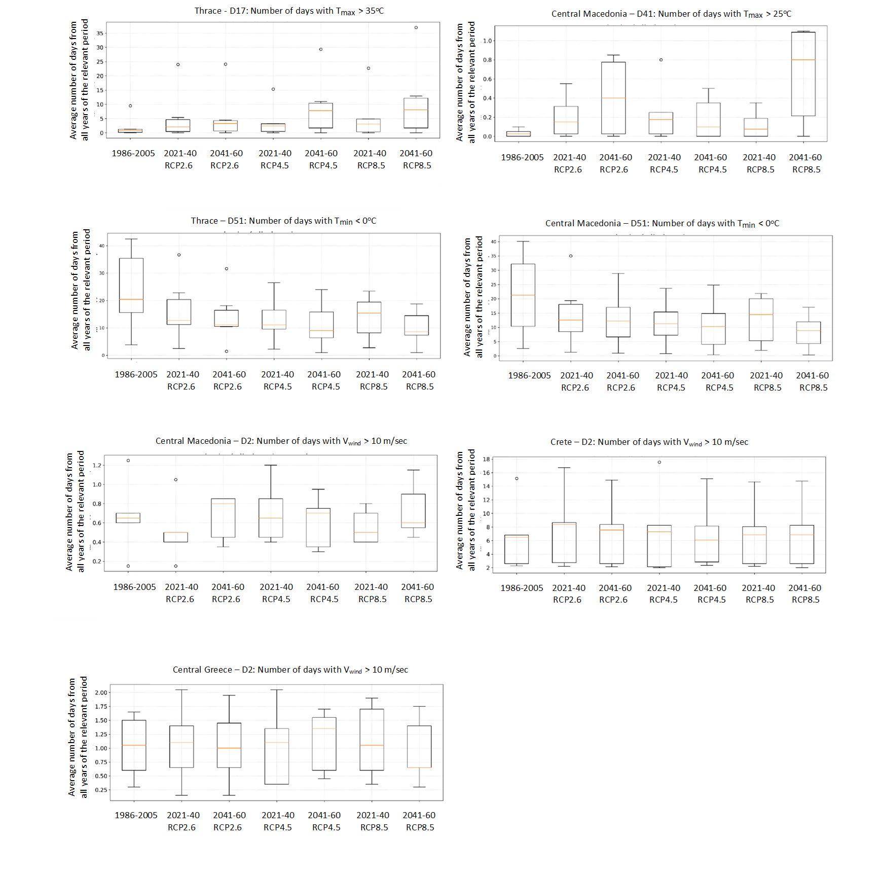
Figure S1(a). Estimated values of selected indicators for heatwaves, frost, and windstorm events under the historical climate reference period and the future periods.
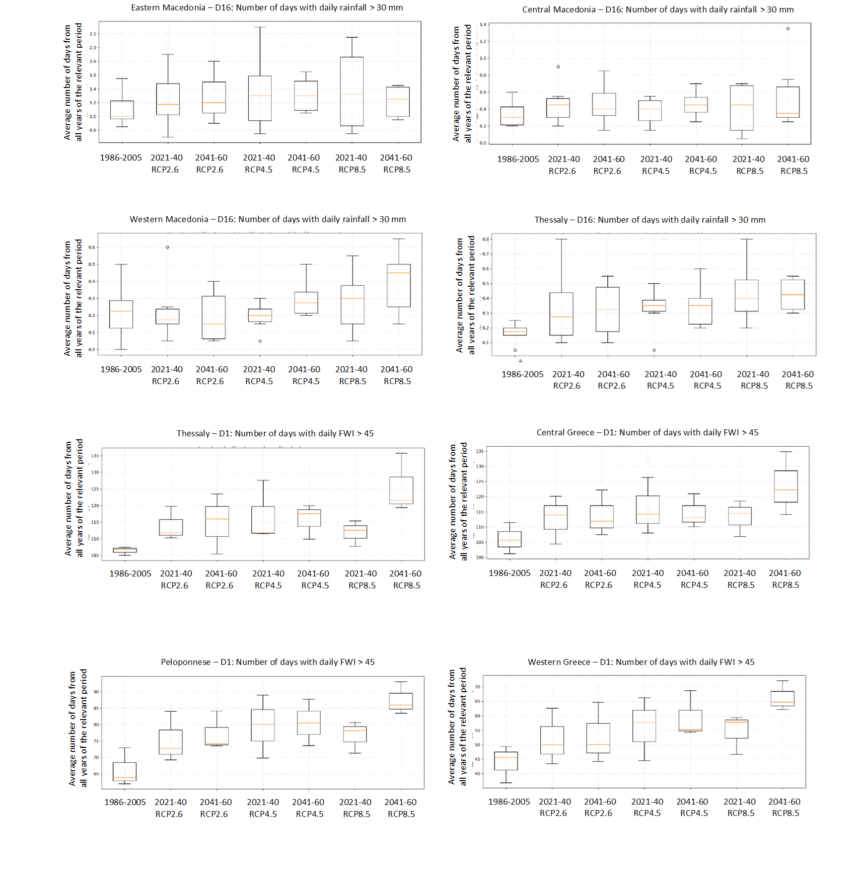
Figure S1(b). Estimated values of selected indicators for extreme rainfall and fire events under the historical climate reference period and the future periods.
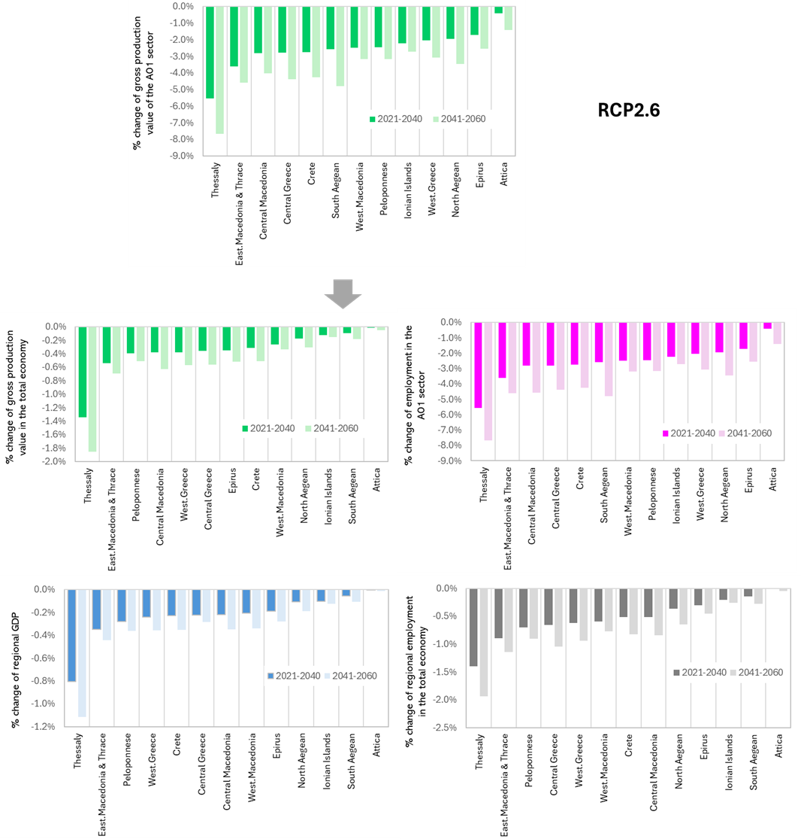

Figure S2. Changes (% with respect to 2018) in regional output and employment which are generated by direct economic effects of (i.e., by changes of the gross production value due to) climate change under RCP2.6, without extreme events.
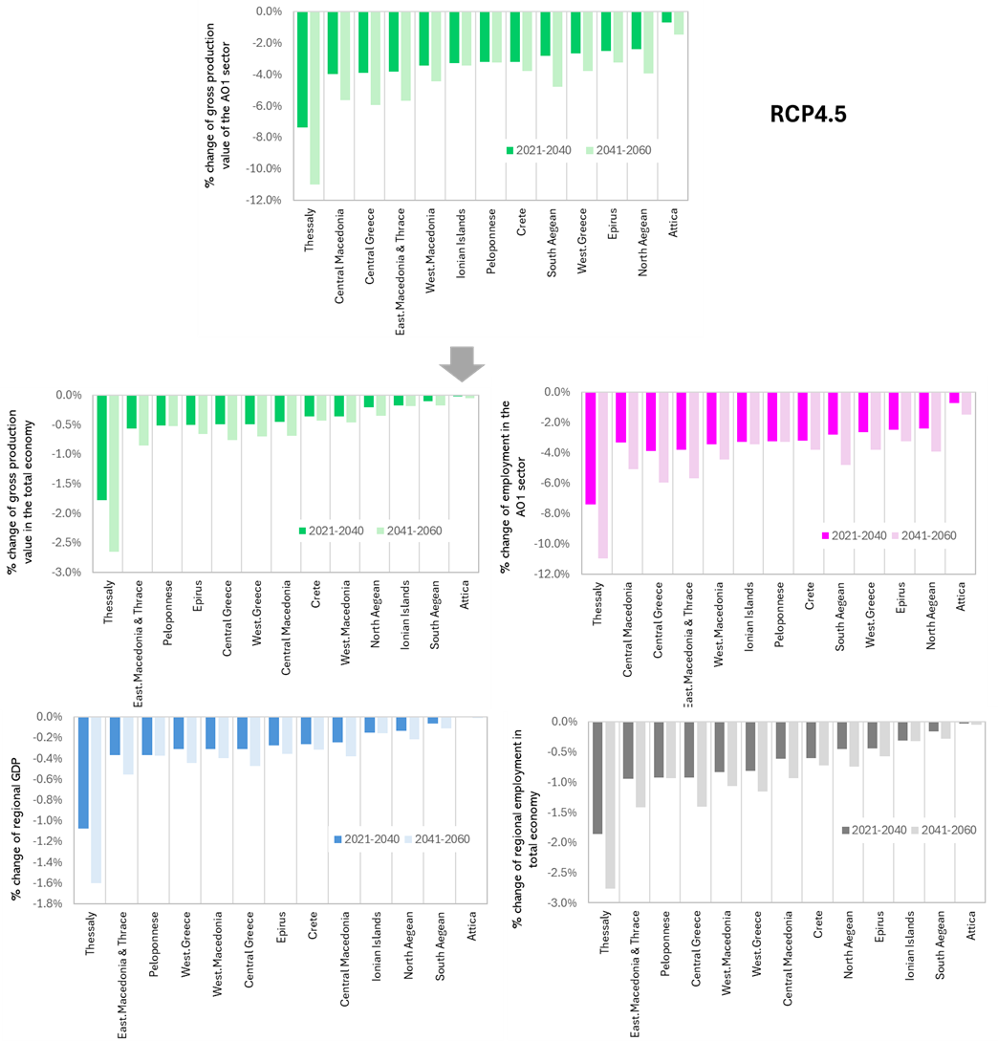

Figure S3. Changes (% with respect to 2018) in regional output and employment which are generated by direct economic effects of (i.e., by changes of the gross production value due to) climate change under RCP4.5, without extreme events.

