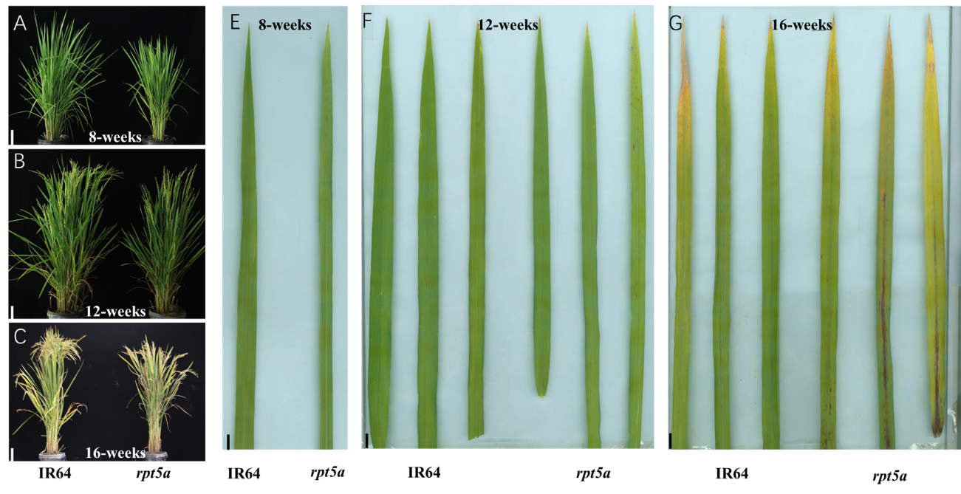
Supplemental Figure S1 The phenotypes of IR64 and rpt5a.
(A): Phenotypes of IR64 and rpt5a at 8 weeks, 12 weeks and 16 weeks. Bar = 20 cm; (B): Leaf phenotypes of IR64 and rpt5a at 8 weeks, 12 weeks and 16 weeks. Bar = 1 cm;

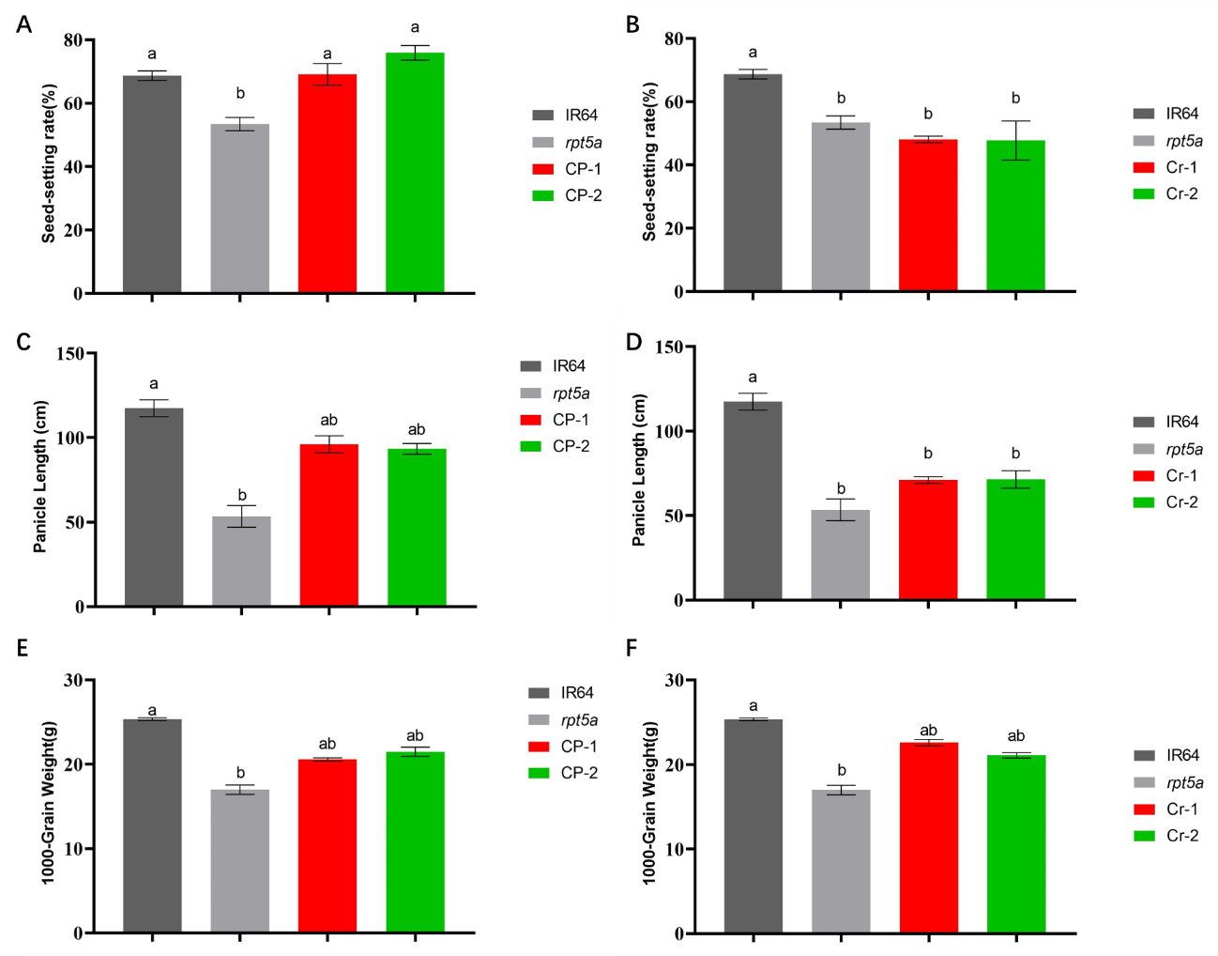
Supplemental Figure S2 Agronomic traits of IR64, rpt5a and complementary lines (CP-1, CP-2), knockout lines (Cr-1, Cr-2).
(A, B): Seed-setting rate; (C, D): Panicle length; (E, F): 1000-Grain weight. Different letters signify statistically significant differences, as assessed by one-way ANOVA followed by Duncan's multiple range test, with a significance threshold of P ≤ 0.05; Error bars represent SD (n = 3).

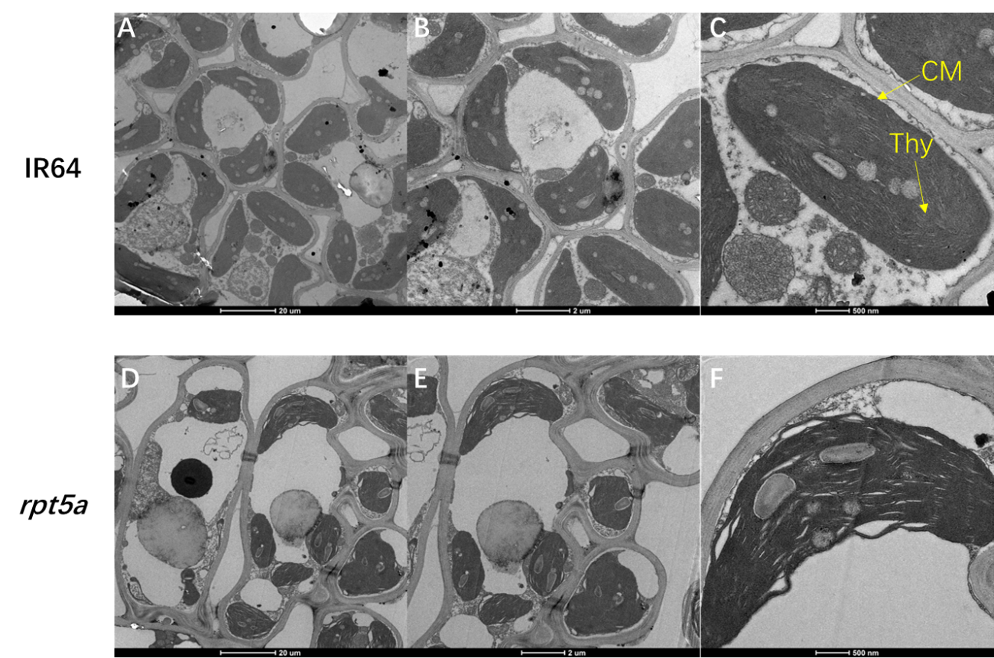

Supplemental Figure S3 TEM observation of the chloroplasts
(A, B, C): TEM observation of the chloroplast in IR64 at the tillering stage; (D, E, F): TEM observation of the chloroplast in rpt5a at the tillering stage. Thy, thylakoid lamellae; CM, chloroplast membrane.

Table S1 Primers used in this study
Name | Primer (5'-3') | Purpose
RM6-F | GTCCCCTCCACCCAATTC | Gene mapping
RM6-R | TCGTCTACTGTTGGCTGCAC | Gene mapping
RM250-F | GGTTCAAACCAAGCTGATCA | Gene mapping
RM250-R | GATGAAGGCCTTCCACGCAG | Gene mapping
RM14229-F | CCCAACCTTAATTCCTCCATCTGC | Gene mapping
RM14229-R | CCCATGGCCTTCCAAATTAAGG | Gene mapping
D237D-F | GGTCGGTCGAGACGTGTAGA | Gene mapping
D237D-R | TTCCCAGAGCACCTTTCATA | Gene mapping
D240A-F | TCTGTCAGTTCTGGCATTGTT | Gene mapping
D240A-R | GAGATTTCACGGGCTTTGTAT | Gene mapping
D240B-F | TGATCTCTCTCCGTAATTTACTG | Gene mapping
D240B-R | ATATGGTTTATGTGGACGCTATA | Gene mapping
C154-2-F | CGAGATACTCCCTCCGTATCA | Gene mapping
C154-2-R | AGCCTAGTTACCTTGGTCCT | Gene mapping
C154-11-F | GCCCTTCACCAATCATTGTA | Gene mapping
C154-11-R | TTGTCTAAGGAACTCAGATCACG | Gene mapping
C154-27-F | AGCAAACTCACTTCCAATAGCA | Gene mapping
C154-27-R | CAGCAGCATTGGCATGTTTA | Gene mapping
PCAMBIA1300-RPT5A-F | tatgaccatgattacgaattc  AGCTAGCACTGGAACAACATCT | Complementation
PCAMBIA1300-RPT5A-R | acgacggccagtgccaagctt  GCCCCAAAGTTAAGCGACAC | Complementation
CR-Target-F | GGCAGATAGCTGCAACTAATCGCG | Knockout vector construction
CR-Target-R | AAACCGCGATTAGTTGCAGCTATC | Knockout vector construction
pCambia1381Z-GUS-F | tatgaccatgattacgaattc  AACGCAATTAATGTGAGTTAGCTCA | GUS assay
pCambia1381Z-GUS-R | tggctgcaggtcgacggatcc CGCTAGGGATTTTGCTTCGA | GUS assay
GFP-RPT5A /RPT5^{AV318E}-F | cgctctagaactagtggatcc  ATGTCGTCGCCGCCGCCC | Subcellular localization
GFP-RPT5A /RPT5^{AV318E}-R | gataagcttgatatcgaattc  AGCGTAATAATTTAAACTGGACTTCTTT | Subcellular localization

