Supplementary Information

Clarifying the dominant role of crystallinity and molecular orientation in differently processed thin films regioregular poly(3-hexylthiophene)

Kumar Vivek Gaurav, Harshita Rai, Kshitij RB Singh, Shubham Sharma, Yoshito Ando, and
Shyam S. Pandey*
Graduate School of Life Science and Systems Engineering, Kyushu Institute of Technology, Kitakyushu, Fukuoka, 808-0196 Japan
*Corresponding author (shyam@life.kyutech.ac.jp)

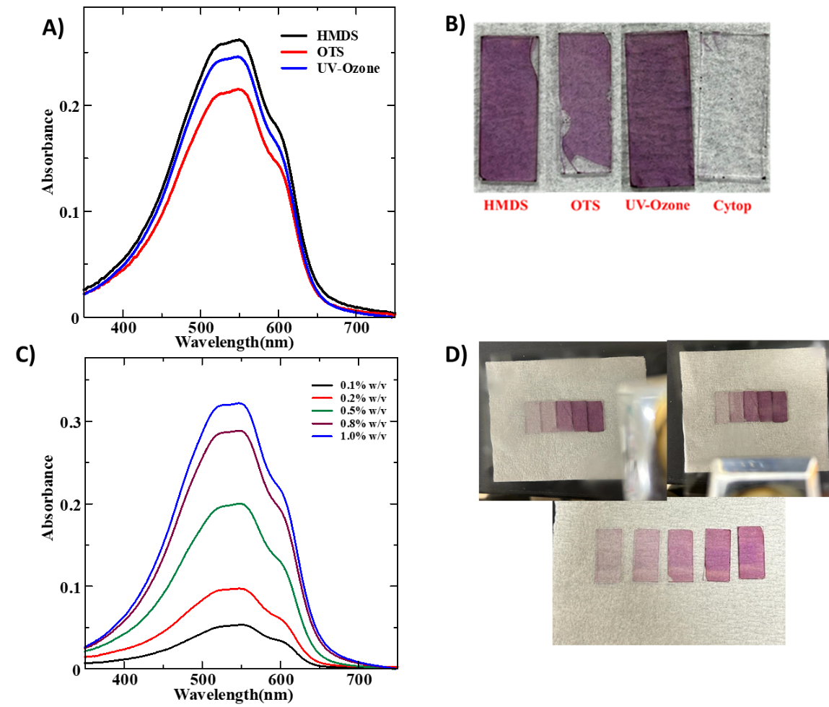
1. Optimization and Optical characterizations of spin-coated films

Figure S1. UV-Visible absorption spectra for spin-coated RR-P3HT thin films fabricated on differently surface-treated glass substrates A) and the photographs of corresponding thin films B). UV-Vis absorption spectra by varying the concentrations of RR-P3HT in Chloroform at a fixed spinning speed of 3500rpm on UV-Ozone treated glass substrate C) and the corresponding photographs spin-coated films with different concentrations under polarizer.
S2. Optimization and Optical characterizations of dip-coated films
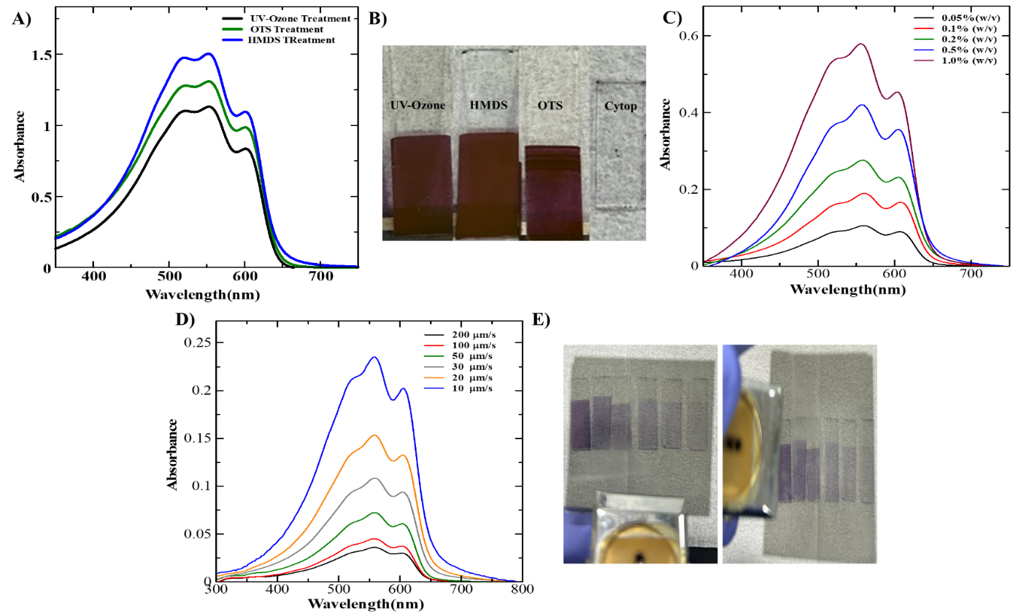
Figure S2. A) Electronic absorption spectra for dip-coated RR-P3HT thin films on glass substrate using different surface modifications at fixed lifting speed and concentration of 20 μm/s and 1.0 % (w/v), respectively and B) photographs of corresponding thin films. C) Absorption spectra on UV-Ozone treated glass substrate with varying concentrations of RR-P3HT in Chloroform at a fixed lifting speed of 20 μm/s. D) Absorption spectra on UV-Ozone treated glass substrate at various lifting speeds while keeping the polymer concentration of 0.1 % fixed and E) corresponding photographs of dip-coated thin films under polarizer.
S3. Optimization and Optical characterizations of FTM-processed thin films
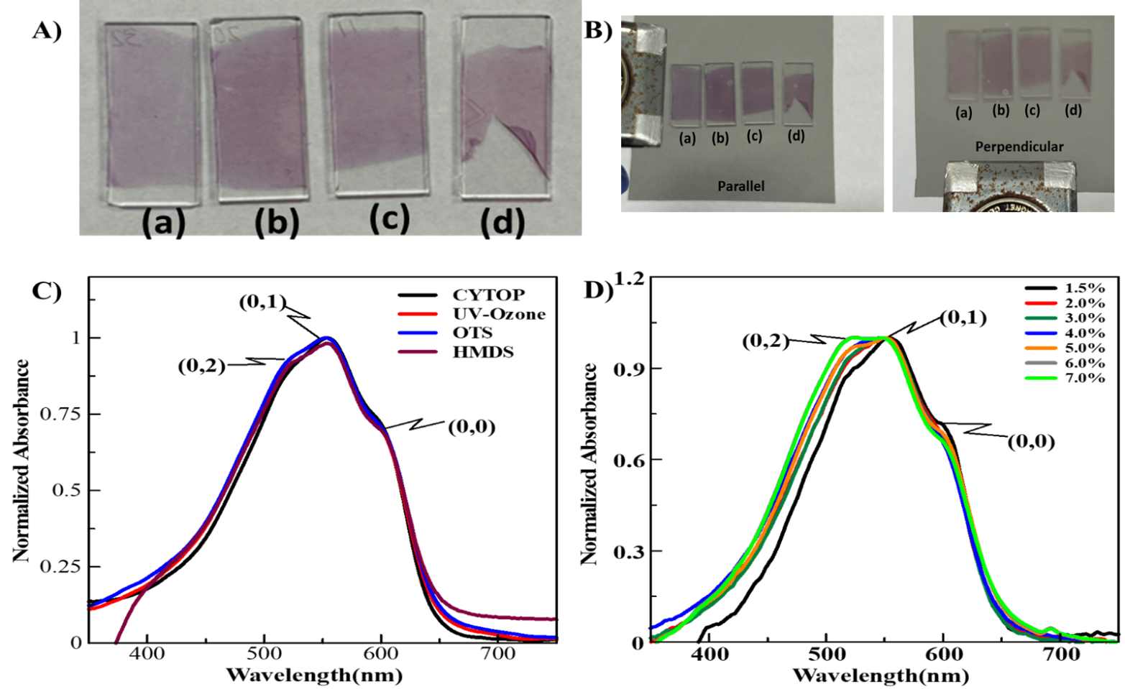
Figure S3. Photographs of the FTM-processed thin films prepared on differently surface-modified glass substrates without polarizer A) and with polarizer B), where a, b, c, and d represent glass substrates modified with CYTOP, OTS, HMDS and UV-Ozone, respectively. Normalized absorption spectra on differently surface-treated glass substrates C) and UV-Ozone treated glass substrates utilizing varying RR-P3HT concentrations.
Keywords: Regioregular poly(3-hexylthiophene); organic field-effect transistors; thin films; crystallinity; orientation; unidirectional floating film transfer

