RISK OF BLOOD CLOTS AFTER COVID-19 VACCINATION AND COVID-19 INFECTION: A RISK-BENEFIT ANALYSIS
Contents
Supplementary Figure S1: Self-controlled case series design.
Supplementary Figure S2: Case-control design: Defining an exposed (SARS-CoV-2 infection) subject.
Supplementary Table S1: List of ICD-10 codes for thromboembolic outcomes (blood clots).
Supplementary Table S2: List of ICD-10 codes for injury.

Figure S1: Self-controlled case series design to study the association between blood clots and the first two doses of either mRNA-1273 or BNT162b2 COVID-19 vaccines. Each patient is followed from the day of exposure to 28 days and censored at the second dose, death or end of observational period.
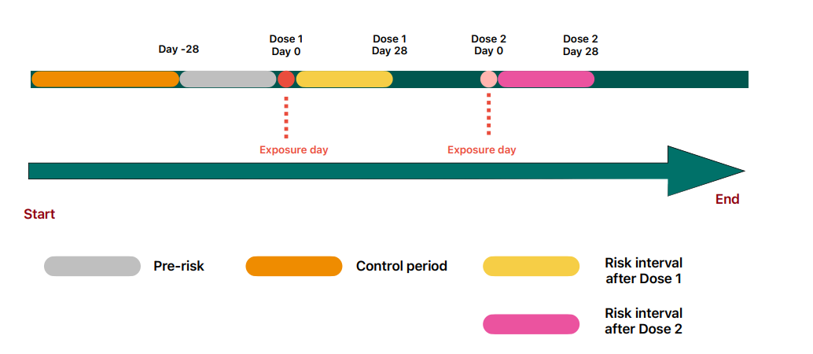

Figure S2: Case-control design to study the association between blood clots and COVID-19 infection. A subject is classified into the exposed group (COVID-19 infected) if they have a positive COVID-19 test in the period 28 days prior to the date of outcome (either blood clots or hospitalized injury).
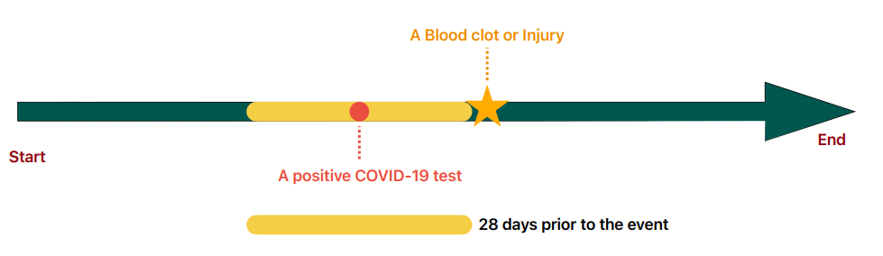

Table S1: ICD-10 codes used to identify thromboembolic events (blood clots).
Outcome | ICD10 code | ICD10 code and description
Venous thromboembolism | I26 | Pulmonary embolism
 | I260 | Pulmonary embolism with mention of acute cor pulmonale
 | I269 | Pulmonary embolism without mention of acute cor pulmonale
 | I81 | Portal vein thrombosis
 | I81X | Portal vein thrombosis
 | I82 | Other venous embolism and thrombosis
 | I820 | Budd-Chiari syndrome
 | I822 | Embolism and thrombosis of vena cava
 | I823 | Embolism and thrombosis of renal vein
 | I828 | Embolism and thrombosis of other specified veins
 | I829 | Embolism and thrombosis of unspecified vein
Arterial thrombosis | I742 | Embolism and thrombosis of arteries of upper extremities
 | I74 | Arterial embolism and thrombosis
 | I740 | Embolism and thrombosis of abdominal aorta
 | I741 | Embolism and thrombosis of other and unspecified parts of aorta
 | I743 | Embolism and thrombosis of arteries of lower extremities
 | I744 | Embolism and thrombosis of arteries of extremities, unspecified
 | I745 | Embolism and thrombosis of iliac artery
 | I748 | Embolism and thrombosis of other arteries
 | I749 | Embolism and thrombosis of unspecified artery
Cerebral venous sinus thrombosis | O225 | Cerebral venous thrombosis in pregnancy
 | O873 | Cerebral venous thrombosis in the puerperium
 | I636 | Cerebral infarction due to cerebral venous thrombosis
 | I676 | Non-pyogenic thrombosis of intracranial venous system
Ischemic stroke | G45 | Transient cerebral ischemic attacks and related syndromes
 | G450 | Vertebrobasilar artery syndrome
 | G451 | Carotid artery syndrome (hemispheric)
 | G452 | Multiple and bilateral precerebral artery syndromes
 | G453 | Amaurosis fugax
 | G454 | Transient global amnesia
 | G458 | Other transient cerebral ischemic attacks and related syndromes
 | G459 | Transient cerebral ischemic attack, unspecified
 | I63 | Cerebral infarction
 | I630 | Cerebral infarction due to thrombosis of precerebral arteries
 | I631 | Cerebral infarction due to embolism of precerebral arteries
 | I632 | Cerebral infarction due to unspecified occlusion or stenosis of precerebral arteries
 | I633 | Cerebral infarction due to thrombosis of cerebral arteries
 | I634 | Cerebral infarction due to embolism of cerebral arteries
 | I635 | Cerebral infarction due to unspecified occlusion or stenosis of cerebral arteries
 | I636 | Cerebral infarction due to cerebral venous thrombosis, non-pyogenic
 | I638 | Other cerebral infarction
 | I639 | Cerebral infarction, unspecified
 | I64 | Stroke, not specified as haemorrhage or infarction
 | I64X | Stroke, not specified as haemorrhage or infarction
Myocardial infarction | I21 | Acute myocardial infarction
 | I210 | Acute transmural myocardial infarction of anterior wall
 | I211 | Acute transmural myocardial infarction of inferior wall
 | I212 | Acute transmural myocardial infarction of other sites
 | I213 | Acute transmural myocardial infarction of unspecified site
 | I214 | Acute subendocardial myocardial infarction
 | I219 | Acute myocardial infarction, unspecified
 | I22 | Subsequent myocardial infarction
 | I220 | Subsequent myocardial infarction of anterior wall
 | I221 | Subsequent myocardial infarction of inferior wall
 | I228 | Subsequent myocardial infarction of other sites
 | I229 | Subsequent myocardial infarction of unspecified site
 | I23 | Certain current complications following acute myocardial infarction
 | I230 | Haemo-pericardium as current complication following acute myocardial infarction
 | I231 | Atrial septal defect as current complication following acute myocardial infarction
 | I232 | Ventricular septal defect as current complication following acute myocardial infarction
 | I233 | Rupture of cardiac wall without haemopericardium as current complication following acute myocardial
 | I234 | Rupture of chordae tendineae as current complication following acute myocardial infarction
 | I235 | Rupture of papillary muscle as current complication following acute myocardial infarction
 | I236 | Thrombosis of atrium, auricular appendage, and ventricle as current complications following acute myocardial
 | I238 | Other current complications following acute myocardial infarction
 | I252 | Old myocardial infarction

Table S2: ICD-10 codes used to identify hospitalized injury event.
Injuries | S00-S09 | Injuries to the head
 | S10-S19 | Injuries to the neck
 | S20-S29 | Injuries to the thorax
 | S30-S39 | Injuries to the abdomen, lower back, lumbar spine, pelvis and external genitals
 | S40-S49 | Injuries to the shoulder and upper arm
 | S50-S59 | Injuries to the elbow and forearm
 | S60-S69 | Injuries to the wrist, hand, and fingers
 | S70-S79 | Injuries to the hip and thigh
 | S80-S89 | Injuries to the knee and lower leg
 | S90-S99 | Injuries to the ankle and foot
 | T07-T35 | Injures and others consequences of external causes
 | T51-T88

