Hierarchical Porosity and Surface Oxygenation of Carbon-Based Cathodes Enhances Discharge Capacity and Decreases Discharge Overpotential of Potassium-Oxygen Batteries
Shikha Singh, Jannis Küpper, Ahed Abouserie, Gianluca Dalfollo, Michael Noyong, and Ulrich Simon*
Institute of Inorganic Chemistry, RWTH Aachen University, 52072 Aachen, Germany;
shikha.singh@ac.rwth-aachen.de, jannis.nicolas.kuepper@rwth-aachen.de; ahed.abouserie@ac.rwth-aachen.de; gianluca.dalfollo@ac.rwth-aachen.de; michael.noyong@ac.rwth-aachen.de;
* Correspondence: ulrich.simon@ac.rwth-aachen.de; Tel.: +49 241 80-99385

Supplementary Information
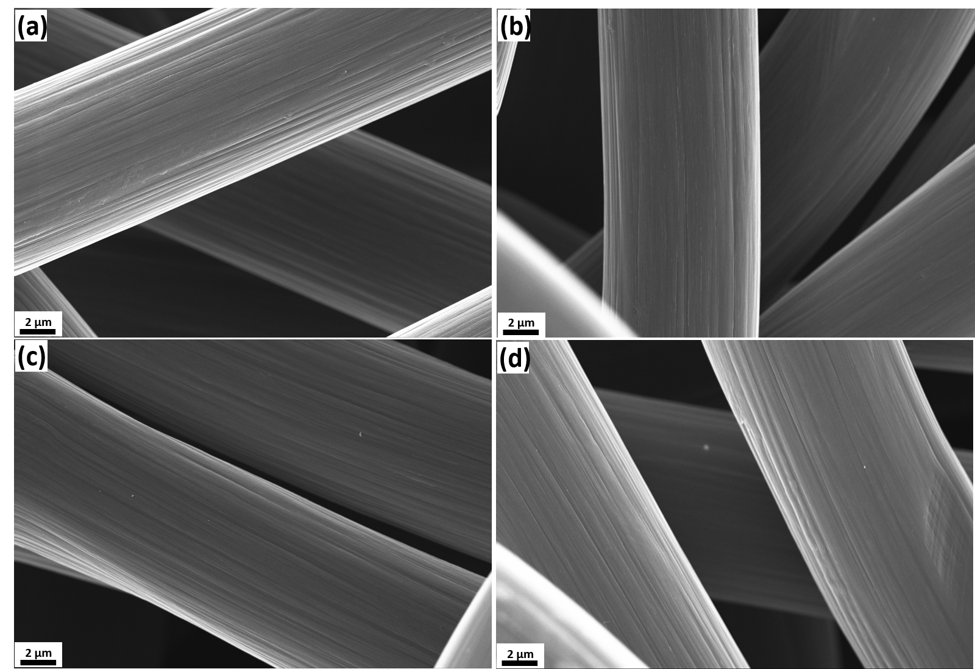
Figure S1: SEM images of (a) CP, (b) CP_4 h, (c) CP_12 h and (d) CP_ 24 h at low magnification. All cathode samples appear similar with respect to their microstructure

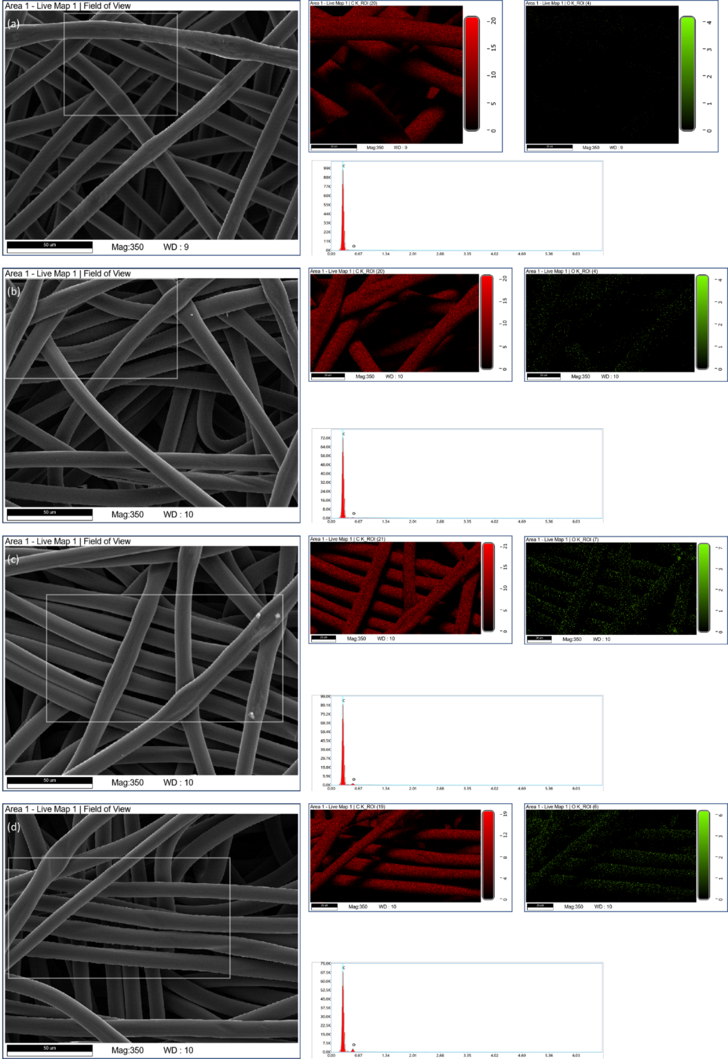
Figure S2: SEM overview images (a-d, left) of carbon paper (a) untreated and treated for (b) 4 h, (c) 12 h and (d) 24 h with their respective EDS mappings of carbon (C_K, red) and oxygen (O_K, green) within the marked areas as well as the sum spectra of the investigated areas (intensity vs. energy). The sum spectra show up to 10 kV no other signals than an intense signal for carbon and increasing intensities for oxygen by increasing treatment time. With carbon as the main element, its elemental maps correspond to the respective SEM images. Due to the lateral position of the EDS detector the signal of lower lying fibers is attenuated or blocked by upper lying fibers. Thus, in the elemental maps a shadowing effect and regions without intensity appear.
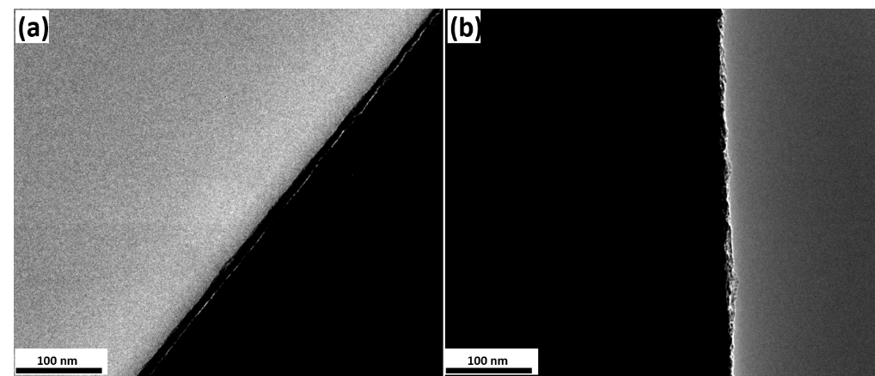

Figure S3: Bright field TEM images of (a) CP and (b) CP_ 24 h. The carbon fibers itself are too thick to transmit electrons and appear black. At the edges a thin zone reveals a smooth surface structure for the untreated fibers. In contrast, the CP_24 h shows a rougher contour.

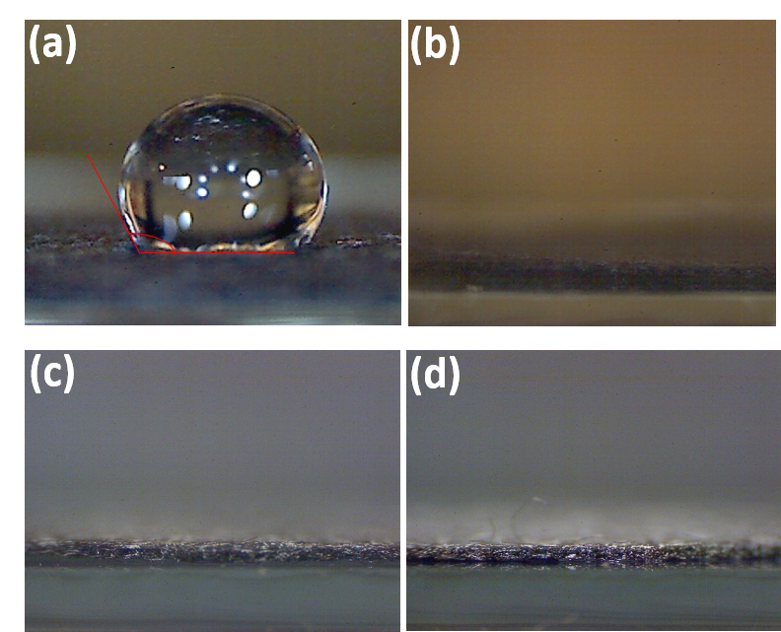
Figure S4: Photographs of contact angle measurements for (a) CP, (b) CP_4 h with DI water and (c) CP, (d) CP_4 h for DMSO. While in (a) the droplet is clearly visible, in (b-d) the liquids spread completely on the thermally treated samples.

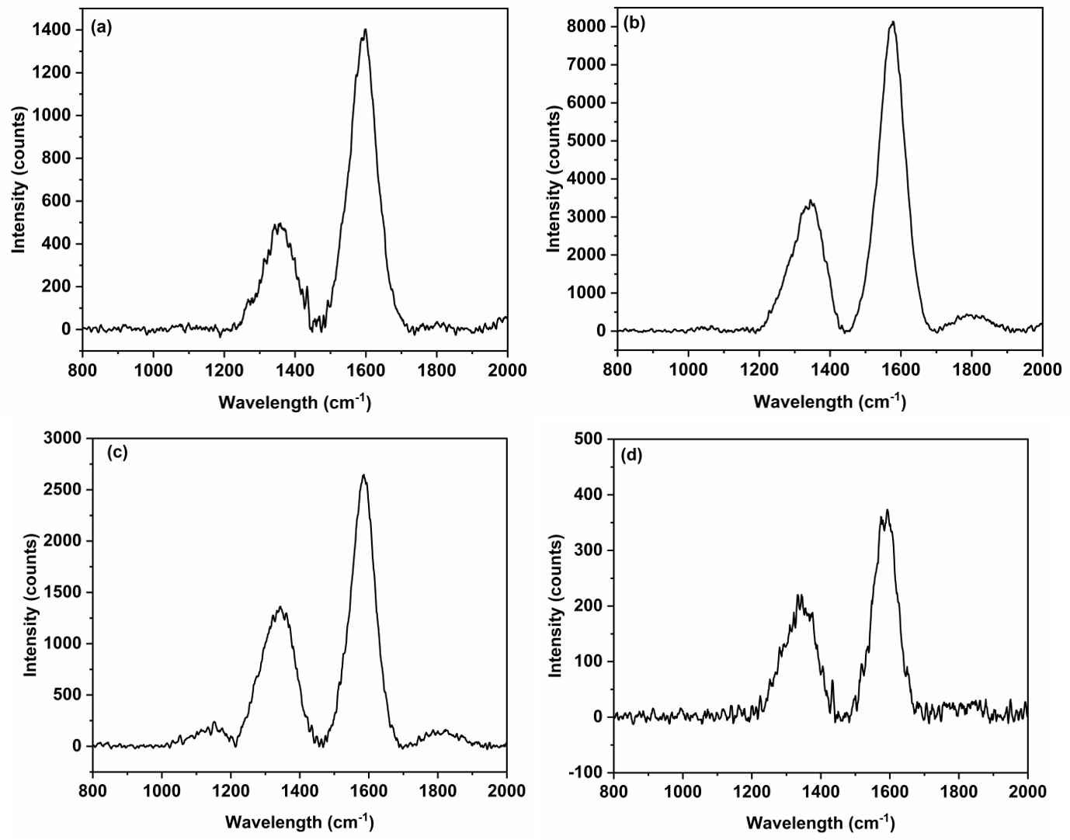
Figure S5: Raman spectra of (a) CP, (b) CP_4 h, (c) CP_12 h, and (d) CP_24 h representing each two maxima at approx. 1351cm⁻¹ and 1570cm⁻¹.

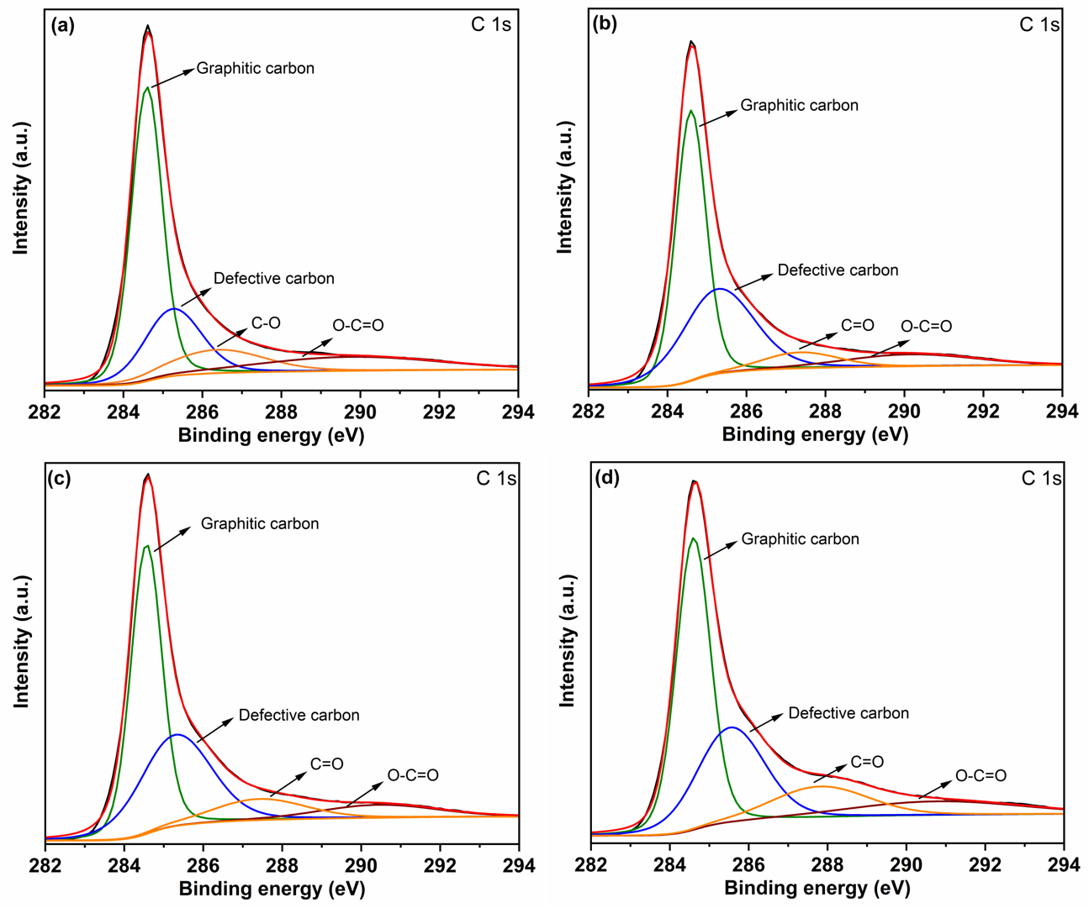
Figure S6: High resolution XPS spectra in the C 1s region for(a) CP, (b) CP_4 h, (c) CP_12 h and (d) CP_24 h.
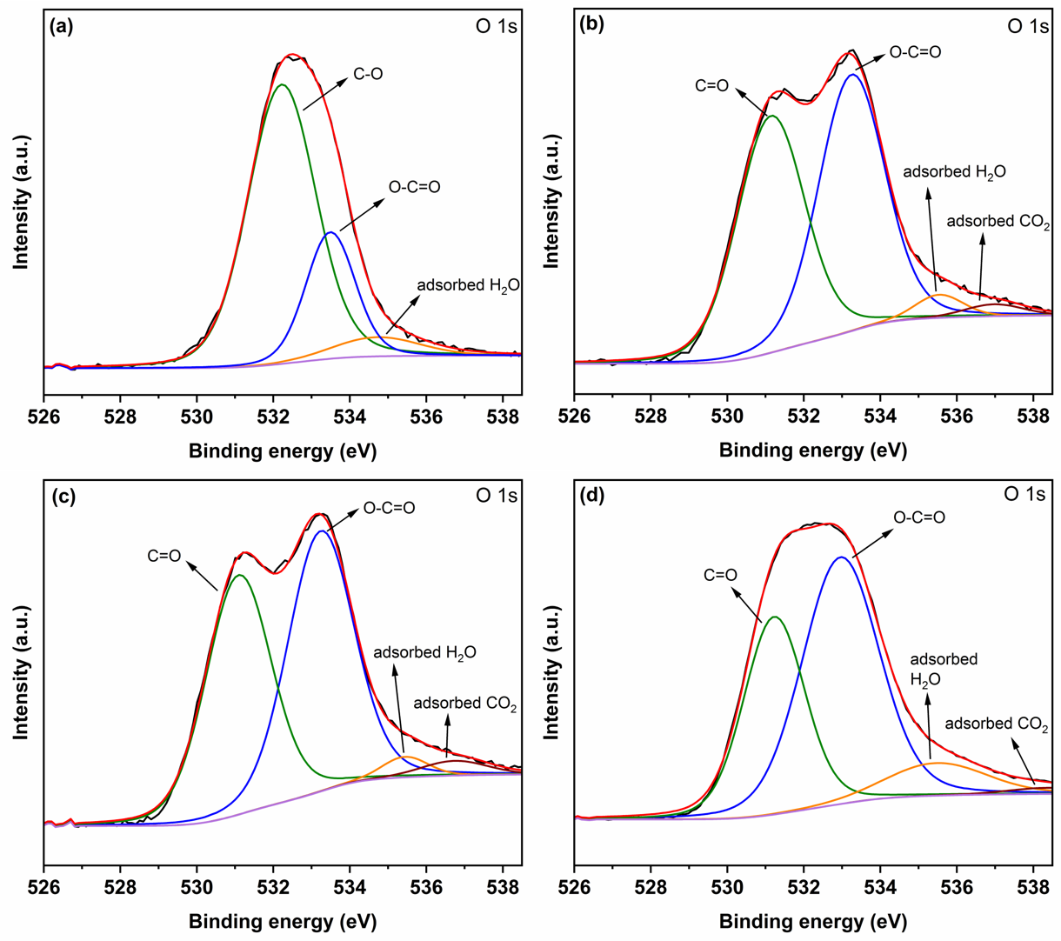
Figure S7: High resolution XPS spectra in the O 1s region for (a) CP, (b) CP_4 h, (c) CP_12 h and (d) CP_24 h. It can be observed that there is an increase for the O-C=O functional groups from CP to CP_24 h.

Figure S8: Pore size distribution of CP_12 h and CP_24 h. Micropores presence can be seen in CP_12 h and CP_24 h have increased micropore content and additional mesopores distributed at an avg size of 3 nm and 6 nm.
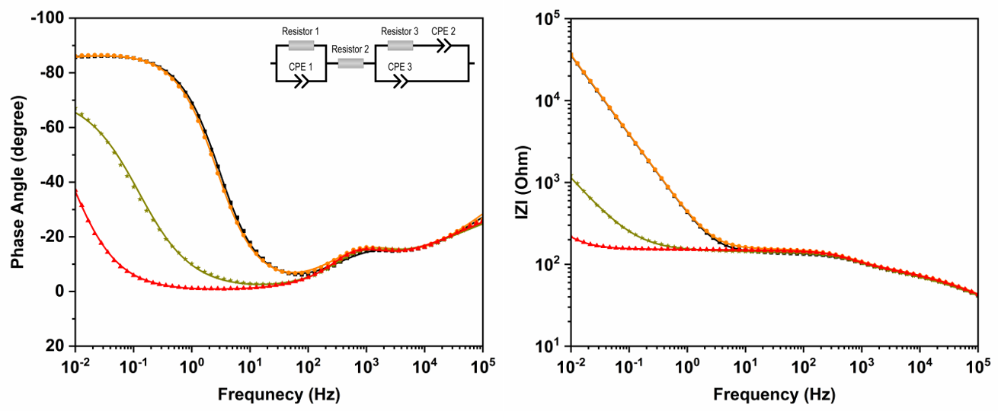
Figure S9: Bode plots obtained via EIS for CP (black), CP_4 h (orange), CP_12 h (green) and CP_24 h (red). Measured data is plotted as point graphs and fits obtained as from model circuit fitting as line graphs. The equivalent circuit is given in inset.

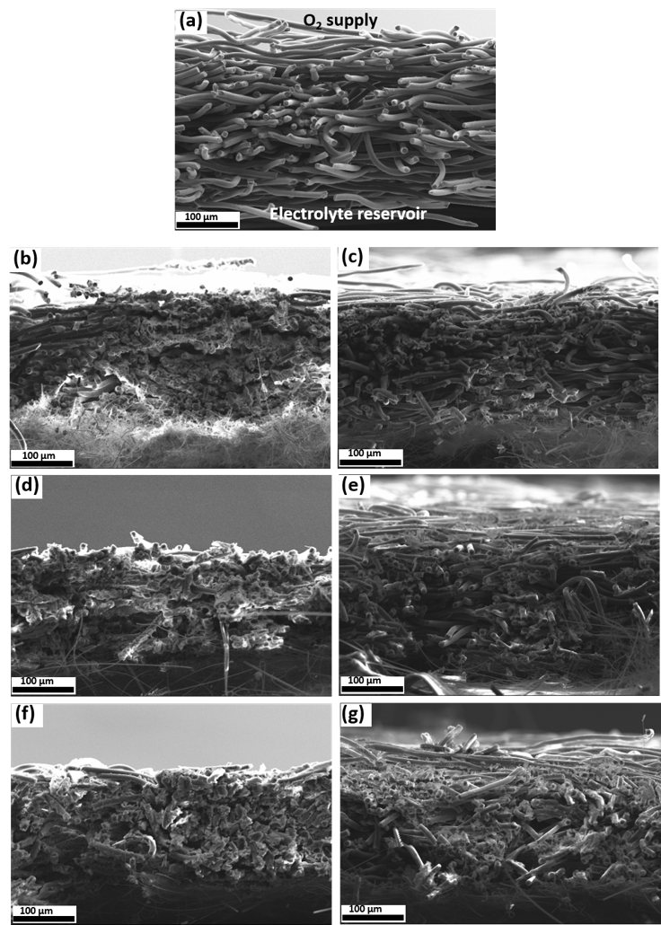
Figure S10: Cross-sectional SEM images of pristine CP (a), CP after discharge at J = 0.1 mA/cm² (b) and J = 1.0 mA/cm² (c), CP_12 h after discharge at J = 0.1 mA/cm² (d) and J = 1.0 mA/cm² (e), CP_24 h after discharge at J = 0.1 mA/cm² (f) and J = 1.0 mA/cm² (g).

Table S1: All the quantitative values of various parameters of CP, CP_4 h, CP_12 h and CP_24 h
 |  | CP | CP_4 h | CP_12 h | CP_24 h
Mass loss (%) |  | 0 | 0 | 3 - 5 | 10 - 15
I_{D}/I_{G} ratio |  | 0.92 | 0.99 | 1.05 | 1.07
O/C ratio |  | 0.058 | 0.062 | 0.079 | 0.168
C_{sp} * 10⁻⁵ (F/cm²) |  | 0.22 | 0.26 | 3.56 | 5.73
Specific surface area (m²/g) |  | 0.33 | 1.2 | 29 | 90
Q (mAh/cm²) at | J = 0.1 mA/cm² | 3.44 | 3.45 | 4.45 | 5
 | J = 0.5 mA/cm² | 1.79 | 1.79 | 2.36 | 2.71
 | J = 1.0 mA/cm² | 0.73 | 0.69 | 1.69 | 1.98
η_{dis} (V) at | J = 0.1 mA/cm² | 0.19 | 0.06 | 0.03 | 0.03
 | J = 0.5 mA/cm² | 0.42 | 0.26 | 0.20 | 0.35
 | J = 1.0 mA/cm² | 0.62 | 0.52 | 0.35 | 0.27

