SUPPLEMENTARY MATERIAL
Title: Cooking Emissions Levels and Associated Health Effects among Households in Dodoma City, Tanzania.

Authors:
Mwanini Yakobo Mkunda¹*, Godson Anna², Aiwerasia Vera Ngowi³, Jovine Bachwenkizi³

Affiliations:
¹Pan African University Life and Earth Science Institute (Including Health and Agriculture) (PAULESI), University of Ibadan, Nigeria

²Faculty of Public Health, University of Ibadan, Nigeria

³Department of Environmental and Occupational Health, Muhimbili University of Health and Allied Sciences, Dar es Salaam, Tanzania

*Corresponding Author:
Email: mkunda200@gmail.com
Phone: +255754325869

1. Supplemental figure
1.1 The storage of fetched firewood in the household
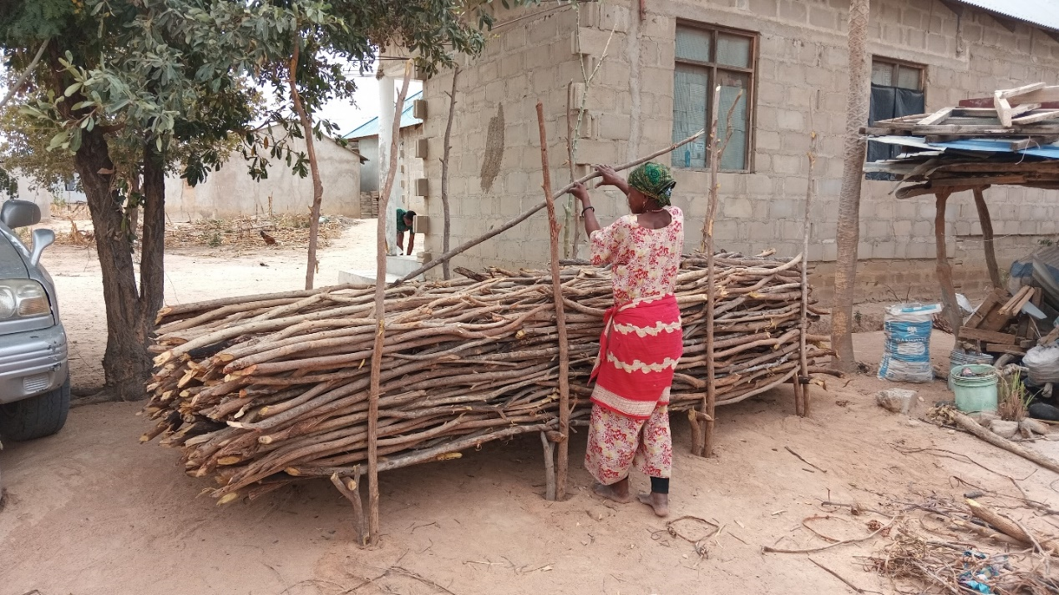
Figure S1. Storage of fetched firewood in the household

1.2 Kitchen location sketches
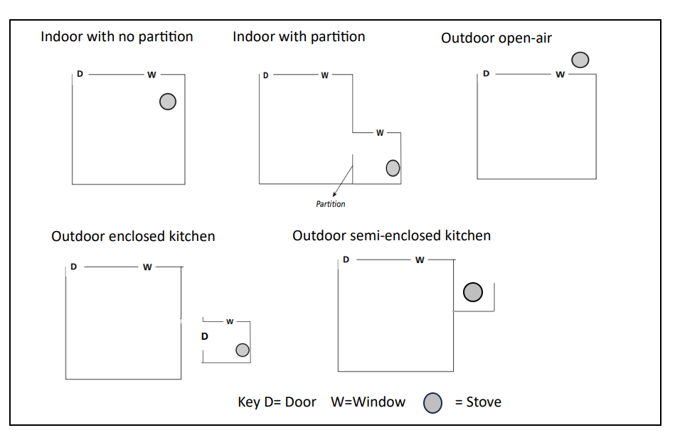
Figure S2. Sketch diagram showing the location of the kitchen

1.3 Correlation among pollutant concentrations, temperature and relative humidity
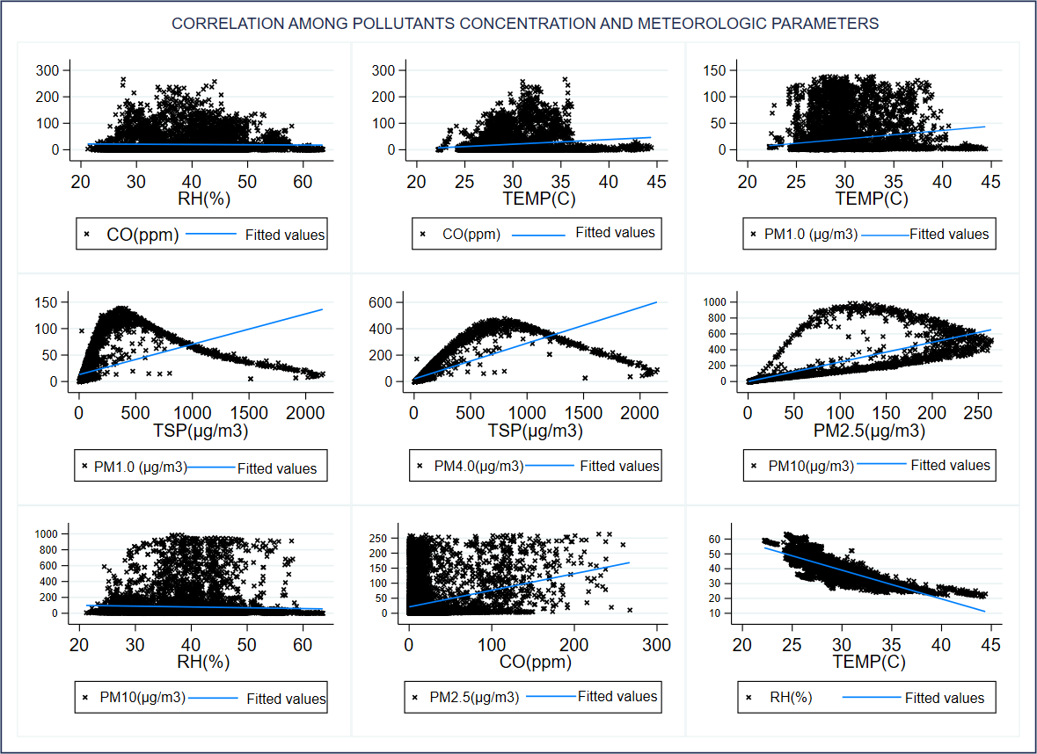
Figure S3. Correlation among pollutant concentrations, temperature and relative humidity
2. Supplemental tables
Table S1. Spearman rank correlation coefficients among pollutant concentrations and meteorologic parameters

Variables | CO (ppm) | PM₁  (µg/m³) | PM_{2.5}  (µg/m³) | PM₄  (µg/m³) | PM₁₀  (µg/m³) | RH  (%) | TEMP  (°C)
CO (ppm) |  |  |  |  |  | 0.0619 | 0.1568
PM₁(µg/m³) | 0.2835 |  |  |  |  | -0.1842 | 0.1666
PM_{2.5}(µg/m³) | 0.2833 | 0.9937 |  |  |  | -0.1816 | 0.1591
PM₄(µg/m³) | 0.2788 | 0.9790 | 0.9948 |  |  | -0.1828 | 0.1548
PM₁₀(µg/m³) | 0.2689 | 0.9513 | 0.9763 | 0.9920 |  | -0.1897 | 0.1530
TSP(µg/m³) | 0.2419 | 0.9034 | 0.9365 | 0.9623 | 0.9869 | -0.2060 | 0.1553
TEMP (°C) |  |  |  |  |  | -0.8321

