Supplementary Information

Fabrication and Characterization of Porous PEGDA Hydrogels for Articular Cartilage Regeneration
Silvia Gonella^{1,2,#}, Margarida F. Domingues^{1,2,#}, Filipe Miguel^{1,2}, Carla S. Moura^{3,4}, Carlos A.V. Rodrigues^{1,2}, Frederico Castelo Ferreira^{1,2} and João C. Silva^{1,2,}*

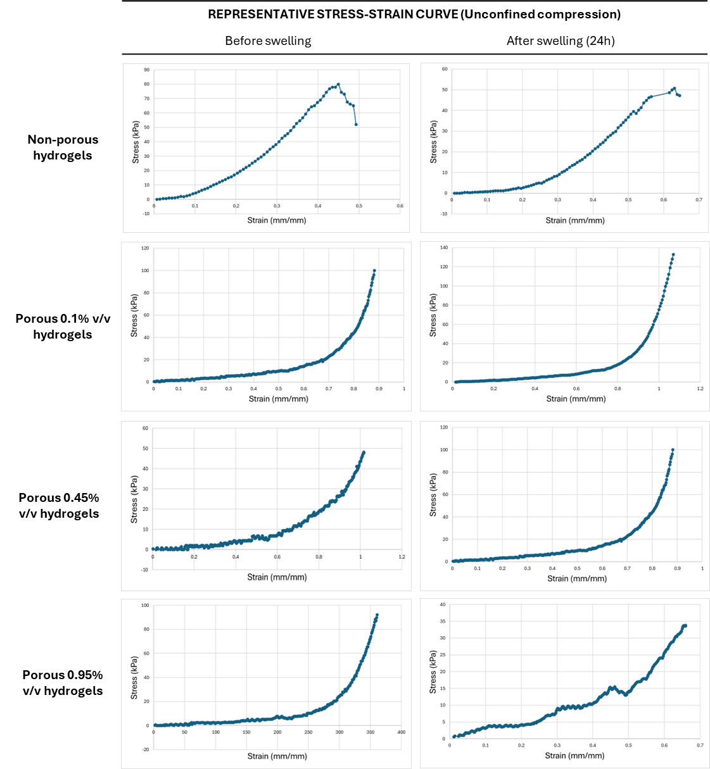
Figure S1 – Representative Stress-Strain Curve for an unconfined compression test for 3 conditions
of non-porous hydrogels with 0.95% v/v photoinitiator and porous hydrogels with 0.1%, 0.45% or 0.95% v/v photoinitiator concentration, after fabrication and after swelling for 24h.

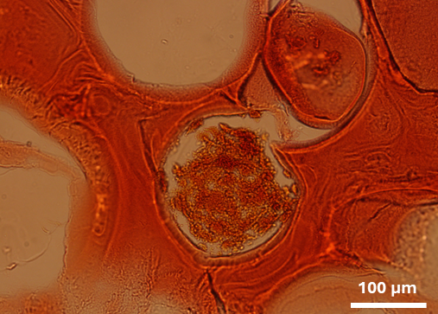
Figure S2 – Safranin-O staining on a histological section of the 3D porous PEGDA scaffold seeded with
MSC aggregates. Staining was performed after 21 Days of culture in presence of a chondrogenic medium.

