Supplementary Information

Section S1. Simulation Details
In the present study, water (four molecules cluster, represented by W), hydrophobic monomer (represented by B) and hydrophilic monomer (represented by A) are represented by bead types P4, C4, SNda, respectively [85]. The solvent consists of 90.9% of P4 water beads along with 9.1% of “antifreeze” beads (represented by WF) which are of type BP4 and slightly bigger than the P4 beads. The WF beads are employed to disturb the lattice packing of the uniformly sized solvent beads and decrease the solvent freezing point [86]. The chemical affinities of bead types are described in the paper of Marrink et al. [85].
The simulations are performed by using the Gromacs 2020.2 MD software. First, simulations are conducted to minimize the energy of the initial system by the steepest descent algorithm. This is followed by a short (2 ns in this work) NVT simulation to equilibrate the system at a desired temperature to ensure algorithmic stability. Subsequently, a sufficiently long NPT simulation (production run) is carried out (600 ns in this work). The reason for conducting NVT simulation first is because that velocity generation at the outset of a simulation, which is done by sampling from a Gaussian distribution that yields the mean temperature, is imperfect. When coupled with a barostat, initial velocity distributions thus generated can frequently lead to numerical instabilities. Hence, equilibration is better performed for an NVT ensemble for a short period of time to get the correct the velocity distribution. Proceeding NPT simulations lead to the establishment of the appropriate system density.
The initial simulation box is cubic with a linear dimension of 40 nm. In comparison, the contour length of the longest copolymer chain is 6.64 nm. During the NPT simulation the box size changes to between 39 and 41 nm to match the correct system density.
The reference pressure and temperature are 1 bar and 300K, respectively. A v-rescale thermostat [89] with a time constant of 1.0 ps is used for temperature coupling. Berendsen barostat [90] with a time constant of 4.0 ps is used for isotropic pressure coupling during the NPT simulations. The simulations employ periodic boundary conditions along all three spatial coordinates. The time step for equilibration runs is 20 fs and the run time is 2 ns. The time step for production runs is 40 fs and the run time is up to 400 ns.

Table S1. Parameter values for non-bonded interactions for the BAB copolymer.

Interaction type | $$ε_{ij}(kJ/mol)$$ | $$σ_{ij}(nm)$$
B-W | 2.7 | 0.47
B-B | 3.5 | 0.47
B-A | 3.1 | 0.47
A-A | 3.375 | 0.43
A-W | 4 | 0.47
W-W | 5 | 0.47
W-WF | 5.6 | 0.57
WF-WF | 5 | 0.47
A-WF | 4 | 0.47
B-WF | 2.7 | 0.47

Table S2. Parameter values for bond stretching interactions.

Bond type | $$b_{0}(nm)$$ | $$K_{b}(kJ/(mol·{nm}^{2}))$$
B-B | 0.47 | 1250
B-A | 0.47 | 1250
A-A | 0.33 | 17000

Table S3. Parameter values for bond bending interactions.

Angle type | $θ_{0}$ (degree) | $$K_{θ}(kJ/mol)$$
B-B-B | 180 | 25
B-B-A | 180 | 25
B-A-A | 120 | 50
A-A-A | 120 | 50

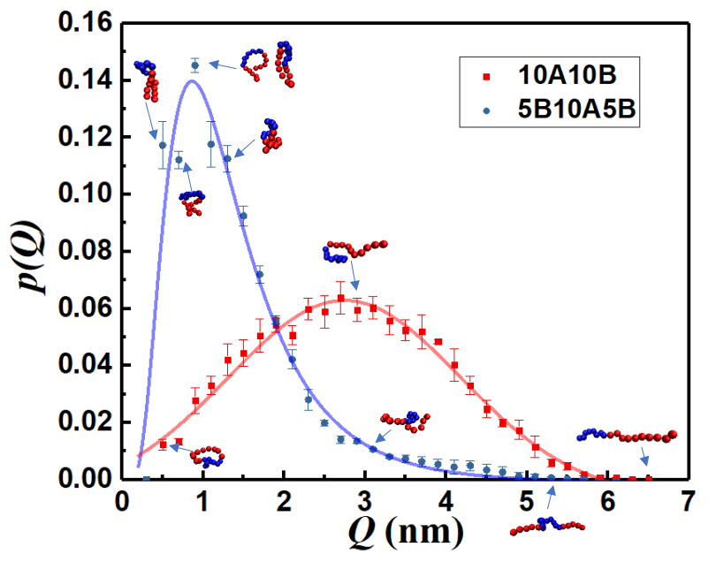
Figure S1. Probability distribution functions of the magnitude of the end-to-end vector Q of a single chain in solution, p(Q), vs. Q for an AB diblock (10 blocks each of A and B) and a BAB triblock (two 5 block B segments on either side of a 10 B block middle segment) copolymers. Typical chain configurations are shown alongside.

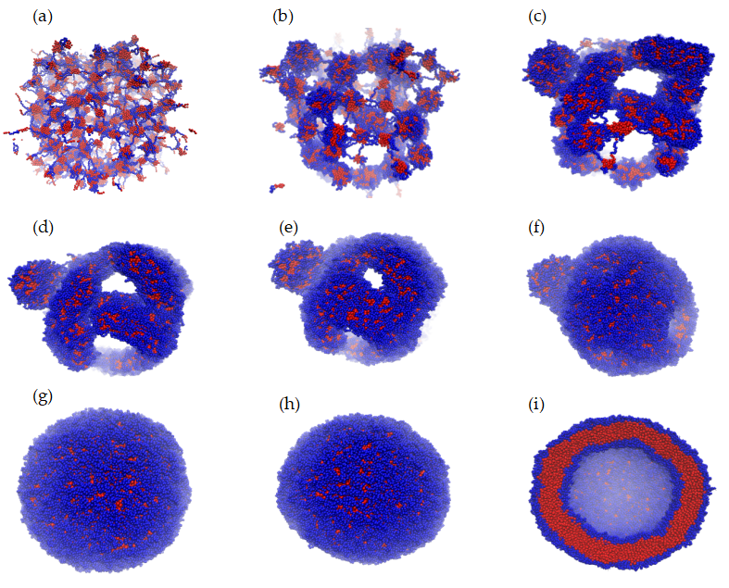

Figure S2. Structure evolution for the C1-type B segment. (a) 0 ns, (b) 10 ns, (c) 20 ns, (d) 30 ns, (e) 40 ns, (f) 50 ns, (g) 150 ns, (h) 600 ns. (i) shows the cross section of the structure in panel (h).

