The association between dietary protein intake and sources and the rate of longitudinal changes in brain structure
Fusheng Cui , Huihui Li, Yi Cao, Weijing Wang, Dongfeng Zhang
Supplemental Table 1 Dietary Protein Sources Classification and Codes
Protein sources | ID | items
red meat | 26066 | Beef
 | 26100 | Lamb
 | 26117 | Pork
Processed meat | 26122 | Processed meat
Poultry | 26121 | Poultry
Eggs | 26088 | Egg and egg dishes
cheese | 26099 | High fat cheese
 | 26103 | Medium and low-fat cheese
Nuts | 26107 | Unsalted nuts and seeds
 | 26108 | Salted nuts and seeds
yogurt | 26102 | Low fat yogurt
 | 26096 | Full fat yogurt
Whole grains | 26105 | Muesli
 | 26076 | Bran cereal
 | 26077 | Oat cereal (non sugar)
 | 26078 | Oat cereal (sugar)
 | 26079 | Other cereal (sugar)
 | 26074 | Whole meal bread
 | 26114 | Whole meal pasta, brown rice and other wholegrains
Legumes | 26086 | Soy desserts and yogurt
 | 26136 | Soy milk
 | 26115 | Peas and sweetcorn
 | 26137 | Meat substitutes - soy
 | 26101 | Legumes and pulses
milk | 26150 | Whole milk
 | 26131 | Semi skimmed milk
 | 26133 | Skimmed milk and cholesterol-lowering milk
sea food | 26109 | Oily fish
 | 26149 | White fish and tinned tuna
 | 26070 | Breaded/battered fish

The questionnaire was first introduced as part of the Assessment visit towards the end of recruitment for the last 70,000 participants. Participants who had provided UK Biobank with e-mail addresses were also invited, via e-mail, to complete the questionnaire online on four separate occasions between Feb 2011 and April 2012.
Assessment center: April 2009 to September 2010
1 st e-mail invitations: Feb 2011 - April 2011
2 ^{nd} email invitations: June 2011 - Aug 2011
3 ^{rd} email invitations: Oct 2011 – Dec 2011
4 ^{th} email invitations: April 2012 – June 2012

Supplemental Table 2 Baseline characteristics of study participants on white matter hyperintensities(N=2679)
 | Total |  | Female | Male | P-value
N |  | 2679 | 1386 | 1293
age, y (mean (SD)) |  | 52.70 (7.41) | 51.71 (7.15) | 53.77 (7.54) | <0.001
sex (%)
female |  | 1386 (51.7) | 1386 (100.0) | 0 (0.0)
male |  | 1293 (48.3) | 0 (0.0) | 1293 (100.0)
MET (%)
low |  | 466 (17.4) | 229 (16.5) | 237 (18.3) | 0.404
medium |  | 1101 (41.1) | 582 (42.0) | 519 (40.1)
high |  | 1112 (41.5) | 575 (41.5) | 537 (41.5)
TDI (mean (SD)) |  | -2.00 (2.64) | -1.92 (2.68) | -2.08 (2.59) | 0.127
smoke (%)
never |  | 1719 (64.2) | 905 (65.3) | 814 (63.0) | 0.221
ever smoker |  | 960 (35.8) | 481 (34.7) | 479 (37.0)
race (%)
others |  | 75 (2.8) | 41 (3.0) | 34 (2.6) | 0.691
white |  | 2604 (97.2) | 1345 (97.0) | 1259 (97.4)
drink (%)
never |  | 54 (2.0) | 34 (2.5) | 20 (1.5) | 0.126
ever drinker |  | 2625 (98.0) | 1352 (97.5) | 1273 (98.5)
education (%)
below |  | 1204 (44.9) | 605 (43.7) | 599 (46.3) | 0.176
college or above |  | 1475 (55.1) | 781 (56.3) | 694 (53.7)
BMI (%)
Underweight |  | 16 (0.6) | 13 (0.9) | 3 (0.2) | <0.001
Normal weight |  | 1124 (42.0) | 718 (51.8) | 406 (31.4)
Overweight and obesity |  | 1539 (57.4) | 655 (47.3) | 884 (68.4)
cancer (%) |  | 219 (8.2) | 133 (9.6) | 86 (6.7) | 0.007
CVD (%) |  | 73 (2.7) | 7 (0.5) | 66 (5.1) | <0.001
hypertension (%) |  | 519 (19.4) | 160 (11.5) | 359 (27.8) | <0.001
DM (%) |  | 79 (2.9) | 25 (1.8) | 54 (4.2) | <0.001
energy (mean (SD)) |  | 8773.90 (2260.05) | 8228.82 (2004.52) | 9358.19 (2370.56) | <0.001
total protein (mean (SD)) |  | 81.75 (22.74) | 78.14 (20.17) | 85.63 (24.63) | <0.001
animal protein (mean (SD)) |  | 53.05 (20.13) | 50.81 (18.60) | 55.45 (21.41) | <0.001
vegetable protein (mean (SD)) |  | 28.71 (9.62) | 27.33 (9.03) | 30.18 (10.02) | <0.001
proportion of animal protein (mean (SD)) |  | 0.64 (0.12) | 0.64 (0.12) | 0.64 (0.11) | 0.74
Proportion of vegetable protein (mean (SD)) |  | 0.36 (0.12) | 0.36 (0.12) | 0.36 (0.11) | 0.74
animal/vegetable (mean (SD)) |  | 0.26 (0.24) | 0.26 (0.25) | 0.25 (0.23) | 0.725
Data for continuous variables are presented as mean (SD). Data for categorical variables are presented as n (%).
Abbreviations: MET, metabolic equivalent; BMI, body mass index; CVDs, cardiovascular diseases; SD, standard deviation; TDI, Townsend deprivation index; DM, diabetes mellitus
Supplemental Table 3 Association between dietary protein intake and longitudinal change rate of total brain, white matter, grey matter volume
 | Total brain volume |  | white matter volume |  | grey matter volume
 | β(SE） | P | β(SE） | P | β(SE） | P
total protein
model1 | -2.775e-06(0.0000122） | 0.82 | 3.584e-06 (2.288e-05) | 0.876 | -7.845e-06 (1.611e-05) | 0.626
model2 | -2.124e-05(1.731e-05) | 0.22 | -6.691e-06 (3.249e-05) | 0.837 | -3.283e-05 (2.29e-05) | 0.152
model3 | -2.115e-05(1.729e-05) | 0.221 | -7.123e-06 (3.245e-05) | 0.826 | -3.218e-05 (2.291e-05) | 0.16
animal/protein
model1 | -7.233e-04 (2.306e-03) | 0.754 | 2.733e-03 (4.324e-03) | 0.527 | -3.927e-03 (3.044e-03) | 0.197
model2 | -7.57e-04 (2.332e-03) | 0.746 | 3.06e-03 (4.376e-03) | 0.484 | -4.249e-03 (3.085e-03) | 0.168
model3 | -6.455e-04 (2.33e-03) | 0.782 | 3.267e-03 (4.37e-03) | 0.455 | -4.227e-03 (3.085e-03) | 0.171
vegetable/protein
model1 | 7.232e-04 (2.306e-03) | 0.754 | -2.733e-03 (4.324e-03) | 0.527 | 3.927e-03 (3.044e-03) | 0.197
model2 | 7.57e-04 (2.332e-03) | 0.746 | -3.06e-03 (4.376e-03) | 0.484 | 4.249e-03 (3.085e-03) | 0.168
model3 | 6.455e-04 (2.33e-03) | 0.782 | -3.267e-03 (4.37e-03) | 0.455 | 4.227e-03 (3.085e-03) | 0.171
vegetable protein
model1 | 8.835e-06 (2.873e-05) | 0.759 | 2.383e-07 (5.388e-05) | 0.996 | 1.779e-05 (3.794e-05) | 0.639
model2 | -1.121e-05 (3.761e-05) | 0.766 | -2.808e-05 (7.057e-05) | 0.691 | 5.531e-06 (4.976e-05) | 0.911
model3 | -1.364e-05 (3.758e-05) | 0.717 | -3.378e-05 (2.581e-05) | 0.792 | 6.269e-05 (4.978e-05) | 0.9
animal protein
model1 | -5.507e-06 (1.370e-05) | 0.688 | 4.464e-06 (2.568e-05) | 0.862 | -1.393e-05 (1.809e-05) | 0.441
model2 | -1.573e-05 (1.581e-05) | 0.32 | -6.17e-07 (2.967e-05) | 0.983 | -2.836e-05 (2.091e-05) | 0.175
model3 | -1.523e-05 (1.579e-05) | 0.335 | 2.856e-08 (2.964e-05) | 0.999 | -2.794e-05 (2.092e-05) | 0.182
animal/vegetable
model1 | -2.835e-04 (1.136e-03) | 0.803 | 1.294e-03 (2.130e-03) | 0.544 | -1.761e-03 (1.500e-03) | 0.24
model2 | -2.843e-04 (1.149e-03) | 0.805 | 1.458e-03 (2.156e-03) | 0.499 | -1.894e-03 (1.520e-03) | 0.213
model3 | -2.358e-04 (1.146e-03) | 0.84 | 1.533e-03 (2.153e-03) | 0.477 | -1.87e-03 (1.52e-03) | 0.219
Model 1 was adjusted for age, and sex.
Model 2 was based on model 1 and additionally adjusted for Townsend Deprivation Index, total energy intake, education level, physical activity, smoking, alcohol intake, race, body weight status.
Model 3 was based on model 2 and further adjusted for baseline cancer, CVDs, hypertension, and diabetes

Supplemental Table 4 Association between dietary protein intake and longitudinal change rate of white matter hyperintensities(N=2679)
 | white matter hyperintensities
 | β(SE） | P
total protein
model1 | 0.0001644 (0.0002247) | 0.464
model2 | -9.480e-05(3.183e-04） | 0.766
model3 | -9.494e-05 (3.186e-04） | 0.766
animal/protein
model1 | 0.009985(0.04235） | 0.814
model2 | 0.01788(0.04286） | 0.677
model3 | 0.01827 (0.04289) | 0.67
vegetable/protein
model1 | -0.0099840 (0.0423502) | 0.814
model2 | 0.01788(0.04286） | 0.677
model3 | 0.01827 (0.04289) | 0.67
vegetable protein
model1 | 0.0003084 (0.0005294) | 0.56
model2 | -3.275e-04(6.934e-04) | 0.637
model3 | -3.339e-04(6.940e-04) | 0.631
animal protein
model1 | 0.0001369 (0.0002519) | 0.587
model2 | -2.149e-05(2.907e-04） | 0.941
model3 | -2.051e-05(2.908e-04) | 0.944
animal/vegetable
model1 | 0.0055685 (0.0208434) | 0.789
model2 | 9.557e-03(2.110e-02) | 0.651
model3 | 9.910e-03(2.111e-02) | 0.639
Model 1 was adjusted for age, and sex.
Model 2 was based on model 1 and additionally adjusted for Townsend Deprivation Index, total energy intake, education level, physical activity, smoking, alcohol intake, race, body weight status.
Model 3 was based on model 2 and further adjusted for baseline cancer, CVDs, hypertension, and diabetes.
Supplemental Figure1 Non-linear associations of dietary protein with the longitudinal change rate of brain structure markers Using a Restricted Cubic Spline Regression Model (N= 2723)
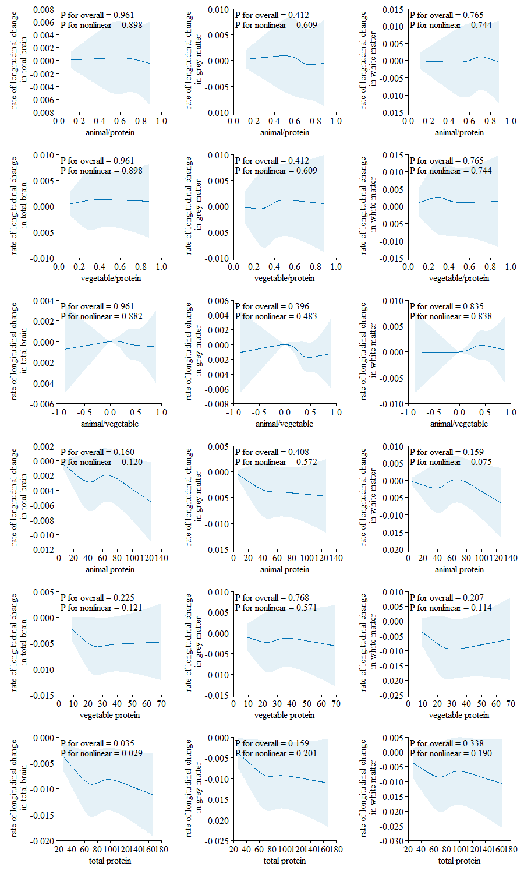
Note: The model was adjusted for age, sex, ethnicity, Townsend deprivation index, education level, physical activity, smoking, body weight status, total energy intake, baseline cancer, CVDs, hypertension, and diabetes.
Supplemental Figure2 Non-linear associations of dietary protein with the longitudinal change rate of white matter hyperintensities Using a Restricted Cubic Spline Regression Model (N= 2679)

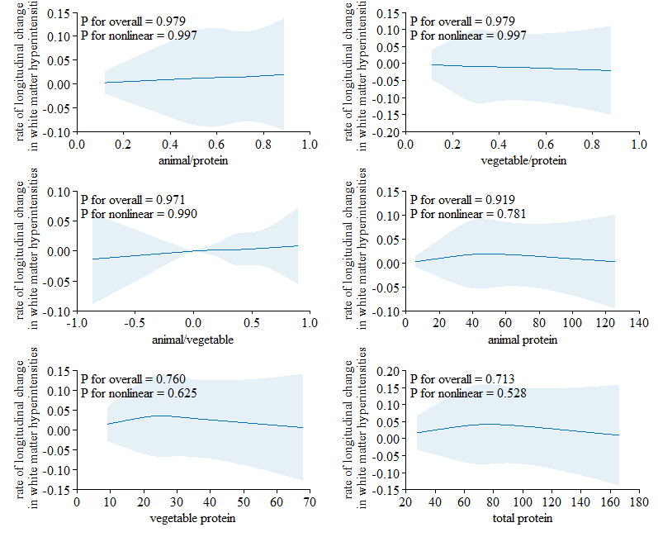
Note: The model was adjusted for age, sex, ethnicity, Townsend deprivation index, education level, physical activity, smoking, body weight status, total energy intake, baseline cancer, CVDs, hypertension, and diabetes.

Supplemental Table 5 Association between dietary protein sources with the longitudinal change rate of hippocampus volume (N=2723)
 |  | total |  |  | hippocampus(left) |  |  | hippocampus(right)
 |  | β | SE | P | β | SE | P | β | SE | P
Red meat | 0 | reference |  |  | reference |  |  | reference
 | lower intake | -0.001289 | 0.001885 | 0.4944 | -0.001584 | 0.002794 | 0.5708 | -0.001028 | 0.002504 | 0.681
 | higher intake | -0.003206 | 0.002171 | 0.1398 | -0.004333 | 0.003217 | 0.1781 | -0.003177 | 0.002883 | 0.271
processed meat | 0 | reference |  |  | reference |  |  | reference
 | lower intake | -0.001934 | 0.001985 | 0.3298 | -0.002031 | 0.00294 | 0.4898 | -0.002854 | 0.002636 | 0.279
 | higher intake | 0.001909 | 0.002023 | 0.3452 | 0.004362 | 0.002997 | 0.1456 | 0.000308 | 0.002686 | 0.909
poultry | 0 | reference |  |  | reference |  |  | reference
 | lower intake | -0.001441 | 0.001834 | 0.4322 | 0.0008925 | 0.002718 | 0.7427 | -0.003271 | 0.002435 | 0.179
 | higher intake | -0.001641 | 0.002389 | 0.4922 | -0.003167 | 0.00354 | 0.371 | -0.00224 | 0.003171 | 0.48
eggs | 0 | reference |  |  | reference |  |  | reference
 | lower intake | 0.002186 | 0.002069 | 0.2907 | -0.00005471 | 0.003068 | 0.9858 | 0.003451 | 0.002745 | 0.2088
 | higher intake | -0.002897 | 0.002182 | 0.1845 | 0.0002213 | 0.003236 | 0.9455 | -0.005598 | 0.002896 | 0.0534
cheese | 0 | reference |  |  | reference |  |  | reference
 | lower intake | -0.003776 | 0.002095 | 0.0716 | -0.007097 | 0.003104 | 0.0223 | -0.00152 | 0.002784 | 0.585
 | higher intake | -0.002528 | 0.002121 | 0.2334 | -0.004368 | 0.003142 | 0.1646 | -0.001013 | 0.002818 | 0.719
nuts | 0 | reference |  |  | reference |  |  | reference
 | lower intake | -0.004524 | 0.002004 | 0.0241 | -0.005238 | 0.00297 | 0.0778 | -0.004435 | 0.002663 | 0.096
 | higher intake | 0.0009412 | 0.002097 | 0.6536 | 0.004306 | 0.003107 | 0.166 | -0.002172 | 0.002787 | 0.436
yogurt | 0 | reference |  |  | reference |  |  | reference
 | lower intake | -0.0008537 | 0.00202 | 0.6727 | 0.0006831 | 0.002994 | 0.8195 | -0.002399 | 0.002682 | 0.371
 | higher intake | -0.0006205 | 0.002032 | 0.7601 | -0.00179 | 0.003011 | 0.5521 | -0.0002294 | 0.002698 | 0.932
whole grains | 0 | reference |  |  | reference |  |  | reference
 | lower intake | 0.001092 | 0.002405 | 0.6497 | 0.001267 | 0.003562 | 0.722 | 0.001545 | 0.003194 | 0.628
 | higher intake | -0.001324 | 0.002444 | 0.5881 | -0.003501 | 0.003621 | 0.3336 | 0.000328 | 0.003246 | 0.92
legumes | 0 | reference |  |  | reference |  |  | reference
 | lower intake | -0.0001805 | 0.001972 | 0.9271 | -3.061E-06 | 0.002923 | 0.9992 | -0.001017 | 0.002619 | 0.698
 | higher intake | -0.0005184 | 0.001974 | 0.7929 | -0.0006546 | 0.002925 | 0.8229 | -0.0007969 | 0.002621 | 0.761
milk | 0 | reference |  |  | reference |  |  | reference
 | lower intake | -0.0004236 | 0.003044 | 0.8893 | 0.003624 | 0.00451 | 0.4218 | -0.003652 | 0.004042 | 0.366
 | higher intake | -0.001149 | 0.003077 | 0.7089 | 0.001162 | 0.004559 | 0.7989 | -0.002848 | 0.004085 | 0.486
sea food | 0 | reference |  |  | reference |  |  | reference
 | lower intake | -0.00233 | 0.001966 | 0.2361 | -0.0004649 | 0.002916 | 0.8733 | -0.00468 | 0.002611 | 0.0732
 | higher intake | -0.004514 | 0.002095 | 0.0313 | -0.003269 | 0.003107 | 0.2929 | -0.005527 | 0.002782 | 0.047

 | hippocampus(left) |  |  | hippocampus(right) |  |  | hippocampus(total)
 | β | SE | P | β | SE | P | β | SE | P
total protein
model1 | 7.47E-05 | 7.934E-05 | 0.346751 | -7.54E-05 | 6.83E-05 | 0.2695 | 1.47E-05 | 5.15E-05 | 0.77564
model2 | -6.86E-05 | 1.173E-04 | 0.559017 | -8.441E-05 | 1.01E-04 | 0.40405 | -5.51E-05 | 7.61E-05 | 0.4697
model3 | -6.55E-05 | 1.176E-04 | 0.57736 | -8.303E-05 | 1.01E-04 | 0.41268 | -5.33E-05 | 7.63E-05 | 0.4852
animal/protein
model1 | -0.0267957 | 1.719E-02 | 0.119353 | -2.697E-02 | 0.014795 | 0.0685 | -2.33E-02 | 1.13E-02 | 0.0399
model2 | -2.625E-02 | 1.744E-02 | 0.13253 | -2.628E-02 | 1.50E-02 | 0.080717 | -2.37E-02 | 1.13E-02 | 0.036
model3 | -2.58E-02 | 1.749E-02 | 0.14023 | -2.568E-02 | 1.51E-02 | 0.088624 | -0.0246523 | 0.0111477 | 0.0272
vegetable/protein
model1 | 2.680E-02 | 1.719E-02 | 0.119348 | 0.0269737 | 0.014795 | 0.0685 | 0.0246526 | 0.0111477 | 0.0272
model2 | 2.625E-02 | 1.744E-02 | 0.132524 | 2.63E-02 | 1.50E-02 | 0.080714 | 2.37E-02 | 1.13E-02 | 0.036
model3 | 2.581E-02 | 1.749E-02 | 0.14023 | 2.57E-02 | 1.51E-02 | 0.08862 | 2.33E-02 | 1.13E-02 | 0.0399
vegetable protein
model1 | 5.298E-04 | 1.951E-04 | 0.006698 | 7.88E-05 | 1.68E-04 | 0.6398 | 0.0002987 | 0.0001267 | 0.0185
model2 | 5.399E-04 | 2.636E-04 | 0.040759 | 2.65E-04 | 2.28E-04 | 0.244234 | 3.66E-04 | 1.71E-04 | 0.0327
model3 | 5.381E-04 | 2.642E-04 | 0.04185 | 2.59E-04 | 2.28E-04 | 0.256594 | 3.63E-04 | 1.71E-04 | 0.0345
animal protein
model1 | -1.657E-05 | 9.127E-05 | 0.856007 | -0.0001169 | 7.85E-05 | 0.1367 | -4.56E-05 | 5.92E-05 | 0.44134
model2 | -1.507E-04 | 1.087E-04 | 0.166061 | -1.18E-04 | 9.38E-05 | 0.209816 | -1.10E-04 | 7.06E-05 | 0.121
model3 | -1.479E-04 | 1.090E-04 | 0.17519 | -1.15E-04 | 9.40E-05 | 0.219522 | -1.08E-04 | 7.07E-05 | 0.1287
animal/vegetable
model1 | -1.446E-02 | 8.428E-03 | 0.08638 | -0.0133562 | 0.007254 | 0.0658 | -1.287E-02 | 5.465E-03 | 0.01869
model2 | -1.390E-02 | 8.552E-03 | 0.104283 | -1.30E-02 | 7.37E-03 | 0.077937 | -1.226E-02 | 5.546E-03 | 0.0273
model3 | -1.369E-02 | 8.575E-03 | 0.11066 | -1.28E-02 | 7.39E-03 | 0.084221 | -1.208E-02 | 5.560E-03 | 0.03
Supplemental Table 6 Association between dietary protein intake with the longitudinal change rate of hippocampus volume in male(N=1337)

Supplemental Table 7 Association between dietary protein intake with the longitudinal change rate of hippocampus volume in female(N=1386)
 | hippocampus(left) |  |  | hippocampus(right) |  |  | hippocampus(total)
 | β | SE | P | β | SE | P | β | SE | P
total protein
model1 | -1.19E-04 | 7.105E-05 | 0.095355 | 4.25E-05 | 6.75E-05 | 0.52914 | -3.44E-05 | 5.08E-05 | 0.4987
model2 | -1.37E-04 | 9.695E-05 | 0.159057 | -4.44E-05 | 9.22E-05 | 0.62983 | -9.03E-05 | 6.93E-05 | 0.1924
model3 | -1.42E-04 | 9.716E-05 | 0.14566 | -4.607E-05 | 9.21E-05 | 0.61682 | -9.22E-05 | 6.94E-05 | 0.184
animal/protein
model1 | -2.467E-02 | 1.160E-02 | 0.033573 | -0.0212083 | 0.011016 | 0.0544 | -0.0229959 | 0.0082765 | 0.00553
model2 | -2.433E-02 | 1.178E-02 | 0.039042 | -2.35E-02 | 1.12E-02 | 0.03598 | -2.41E-02 | 8.40E-03 | 0.00422
model3 | -2.426E-02 | 1.180E-02 | 0.03996 | -2.33E-02 | 1.12E-02 | 0.0373 | -2.40E-02 | 8.42E-03 | 0.00442
vegetable/protein
model1 | 2.467E-02 | 1.160E-02 | 0.033574 | 0.0212083 | 0.011016 | 0.0544 | 0.0229958 | 0.0082765 | 0.005535
model2 | 2.433E-02 | 1.178E-02 | 0.039043 | 2.35E-02 | 1.12E-02 | 0.03598 | 2.41E-02 | 8.40E-03 | 0.00422
model3 | 2.426E-02 | 1.180E-02 | 0.03996 | 2.33E-02 | 1.12E-02 | 0.0373 | 2.40E-02 | 8.42E-03 | 0.00442
vegetable protein
model1 | 0.0001899 | 1.126E-04 | 0.0918 | 9.58E-05 | 1.58E-04 | 0.543494 | 0.0002648 | 0.0001496 | 0.07693
model2 | 2.67E-04 | 1.435E-04 | 0.0632 | 2.56E-04 | 2.01E-04 | 0.20283 | 2.60E-04 | 1.91E-04 | 0.17373
model3 | 2.64E-04 | 1.438E-04 | 0.0671 | 2.51E-04 | 2.02E-04 | 0.21351 | 2.58E-04 | 1.91E-04 | 0.17657
animal protein
model1 | -1.63E-04 | 7.725E-05 | 0.034569 | -1.34E-05 | 7.35E-05 | 0.85516 | -8.64E-05 | 5.52E-05 | 0.118
model2 | -1.57E-04 | 8.677E-05 | 0.070069 | -8.54E-05 | 8.24E-05 | 0.3004 | -1.22E-04 | 6.20E-05 | 0.0488
model3 | -1.60E-04 | 8.692E-05 | 0.06581 | -8.37E-05 | 8.25E-05 | 0.31025 | -1.23E-04 | 6.21E-05 | 0.0478
animal/vegetable
model1 | -1.186E-04 | 7.105E-05 | 0.095355 | 4.25E-05 | 6.75E-05 | 0.52914 | -3.437E-05 | 5.080E-05 | 0.4987
model2 | -1.366E-04 | 9.695E-05 | 0.159057 | -4.61E-05 | 9.21E-05 | 0.61682 | -9.034E-05 | 6.927E-05 | 0.1924
model3 | -1.415E-04 | 9.716E-05 | 0.14566 | -4.44E-05 | 9.22E-05 | 0.62983 | -9.217E-05 | 6.941E-05 | 0.184

Supplemental Table 8 Association between dietary protein intake with the longitudinal change rate of hippocampus volume adjusted for AD-PRS(N=1386)
 | hippocampus(left) |  |  | hippocampus(total) |  |  | hippocampus(right)
 | β | SE | P | β | SE | P | β | SE | P
total protein | -9.31E-05 | 7.71E-05 | 0.2273 | -6.59E-05 | 5.19E-05 | 0.2046 | -6.21E-05 | 6.88E-05 | 0.36724
animal/protein | -2.53E-02 | 1.04E-02 | 0.0149 | -2.36E-02 | 6.97E-03 | 0.000724 | -2.40E-02 | 9.25E-03 | 0.00954
vegetable/protein | 2.36E-02 | 6.97E-03 | 0.000724 | 2.53E-02 | 1.04E-02 | 0.0149 | 2.40E-02 | 9.25E-03 | 0.00954
vegetable protein | 3.06E-04 | 1.12E-04 | 0.00644 | 3.91E-04 | 1.67E-04 | 0.0195 | 2.50E-04 | 1.49E-04 | 0.09411
animal protein | -1.10E-04 | 4.75E-05 | 0.0209 | -1.48E-04 | 7.05E-05 | 0.0365 | -9.64E-05 | 6.30E-05 | 0.12566
animal/vegetable | -1.13E-02 | 3.44E-03 | 0.000976 | -1.24E-02 | 5.11E-03 | 0.015 | -1.13E-02 | 4.56E-03 | 0.01356
The analyses were based on Model 3 in the main analysis (adjusted for age, sex, ethnicity, Townsend deprivation index, education level, physical activity, smoking, body weight status, total energy intake, baseline cancer, CVDs, hypertension, and diabetes) with additional adjustment for polygenic risk scores of Alzheimer’s diseases (AD-PRS).

Supplemental Table 9 Association between dietary protein intake with the longitudinal change rate of hippocampus volume among participants with at least two waves of dietary data (N=2009)
 | hippocampus(left) |  |  | hippocampus(total) |  |  | hippocampus(right)
 | β | SE | P | β | SE | P | β | SE | P
total protein | -1.88E-04 | 1.03E-04 | 0.06782 | -1.18E-04 | 6.92E-05 | 0.0894 | -8.67E-05 | 9.15E-05 | 0.3435
animal/protein | -3.00E-02 | 1.29E-02 | 0.02019 | -2.80E-02 | 8.69E-03 | 0.00131 | -2.91E-02 | 1.15E-02 | 0.0114
vegetable/protein | 3.00E-02 | 1.29E-02 | 0.02019 | 2.80E-02 | 8.69E-03 | 0.00131 | 2.91E-02 | 1.15E-02 | 0.0114
vegetable protein | 4.51E-04 | 2.09E-04 | 0.03126 | 3.81E-04 | 1.41E-04 | 0.00693 | 3.57E-04 | 1.87E-04 | 0.055652
animal protein | -2.37E-04 | 9.17E-05 | 0.00996 | -1.67E-04 | 6.18E-05 | 0.00688 | -1.38E-04 | 8.18E-05 | 0.0919
animal/vegetable | -1.42E-02 | 6.38E-03 | 0.02575 | -1.32E-02 | 4.30E-03 | 0.00224 | -1.37E-02 | 5.68E-03 | 0.0162
The model was adjusted for age, sex, ethnicity, Townsend deprivation index, education level, physical activity, smoking, body weight status, total energy intake, baseline cancer, CVDs, hypertension, and diabetes among participants with at least two waves of dietary data.

