Research Title: Determinants and Their Maturity on the effective procurement process in a manufacturing organization: A Practitioner’s Perspective.
TO:

Name:
Designation:
Organization:
Survey Q ID:

Baseline Q ID:
Area:
Q Set: A

Dear Sir/Madam,

I have been doing a research titled ‘Determinants and Their Maturity on the effective procurement process in a manufacturing organization: A Practitioner’s Perspective’. This research is a part of the requirement of the Ph.D. in Logistics and Supply Chain Management program in Hamad Bin Khalifa University.
The aim of the study is to identify/explore the determinants and constraints that influence effective procurement management in manufacturing projects. Your thoughtful opinion will be valuable to get a conclusion.
The information you provide will be used absolutely for academic purpose. Participation in this study is voluntary, and, you are free to withdraw at any stage. Furthermore, all information you provide is confidential, and, in no way will personally identifiable information be made available without your knowledge and consent.
If you have any questions regarding this research, please contact by the under-mentioned phone number.
Phone: +974 33555627
Email: arfatmarine27@gmail.com
Thank you for your participation.
Mohammed Arfat Raihan Chowdhury

Background Information
- Name:
[Grab your reader’s attention with a great quote from the document or use this space to emphasize a key point. To place this text box anywhere on the page, just drag it.]

- Designation:
[Grab your reader’s attention with a great quote from the document or use this space to emphasize a key point. To place this text box anywhere on the page, just drag it.]

- Name of organization:
[Grab your reader’s attention with a great quote from the document or use this space to emphasize a key point. To place this text box anywhere on the page, just drag it.]

- Total years of experience in retail:
- 1-2 Years
- 2-3 Years
- 3-4 Years
- 4+ Years

- Total training period related to quality control:
- 7-21 days
- 1-3 Months
- 3-6 Months
- 6+ Months

- Technological skills:
- Fair
- Good
- Very Good

- How useful is the current fruit merchandising system in terms of service deliver?

- How useful is the curre

Procurement process areas
Identification of needs
Plan and strategy
Acquisition plan
Procurement method selection
Requisition Assessment
Bid Documents Criteria Evaluation
Trade Tender
Awarding contract
Organization
Contract Administration

2nd Part:

CMMM:
The Contract Management Maturity Model (CMMM) is a visual tool designed to assist the procurement organizations in assessing the steps they need to take when procuring supplies, services, or integrated solutions. It consists of five levels of maturity applied to six key process areas and related practice activities of the contract management process. The five levels of maturity range from an “ad hoc” level (Level 1) to a fully “optimized” level (Level 5).
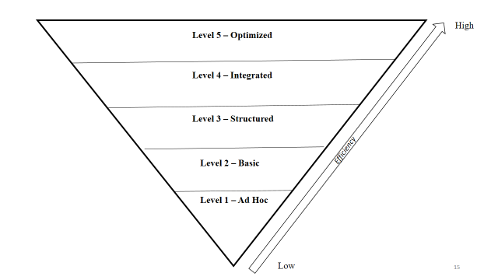

- How matured is your first selected key process area in terms of the adaptability of the blockchain technology?

- Level- 1
- Level- 2
- Level- 3
- Level- 4
- Level- 5

- How matured is your second selected key process area in terms of the adaptability of the blockchain technology?

- Level- 1
- Level- 2
- Level- 3
- Level- 4
- Level- 5
- How matured is your third selected key process area in terms of the adaptability of the blockchain technology?

- Level- 1
- Level- 2
- Level- 3
- Level- 4
- Level- 5
- How matured is your fourth selected key process area in terms of the adaptability of the blockchain technology?

- Level- 1
- Level- 2
- Level- 3
- Level- 4
- Level- 5
- How matured is your fifth selected key process area in terms of the adaptability of the blockchain technology?

- Level- 1
- Level- 2
- Level- 3
- Level- 4
- Level- 5
- How matured is your sixth selected key process area in terms of the adaptability of the blockchain technology?

- Level- 1
- Level- 2
- Level- 3
- Level- 4
- Level- 5

