Supplementary data
Supp Fig 1.
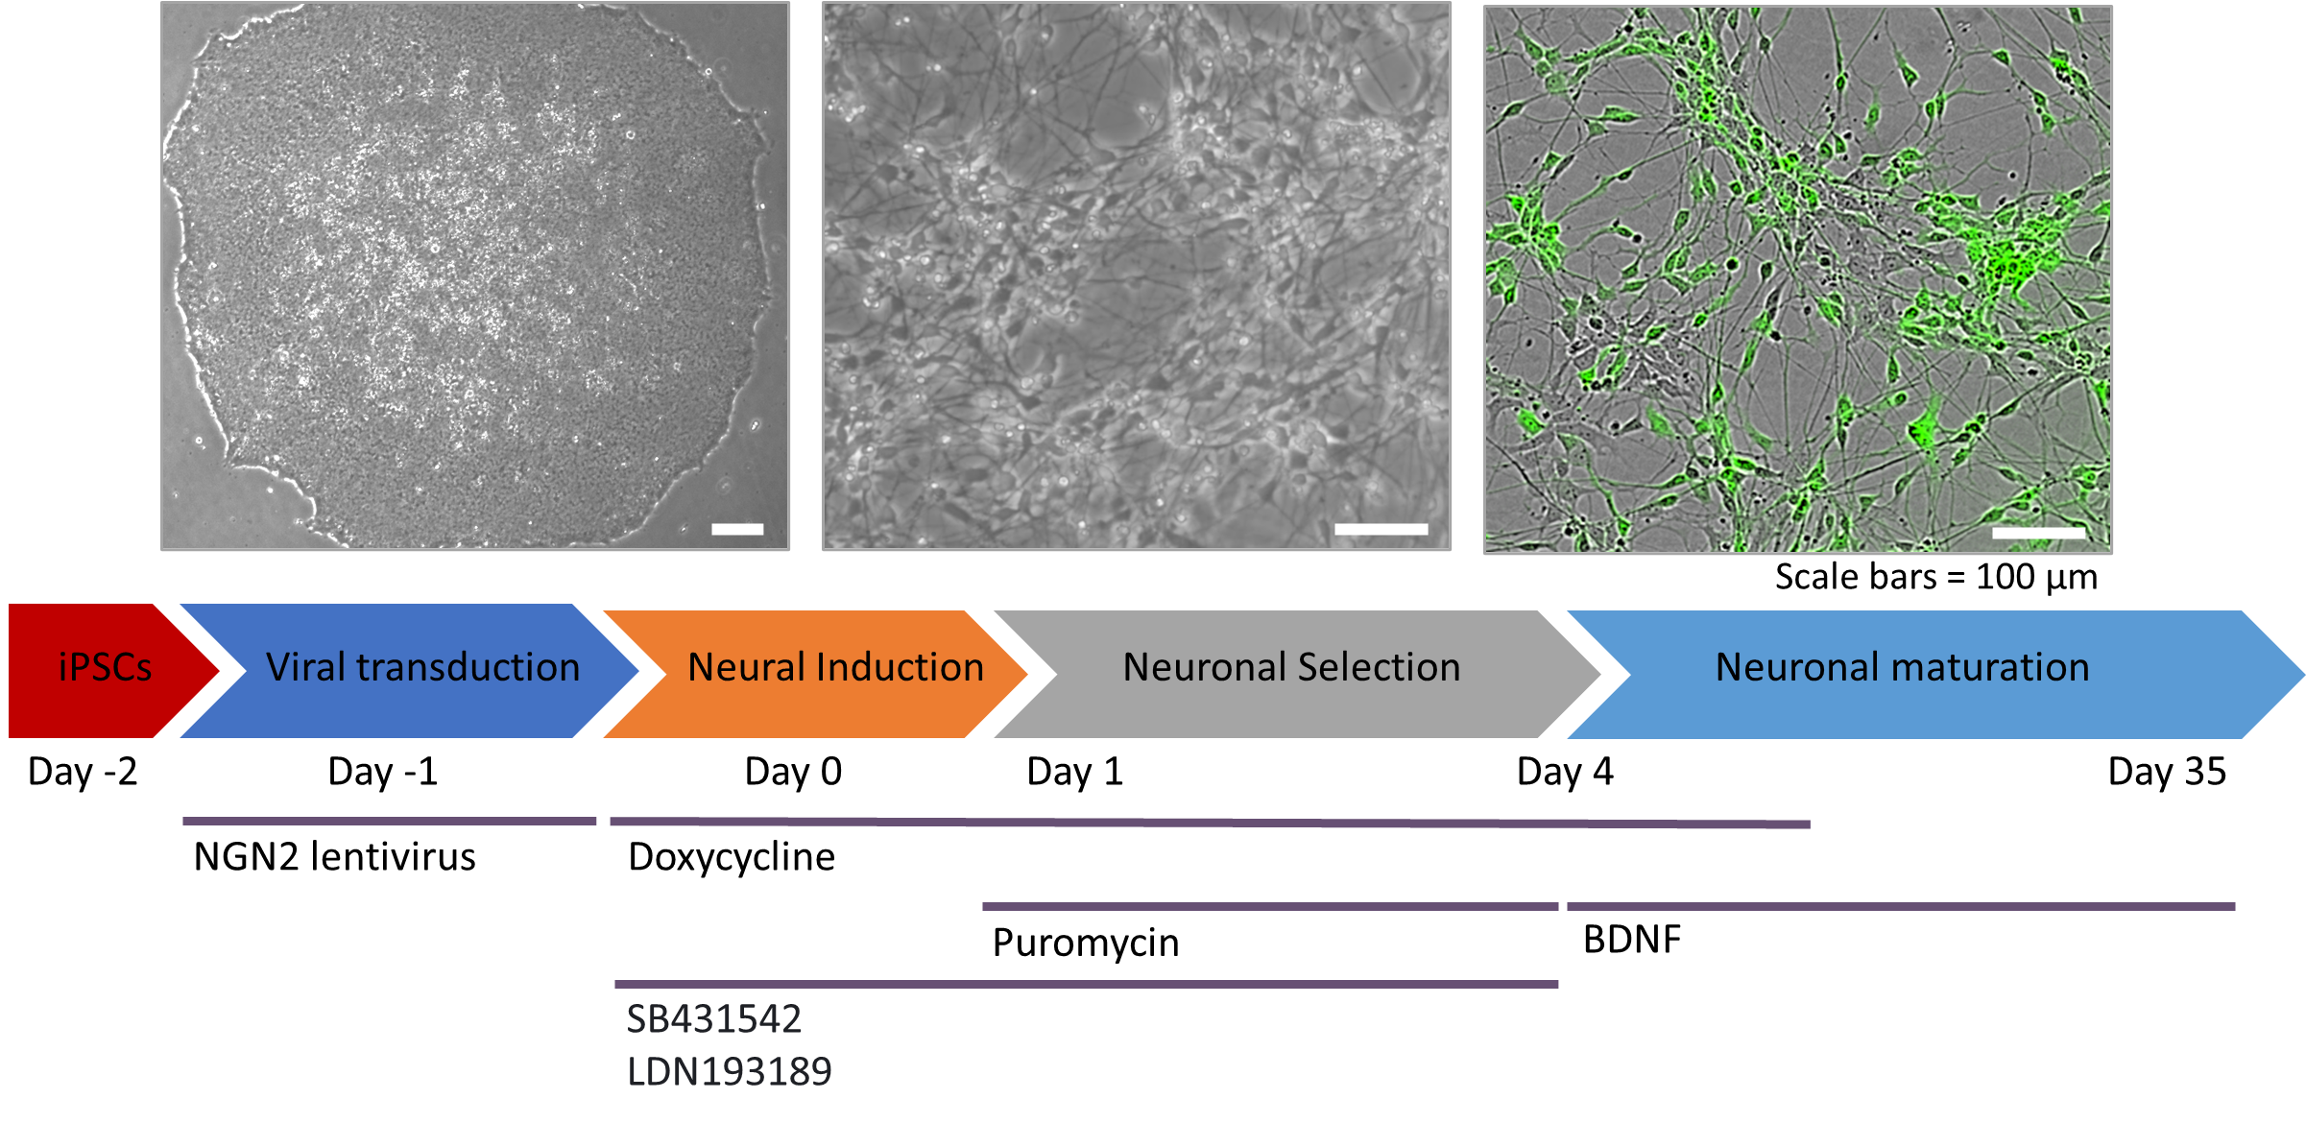

Supp. Fig. 1. Representative images and timeline of differentiation. Images show pluripotent stem cell colony and neurons after 35days of differentiation. Expression of GFP confirms expression of the lentiviral Ngn2 construct. Protocol as per Nehme et al., 2018.

