Appendix A

Kolmogorov-Smirnov test of normality
1.1 All sound factors have p< 0.001 and thus significantly deviate from a normal distribution.
Tests of Normality
 | Kolmogorov-Smirnovª
 | Statistic | df | Sig.
A Weighted (Mean dB) | .125 | 282764 | <.001
ACI | .204 | 282763 | <.001
TFSDBirds | .198 | 282763 | <.001
BIO | .104 | 282763 | <.001
NP | .052 | 282763 | <.001
NDSI | .060 | 282763 | <.001
M | .278 | 282763 | <.001
Ht | .210 | 282763 | <.001
- Lilliefors Significance Correction

Normal Q-Q plots of sound factors illustrate the K-S findings

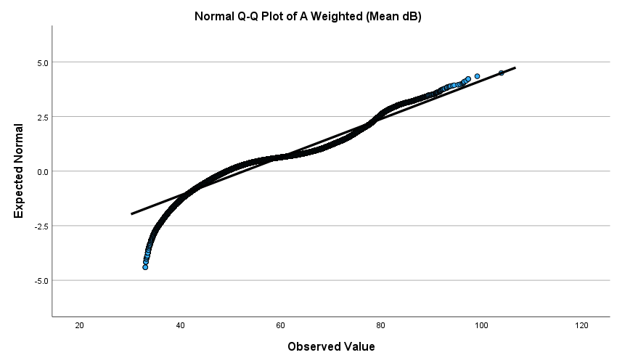

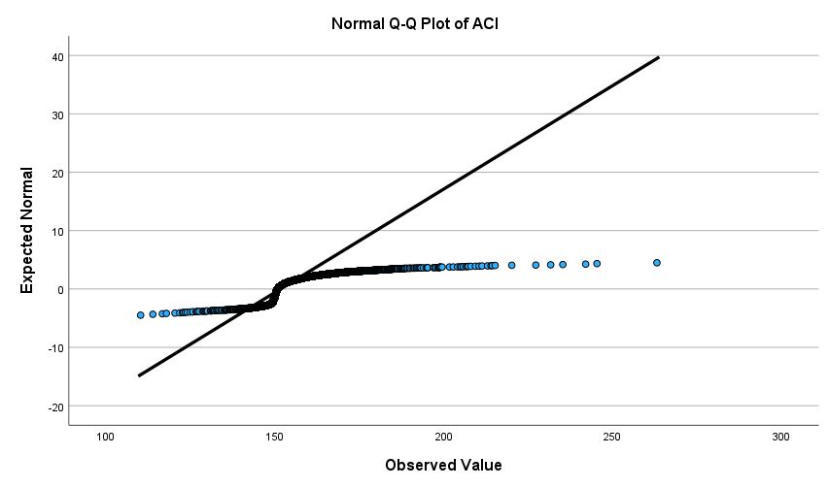

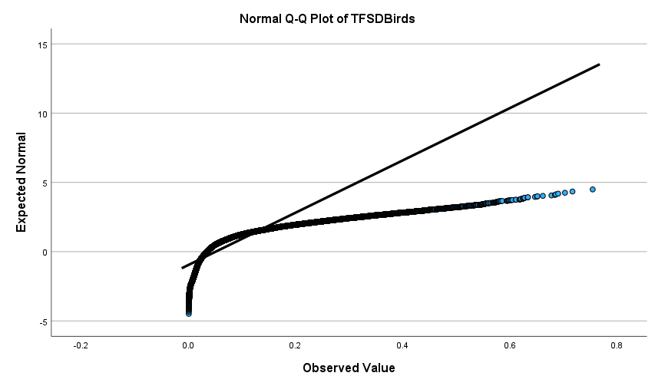
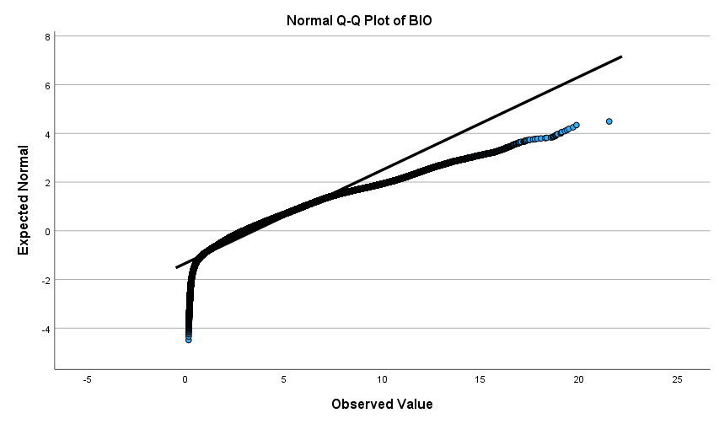
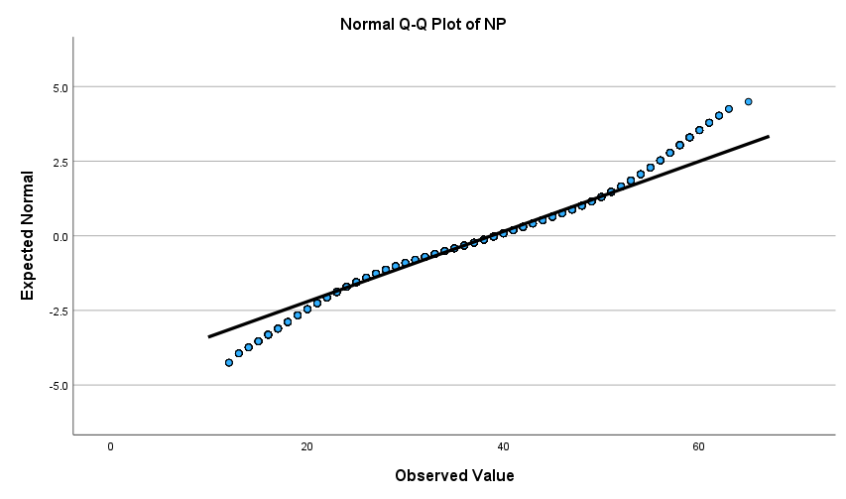
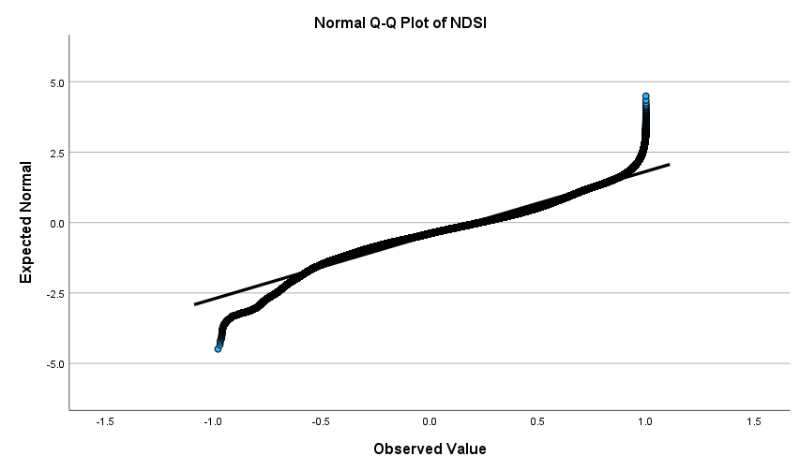
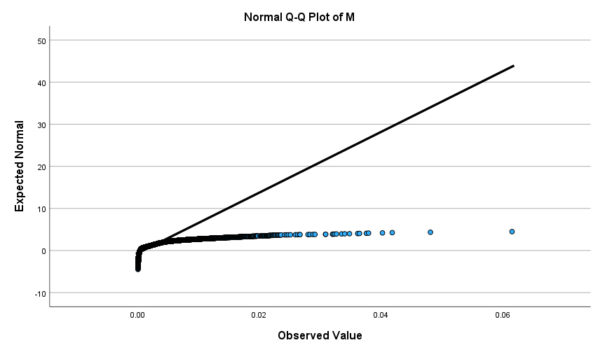
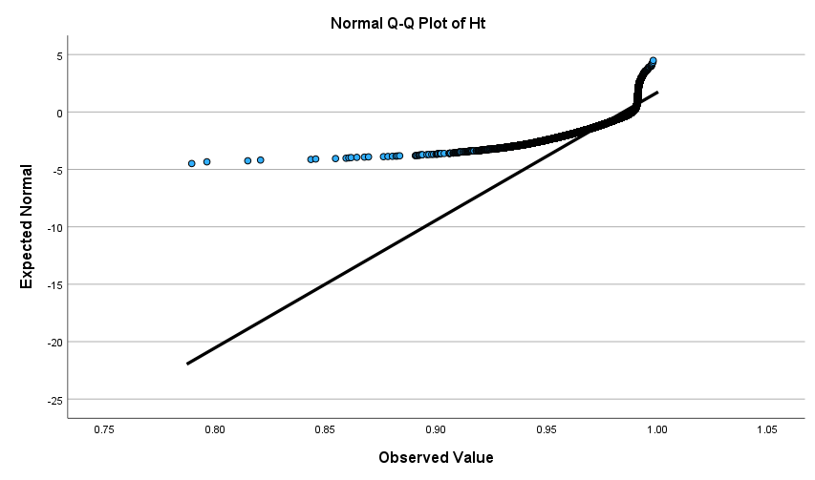

Spearman’s Correlation of BPI and BIO in only quiet areas
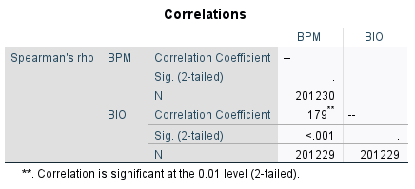

Spearman’s Correlation of BPI and BIO in only noise hot spots

