Appendix A. Supplementary material
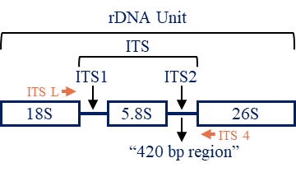
Supplemental Figure 1. Banana ribosomal DNA unit structure. The ribosomal DNA unit (rDNA) of banana containing 18S, ITS1, 5.8S, ITS2, and 26S. Internal transcribed spacers (ITS), including ITS1, 5.8S, and ITS2, was cloned using one pair of primers (ITS L and ITS 4, the positions are indicated) in this study. The “420 bp region” is located between 5.8S and 26S.

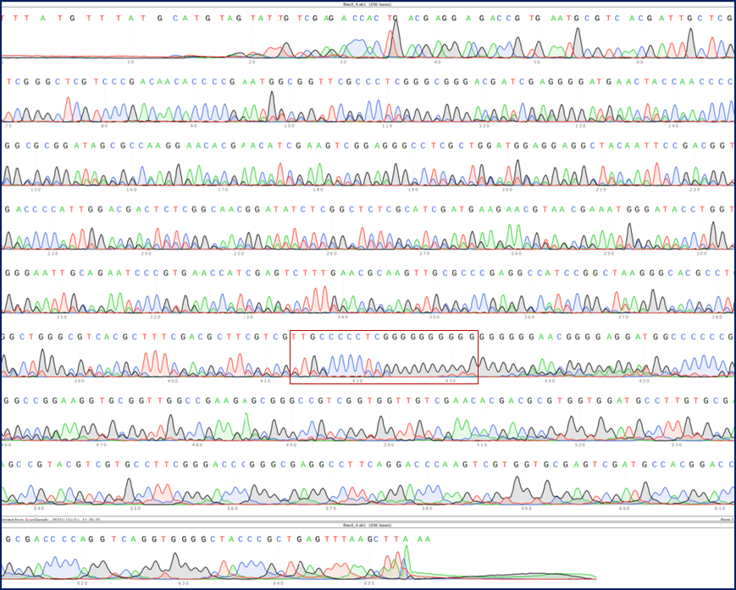
Supplemental Figure 2. Internal transcribed spacers (ITS) sequencing peak map of one clone of the Cavendish banana variety Brazil. The ITS of another biological repetition of ‘Brazil’ was amplified by PCR and sequenced through Sanger sequencing. The ab1 file was opened in Snap Gene software and the whole sequencing peak map is shown. The position of the “420 bp region” is indicated. Green, red, blue, and black peaks represent “A”, “T”, “C”, and “G”, respectively.

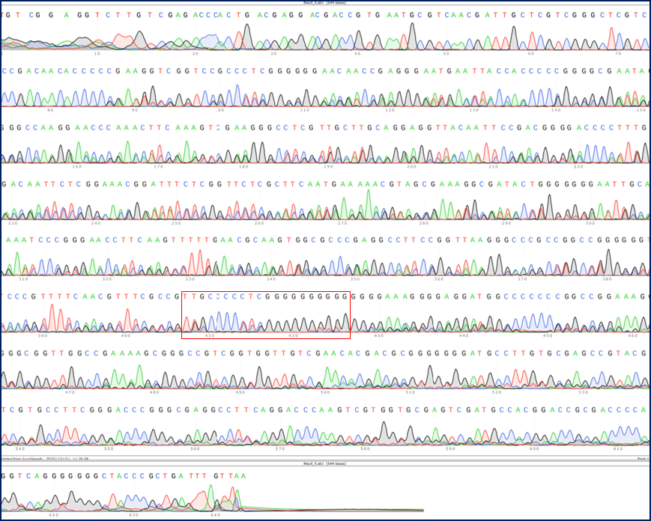
Supplemental Figure 3. Internal transcribed spacers (ITS) sequencing peak map of another clone of the Cavendish banana variety Brazil. ITS of another ‘Brazil’ were amplified by PCR and sequenced through Sanger sequencing. The ab1 file was opened in Snap Gene software and the whole sequencing peak map is shown. The position of the “420 bp region” is indicated. Green, red, blue, and black peaks represent “A”, “T”, “C”, and “G”, respectively.

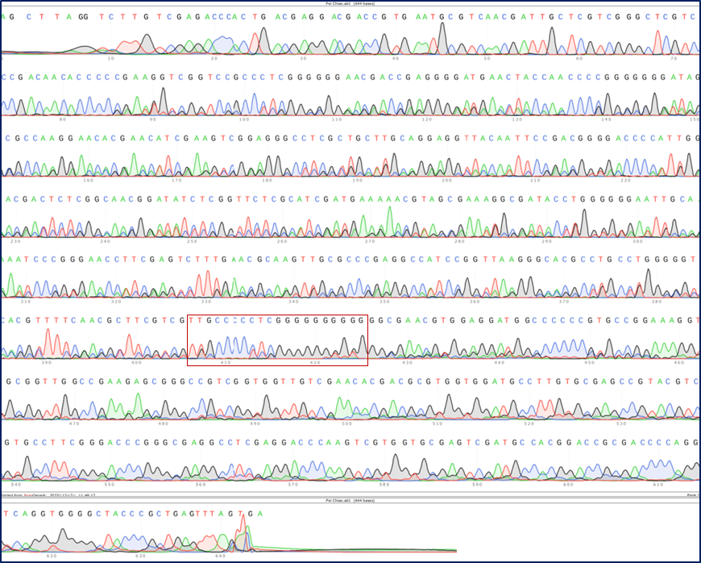
Supplemental Figure 4. Internal transcribed spacers (ITS) sequencing peak map of the Cavendish banana variety Pei Tiao. ITS of ‘Pei Chiao’ were amplified by PCR and sequenced through Sanger sequencing. The ab1 file was opened in Snap Gene software and the whole sequencing peak map is shown. The position of the “420 bp region” is indicated. Green, red, blue, and black peaks represent “A”, “T”, “C”, and “G”, respectively.
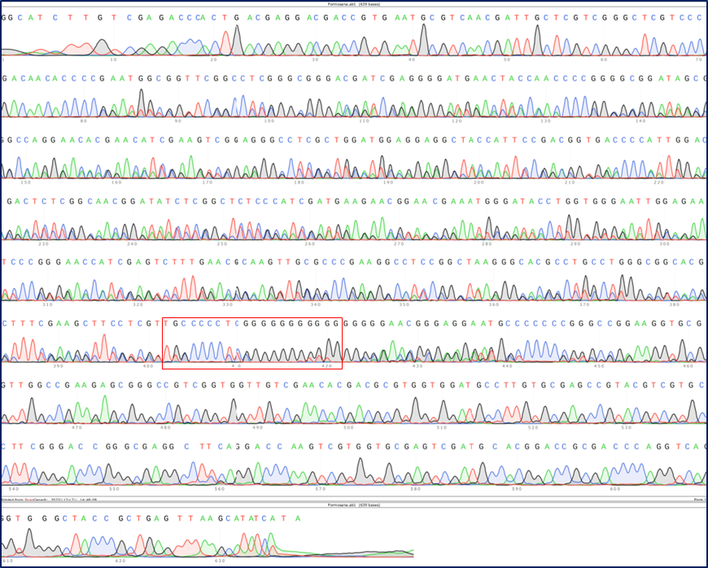
Supplemental Figure 5. Internal transcribed spacers (ITS) sequencing peak map of the Cavendish banana variety Formosana. ITS of ‘Formosana’ were amplified by PCR and sequenced through Sanger sequencing. The ab1 file was opened in Snap Gene software and the whole sequencing peak map is shown. The position of the “420 bp region” is indicated. Green, red, blue, and black peaks represent “A”, “T”, “C”, and “G”, respectively.

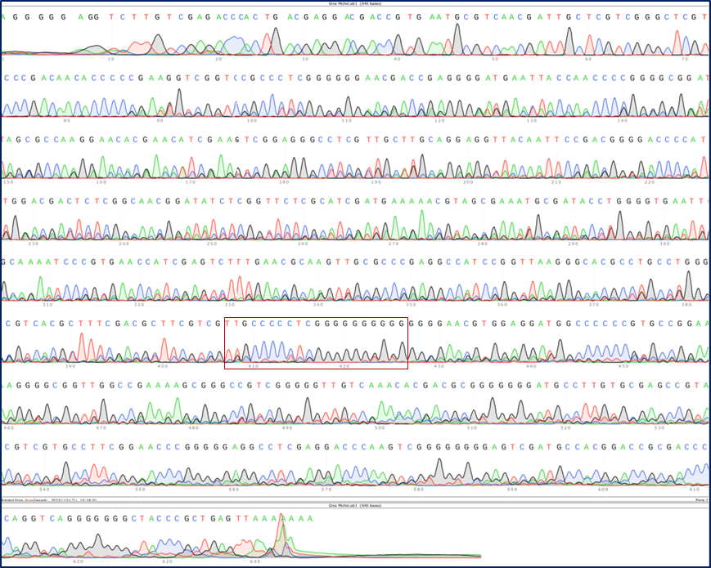
Supplemental Figure 6. Internal transcribed spacers (ITS) sequencing peak map of the Gros Michel banana variety Gros Michel. ITS of ‘Gros Michel’ were amplified by PCR and sequenced through Sanger sequencing. The ab1 file was opened in Snap Gene software and the whole sequencing peak map is shown. The position of the “420 bp region” is indicated. Green, red, blue, and black peaks represent “A”, “T”, “C”, and “G”, respectively.
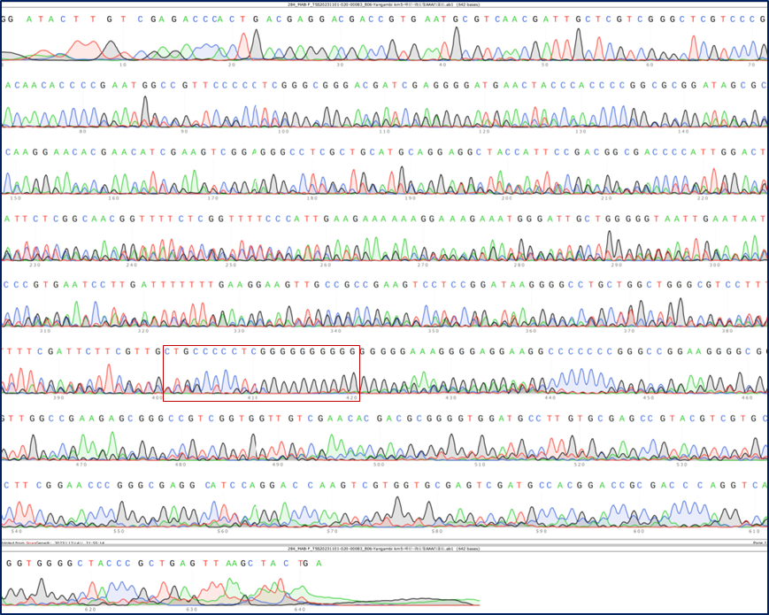
Supplemental Figure 7. Internal transcribed spacers (ITS) sequencing peak map of the Ibota Bota banana variety Yangambi KM5. ITS of ‘Yangambi KM5’ were amplified by PCR and sequenced through Sanger sequencing. The ab1 file was opened in Snap Gene software and the whole sequencing peak map is shown. The position of the “420 bp region” is indicated. Green, red, blue, and black peaks represent “A”, “T”, “C”, and “G”, respectively.

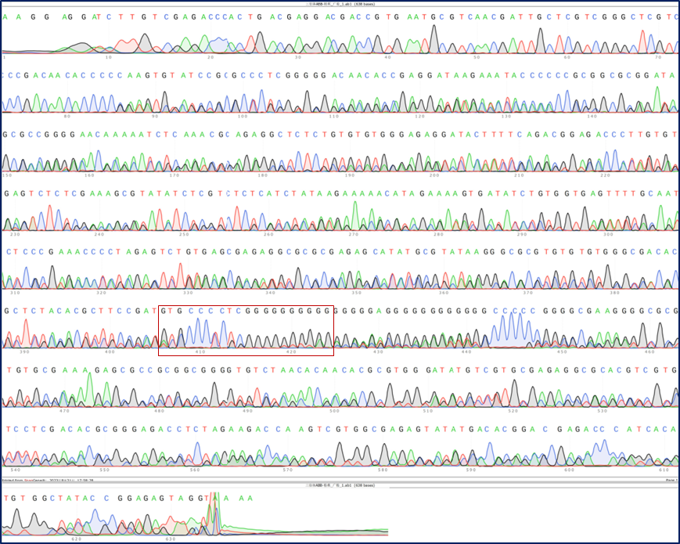
Supplemental Figure 8. Internal transcribed spacers (ITS) sequencing peak map of the Pisang Awak banana variety Guang Fen No.1. ITS of ‘Guang Fen No.1’ were amplified by PCR and sequenced through Sanger sequencing. The ab1 file was opened in Snap Gene software and the whole sequencing peak map is shown. The position of the “420 bp region” is indicated. Green, red, blue, and black peaks represent “A”, “T”, “C”, and “G”, respectively.
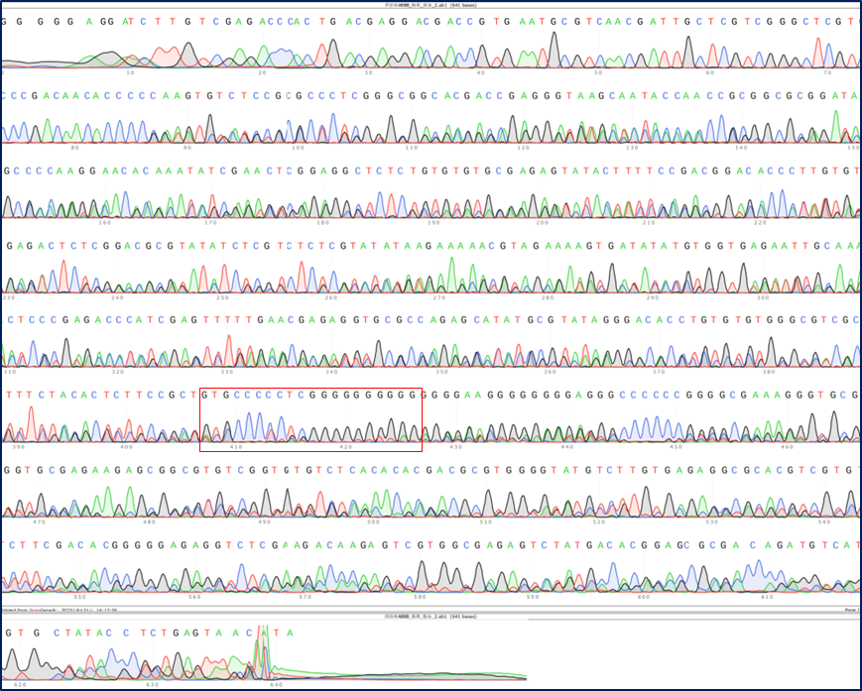
Supplemental Figure 9. Internal transcribed spacers (ITS) sequencing peak map of the hybrid banana variety Fen Za No.1. ITS of ‘Fen Za No.1’ were amplified by PCR and sequenced through Sanger sequencing. The ab1 file was opened in Snap Gene software and the whole sequencing peak map is shown. The position of the “420 bp region” is indicated. Green, red, blue, and black peaks represent “A”, “T”, “C”, and “G”, respectively.

