Supplementary Materials
On the Structural and Molecular Properties of PEO and PEO-PPG Functionalized Chitosan Nanoparticles for Drug Delivery
Rejeena Jha¹, Hyrum Harlow¹, Mourad Benamara², Robert A. Mayanovic¹*
1 Department of Physics, Astronomy, and Materials Science, Missouri State University, Springfield, MO 65804, USA
2 University of Arkansas Nano-Bio Materials Characterization Facility, University of Arkansas, Fayetteville, AR 72701, USA
* Correspondence: robertmayanovic@missouristate.edu
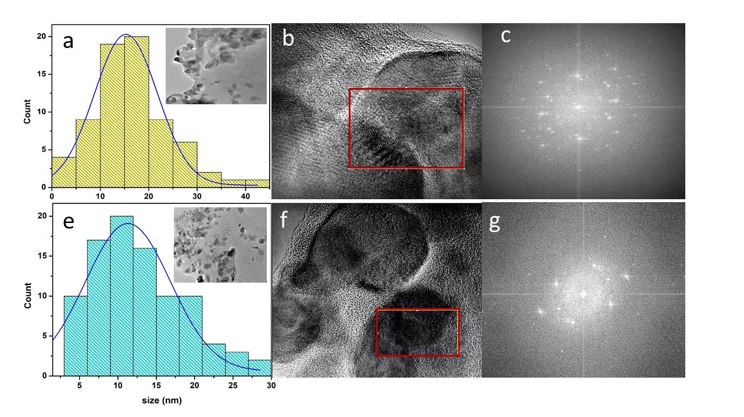

Figure S1. a) Size distribution histogram calculated from TEM data (inset shows a TEM image), b) a HRTEM image and c) a FFT of the region delineated by the rectangle shown in b) of sample CNP-0.5%; d) size distribution histogram and a corresponding a TEM image shown in the inset, e) a HRTEM image and f) a FFT of the region outlined by the rectangle in e) of sample 1% CNP-PEO.
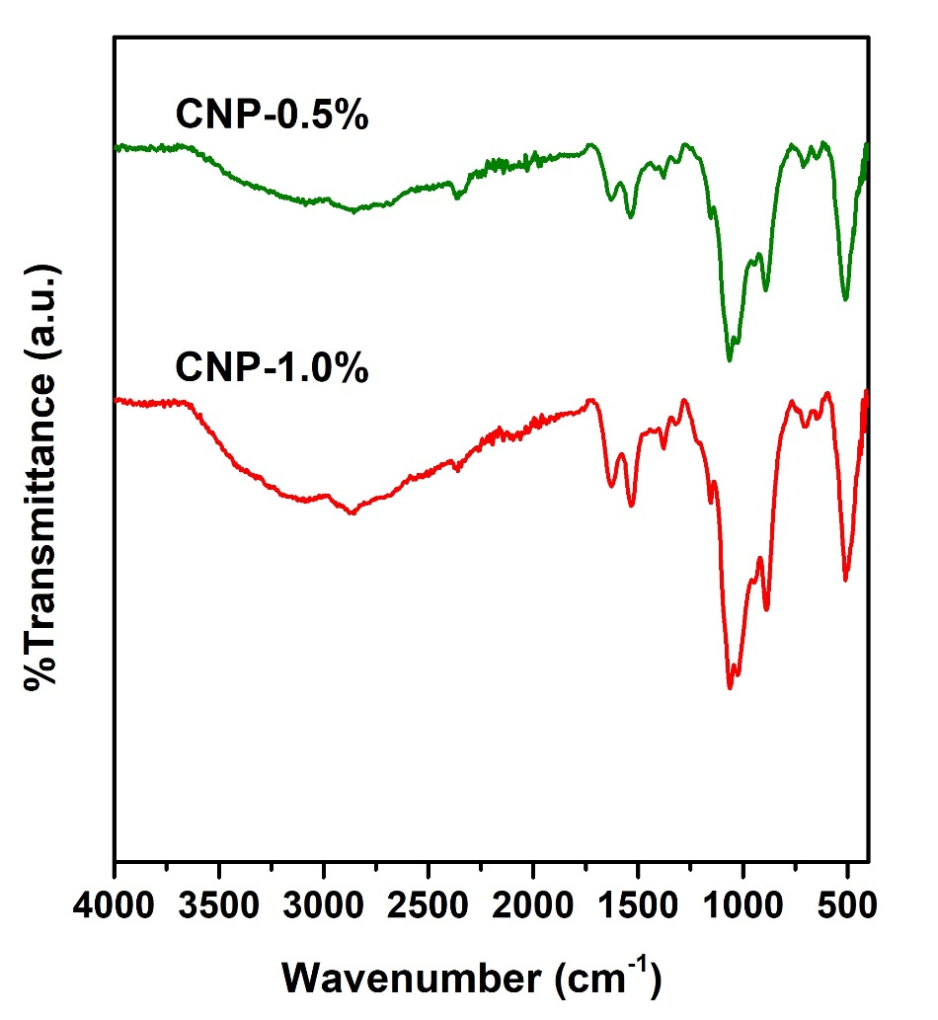

Figure S2. FTIR spectra measured from the CNP-1.0% and CNP-0.5% samples indicating negligible concentration dependence.

