Supplemental data

1. Variants in the database in Pgxtools

Supplemental table 1, Genes and variants for PGx analysis
Gene | Drug(s) | Variants
 |  | cDNA | rs number
COMT | Opioid | c.472G>A | rs4680
CYP2B6 | Efavirenz | c.983T>C | rs28399499
 |  |  | rs34223104
 |  | c.219-237A>G | rs776746
 |  | c.432+2T>C | rs55965422
CYP2C19 | Clopidogrel, Proton Pump Inhibitors (Omeprazole, Lansoprazole, Pantoprazole and Dexlansoprazole), Selective Serotonin Reuptake Inhibitors (Citalopram, Escitalopram and Sertraline), Tricyclic Antidepressants (Tertiary Amines Amitriptyline, Clomipramine, Doxepin, Imipramine and Trimipramine), Voriconazole | c.1A>G | rs28399504
 |  | c.1297C>T | rs56337013
 |  | c.395G>A | rs72552267
 |  | c.819+2T>A | rs72558186
 |  | c.358T>C | rs41291556
 |  | c.431G>A | rs17884712
 |  | c.680C>T | rs6413438
 |  | c.-806C>T | rs12248560
 |  | 332-23A>G in the absence of 681G>A | rs12769205
 |  | c.430C>T | rs1799853
 |  | c.1075A>C | rs1057910
CYP2C9 | Warfarin | c.1076T>C | rs56165452
 |  | c.1080C>G | rs28371686
 |  | c.818delA | rs9332131
 |  | c.449G>A | rs7900194
 |  | c.752A>G | rs2256871
 |  | c.1003C>T | rs28371685
 |  | c.1465C>T | rs9332239
 |  | c.269T>C | rs72558187
 |  | c.374G>A
 |  | c.485C>A | rs72558190
 |  | c.895A>G | rs72558192
 |  | c.1144C>T
 |  | c.1190A>C | rs72558193
 |  | c.353_362del | rs1304490498
 |  | c.389C>G | rs200965026
 |  | c.641A>T
 |  | c.1429G>A | rs781583846
 |  | c.395G>A | rs200183364
 |  | 374G>T + 430C>T
 |  | c.-1639G>A | rs9923231
 |  | c.85G>T | rs104894539
CYP2D6 | Ondansetron and Tropisetron, Selective Serotonin Reuptake Inhibitors (Paroxetine and Fluvoxamine), Opioid (Codeine, Tramadol and Hydrocodone), Atomoxetine, Tricyclic Antidepressants, Tamoxifen | c.775del | rs35742686
 |  | c.506-1G>A | rs3892097
 |  | c.454del | rs5030655
 |  | c.971A>C | rs5030867
 |  | c.505G>T | rs5030865
 |  | c.886C>T | rs16947
 |  | c.841_843del | rs5030656
 |  | c.100C>T | rs1065852
 |  | c.124G>A | rs5030862
 |  | c.137dup | rs774671100
 |  | c.320C>T | rs28371706
 |  | c.805dup | rs72549352
 |  | c.1012G>A | rs59421388
 |  | c.406_408delins  ATC | rs61736512+  rs1058164
 |  | c.1319G>A | rs267608319
 |  | c.320C>T | rs28371706
 |  | c.985+39G>A | rs28371725
 |  | c.1088_1089dup | rs72549346
 |  | c.358T>A | rs1135822
 |  | c.1030C>T | rs72549347
 |  | c.975G>A | rs79292917
 |  | c.785A>G | rs2279343
 |  | c.516G>T | rs3745274
CYP3A5 | Tacrolimus | c.624G>A | rs10264272
 |  | c.1035dup | rs41303343
 |  | c.82C>T | rs55817950
 |  | c.1009G>A | rs28383479
CYP4F2 | Warfarin | c.1457G>C | rs1135840
DPYD | Fluoropyrimidines 5-fluorouracil | c.557A>G | rs115232898
 |  | c.1129-5923C>G | rs75017182
 |  | c.1679T>G | rs55886062
 |  | c.1905+1G>A | rs3918290
 |  | c.2846A>T | rs67376798
 |  | c.295_298delTCAT | rs72549309
 |  | c.703C>T | rs1801266
 |  | c.2657G>A | rs1801267
 |  | c.2983G>T | rs1801268
 |  | c.1003G>T | rs72549306
 |  | c.238G>C | rs1800462
 |  | c.460G>A | rs1800460
IL28B | PEG Interferon-Alpha-Based Regimens |  | rs12979860
NUDT15 | Thiopurine | c.52G>A | rs186364861
 |  | c.681G>A | rs4244285
 |  | c.636G>A | rs4986893
SLCO1B1 | Simvastatin | c.521T>C | rs4149056
 |  | c.-910G>A | rs4149015
TPMT | Thiopurine (thioguanine, mercaptopurine and azathioprine) | c.719A>G | rs1142345
 |  | c.626-1G>A | rs1800584
 |  | c.146T>C | rs72552740
 |  | c.644G>A | rs56161402
 |  | c.374C>T | rs200220210
 |  | c.415C>T | rs116855232
 |  | c.416G>A | rs147390019
VKORC1 | Warfarin | c.106G>T | rs61742245
 |  | c.121G>T
 |  | c.134T>C | rs104894540
 |  | c.172A>G | rs104894541
 |  | c.196G>A | rs72547529
 |  | c.358C>T | rs7200749
 |  | c.383T>G | rs104894542
 |  | c.1297G>A | rs2108622
 |  | c.886C>T | rs16947

The table summarizes the genes, drugs and gene variants used in the Pgxtools. Gene variants are expressed in the form of cDNA change and rs number. Gene variants are selected from CPIC guidelines. Interpretations are made based on diplotypes in Pgxtools. The cDNA and rs numbers of SNPs are taken from allele definition tables in the CPIC guidelines. We have limited our scope to the single nucleotide polymorphisms (SNPs) in this article as the PGx significance of the SNPs are most studied and better understood. The other forms of variants such as large Indels, CNVs would be considered when PGx guidelines and software algorithms for them are more mature.

2. Visualization of BAM/CRAM in G1K with EnsEMBL
To investigate why a small percentage of samples have different variants and / or genotypes reported by G1K and Pgxtools in Table 2, we performed a manual three-way comparison by visually inspecting alignments in a genome browser in EnsEMBL. The screenshot shows that there is a mixture of G and A at the position 42,130,692 in both Chromosome 22 in the NA19210.final.cram in G1K alignment (Supplemental figure 1). If G > 50%, we call it wild type and if A > 50%, we call it variant 22:42130692:G:A.
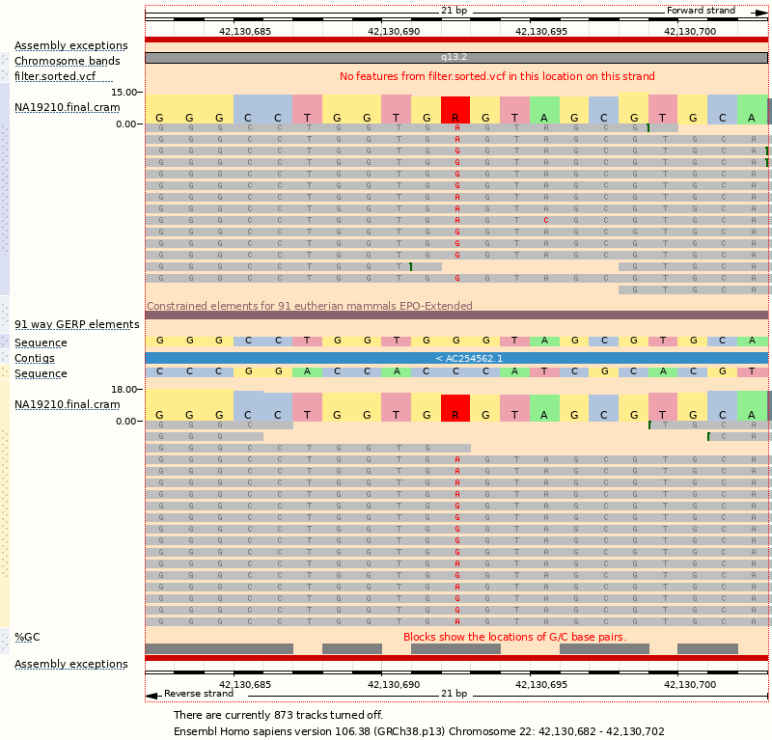

Supplemental figure 1. G1K sample alignments NA19210.final.cram around 42130692

3. PGx reports
- Single-gene-drug-pair report format (e.g. HG01183_basic_report_TPMT_Thiopurine.html)

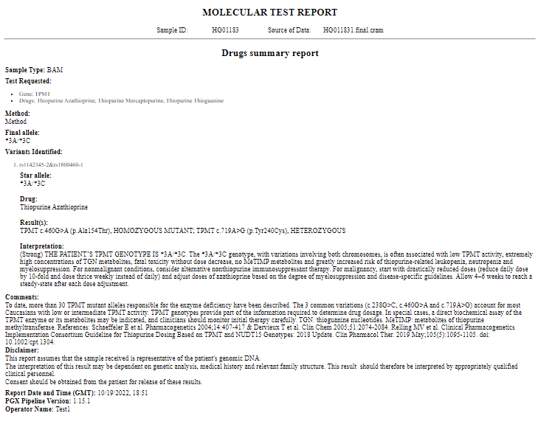

Supplemental figure 2. Pharmacogenetics report on TPMT and thiopurine pair for sample HG01183.
- All-gene-summary report format (e.g. HG01183_genes_summary_report.html)

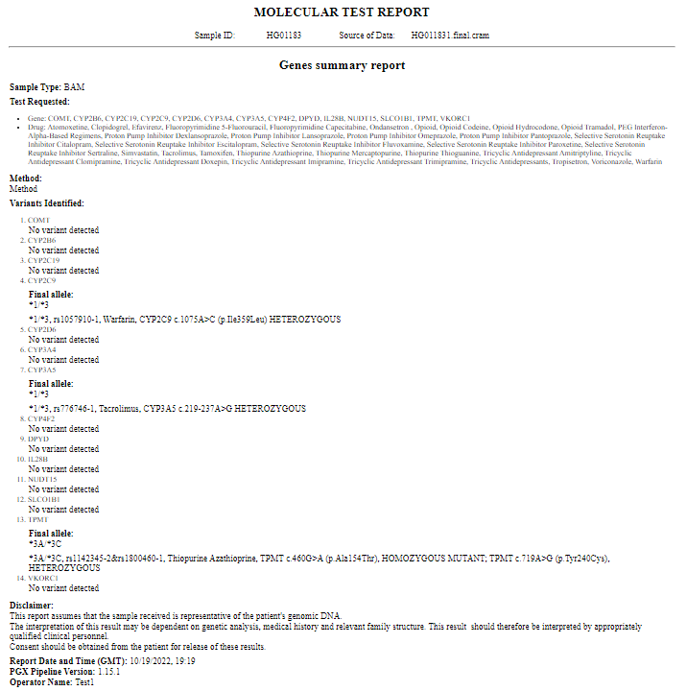

Supplemental figure 3. Pharmacogenetics summary report on all PGx gene variants found in sample HG01183.

