Supplementary Information
Pressure sensor
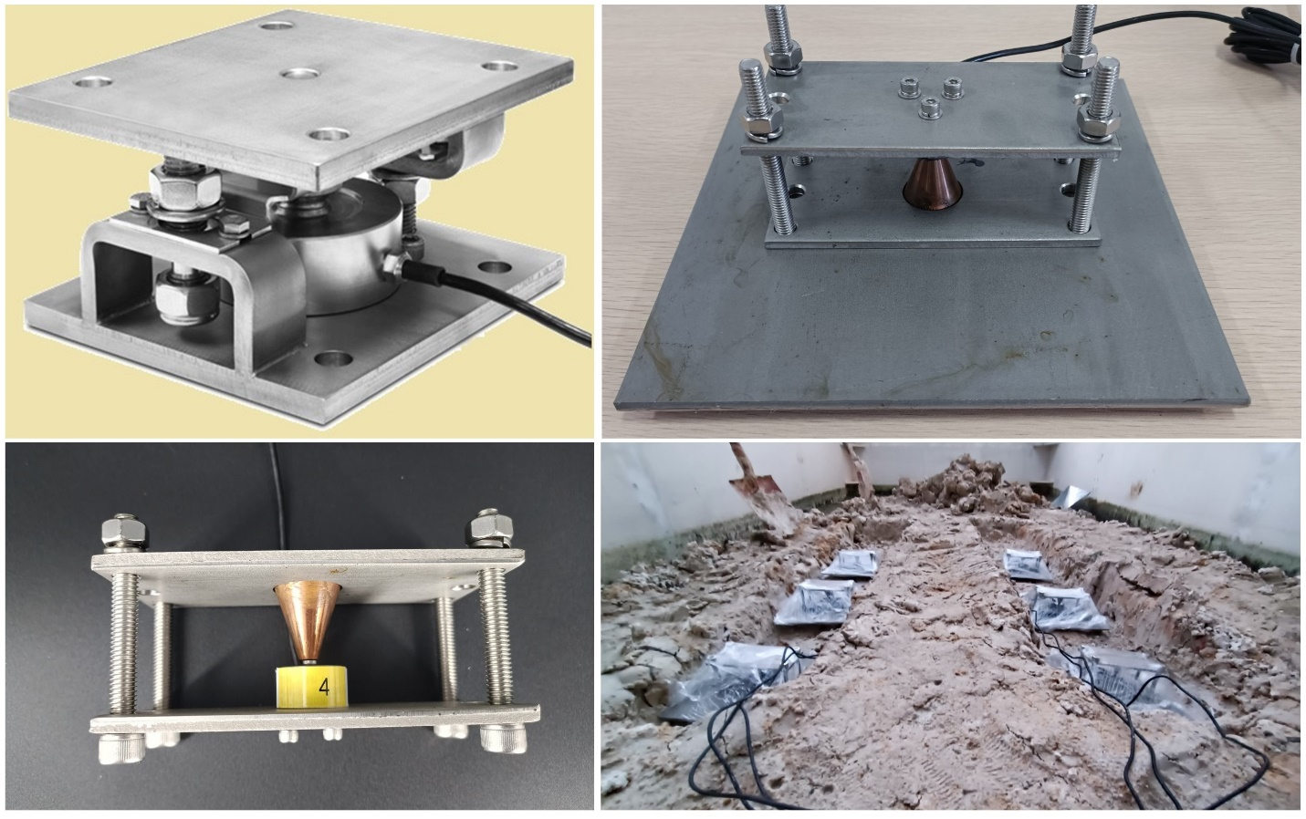
Supplementary Figure 1. Pressure sensor, including sensor bracket.

Soil bin
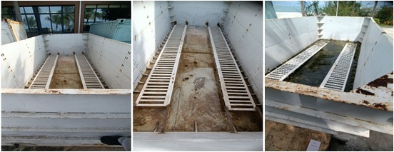

Supplementary Figure 2. Soil bin setup for the experiment.

9-axis attitude sensor
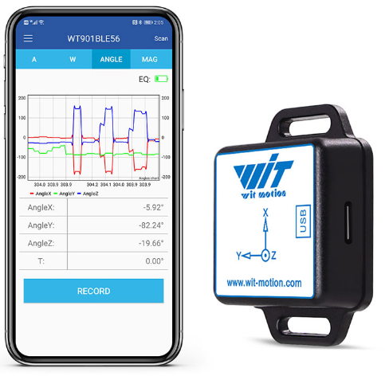

Supplementary Figure 3. Attitude sensor (WitMotion Bluetooth BLE 5.0 9 Axis Low-consumption Sensor WT901BLECL Angle + Acceleration + Gyro + Mag MPU9250 on PC/Android, China)

Soil moisture and measurement system
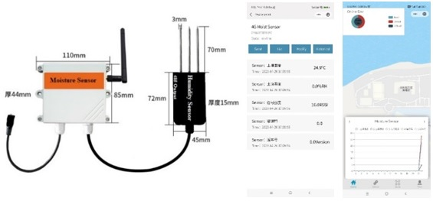

Supplementary Figure 4. Moisture sensor wireless interface and WeChat Mini app interface.

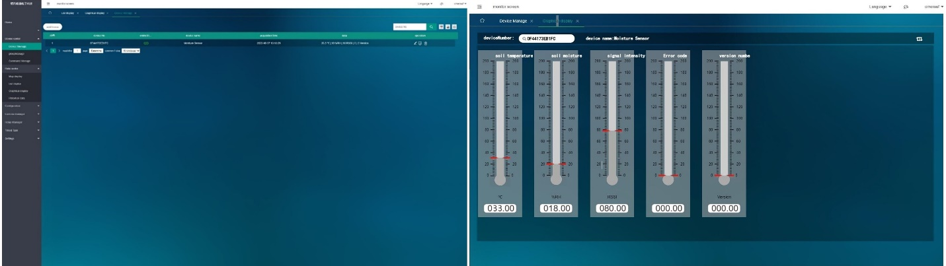
Supplementary Figure 5. Soil moisture sensors’ real-time data monitoring web-based interface tool shows temperature, humidity, and signal strength.

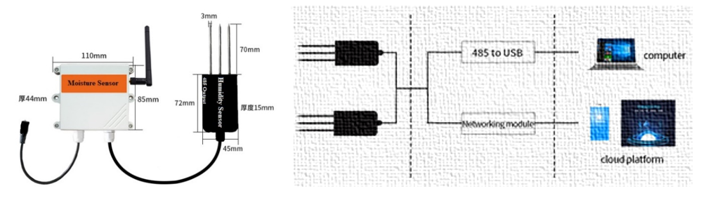

(a) (b)
Supplementary Figure 6. (a) 4G wireless soil temperature and moisture sensor (b) Wireless communication module.

Data acquisition FD0843 (6 Channel)
The FD0843, with its integrated Wireless Serial Communication Module, serves as a data collection hub, adept at gathering and transmitting information from sensors through its 6 channels. When pressure sensors are connected to the FD0843, each sensor’s data flows into one of these channels, simplifying data aggregation and transmission. Its wireless capability enhances the ease and versatility of data retrieval, facilitating both real-time monitoring and subsequent analysis on a computer. By analyzing this data, we can gain deeper insights into how different loads impact sinkage, enriching our knowledge of pressure sinkage behaviour. To ensure precision in data collection, it’s essential to install, set up, and calibrate both the FD0843 and the pressure sensors correctly. For optimal setup and operation, always adhere to the manufacturer’s instructions or seek advice from technical specialists.
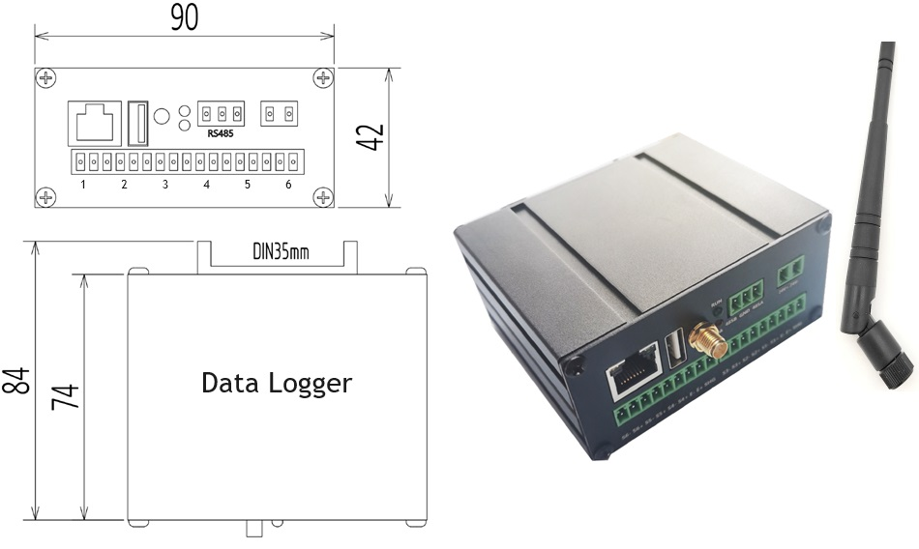
Supplementary Figure 7. 6-channel Wireless Data Acquisition System.

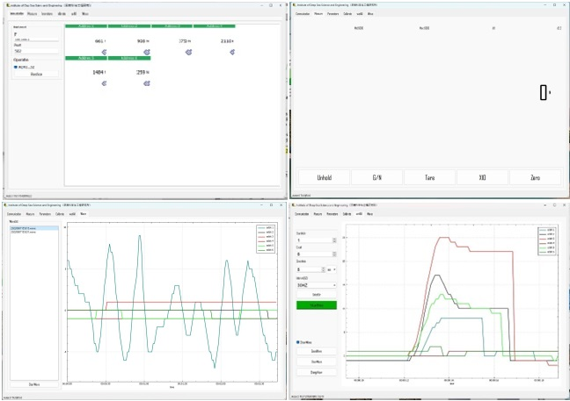
Supplementary Figure 8. 6-Channel Computer-Enabled Ground Pressure Measurement Software.

Data logger specifications
Supplementary Table 1. Data logger detailed specifications.
Parameters | Specifications
Body | Aluminum alloy housing
Size | 90mm×42mm×84mm
Use environment | Temperature: －30°～ 65 ℃;  Relative humidity: 10% ～ 95%
Protection | IP20
Operating Voltage | 9～24 VDC, Power ＜10W
Supporting sensor | 1～6
Maximum input signal | 5mV/V
A/D update rate | 1600Hz
Measurement rate | 100/200/400/800/1600
Data transfer rate | 100Mb/s
Sensor excitation voltage | 5VDC
Minimum input sensitivity | 0.5μV/d
Serial port | RS-485, 4800 ～ 115, 200 Baud rate
Wireless transmission | WiFi communication
Software | Computer-based software
Supporting protocol | MODBUS-RTU、MODBUS-UDP、Ether-CAT
Interface type | Ethernet

Soil Properties
Supplementary Table 2. Mechanical Soil Properties for Bentonite and Diatom Soils
Mechanical Soil Property | Bentonite | Diatom
Compressibility | High | Low
Shear Strength | Low | High
Friction Angle | Low | High
Cohesion | High | Low
Dilatancy | High | Low
Plasticity | High | Low

Loose Soil Properties
Supplementary Table 3. Loose Soil Properties for the Tracked Vehicle, Soil Bin Experiment
Parameter | Unit | Bentonite |  |  | Diatom
Condition | - | Loose | Loose | Loose | Loose | Loose | Loose
Moisture Content (±) | % | 10 | 20 | 30 | 10 | 20 | 30
Normal Stiffness | kPa | 26 | 35 | 32 | 43 | 67.7 | 78
Terrain Stiffness (k∅) | kN/m | 18 | 17.1 | 20 | 27 | 32 | 37
Ground Pressure | PSI | 23 | 28 | 32 | 28 | 32 | 37
Sinkage | cm | 2.5 | 3.6 | 4.8 | 1.8 | 2.6 | 3.8
Sinkage Ratio (s/D) | - | 0.19 | 0.18 | 0.16 | 0.13 | 0.1 | 0.8
Shear Stiffness | kPa | 12 | 17 | 19 | 26 | 31 | 37
Cohesion | kPa | 6.5 | 8.7 | 10.5 | 4.2 | 5.5 | 6.3
Friction Angle | ° | 26 | 28.5 | 30 | 33 | 34.5 | 37
Hardening Ratio | - | 1.7 | 2.1 | 2.32 | 1.5 | 2.15 | 2.6
Dilation Angle | ° | 6 | 5.5 | 6.5 | 3.5 | 5 | 6.5
Fluid Content | % | 10 | 15 | 20 | 12 | 16 | 19
Ground Pressure | kPa | 23 | 29 | 34 | 36 | 42 | 46

Compact Soil Properties
Supplementary Table 4. Compact Soil Properties for the Tracked Vehicle, Soil Bin Experiment
Parameter | Unit | Bentonite |  |  | Diatom
Condition | - | Compact | Compact | Compact | Compact | Compact | Compact
Moisture Content (±) | % | 10 | 20 | 30 | 10 | 20 | 30
Normal Stiffness | kPa | 37 | 46 | 61 | 58 | 84 | 91
Terrain Stiffness (k∅) | kN/m | 16.3 | 18.9 | 26 | 35 | 43 | 46
Ground Pressure | PSI | 26 | 31 | 37 | 33 | 37 | 42
Sinkage | cm | 1.1 | 2.3 | 3.1 | 0.8 | 1.3 | 2.1
Sinkage Ratio (s/D) | - | 0.11 | 0.09 | 0.06 | 0.12 | 0.07 | 0.06
Shear Stiffness | kPa | 16 | 19 | 26 | 37 | 41.6 | 48.5
Cohesion | kPa | 8.5 | 12.7 | 14.5 | 7.3 | 8.2 | 9.5
Friction Angle | ° | 28 | 31 | 35 | 35 | 37 | 41
Hardening Ratio | - | 2.3 | 2.5 | 2.7 | 2.6 | 3.3 | 3.8
Dilation Angle | ° | 7 | 7.9 | 8.8 | 6 | 7.5 | 8.7
Friction Coefficient | μ | 0.8 | 0.65 | 0.58 | 0.9 | 0.84 | 0.76
Ground Pressure | kPa | 31 | 38 | 45 | 33 | 46 | 52

Mechanics of track soil interaction
Supplementary Table 5. The Physical Properties of Bentonite, Diatom, and Sand Gravel Mixture
Parameter | Unit | Bentonite | Diatom | Sand Gravel mixture
Classification | - | Clay soil | Sedimentary deposit/rock | Silty gravel
Bulk density | g/cm³ | 1.4 (Loose)  1.5 (Compact) | 1.1 (Loose)  1.2 (Compact) | 1.6 (Loose)  1.7 (Compact)
Water Moisture content | % | 29 | 23 | 11
Internal friction angle | ° | 21 | 27 | 35
Cohesion | kPa | High | Low | Very low
Porosity | % | 54 | 62 | 31
Swelling Capacity | % | High | Low | Very low
Specific gravity | - | 2.4 | 2.2 | 2.6
Soil cone index (dry) | MPa | 1.7 | 1.0 | 3.4
Soil cone index (wet) | MPa | 1.1 | 0.6 | 1.9

Soil bin
Supplementary Table 6. The Parameters for the Soil Bin are Used for Pressure Sinkage and Bearing Capacity
Soil Bin Specifications | Values
Length | 610 cm
Width | 245 cm
Height | 180 cm
Thickness | 0.4 cm
Depth | 175 cm
Material | Steel
Capacity | Adequate for accommodating small to medium rubber-tracked vehicles
Drainage System | Installed to control surplus water and soil saturation efficiently.
Side Walls | Smooth and vertical to reduce vehicle motion interference
Floor Surface | Even and level for uniform testing
Lighting | Adequate lighting for assessing visibility
Safety Features | Guardrails or obstacles for operator safety
Data Collection | Integration of sensor and data acquisition equipment

Soil’s Detailed Properties
Supplementary Table 7. Detailed Properties of Test Soils
Parameter name | Unit | Value
Soil particle density  - Bentonite  - Diatom  - Sand gravel mixture | g/cm³ | 2.7  2.3  2.7
Natural moisture content  - Bentonite  - Diatom  - Sand gravel mixture | % | 21  8  9
Grain size distribution  - Bentonite  - Diatom  - Sand gravel mixture | mm | < 0.002  0.1  2 ~ 5
Maximum dry density  - Bentonite  - Diatom  - Sand gravel mixture | g/cm³ | 1.2  1.7  1.8
Optimum moisture content  - Bentonite  - Diatom  - Sand gravel mixture | % | 19  13  8

Tracked Vehicle Motion Test
Supplementary Table 8. Rubber Tracked Vehicle Motion Test on Diatom and Bentonite Soil
Soil Type | Soil Density | Speed (m/sec) | Motion Observation
Bentonite soil | Loose (g/cm³) | 0.1 | Very high sinkage, unable to move
Bentonite soil | Loose (g/cm³) | 0.2 | N/A, unable to achieve speed
Bentonite soil | Loose (g/cm³) | 0.3 | N/A, unable to achieve speed
Bentonite soil | Compacted (g/cm³) | 0.1 | Moderate sinkage, able to move
Bentonite soil | Compacted (g/cm³) | 0.2 | High sinkage, difficulty moving
Bentonite soil | Compacted (g/cm³) | 0.3 | Unable to move, gets stuck
Diatom soil | Loose (g/cm³) | 0.1 | High sinkage, low traction
Diatom soil | Loose (g/cm³) | 0.2 | Higher sinkage, difficulty moving
Diatom soil | Loose (g/cm³) | 0.3 | Unable to move, gets stuck
Diatom soil | Compacted (g/cm³) | 0.1 | Low sinkage, good traction
Diatom soil | Compacted (g/cm³) | 0.2 | Moderate sinkage, able to move
Diatom soil | Compacted (g/cm³) | 0.3 | High sinkage, difficulty moving

Cone index measurement
Supplementary Table 9. Experimental Soil Properties and Cone Index Measurement for Bentonite and Diatom
Soil type | Moisture content ± % | Loose Density 3g/cm³ | Compacted Density g/cm³ | Compaction % | Depth cm | Cone Index kPa
Bentonite | 10 | 1.3 | 1.5 | 15.38 | 10 | 94.12
 |  |  |  |  | 20 | 215.25
 |  |  |  |  | 30 | 127.36
 |  |  |  |  | 40 | 179.48
Bentonite | 20 | 1.2 | 1.4 | 17.67 | 10 | 184.16
 |  |  |  |  | 20 | 94.28
 |  |  |  |  | 30 | 179.4
 |  |  |  |  | 40 | 127.52
Bentonite | 30 | 1.1 | 1.3 | 18.18 | 10 | 94.44
 |  |  |  |  | 20 | 162.36
 |  |  |  |  | 30 | 127.6
 |  |  |  |  | 40 | 215.72
Diatom | 10 | 0.9 | 1.1 | 22.29 | 10 | 269.14
 |  |  |  |  | 20 | 293.62
 |  |  |  |  | 30 | 318.11
 |  |  |  |  | 40 | 342.59
Diatom | 20 | 0.8 | 1.0 | 25.4 | 10 | 219.38
 |  |  |  |  | 20 | 238.12
 |  |  |  |  | 30 | 257.86
 |  |  |  |  | 40 | 278.59
Diatom | 30 | 0.7 | 0.9 | 28.57 | 10 | 175.21
 |  |  |  |  | 20 | 192.44
 |  |  |  |  | 30 | 212.67
 |  |  |  |  | 40 | 231.89

