Supporting information

Synthesis and biological evaluation of novel amino and amido substituted pentacyclic benzimidazole derivatives

Nataša Perin¹, Marjana Gulin¹, Marija Kos¹, Leentje Persoons², Dirk Daelmans², Ivana Fabijanić³, Marijana Radić Stojković^{3,}* and Marijana Hranjec ^{1,}*

¹ Department of Organic Chemistry, Faculty of Chemical Engineering and Technology, University of Zagreb, Marulićev trg 20, HR-10000 Zagreb, Croatia;
² KU Leuven, Department of Microbiology and Immunology, Laboratory of Virology and Chemotherapy, Rega Institute, Leuven, Belgium; ³ Ruđer Bošković Institute, Division of Organic Chemistry and Biochemistry, Bijenička cesta 54, HR-10000 Zagreb, Croatia;

Contents
1. Spectroscopic characterization of pentacyclic benzimidazoles in aqueous solutions.
2. Interactions of pentacyclic benzimidazoles with ds-polynucleotides in neutral medium (pH=7.0)
2.1. Fluorimetric titrations
2.2. Thermal melting experiments
2.3. Circular dichroism (CD) titrations
3. NMR spectra of synthesized compounds (S18-S59)

1. Spectroscopic characterization of pentacyclic benzimidazoles in aqueous solutions

Figure S1. UV/Vis spectra changes of 22 at different concentrations (concentration range from 5.0 × 10⁻⁶ to 2.0 × 10⁻⁵ mol dm⁻³) at pH=7.0, sodium cacodylate buffer, I=0.05 M.
Figure S2. UV/Vis spectra changes of 19 at different concentrations (concentration range from 5.0 × 10⁻⁶ to 1.99 × 10⁻⁵ mol dm⁻³) at pH=7.0, sodium cacodylate buffer, I=0.05 M.

Figure S3. UV/Vis spectra changes of 9 at different concentrations (concentration range from 5.0 × 10⁻⁶ to 1.99 × 10⁻⁵ mol dm⁻³) at pH=7.0, sodium cacodylate buffer, I=0.05 M.

Figure S4. UV/Vis spectra changes of 6 at different concentrations (concentration range from 5.0 × 10⁻⁶ to 1.99 × 10⁻⁵ mol dm⁻³) at pH=7.0, sodium cacodylate buffer, I=0.05 M.

Table S1. Electronic absorption data of 6, 9, 19 and 22.

 | pH = 7.0ª
 | λ_{max} / nm | ε × 10³ / mmol⁻¹ cm²
6 | 253 | 33.25
 | 265 | 30.30
 | 390 | 6.48
9 | 266 | 30.93
 | 406 | 12.46
19 | 271 | 26.04
 | 447 | 17.77
22 | 268 | 21.48
 | 436 | 13.13
ª Sodium cacodylate buffer, I = 0.05 mol dm⁻³, pH = 7.0.

The emission intensities of buffered aqueous solutions (sodium cacodylate buffer, I = 0.05 mol dm⁻³, pH = 7.0) of studied compounds were proportional to their concentrations up to c = 2.0 × 10⁻⁶ mol dm⁻³ (Figures S5-S8).
Figure S5. Emission and excitation spectra changes of 22 at different concentrations at λ_{exc}=436 nm (concentration range from 5.0 × 10⁻⁷ to 2.0 × 10⁻⁶ mol dm⁻³) at pH=7.0, Na cacodylate buffer, I=0.05 mol dm⁻³.
Figure S6. Emission and excitation spectra changes of 19 at different concentrations at λ_{exc}=447 nm (concentration range from 5.0 × 10⁻⁷ to 2.0 × 10⁻⁶ mol dm⁻³) at pH=7.0, Na cacodylate buffer, I=0.05 mol dm⁻³.
Figure S7. Emission and excitation spectra changes of 9 at different concentrations at λ_{exc}=406 nm (concentration range from 5.0 × 10⁻⁷ to 2.0 × 10⁻⁶ mol dm⁻³) at pH=7.0, Na cacodylate buffer, I=0.05 mol dm⁻³.
Figure S8. Emission and excitation spectra changes of 6 at different concentrations at λ_{exc}=392 nm (concentration range from 5.0 × 10⁻⁷ to 2.0 × 10⁻⁶ mol dm⁻³ ) at pH=7.0, Na cacodylate buffer, I=0.05 mol dm⁻³.

2. Interactions of pentacyclic benzimidazoles with ds-polynucleotides in neutral medium (pH=7.0)

2.1. Fluorimetric titrations

Figure S9. a) Changes in fluorescence spectrum of 22 (c= 1.0 × 10⁻⁶ mol dm⁻³, λ_{exc}=436 nm) upon titration with ctDNA (c= 5.0 × 10⁻⁷ – 8.0 × 10⁻⁶ mol dm⁻³); b) Dependence of 22 absorbance at λ_{max} = 537 nm on c(ctDNA), at pH=7.0, sodium cacodylate buffer, I = 0.05 mol dm⁻³.

Figure S10. a) Changes in fluorescence spectrum of 19 (c= 1.0 × 10⁻⁶ mol dm⁻³, λ_{exc}=447 nm) upon titration with ctDNA (c= 5.0 × 10⁻⁷ – 6.5 × 10⁻⁶ mol dm⁻³); b) Dependence of 19 absorbance at λ_{max} = 531 nm on c(ctDNA), at pH=7.0, sodium cacodylate buffer, I = 0.05 mol dm⁻³.
Figure S11. a) Changes in fluorescence spectrum of 9 (c= 1.0 × 10⁻⁶ mol dm⁻³, λ_{exc}=406 nm) upon titration with ctDNA (c= 5.0 × 10⁻⁷ – 4.0 × 10⁻⁶ mol dm⁻³); b) Dependence of 9 absorbance at λ_{max} = 540 nm on c(ctDNA), at pH=7.0, sodium cacodylate buffer, I = 0.05 mol dm⁻³.

Figure S12. a) Changes in fluorescence spectrum of 6 (c= 1.0 × 10⁻⁶ mol dm⁻³, λ_{exc}=392 nm) upon titration with ctDNA (c= 5.0 × 10⁻⁷ – 4.0 × 10⁻⁶ mol dm⁻³); b) Dependence of 6 absorbance at λ_{max} = 531 nm on c(ctDNA), at pH=7.0, sodium cacodylate buffer, I = 0.05 mol dm⁻³.

Figure S13. a) Changes in fluorescence spectrum of 22 (c= 5.0 × 10⁻⁷ mol dm⁻³, λ_{exc}=436 nm) upon titration with rArU (c= 2.0 × 10⁻⁷ – 2.0 × 10⁻⁶ mol dm⁻³); b) Dependence of 22 absorbance at λ_{max} = 536 nm on c(rArU), at pH=7.0, sodium cacodylate buffer, I = 0.05 mol dm⁻³.

Figure S14. a) Changes in fluorescence spectrum of 19 (c= 5.0 × 10⁻⁷ mol dm⁻³, λ_{exc}=447 nm) upon titration with rArU (c= 1.0 × 10⁻⁷ – 1.5 × 10⁻⁶ mol dm⁻³); b) Dependence of 19 absorbance at λ_{max} = 529 nm on c(rArU), at pH=7.0, sodium cacodylate buffer, I = 0.05 mol dm⁻³.

2.2. Thermal melting experiments

Figure S15. Melting curve of ctDNA upon addition of ratio, r ( [compound/ [polynucleotide])=0.1 of 6, 9, 19 and 22 at pH = 7.0 (buffer sodium cacodylate, I = 0.05 mol dm⁻³).

Figure S16. Melting curve of rArU upon addition of ratio, r ([compound/ [polynucleotide]) = 0.1 of 19 and 22 at pH = 7.0 (buffer sodium cacodylate, I = 0.05 mol dm⁻³).

2.3. Circular dichroism (CD) titrations

 | 22 | 19 | 9 | 6
ct DNA
rArU

Figure S17. CD titration of ctDNA and rArU (c = 3.0 × 10⁻⁵ mol dm⁻³) with 6, 9, 19 and 22 at molar ratios r = [compound] / [polynucleotide] (pH = 7.0, buffer sodium cacodylate, I = 0.05 mol dm⁻³).

3. NMR spectra of synthesized compounds
Figure S18. ¹H NMR spectrum (DMSO-d₆, 300 MHz) of 7-oxo-5,7-dihydrobenzo[g]benzo[4,5]imidazo[1,2-a][1,8]naphthyridine-6-carbonitrile 4
Figure S19. ¹H NMR spectrum (DMSO-d₆, 300 MHz) of 7-chlorobenzo[g]benzo[4,5]imidazo[1,2-a][1,8]naphthyridine-6-carbonitrile 5
Figure S20. ¹³C NMR spectrum (DMSO-d₆, 100 MHz) of 7-chlorobenzo[g]benzo[4,5]imidazo[1,2-a][1,8]naphthyridine-6-carbonitrile 5

Figure S21. ¹H NMR spectrum (DMSO-d₆, 300 MHz) of 7-((3-N,N-(dimethylamino)propyl)amino)benzo[g]benzo[4,5]imidazo[1,2-a][1,8]naphthyridine-6-carbonitrile 6

Figure S22. ¹³C NMR spectrum (DMSO-d₆, 75 MHz) of 7-((3-N,N-(dimethylamino)propyl)amino)benzo[g]benzo[4,5]imidazo[1,2-a][1,8]naphthyridine-6-carbonitrile 6

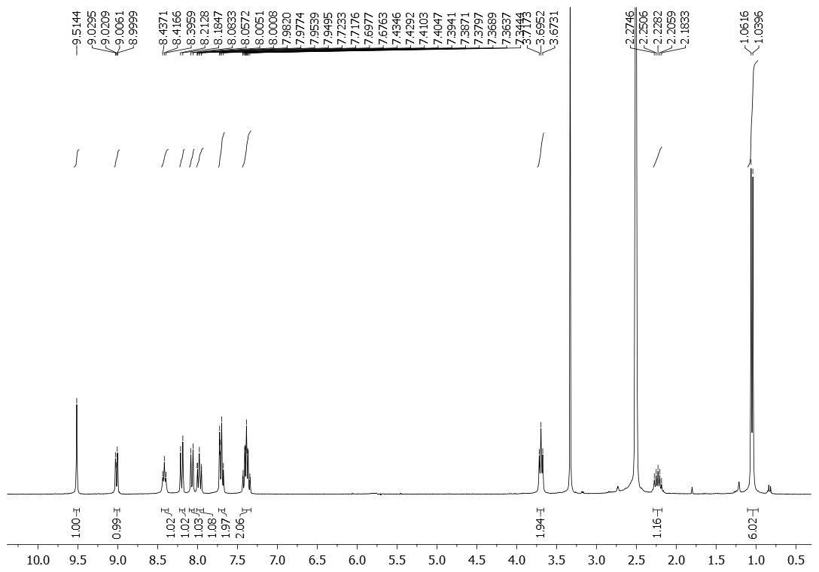

Figure S23. ¹H NMR spectrum (DMSO-d₆, 300 MHz) of 7-(N-isobutylamino)benzo[g]benzo[4,5]imidazo[1,2-a][1,8]naphthyridine-6-carbonitrile 7

Figure S24. ¹³C NMR spectrum (DMSO-d₆, 75 MHz) of 7-(N-isobutylamino)benzo[g]benzo[4,5]imidazo[1,2-a][1,8]naphthyridine-6-carbonitrile 7

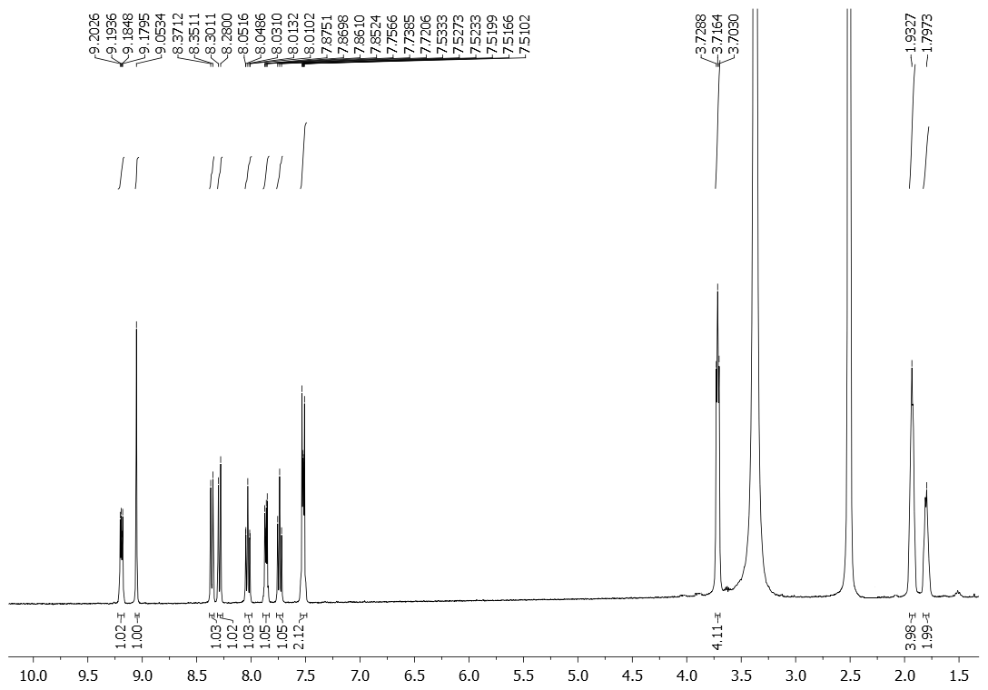

Figure S25. ¹H NMR spectrum (DMSO-d₆, 300 MHz) of 7-(piperidin-1-yl)benzo[g]benzo[4,5]imidazo[1,2-a][1,8]naphthyridine-6-carbonitrile 8

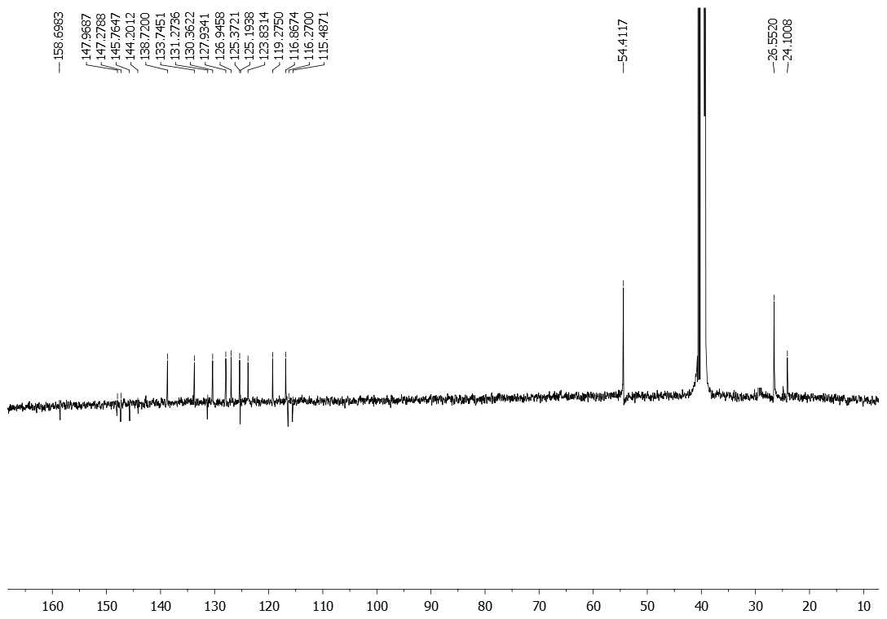

Figure S26. ¹³C NMR spectrum (DMSO-d₆, 75 MHz) of 7-(piperidin-1-yl)benzo[g]benzo[4,5]imidazo[1,2-a][1,8]naphthyridine-6-carbonitrile 8
Figure S27. ¹H NMR spectrum (DMSO-d₆, 300 MHz) of 7-(piperazin-1-yl)benzo[g]benzo[4,5]imidazo[1,2-a][1,8]naphthyridine-6-carbonitrile 9
Figure S28. ¹³C NMR spectrum (DMSO-d₆, 75 MHz) of 7-(piperazin-1-yl)benzo[g]benzo[4,5]imidazo[1,2-a][1,8]naphthyridine-6-carbonitrile 9
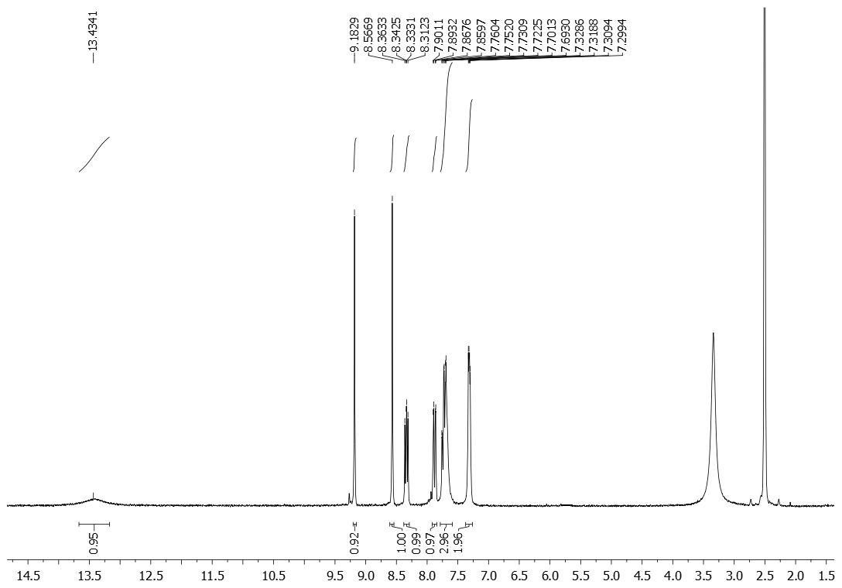
Figure S29. ¹H NMR spectrum (DMSO-d₆, 300 MHz) of (E)-2-(1H-benzo[d]imidazol-2-yl)-3-(2-chloro-7-fluoroquinolin-3-yl)acrylonitrile 13
Figure S30. ¹³C NMR spectrum (DMSO-d₆, 75 MHz) of (E)-2-(1H-benzo[d]imidazol-2-yl)-3-(2-chloro-7-fluoroquinolin-3-yl)acrylonitrile 13
Figure S31. ¹H NMR spectrum (DMSO-d₆, 300 MHz) of 11-fluorobenzo[g]benzo[4,5]imidazo[1,2-a][1,8]naphthyridine-6-carbonitrile 16
Figure S32. ¹³C NMR spectrum (DMSO-d₆, 75 MHz) of 11-fluorobenzo[g]benzo[4,5]imidazo[1,2-a][1,8]naphthyridine-6-carbonitrile 16
Figure S33. ¹H NMR spectrum (DMSO-d₆, 300 MHz) of 11-((3-N,N-(dimethylamino)propyl)amino)benzo[g]benzo[4,5]imidazo[1,2-a][1,8]naphthyridine-6-carbonitrile 19
Figure S34. ¹³C NMR spectrum (DMSO-d₆, 150 MHz) of 11-((3-N,N-(dimethylamino)propyl)amino)benzo[g]benzo[4,5]imidazo[1,2-a][1,8]naphthyridine-6-carbonitrile 19
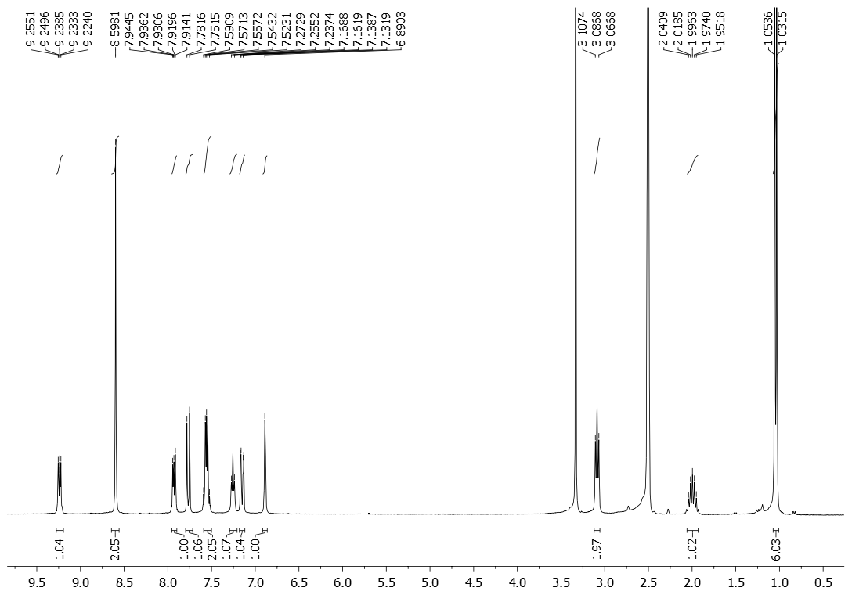
Figure S35. ¹H NMR spectrum (DMSO-d₆, 300 MHz) of 11-(N-isobutylamino)benzo[g]benzo[4,5]imidazo[1,2-a][1,8]naphthyridine-6-carbonitrile 20
Figure S36. ¹³C NMR spectrum (DMSO-d₆, 75 MHz) of 11-(N-isobutylamino)benzo[g]benzo[4,5]imidazo[1,2-a][1,8]naphthyridine-6-carbonitrile 20

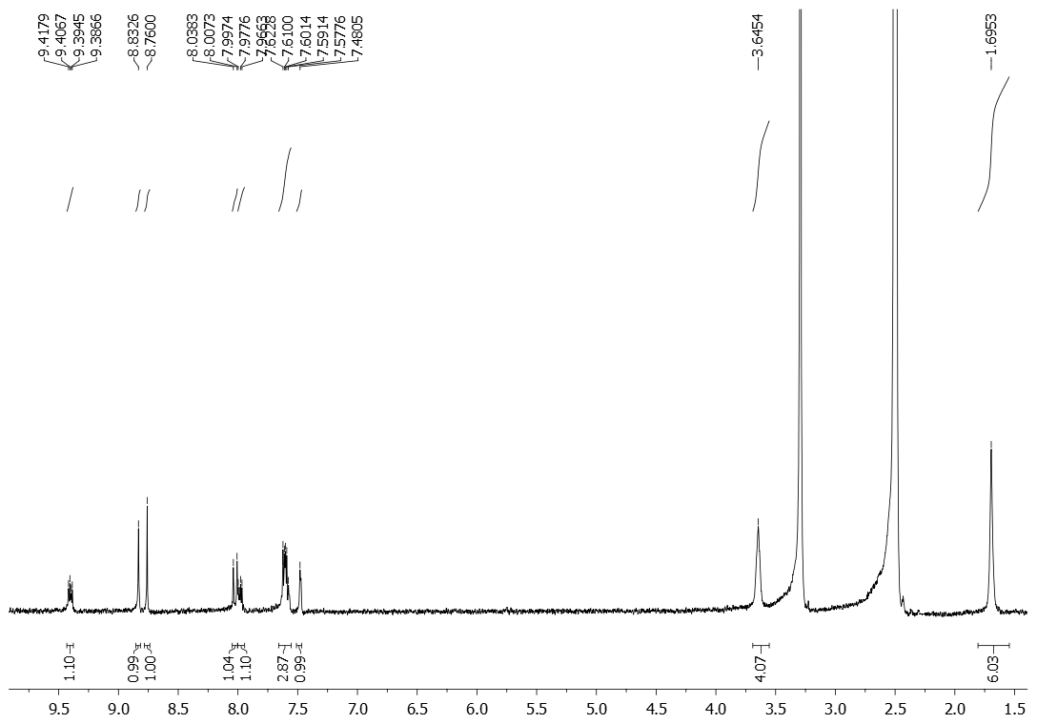

Figure S37. ¹H NMR spectrum (DMSO-d₆, 300 MHz) of 11-(piperidin-1-yl)benzo[g]benzo[4,5]imidazo[1,2-a][1,8]naphthyridine-6-carbonitrile 21

Figure S38. ¹³C NMR spectrum (DMSO-d₆, 75 MHz) of 11-(piperidin-1-yl)benzo[g]benzo[4,5]imidazo[1,2-a][1,8]naphthyridine-6-carbonitrile 21
Figure S39. ¹H NMR spectrum (DMSO-d₆, 300 MHz) of 11-(piperazin-1-yl)benzo[g]benzo[4,5]imidazo[1,2-a][1,8]naphthyridine-6-carbonitrile 22
Figure S40. ¹³C NMR spectrum (DMSO-d₆, 75 MHz) of 11-(piperazin-1-yl)benzo[g]benzo[4,5]imidazo[1,2-a][1,8]naphthyridine-6-carbonitrile 22
Figure S41. ¹H NMR spectrum (DMSO-d₆, 600 MHz) of (E)-2-(1H-benzo[d]imidazol-2-yl)-3-(2-chloroquinolin-3-yl)acrylonitrile 14
Figure S42. ¹³C NMR spectrum (DMSO-d₆, 150 MHz) of (E)-2-(1H-benzo[d]imidazol-2-yl)-3-(2-chloroquinolin-3-yl)acrylonitrile 14
Figure S43. ¹H NMR spectrum (DMSO-d₆, 600 MHz) of (E)-2-(1H-benzo[d]imidazol-2-yl)-3-(quinolin-3-yl)acrylonitrile 15
Figure S44. ¹³C NMR spectrum (DMSO-d₆, 75 MHz) of (E)-2-(1H-benzo[d]imidazol-2-yl)-3-(quinolin-3-yl)acrylonitrile 15
Figure S45. ¹H NMR spectrum (DMSO-d₆, 600 MHz) of benzo[g]benzo[4,5]imidazo[1,2-a][1,8]naphthyridine-6-carbonitrile 17
Figure S46. ¹³C NMR spectrum (DMSO-d₆, 75 MHz) of benzo[g]benzo[4,5]imidazo[1,2-a][1,8]naphthyridine-6-carbonitrile 17
Figure S47. ¹H NMR spectrum (DMSO-d₆, 600 MHz) of benzo[g]benzo[4,5]imidazo[1,2-a][1,5]naphthyridine-7-carbonitrile 18
Figure S48. ¹³C NMR spectrum (DMSO-d₆, 150 MHz) of benzo[g]benzo[4,5]imidazo[1,2-a][1,5]naphthyridine-7-carbonitrile 18
Figure S49. ¹H NMR spectrum (DMSO-d₆, 300 MHz) of benzo[g]benzo[4,5]imidazo[1,2-a][1,8]naphthyridine-6-carboxylic acid 23
Figure S50. ¹H NMR spectrum (DMSO-d₆, 400 MHz) of benzo[g]benzo[4,5]imidazo[1,2-a][1,5]naphthyridine-7-carboxylic acid 27
Figure S51. ¹³C NMR spectrum (DMSO-d₆, 100 MHz) of benzo[g]benzo[4,5]imidazo[1,2-a][1,5]naphthyridine-7-carboxylic acid 27
Figure S52. ¹H NMR spectrum (DMSO-d₆, 400 MHz) of N-(3-N,N-(dimethylamino)propyl)benzo[g]benzo[4,5]imidazo[1,2-a][1,8]naphthyridine-6-carboxamide 25
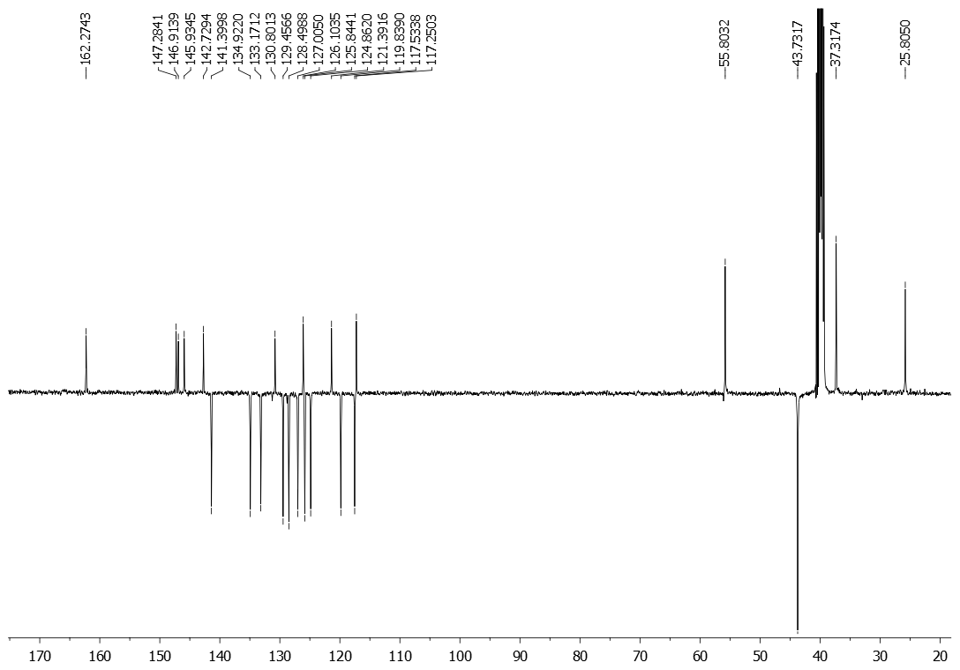
Figure S53. ¹³C NMR spectrum (DMSO-d₆, 100 MHz) of N-(3-N,N-(dimethylamino)propyl)benzo[g]benzo[4,5]imidazo[1,2-a][1,8]naphthyridine-6-carboxamide 25
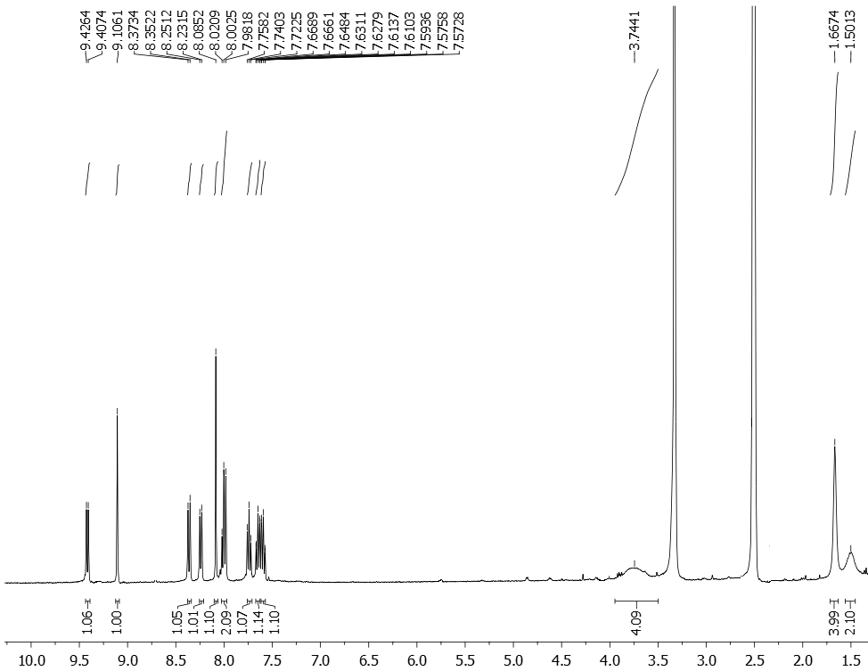
Figure S54. ¹H NMR spectrum (DMSO-d₆, 400 MHz) of benzo[g]benzo[4,5]imidazo[1,2-a][1,8]naphthyridin-6-yl(piperidin-1-yl)methanone 26
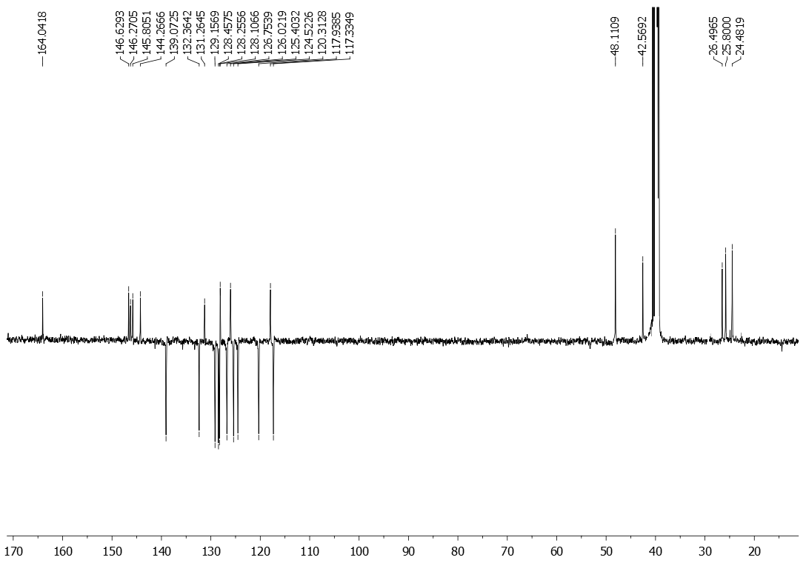
Figure S55. ¹³C NMR spectrum (DMSO-d₆, 100 MHz) of benzo[g]benzo[4,5]imidazo[1,2-a][1,8]naphthyridin-6-yl(piperidin-1-yl)methanone 26

Figure S56. ¹H NMR spectrum (DMSO-d₆, 400 MHz) of N-isobutylbenzo[g]benzo[4,5]imidazo[1,2-a][1,5]naphthyridine-7-carboxamide 29
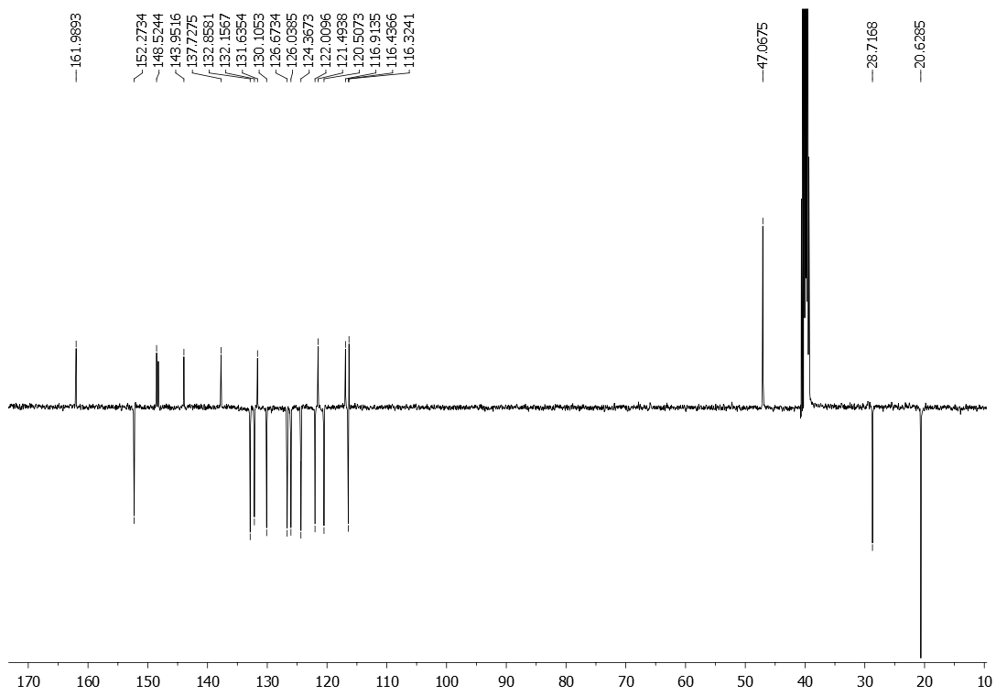
Figure S57. ¹³C NMR spectrum (DMSO-d₆, 100 MHz) of N-isobutylbenzo[g]benzo[4,5]imidazo[1,2-a][1,5]naphthyridine-7-carboxamide 29
Figure S58. ¹H NMR spectrum (DMSO-d₆, 400 MHz) of N,N-dimethylbenzo[g]benzo[4,5]imidazo[1,2-a][1,5]naphthyridine-7-carboxamide 30
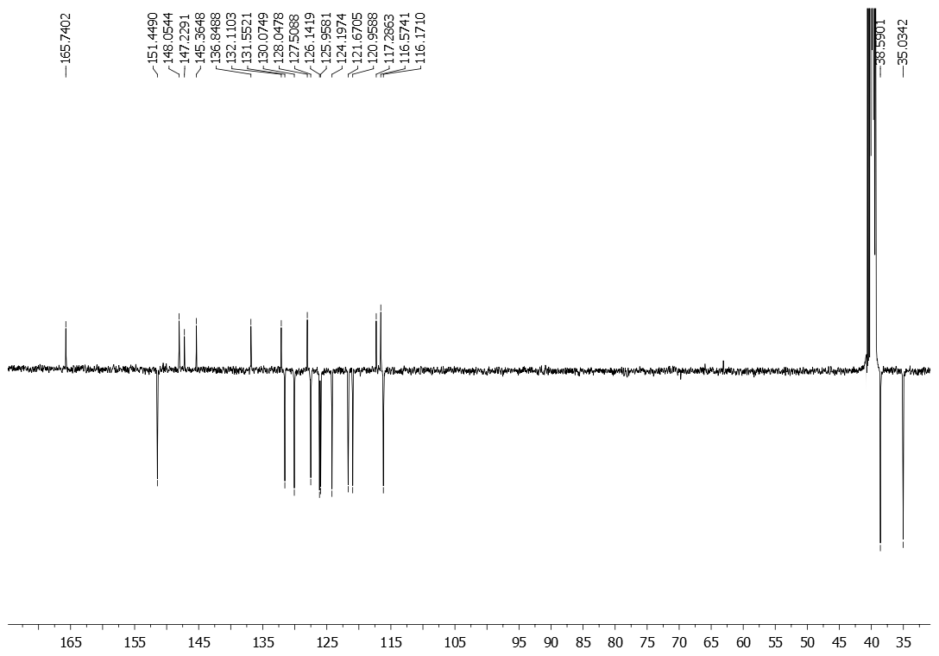
Figure S59. ¹³C NMR spectrum (DMSO-d₆, 100 MHz) of N,N-dimethylbenzo[g]benzo[4,5]imidazo[1,2-a][1,5]naphthyridine-7-carboxamide 30

