Table 1S.
Summary of Software and Algorithms used for the LittleBeats Platform and in the Technical Validation Studies
Paper section | Software/open-sourced ML model used | Purpose
Device overview | Code developed in-house in C using Adafruit Libraries |  | LittleBeats data acquisition
Device overview | Python code developed in-house |  | To pre-process the data before running the ML/signal processing algorithms
Studies 1 & 2 | CardioPeak & Segmenter |  | To extract IBI (also called R-R peaks) from ECG data for a given session or task
Studies 1 & 2 | CardioEdit v1.5 | To manually edit IBI data
Studies 1 & 2 | CardioBatch Plus | To extract respiratory sinus arrythmia (RSA) values from the IBI data files
Study 3 | Sklearn | To implement ML Algorithms
Study 4 | Built-in clipfix function in Audacity software | To alleviate clipping in LB audio
Study 4 | sklearn | To implement LDA algorithm to perform SER
Study 5 | Wav2vec 2.0 | To perform ASR on Rainbow Passage
Study 5 | KenLM | To implement language modeling used in ASR inference

Figure S1. Plots of aligned interbeat intervals (IBI) from LittleBeats™ (orange line) and BIOPAC (blue line) during (a) baseline, (b) puzzle task, (c) recovery, and (d) matrices task from an adult participant (Study 1). The X and Y axes each represent time in seconds.

- Baseline
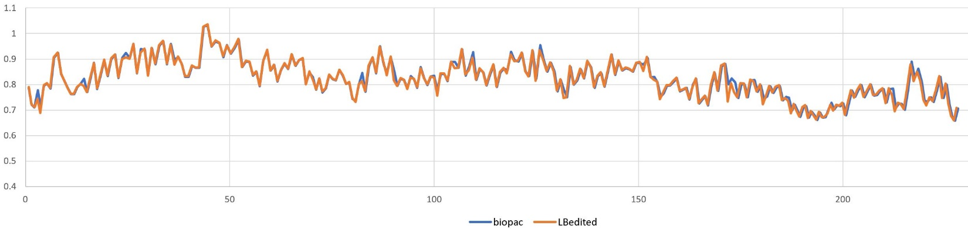
- Puzzle task
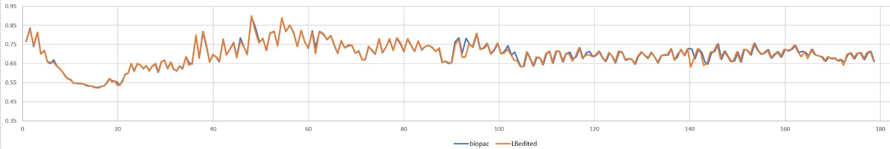
- Recovery
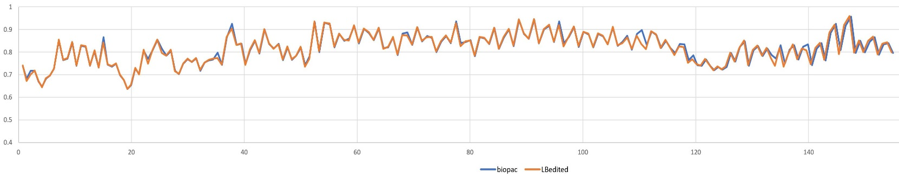
- Matrices task
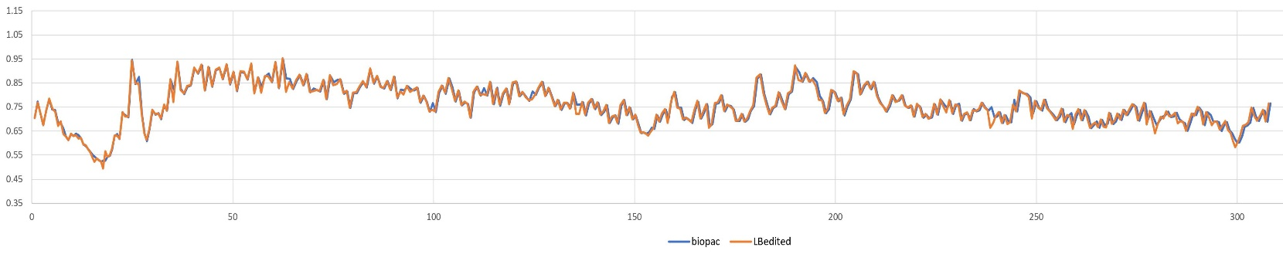

Figure S2. Plots of aligned interbeat intervals (IBI) from LittleBeats™ (orange line) and BIOPAC (blue line) during (a) baseline, (b) SFP play, (c) SFP still, and (d) SFP reunion episodes from an infant participant (Study 2). The X and Y axes each represent time in seconds.

- Baseline
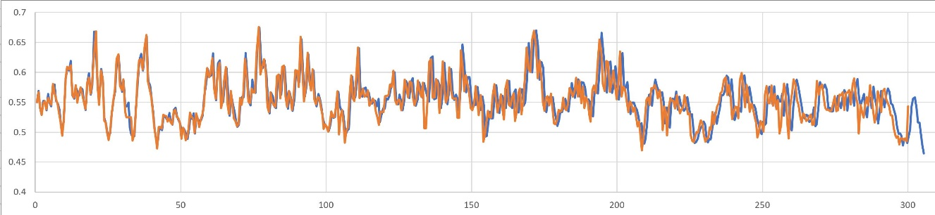
- SFP play
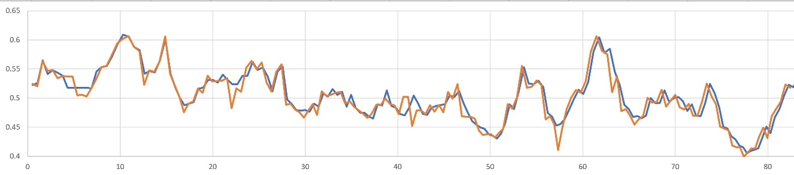
- SFP still
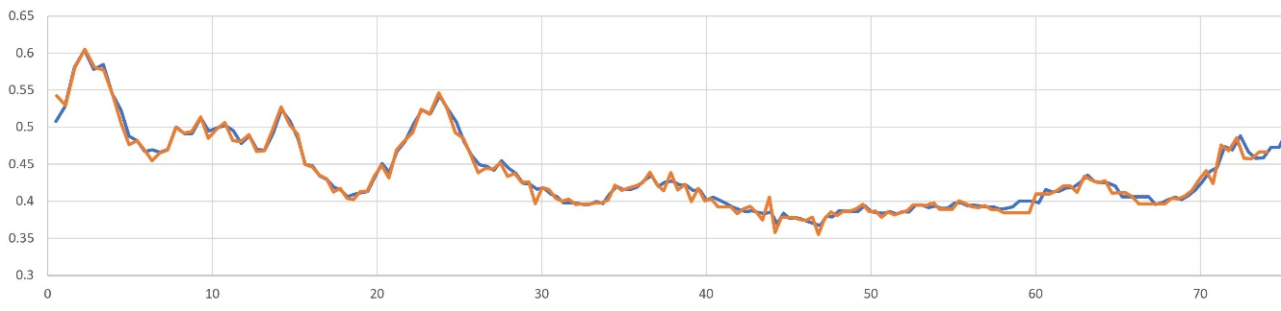
- SFP reunion
