Table S1. Details of satellite covariates from sentinel-1 and 2A used in the study.
Covariates | Abbreviation |  | Formula | Reference
Coastal aerosol | B1 | - |  | (Li et al., 2016)
Blue band | B2 | - |  | (Wulder et al., 2016)
Green band | B3 | - |  | (Wulder et al., 2016)
Red band | B4 | - |  | (Wulder et al., 2016)
Vegetation red edge | B5 | - |  | (Horler et al., 1983)
Vegetation red edge | B6 | - |  | (Horler et al., 1983)
Vegetation red edge | B7 | - |  | (Horler et al., 1983)
NIR | B8 | - |  | (Wulder et al., 2016)
Narrow NIR | B8A | - |  | (Wulder et al., 2016)
Water vapour | B9 | -
SWIR-1 | B11 | - |  | (Wulder et al., 2016)
SWIR-2 | B12 | - |  | (Wulder et al., 2016)
Backscattering coefficients of VH band | Sigma0_VH | - |  | (Attema et al., 2010)
Backscattering coefficients of VV band | Sigma0_VV | - |  | (Attema et al., 2010)
Corrected Transformed Vegetation Index | CTVI | $$\frac{NDVI+0.5}{Abs\left(NDVI+0.5\right)}×\sqrt{Abs\left(NDVI+0.5\right)}$$ |  | (Perry and Lautenschlager, 1984)
Difference Vegetation Index | DVI | s × NIR - R |  | (Richardson and Wiegand, 1977)
Green Normalized Difference Vegetation Index | GNDVI | $$\frac{NIR-G}{NIR+G}$$ |  | (Gitelson et al., 1996)
Global Environmental Monitoring Index | GEMI | $$η\left(1-0.25η\right)-\frac{R-0.125}{1-R}$$  $$η= \frac{2\left({NIR}^{2}-R^{2}\right)+1.5NIR+0.5R}{NIR+R+0.5}$$ |  | (Pinty and Verstraete, 1992)
Modified Normalized Difference Water Index | MNDWI | $$\frac{\left(G-SWIR\right)}{\left(G+SWIR\right)}$$ |  | (Xu, 2006)
Modified Soil Adjusted Vegetation Index | MSAVI | $$NIR+0.5-(0.5\sqrt{{\left(2NIR+1\right)}^{2}-8(NIR-2R)}$$ |  | (Qi et al., 1994)
Modified Soil Adjusted Vegetation Index 2 | MSAVI2 | $$\frac{2NIR+1-\sqrt{{\left(2NIR+1\right)}^{2}-8\left(NIR-R\right)}}{2}$$ |  | (Qi et al., 1994)
Normalized Burn Ratio Index | NBRI | $$\frac{\left(NIR-SWIR1\right)}{(NIR+SWIR1)}$$ |  | (García and Caselles, 1991)
Normalized Difference Vegetation Index | NDVI | $$\frac{NIR-R}{NIR+R}$$ |  | (Purevdorj et al., 1988)
Normalized Difference Water Index | NDWI | $$\frac{G-NIR}{G+NIR}$$ |  | (McFEETERS, 1996)
Normalized Difference Water Index 2 | NDWI2 | $$\frac{\left(NIR-SWIR1\right)}{(NIR+SWIR1)}$$ |  | (Gao, 1996)
Ratio Vegetation Index | RVI | $$\frac{R}{NIR}$$ |  | (Richardson and Wiegand, 1977)
Normalized Ratio Vegetation Index | NRVI | $$\frac{\left(\frac{R}{NIR}-1\right)}{\left(\frac{R}{NIR}+1\right)}$$ |  | (Baret and Guyot, 1991)
Soil Adjusted Vegetation Index | SAVI | $$\frac{NIR-R}{NIR+R}×(1+L)$$ |  | (Huete, 1988)
Soil Adjusted Total Vegetation Index | SATVI | $$\frac{\left(SWIR1-R\right)}{\left(SWIR1+R+L\right)}×\left(1+L\right)-\frac{SWIR2}{2}$$ |  | (Marsett et al., 2006)
Specific Leaf Area Vegetation Index | SLAVI | $$\frac{NIR}{\left(R+SWIR2\right)}$$ |  | (Lymburner et al., 2000)
Simple Ratio Vegetation Index | SR | $$\frac{NIR}{R}$$ |  | (Birth and McVey, 1968)
Transformed Vegetation Index | TVI | $$\sqrt{\frac{\left(NIR-R\right)}{NIR+R}}+0.5$$ |  | (Deering, 1975)
Thiam’s Transformed Vegetation Index | TTVI | $$\sqrt{Abs(NDVI+0.5)}$$ |  | (Thiam, 1998)
Weighted Difference Vegetation Index | WDVI | NIR – a × R |  | (Richardson and Wiegand, 1977)
Table S2. Calibration between downscaled aggregated LST using RF, TsHARP and TPS with observed LST (Landsat-8/9).
 | RF |  |  | TsHARP |  |  | TPS
Date | R² | RMSE | nRMSE | R² | RMSE | nRMSE | R² | RMSE | nRMSE
 |  |  |  | IARI
30.Oct.2020 | 0.985 | 0.228 | 0.075 | 0.976 | 0.367 | 0.12 | 0.991 | 0.176 | 0.058
24.Nov.2020 | 0.997 | 0.196 | 0.067 | 0.963 | 0.276 | 0.094 | 0.97 | 0.227 | 0.077
17.Dec.2022 | 0.979 | 0.192 | 0.067 | 0.957 | 0.256 | 0.089 | 0.983 | 0.173 | 0.06
27.Jan.2021 | 0.976 | 0.163 | 0.056 | 0.965 | 0.166 | 0.071 | 0.982 | 0.143 | 0.049
20.Feb.2021 | 0.979 | 0.173 | 0.058 | 0.969 | 0.233 | 0.078 | 0.989 | 0.129 | 0.043
23.Mar.2021 | 0.983 | 0.192 | 0.064 | 0.964 | 0.309 | 0.078 | 0.995 | 0.106 | 0.035
18.Nov.2021 | 0.982 | 0.167 | 0.056 | 0.985 | 0.165 | 0.055 | 0.981 | 0.174 | 0.058
13.Dec.2021 | 0.984 | 0.186 | 0.063 | 0.987 | 0.173 | 0.059 | 0.981 | 0.204 | 0.07
29.Dec.2021 | 0.961 | 0.153 | 0.052 | 0.962 | 0.161 | 0.052 | 0.981 | 0.204 | 0.07
15.Feb.2022 | 0.983 | 0.142 | 0.048 | 0.961 | 0.233 | 0.079 | 0.996 | 0.069 | 0.023
19.Mar.2022 | 0.985 | 0.187 | 0.061 | 0.967 | 0.312 | 0.101 | 0.999 | 0.045 | 0.015
04.Apr.2022 | 0.985 | 0.187 | 0.06 | 0.968 | 0.292 | 0.093 | 0.995 | 0.11 | 0.035
Mean | 0.982 | 0.181 | 0.061 | 0.969 | 0.245 | 0.081 | 0.987 | 0.147 | 0.049
SD | 0.008 | 0.023 | 0.007 | 0.009 | 0.069 | 0.020 | 0.009 | 0.056 | 0.020
SE | 0.0023 | 0.0065 | 0.0021 | 0.0027 | 0.019 | 0.0057 | 0.0024 | 0.016 | 0.0056
 |  |  |  | CAZRI
5.Mar.2021 | 0.976 | 0.385 | 0.123 | 0.977 | 0.359 | 0.114 | 0.992 | 0.214 | 0.068
21.Mar.2021 | 0.983 | 0.305 | 0.097 | 0.994 | 0.17 | 0.054 | 0.991 | 0.213 | 0.068
18.Dec.2021 | 0.979 | 0.323 | 0.108 | 0.993 | 0.178 | 0.06 | 0.991 | 0.205 | 0.069
21.Feb.2022 | 0.981 | 0.439 | 0.143 | 0.982 | 0.274 | 0.089 | 0.999 | 0.055 | 0.018
Mean | 0.980 | 0.363 | 0.118 | 0.987 | 0.245 | 0.079 | 0.993 | 0.172 | 0.056
SD | 0.003 | 0.061 | 0.020 | 0.008 | 0.089 | 0.028 | 0.004 | 0.078 | 0.025
SE | 0.0014 | 0.030 | 0.0099 | 0.0041 | 0.044 | 0.013 | 0.0019 | 0.038 | 0.012
 |  |  |  | UBKV
08.Mar.2021 | 0.989 | 0.103 | 0.034 | 0.952 | 0.24 | 0.08 | 0.997 | 0.051 | 0.017
24.Mar.2021 | 0.979 | 0.148 | 0.049 | 0.966 | 0.202 | 0.067 | 0.994 | 0.079 | 0.026
05.Dec.2021 | 0.982 | 0.163 | 0.054 | 0.977 | 0.189 | 0.063 | 0.987 | 0.14 | 0.047
21.Dec.2021 | 0.981 | 0.117 | 0.06 | 0.975 | 0.213 | 0.072 | 0.987 | 0.149 | 0.05
Mean | 0.983 | 0.133 | 0.049 | 0.968 | 0.211 | 0.071 | 0.991 | 0.105 | 0.035
SD | 0.004 | 0.028 | 0.011 | 0.011 | 0.022 | 0.007 | 0.005 | 0.047 | 0.016
SE | 0.0021 | 0.013 | 0.0055 | 0.0056 | 0.010 | 0.0036 | 0.0025 | 0.023 | 0.0080
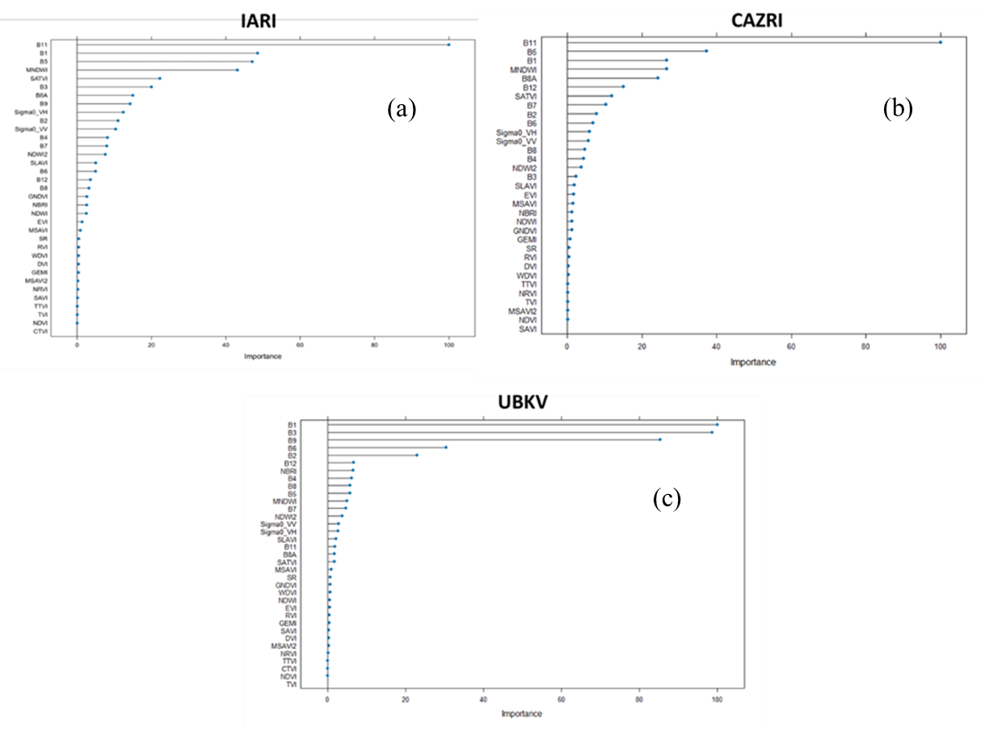
Figure S1. Variable importance in downscaling LST by RF model (a) IARI (b) CAZRI and (c) UBKV.

Figure S2. Validation of downscaled-and-aggregated LST from LANDSAT-8 with MODIS Aqua and Terra LST products at 1000 m resolution [1:1 line is shown as dotted line].
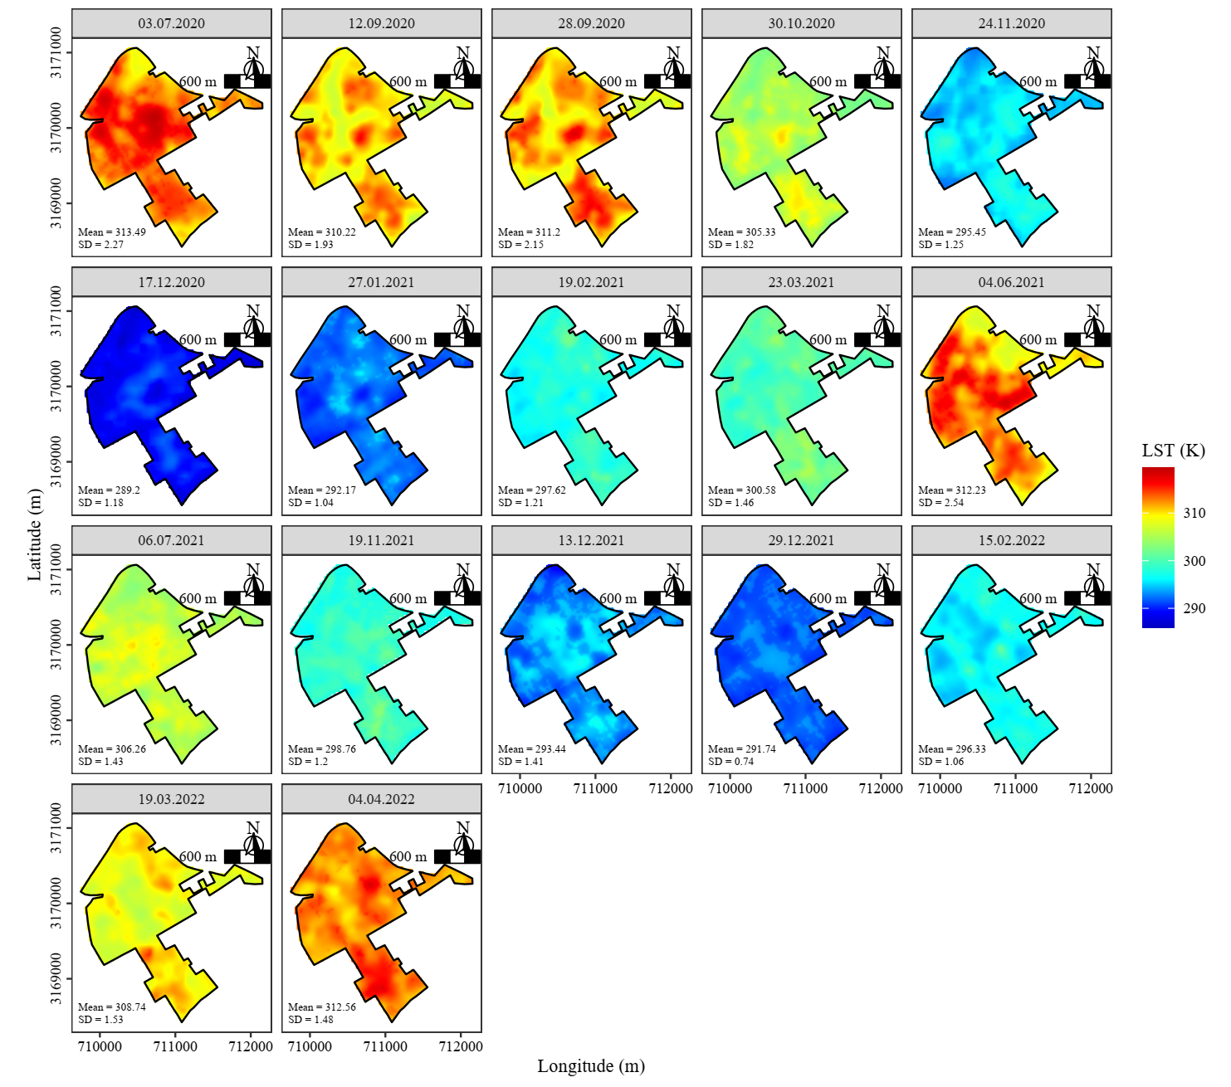
Figure S3. Spatial extent of observed LST (30 m) over IARI farm scale in pre- and post-monsoon period, 2020-2022.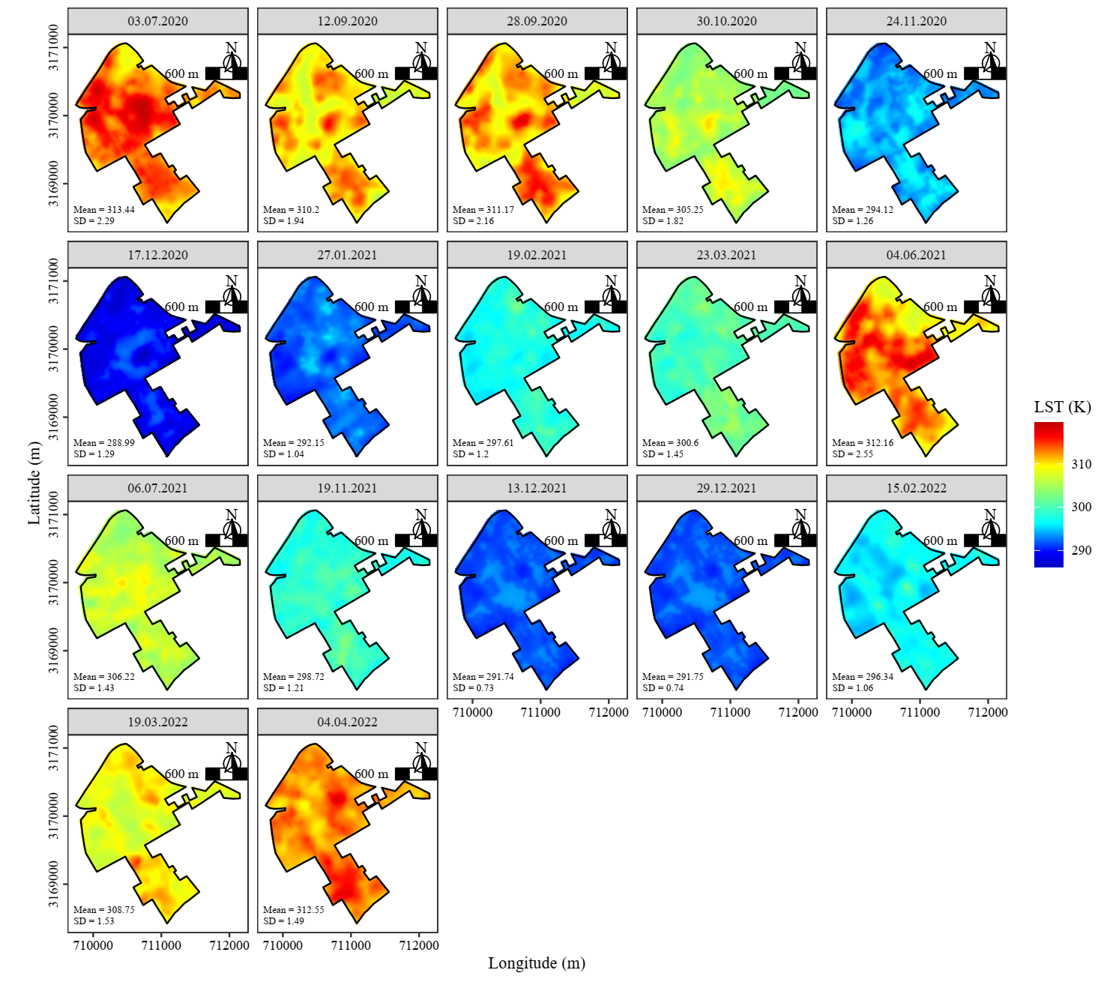
Figure S4. Spatial extent of TPS downscaled LST (10 m) over IARI farm scale pre- and post-monsoon period, 2020-2022.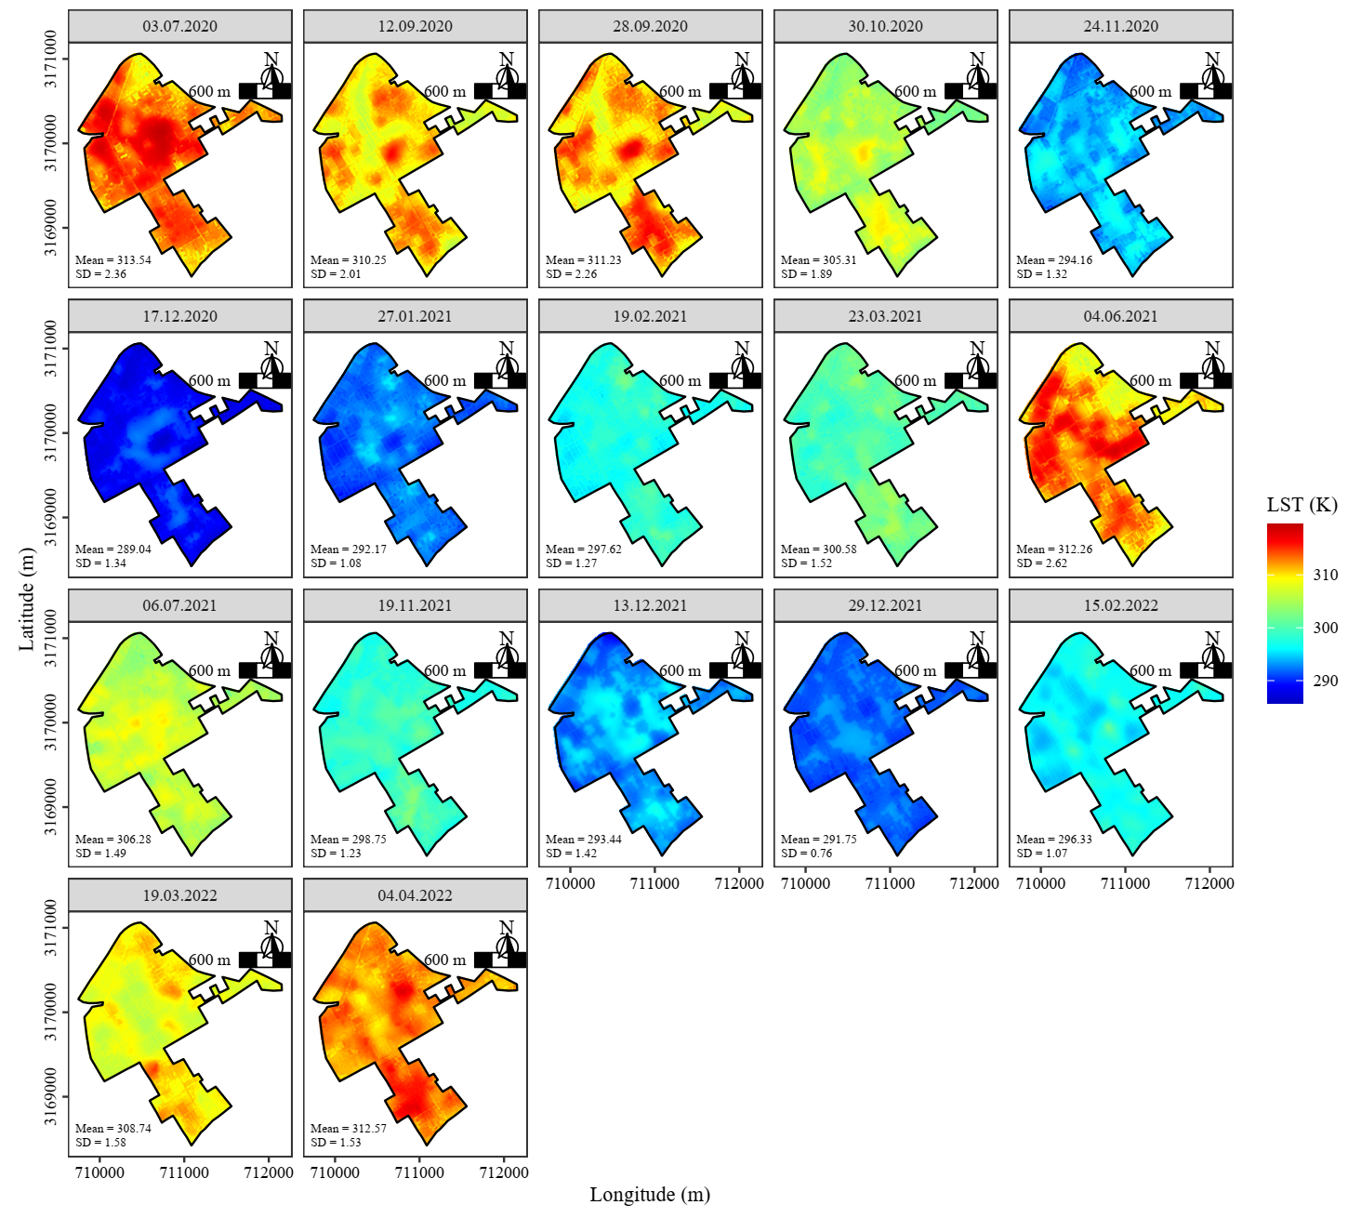
Figure S5. Spatial extent of TsHARP downscaled LST (10 m) over IARI farm scale in the scale pre and post-monsoon period, 2020-2022.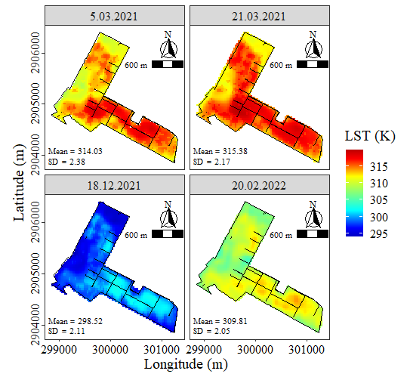
Figure S6. Spatial extent of observed LST (30 m) over CAZRI site.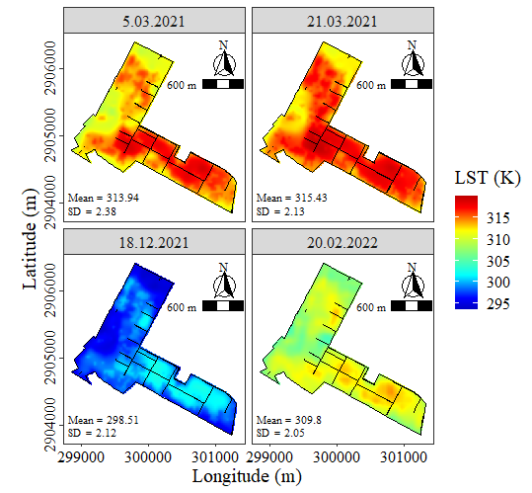
Figure S7. Spatial extent of TPS downscaled LST (10 m) over CAZRI site.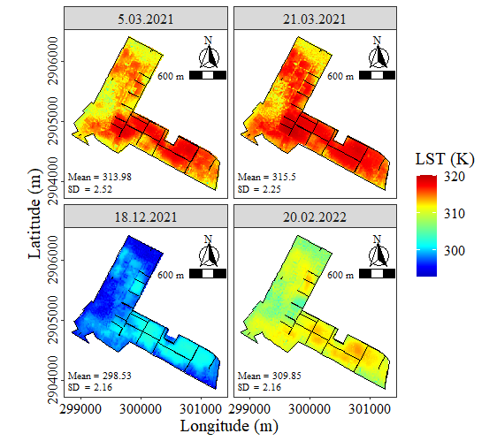
Figure S8. Spatial extent of TsHARP downscaled LST (10 m) over CAZRI site.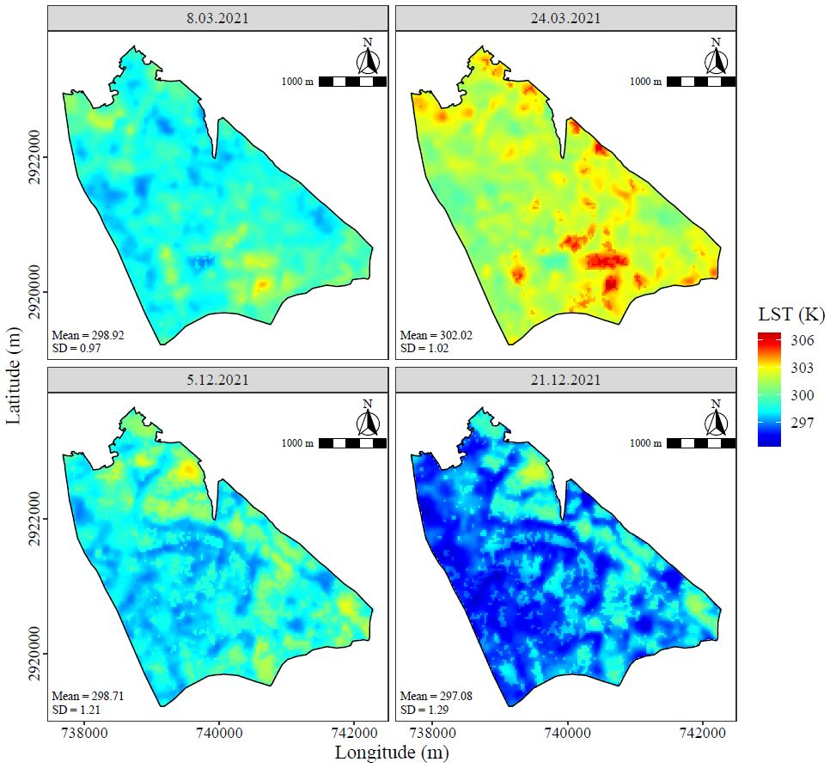
Figure S9. Spatial extent of observed LST (30 m) over UBKV site.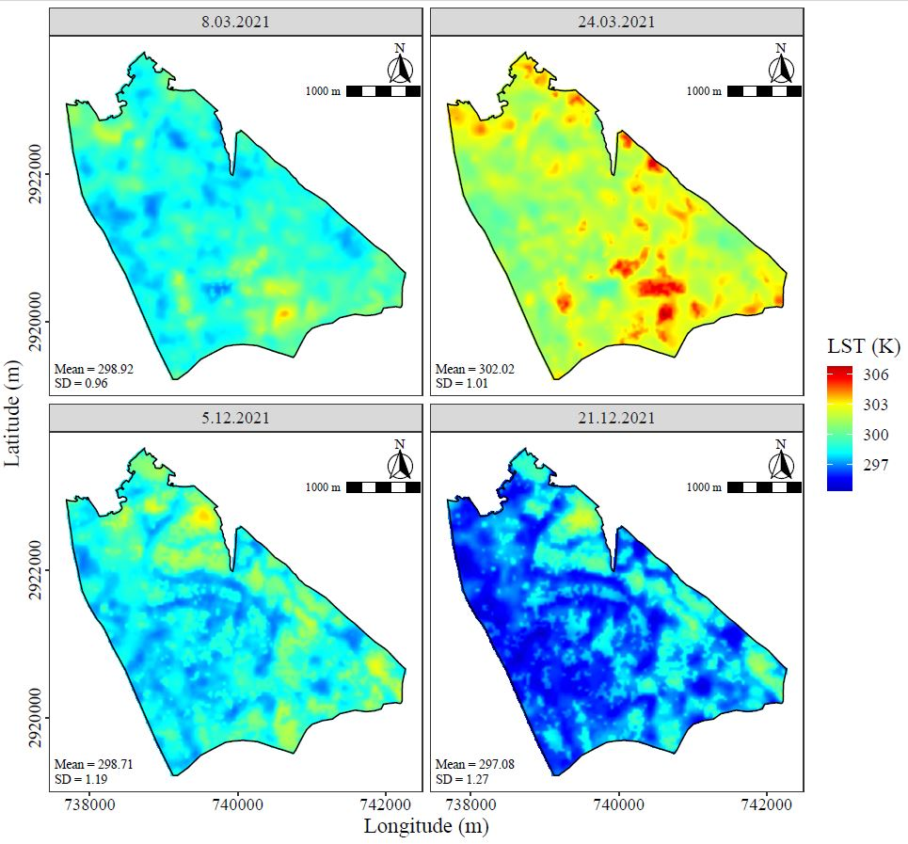
Figure S10. Spatial extent of TPS downscaled LST (10 m) over UBKV site.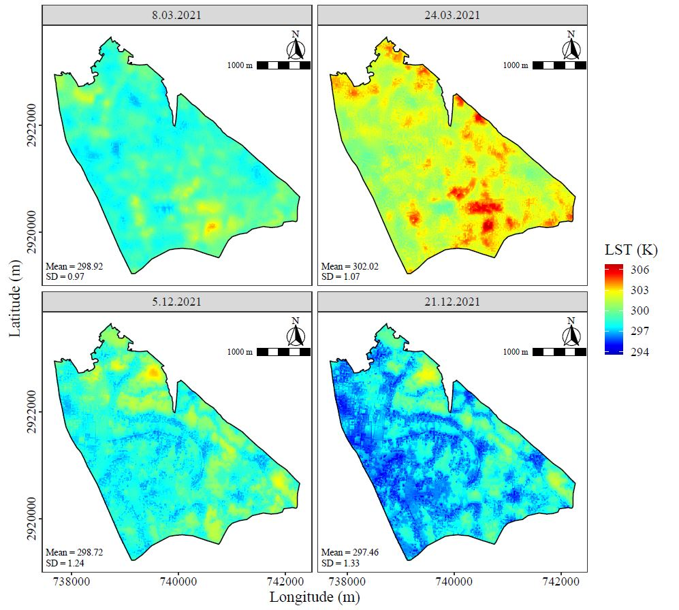
Figure S11. Spatial extent of TsHARP downscaled LST (10 m) over UBKV site.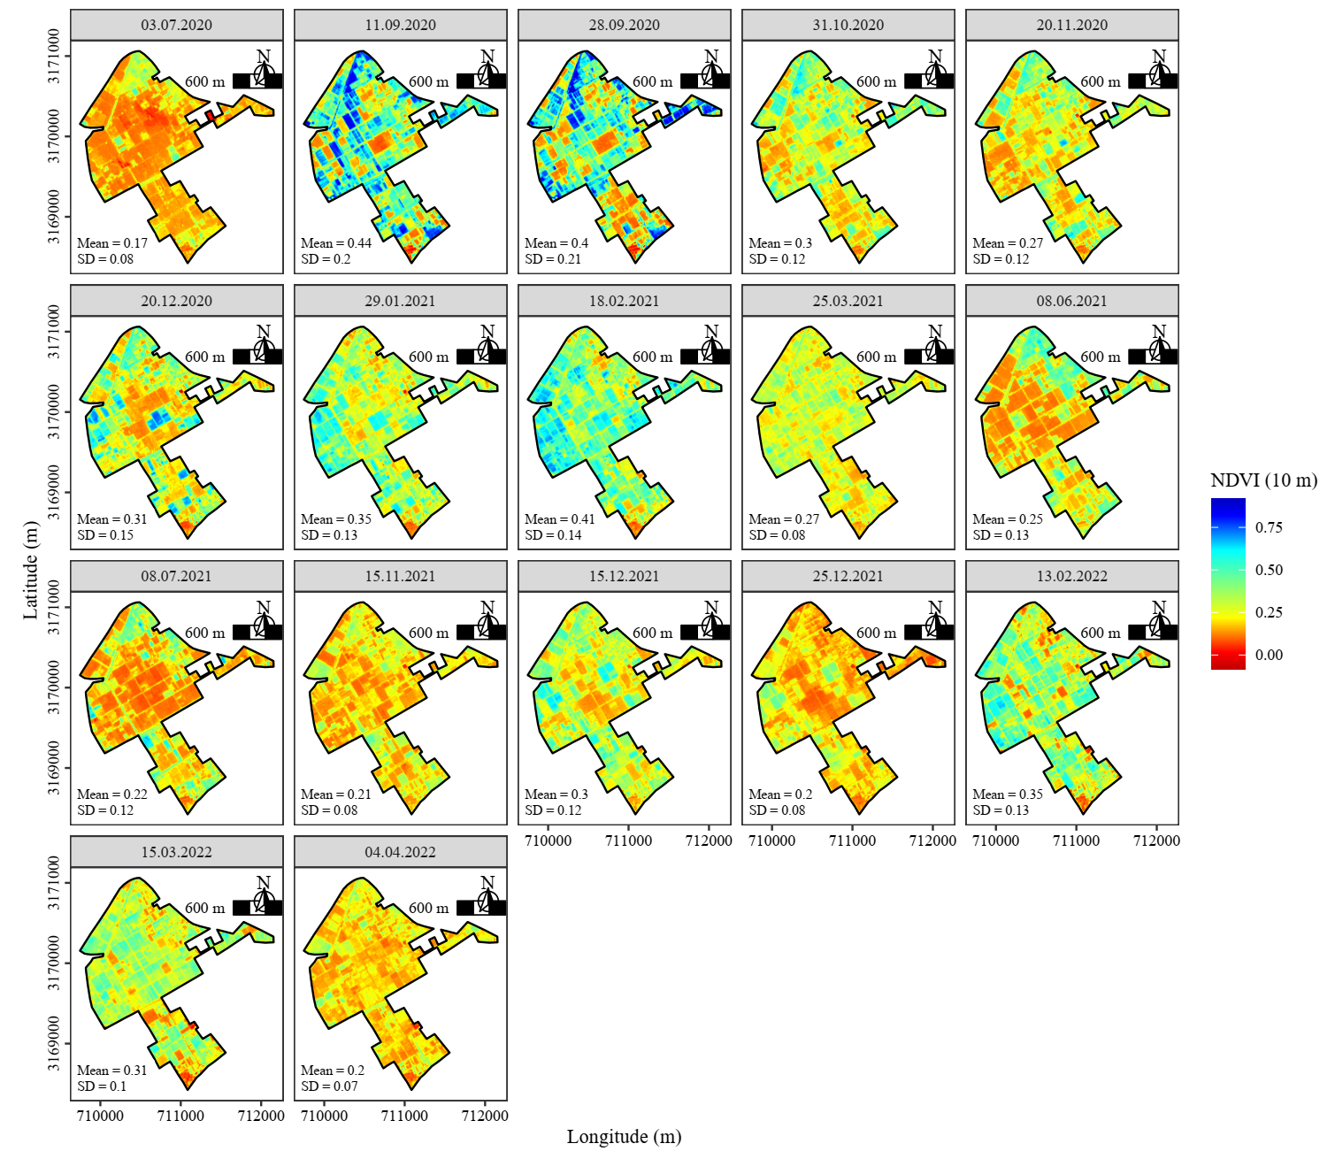
Figure S12. NDVI maps at IARI (semi-arid) site, covered the pre-monsoon to post-monsoon period from 2020-2022.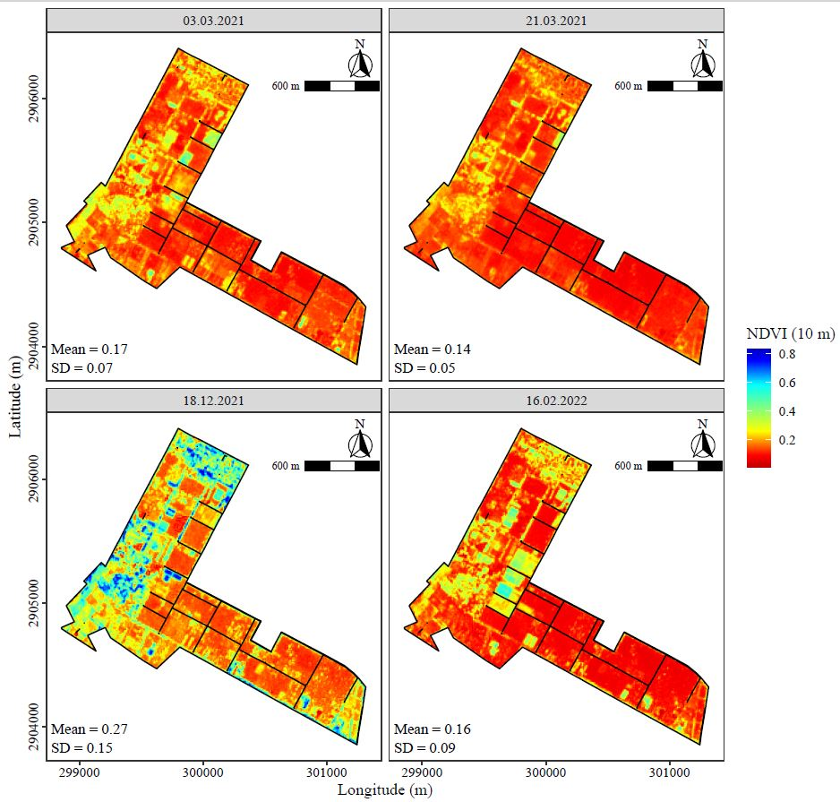
Figure S13. NDVI maps at 10 m over CAZRI (arid) site 2021-2022.
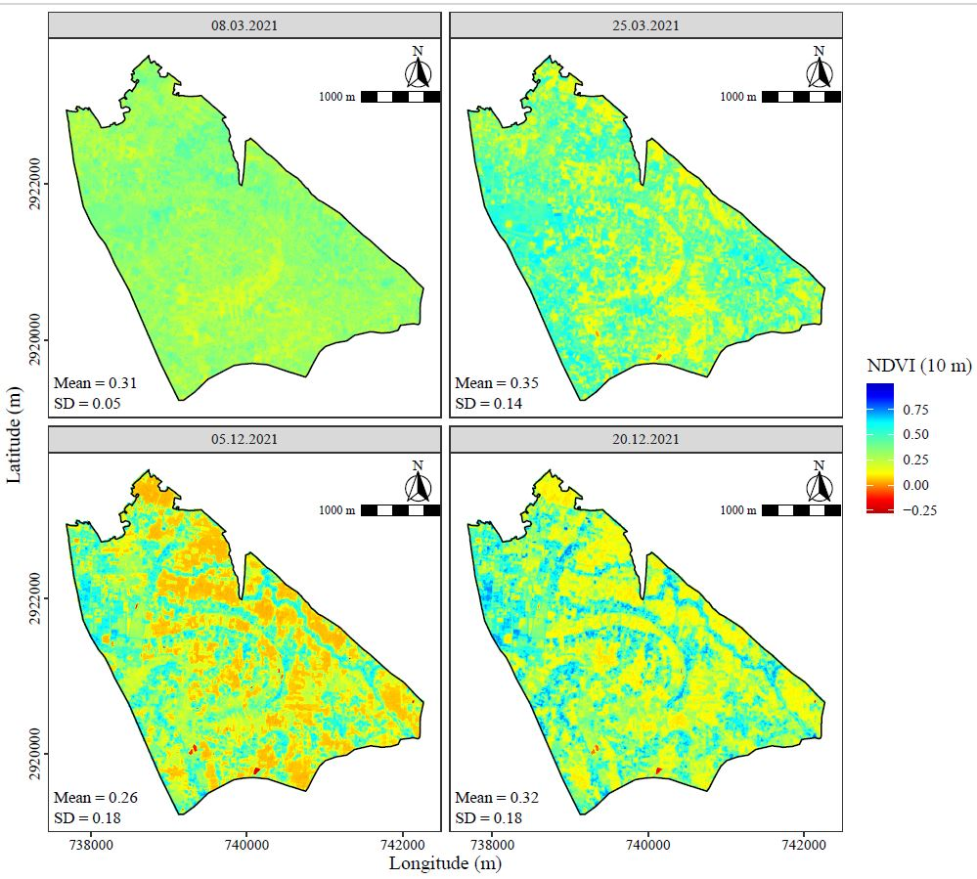
Figure S14. NDVI maps at 10 m over UBKV (Per-humid) site 2021.

