Supplementary Materials

Integrating high-resolution mass spectral data, bioassays and computational models to annotate bioactives in botanical extracts: Case Study - analysis of Centella asiatica extract associates dicaffeoylquinic acids with protection against amyloid-β toxicity in an MC65 cell model.
Armando Alcazar Magana^{1,2}, Ashish Vaswani¹, Kevin S. Brown^{3,4}, Yuan Jiang⁵, Md Nure Alam¹, Maya Caruso⁶, Parnian Lak¹, Paul Cheong¹, Nora Gray^{2,6}, Joseph Quinn^{6,7}, Amala Soumyanath^{2,6}, Jan F. Stevens^{2,3,8}, Claudia S. Maier^{1,2,8}*
¹ Department of Chemistry, Oregon State University, Corvallis, OR 97331, USA
² BENFRA Botanical Dietary Supplements Research Center, Oregon Health and Science University, Portland, OR 97239, USA
³ Department of Pharmaceutical Sciences, Oregon State University, 1601 SW Jefferson Way, Corvallis, OR 97331, USA
⁴ School of Chemical, Biological, and Environmental Engineering, Oregon State University, 116 Johnson Hall, 105 SW 26th Street, Corvallis, OR 97331, USA
⁵ Department of Statistics, Oregon State University, Corvallis, OR 97331, USA
⁶ Department of Neurology, Oregon Health and Science University, Portland, OR 97239, USA
⁷ Parkinson’s Disease Research Education and Clinical Care Center, Veterans’ Administration Portland Health Care System, Portland, OR, USA
⁸ Linus Pauling Institute, Oregon State University, Corvallis, OR 97331, USA
* Correspondence: claudia.maier@oregonstate.edu
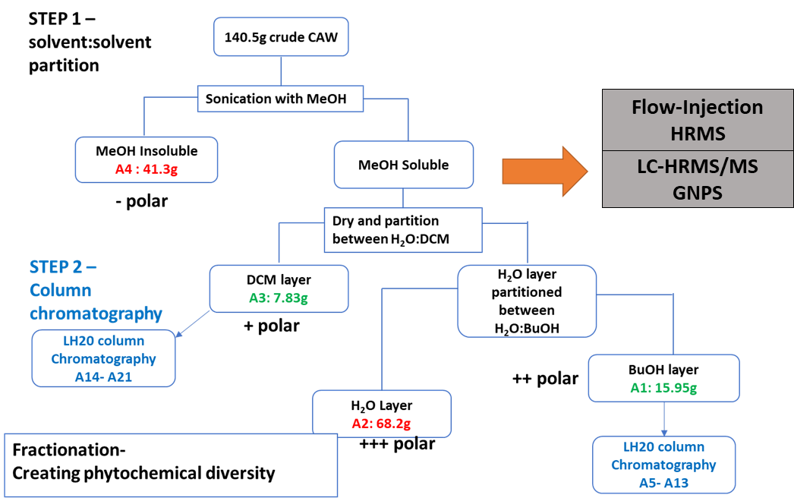
Figure S1. Fractionation scheme. 21 subfractions of CAW extract generated by solvent:solvent partitioning and LH-20 column chromatography. We analyzed each subfraction by flow-injection HRMS and correlated the features found with cytoprotective activity in an amyloid β-toxicity MC65 neuroblastoma cell model. In addition, CAW was analyzed by LC-HRMS/MS for obtaining precursor and fragment ion information for GNPS molecular network analysis. Relative polarity across fractions is indicated by “–“ and “+”.

