Supplementary Materials

GlcNAc6ST2/Chst4 is essential for the synthesis of R-10G-reactive keratan sulfate/sulfated N-acetyllactosamine oligosaccharides in mouse pleural mesothelium

Yoshiko Takeda-Uchimura¹, Midori Ikezaki², Tomoya O. Akama³, Yoshito Ihara², Fabrice Allain¹, Kazuchika Nishitsuji^{1,2} and Kenji Uchimura¹*

¹Univ. Lille, CNRS, UMR 8576 - UGSF - Unité de Glycobiologie Structurale et Fonctionnelle, Lille, France; yoshiko.uchimura@univ-lille.fr (Y.T.-U.); fabrice.allain@univ-lille.fr (F.A.); kazuchika.nishitsuji@univ-lille.fr (K.N.); kenji.uchimura@univ-lille.fr (K.U.)
²Department of Biochemistry, School of Medicine, Wakayama Medical University, Wakayama 641-8509, Japan; nishit@wakayama-med.ac.jp (K.N.); ikezaki@wakayama-med.ac.jp (M.I.); y-ihara@wakayama-med.ac.jp (Y.I.)
³Department of Pharmacology, Kansai Medical University, Osaka 570-8506, Japan; akamat@hirakata.kmu.ac.jp (T.-O.A.)

*Correspondence: kenji.uchimura@univ-lille.fr ; +33(0) 20 33 72 39

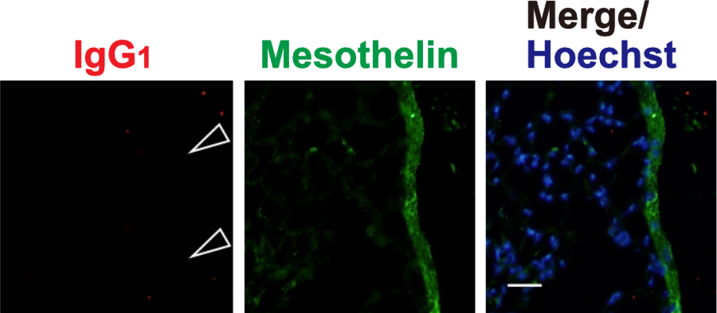

Figure S1. Immunohistochemical analysis of the mouse lung with control IgG₁.
Lung sections prepared from normal wild-type mice were co-stained with control mouse IgG₁ (red) and an anti-mesothelin (green) followed by Hoechst 33342 nuclear staining (blue). Signals with control IgG₁ in the pleural mesothelium are negligible (open arrowheads) revealed by co-stained signals with a mesothelium marker, mesothelin. Representative fluorescence microscope images of the lower/middle region of left lung lobe are shown (n = 2). Scale bar: 20 µm.

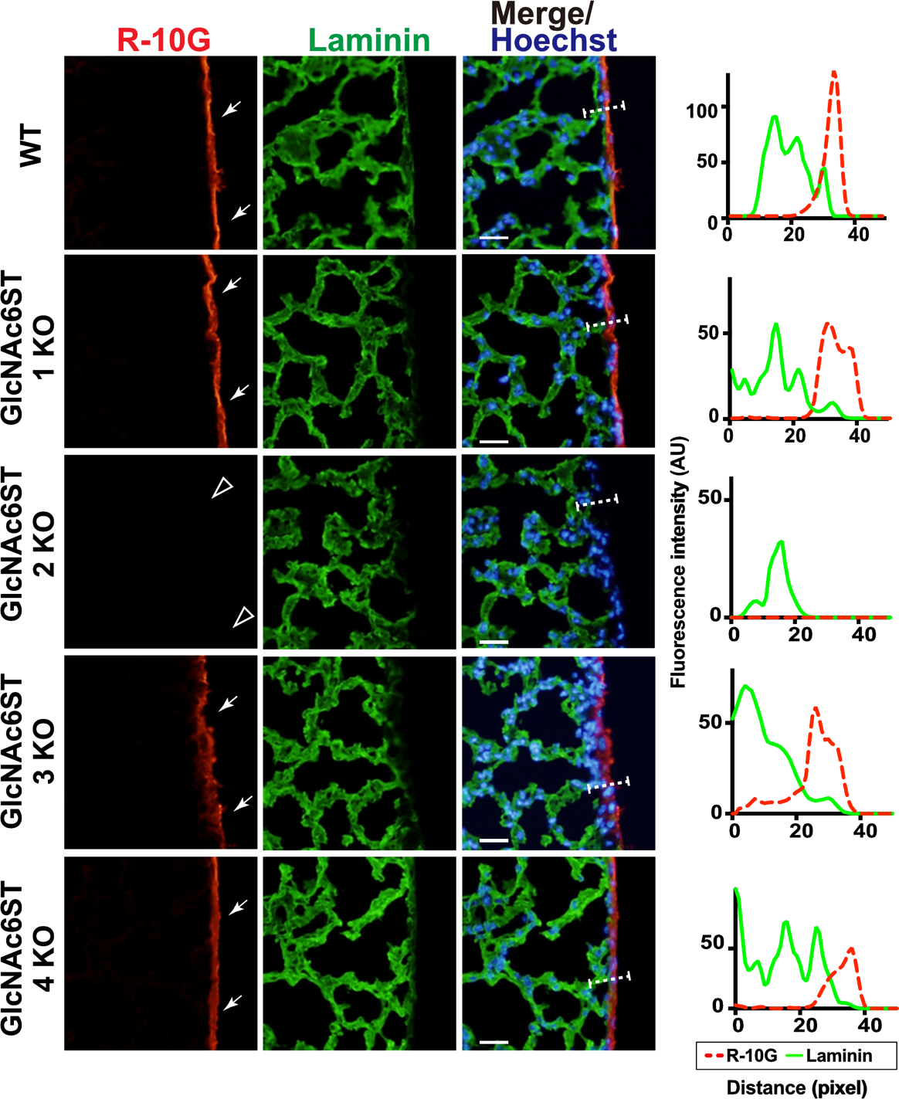

Figure S2. Immunohistochemical analysis of the mouse lung with R-10G and anti-laminin.
Lung sections prepared from normal wild-type (WT), Chst2-deficient (GlcNAc6ST1 KO), Chst4-deficient (GlcNAc6ST2 KO), Chst5-deficient (GlcNAc6ST3 KO), or Chst7-deficeint (GlcNAc6ST4 KO) mice were co-stained with R-10G (red) and anti-laminin (green) followed by Hoechst 33342 nuclear staining (blue). Dense R-10G staining in the pleural mesothelium is shown (arrows). Sections of GlcNAc6ST2 KO showed negligible levels of R-10G signals in the mesothelium (open arrowheads). Digital images were captured using the same settings for each staining. The plot profiles of R-10G and laminin staining are shown. The signal intensities along the path of the line marker (dashed white line) in the merged images were measured as described in Materials and Methods (n = 3 for each genotype). Scale bar: 20 µm.

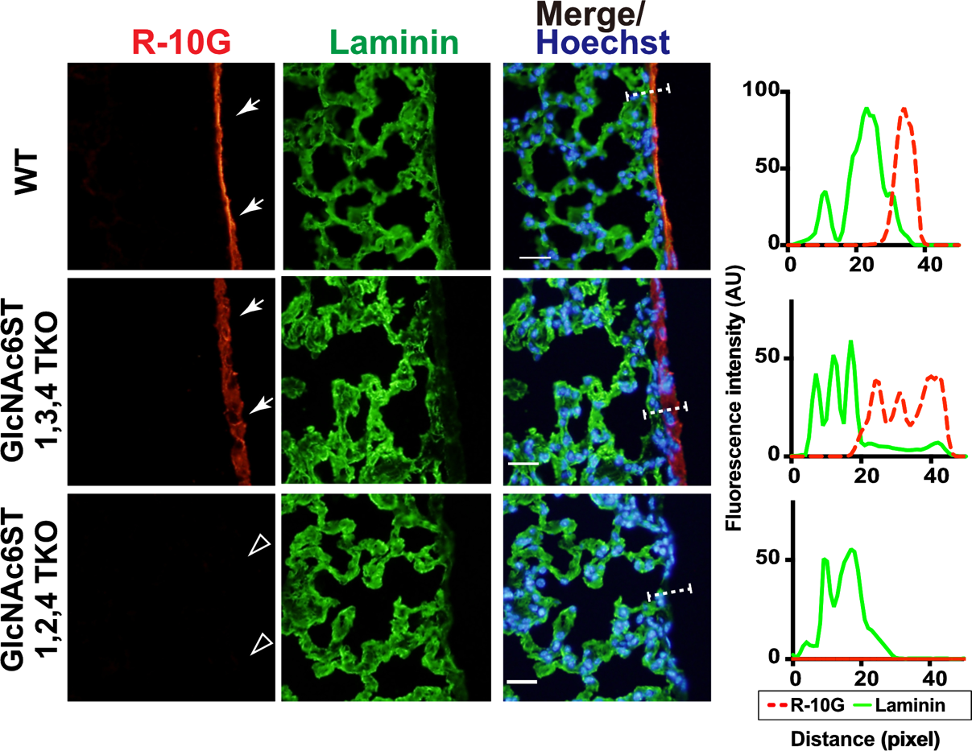

Figure S3. Immunohistochemical analysis of the mouse lung with R-10G and anti-laminin.
Lung sections prepared from normal wild-type (WT), Chst2/Chst5/Chst7 triple-deficient (GlcNAc6ST1,3,4 TKO) and Chst2/Chst4/Chst7 triple-deficient (GlcNAc6ST1,2,4 TKO) mice were co-stained with R-10G (red) and anti-laminin (green) followed by Hoechst 33342 nuclear staining (blue). Dense R-10G staining in the pleural mesothelium is shown (arrows). Sections of GlcNAc6ST1,2,4 TKO showed negligible levels of R-10G signals in the mesothelium (open arrowheads). Digital images were captured using the same settings for each staining. The plot profiles of R-10G and laminin staining are shown. The signal intensities along the path of the line marker (dashed white line) in the merged images were measured as described in Materials and Methods (n = 3 for each genotype). Scale bar: 20 µm.

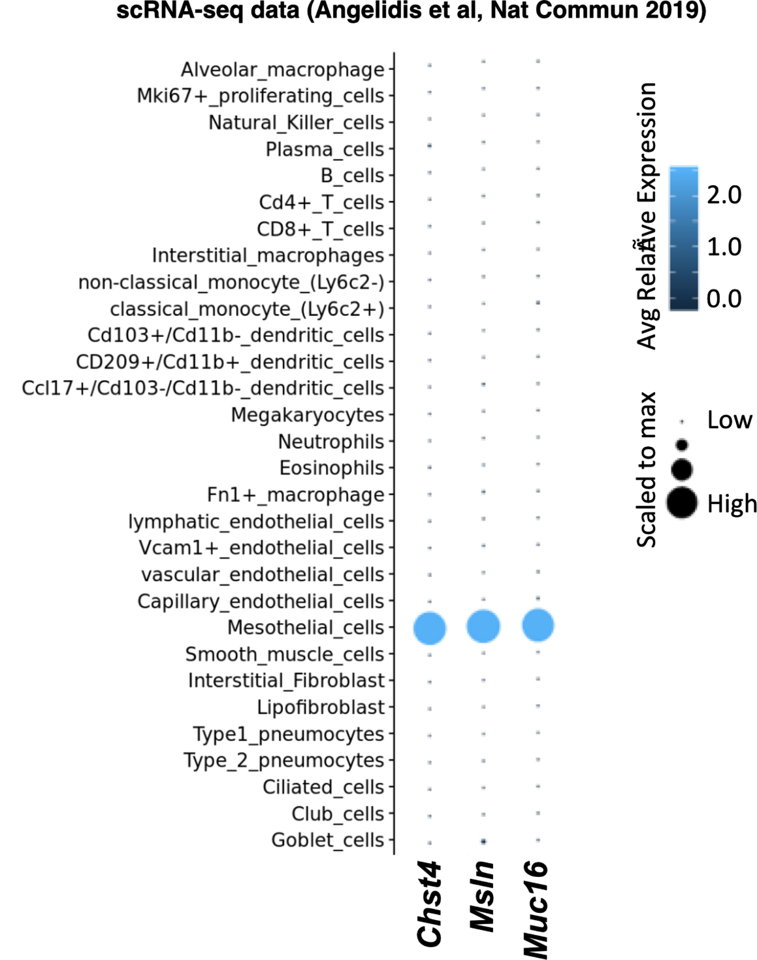

Figure S4. Single cell RNA-seq data showing high, selective expression of Chst4, Msln and Muc16 in mesothelial cells in mouse lung.
Data pertinent to the genes of Chst4, Msln and Muc16 were mined from a published single cell RNA sequencing (scRNA-Seq) analysis of adult mouse lung (Angelidis, L. et al., Nat Commun 2019, DOI: 10.1038/s41467-019-08831-9). Comparison of their transcription profiles in various cell types of the lung was performed using an scRNA-Seq transcriptome platform (https://theislab.github.io/LungAgingAtlas/).

