Epicardial atrial fat at cardiac magnetic resonance imaging and AF recurrence after transcatheter ablation
Supplementary Material

Figure S1. Direct comparison of the absolute LA EAT volume according to recurrence status.
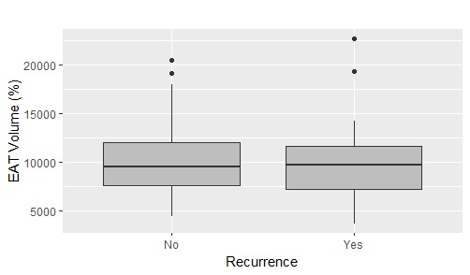

Figure S2. ROC curve analysis for the absolute LA EAT volume. Finest cut-off identified with the Youden index wass 19.2 ml with a sensitivity of 0.12, a specificity of 0.97, positive predictive value of 0.67 and negative predictive value of 0.68.
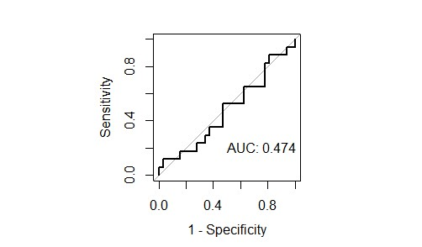

Figure S3. Kaplan-Meier arrhythmia-free survival curves stratified by the absolute LA EAT volume above o below 19.2 ml, showing no statistically significant difference (62% vs 33%; p-value=0.2).
