Supplementary Figures
Visualization of Glioblastoma with Infrared-Labeled Aptamers for Fluorescent Guided Surgery

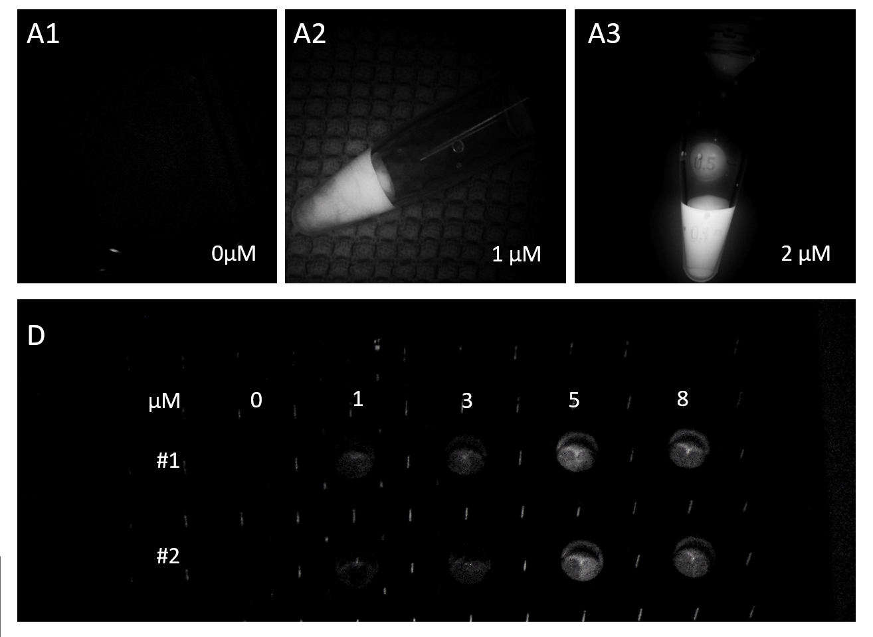
Figure S1. Fluorescent microscopy of IR-Glint (A) in solution of DPBS in concentrations 0µM (1); 1 µM (2) and 2 µM (3). Glial tumor tissues incubated with Cy 7.5-labeled aptamers (#1 – Gli-233 nt and 233, #2 – Gli-55 3L) in 1 – 8 µM under IR-module of surgical microscope Zeiss Kinevo 900. In panel A IR-Glint were in 1.5 ml vials. In panel B the tissue samples were in 96-well plate.

Figure S2. Distribution of IR-Glint in healthy mice after intravenous injection registered at Brightfield (1), IR fluorescence (F). Mice prior injection (A), 5 minutes (B), 40 minutes (C), 90 minutes (D), and 24 hours (E) after the tail vein injection. Accumulation of IR-Glint in organs (F): 1 - brain, 2 – kidneys, 3 - spleen, 4 - liver, 5 - intestines, 6 - gallbladder, 7 - lungs, and 8 - heart.

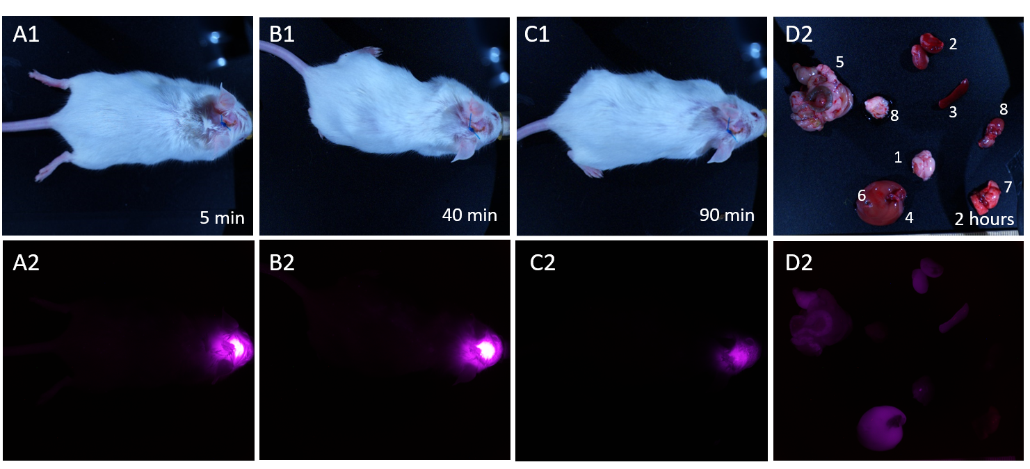

Figure S3. Distribution of IR-Glint in healthy mice with intracranial window after subcutaneous injection registered at Brightfield (1), IR fluorescence (2). Mice 5 minutes (A), 40 minutes (B), 90 minutes (C). Accumulation of IR-Glint in organs (D): 1 – brain, 2 – kidneys, 3 – spleen, 4 – liver, 5 – intestines, 6 – gallbladder, 7 – lungs, and 8 – heart, 9 – peritoneal fat.

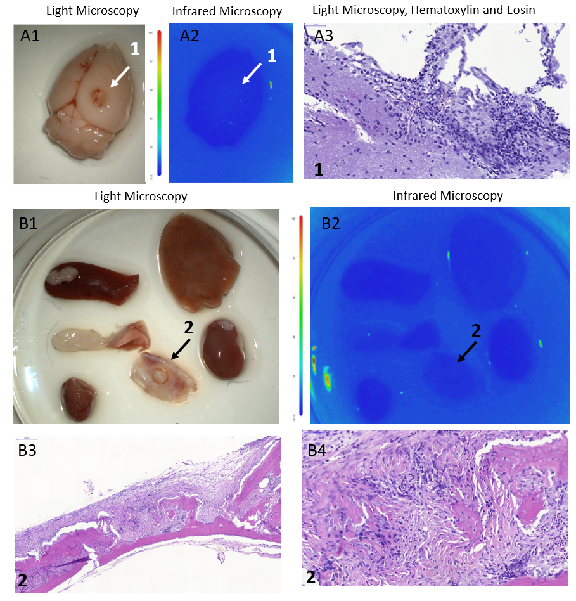

Figure S4. Backgraund IR frluorescence (A2, B2) and light microscopy (A1, B1) of ortotopicaly xenotransplanted glioblastoma (A1, arrow 1), tumor inside the skull (B1, arrow 2) and organs (B1) without IR-Glint administration. H&E staining confirmed glial tumor formation in mice brains (A3) and inside the skull (B3, B4).

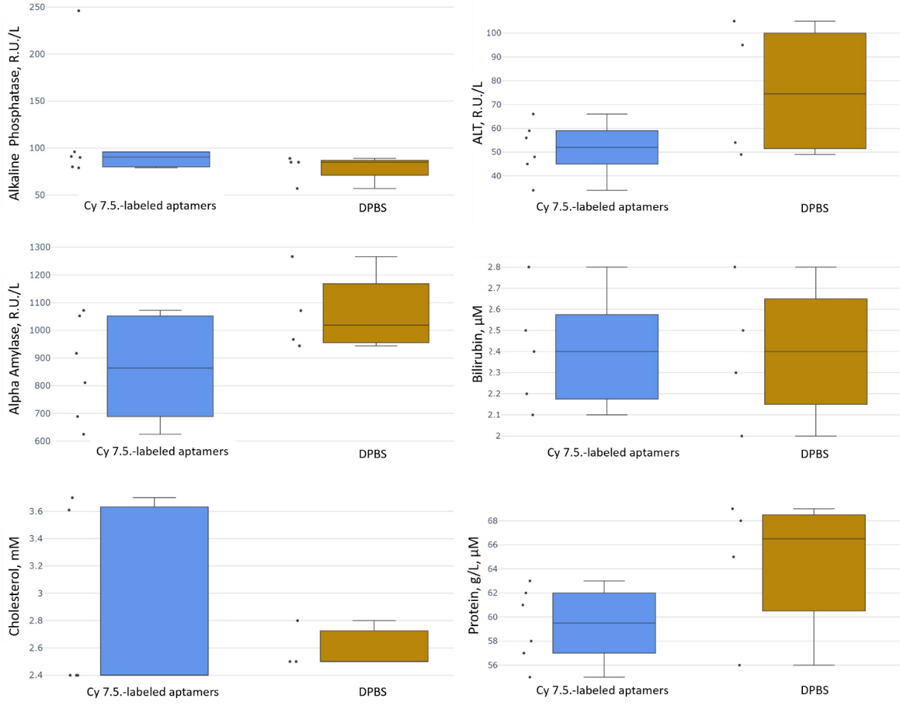

Figure S5. Blood biochemical parameters of mice injected with IR-Glint (pooled Gli-233nt and Gli-55_3L).

