**Co-Delivery of a Novel Lipidated TLR7/8 Agonist and Hemagglutinin-based Influenza Antigen Using Silica Nanoparticles Promotes Enhanced Influenza-Specific Immune Responses**

**Walid M. Abdelwahab1,2, Sarah Auclair1,2, Timothy Borgogna1,2, Karthik Siram1,2, Alexander Riffey1,2, Hélène G. Bazin3, Howard B. Cottam4, Tomoko Hayashi4, Jay T. Evans1,2,3, David J. Burkhart1,2,3\***

1Center for Translational Medicine, 2Department of Biomedical and Pharmaceutical Sciences, University of Montana, 32 Campus Drive, Missoula, MT 59802, 3Inimmune Corporation, 1121 East Broadway, Missoula, MT 59812**,** 4Moores Cancer Center, University of California San Diego, La Jolla, CA 92093-0809

______________________________________________________________________

* Corresponding author

Tel: (+1) 406-361-1672

E-mail address: david.burkhart@mso.umt.edu

Biomedical & Pharmaceutical Sciences

Skaggs School of Pharmacy

32 Campus Dr.

University of Montana

Missoula, MT 59812

**Table S1. Reagents used in ELISA**

|  |  |  |  |
| --- | --- | --- | --- |
| **Reagents** | **Dilution factor** | **Source** | **Catalog #** |
| *Capture antibodies* |  |  |  |
| Purified rat anti-mouse TNFα | 125 | Thermo Fisher Scientific | 14-7325-85 |
| Purified rat anti-mouse IL-12 p40/p70 | 200 | BD Biosciences | 551219 |
| Purified rat anti-mouse IL-6 | 100 | BD Biosciences | 554400 |
| *Detecting antibodies* |  |  |  |
| Biotin mouse anti- mouse TNFα | 250 | Thermo Fisher Scientific | 14-7325-86 |
| Biotin rat anti-mouse IL-12 p40/p70 | 1000 | BD Biosciences | 554476 |
| Biotin rat anti-mouse IL-6 | 1000 | BD Biosciences | 554402 |
| *Other reagents* |  |  |  |
| Streptavidin, HRP | 1000 | Thermo Fisher Scientific | 43-4323 |
| KPL SureBlueTM TMB Peroxidase Substrate |  | Seracare | 5120-0077 |

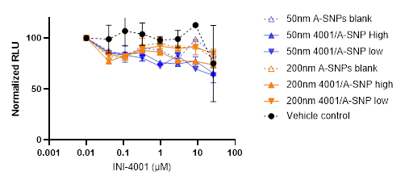

**Figure S1. Effect of INI-4001/A-SNP formulations on viability of human PBMCs.** PBMCs were cultured with serially diluted SNP formulations for 24 hours and cell viability determined using the CellTiter Glo assay system. Viability is expressed as percent relative luminescent units (RLU) compared to PBMCs incubated 24 hours without the formulations. Data shown as mean ± SD of 3 independent experiments. Color should be used in print.



Figure S2. IL-12 release by 50, and 200nm INI-4001/A-SNP in TLR7 deficient mBMDC. Wild type and TLR7 deficient mBMDC were incubated with the formulations overnight, and IL-12 release was determined by ELISA. A/SNP alone, LPS, and 1V270 (TLR7 ligand) served as controls.

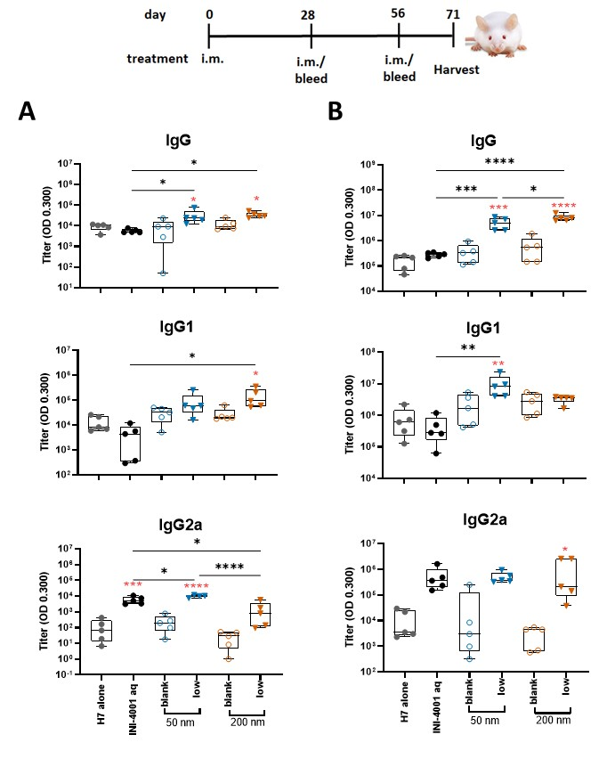

Figure S3. H7-specific antibody titers 28 days post primary (A) or secondary (B) vaccination. Mice were immunized with 1 µg of influenza/A H7 trimer adsorbed onto INI-4001/SNP at the described particle size and coating density. One-way ANOVA of log-transformed data followed by uncorrected Fisher’s multiple comparisons was used to calculate statistically significant differences between the INI-4001 containing groups (black) and the H7 antigen only group (red). * p < 0.05; ** p < 0.01; *** p < 0.001; ****p < 0.0001. N = 5

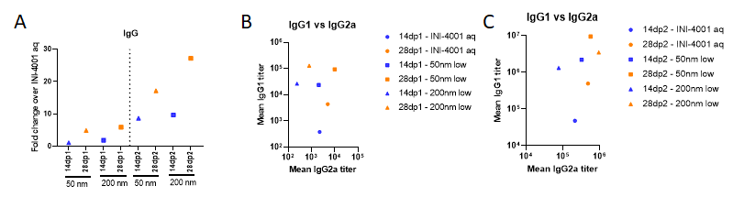

**Figure S4:** (A) Ratio of H7-specific antibody titers of the 50 and 200 nm low-density INI-4001/A-SNP formulations over the INI-4001 aqueous control 14 vs 28 days post primary or secondary vaccination. Scatter plot of the mean values of the IgG2a titers (X-axis) and IgG1 (Y-axis) for each formulation post-primary (B) or post-secondary (C) immunization was generated to show the adjuvant potency distribution.