Supplementary data
Comparative Effect of Fe, Co, Ni Oxides Supported on Ti-Incorporated Zeolite Y on Photocatalytic Performances

Gabriela Petcu^{1,*}, Elena M. Anghel¹, Irina Atkinson¹, Daniela C. Culita¹, Nicoleta G. Apostol², Florica Papa¹, Adriana Baran¹, Jean-Luc Blin³ and Viorica Parvulescu^{1,*}
¹ Institute of Physical Chemistry "Ilie Murgulescu" of the Romanian Academy, 202 Splaiul Independentei, 060021 Bucharest, Romania; gpetcu@icf.ro (G.P.), manghel@icf.ro (E.M.A.), iatkinson@icf.ro (I.A.), dculita@icf.ro (D.C.C.), floricapapa@gmail.com (F.P.), adibaran@gmail.com (A.B.), vpirvulescu@icf.ro (V.P.)
² National Institute of Materials Physics, Atomistilor 405A, 077125 Magurele, Romania;
nicoleta.apostol@infim.ro
³ Faculty of Sciences and Technology, University of Lorraine, CNRS, L2CM, F-54000 Nancy, France; jean-luc.blin@univ-lorraine.fr
* Correspondence: gpetcu@icf.ro (G.P.), vpirvulescu@icf.ro (V.P.)

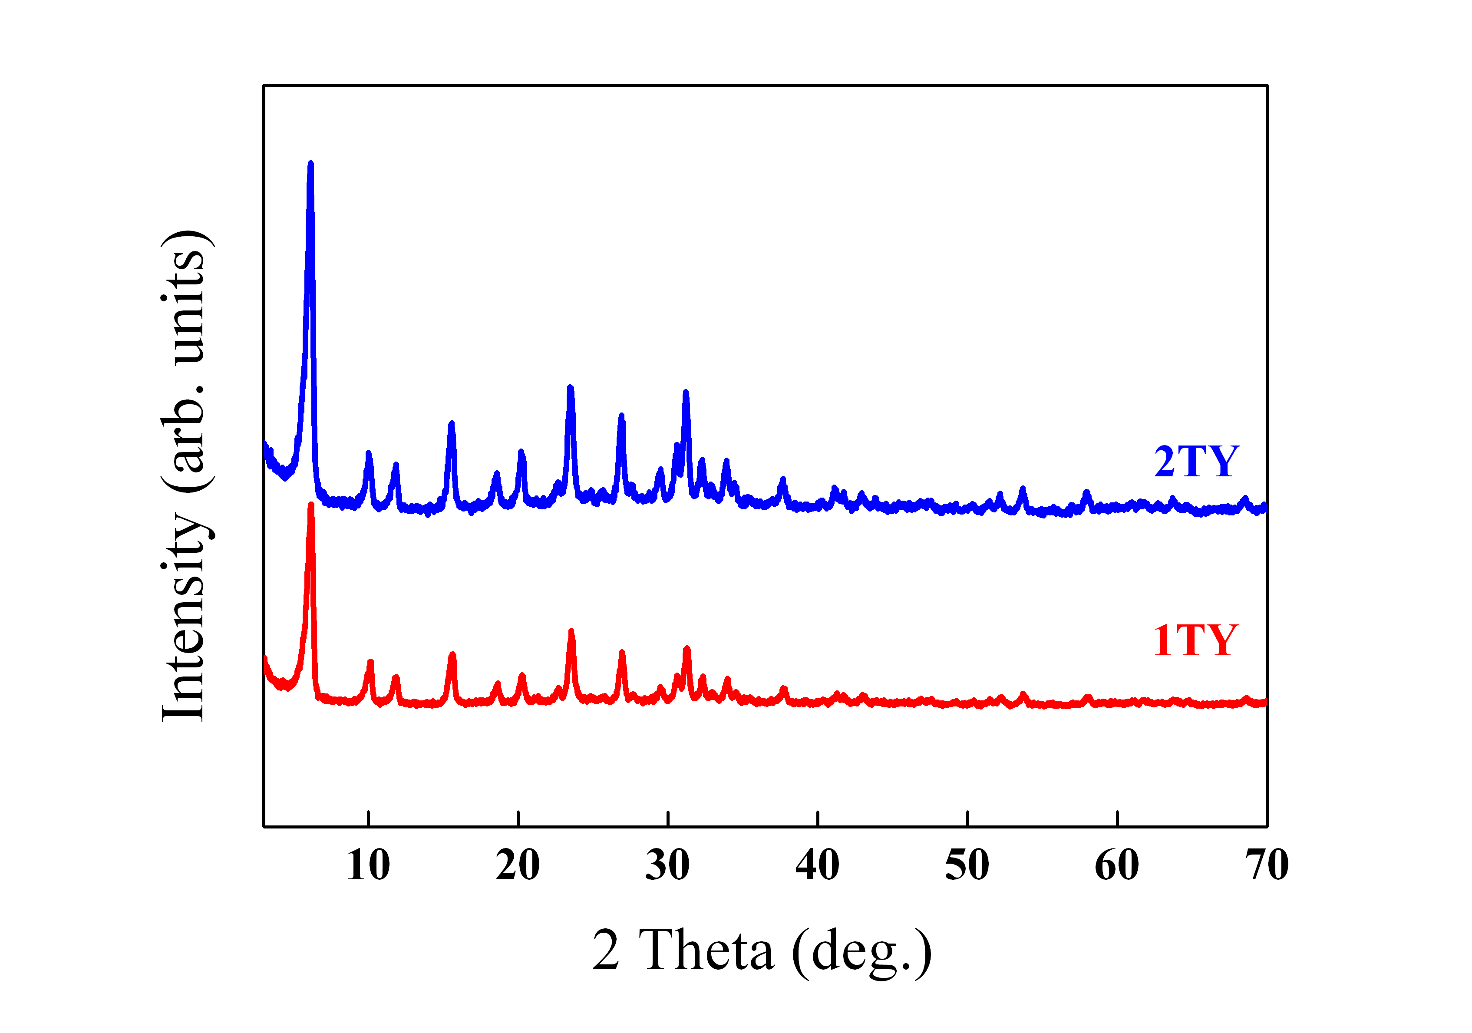

Figure S1. XRD patterns of Ti-zeolite Y supports.

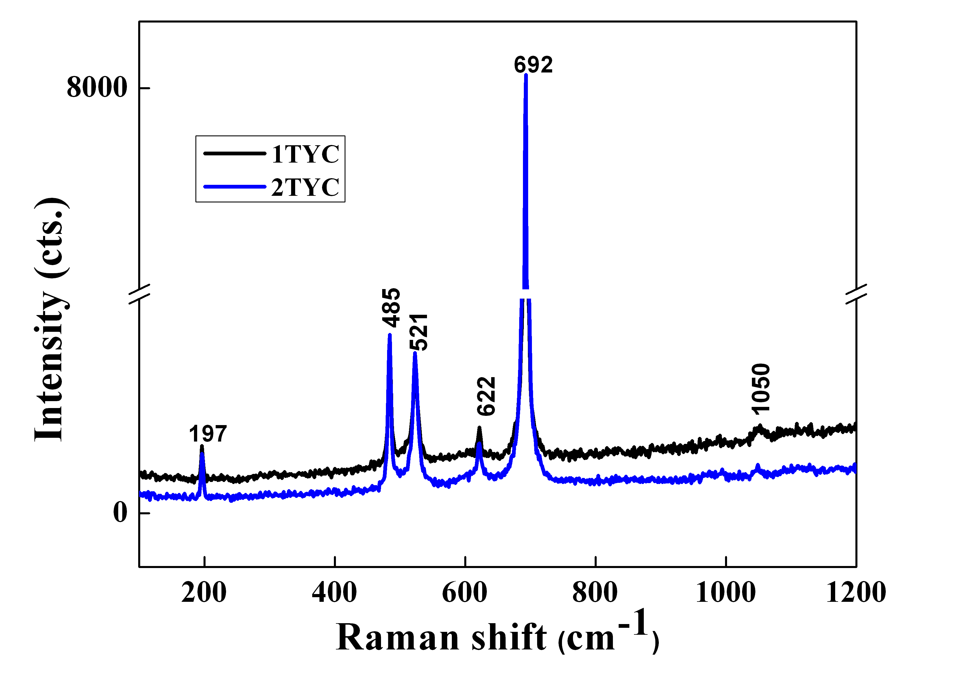

Figure S2. Vis-Raman spectra of the (½)TYC materials.

