Supplementary Material

Seasonal bleaching and partial mortality of Pocillopora verrucosa corals of the coast of central Vietnam.
F.V. Lishchenko*, Yu.A. Burmistrova, R.A. Petrochenko, T.H. Nguen, T.A. Britayev
* Correspondence: Corresponding Author: Fedor-LN@ya.ru

Supplementary Figures

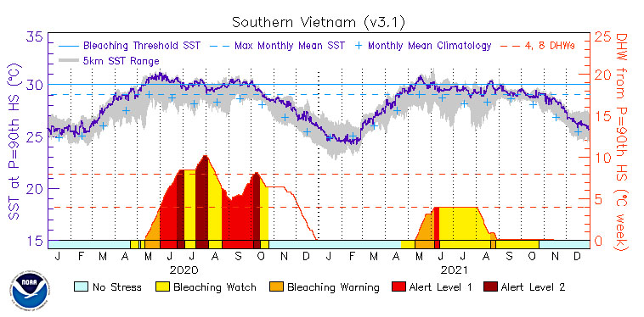
Supplementary Figure 1. Southern Vietnam, 5 km Regional Bleaching Heat Stress Maps and Gauges (Version 3.1). https://coralreefwatch.noaa.gov/product/vs/gauges/southern_vietnam.php

 | Water temperature |  | Precipitation |  |  |  | Eastern wind speed*
Month | Monthly average,  ˚C | Daily minimum/maximum,  ˚C | Monthly average,  mm | Daily maximum,  mm/day | Accumulated precipitation,  mm/month | Number of rainy days | Monthly average,  m/s | Daily maximum  m/s | Number of windy days
June 2020 | 28.16 | 26.69-29.54 | 0.07 | 1.75 | 2.0 | 2 | 1.01 | 2.00 | 22
July 2020 | 28.02 | 26.39-29.84 | 0.45 | 5.25 | 14.0 | 5 | 1.12 | 1.90 | 25
August 2020 | 29.24 | 27.33-30.31 | 1.74 | 39.25 | 54.0 | 9 | 1.23 | 2.21 | 25
September 2020 | 30.60 | 29.50-31.28 | 3.88 | 48.75 | 116.3 | 9 | 1.51 | 2.22 | 26
October 2020 | 29.37 | 27.41-31.18 | 10.22 | 72.25 | 316.8 | 20 | 1.23 | 1.92 | 27
November 2020 | 27.04 | 26.11-28.30 | 19.68 | 165.5 | 590.5 | 12 | 1.56 | 2.12 | 28
December 2020 | 25.35 | 24.24-26.23 | 8.10 | 71.5 | 251.0 | 14 | 1.77 | 3.27 | 27
January 2021 | 23.47 | 22.92-24.04 | 0.21 | 2 | 6.5 | 7 | 1.74 | 2.62 | 29
February 2021 | 24.10 | 23.34-25.78 | 0.00 | 0 | 0.0 | 0 | 1.64 | 2.20 | 27
March 2021 | 26.43 | 24.99-28.27 | 0.85 | 12.75 | 26.5 | 7 | 1.31 | 2.14 | 26
April 2021 | 28.15 | 26.33-29.79 | 4.10 | 48 | 123.0 | 5 | 1.24 | 1.88 | 24

Supplementary Tables
Supplementary Table 1. Seasonal variation of the environmental factors at the Dam Bay station. *winds, blowing from east and south-east directions (80-190°).

Supplementary Table 2. Impact of environmental factors on bleaching. Significant impacts are highlighted in bold.
Effect | Sum of squares | df | Mean square | F | p | η_{p}²
Intercept | 397.224 | 1 | 397.224 | 4.199 | 0.045 | 0.070
Water temperature | 1122.967 | 1 | 1122.967 | 11.870 | 0.001 | 0.175
Precipitation | 265.307 | 1 | 265.307 | 2.804 | 0.100 | 0.048
Eastern wind speed | 228.846 | 1 | 228.846 | 2.419 | 0.126 | 0.041
Colony density | 318.834 | 4 | 79.708 | 0.843 | 0.504 | 0.057
PM in the previous survey | 712.714 | 1 | 712.714 | 7.533 | 0.008 | 0.119
Error | 5298.093 | 56 | 94.609

Supplementary Table 3. Impact of environmental factors on partial mortality. Significant impacts are highlighted in bold.
Effect | Sum of squares | df | Mean square | F | p | η_{p}²
Intercept | 0.005 | 1 | 0.005 | 0.000 | 0.984 | < 0.001
Water temperature | 74.550 | 1 | 74.550 | 6.120 | 0.016 | 0.099
Precipitation | 18.051 | 1 | 18.051 | 1.482 | 0.229 | 0.026
Eastern wind speed | 159.212 | 1 | 159.212 | 13.069 | 0.001 | 0.189
Colony density | 49.253 | 4 | 12.313 | 1.011 | 0.410 | 0.067
Bleaching in the previous survey | 75.094 | 1 | 75.094 | 6.164 | 0.016 | 0.099
Error | 682.192 | 56 | 12.182

