Supplementary information

The Crayfish Plague Pathogen Aphanomyces astaci in Ireland
¹ 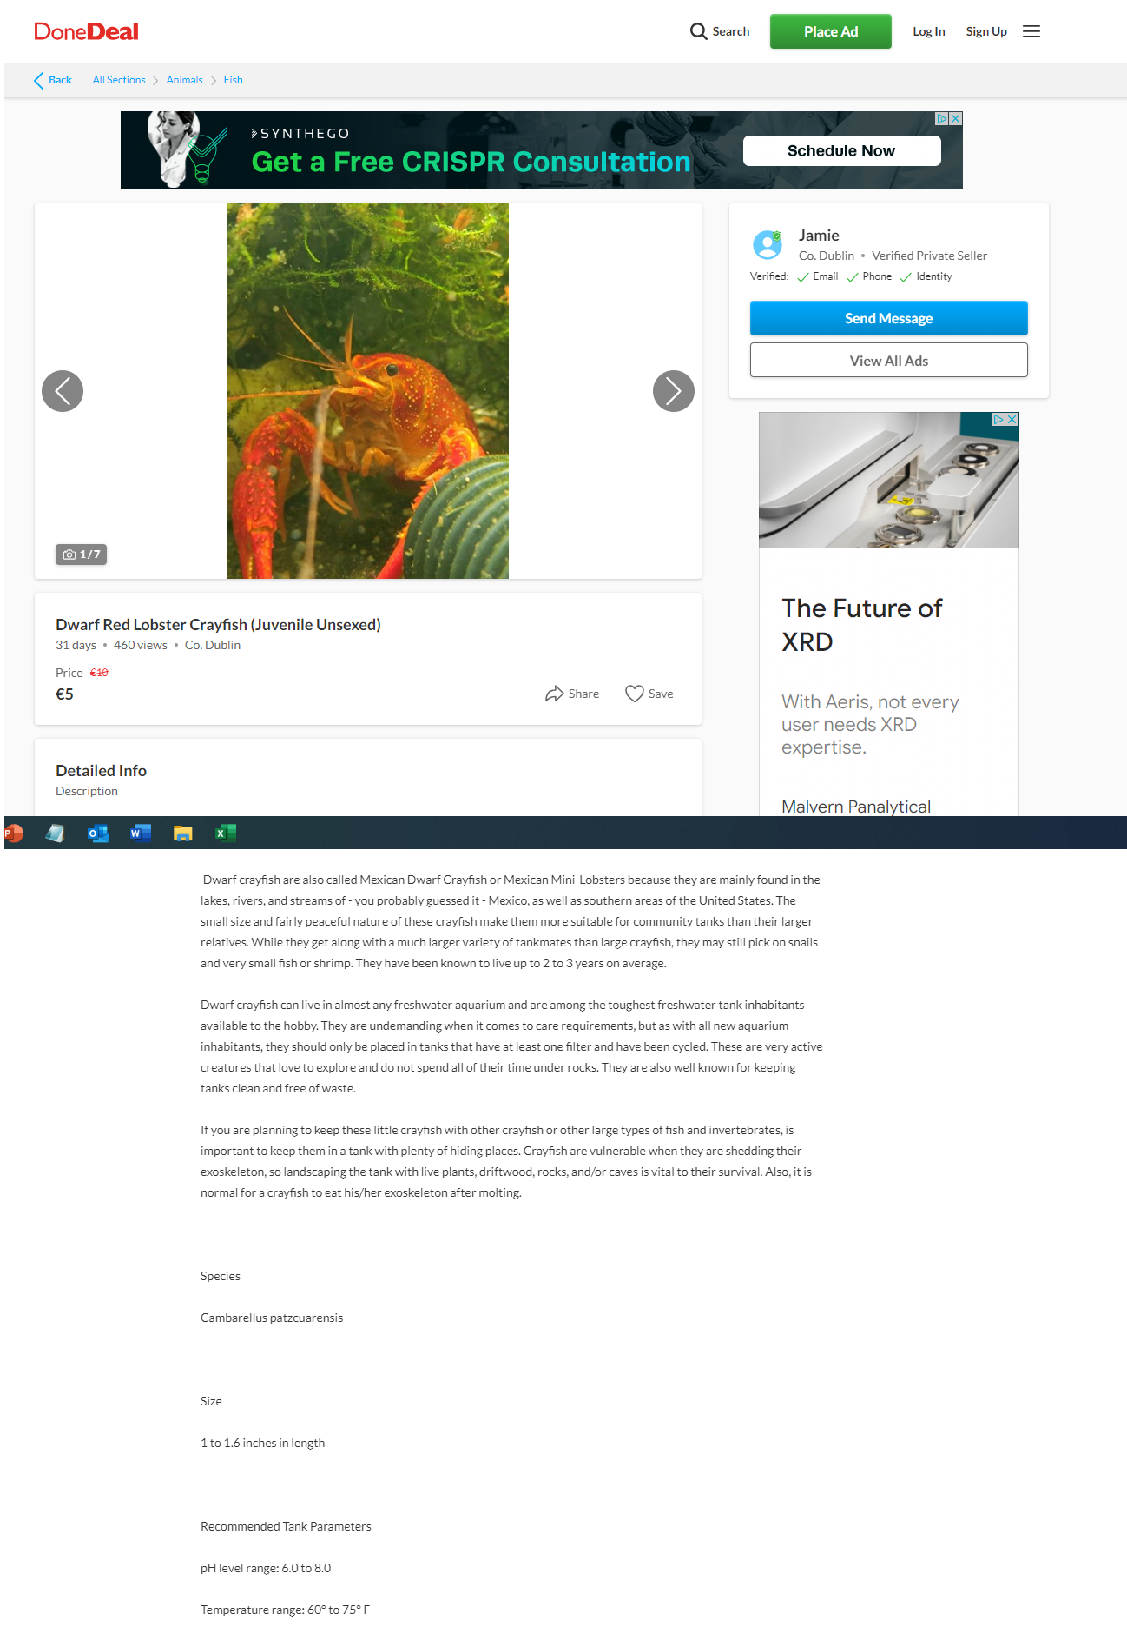
Figure S1. An advertisment for Cambarellus patzcuarensis on DoneDeal in Ireland, September 2023. The advert was online for a minimum of 43 days.

