On Bisphosphonates and COVID-19: In silico Model Suggests Inhibition of SARS-CoV-2 RdRp as Potential Explanation
Muzaffar-Ur-Rehman Mohammed ^{1 ‡}, Kishor Suryakant Chougule ^{1 ‡}, Chandu Ala ¹, Pranali Vijaykumar Kuthe ¹, Mohit Garg ², Murugesan Sankaranarayanan ¹*, and Seshadri S. Vasan ^{3, 4}*
¹ Department of Pharmacy, Birla Institute of Technology and Science, Pilani 333031, India; p20210457@pilani.bits-pilani.ac.in, h20210293@pilani.bits-pilani.ac.in, p20210055@pilani.bits-pilani.ac.in, p20220062@pilani.bits-pilani.ac.in, murugesan@pilani.bits-pilani.ac.in
² Department of Chemical Engineering, Birla Institute of Technology and Science, Pilani 333031, India; mohit.garg@pilani.bits-pilani.ac.in
³ School of Medical and Health Sciences, Edith Cowan University, Joondalup, WA 6027, Australia
⁴ Department of Health Sciences, University of York, York YO10 5DD, U.K; prof.vasan@york.ac.uk

* Correspondence: murugesan@pilani.bits-pilani.ac.in or prof.vasan@york.ac.uk
‡ These authors contributed equally to this work.

Table 1: Timeline plots and 2D interaction diagrams of the selected seven hit compounds
S. no | Time-line plot | 2D interaction diagram
1. | CHEMBL164344
2. | CHEMBL196676
3. | CHEMBL387132
4. | CHEMBL4291724
5. | CHEMBL608526†
6. | CHEMBL4569308†
7. | CHEMBL98211†
8. | CHEMBL164344†
9. | Remdesivir
10. | Cinnamaldehyde | 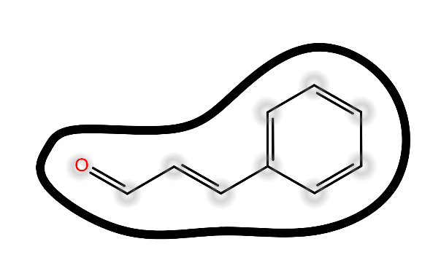
† indicates protomers

