Appendix A: participatory studies for planning of urban green spaces
Table A.1.
Participatory approaches to planning of urban green spaces, specifying which elements were included
Source | Multiple health-  related benefits | Health-related burdens | Design  of green space * | Assess-ment of impacts | Mapping ** | Comments
Brown et al. (2015) | X | (X) | - | - | X | Review, burdens included in 1 out of 30 studied approaches.
Bush et al. (2021) | X | - | - | - | -
Czismady et al. (2016) | - | - | - | - | -
Fors et al. (2015) | X | - | - | X | - | Review of 31 studied approaches
García de Jalón et al., (2020) | X | (X) | - | X | - | Some burdens of land use change included, but not related to UGS.
Jones et al. (2020) | X | - | - | X | X
Kyttä et al. (2013) | - | - | - | - | X
Literat (2013) | - | - | - | - | X
Menconi et al. (2020) | - | - | X | - | -
Møller et al. (2019) | - | - | - | - | X
Pietrzyk-Kaszyńska et al. (2017) | X | - | X | - | X
Turan et al. (2016) | - | - | - | - | -
Vaňo et al. (2021) | - | - | - | - | -
Veen et al. (2020) | X | - | X | - | -
Zhou et al. (2016) | - | - | - | - | X
* Or development of green space design principles
** Mapping participant-assessed use or valuation of areas and/or mapping participatory designs and/or mapping participatory assessment results

Reference list for sources in this Appendix
Brown, G., & Fagerholm, N. (2015). Empirical PPGIS/PGIS mapping of ecosystem services: A review and evaluation. Ecosystem Services, 13, 119-133. doi:https://doi.org/10.1016/j.ecoser.2014.10.007
Bush, J., Ashley, G., Foster, B., & Hall, G. (2021). Integrating green infrastructure into urban planning: Developing Melbourne’s green factor tool.
Csizmady, A., Treija, S., Fáczányi, Z., & Balogh, P. I. (2016). Participatory design processes for the development of green areas of large-scale housing: case studies from Budapest and Riga. Critical Housing Analysis, 3(2), 17-25.
Fors, H., Molin, J. F., Murphy, M. A., & Konijnendijk van den Bosch, C. (2015). User participation in urban green spaces – For the people or the parks? Urban Forestry & Urban Greening, 14(3), 722-734. doi:https://doi.org/10.1016/j.ufug.2015.05.007
García de Jalón, S., Chiabai, A., Mc Tague, A., Artaza, N., de Ayala, A., Quiroga, S., . . . Taylor, T. (2020). Providing Access to Urban Green Spaces: A Participatory Benefit-Cost Analysis in Spain. International Journal of Environmental Research and Public Health, 17(8), 2818.
Jones, L., Holland, R. A., Ball, J., Sykes, T., Taylor, G., Ingwall-King, L., . . . S.-H. Peh, K. (2020). A place-based participatory mapping approach for assessing cultural ecosystem services in urban green space. People and Nature, 2(1), 123-137. doi:https://doi.org/10.1002/pan3.10057
Kyttä, M., Broberg, A., Tzoulas, T., & Snabb, K. (2013). Towards contextually sensitive urban densification: Location-based softGIS knowledge revealing perceived residential environmental quality. Landscape and Urban Planning, 113, 30-46. doi:https://doi.org/10.1016/j.landurbplan.2013.01.008
Literat, I. (2013). Participatory mapping with urban youth: The visual elicitation of socio-spatial research data. Learning, Media and Technology, 38(2), 198-216.
Menconi, M. E., Tasso, S., Santinelli, M., & Grohmann, D. (2020). A card game to renew urban parks: Face-to-face and online approach for the inclusive involvement of local community. Evaluation and Program Planning, 79, 101741. doi:https://doi.org/10.1016/j.evalprogplan.2019.101741
Møller, M. S., Olafsson, A. S., Vierikko, K., Sehested, K., Elands, B., Buijs, A., & van den Bosch, C. K. (2019). Participation through place-based e-tools: A valuable resource for urban green infrastructure governance? Urban Forestry & Urban Greening, 40, 245-253. doi:https://doi.org/10.1016/j.ufug.2018.09.003
Pietrzyk-Kaszyńska, A., Czepkiewicz, M., & Kronenberg, J. (2017). Eliciting non-monetary values of formal and informal urban green spaces using public participation GIS. Landscape and Urban Planning, 160, 85-95. doi:https://doi.org/10.1016/j.landurbplan.2016.12.012
Turan, S. Ö., Pulatkan, M., Beyazlı, D., & Özen, B. S. (2016). User Evaluation of the Urban Park Design Implementation with Participatory Approach Process. Procedia - Social and Behavioral Sciences, 216, 306-315. doi:https://doi.org/10.1016/j.sbspro.2015.12.042
Vaňo, S., Stahl Olafsson, A., & Mederly, P. (2021). Advancing urban green infrastructure through participatory integrated planning: A case from Slovakia. Urban Forestry & Urban Greening, 58, 126957. doi:https://doi.org/10.1016/j.ufug.2020.126957
Veen, E. J., Ekkel, E. D., Hansma, M. R., & de Vrieze, A. G. (2020). Designing urban green space (UGS) to enhance health: a methodology. International Journal of Environmental Research and Public Health, 17(14), 5205.
Zhou, X., Li, D., & Larsen, L. (2016). Using web-based participatory mapping to investigate children’s perceptions and the spatial distribution of outdoor play places. Environment and Behavior, 48(7), 859-884.

Appendix B: scores per neighborhood
Tables with normalized values for the 27 Maastricht neighborhoods with a sample size above 50 respondents (with the exception of neighborhood Heugemerveld). Explanation of the neighborhood selection method:
- Selection round 1 and selection round 2 together contain all selected indicators: the economic, health (Table B.1) and green indicators (Table B.2).
- In order to select neighborhoods that represent the most vulnerable situation, socio-economic and health indicators for which high values correspond to favorable societal outcomes are converted to a low score.
- The same weighting factor was used for each indicator (factor 1).
- Values are normalized for the maximum value: the highest raw value is assigned value 1.
- In selection round 2, the neighborhoods with relatively low scores in round 1 (colored green in part 1) were not included.
- The neighborhoods are ranked from high to low score.

Table B.1.
Economic scores per neighborhood. [+] = High value = high score. [-] = High value = low score. ‘Norm’ = normalized score.
Selection round: 1 | Income per resident x €1000 [-]¹ |  | % below social minimum [+]¹ |  | % allowance [+]¹ |  | % trouble getting by [+]¹
Neighborhood | Raw | Norm | Raw | Norm | Raw | Norm | Raw | Norm
Malpertuis | 15 | 1.00 | 19 | 0.86 | 10 | 0.93 | 33 | 0.86
Pottenberg | 17 | 0.90 | 20 | 0.91 | 10 | 1.00 | 31 | 0.80
Nazareth | 17 | 0.88 | 17 | 0.77 | 8 | 0.76 | 36 | 0.95
Mariaberg | 17 | 0.90 | 20 | 0.91 | 7 | 0.70 | 38 | 1.00
Caberg | 15 | 1.00 | 20 | 0.91 | 9 | 0.83 | 30 | 0.78
Wittevrouwenveld | 17 | 0.88 | 20 | 0.91 | 7 | 0.69 | 29 | 0.76
Malberg | 18 | 0.87 | 15 | 0.68 | 5 | 0.53 | 29 | 0.77
Limmel | 16 | 0.93 | 15 | 0.68 | 5 | 0.46 | 33 | 0.87
Sint Maartenspoort | 18 | 0.83 | 22 | 1.00 | 5 | 0.52 | 31 | 0.80
Heugemerveld | 18 | 0.86 | 14 | 0.64 | 4 | 0.36 | 30 | 0.79
Daalhof | 21 | 0.71 | 11 | 0.50 | 3 | 0.33 | 19 | 0.50
De Heeg | 21 | 0.74 | 11 | 0.50 | 3 | 0.29 | 25 | 0.64
Heer | 21 | 0.72 | 10 | 0.45 | 3 | 0.29 | 18 | 0.47
Kommelkwartier | 24 | 0.64 | 13 | 0.59 | 1 | 0.13 | 27 | 0.71
Heugem | 22 | 0.68 | 9 | 0.41 | 3 | 0.25 | 15 | 0.40
Wyckerpoort | 20 | 0.75 | 14 | 0.64 | 4 | 0.39 | 15 | 0.40
Brusselsepoort | 21 | 0.73 | 12 | 0.55 | 2 | 0.22 | 13 | 0.33
Statenkwartier | 36 | 0.42 | 6 | 0.27 | 1 | 0.06 | 32 | 0.84
Belfort | 23 | 0.66 | 4 | 0.18 | 0 | 0.04 | 14 | 0.37
Scharn | 27 | 0.56 | 7 | 0.32 | 1 | 0.13 | 15 | 0.40
Amby | 25 | 0.61 | 5 | 0.23 | 1 | 0.07 | 12 | 0.32
Wolder | 27 | 0.57 | 6 | 0.27 | 1 | 0.07 | 16 | 0.41
Campagne | 35 | 0.44 | 6 | 0.27 | 0 | 0.00 | 11 | 0.28
Jekerdal | 33 | 0.47 | 5 | 0.23 | 2 | 0.16 | 20 | 0.51
Wyck | 31 | 0.49 | 7 | 0.32 | 1 | 0.08 | 14 | 0.36
Biesland | 36 | 0.42 | 5 | 0.23 | 0 | 0.00 | 9 | 0.24
Villapark | 36 | 0.42 | 4 | 0.18 | 1 | 0.09 | 7 | 0.17

Table B.1 (continued)
Health-related scores per neighborhood. [+] = High value = high score. [-] = High value = low score. ‘Norm’ = normalized score.
Selection round: 1 | % risk anxiety disorder  /depression [+]² |  | % good  self-assessed health. [-]² |  | % medium to strongly  socially excluded [+]² |  | % lonely  [+]² |  | % overweight  [+]² |  | % meets  movement norm [-]² |  | Total  Score
Neighborhood | Raw | Norm | Raw | Norm | Raw | Norm | Raw | Norm | Raw | Norm | Raw | Norm
Malpertuis | 62% | 0.90 | 53% | 1.00 | 21% | 1.00 | 60% | 0.92 | 59% | 0.95 | 57% | 0.76 | 9.17
Pottenberg | 53% | 0.76 | 53% | 1.00 | 17% | 0.83 | 59% | 0.90 | 56% | 0.90 | 57% | 0.75 | 8.77
Nazareth | 69% | 1.00 | 59% | 0.89 | 19% | 0.91 | 57% | 0.87 | 48% | 0.78 | 59% | 0.74 | 8.55
Mariaberg | 57% | 0.82 | 63% | 0.84 | 16% | 0.79 | 58% | 0.88 | 51% | 0.82 | 58% | 0.74 | 8.41
Caberg | 58% | 0.83 | 53% | 1.00 | 12% | 0.55 | 53% | 0.81 | 58% | 0.93 | 61% | 0.71 | 8.35
Wittevrouwenveld | 53% | 0.77 | 62% | 0.86 | 11% | 0.54 | 57% | 0.88 | 57% | 0.92 | 58% | 0.75 | 7.94
Malberg | 51% | 0.74 | 57% | 0.93 | 12% | 0.57 | 58% | 0.88 | 58% | 0.94 | 48% | 0.90 | 7.79
Limmel | 54% | 0.78 | 68% | 0.77 | 17% | 0.80 | 46% | 0.70 | 47% | 0.76 | 57% | 0.76 | 7.51
Sint Maartenspoort | 35% | 0.50 | 80% | 0.66 | 12% | 0.56 | 43% | 0.65 | 36% | 0.59 | 43% | 1.00 | 7.11
Heugemerveld | 45% | 0.65 | 66% | 0.81 | 3% | 0.13 | 66% | 1.00 | 62% | 1.00 | 66% | 0.65 | 6.89
Daalhof | 48% | 0.70 | 65% | 0.81 | 7% | 0.33 | 50% | 0.76 | 56% | 0.90 | 62% | 0.70 | 6.25
De Heeg | 47% | 0.68 | 73% | 0.73 | 6% | 0.31 | 51% | 0.77 | 52% | 0.84 | 61% | 0.71 | 6.20
Heer | 49% | 0.71 | 76% | 0.70 | 9% | 0.46 | 52% | 0.80 | 47% | 0.76 | 64% | 0.67 | 6.04
Kommelkwartier | 39% | 0.57 | 86% | 0.62 | 13% | 0.61 | 36% | 0.55 | 29% | 0.46 | 53% | 0.82 | 5.69
Heugem | 50% | 0.73 | 63% | 0.85 | 4% | 0.19 | 44% | 0.67 | 46% | 0.74 | 58% | 0.75 | 5.67
Wyckerpoort | 36% | 0.52 | 79% | 0.67 | 4% | 0.21 | 42% | 0.63 | 43% | 0.69 | 59% | 0.73 | 5.63
Brusselsepoort | 26% | 0.38 | 83% | 0.64 | 4% | 0.18 | 55% | 0.84 | 32% | 0.51 | 62% | 0.70 | 5.09
Statenkwartier | 47% | 0.69 | 78% | 0.68 | 11% | 0.52 | 41% | 0.62 | 22% | 0.36 | 71% | 0.61 | 5.07
Belfort | 46% | 0.66 | 77% | 0.69 | 1% | 0.05 | 49% | 0.75 | 48% | 0.77 | 49% | 0.87 | 5.04
Scharn | 41% | 0.60 | 76% | 0.70 | 6% | 0.28 | 40% | 0.60 | 42% | 0.67 | 68% | 0.64 | 4.91
Amby | 33% | 0.48 | 80% | 0.67 | 5% | 0.23 | 42% | 0.63 | 53% | 0.85 | 57% | 0.76 | 4.85
Wolder | 39% | 0.56 | 80% | 0.66 | 4% | 0.19 | 43% | 0.66 | 48% | 0.77 | 73% | 0.59 | 4.77
Campagne | 34% | 0.49 | 69% | 0.76 | 5% | 0.24 | 44% | 0.67 | 41% | 0.66 | 64% | 0.67 | 4.48
Jekerdal | 37% | 0.53 | 76% | 0.69 | 0% | 0.00 | 37% | 0.56 | 41% | 0.66 | 73% | 0.60 | 4.41
Wyck | 38% | 0.55 | 86% | 0.62 | 1% | 0.03 | 40% | 0.60 | 28% | 0.45 | 58% | 0.74 | 4.23
Biesland | 30% | 0.44 | 77% | 0.69 | 3% | 0.16 | 38% | 0.58 | 36% | 0.58 | 64% | 0.68 | 4.02
Villapark | 31% | 0.45 | 81% | 0.65 | 1% | 0.04 | 32% | 0.48 | 38% | 0.61 | 74% | 0.59 | 3.70
¹ Source of socio-economic data: CBS (2017), 'Wijk- en Neighborhood Map 2017' (https://www.cbs.nl/nl-nl/dossier/nederland-regionaal/geographic-data)
² Source of health data: GGD Zuid Limburg (2018) "Health Monitor Adults & Elderly 2016", https://www.gezondheidheidsatlaszl.nl.

Table B.2
Scores per neighborhood on the UGS selection indicators. ‘Norm’ = normalized score.
Selection round: 2 | % NDVI green |  | Quantity average reachable green (ha) |  | Total UGS  Score¹
 | Low value = high score |  | Low value = high score
Neighborhood | Raw | Norm | Raw | Norm
Malpertuis | 32 | 0.16 | 5.0 | 0.15 | 0.31
Pottenberg | 31 | 0.16 | 9.4 | 0.08 | 0.24
Nazareth | 21 | 0.24 | 1.9 | 0.41 | 0.65
Mariaberg | 18 | 0.29 | 2.4 | 0.32 | 0.60
Caberg | 23 | 0.22 | 4.1 | 0.19 | 0.41
Wittevrouwenveld | 19 | 0.27 | 1.8 | 0.42 | 0.69
Malberg | 28 | 0.19 | 4.0 | 0.19 | 0.38
Limmel | 23 | 0.22 | 2.6 | 0.30 | 0.52
Sint Maartenspoort | 11 | 0.48 | 3.9 | 0.20 | 0.68
Heugemerveld | 32 | 0.16 | 3.1 | 0.25 | 0.41
Daalhof | 34 | 0.15 | 4.0 | 0.19 | 0.34
De Heeg | 26 | 0.20 | 3.7 | 0.21 | 0.41
Heer | 51 | 0.10 | 6.2 | 0.12 | 0.22
Kommelkwartier | 11 | 0.46 | 1.5 | 0.50 | 0.96
Heugem | 17 | 0.31 | 1.9 | 0.40 | 0.71
Wyckerpoort | 12 | 0.44 | 1.3 | 0.59 | 1.03
Brusselsepoort | 41 | 0.13 | 3.5 | 0.22 | 0.35
Statenkwartier | 29 | 0.18 | 2.3 | 0.33 | 0.51
Belfort | 29 | 0.18 | 5.9 | 0.13 | 0.31
Scharn | 10 | 0.54 | 0.8 | 1.00 | 1.54
Amby | 31 | 0.16 | 4.0 | 0.19 | 0.35
Wolder | 29 | 0.18 | 2.4 | 0.32 | 0.50
Campagne | 27 | 0.19 | 5.2 | 0.15 | 0.34
Jekerdal | 33 | 0.16 | 3.5 | 0.22 | 0.38
Wyck | 5 | 1.00 | 0.8 | 0.98 | 1.98
Biesland | 27 | 0.19 | 3.7 | 0.21 | 0.40
Villapark | 34 | 0.15 | 3.1 | 0.25 | 0.40
¹ Values for neighborhoods selected in round 1 are in bold and underlined.

Appendix C: overview of the geoprocessing method per module
This Appendix provides an overview of the geoprocessing method of two additional modules for the model (Oosterbroek et al., 2023): ‘Active transport’ and ‘Traffic unsafety’, by presenting a table and an associated diagram with geoprocessing steps. An overview of the geoprocessing method of the other modules of the EcoMATCH model as addressed in this study can be found in Appendix B of Oosterbroek et al. (2023). The code of each module was written in Python programming language (python.org) because of its compatibility with the ArcGIS geo-information software that was used (arcgis.com). To shorten processing time, all input datasets were clipped to the extent of the neighborhood buffer area for geoprocessing. For references to map sources, see Appendix A in Oosterbroek et al. (2023).

Module ‘Active transport'
Figure C.1 displays the steps to estimate active transport (meters walked). Table C.1 describes the most important of these steps and specifies the parameter values used.
Table C.1: Steps to estimate active transport
 | Main Step | Description | Parameters, parameter values, and sources
1 | Extend footpath segment map to connect segments. | The footpath segment map is based on footpath maps such as of Open Street Map (see Appendix B of Oosterbroek et al. (2023) in which not all public footpaths may be connected. This step aims to create a more connected footpath network [1] where such connections are not obstructed [2]. | [1] Footpath connection buffer range = 5 meter.  [2] Barriers: buildings OR walls OR fences OR shrubs OR herbs OR water.
2 | Create expanded pedestrian area network map that includes ‘transition areas’. | Add road types that are possible to walk on for pedestrians (but suboptimal) to the extended footpath network of Step 1 [3]. | [3] Road types added: regional, main, local, street, other road, bicycle path.
3a | Create suitability map for accessibility. | Add accessibility values to the different pedestrian area types of Step 2 [4]. Assign these values to each raster cell [5] of the expanded pedestrian area network map. | [4] Accessibility values for pedestrian area types (where value 1 = full accessibility): footpath = 1, bicycle path = 0.5, (mown) grass = 0.5, road crossing place = 0.3, car road = 0.1.  [5] Cell resolution for value assignment = 1 meter.
3b | Create suitability map for aesthetics. | Normalize Unattractiveness scores per street segment (output of Module 4) and convert to Aesthetics values [6]. Assign these aesthetics values to each street segment of the expanded pedestrian area network map of Step 2. | [6] IF Unattractiveness score = highest of all street segments THEN Aesthetics value = 0.1. IF Unattractiveness score = lowest of all street segments THEN Aesthetics value = 1.0.
3c | Create suitability map for safety. | Based on selected busy car road types [7], create Traffic unsafety scores for each cell [5] on the pedestrian area network [8]. Normalize Perceived (social) unsafety scores per street segment (output of Module 7) and convert to Perceived (social) safety values [9]. Assign these Perceived (social) safety values to each street segment of the expanded pedestrian area network map of Step 2.Based on the values of [8] and [9], calculate the Mean safety score [10] and assign it to each raster cell [5] of the expanded pedestrian area network map. | [7] Road types selected: highway, regional, main.  [8] IF shortest distance from pedestrian area to busy car road = 0 meter THEN Traffic safety value = 0.1. IF shortest distance from pedestrian area to busy car road >= 50 meter THEN Traffic safety value = 1.0.  [9] IF Perceived unsafety score = 100 THEN Perceived safety value = 0.1. IF Perceived unsafety score = 0 THEN Perceived safety value = 1.0.  [10] Mean safety score = T * W_{T} + P * W_{P}. Where T = Traffic safety score, P = Perceived (social) safety score, W_{T} = Traffic safety weight = 0.5 and W_{P} = Perceived safety weight = 0.5. (Traffic safety is assumed to be more important during nighttime, and Perceived social safety during nighttime.) (Duncan & Mummery, 2007; Dessing et al., 2016)
4a | Calculate weighted average suitability scores. | Calculate weighted average suitability score for each raster cell [5] of the expanded pedestrian area network map [11]. | [11] Suitability score = A * W_{A} + E * W_{E} + S * W_{S}. Where A = Accessibility score, E = Aesthetics score, S = Safety score W_{A} = Accessibility weight = 0.33, W_{E} = Aesthetics weight = 0.33 and W_{S} = Safety weight = 0.33.
4b | Calculate ‘cost distance’ scores for pedestrian area network map. | Calculate ‘cost distance’ scores for each raster cell [5] of the expanded pedestrian area network map [12, 13]. (A cost distance score of 1 implies that it has a cost of 1 to walk 1 meter, resembling the situation of an unsuitable walking environment in this modeling approach: a more suitable walking environment lowers the cost distance score to a value between 0 and 1.) | [12] Additional walking (cost) distance when high walking-friendliness (high suitability) of the route (D_{additional}) = 0.3 (30%). (Dessing et al., 2016; Joosten, 2022)  [13] Cost distance score = 1-(1-(1/(1+D_{additional}))) * Suitability score
5a | Create map with shopping destinations (points map) | Create point density map of buildings with function ‘store’ [14]. Transfer value to the closest point on the footpath network | [14] Select points where point density per ha > 3.
5b | Create map with ‘gathering’ or ‘sport’ destinations (points map) | Create point density map of buildings with function ‘gathering’ or ‘sport’[15].  Transfer value to the closest point on the footpath network. | [15] Select points where point density per ha > 3.
6 | Create resident travel start locations map (points) | Transfer the population count of the Residential zones map to the closest point on the footpath network.
7a | Create shortest walking route from residential zone to shopping destination. | Use each point of the Resident travel start locations map as source (start location) and the Shopping travel destinations map as possible destinations [16]. | Maximum walking (cost) distance when low walking-friendliness (low suitability) of the route = 1000 meter (Bassett et al., 2000; Yang & Diez-Roux, 2012)
7b | Create shortest walking route from residential zone to recreational destination. | Use each point of the Resident travel start locations map as source (start location) and the Recreation travel destinations map as possible destinations [16].
8 | Calculate weighted average walking meters for residential zone. | Correct the calculated distances (Step 7a and Step 7b) for trip frequency per travel destination type (motive) [17]. | [17] Distance per day_{zone} (m) = Distance_{shopping} (m) * Walking frequency_{shopping +} Distance_{recreation} (m) * Walking frequency_{recreation.} Where Distance_{shopping} = shortest walking route distance (Step 7a), Walking frequency_{shopping} = 0.12 trips per person per day, Distance_{recreation} = shortest walking route distance (Step 7b) and Walking frequency_{recreation} = 0.18 trips per person per day (for Recreation or Leisure walk). (CBS, 2018)
9 | Repeat for each road segment | Repeat Step 7a, 7b and 8 within the grey box of Figure C.1 for each street segment.
10 | Calculate weighted average walking meters for residents per street segment. | Calculate weighted average walking meters per street segment by assigning the calculated distances of residential zones (Step 9) to those street segments that are closest, and correcting for resident counts per residential zone [18]. | [18] Distance per day_{mean} (m) $=(\sum_{i =1}^{n}{{Distance per day}_{zone, i}*}{Residents}_{zone,i}^{})/N$  Where Distance per day_{zone,i} is the result of Step 8, Residents_{zone,i} is the number of residents assigned to the corresponding travel start location (Step 6), n is the number of residential zones and N is the total number of residents assigned to the street segment.

Elaboration on Step 7-9: walking route creation and destinations
Shopping areas and recreational areas were chosen as types of resident travel destination since shopping, recreation and leisure walk are the travel motives for which relatively the most trips are made on foot in the Netherlands (CBS, 2018). Per route from residential area to each of these destination types, the algorithm for this module can produce six types of outcomes when comparing the situation with versus without UGS:
- With the addition of UGS, another destination is chosen at a further distance than is the case without UGS. The result is that more distance is walked.
- With the addition of UGS, a detour is chosen to the same destination. The result is that more distance is walked.
- With the addition of UGS, a shortcut is chosen to the same destination. The result is that less distance is walked.
- Only with the addition of UGS, the route is not considered too long to walk. The result is that the full distance walked is attributed to UGS.
- With the addition of UGS, the route is the same. The result is that an equal distance is walked.
- Regardless of with or without the addition of UGS, the route is too long to walk. It is assumed that motorized or public transport is taken instead (resulting in a significantly lower distance walked and a lower impact of UGS). The result is that no distance is walked in either case.
As described in Table C.1: to come to a value for the active transport indicator (meters walked), the weighted average distance of these impacts is calculated. This implies that the calculation takes into account all residential zones within the area of interest (Step 9) and corrects for both travel motive (Step 8) and population density (Step 10).

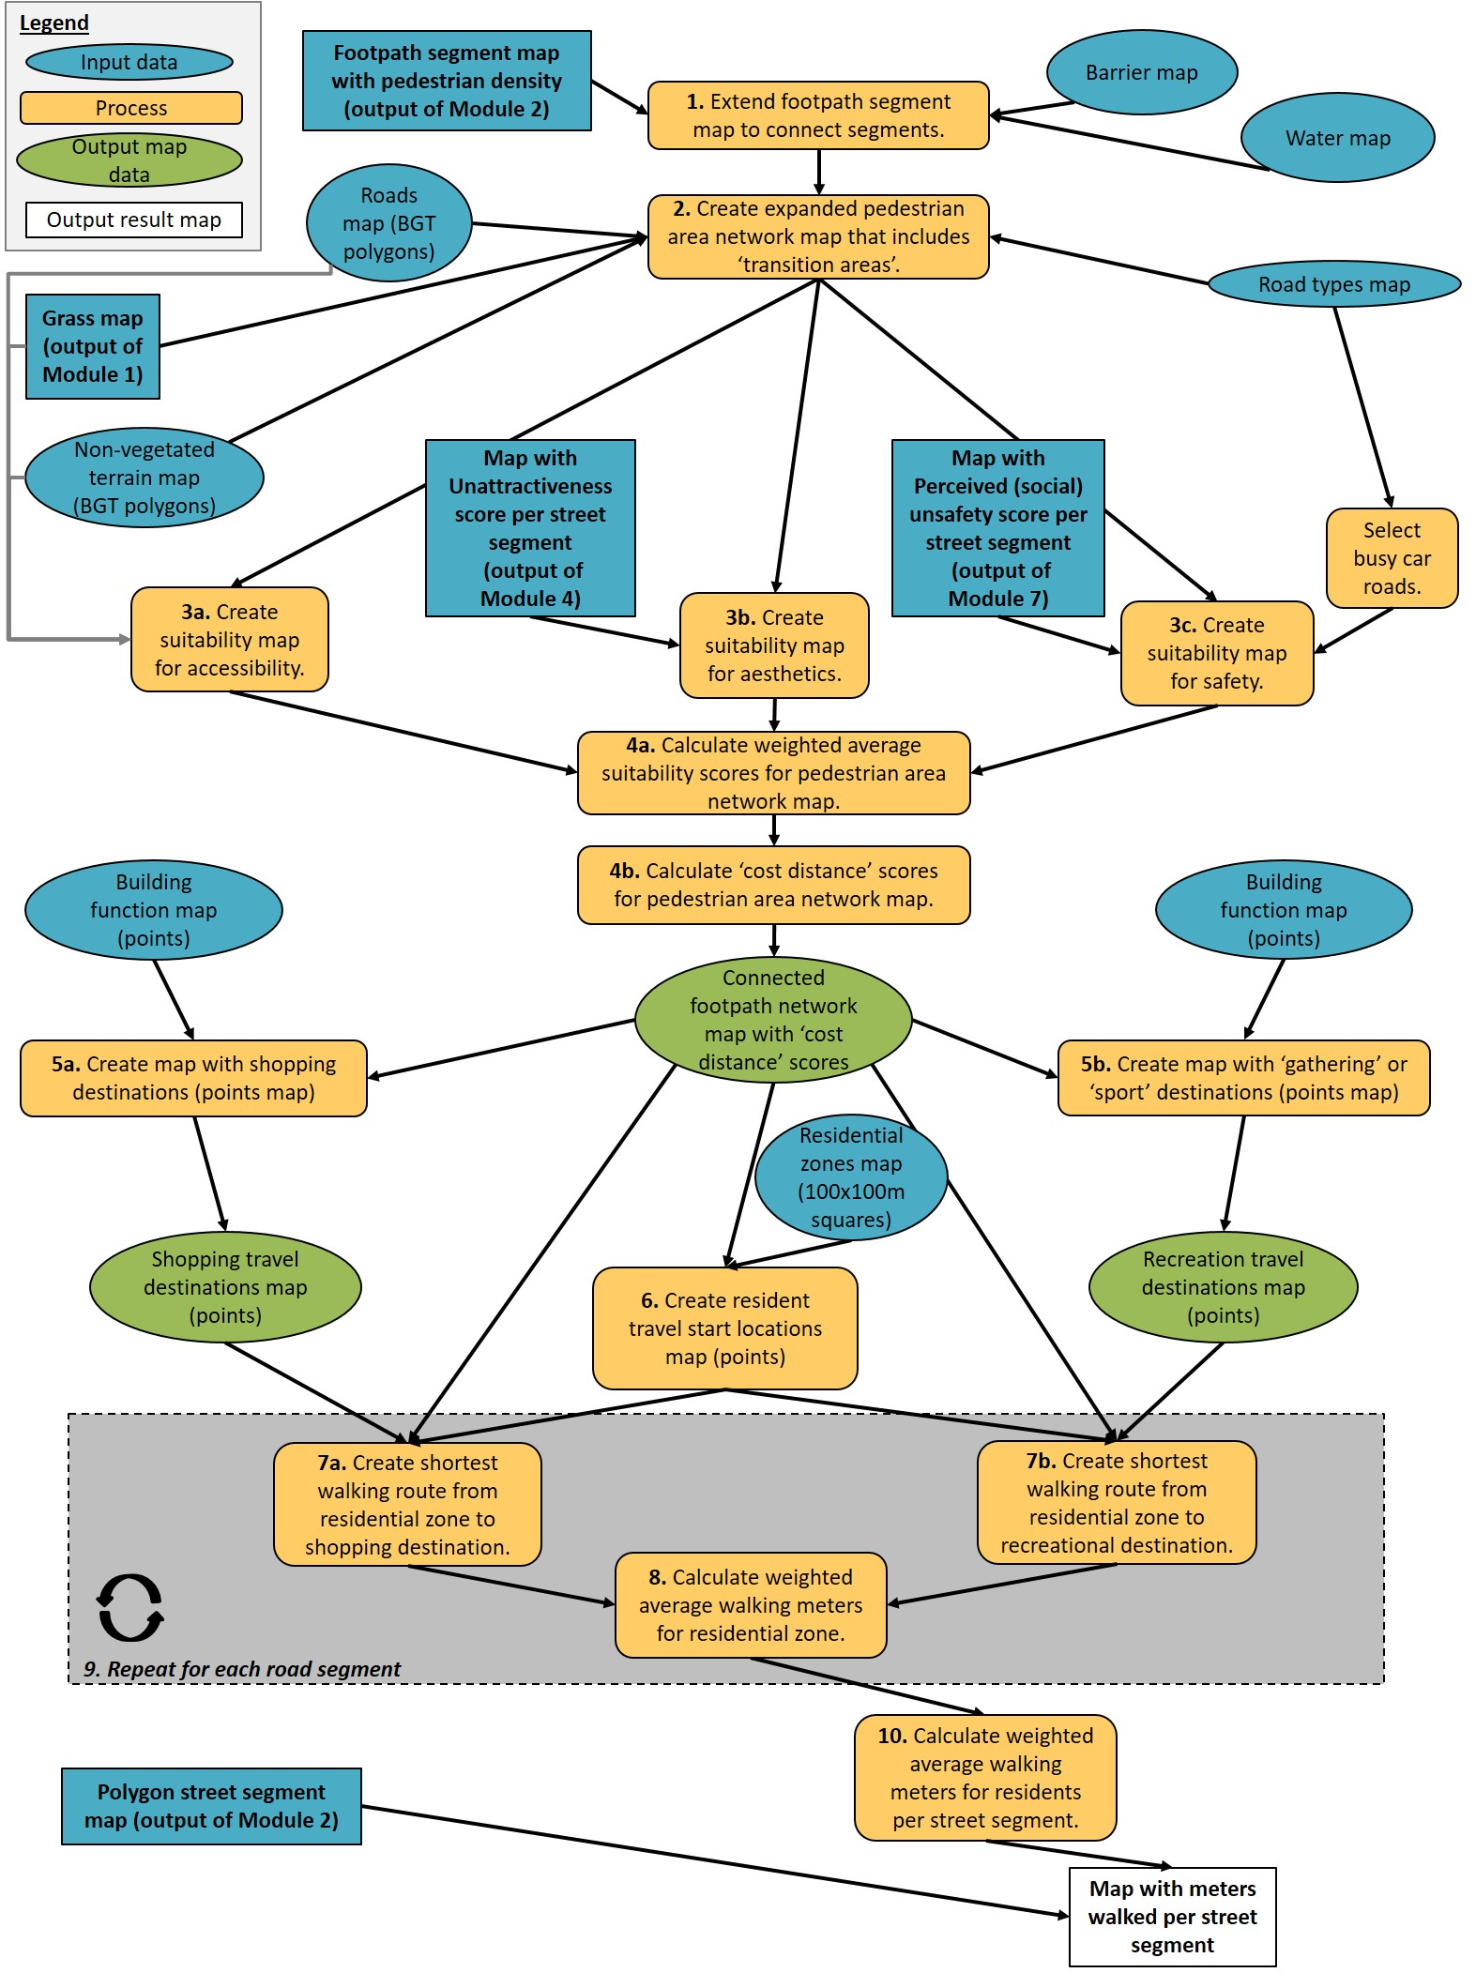
Figure C.1: overview of GIS datasets and main GIS processes to estimate active transport. Each process step can include multiple GIS tools as well as auxiliary code. Processes with numbered steps are described in Table C.1.

Module ‘Traffic unsafety’
Figure C.2 displays the steps to estimate traffic unsafety. Table C.2 describes the most important of these steps and specifies the parameter values used.
Table C.2: Steps to estimate traffic unsafety.
 | Main Step | Description | Parameters, parameter values, and sources
1 | Select crossroads with faster traffic and close to footpath network. | Select crossroads with car road types [1], and within a set distance of the footpath network [2]. | [1] Road type = regional OR main OR local OR street or other road.  [2] Crossroad-footpath distance = 100 meter.
2 | Select car lane areas close to crossroads. | Select car lane areas within a set distance of the crossroad [3]. | [3] Crossroad-buffer distance = 50 meter.
3 | Assign car speeds to car lane areas | Assign car speeds to car lanes based on road type [4] | [4] IF Road type = regional OR main OR local THEN Car speed = 50 km/h. IF Road type = street or other road THEN Car speed = 30 km/h.
4 | Select car lane areas within car stopping distance. | Select part of the car lane area within the car stopping distance based on car speed [5] | [5] IF Car speed = 30 km/h THEN Car stopping distance = Selected car lane area length = 14 meter. IF Car speed = 50 km/h THEN Car stopping distance = Selected car lane area length = 28 meter. (Rijksoverheid, 2023)
5 | Create viewshed from central point in car lane area. | Create a viewshed with set parameters [6] from the central point in the selected car lane area (Step 4) and in the direction of the crossroad. (Main geo-tool: ‘Viewshed’.) | [6] Viewshed range = car lane area-specific stopping range (of Step 4) * 2. Horizontal viewing angle = 180°. Vertical viewing angle up = 30°. Vertical viewing angle down = 30°. Eye level = 1.0 meter (driver’s eye-level height).
6 | Create distance accumulation area from crossroad over footpath network. | Create a maximum walking distance area with set parameters [7] from the edges of the crossroad over the connected footpath network. (Main geo-tool: ‘Distance Accumulation’.) This area around the crossroad was chosen to assess to what extent the car driver’s field of view (Step 5) would cover possible pedestrian locations. | [7] Max. distance = 15 m. (At walking speed, this distance is reached within 10 seconds, which is larger than the stopping times associated with the stopping distances of Step 4.)
7 | Calculate pedestrian area invisibility fraction from driver viewpoint. | Calculate the fraction of the pedestrian area around the crossroad that is invisible for the driver [8]. | Fraction pedestrian area invisible_{driver} = 1 – (visible area for driver (Step 5) within pedestrian area around crossroad (Step 6) / pedestrian area around crossroad (Step 6) ).
8 | Repeat for each car lane area close to each crossroad. | Repeat Step 5, 6 and 7 within the grey box of Figure C.2 for each car lane area close to each crossroad.
9 | Assign pedestrian invisibility scores to street segments. | Assign mean pedestrian invisibility fraction values (Step 7) within street segments to these street segments.

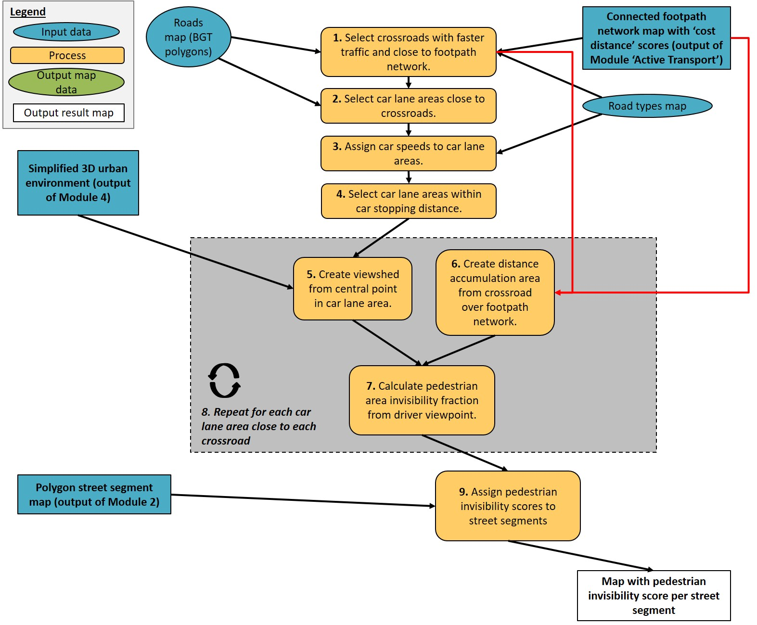
Figure C.2: overview of GIS datasets and main GIS processes to estimate traffic unsafety. Each process step can include multiple GIS tools as well as auxiliary code. Processes with numbered steps are described in Table C.2.

Reference list for sources in this Appendix
Bassett Jr, D. R., Cureton, A. L., & Ainsworth, B. E. (2000). Measurement of daily walking distance-questionnaire versus pedometer. Medicine and science in sports and exercise, 32(5), 1018-1023.
CBS. (2018). Onderzoek verplaatsingen in Nederland (OViN) 2017. In Onderzoeksbeschrijving. Den Haag, The Netherlands: Centraal Bureau voor de Statistiek.
Dessing, D., de Vries, S.I., Hegeman, G. et al. (2016). Children’s route choice during active transportation to school: difference between shortest and actual route. International Journal of Behavioral Nutrition and Physical Activity 13, 48. doi:https://doi.org/10.1186/s12966-016-0373-y
Duncan, M.J., & Mummery, W.K. (2007). GIS or GPS? A Comparison of Two Methods For Assessing Route Taken During Active Transport. American Journal of Preventive Medicine, 33(1), 51-53. doi:https://doi.org/10.1016/j.amepre.2007.02.042
Joosten, L. (2022). How urban spatial design affects transport-related cycling: A neighbourhood comparison in Maastricht (master thesis).
Oosterbroek, B., de Kraker, J., Huynen, M. M. T. E., Martens, P., & Verhoeven, K. (2023). Assessment of green space benefits and burdens for urban health with spatial modeling. Urban Forestry & Urban Greening, 86, 128023. doi: https://doi.org/10.1016/j.ufug.2023.128023.
Rijksoverheid. (2023). Kom veilig Thuis, Snelheid, Risico's. Retrieved from https://www.komveiligthuis.nl
Yang, Y., & Diez-Roux, A. V. (2012). Walking distance by trip purpose and population subgroups. American journal of preventive medicine, 43(1), 11-19.

Appendix D: search for participatory mapping evaluation criteria and inclusion method in detail
We employed two search engines (Web of Science, Google Scholar) to identify evaluation criteria for participatory mapping. These search engines have different capabilities. Therefore, the exact search queries differed:
- Web of Science provides capabilities to support complex Boolean phrases. However, if the user indicates to search for a topic keyword, this implies a search in the title, abstract and keywords but not in the full text itself.
- In Google Scholar, if the user indicates a search for a regular keyword, results of which the keyword is somewhere in the full text will be retrieved as well. Moreover, the possible result type is not only articles, but reports as well. However, Google Scholar has a limited capacity to handle long and more complex Boolean phrases.

A. Web of Science Boolean phrases: keywords, keyword sets and set combinations
Sources containing participatory mapping evaluation criteria were identified through the Web of Science literature search by composing one search query for documentation title and one for its ‘topic’:
Title includes: ‘Participatory mapping method’ keyword

AND
Title/Abstract/keywords include: ‘Participatory mapping method’ keyword AND (‘Multiple criteria’ keyword OR ‘Multiple methods or case studies’ keyword)

In the boxes below, we use the operators ‘AND’ and ‘OR’ as can be considered common in Boolean phrases, symbol ‘*’ to resemble all keywords starting with the preceding characters (wildcard) and symbol ‘ " ’ to enclose an exact phrase. The lower and upper case are for readability only and should be interpreted as searching for results with the lower case, upper case and mixed-case equivalents.
Finally, only the following Web of Science Categories were checked: Agriculture multidisciplinary, Biodiversity conservation, Biology, Clinical Neurology, Communication, Computer science information systems, Computer science interdisciplinary applications, Cultural studies, Ecology, Engineering Civil, Engineering environmental, Engineering multidisciplinary, Environmental Sciences, Environmental studies, Forestry, Geochemistry geophysics, Geography, Geography physical, Geosciences multidisciplinary, Green sustainable science technology, Infectious Diseases, Mathematical computational biology, Mutidisciplinary Sciences, Public Environmental Occupational Health, Regional urban planning, Social sciences interdisciplinary, Sociology, Urban studies, Water resources.
Box D.1.
Sets of keywords used and combined in the Boolean phrases.
- Participatory mapping method: “participatory map*” OR PM OR *PGIS OR “public participation GIS” OR “public participation Geo*” OR “participatory GIS” OR “volunteered geographic information” OR VGI OR “human ecology mapping” OR (participat* AND place) OR (participat* AND location) OR (participat* AND spat*) OR (participat* AND geo*) OR (participat* AND GIS) OR (tool* AND place) OR (tool* AND location) OR (tool * AND spat*) OR (tool* AND geo*) OR (tool* AND GIS*)
- Multiple criteria : evaluat* OR review OR criteria OR performance
- Multiple methods or case studies: OR overview OR cases OR “case studies” OR methods OR (strengths AND weakness*) OR (opportunit* AND threat*)

B. Google and Google Scholar Boolean phrases: keywords, keyword sets and set combinations
We assessed the first 500 results from this Google Scholar search for relevance as possible sources containing participatory mapping evaluation criteria:
Title/Text includes: ‘Participatory mapping method’ keyword AND ‘Multiple criteria’ keyword AND ‘Multiple methods or case studies’ keyword

Appendix E: input children and elderly in the first meeting
Table E.1.
Input children and elderly during the first meeting.
Group (number) | Notes Urban Green Spaces *, ** | Notes other
Pottenberg  Elderly neighborood center Pottenberg (12) | General:  - Adjust roundabouts / flowers / make them more beautiful. It is the entrance of the neighborhood and is now not beautiful (looks like a disadvantaged neighborhood).  - For the remainder: enough green; satisfied with green. | Around the neighborhood core / church:  - Place benches.  - Clean up rubbish from containers.  - Too far for most old people.  - Don't expect other people to sit down.  - Don't change anything else.  - Location will not be used more in the future.  "Strip" at primary school:  - “If there were benches, we would not sit there because of foreign people”  - We don't feel at home there  Park at / behind the neighborhood center:  - Is hiking area. Especially in summer; in light and good weather  General:  - Prefer more shops in the area where they can go on foot.  - “We see few children outside; they are all inside"  - “The neighborhood is no longer what it used to be.“
Pottenberg  Children ‘Scouting West’ (16) | Potteriestraat: climbing trees and play trees, paths, shrubs for protection  Vennepark West: play shrubs and trees, paths, obstacle courses made of poles, tree-discs and stones.  Other: shrubs | Potteriestraat: large climbing frame (net) between the trees, swimming lake  Vennepark West: tunnel, swing, slide, swimming pool, pond (with boat / raft), skate park  Other: skate parks, football fields, ponds
Pottenberg  Children elementary school ‘El Habib’ (7) | Potteriestraat: larger playground (made of sand, the grass can be removed for that), hill, flowers, path  Vennepark East: maze (shrubs), hill, (living) willow tunnel, vegetable garden, flower beds (also for butterfly garden), dining area, (living) willow huts, paths  Grassland under Pottenberg: maze  Other: (willow) huts, hills | Potteriestraat: climbing and playing objects, larger football field  Vennepark East: bicycle rack, benches, cable car  Grassland under Pottenberg: tunnel, football field must remain  Other: tunnels, bird houses
Wittevrouwenveld  Elderly neighborood center Wittevrouwenveld (5) | Geusseltpark: more (single) trees  Other places: enough green, satisfied with the large ‘Groene Loper’ park. | Geusseltpark: more benches.  Other places: more waste bins.
Wittevrouwenveld  Children elementary school ‘De Letterdoes’ (5) | Leeuwenplein: play objects (fallen trees, stepping stones) hill, bridge, climbing tree, path, flowers  Aldegonda and Gerberga plantsoen: grass bridge, stepping stones / trunks, small trees  Friezenplein: flowers  Geusseltpark South: trail of tree logs  Other: in smaller areas of green space, the block hedges may be removed to make room for play areas with sometimes climbing trees | Leeuwenplein: larger football field, climbing tower, movement equipment, seesaw, swing, dog field, benches, waste bins  Aldegonda and Gerberga plantsoen: slide, climbing frame, seesaw  Geusseltpark South: large slide  Other: Smaller areas of UGS are allowed to have swings, climbing frames, skate rinks, slides, trash cans and dog leash
* Based on the drawings, notes and comments of the participants during the participation design session.
** Black text = UGS added, red text = UGS removed.

Appendix F: digitized initial green designs after the first meeting

Neighborhood Wittevrouwenveld, urban green space designs elementary school
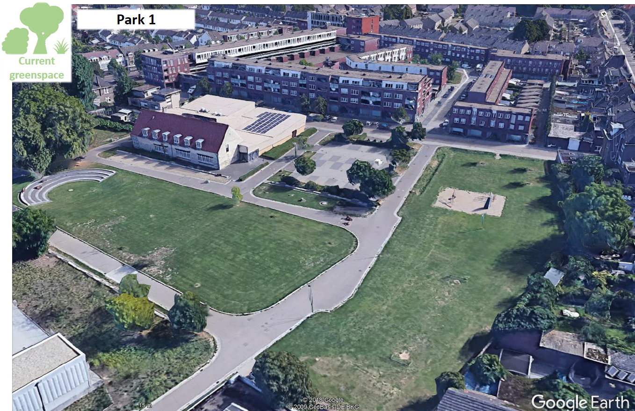
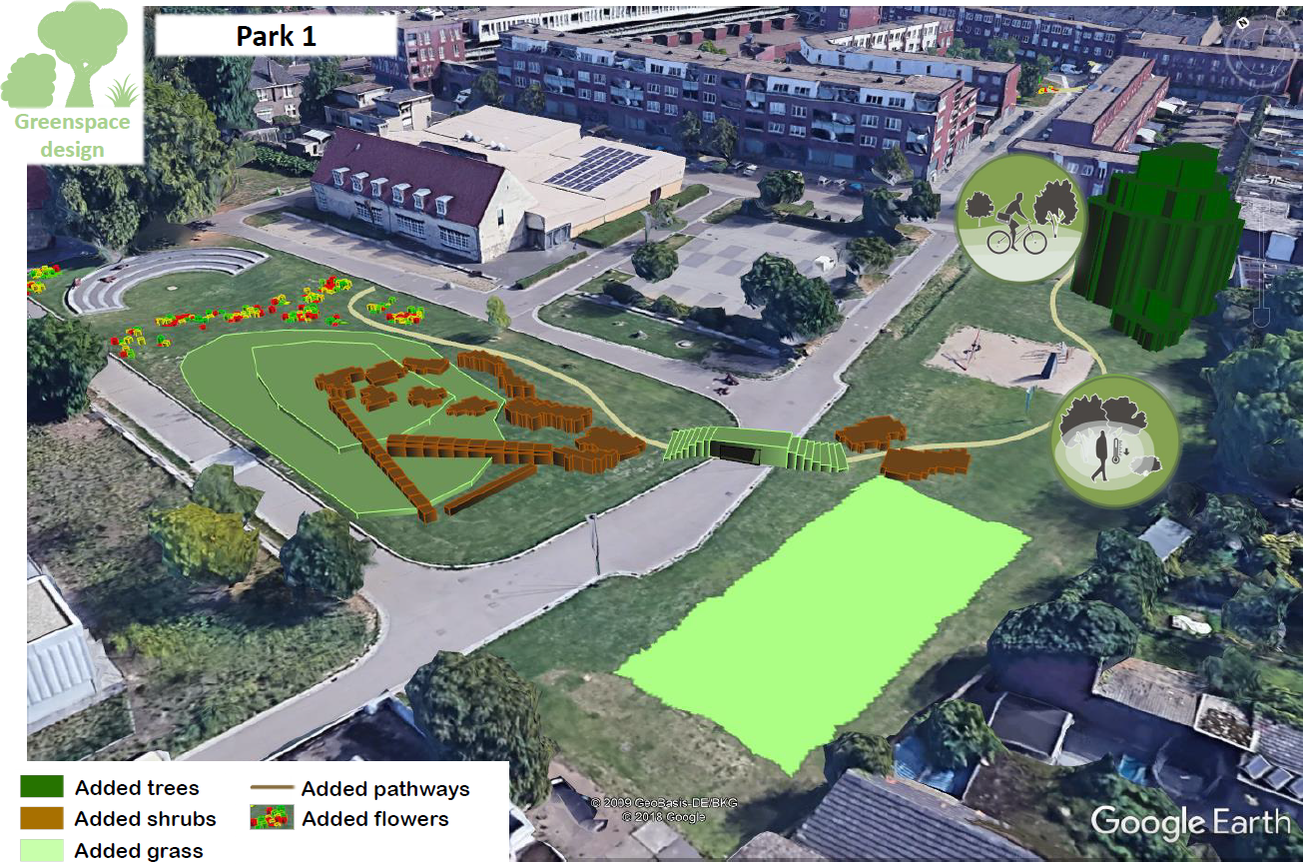
Fig. F.1. Above: current situation of focus area ‘Park 1’. Below: green design for Wittevrouwenveld by children of an elementary school.
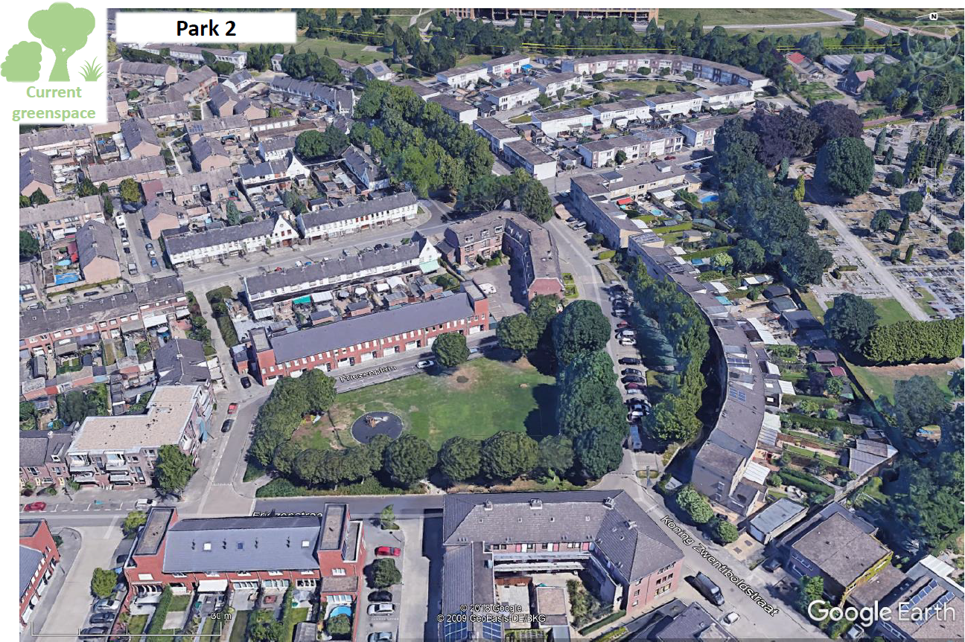
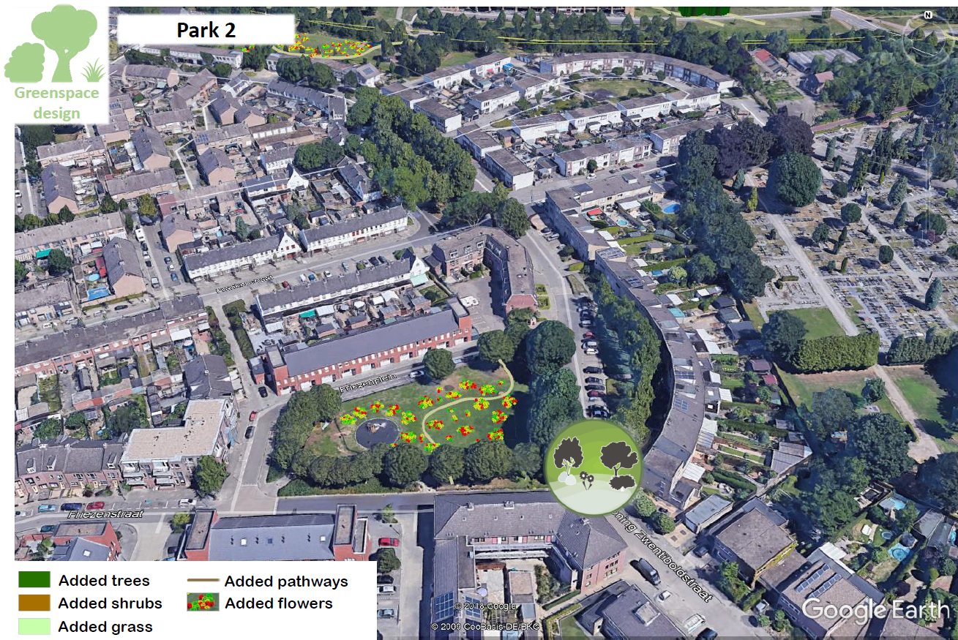
Fig. F.2. Above: current situation focus area ‘Park 2’. Below: green design for Wittevrouwenveld by children of an elementary school.
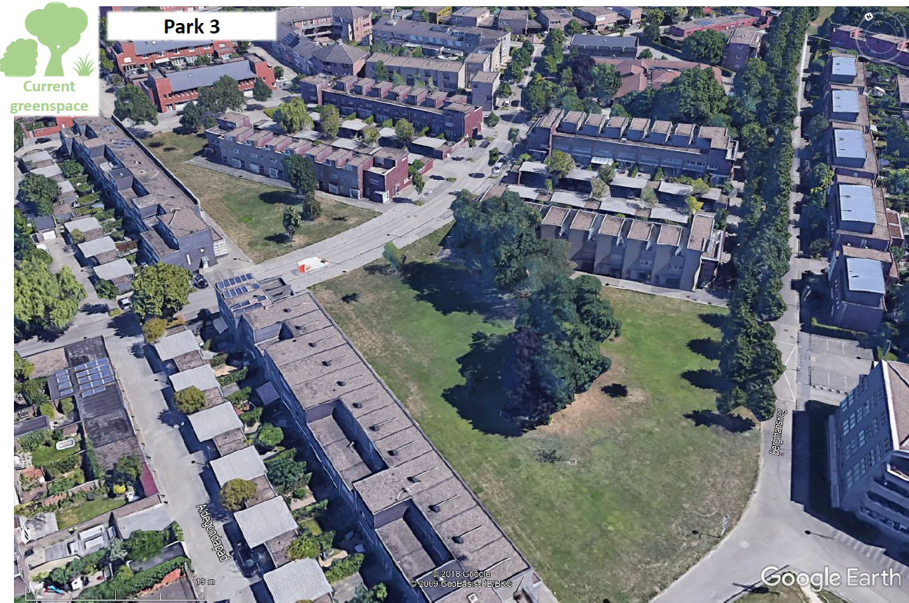
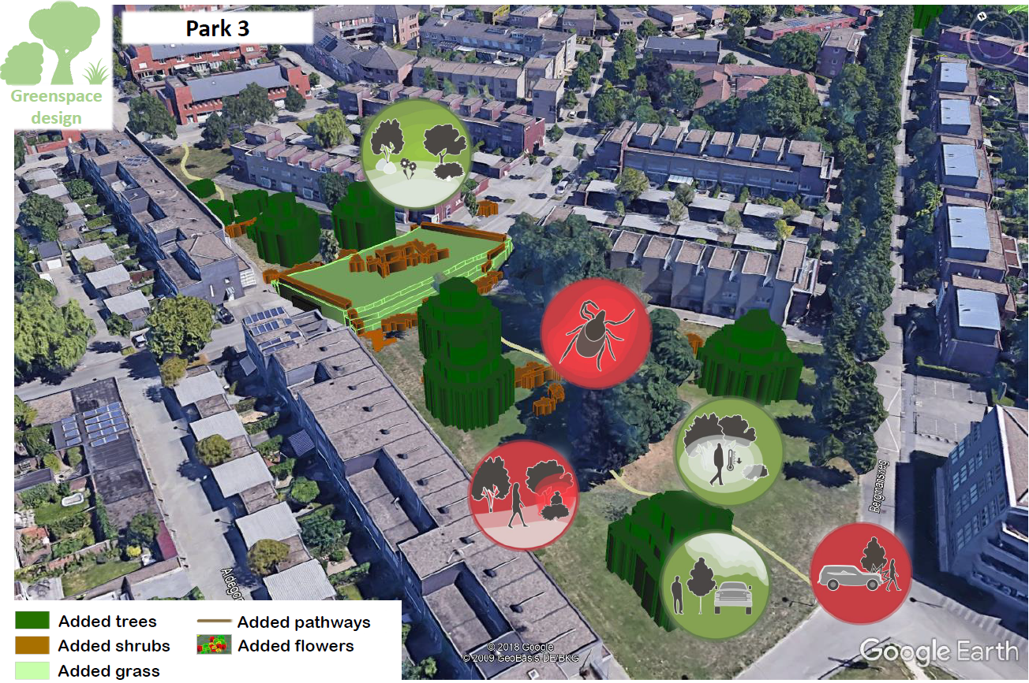
Fig. F.3. Above: current situation focus area ‘Park 3’. Below: green design for Wittevrouwenveld by children of an elementary school.

Neighborhood Wittevrouwenveld, green space design meeting center (elderly)
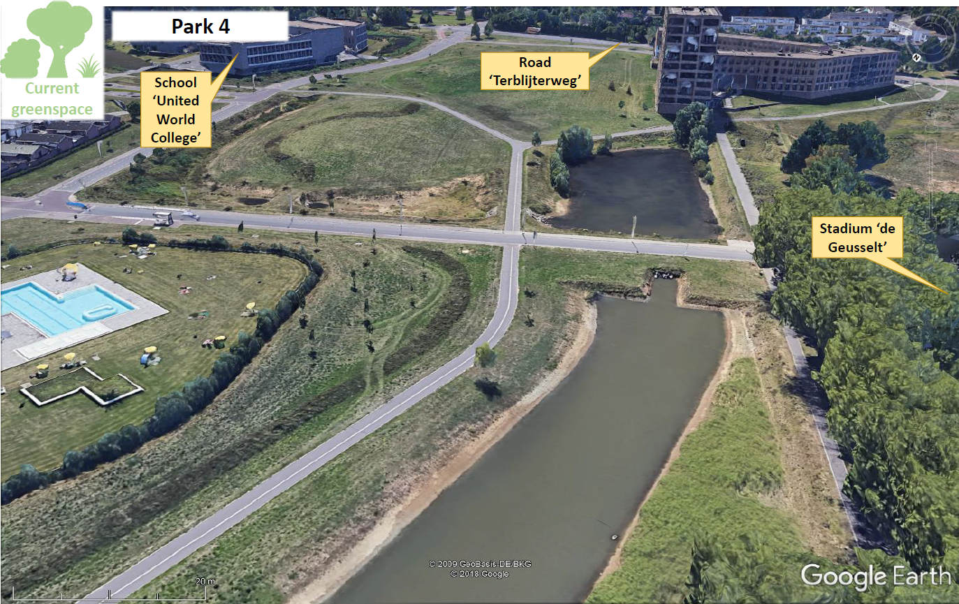
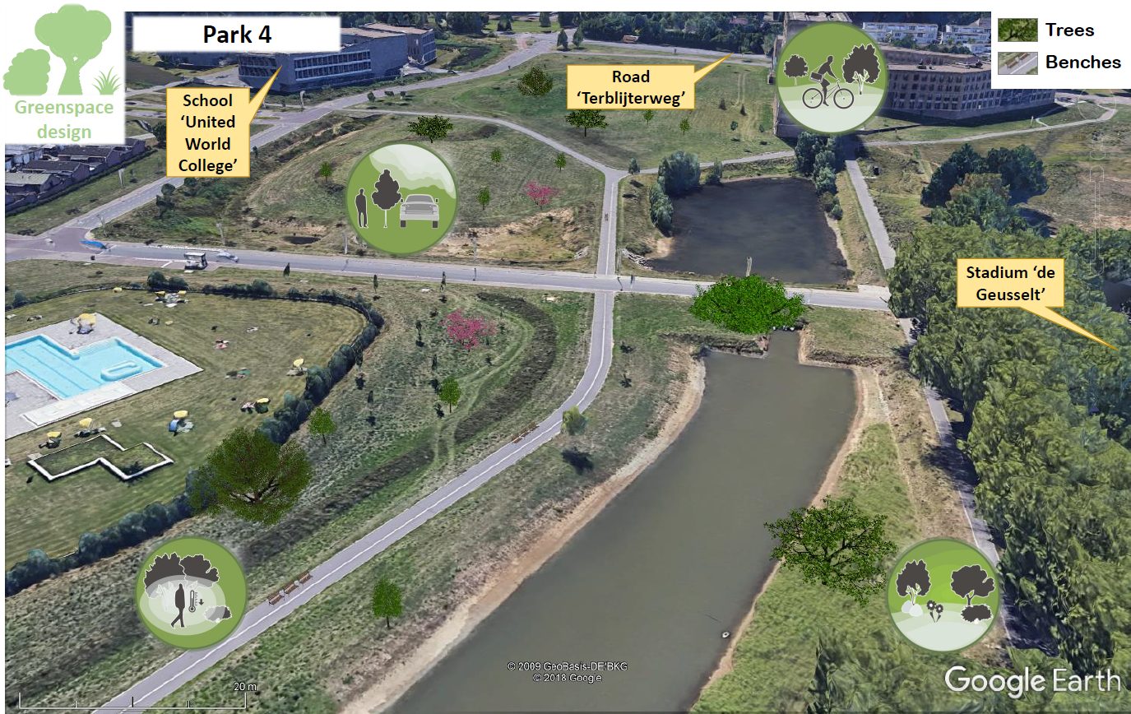
Fig. F.4. Above: current situation focus area ‘Park 4’. Below: green design for Wittevrouwenveld by elderly people who come together in the neighborhood meeting center.

Neighborhood Pottenberg, urban green space designs elementary school
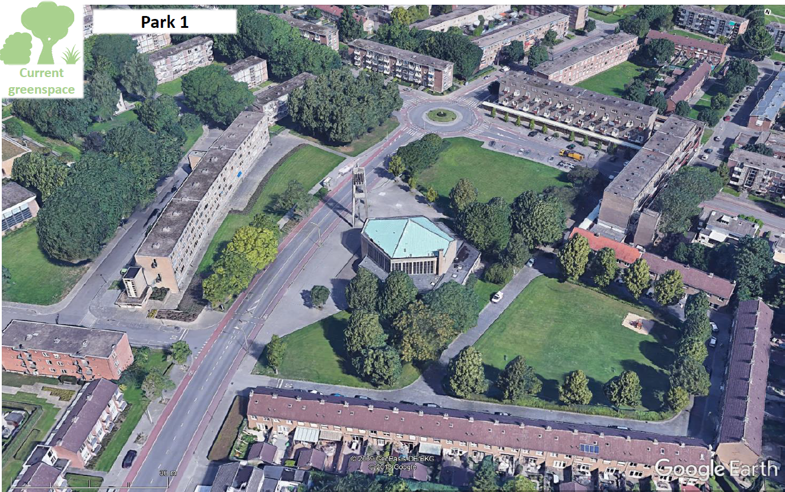
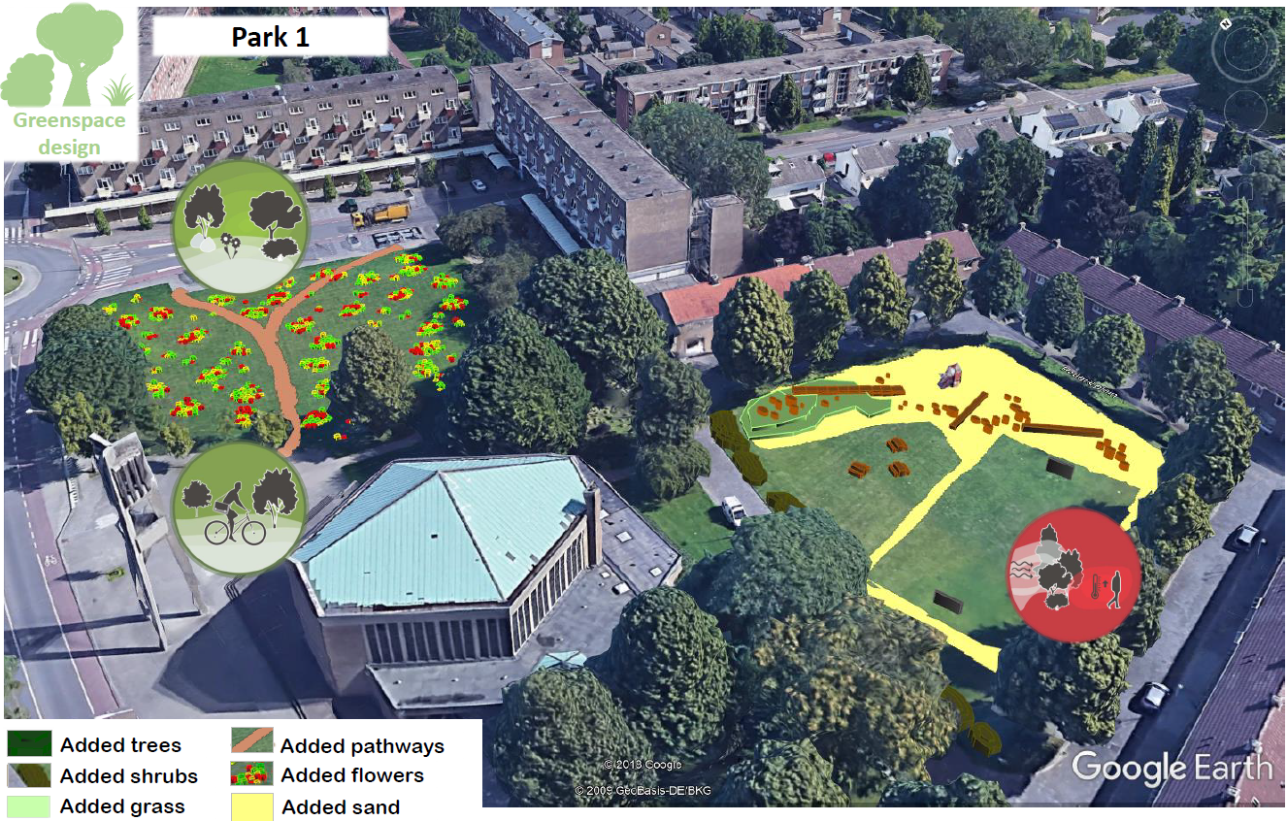
Fig. F.5. Above: current situation in focus area ‘Park 1’. Below: green design for Pottenberg by children of an elementary school.
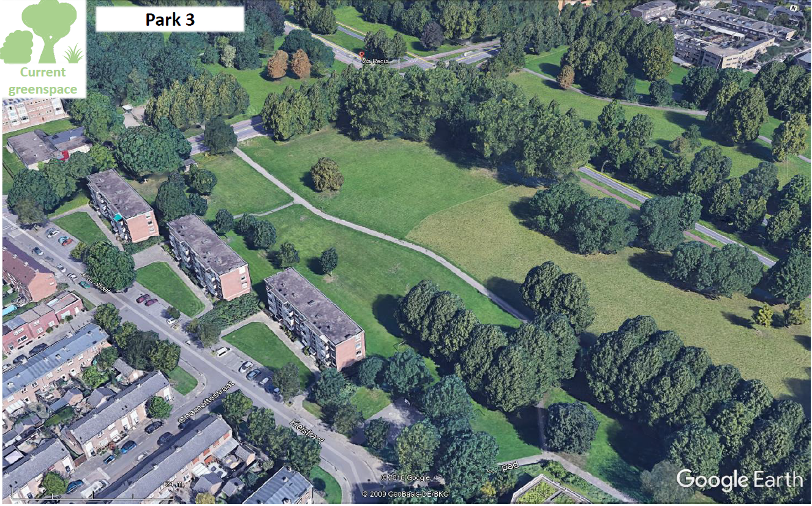
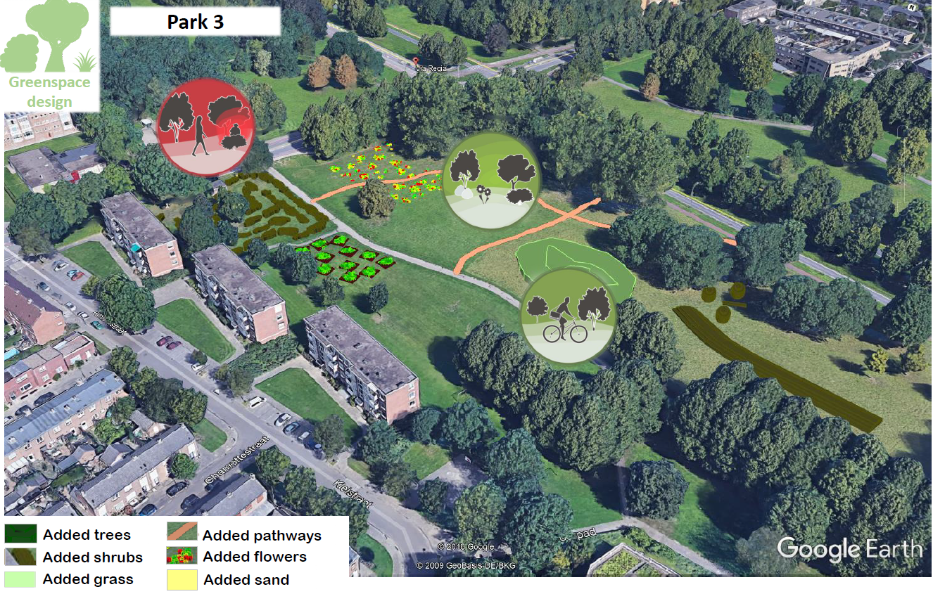
Fig. F.6. Above: current situation of focus area ‘Park 3’. Below: green design for Pottenberg by children of an elementary school.

Neighborhood Pottenberg, urban green space designs scouting
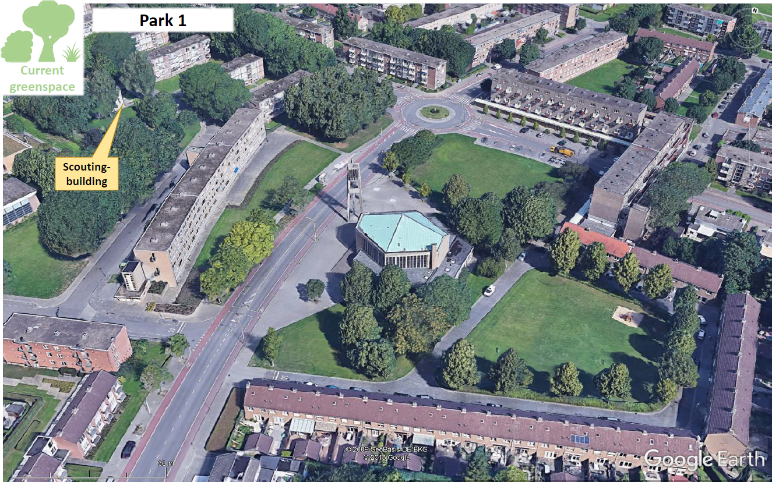
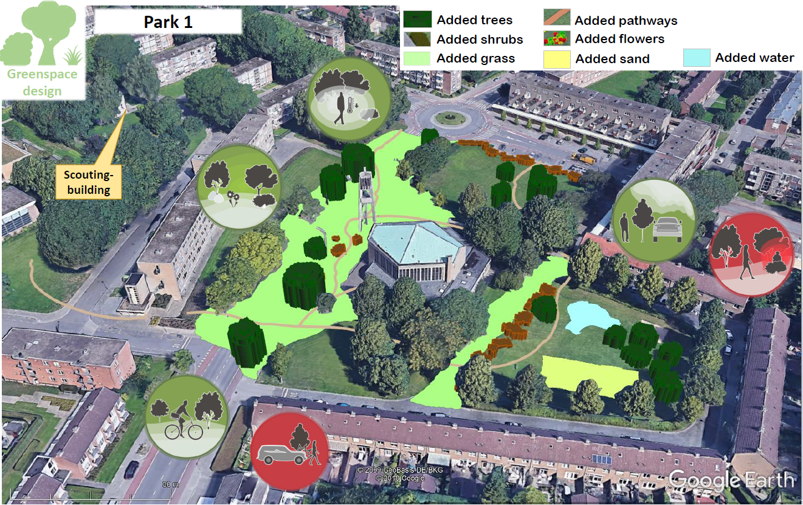
Fig. F.7. Above: current situation focus area ‘Park 1’. Below: green design for Pottenberg by children of a Scouting group.
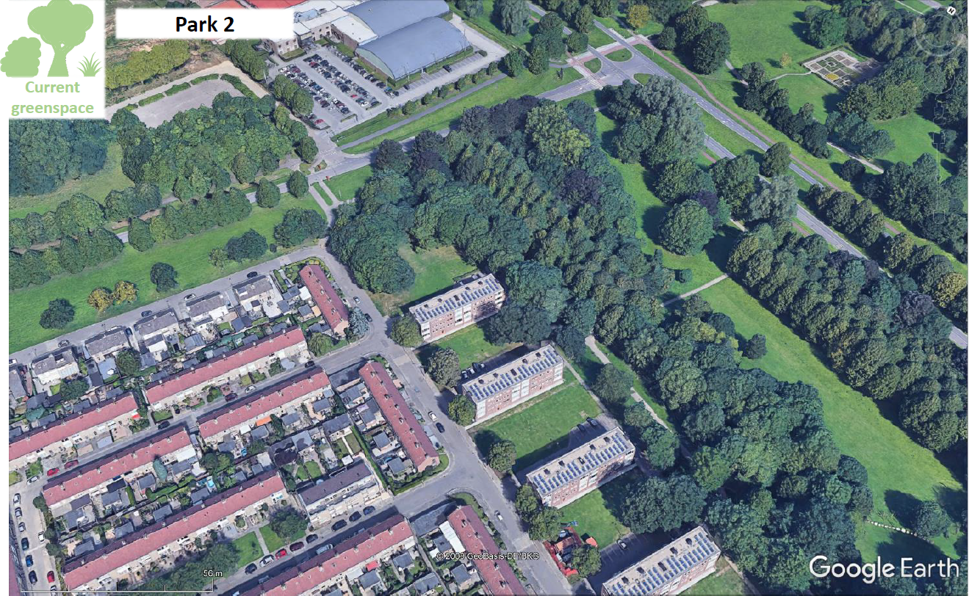
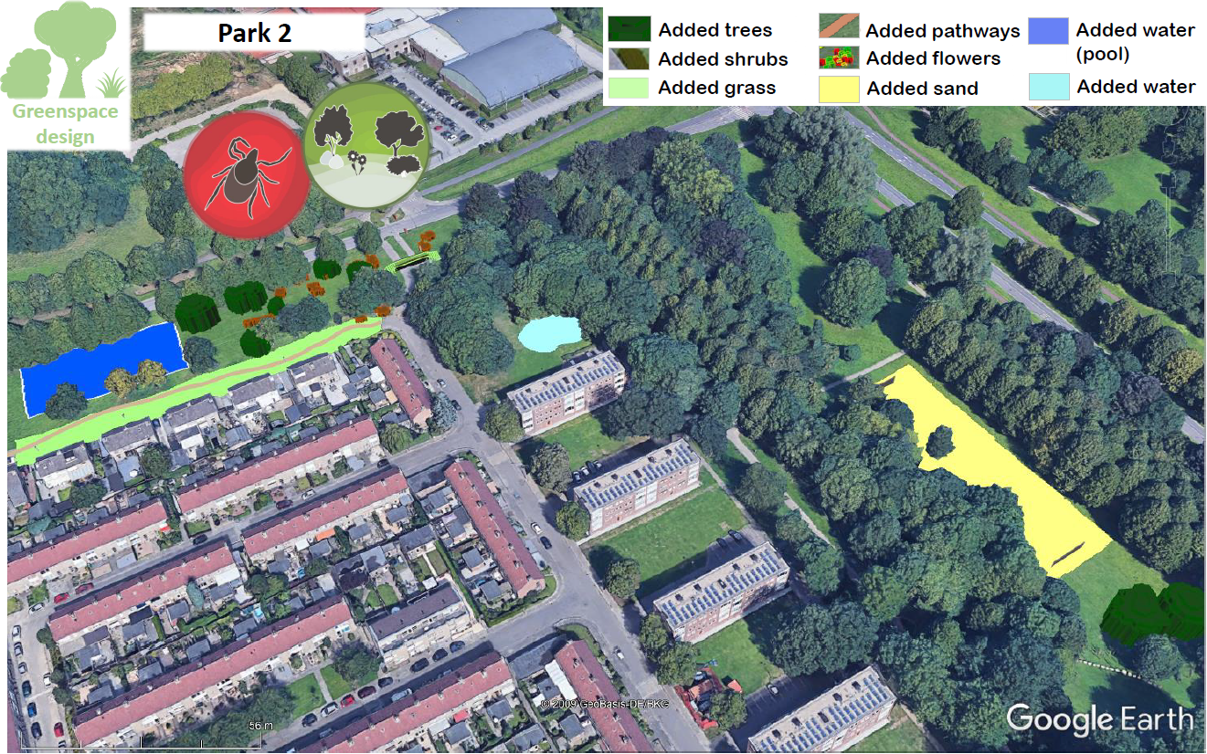
Fig. F.8. Above: current situation of focus area ‘Park 2’. Below: green design for Pottenberg by children of a scouting group

Neighborhood Pottenberg, green space design meeting center (elderly)
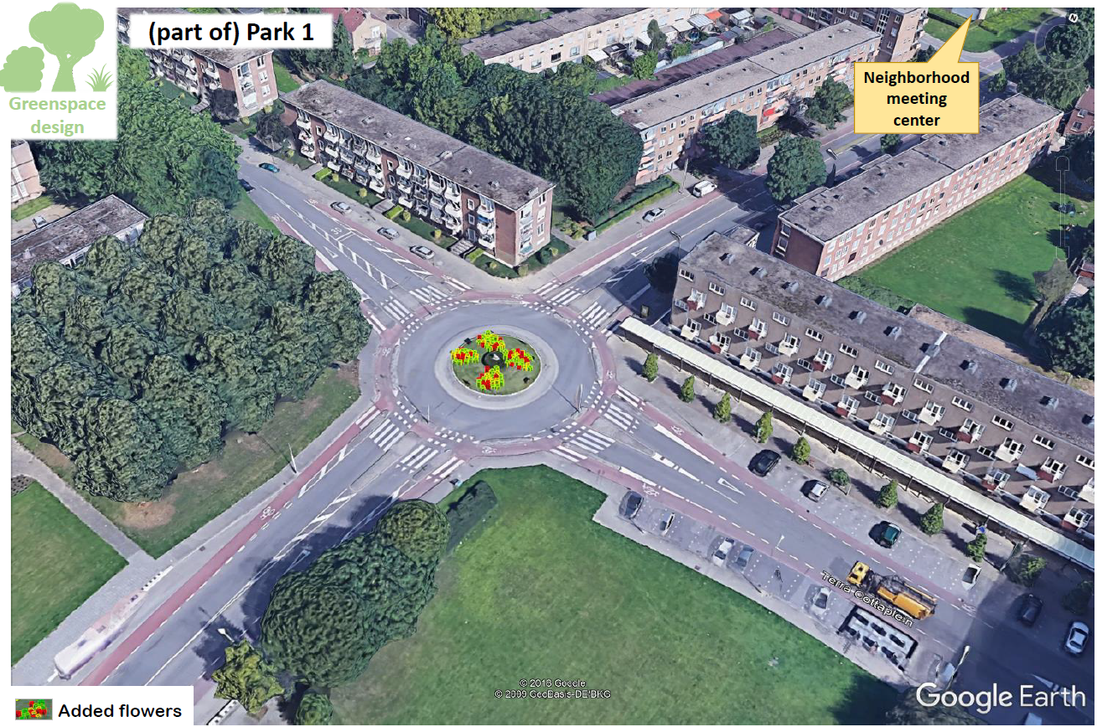
Fig. F.9. Green design of part of focus area ‘Park 1’ by elderly of the neighborhood meeting center.

Appendix G: input children and the elderly during feedback meeting
Table G.1.
Input children and elderly during the feedback meeting.
Group (number) | Notes Urban Green Spaces *, ** | Notes other
Pottenberg  Elderly neighborood center Pottenberg (12) | General:  - Also more flowers at church opposite shops  - Street trees must remain. Where there is nothing now, new trees may be placed in a limited way. The leaves and chestnuts are dangerous if not properly disposed of. In general, the municipality does not do this enough.  - Shrubs on roundabouts, for example, must be well maintained for traffic safety (view of cyclists). | General:  - Another dog exercise area is desirable due to the many dog poo in east park
Pottenberg  Children ‘Scouting West’ (16) | Potteriestraat:  - Add flowers  Van de Vennepark West:  - Remove a few trees to make place for a large football field
Pottenberg  Children elementary school ‘El Habib’ (7) | Van de Vennepark: hedgerows alongside the pathways | Potterie Street: sports equipment, large sofa, benches  Van de Vennepark: eating place  Opinions are divided about the extent to which play areas should be shielded (from supervision from houses): most find the many houses overlooking the play area at Potteriestraat negative, but others do not mind.
Wittevrouwenveld  Elderly neighborood center Wittevrouwenveld (5) | Geusseltpark:  - The extra trees are an addition. In particular, there should be more flower trees (because there used to be more and now there are few).  - The model outcome showed the crossing over the Terblijterweg as one of the unsafest places in the road where green spaces are blocking view. This is confirmed.  - In terms of paths, the park is already sufficient. These may then only be used by hikers: several participants find it annoying to encounter cyclists. A separate cycle path is ok. | General:  - Model outcome was the park east of the UWC as one of the most unsafe places. This is confirmed by the participants. They indicate that public places in the city should simply be safe, even though such a place may not be on a frequently used route. For example through installing more lighting.  - When crossing the ‘Groene Loper’ park at the end of the Frankenstraat, it is not clear to cyclists where they can do this safely. This leads to unsafe situations.  - Self-management of flower boxes (eg in the van Oppenstraat) is neglected.
Wittevrouwenveld  Children elementary school ‘De Letterdoes’ (5) | Aldegonda and Gerberga plantsoen:  - The current trees that are close to each other must be removed (related to perceived unsafety).  - Tree discs / stumps / stepping stones are seen as a fun element for "the ground is lava" game.  Friezenplein: walking paths | Friezenplein:  - More exercise equipment can be installed  - The children already use the Leeuwenplein for meeting and playing for group games. A second 'hangout' is close by (at 'workhouse'. They like to go here instead of closer to school (Wijckerpoort Noord, 1km) because there is less dog poo here, the supermarket is nearby, the tire swing, and shade. The children note that the Aldegonda and Gerberga plantsoen are already suitable for ball games.
* Additions to / adjustments of the session 1 designs after taking note of the digitized designs of session 1, model estimates of health-related benefits and burdens of the current green space, and model estimates of health-related benefits and burden of the participatory design.
** Black text = UGS added, red text = UGS removed.

Appendix H: current and designed green situation for neighborhood Pottenberg

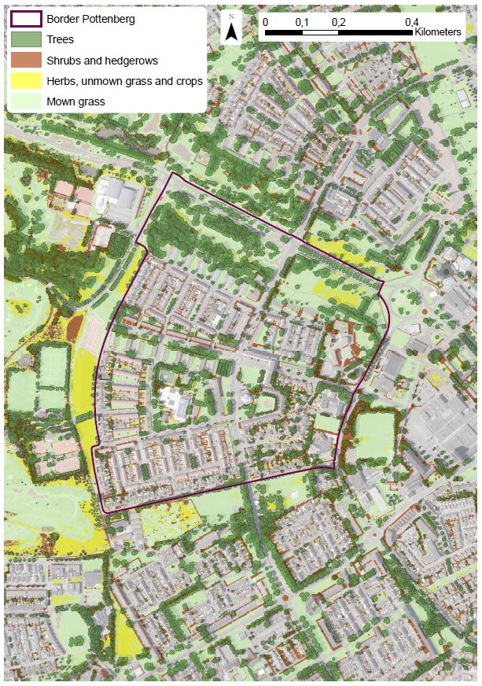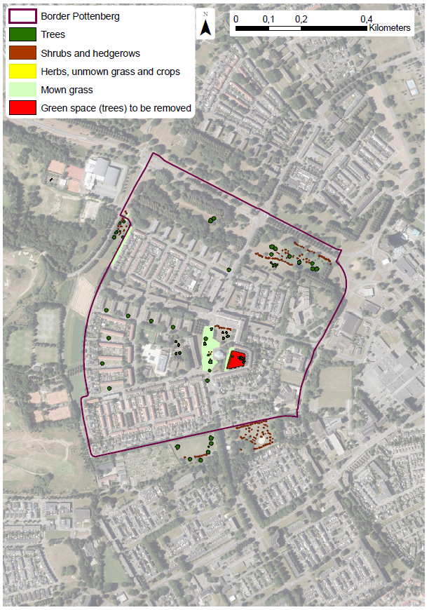
Figure H.1: on the left the current green situation for neighborhood ‘Pottenberg’, on the right an overview of the final green designs that could supplement this green situation.

Appendix I: degree of use per neighborhood and per participant group
See Table O.1 for the self-assessed UGS usage scores per neighborhood and per participant group. The average scores where opinions differed, was calculated as follows: participants were included in the score if they either lived near the focus area, if they come there, or if they base their estimate of (non-) use on the presumed situation that they would live in the neighborhood. (Participants who otherwise indicated not to use the UGS or did not make an estimation, were not included in the mean score.)

Table I.1.
self-assessed urban green space usage scores.
Group | Number | Estimated use current*, ** | Summary corrected participatory design | Estimated use after desing
Pottenberg  Elderly neighborood center Pottenberg (12) | 12 | Vennepark 3, 3 1  Around church 2  (walking by)  Green area close to elementary school is not used. | More flowers on the roundabouts and at the church opposite the shops. Place street trees where there are currently no limited places. Another dog-letting area (less poo), benches, bushes on roundabouts pruned for traffic safety. | Vennepark 4, 4 2  Around church 2  Most indicate that they would go there a little more often (no opposing voices).
Pottenberg  Children ‘Scouting West’ (16) | 16 | Potteriestraat and green area close to elementary school: 1.1 (n=14)  Vennepark West: 1.3 (n=14) | Potteriestraat: climbing trees and play trees, paths, flowers, shrubs that close off the area  Vennepark West: remove a few trees for a football field, playing shrubs and trees, paths | Potteriestraat: 1.6 (n=16)  Vennepark West: 2.3 (n=16)
Pottenberg  Children elementary school ‘El Habib’ (7) | 7 | Potteriestraat: 0.4 (n=5)  Vennepark Oost: 0.7 (n=7) | Potteriestraat: climbing and playing objects, hill, larger football field, flowers, path  Vennepark: hill, willow tunnel, vegetable garden, flower bed, eating area, willow huts, paths | Potteriestraat: 2.9 (n=7)  Vennepark: 3.0 (n=7)
Wittevrouwenveld  Elderly neighborood center Wittevrouwenveld (5) | 5 | Geusseltpark 3 3 2  Assessed for Geusseltpark: the other 2 areas were already found to be in good condition. 2 participants do not use the Geusseltpark area because they live too far away (not included in the score). The other 3 participants agree with each-other that they use the area for walking and relaxing. The score for meeting varies (individual scores 1, 2 and 3). | More benches, more (single) trees, especially flower trees. | 4 4 3 The 3 participants indicate that they would go there a little more often.
Wittevrouwenveld  Children elementary school ‘De Letterdoes’ (5) | 5 | Leeuwenplein: 2.8  Aldegonda- en Gerbergaplantsoen: 1.5  Friezenplein: 1  All locations were rated by all children whilst they were assuming they lived nearby. | Leeuwenplein: play objects (fallen trees, stepping stones) hill, bridge, climbing tree, path  Aldegonda and Gerberga plantsoen: grass bridge, stepping stones / trunks, small trees, climbing trees, trees close together just away  Friezenplein: flowers, walking paths (exercise equipment) | Leeuwenplein: 3  Gerbergaplantsoen: 3  Friezenplein: 2
* Green score is for physical activity, blue for stress reduction, yellow for meeting. Children are not distinguished and asked to give a general usage score for "going there to play and to meet other children".
** Usage level’s are 0 (never), 1 (a few times per year), 2 (a few times per month), 3 (a few times per week), 4 (used when estimated use increased while current use already scored ‘3’.

