Type of the Paper (Article)
Ferroptosis inducers up-regulate PD-L1 in recurrent triple negative breast cancer
Christophe Desterke ^{1,*}, Yao Xiang ², Rima Elhage ^{2,3}, Clémence Duruel ^{2,3}, Yunhua Chang ^{2, *} and Ahmed Hamaï ^{2,3,*}
¹ UFR Médecine-INSERM UMRS1310, Université Paris-Saclay, F-94800 Villejuif, France
² INSERM UMR-S1151, CNRS UMR-S8253, Institut Necker Enfants Malades, Université Paris Cité, F-75015 Paris, France; xiangyao.ecole@outlook.com (Y.X.); rima.elhage@inserm.fr (R.E.); clemence.duruel@inserm.fr (C.Du.)
³ Team 5/Ferostem Group, F-75015 Paris, France
* Correspondence: christophe.desterke@inserm.fr (C.D.); yunhua.chang-marchand@inserm.fr (Y.C.); ahmed.hamai@inserm.fr (A.H.)

SUPPLEMENTAL FIGURES
Figure S1. Breast tumor expression of markers included in CD274-ferrptosis score (TCGA cohort): A/ CD274 expression stratified on pam50 molecular classification (dot colors represent node stages and dot size is relative to the age of diagnosis); B/ IFNG expression stratified on pam50 molecular classification (dot colors represent node stages and dot size is relative to the age of diagnosis); C/ IDO1 expression stratified on pam50 molecular classification (dot colors represent node stages and dot size is relative to the age of diagnosis); D/ TNFAIP3 expression stratified on pam50 molecular classification (dot colors represent node stages and dot size is relative to the age of diagnosis).

Figure S2. OncotypeDx quantification in breast tumor sample and Schoenfeld test for multivariable survival model (TCGA cohort): A/ Scatterplot of oncoDx score versus CD274-ferroptosis driver score stratified on pam50 molecular classification (Student ttest on OncoDx score was done between CD274-ferroptosis groups low and high); B/ Schoenfeld test done on covariates included in overall survival multivariable model of the TCGA cohort.

Figure S3. Overexpression of CD274, IDO1, IFNG and TNFAIP3 in TNBC subgroup of METABRIC cohort: A/ Boxplot of CD274 expression stratified on TNBC subgroup membership; B/ Boxplot of IDO1 expression stratified on TNBC subgroup membership; C/ Boxplot of IFNG expression stratified on TNBC subgroup membership; D/ Boxplot of TNFAIP3 expression stratified on TNBC subgroup membership
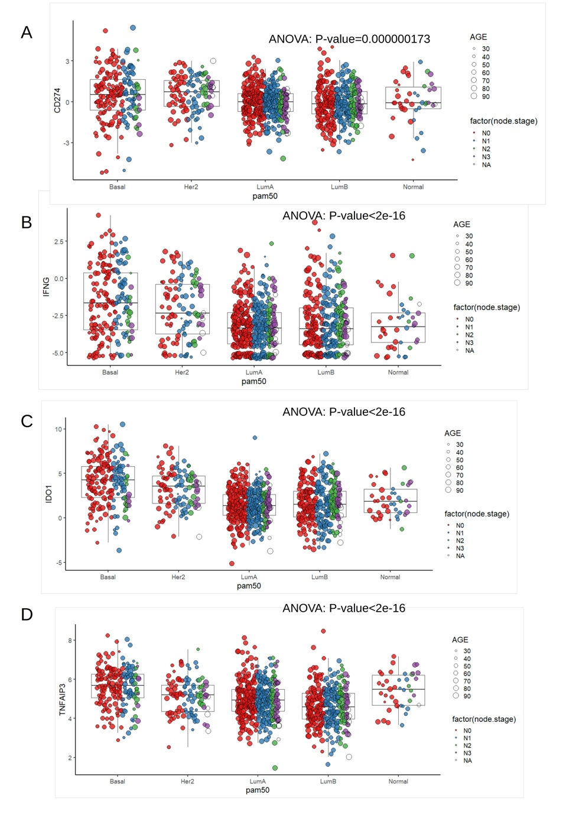

Figure S1.

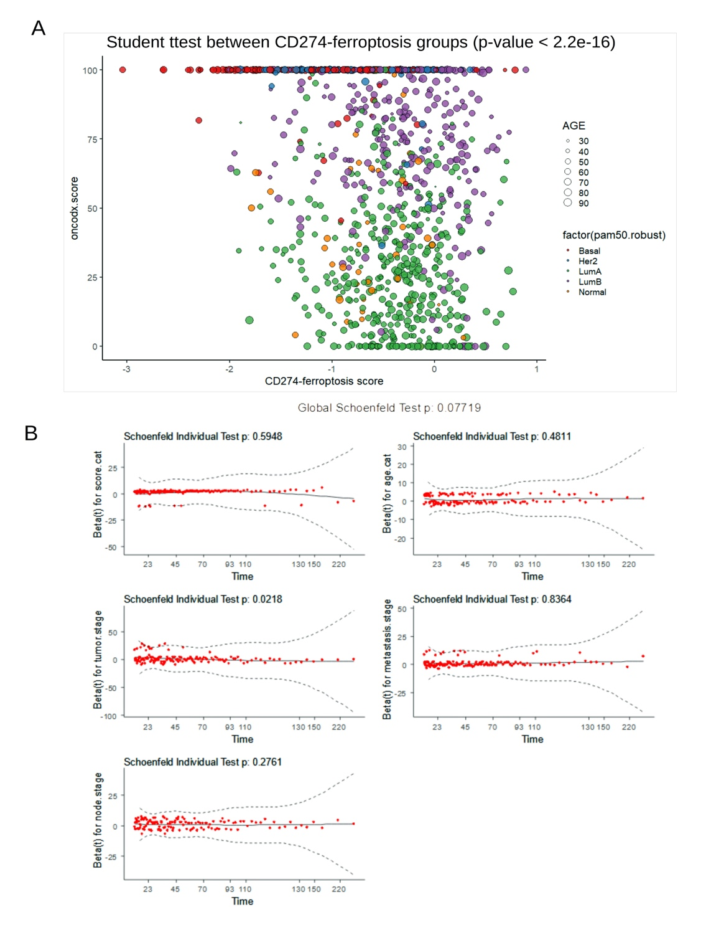
Figure S2

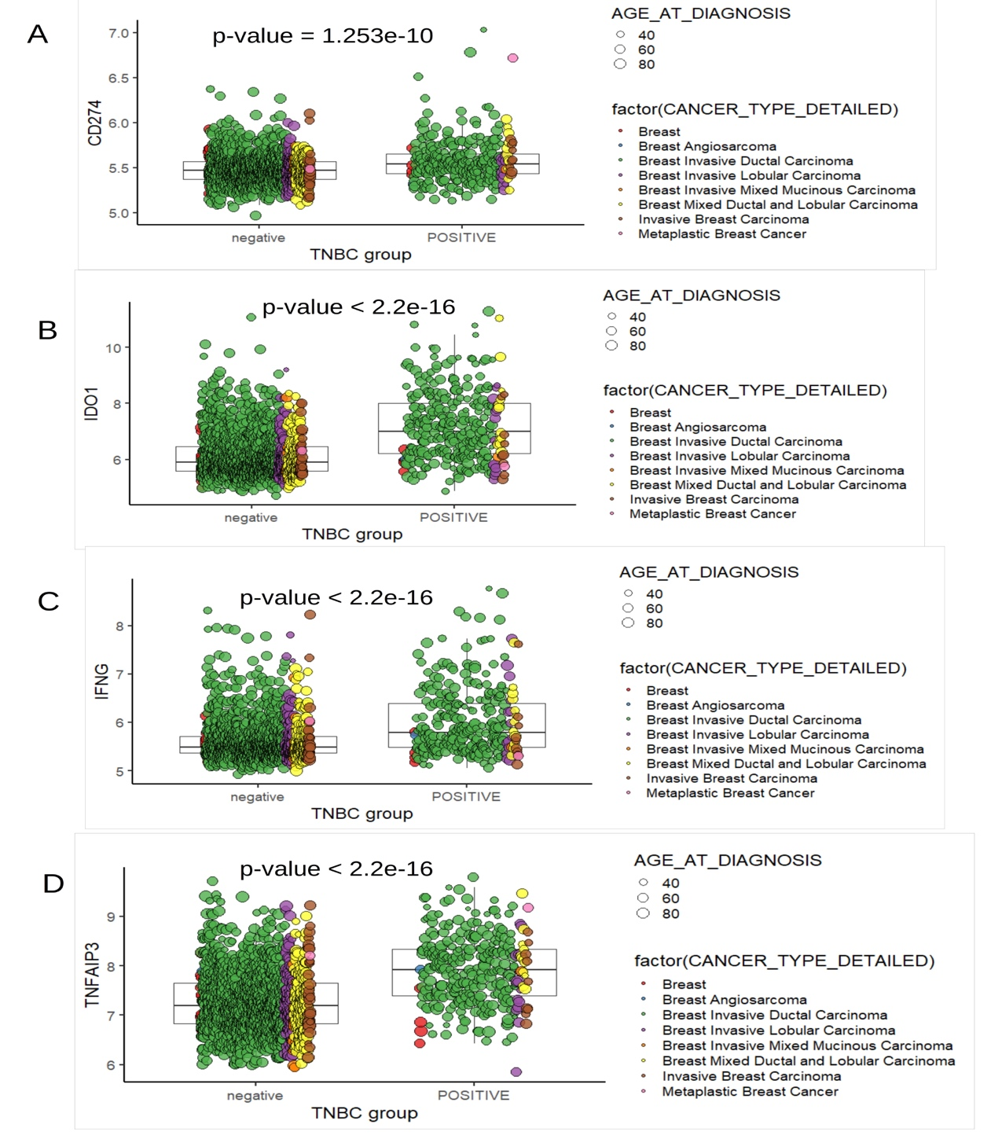

Figure S3

