Table S1
Gene and accession numbers of the redox enzymes and control proteins from the UniProt™ Protein Database
Parasite | Enzyme | Gene number | Accession number | Redox drug
G. duodenalis | PFOR | Q24982 | AAA74894.1 | Metronidazole
E. histolytica | PFOR | N9TJX2 | ENY63830.1 | Metronidazole
C. parvum | PFOR | A1DRF1 | ABK91849.1 | Nitazoxanide

Parasite | Control protein1 | Gene/Accession number | Control protein 2 | Gene/Accession number | Control protein 3 | Gene/Accession number
G. duodenalis | GAPDH | P53429  AAB18421.1 | TUB | A8BPC0  EDO78046.1 | RPB1 | Q8MUU2 AAM77743.1
E. histolytica | GAPDH | C4LVR9  BAN37492.1 | TUB | P31017  AAA57315.1 | RPB1 | Q6IUR3 AAT40981.1
C. parvum | GAPDH | Q7YYQ9  BAJ77164.1 | TUB | Q9UAC3  AAD20239.1 | RPB1 | A0A7G2HJ78 CAD98371.1

Table S2
List of protozoa showing how their lifecycle supports the horizontal acquisition of PFOR from bacteria based on the proximity hypothesis.
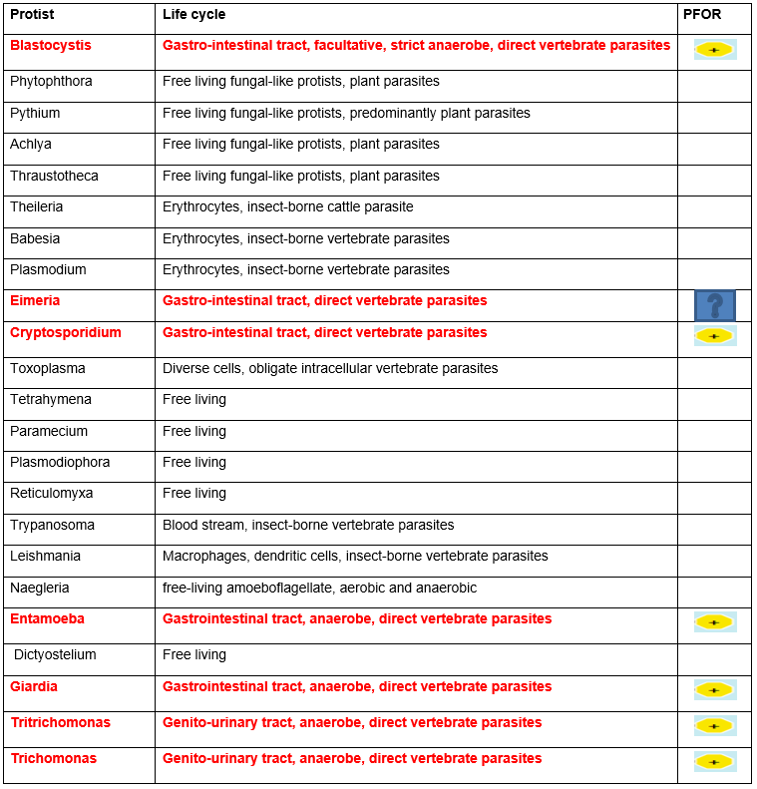

Straminopiles Alveolates Rhizaria
Excavates Amoebozoa Metamonads

