SUPPORTING INFORMATION

Investigation of novel thiazole derivatives bearing the benzenesulfonamide moiety as MAO inhibitors with a promising activity profiles

Anton Shetnev,^{1,2} Julia Efimova,^{1,3} Olga Gasilina,^{1,3} Eugenia Shabalina,² Dmitry Lifanov,² Elena Petersen,² Mikhail Korsakov,^{1,3} Anél Petzer,⁴ Jacobus P. Petzer ⁴

¹ Pharmaceutical Technology Transfer Center, Yaroslavl State Pedagogical University named after K.D.Ushinsky, Respublikanskaya street, 108/1, Yaroslavl, 150000, Russian Federation
² Moscow Institute of Physics and Technology, Institutskiy per., 9, Dolgoprudny, Moscow Region, 141701, Russian Federation
³ Russian State University named after A.N. Kosygina (Technology. Design. Art), 33 Sadovnicheskaya St., Moscow 117997, Russian Federation
⁴ Pharmaceutical Chemistry and Centre of Excellence for Pharmaceutical Sciences, North-West University, Potchefstroom 2520, South Africa

Table of contents
S1. Chemicals and instrumentation
S2. Preparation and characterization of thioamides (1a–o)

S3 Preparation and characterization of (2-bromoacetyl)benzenesulfonamides (2) and 2-bromo-1-(phenyl)ethanones (5)

References

NMR spectra

S1. Chemicals and instrumentation
All reagents and solvents were obtained from commercial sources (Aldrich, Fluka, Merck) and were used without further purification. Reactions were monitored with silica gel TLC using a mixture of toluene, acetone and petroleum ether (60:100:100) as eluent. Melting points were measured with a Stuart SMP30 apparatus in capillary tubes and are uncorrected. Electrospray ionization (ESI) mass spectra were obtained on a Bruker maXis spectrometer equipped with an ESI source. The instrument was operated in positive ion mode using an m/z range of 50–1200. The flow rate of the nebulizer gas was set to 1.0 bar, and that of the drying gas was set to 4.0 L/min. NMR spectra were recorded on a Bruker Avance 400 at ambient temperature, and were referenced to the residual solvent signal. ¹H NMR spectra were recorded at 400 MHz while ¹³C NMR spectra were recorded at 100 MHz. Chemical shifts are reported in parts per million (ppm).

S2. Preparation and characterization of thioamides (1a–o)
General procedure for the preparation of thioamides (1a–o) (GP4). Following to the previously reported procedure, phosphorus pentasulfide (3.4 mmol, 2.1 equiv.) was dissolved in dry ethanol. The nitrile reagent was added and the reaction mixture was stirred at 70 °C overnight. The solvent was evaporated under reduced pressure and the reaction mixture was diluted with cold water (5 mL). The resulting precipitate was collected by filtration, washed with toluene (15 mL) and air-dried at 50 °C (Kaboudin & Elhamifar, 2006).

Thiophene-2-carbothioamide (1a). The reaction of 2-thiophenecarbonitrile (8.13 mmol, 0.93 g) according to general procedure GP4 afforded 0.91 g (79%) of 1n isolated as the green crystalline solid. m.p. 105-106 °C. ¹H NMR (400 MHz, DMSO-d₆) δ 9.63 (s, 1H), 9.44 (s, 1H), 7.78 (d, J = 4.9 Hz, 1H), 7.70 (d, J = 3.4 Hz, 1H), 7.19 – 7.10 (m, 1H) (Papadopoulos 1974).

Thiobenzamide (1b)
The reaction of benzonitrile (9.79 mmol, 1 g) according to general procedure GP4 afforded 1.0 g (75%) of 1l isolated as the beige crystalline solid. m.p. 114-116 °C. ¹H NMR (400 MHz, DMSO- d₆) δ 9.85 (s, 1H), 9.57 (s, 1H), 7.87 (d, J = 8.0 Hz, 2H), 7.50 (t, J = 7.3 Hz, 1H), 7.41 (t, J = 7.5 Hz, 2H) (Guo et al., 2019).

4-(Dimethylamino)benzenecarbothioamide (1c). The reaction of 4-(dimethylamino)benzonitrile (0.02 mol, 3 g) according to general procedure GP4 afforded 3.2 g (89%) of 1f isolated as the yellow solid. m.p. 111-112 °C. ¹H NMR (400 MHz, DMSO- d₆) δ ¹H NMR (400 MHz, DMSO-d₆) δ 9.27 (s, 1H), 9.06 (s, 1H), 7.96 – 7.88 (m, 2H), 6.68 – 6.61 (m, 2H), 3.34 (s, 6H) (You et al., 1991).

3,4-Dichlorobenzenecarbothioamide (1d). The reaction of 3,4-dichlorobenzonitrile (5.81 mmol, 1 g) according to general procedure GP4 afforded 0.9 g (79%) of 1k isolated as the yellow crystalline solid. m.p. 132-134 °C. ¹H NMR (400 MHz, DMSO- d₆) δ 9.62 (s, 1H), 9.30 (s, 1H), 8.16 (s, 1H), 7.62 (d, J = 4.7 Hz, 1H), 7.53 (dd, J = 4.9, 3.0 Hz, 1H) (Guo et al., 2019).

Thiobenzamide (1e) was obtained from commercial source (Merck LTD)

4-(Fluoro)benzenecarbothioamide (1e). The reaction of 4-(fluoro)benzonitrile (0.04 mol, 5 g) according to general procedure GP4 afforded 2.59 g (40%) of 1a isolated as the green solid. m.p. 148 °C. ¹H NMR (400 MHz, DMSO- d₆) δ 9.88 (s, 1H), 9.50 (s, 1H), 8.02 – 7.93 (m, 2H), 7.31 – 7.20 (m, 2H) (Crane et al., 2004).

5-Methylthiophene-2-carbothioamide (1f). The reaction of 5-methyl-2-thiophenecarbonitrile (8.12 mmol, 1 g) according to general procedure GP4 afforded 1.02 g (80%) of 1m isolated as the green crystalline solid. m.p. 165-169 °C. ¹H NMR (400 MHz, DMSO-d₆) δ 9.46 (s, 1H), 9.28 (s, 1H), 7.51 (d, J = 3.7 Hz, 1H), 6.85 (d, J = 3.2 Hz, 1H), 2.41 (s, 3H) (Yang et al., 2013).

4-(Trifluoromethoxy)benzenecarbothioamide (1g). The reaction of 4-(trifluoromethoxy)benzonirile (0.016 mol, 3 g) according to general procedure GP4 afforded 1.61 g (45%) of 1b isolated as the yellow solid. m.p. 119-123 °C. ¹H NMR (400 MHz, DMSO- d₆) δ 9.98 (s, 1H), 9.59 (s, 1H), 8.03 – 7.95 (m, 2H), 7.44 – 7.36 (m, 2H) (You et al., 1991).

4-Isopropylthiobenzamide (1h). The reaction of 4-isopropylbenzonitrile (0.02 mol, 3 g) according to general procedure GP4 afforded 1.88 g (52%) of 1c isolated as the white solid. m.p. 147-148 °C. ¹H NMR (400 MHz, DMSO-d₆) δ 9.76 (s, 1H), 9.40 (s, 1H), 7.85 – 7.81 (m, 2H), 7.31 – 7.25 (m, 2H), 2.92 (p, J = 6.9 Hz, 1H), 1.21 (d, J = 7.0 Hz, 6H) (Faucher et al, 2008).

3,4-Dimethoxybenzenecarbothioamide (1i). The reaction of 3,4-dimethoxybenzonitrile (0.018 mol, 3 g) according to general procedure GP4 afforded 2.78 g (77%) of 1d isolated as the pink solid. m.p. 184 °C. ¹H NMR (400 MHz, DMSO-d₆) δ 9.64 (s, 1H), 9.32 (s, 1H), 7.64 – 7.54 (m, 2H), 6.97 (d, J = 8.4 Hz, 1H), 3.80 (d, J = 4.3 Hz, 6H) (Aki et al., 2002).

3-(Trifluoromethyl)benzenecarbothioamide (1j). The reaction of 4-(trifluoromethyl)benzonitrile (0.02 mol, 3 g) according to general procedure GP4 afforded 3.7 g (90%) of 1h isolated as the yellow solid. ¹H NMR (DMSO-d₆) δ 8.27 (s, 1H), 8.15 (s, 1H), 8.06 (d, J = 7.9 Hz, 1H), 7.93 (d, J = 7.91 Hz, 1H), 7.74 (t, J = 7.9 Hz, 1H), 7.31 (s, 1H) (Sierra et al., 2007).

4-Methoxybenzenecarbothioamide (1k). The reaction of 4-methoxybenzonitrile (0.023 mol, 3 g) according to general procedure GP4 afforded 3.1 g (79%) of 1e isolated as the yellow solid. m.p. 99-100 °C. ¹H NMR (400 MHz, CDCl₃) δ 9.58 (s, 1H), 9.24 (s, 1H), 7.93 – 7.86 (m, 2H), 6.87 – 6.80 (m, 2H), 3.81 (s, 3H) (Soh et al., 2006).

S3 Preparation and characterization of (2-bromoacetyl)benzenesulfonamides (2) and 2-bromo-1-(phenyl)ethanones (5)
General procedure for the preparation of (2-bromoacetyl)benzenesulfonamides (2) and 2-bromo-1-(phenyl)ethanones (5) (GP5). Acetylbenzenesulfonamide or R-substituted-acetylbenzene (4.5 mmol, 1 equiv.) was dissolved in acetic acid (22 ml), while bromine (4.7 mmol, 1.05 equiv) was mixed separately with acetic acid (5 ml). The first portion of bromine was added to the reaction mixture and the solution became colorless. The remaining bromine solution was subsequently added dropwise. The reaction mixture was stirred at 40 °C for 1 h, cooled to room temperature and the solvent was evaporated under reduced pressure. The resulting oil was diluted with cold water (25 ml) and the precipitate that formed was collected by filtration, washed with water (15 ml) and air-dried at 25 °C (Jacobs et al., 2022).

4-(2-Bromoacetyl)benzenesulfonamide (2a). The reaction of 4-acetylbenzenesulfonamide (4.5 mmol, 1 g) according to general procedure GP5 afforded 1.22 g (98%) of 2a isolated as the beige crystalline solid. m.p. 154-155 °C. ¹H NMR (400 MHz, DMSO-d₆) δ 8.17 (d, J = 8.2 Hz, 2H), 7.96 (d, J = 8.2 Hz, 2H), 7.57 (s, 2H), 4.98 (s, 2H) (Scobie et al, 2018).

3-(2-Bromoacetyl)benzenesulfonamide (2b). The reaction of 3-acetylbenzenesulfonamide (12.5 mmol, 2.5 g) according to general procedure GP5 afforded 3.12 g (90%) of 2b isolated as the beige crystalline solid. m.p. 130-132 °C. ¹H NMR (400 MHz, DMSO-d₆) δ 8.16 (d, J = 7.2 Hz, 2H), 8.07 (d, J = 7.2 Hz, 2H), 7.95 (m2H), 7.56 (s, 2H), 4.97 (s, 2H) (Fujikura et al., 1982).

1-(1,3-Benzodioxol-5-yl)-2-bromoethanone (5a). The reaction of 5-acetyl-1,3-benzodioxole (0.03 mol, 5 g) according to general procedure GP5 afforded 5.03 g (69%) of 5a isolated as the beige solid. m.p. 87-88 °C. ¹H NMR (300 MHz, CDCl₃): d 4.39 (s, 2H), 6.03 (s, 2H), 6.85 (d, 1H, J = 8.1 Hz), 7.48 (d, 1H, J = 1.8 Hz), 7.60 (dd, 1H, J = 8.1 Hz, J = 1.8 Hz) (Antunes et al., 2004).

2-Bromo-1-(4-chlorophenyl)ethanone (5b). The reaction of 1-(4-chlorophenyl)ethanone (0.032 mol, 5 g) according to general procedure GP5 afforded 4.49 g (60%) of 5b isolated as the white solid. m.p. 94-96 °C. ¹H NMR (400 MHz, CDCl₃) δ: 7.48 (d, J = 8.8 Hz, 2 H), 7.94 (d, J = 8.8 Hz, 2 H). 4.41 (s, 2H) (Patonay et al., 2002).

References
- Aki, S.; Fujioka, T.; Ishigami, M.; Minamikawa, J. A practical synthesis of 3,4-diethoxybenzthioamide based on friedel-crafts reaction with potassium thiocyanate in methanesulfonic acid. Bioorg. Med. Chem. Lett. 2002, 12, 2317-2320.
- Antunes, H.; Fardelone, L.d.C.; Rodrigues, J.A.R.; Moran, P.J.S. Chemoenzymatic syntheses of (r)-2-bromo-, (r)2-chloro- and (r)2-azido-1-(1,3-benzodioxol-5-yl)-1-ethanol. Tetrahedron Asymmetry 2004, 15, 2615-2620.
- Crane, L.J.; Anastassiadou, M.; Stigliani, J.-L.; Baziard-Mouysset, G.; Payard, M. Reactions of some ortho and para halogenated aromatic nitriles with ethylenediamine: Selective synthesis of imidazolines. Tetrahedron 2004, 60, 5325-5330.
- Faucher, N. E.; Martres, P.; Meunier, S. Indole derivatives useful as ppar activators. Application PCT/EP2008/063371, 7 Oct 2008
- Fujikura, T.; Niigata, K.; Hashimoto, S.; Imai, K.; Takenaka, T. Studies on benzenesulfonamide derivatives with &alpha;-and &beta;-adrenergic antagonistic and antihypertensive activities. Chem. Pharm. Bull. 1982, 30, 4092-4101.
- Guo, J.; Hao, Y.; Ji, X.; Wang, Z.; Liu, Y.; Ma, D.; Li, Y.; Pang, H.; Ni, J.; Wang, Q. Optimization, structure–activity relationship, and mode of action of nortopsentin analogues containing thiazole and oxazole moieties. J. Agric. Food Chem. 2019, 67, 10018-10031.
- Jacobs, J. W., Leadbetter, M. R., Bell, N., Koo-McCoy, S., Carreras, C. W., He, L., Kohler, J., Kozuka, K., Labonté, E. D., Navre, M., Spencer, A. G., Charmot, D. (2022). Discovery of tenapanor: A first-in-class minimally systemic inhibitor of intestinal na+/h+ exchanger isoform 3. ACS Med. Chem. Lett. 2022, 13(7), 1043–1051.
- Jensen, K. A., & Schmith, K. Über die Konstitutionsspezifität der bakteriostatischen Wirkung von p-(Aminomethyl)-benzolsulfonamid. Z Physiol Chem Zschr. physiol. Chem. 1944, 280(1-2), 35–38.
- Kaboudin, B.; Elhamifar, D. Phosphorus pentasulfide: A mild and versatile reagent for the preparation of thioamides from nitriles. Synthesis. 2006, 224-226.
- Matsuda, K.; Yanagisawa, I.; Isomura, Y.; Mase, T.; Shibanuma, T. Alternative synthesis of dibenzo-and dipyrido-[1,3]diazepines from thioamides and o,o′-diaminobiaryls. Synth. Commun. 1997, 27, 2393-2402.
- Papadopoulos, E.P. Preparation and reactions of n-ethoxycarbonylthiophene-2-carboxamide and n-ethoxycarbonylthiophene-2-thiocarboxamide. J. Org. Chem., 1974, 39, 2540-2542.
- Patonay, T.; Juhász-Tóth, É.; Bényei, A. Base-induced coupling of α-azido ketones with aldehydes − an easy and efficient route to trifunctionalized synthons 2-azido-3-hydroxy ketones, 2-acylaziridines, and 2-acylspiroaziridines. Eur. J. Org. Chem., 2002, 285-295.
- Scobie, M. Mth1 Inhibitors for Treatment of Inflammatory and Autoimmune Conditions. U.S. Patent US16/120,170, 31 August 2018.
- Sierra, M.L.; Beneton, V.; Boullay, A.B.; Boyer, T.; Brewster, A.G.; Donche, F.; Forest, M.C.; Fouchet, M.H.; Gellibert, F.J.; Grillot, D.A., et al. Substituted 2-[(4-aminomethyl)phenoxy]-2-methylpropionic acid pparalpha agonists. 1. Discovery of a novel series of potent hdlc raising agents. J. Med. Chem., 2007, 50, 685-695.
- Soh, C.H.; Chui, W.K.; Lam, Y. Synthesis of 2,4-disubstituted 5-aminoimidazoles using microwave irradiation. J. Comb. Chem., 2006, 8, 464-468.
- Yang, J.; Pi, W.; Xiong, L.; Ang, W.; Yang, T.; He, J.; Liu, Y.; Chang, Y.; Ye, W.; Wang, Z., et al. 3h-1,2,4-dithiazol-3-one compounds as novel potential affordable antitubercular agents. Bioorg. Med. Chem. Lett. 2013, 23, 1424-1427.
- You, Q.-D.; Zhou, H.-Y.; Wang, Q.-Z.; Lei, X.-H. Preparation of n-unsubstituted thioamides by a modified willgerodt-kindler reaction. Org. Prep. Proced. Int. 1991, 23, 435-438.

NMR spectra

4-(2-(Thiophen-2-yl)thiazol-4-yl)benzenesulfonamide (3a)
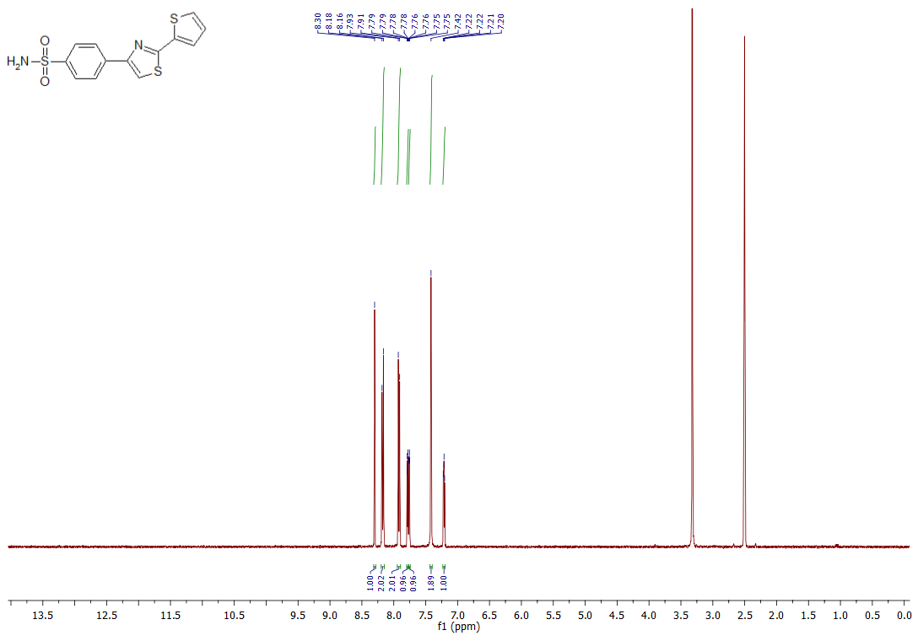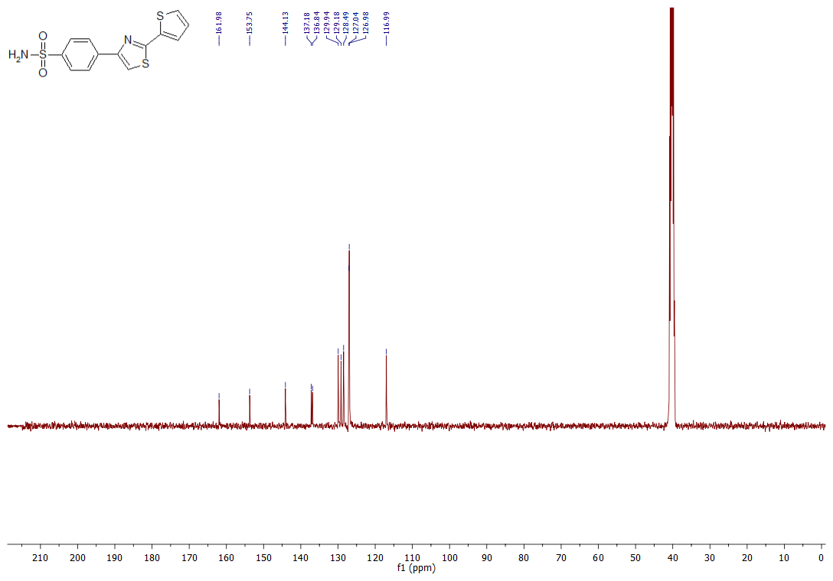

4-(2-Phenylthiazol-4-yl)benzenesulfonamide (3b)
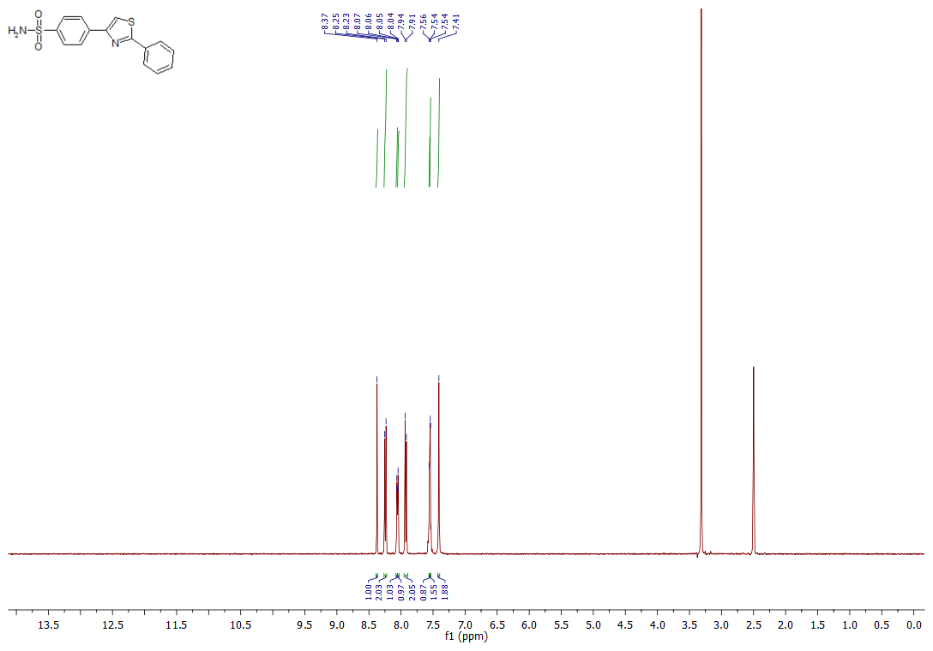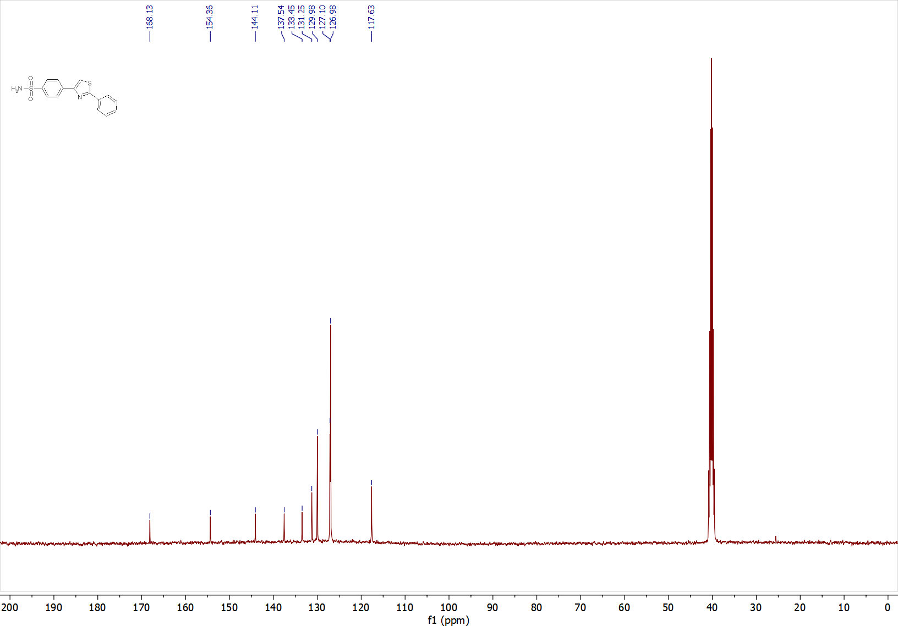
4-(2-(4-(Dimethylamino)phenyl)thiazol-4-yl)benzenesulfonamide (3c)
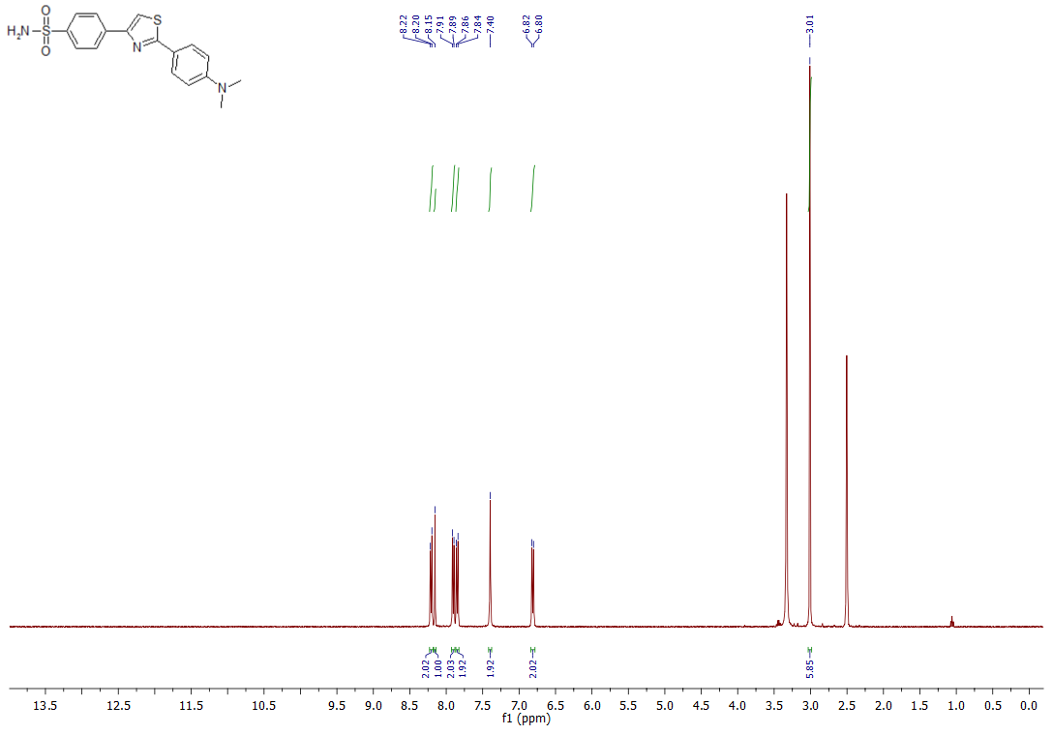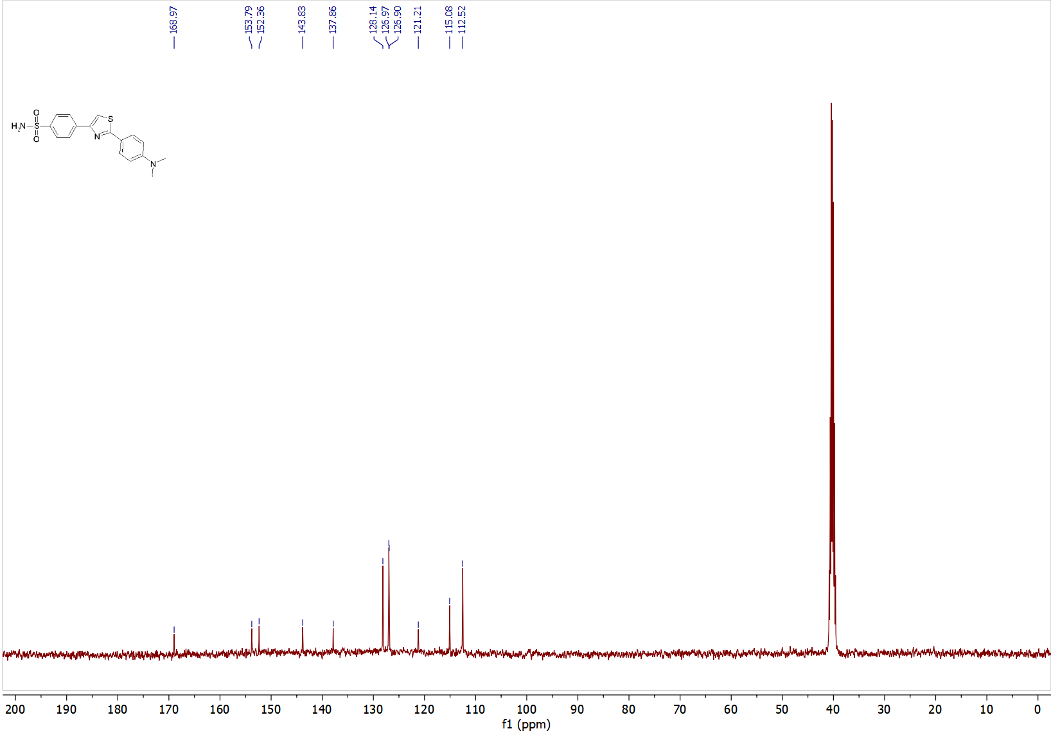
4-(2-(3,4-Dichlorophenyl)thiazol-4-yl)benzenesulfonamide (3d)
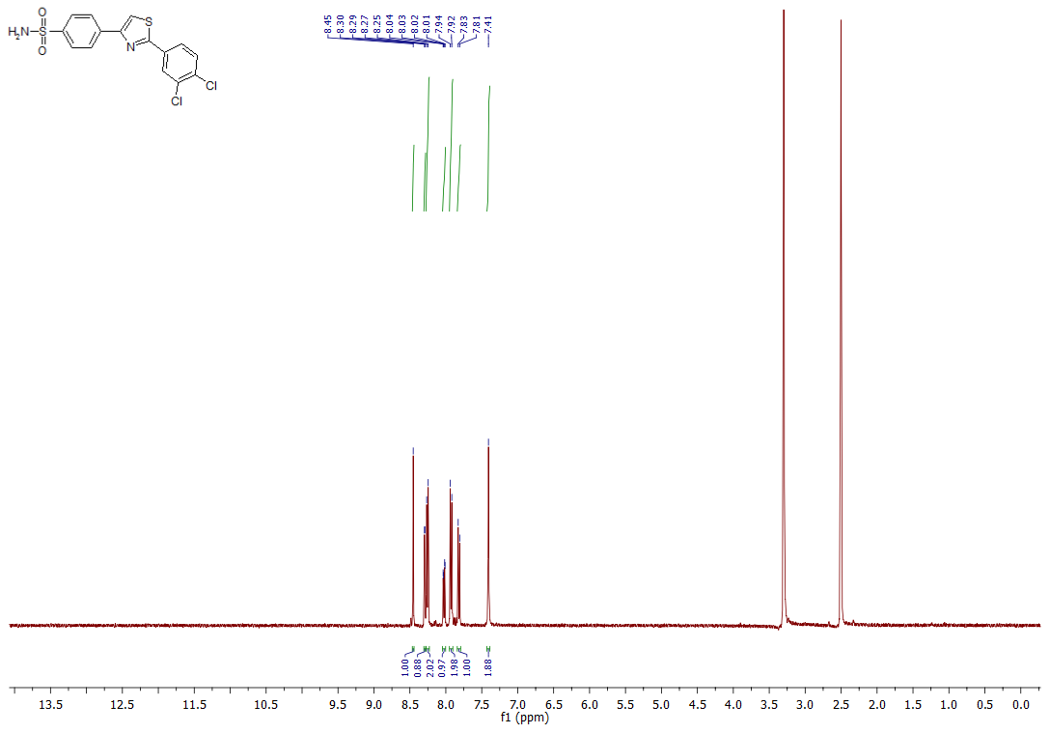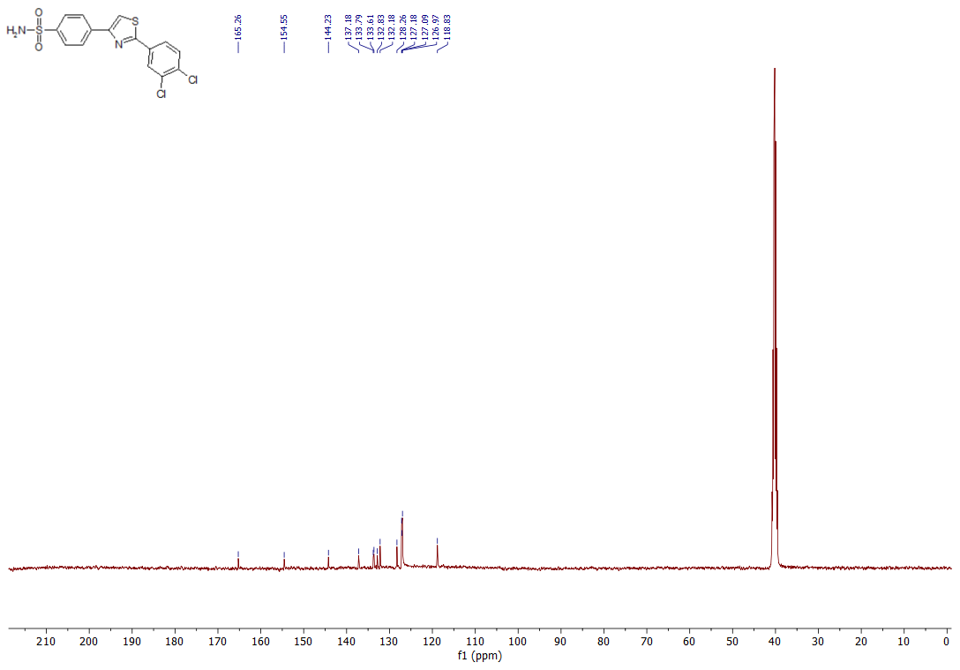
4-(2-Methylthiazol-4-yl)benzenesulfonamide (3e)
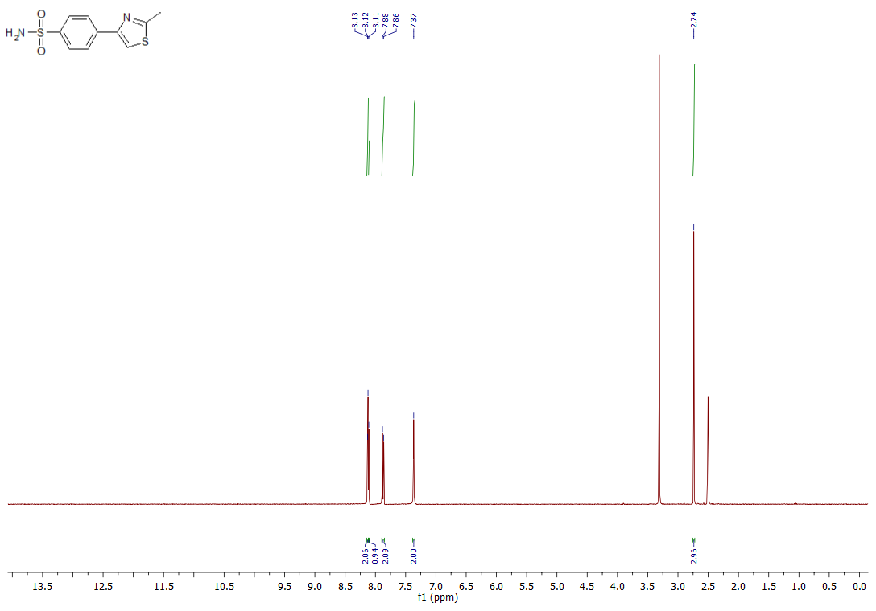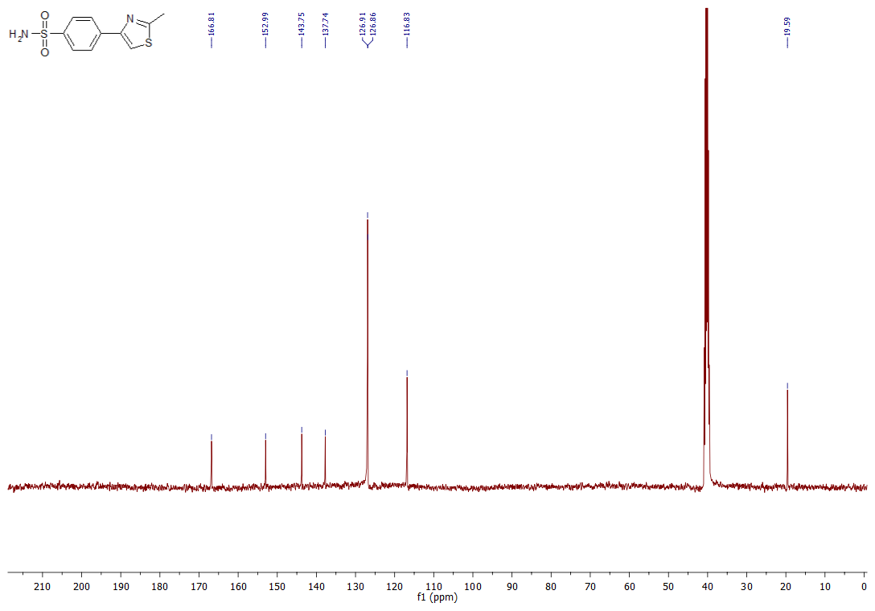
4-(2-(4-Fluorophenyl)thiazol-4-yl)benzenesulfonamide (3f)
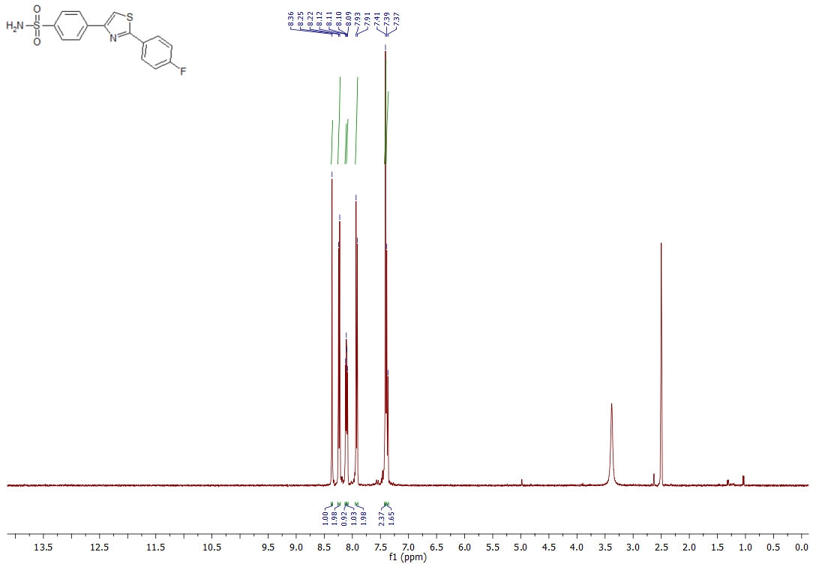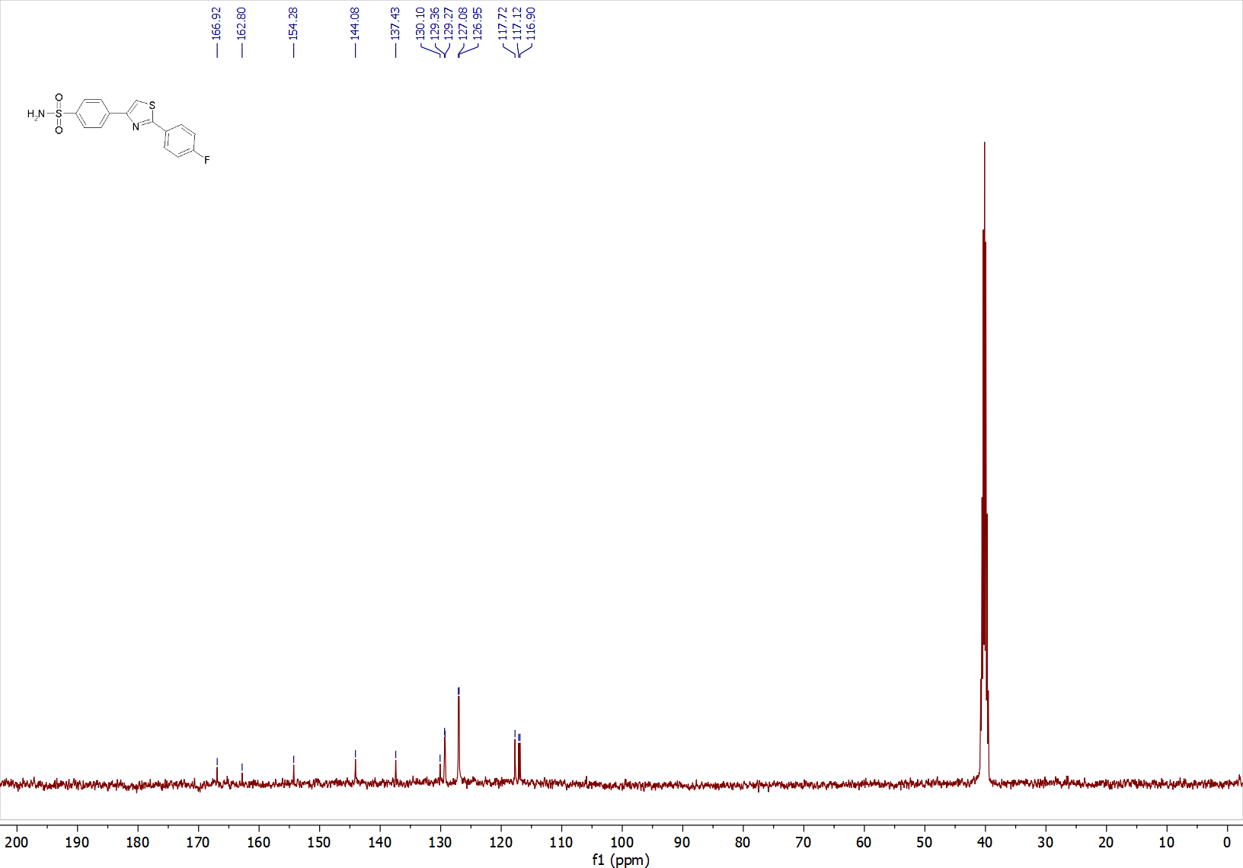
4-(2-(5-Methylthiophen-2-yl)thiazol-4-yl)benzenesulfonamide (3g)
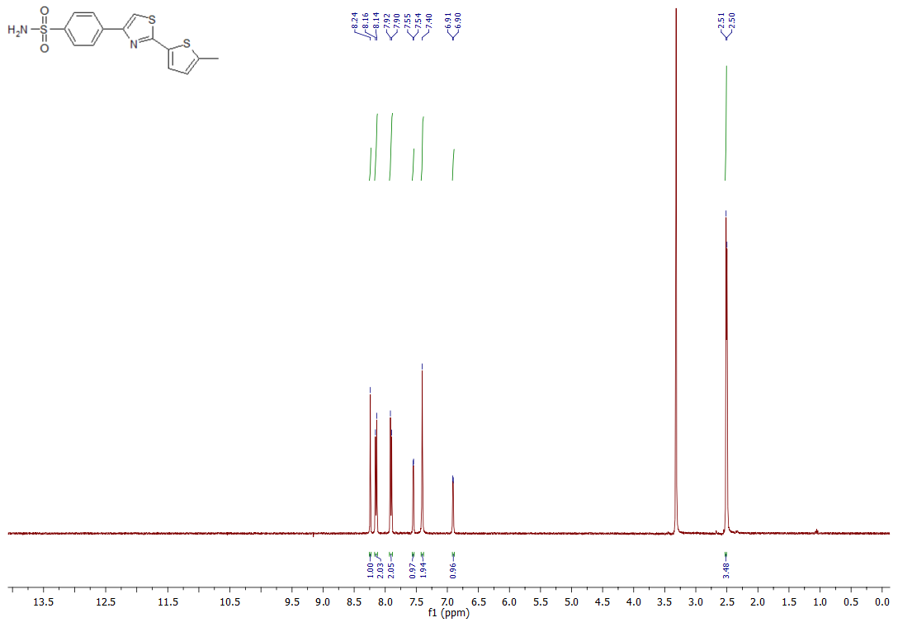 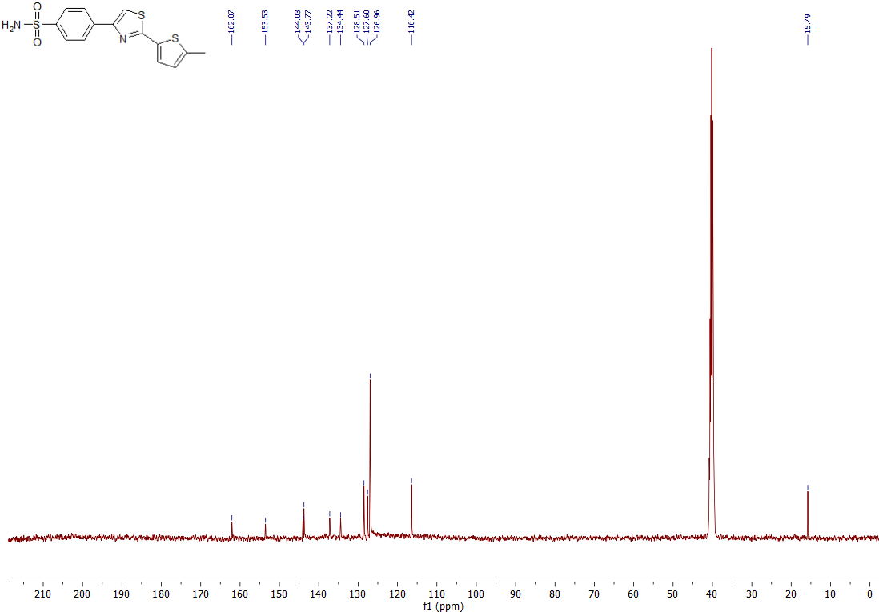
4-(2-(4-(Trifluoromethoxy)phenyl)thiazol-4-yl)benzenesulfonamide (3h)
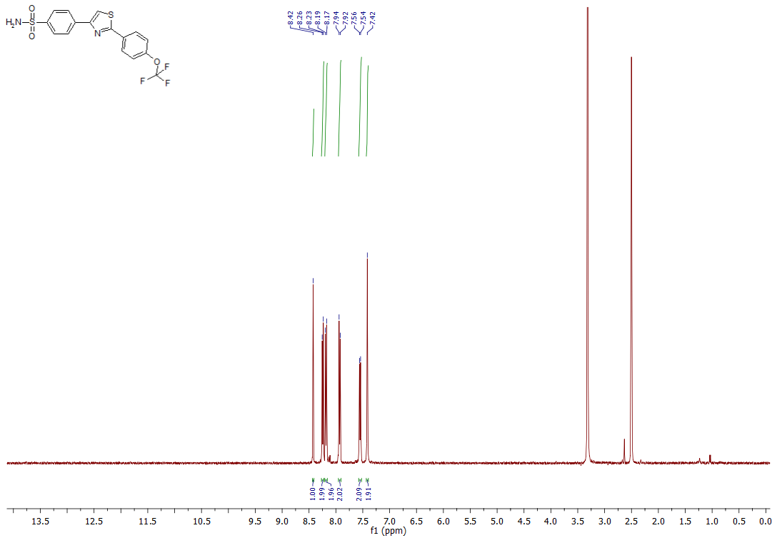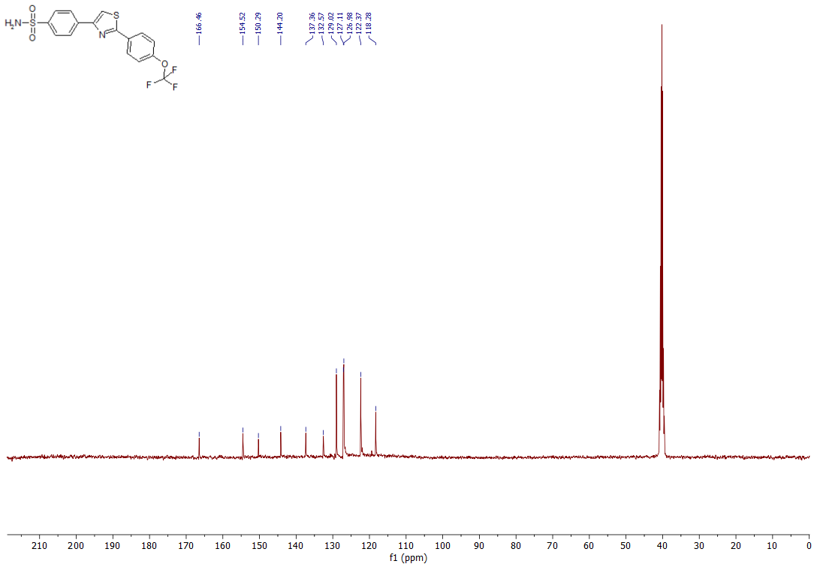
3-(2-Methylthiazol-4-yl)benzenesulfonamide (3i)
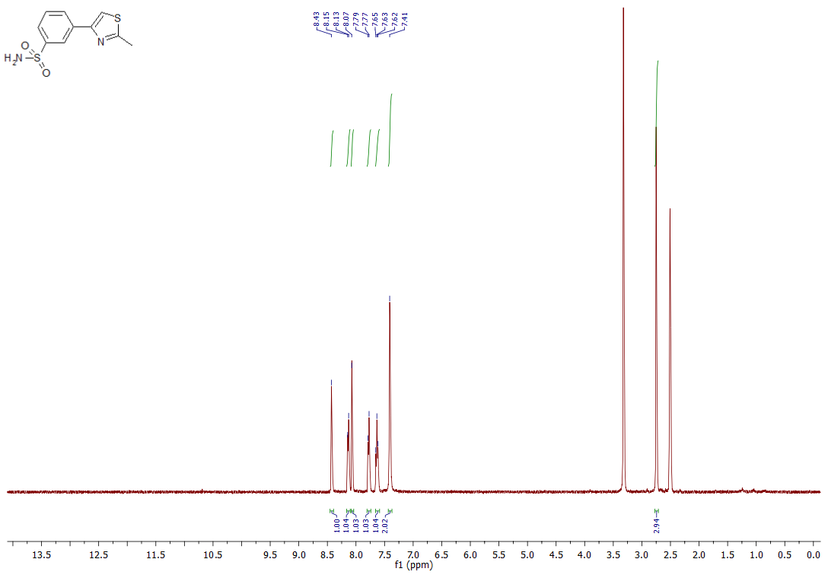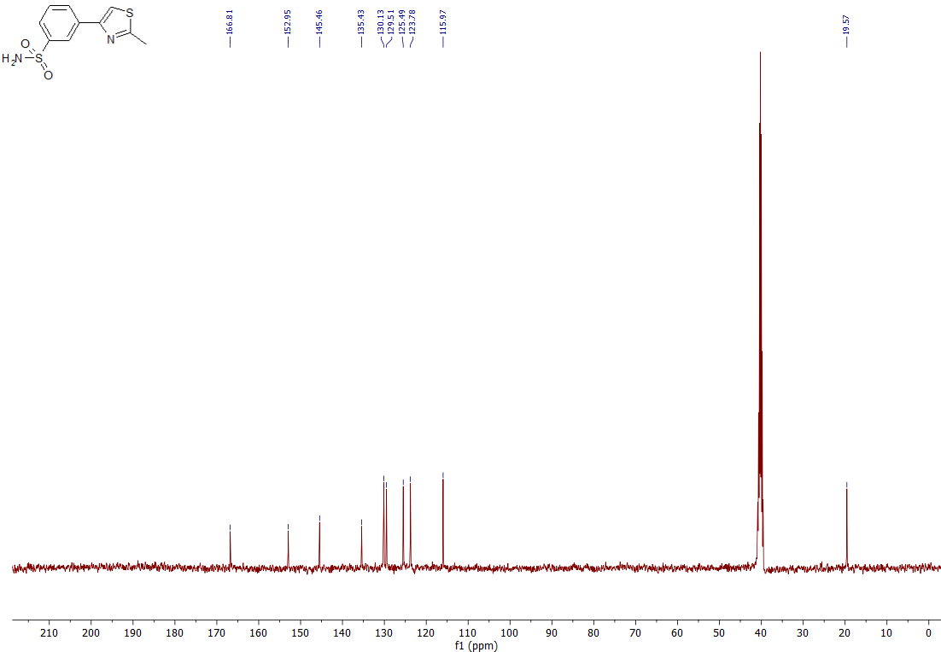
3-(2-Phenylthiazol-4-yl)benzenesulfonamide (3j)
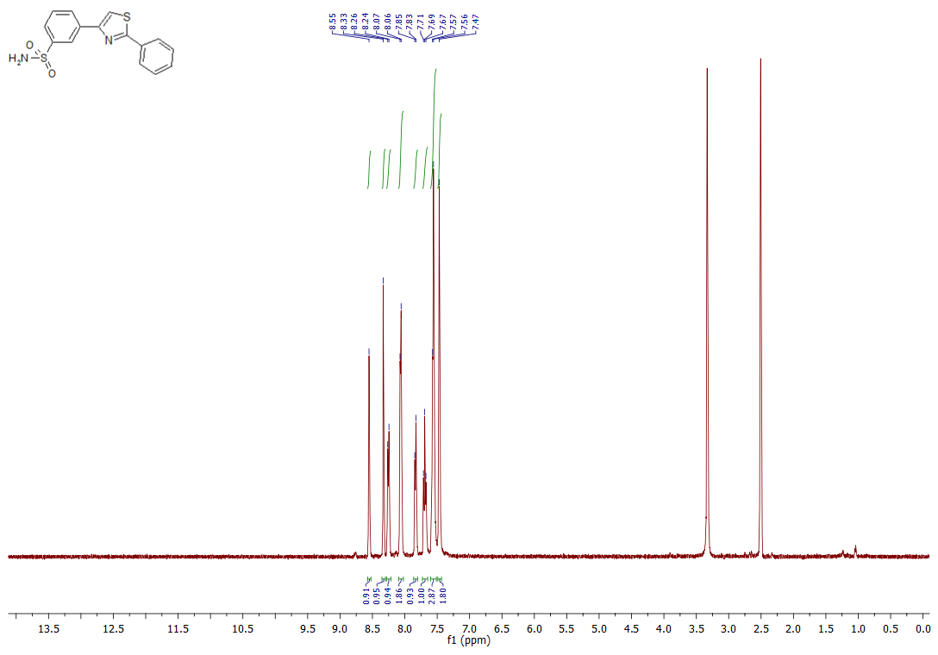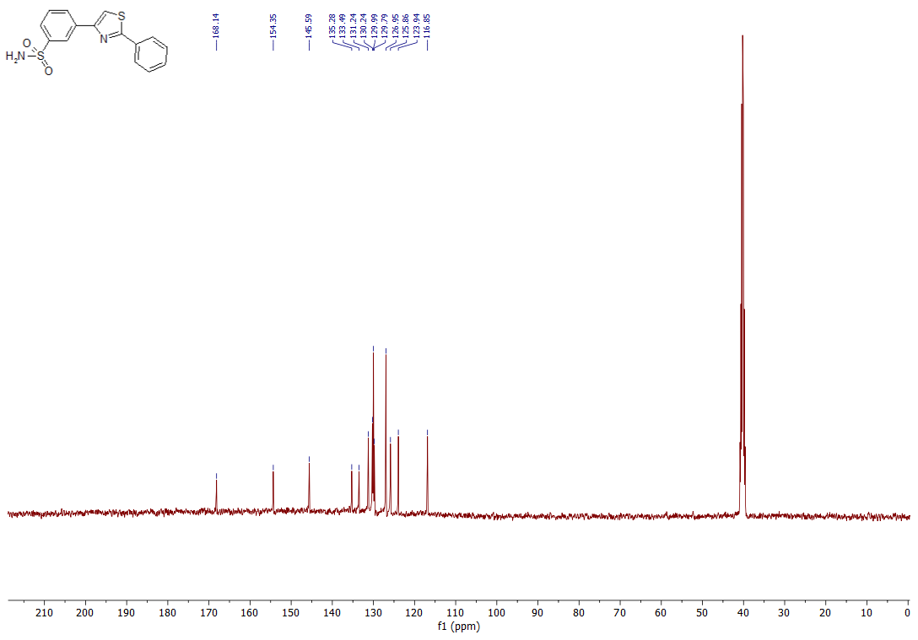
4-(2-(4-Isopropylphenyl)thiazol-4-yl)benzenesulfonamide (3k)
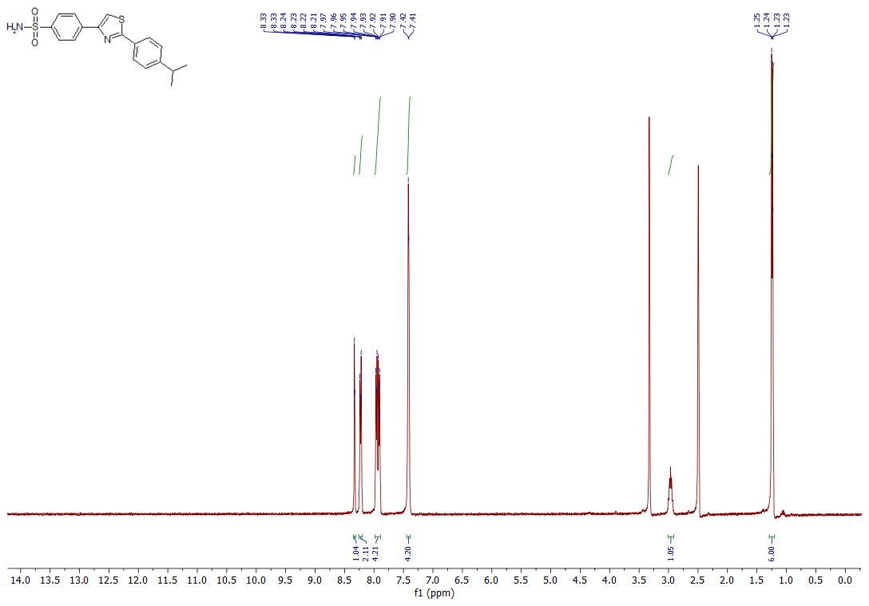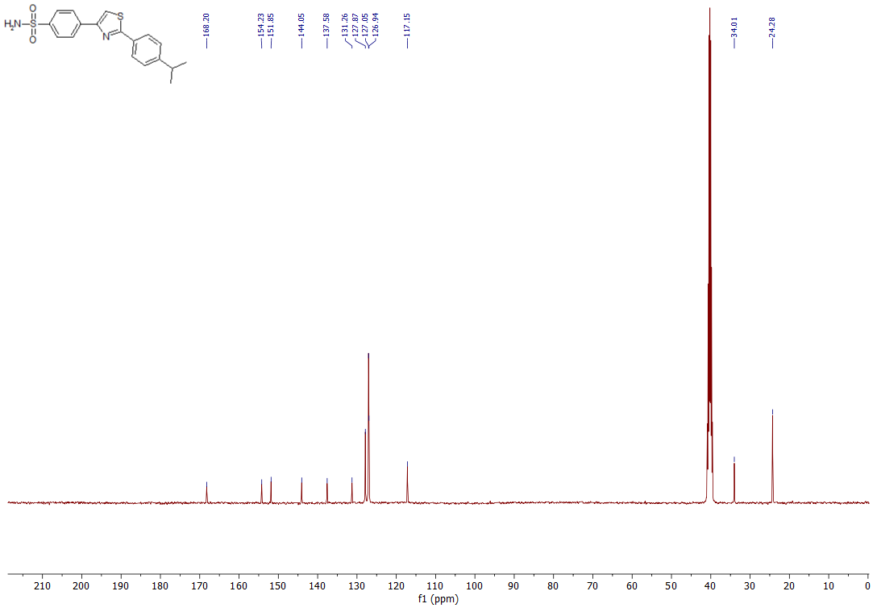
3-(2-(4-Fluorophenyl)thiazol-4-yl)benzenesulfonamide (3l)
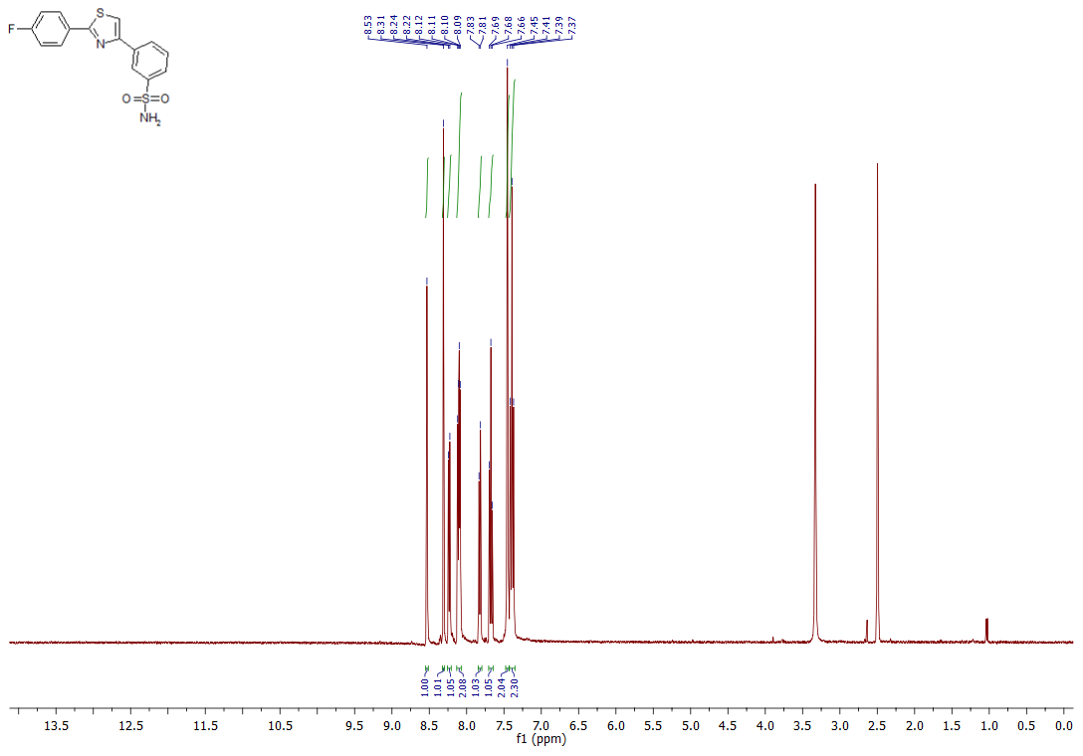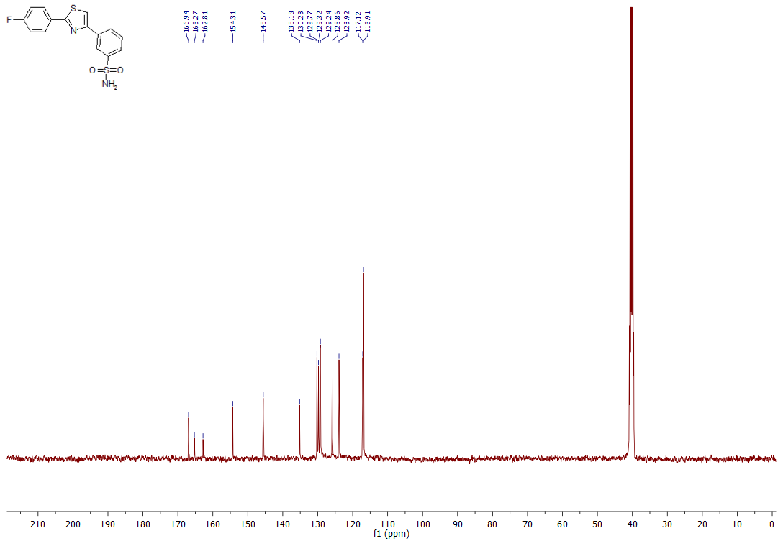
3-(2-(3,4-Dichlorophenyl)thiazol-4-yl)benzenesulfonamide (3m)
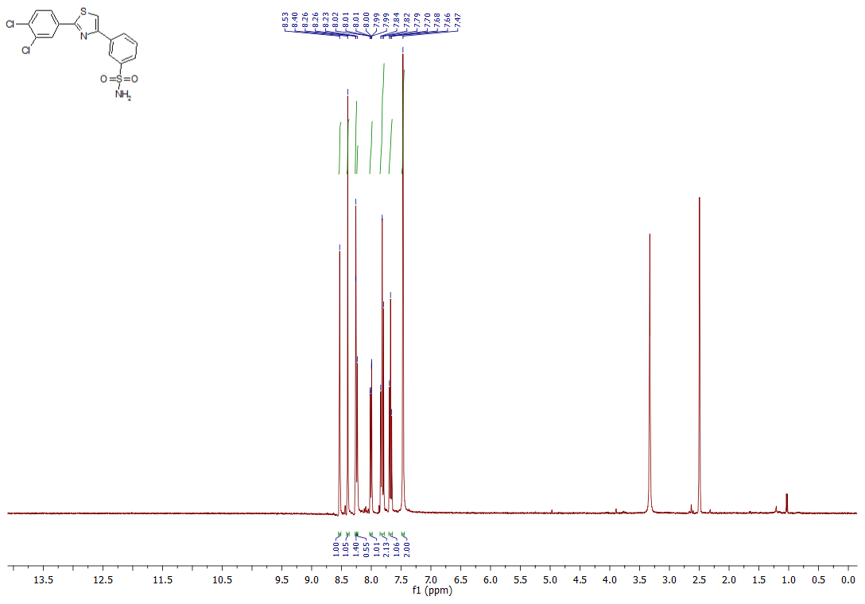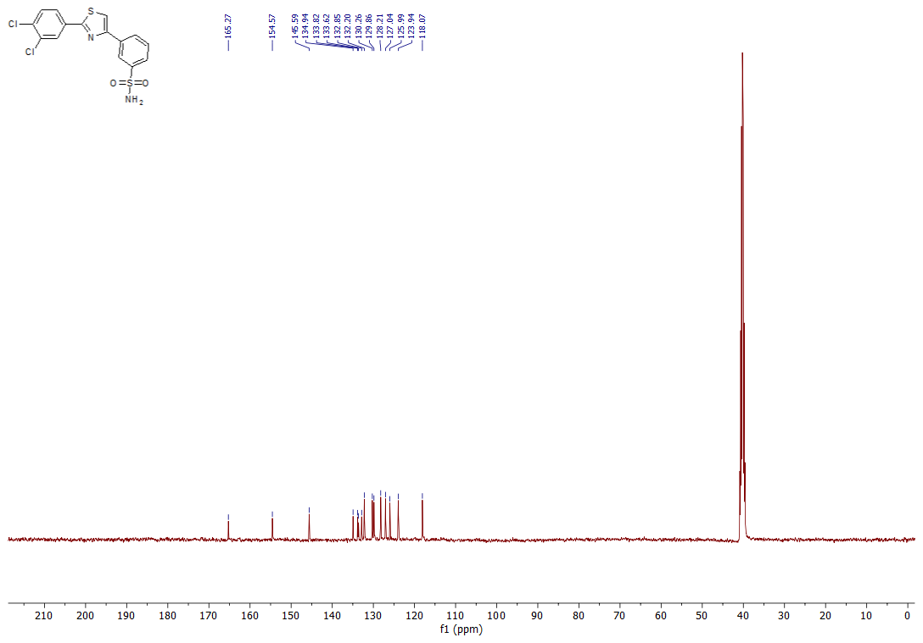
3-(2-(4-Isopropylphenyl)thiazol-4-yl)benzenesulfonamide (3n)
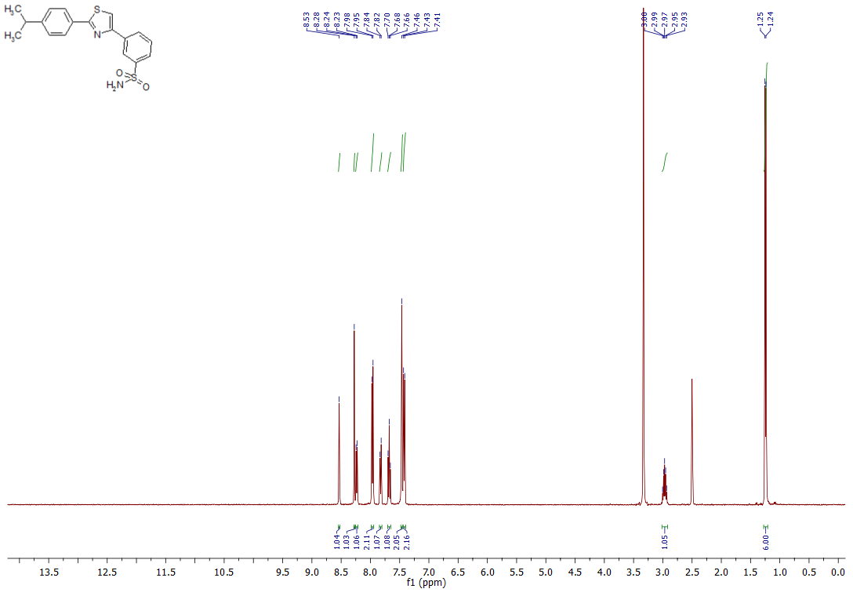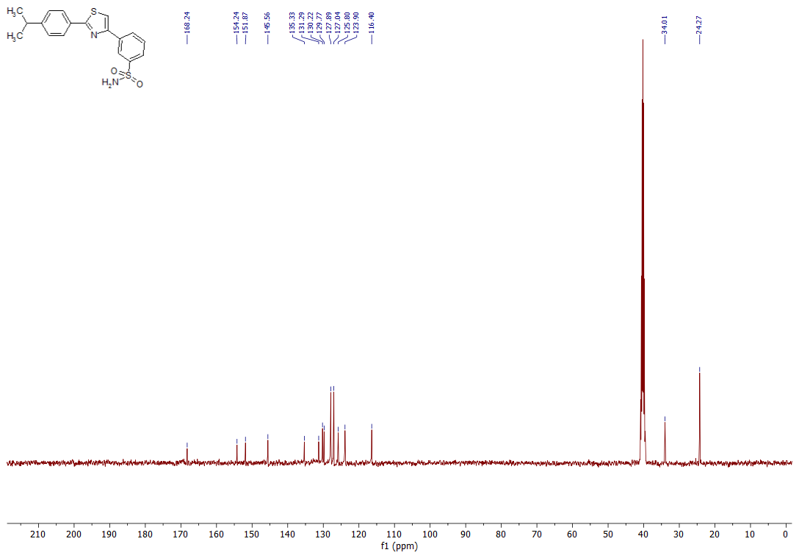
3-(2-(3,4-Dimethoxyphenyl)thiazol-4-yl)benzenesulfonamide (3o)
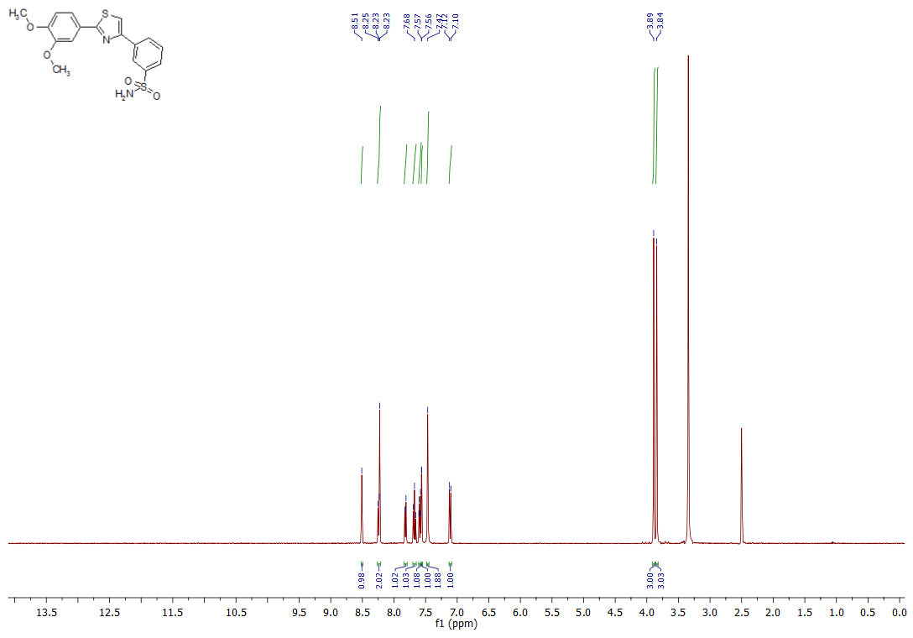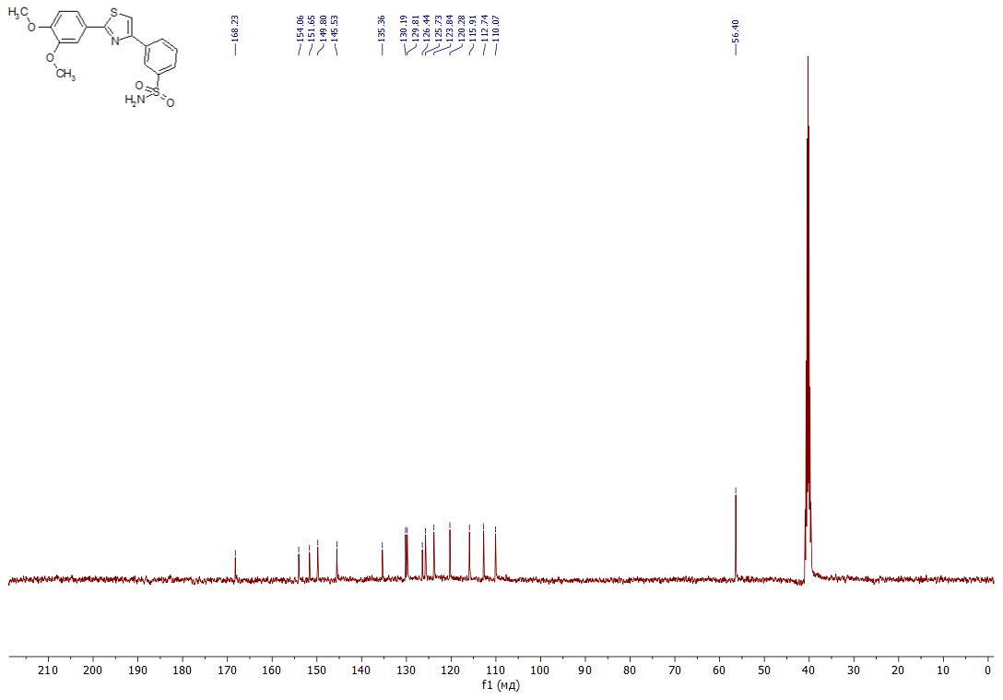
4-[2-(3,4-Dimethoxyphenyl)-1,3-thiazol-4-yl]benzenesulfonamide (3p)
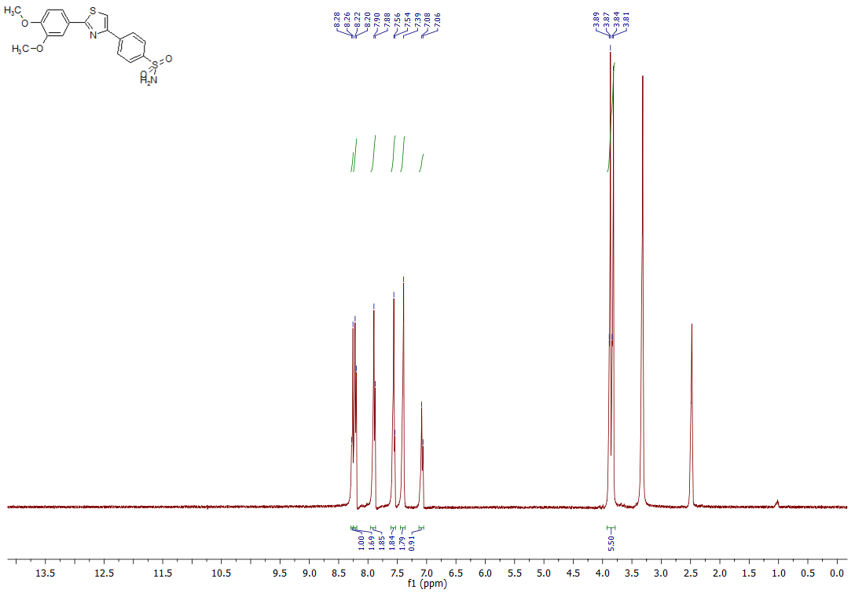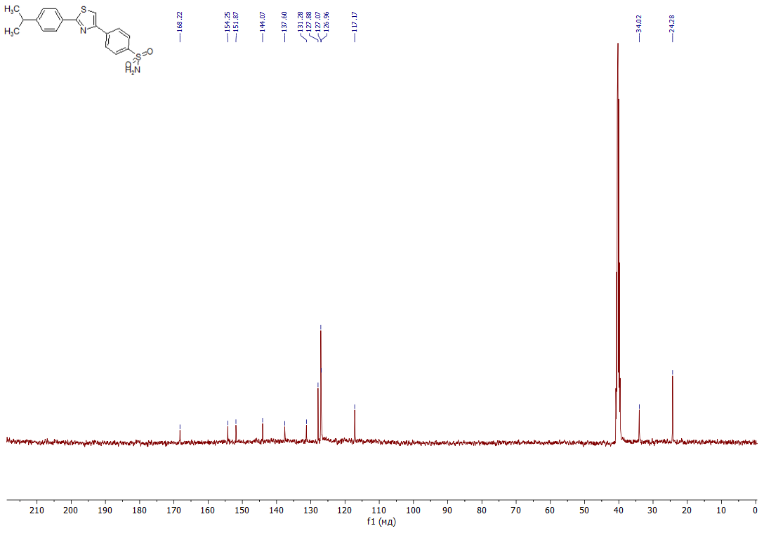
3-{2-[4-(Dimethylamino)phenyl]-1,3-thiazol-4-yl}benzenesulfonamide (3q)
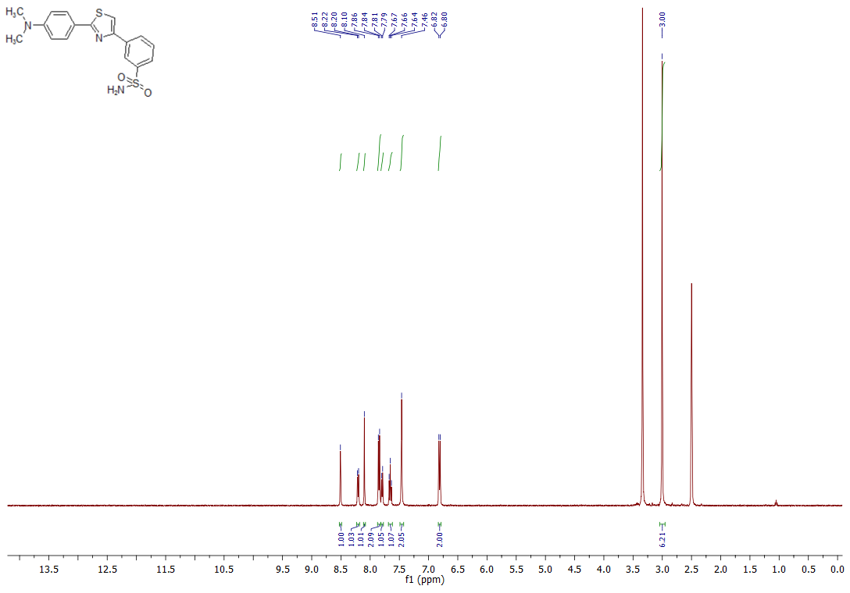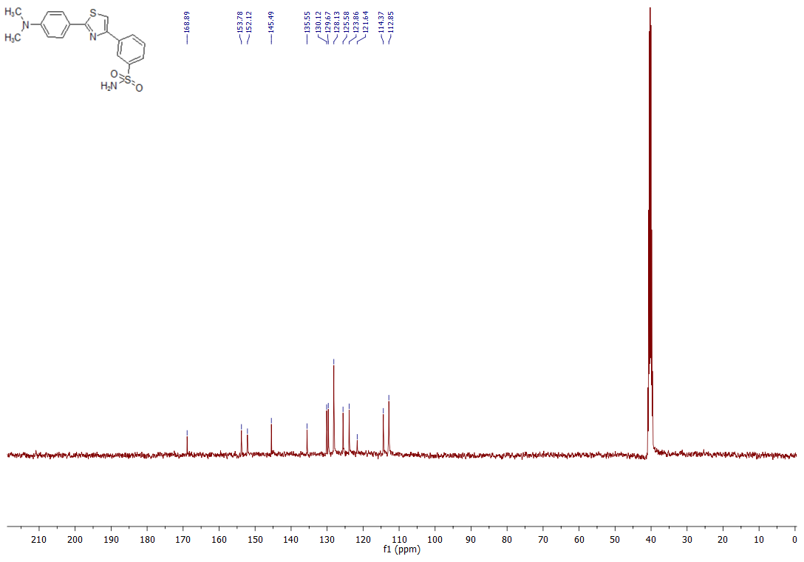
3-(2-(4-(Trifluoromethoxy)phenyl)thiazol-4-yl)benzenesulfonamide (3r)
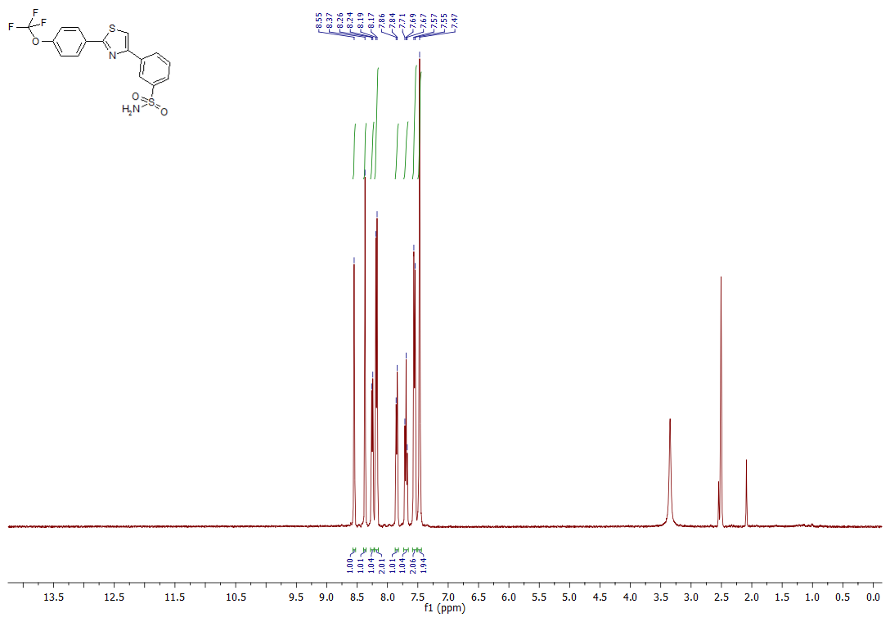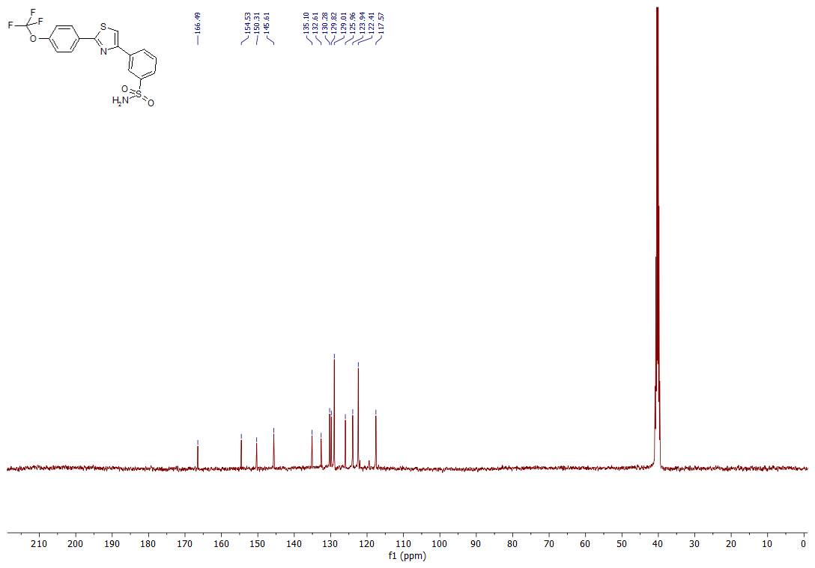
4-(2-(3-(trifluoromethoxy)phenyl)thiazol-4-yl)benzenesulfonamide (3s)
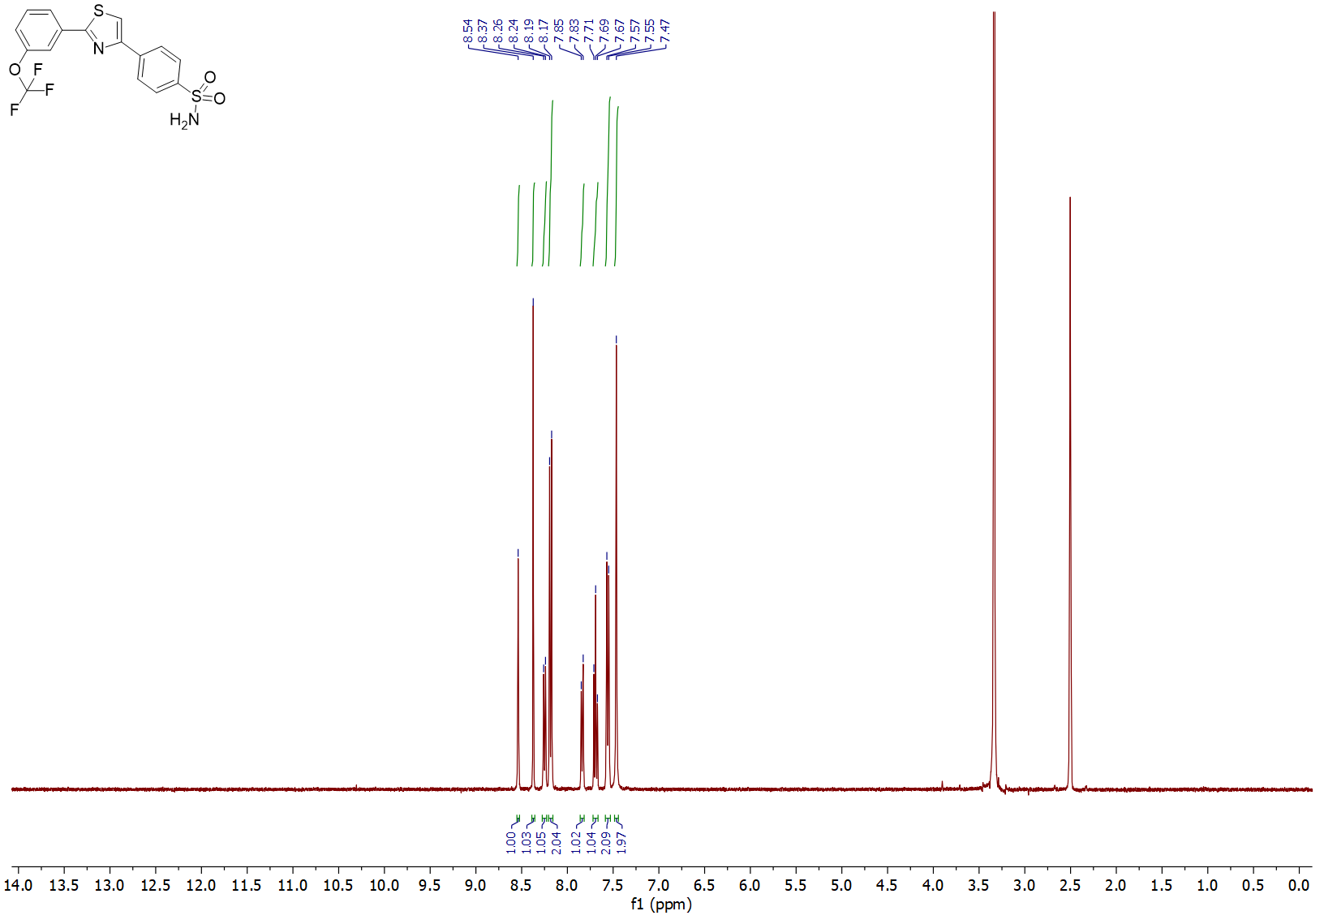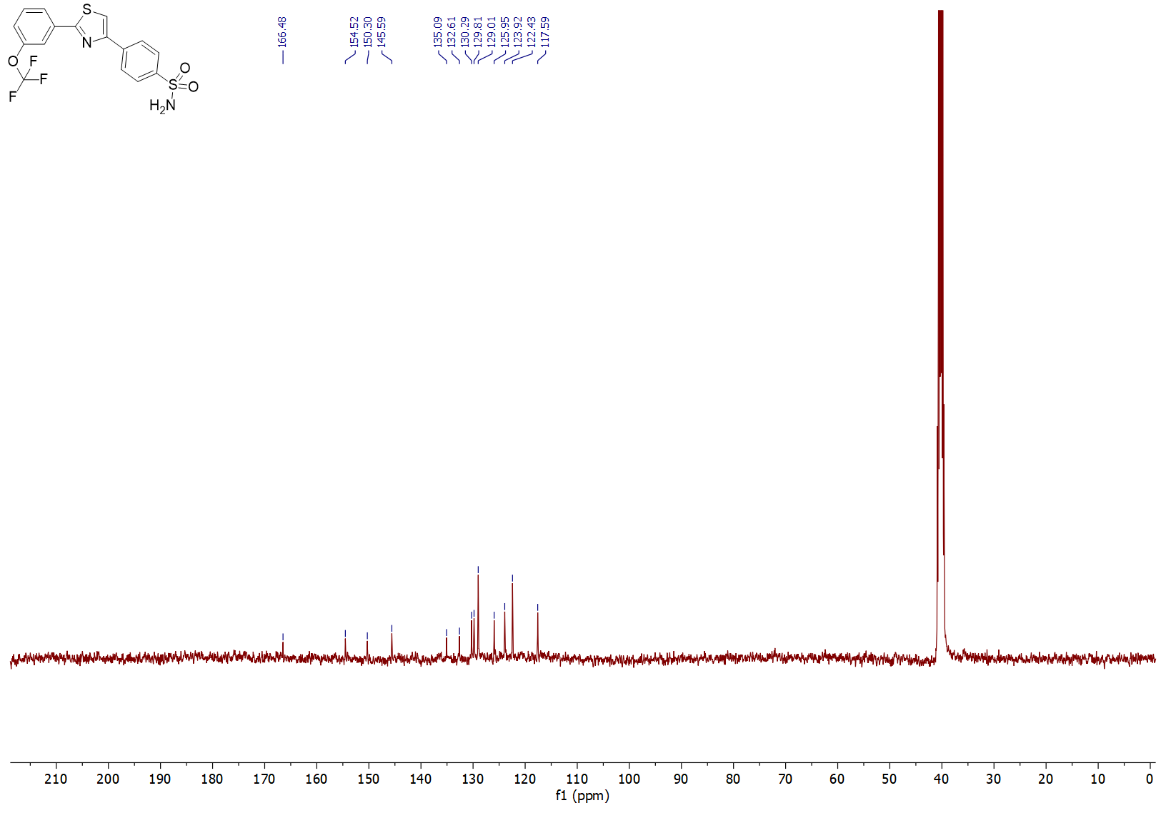

3-(2-(4-Methoxyphenyl)thiazol-4-yl)benzenesulfonamide (3t)
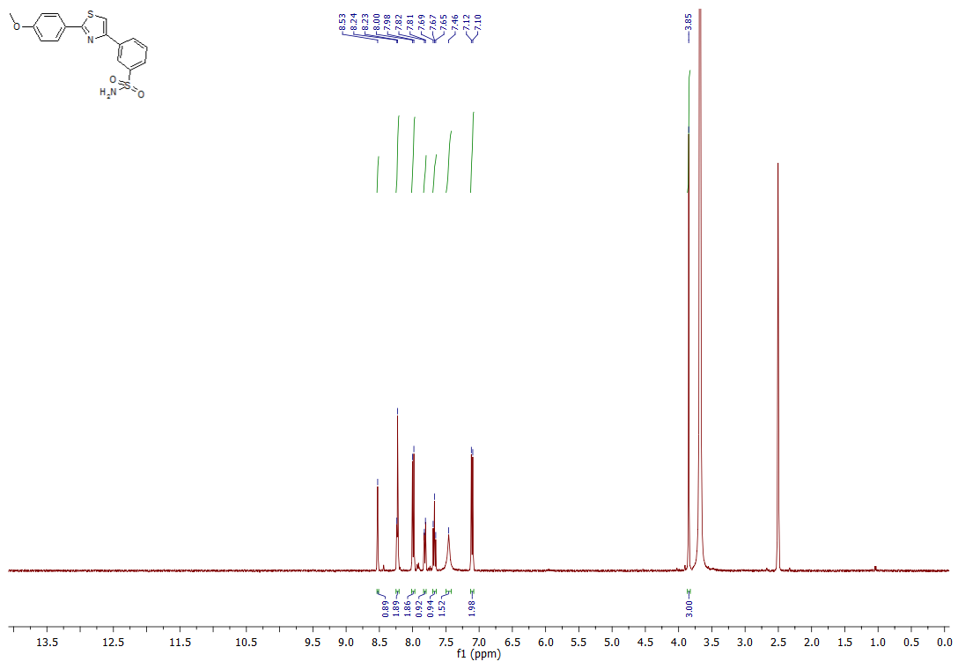
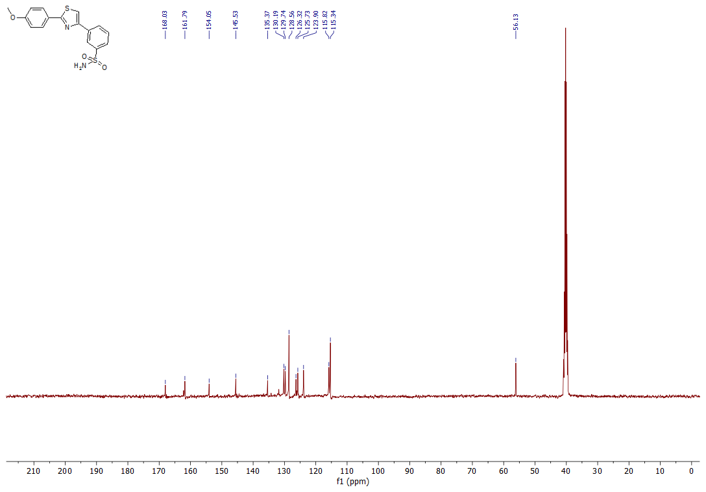

4-(4-(Benzo[d][1,3]dioxol-5-yl)thiazol-2-yl)benzenesulfonamide (6a)
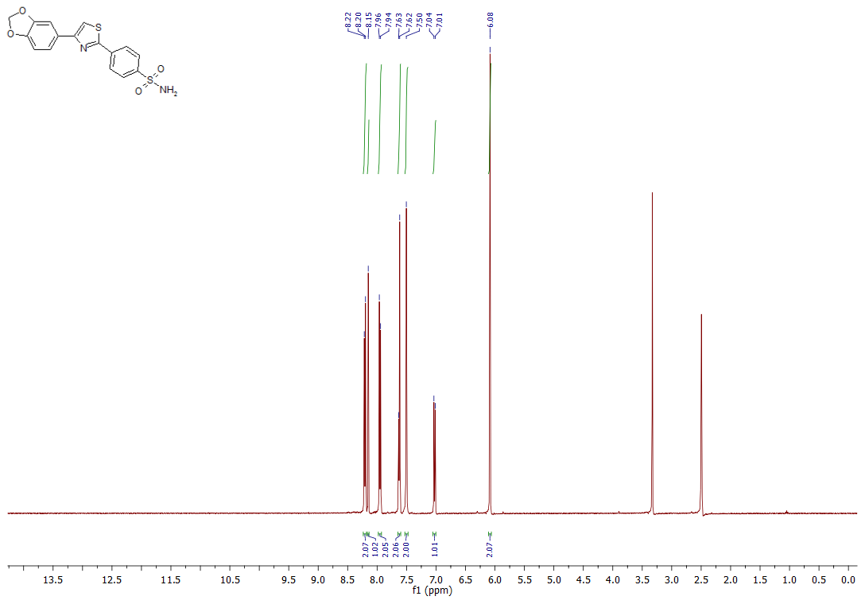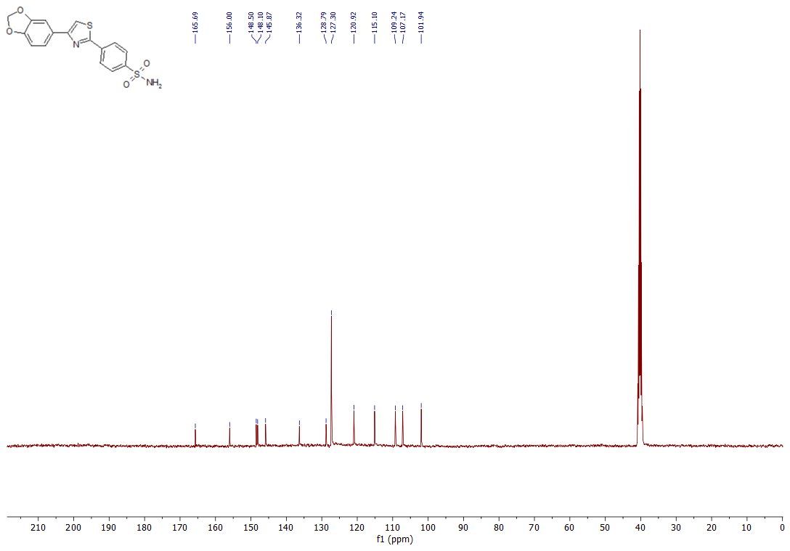
4-(4-(4-Chlorophenyl)thiazol-2-yl)benzenesulfonamide (6b)
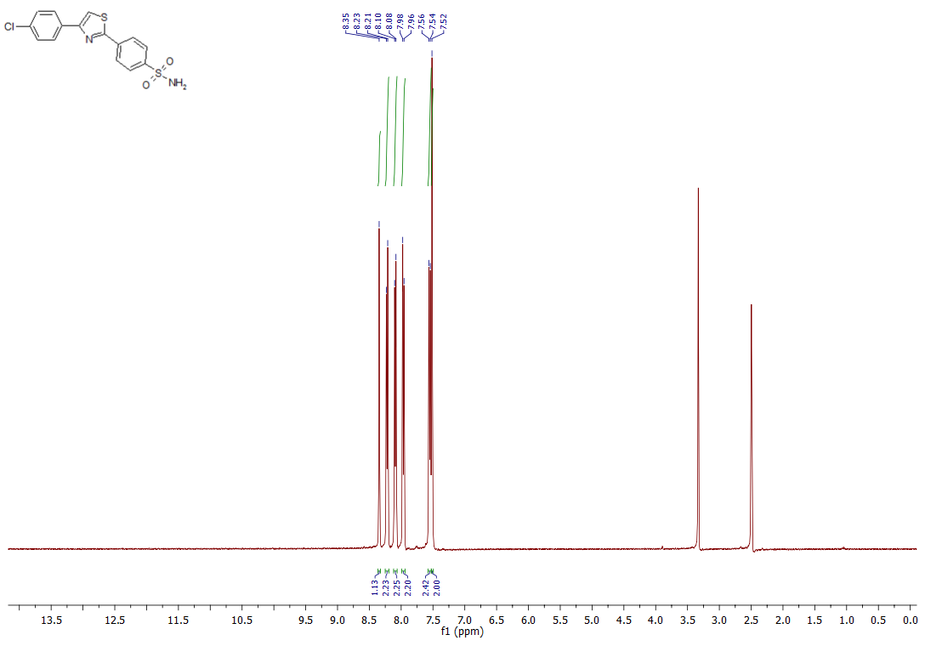
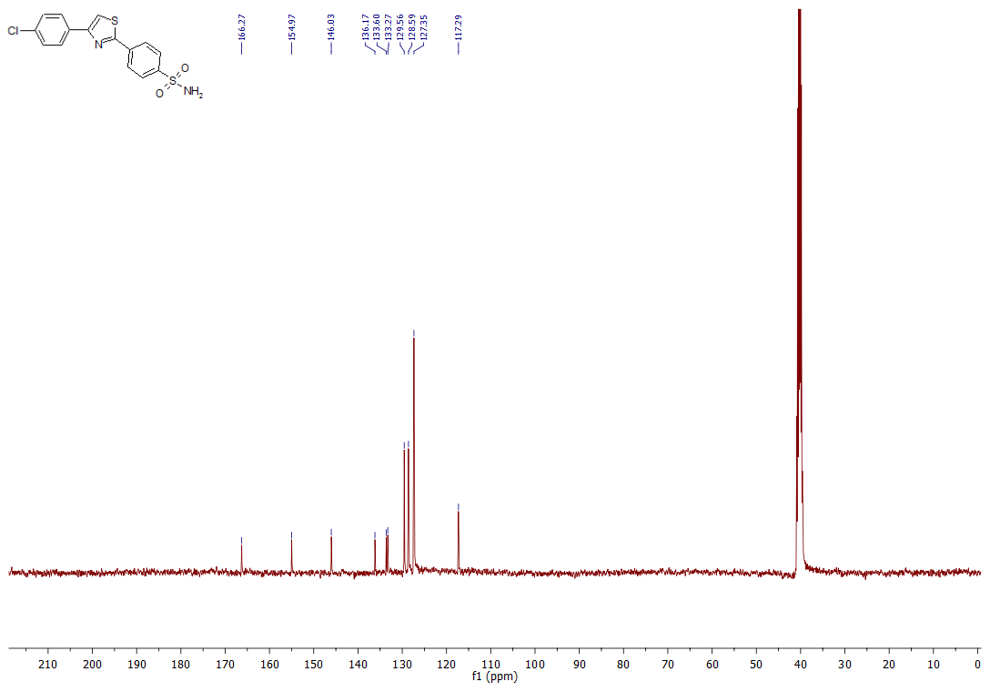
- (4,5-Dimethylthiazol-2-yl)benzenesulfonamide (8)
- 