Figure S1. Mass spectra of Lys-C peptides originated from (a) non-treated and (b) NtPhyt-treated CRT3 bands (arrows in Figure 1A); (c) non-treated and (d) NtPhyt-treated CRT3 D420E bands (lanes 3 and 4 in Figure 2A). Positions of the characteristic C-terminal semi-LysC peptides and of the N-terminal peptides are marked in red.

Figure S2. MS/MS fragmentation spectra of the characteristic C-terminal semi-LysC peptides of CRT3 ((a) non-treated, (b) NtPhyt-treated) and CRT3 D420E mutant ((c) non-treated, (d) NtPhyt-treated) marked in Figure S1.

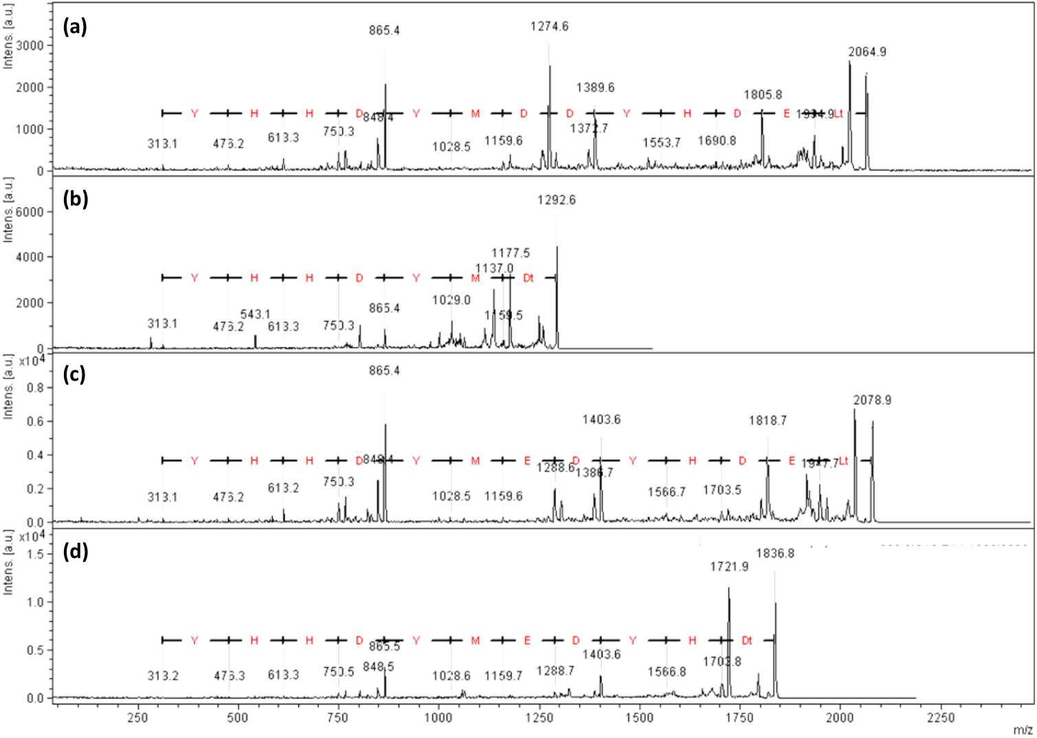

Figure S3. Sequence coverage of the apoplastic 26 kDa CRT3 fragment originated from EGFP_CRT3_ΔC6 protein with mass spectrometry-identified peptides.
Sequences of tryptic (blue upper bracket) and Glu-C (red bottom bracket) peptides for which identity was confirmed by MS/MS fragmentation are shown. Boundaries of the N-, P-, and C-terminal domains of NtCRT3 are indicated below the amino acid sequence.

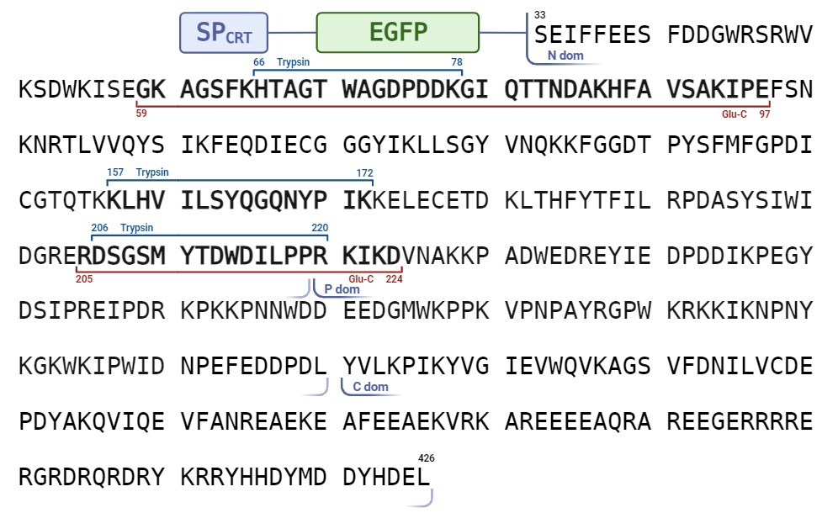

Table S1. List of the primers used in this study.
# | Primer name | Sequence
1 | CRT3_Pst700_dir | AAGCCTGCAGACTGGGAAGAC
2 | CRT3_D420E_Sac_rev | CGGAGCTCTTAAAGTTCATCATGGTAGTCTTCCATATAATC
3 | CRT_Kpn_Nco_dir | CAAGGTACCATGGCTCTCTCTGAGCATAAAC
4 | CRT_SP_Sal_rev | GTGGTCGACGAAAATCTCAGATGCTGAAG
5 | CRT_LF_Apa_Nde_dir | GAGGGCCCGCATCTCATATGTCTGAGATTTTCTTTGAAGAAAG
6 | CRT_1-420_Sac_rev | CGGAGCTCTTAATCCATATAATCGTGGTGATAGC
7 | EGFP_Sal_dir | GAGGTCGACAAATCTGAGATGGTGAGCAAGGGCGAG
8 | EGFP_Apa_rev | GTGGGCCCACCTGGAGACTTGTACAGCTCGTCCATGC
9 | pLH_seq_dir | GACCTCGAGAATTCTCAAC
10 | NtPhyt-His_rev | GGGAGCTCTTAATGGTGATGATGATGGTGCAGAGGATCCACTCCTATG

