Deletion of LeuRS influenced osmotic stress tolerance, nitrogen and carbon metabolism, and sexual development of Aspergillus montevidensis
Xiaowei Ding, Wanting Liu, Kaihui Liu, Xiang Gao, Yue Liu
School of Food and Biological Engineering, Shaanxi University of Science and Technology, Xi'an 710021, China.

Fig. S1 Knock-out of the gene LeuRS in A. montevidensis (WT). (a) The gene replacement strategy for the construction of the ΔleuRS strain. (b) Sequencing verification of ΔleuRS mutant of A. montevidensis.
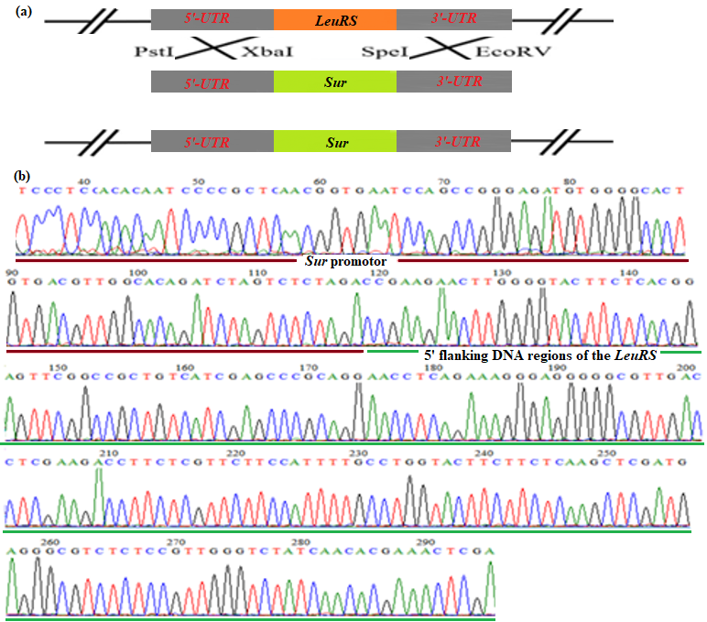

Fig. S2 Growth rates of mycelia of ΔleuRS mutants and WT strains.
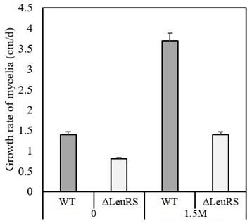

Fig. S3 Morphological characteristics of ΔleuRS mutants and WT strains grown on the YPD media without salt. Colonial traits of ΔleuRS mutants (a) and WT strains (b). Microscopic characters of ΔleuRS mutants (c) and WT strains (d).
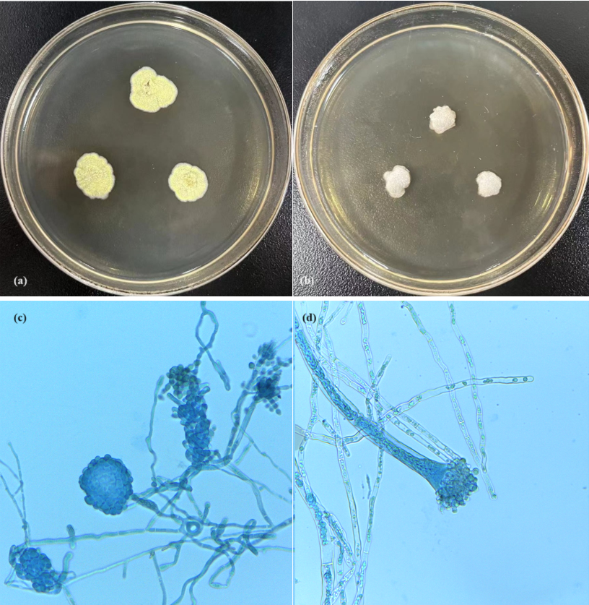

Fig. S4 Antioxidative enzymatic activities of ΔleuRS mutants and WT strains.
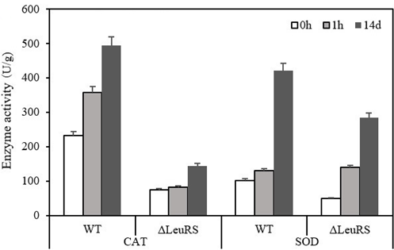

Fig. S5 GO terms of DEGs of ΔleuRS mutants and WT strains treated with 1.5 M NaCl for 0h, 1h, and 14 days, respectively.
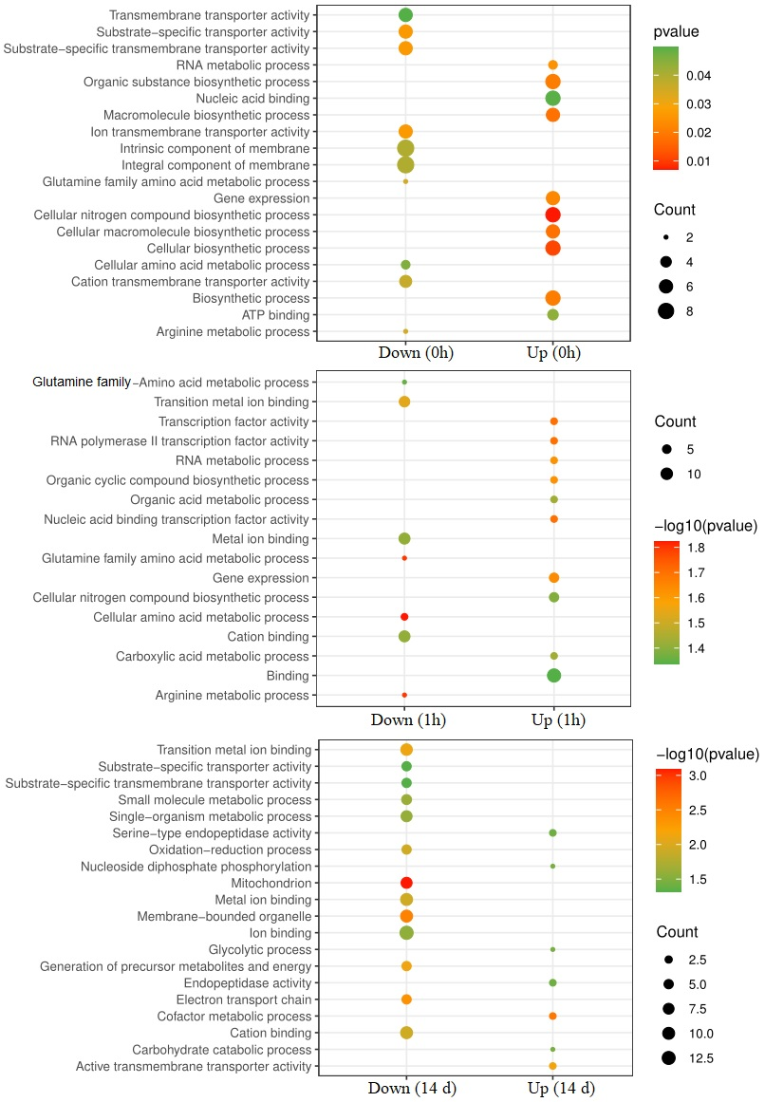

Fig. S6 PCA of differential metabolites between ΔleuRS mutants and WT strains treated with 1.5 M NaCl for 0h, 1h, and 14 days, respectively.
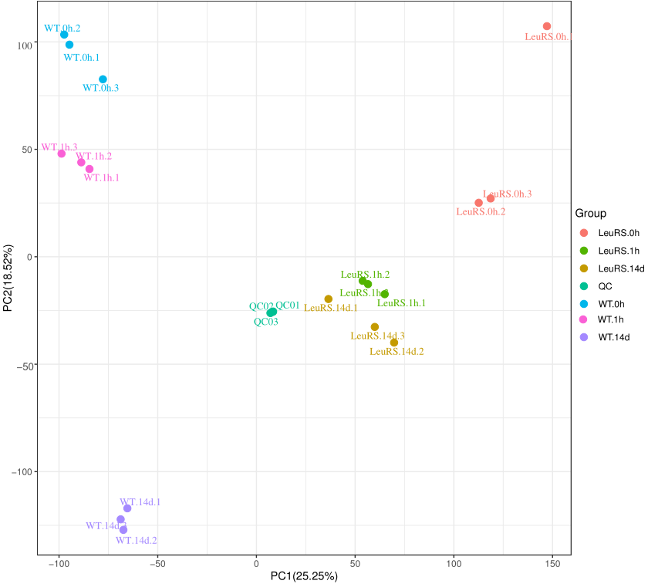

Fig. S7 KEGG enrichment analysis of differential metabolites between ΔleuRS mutants and WT strains treated with 1.5 M NaCl for 0h, 1h, and 14 days, respectively.
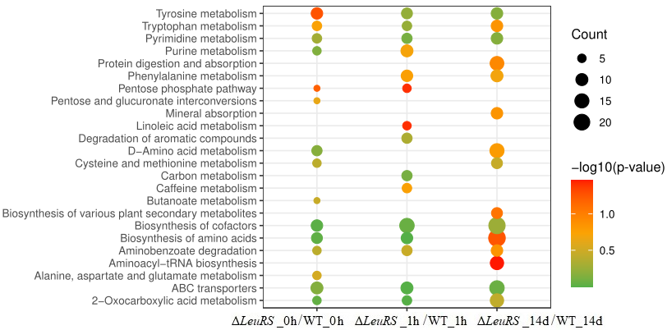

Table S1 Differentially expressed genes of in compared groups of ΔleuRS mutants and WT strains treated with 1.5 M NaCl for 0h, 1h, and 14 days, respectively.
 | KEGG pathways | Gene ID | Putative functions | Log₂ fold change
Transporter | ABC transporter (ΔLeuRS.0h-VS-WT.0h) | Unigene0005868 | Brefeldin A efflux transporter Bfr1 | 9.2
 |  | Unigene0001685 | ABC transporter G family member 21 | 5.2
 |  | Unigene0004891 | ABC a-pheromone efflux pump AtrD | -1.9
 |  | Unigene0002816 | ABC transporter subfamily D | -3.6
 |  | Unigene0001016 | ABC transporter, subfamily G | -4.7
 |  | Unigene0001056 | ABC transporter, subfamily G | -5.5
 |  | Unigene0001160 | ABC transporter, subfamily G | -6
 |  | Unigene0004149 | Polysaccharide transport protein (ABC-2 type transporter) | -8.1
 |  | Unigene0003060 | ABC transporter, subfamily B | -9.6
Nitrogen metabolism | Nitrogen metabolism (ΔLeuRS.1h-VS-WT.1h) | Unigene0003950 | Carbonic anhydrase | 4.1
 |  | Unigene0000422 | Nitronate monooxygenase | -1.8
 |  | Unigene0001007 | Nitrate reductase | -1.4
 |  | Unigene0003764 | Nitrate reductase | -3.7
 |  | Unigene0002426 | Nitrite reductase | -4.4
 | Alanine, aspartate and glutamate metabolism (ΔLeuRS.1h-VS-WT.1h) | Unigene0006877 | Aspartate carbamoyl transferase | 2.2
 |  | Unigene0005890 | Glutamine synthetase | 7.3
 |  | Unigene0001465 | Aspartate aminotransferase | -2.5
 |  | Unigene0004583 | Glutamate dehydrogenase | -1
 |  | Unigene0003221 | Glutamine synthetase | 1.4
 |  | Unigene0000761 | 1-Pyrroline-5-carboxylate dehydrogenase | -1.7
 |  | Unigene0001320 | 1-Pyrroline-5-carboxylate dehydrogenase | -4.8
 |  | Unigene0001538 | Succinate-semialdehyde dehydrogenase | -1.9
 |  | Unigene0001335 | Succinate semialdehyde dehydrogenase | -3.1
 |  | Unigene0003008 | Adenylosuccinate synthase | -2.1
 |  | Unigene0001305 | Adenylosuccinate synthase | -2.4
 |  | Unigene0001073 | Argininosuccinate synthase | -3
 |  | Unigene0005058 | Argininosuccinate synthase | -12.6
 |  | Unigene0002828 | Argininosuccinate synthase | -13.2
 |  | Unigene0000069 | Carbamoyl-phosphate synthase | -2.3
 | Arginine and proline metabolism (ΔLeuRS.14d-VS-WT.14d) | Unigene0000832 | Agmatinase | 3.1
 |  | Unigene0005572 | D-Amino-acid oxidase | 3.1
 |  | Unigene0001647 | Agmatine deiminase | 2.9
 |  | Unigene0007057 | Ornithine decarboxylase | 1.6
 |  | Unigene0000297 | Amidase | -1.8
 |  | Unigene0003641 | Agmatine deiminase | -1.9
 |  | Unigene0002559 | S-Adenosylmethionine decarboxylase proenzyme | -2.9
 |  | Unigene0004935 | Arginase | -14.5
 |  | Unigene0006346 | Arginase | -15.5
 | Arginine biosynthesis (ΔLeuRS.14d-VS-WT.14d) | Unigene0000121 | Ornithine carbamoyl transferase | -3
 |  | Unigene0000425 | Argininosuccinate lyase | -3.1
 | Tryptophan metabolism (ΔLeuRS.14d-VS-WT.14d) | Unigene0002356 | Kynurenine aminotransferase | -1.6
 |  | Unigene0000297 | Amidase | -1.8
 |  | Unigene0000864 | Kynureninase | -1.9
 |  | Unigene0003544 | Amidase | -2
 |  | Unigene0003677 | NADPH-cytochrome P450 reductase | -2.5
 |  | Unigene0005590 | Aminocarboxymuconate-semialdehyde decarboxylase | -10.6
 |  | Unigene0006491 | L-Amino-acid oxidase | -3
 |  | Unigene0000117 | 3-(3-Hydroxy-phenyl) propionate hydroxylase | -1.3
 | Cysteine and methionine metabolism (ΔLeuRS.14d-VS-WT.14d) | Unigene0000789 | Cysteine synthase | 1.6
 |  | Unigene0002764 | Phosphoserine aminotransferase | -2.1
 |  | Unigene0002160 | 3-Phosphoglycerate dehydrogenase | -2.3
 |  | Unigene0002871 | Threonine dehydratase | -4
 | Valine, leucine and isoleucine (ΔLeuRS.14d-VS-WT.14d) | Unigene0001706 | Methylmalonate-semialdehyde dehydrogenase | 2.1
 | Glycine, serine and threonine metabolism (ΔLeuRS.14d-VS-WT.14d) | Unigene0001414 | Dimethylglycine oxidase | 1.3
Carbon metabolism | Glyoxylate and dicarboxylate metabolism (ΔLeuRS.1h-VS-WT.1h) | Unigene0005896 | Oxalate decarboxylase | 7.8
 |  | Unigene0000101 | Catalase | 1.3
 |  | Unigene0003313 | Catalase | -2.5
 |  | Unigene0000920 | Catalase | -3.5
 |  | Unigene0001315 | Catalase | -4
 |  | Unigene0002534 | Glycine hydroxymethyltransferase | 4.4
 |  | Unigene0001732 | Malate synthase | -2.2
 |  | Unigene0006438 | Aminomethyltransferase | -2.5
 |  | Unigene0001841 | Aconitate hydratase | -4.2
 |  | Unigene0003026 | (S)-2-Hydroxy-acid oxidase | -10.6
 | Degradation of aromatic compounds (ΔLeuRS.1h-VS-WT.1h) | Unigene0006805 | 2,4-Dichlorophenol 6-monooxygenase | 2.7
 |  | Unigene0005187 | 2,4-Dichlorophenol 6-monooxygenase | 2
 |  | Unigene0007002 | Benzaldehyde dehydrogenase | -1.7
 |  | Unigene0007085 | Catechol 1,2-dioxygenase | 2.5
 |  | Unigene0001567 | Cyclohexanone monooxygenase | -2.8
 |  | Unigene0003057 | Cyclohexanone monooxygenase | -2.8
 |  | Unigene0000541 | Salicylate hydroxylase | 2.2
 |  | Unigene0002548 | Salicylate hydroxylase | -1.2
 |  | Unigene0001505 | Salicylate hydroxylase | -1.3
 |  | Unigene0000894 | Salicylate hydroxylase | -1.3
 |  | Unigene0000935 | Salicylate hydroxylase | -3.5
 |  | Unigene0004389 | Cytochrome P450 monooxygenase | -1.1
 |  | Unigene0002791 | Benzoate 4-monooxygenase | 1.7
 |  | Unigene0002732 | Benzoate 4-monooxygenase | -4.1
 |  | Unigene0002878 | Benzoate 4-monooxygenase | -9.5
 |  | Unigene0001254 | Benzoate 4-monooxygenase | -2.2
 | Butanoate metabolism (ΔLeuRS.1h-VS-WT.1h) | Unigene0002461 | Acetolactate synthase | 2.5
 | Linoleic acid metabolism (ΔLeuRS.1h-VS-WT.1h) | Unigene0000345 | Tartrate dehydrogenase | 2.1
 |  | Unigene0002091 | Aldo-keto reductase (YakC) | -2.7
 |  | Unigene0001954 | Acetoacetyl-CoA synthetase | -3.8
 |  | Unigene0001220 | Cytosolic phospholipase | 2
 |  | Unigene0001243 | Linoleate 10R-lipoxygenase | -1.8
 |  | Unigene0002291 | Short-chain dehydrogenase | -4
 |  | Unigene0003617 | Short chain dehydrogenase | -2.1
 |  | Unigene0005446 | Short-chain dehydrogenase | 2.2
 |  | Unigene0006189 | Short chain dehydrogenase | -1.6
 | Sugar metabolism (ΔLeuRS.14d-VS-WT.14d) | Unigene0001181 | MFS monosaccharide transporter | 2
 |  | Unigene0002542 | MFS monosaccharide transporter | -6.7
 |  | Unigene0005333 | Pyruvate decarboxylase | 4.4
 |  | Unigene0003461 | Pyruvate decarboxylase | 1.6
 |  | Unigene0005671 | Enolase | 2
 |  | Unigene0003085 | Hexokinase | 9.8
 |  | Unigene0007022 | Phosphoenolpyruvate carboxykinase | 2
 |  | Unigene0000622 | Phosphoenolpyruvate carboxykinase | -1.8
 |  | Unigene0004585 | Glyceraldehyde 3-phosphate dehydrogenase | 1.8
 |  | Unigene0003587 | Glyceraldehyde 3-phosphate dehydrogenase | -9.6
 |  | Unigene0001574 | Formaldehyde dehydrogenase | -1.8
 |  | Unigene0001853 | Alcohol dehydrogenase | -1.8
 |  | Unigene0002392 | Alcohol dehydrogenase | 1.9
 |  | Unigene0004713 | Alcohol dehydrogenase | 2.8
 |  | Unigene0000517 | Alcohol dehydrogenase | 2.9
 |  | Unigene0001392 | Citrate synthase | 8.5
 |  | Unigene0006966 | Citrate synthase | -2.6
 |  | Unigene0000380 | Succinyl-CoA synthetase | 1.7
 |  | Unigene0003564 | Malate dehydrogenase | 1.6
 |  | Unigene0000160 | Malate dehydrogenase | 2.4
 |  | Unigene0003272 | Ribulose-phosphate 3-epimerase/ | 2.1
 |  | Unigene0001107 | 6-Phosphogluconate dehydrogenase | 1.5
 | Propanoate metabolism (ΔLeuRS.14d-VS-WT.14d) | Unigene0005640 | 2-Methylcitrate dehydratase | -3
 |  | Unigene0003886 | Methylisocitrate lyase | -8.4
 |  | Unigene0001311 | Methyl acetate hydrolase/ Butanoate metabolism | -8.6
 | Biosynthesis of unsaturated fatty acids (ΔLeuRS.14d-VS-WT.14d) | Unigene0002929 | 1,3,6,8-Tetrahydroxynaphthalene reductase | 5.8
 |  | Unigene0000258 | Acyl-CoA oxidase | 2
 |  | Unigene0001147 | 3-Oxoacyl-[acyl-carrier protein] reductase | 1.5
 |  | Unigene0001456 | 3-Ketoacyl-ACP reductase | 1.5
 |  | Unigene0001668 | Stearic acid desaturase | -1.9
Reproduction-related genes | Sexual/asexual genes (ΔLeuRS.14d-VS-WT.14d) | Unigene0001820 | Sexual development activator VeA | -1.2
 |  | Unigene0001807 | Sexual development activator VeA | -2.7
 |  | Unigene0006340 | VelB | -1.5
 |  | Unigene0006340 | wetA | -1.5
 |  | Unigene0001761 | sidC | -1.8
 |  | Unigene0000774 | sakA | -1.2
 |  | Unigene0007108 | BrlA | 2.1
 |  | Unigene0003472 | Arp1/2 | 5.4
 |  | Unigene0002929 | Arp1/2 | 5.8
 |  | Unigene0003245 | Arp1/2 | 7.8

Table S2 Differentially metabolites of in compared groups of ΔleuRS mutants and WT strains treated with 1.5 M NaCl for 0h, 1h, and 14 days, respectively.
ΔLeuRS_0h/WT_0h |  | Log₂ fold change | P-value
Amino acid and derivatives | D-Alanyl-D-alanine | 14.2 | 0.001
 | H-Thr-Phe-OH | 5.7 | 0.031
 | Alanylglycine | 4.2 | 0.018
 | γ-Glutamylleucine | 3.6 | 0.013
 | ε-(γ-Glutamyl)-lysine | 3.5 | 0.005
 | Glycyl-glycine | 2.1 | 0.000
 | Glycylproline | 1.7 | 0.003
 | Norvaline | -4.2 | 0.001
 | N-(2-Furoyl)glycine | -11.4 | 0.011
 | H-Leu-Val-OH | 7.3 | 0.035
Carbohydrates and derivatives | D-Mannose | 4.9 | 0.026
 | 4-O-α-D-Galactopyranuronosyl-D-galacturonic acid | 3.2 | 0.013
 | Deoxyribose 5-phosphate | 2.9 | 0.027
 | Sweroside | 2.3 | 0.045
 | Gluconolactone | 1.4 | 0.044
 | Uridine diphosphate-N-acetylglucosamine | 1.3 | 0.008
 | 1-Deoxy-D-xylulose 5-phosphate | 1.3 | 0.003
 | Ribitol | 1.1 | 0.007
Organic acids | 4-Hydroxy-3-methoxymandelic acid | 5.9 | 0.015
 | Diaminopimelic acid | 4.9 | 0.048
 | α-Ketoisovaleric acid | 4.2 | 0.017
 | Pyruvic acid | 3.9 | 0.014
 | Succinic acid | 2.4 | 0.034
 | Quinic acid | 1.9 | 0.042
 | 3,7-Dimethyluric acid | 1.9 | 0.014
 | 7-Ketodeoxycholic acid | 1.6 | 0.013
 | Indole-3-carboxylic acid | 1.5 | 0.003
 | L-2-Hydroxyglutaric acid | 1.3 | 0.011
 | 2-(Methylamino) benzoic acid | 1.2 | 0.008
 | Caffeic acid | 1.2 | 0.042
 | 4-Acetamidobutanoic acid | -1.2 | 0.036
 | 4-Methoxyphenylacetic acid | -2.2 | 0.033
 | Gentisic acid | -2.4 | 0.001
 | Pyrrole-2-carboxylic acid | -2.5 | 0.012
 | Indoleacetic acid | -2.9 | 0.000
 | Carnosic acid | -3.2 | 0.003
 | Quinolinic acid | -3.8 | 0.005
 | Allantoic acid | -5.1 | 0.013
 | 2,3-Dihydroxybenzoic acid | -6.8 | 0.007
 | Itaconic acid | 2.5 | 0.041
Fatty acids | 2-Hydroxystearic acid | 3.3 | 0.000
 | 16-Hydroxy hexadecanoic acid | 2.6 | 0.000
 | γ-Linolenic acid | 2.2 | 0.004
 | Linoleic acid | 1.2 | 0.047
 | Azelaic acid | -1.8 | 0.002
Nucleotides and derivatives | Ribothymidine | 4.0 | 0.000
 | Thymidine | 4.0 | 0.017
 | Uridine | 3.3 | 0.029
 | Cytidine monophosphate | 3.1 | 0.044
 | 6-Methyladenine | 1.9 | 0.001
 | Pseudouridine | 1.9 | 0.002
 | 5'-Methylthioadenosine | 1.5 | 0.039
 | NAD | -3.4 | 0.003
 | 7-Methylguanine | -10.3 | 0.002
 | Adenine | -11.3 | 0.009
ΔLeuRS_1h/WT_1h |  | Log₂ fold change | p-value
Amino acid and derivatives | D-Alanyl-D-alanine | 13.8 | 0.001
 | N-Acetylglutamine | 5.4 | 0.013
 | H-Leu-Val-OH | 4.7 | 0.002
 | Alanylglycine | 4.6 | 0.002
 | Epsilon-(γ-Glutamyl)-lysine | 3.9 | 0.003
 | γ-Glutamylalanine | 3.7 | 0.013
 | L-Phenylalanine | 3.4 | 0.009
 | L-Methionine | 3.3 | 0.009
 | L-Threonine | 3.3 | 0.018
 | D-Alanine | 3.3 | 0.010
 | L-Tyrosine | 3.1 | 0.017
 | N-Acetyl-L-methionine | 3.0 | 0.004
 | γ-Glutamylleucine | 3.0 | 0.037
 | L-Lysine | 2.7 | 0.021
 | L-Histidine | 2.5 | 0.006
 | Glycyl-glycine | 2.5 | 0.032
 | L-Serine | 2.3 | 0.001
 | L-Glutamine | 2.3 | 0.017
 | Glycine | 1.8 | 0.026
 | L-Asparagine | 1.8 | 0.002
 | cis-4-Hydroxy-D-proline | 1.7 | 0.031
 | N-Formyl-L-methionine | 1.6 | 0.006
 | O-Acetyl-L-serine | 1.6 | 0.010
 | Glutamyl glutamic acid | 1.1 | 0.003
 | L-Glutamic acid | 1.1 | 0.014
 | Phenylalanyl phenylalanine | -1.3 | 0.038
 | N-(2-Furoyl) glycine | -5.2 | 0.007
 | Norvaline | -10.6 | 0.035
 | H-Thr-Phe-OH | 3.3 | 0.006
 | Threonic acid | 1.3 | 0.023
 | L-Isoleucine | -1.1 | 0.040
Carbohydrates and derivatives | D-Mannose | 4.2 | 0.017
 | D-Galactose | 3.3 | 0.032
 | N-Acetyl-glucosamine 1-phosphate | 3.1 | 0.018
 | D-Arabinose | 2.4 | 0.003
 | D-Ribose | 1.4 | 0.013
 | L-Ribulose | 1.3 | 0.033
 | N-Acetylmannosamine | -1.0 | 0.001
 | D-Gluconic acid | -1.3 | 0.005
 | p-Cresol glucuronide | -1.4 | 0.012
 | Sucrose | -1.4 | 0.004
 | N,N'-Diacetylchitobiose | -1.4 | 0.022
 | Forsythiaside | -1.5 | 0.010
 | N-Acetyl-D-glucosamine | -1.7 | 0.000
 | Trehalose 6-phosphate | -1.9 | 0.001
 | Ribitol | 1.5 | 0.014
Organic acids | 4-Hydroxyphenylpyruvate | 16.5 | 0.005
 | Pyruvic acid | 4.9 | 0.005
 | Taurine | 4.1 | 0.008
 | Dehydroascorbic acid | 2.2 | 0.034
 | Phenyllactic acid | 2.1 | 0.005
 | Methylmalonic acid | 1.9 | 0.018
 | Stearic acid | 1.8 | 0.007
 | 2-Hydroxy-3-(4-hydroxyphenyl) propanoic acid | 1.8 | 0.014
 | L-Lactic acid | 1.6 | 0.007
 | Uric acid | 1.4 | 0.018
 | Quinic acid | 1.4 | 0.001
 | Cholic acid | 1.3 | 0.036
 | Cryptochlorogenic acid | 1.1 | 0.002
 | Indolelactic acid | -1.2 | 0.007
 | Orotic acid | -1.2 | 0.007
 | Pyridoxal | -1.3 | 0.000
 | m-Coumaric acid | -1.4 | 0.001
 | Mandelic acid | -1.4 | 0.014
 | Gallic acid | -1.7 | 0.003
 | 3-(2-Hydroxyphenyl) propanoic acid | -1.7 | 0.006
 | 6-Hydroxynicotinic acid | -1.7 | 0.006
 | 3-Hydroxyphenylacetic acid | -1.8 | 0.002
 | Carnosic acid | -2.5 | 0.005
 | Indoleacetic acid | -3.1 | 0.005
 | Argininosuccinic acid | -3.3 | 0.003
 | Isonicotinic acid | -3.9 | 0.002
 | 4-Hydroxycinnamic acid | -4.1 | 0.012
 | 4-Methoxyphenylacetic acid | -4.3 | 0.023
 | Pyrrole-2-carboxylic acid | -4.3 | 0.014
 | Quinolinic acid | -5.3 | 0.004
 | Gentisic acid | -6.2 | 0.037
 | 2,3-Dihydroxybenzoic acid | -7.4 | 0.000
 | Tropic acid | -9.8 | 0.022
 | Allantoic acid | -10.1 | 0.001
 | Itaconic acid | -11.9 | 0.004
Fatty acids | 4-Acetamidobutanoic acid | -2.2 | 0.000
 | Glutaric acid | 1.7 | 0.005
 | L-2-Hydroxyglutaric acid | 1.2 | 0.010
 | Bovinic acid | 1.1 | 0.009
 | 4-Acetylbutyrate | 3.4 | 0.003
 | 10E,12Z-Octadecadienoic acid | 2.9 | 0.006
 | Ketoleucine | 2.8 | 0.000
 | α-Ketocaproic acid | 2.3 | 0.002
 | 2-Hydroxycinnamic acid | 2.3 | 0.010
 | Aminoadipic acid | 2.2 | 0.009
 | 3-Methylxanthine | 5.9 | 0.004
 | α-Ketoisovaleric acid | 4.8 | 0.002
 | Diaminopimelic acid | 4.7 | 0.000
 | Pelargonic acid | -1.4 | 0.003
 | 16-Hydroxy hexadecanoic acid | 4.2 | 0.012
 | γ-Linolenic acid | 3.6 | 0.002
 | 13S-Hydroxyoctadecadienoic acid | 3.5 | 0.021
Nucleotides and derivatives | 3'-AMP | 6.3 | 0.001
 | Ribothymidine | 6.3 | 0.008
 | Uridine | 4.4 | 0.003
 | Deoxyuridine | 4.1 | 0.017
 | Cytidine monophosphate | 4.1 | 0.018
 | N₂,N₂-Dimethylguanosine | 3.9 | 0.018
 | 8-Hydroxy-2'-deoxyguanosine | 3.1 | 0.030
 | Pseudouridine | 2.8 | 0.008
 | 6-Methyladenine | 2.2 | 0.018
 | Thymidine | 2.1 | 0.013
 | Cytarabine | 2.0 | 0.010
 | Hypoxanthine | 1.9 | 0.016
 | 6-Dimethylaminopurine | -1.5 | 0.003
 | Bilobalide A | -1.5 | 0.017
 | 5-Hydroxymethyluracil | -3.1 | 0.001
 | 3-Methyluridine | -4.8 | 0.001
 | 7-Methylguanine | -11.0 | 0.007
ΔLeuRS_14d/WT_14d |  | Log₂ fold change | p-value
Amino acid and derivatives | Norvaline | 5.9 | 0.042
 | Alanylglycine | 4.7 | 0.017
 | DL-Phenylalanine | 4.3 | 0.032
 | Anserine | 3.5 | 0.013
 | N-(2-Furoyl) glycine | 1.8 | 0.044
 | O-Acetyl-L-serine | 1.7 | 0.000
 | H-Thr-Phe-OH | -1.0 | 0.005
 | Glycyl-glycine | -1.1 | 0.004
 | cis-4-Hydroxy-D-proline | -1.7 | 0.000
 | N-Acetylhistidine | -2.4 | 0.002
 | ε-(γ-Glutamyl)-lysine | -2.9 | 0.004
 | H-Leu-Val-OH | -3.0 | 0.000
 | 4-Hydroxyproline | -3.6 | 0.001
Carbohydrates and derivatives | Gluconic acid | 13.5 | 0.042
 | N-Acetyl-D-glucosamine | 4.6 | 0.045
 | L-Fucose | 4.4 | 0.012
 | UDP-D-galactose | 3.9 | 0.000
 | D-Mannose | 3.9 | 0.033
 | UDP-N-Acetyl-α-D-galactosamine | 3.3 | 0.009
 | L-Iditol | 2.8 | 0.007
 | Trehalose 6-phosphate | 2.5 | 0.009
 | D-Arabinose | 2.0 | 0.003
 | 1-Kestose | 1.5 | 0.018
 | N-Acetylmannosamine | -1.2 | 0.004
 | Naringenin 4'-O-glucuronide | -1.3 | 0.010
 | 1-Deoxy-D-xylulose 5-phosphate | -2.1 | 0.000
 | p-Cresol glucuronide | -3.1 | 0.001
 | D-Ribose | -8.2 | 0.009
 | Astilbin | -1.5 | 0.000
 | Mannitol | -3.9 | 0.000
 | Sweroside | 2.6 | 0.014
 | Cosmosiin | -3.5 | 0.001
Organic acids | 4-Hydroxyphenylpyruvate | 19.0 | 0.025
 | Kynurenic acid | 14.4 | 0.002
 | Indoleacetic acid | 13.4 | 0.031
 | m-Coumaric acid | 10.6 | 0.015
 | Citraconic acid | 9.0 | 0.028
 | Formylanthranilic acid | 3.8 | 0.001
 | Isocitric acid | 3.2 | 0.000
 | 3-(2-Hydroxyphenyl) propanoic acid | 2.9 | 0.014
 | 3-Furoic acid | 2.5 | 0.042
 | Benzoic acid | 2.4 | 0.018
 | Quinolinic acid | 1.9 | 0.022
 | Phenylpyruvic acid | 1.9 | 0.015
 | 1,7-Dimethyluric acid | 1.9 | 0.023
 | Linoleic acid | 1.8 | 0.041
 | 4-Methoxyphenylacetic acid | 1.7 | 0.008
 | But-2-enoic acid | 1.2 | 0.015
 | 5-Methoxysalicylic acid | -1.5 | 0.001
 | Nicotinic acid | -1.6 | 0.017
 | Maleic acid | -1.7 | 0.009
 | 4-Pyridoxic acid | -1.7 | 0.000
 | Pyruvic acid | -1.8 | 0.000
 | Byssochlamic acid | -1.8 | 0.001
 | Gallic acid | -1.9 | 0.001
 | Xanthurenic acid | -1.9 | 0.003
 | Tropic acid | -2.1 | 0.000
 | 2,3-Dihydroxybenzoic acid | -2.1 | 0.001
 | Allantoic acid | -2.2 | 0.001
 | 2-Hydroxycinnamic acid | -2.4 | 0.000
 | Fumaric acid | -2.4 | 0.013
 | Phloretic acid | -2.7 | 0.001
 | trans-Aconitic acid | -2.7 | 0.000
 | Argininosuccinic acid | -2.8 | 0.004
 | Uric acid | -2.9 | 0.000
 | 4-O-α-D-Galactopyranuronosyl-D-galacturonic acid | -3.3 | 0.002
 | Dehydroascorbic acid | -5.5 | 0.001
 | Picolinic acid | -7.7 | 0.007
 | 3-Methoxybenzenepropanoic acid | 2.8 | 0.032
Fatty acids | PE (16:0/18:2(9Z,12Z)) | -3.9 | 0.002
 | 10E,12Z-Octadecadienoic acid | -4.0 | 0.010
 | Ketoleucine | -6.0 | 0.001
 | 2-Hydroxyadipic acid | -2.1 | 0.000
 | 13S-hydroxyoctadecadienoic acid | -1.8 | 0.000
 | γ-Linolenic acid | -1.7 | 0.016
 | Glutaric acid | 1.6 | 0.033
 | 2-Hydroxy-3-methylbutyric acid | 1.4 | 0.030
 | 3-Hydroxyvaleric acid | 1.3 | 0.019
 | α-Ketoisovaleric acid | -1.1 | 0.002
 | 9,10-Epoxyoctadecanoic acid | -1.2 | 0.001
 | 16-Hydroxy hexadecanoic acid | -1.3 | 0.008
 | 4-Acetamidobutanoic acid | 1.9 | 0.012
 | Pelargonic acid | 1.9 | 0.019
Nucleotides and derivatives | Uridine | 3.3 | 0.000
 | 6-Methyladenine | 2.7 | 0.001
 | Deoxyuridine | 1.5 | 0.025
 | Ribothymidine | 1.1 | 0.031
 | Pseudouridine | 1.0 | 0.012
 | 2-Methylguanosine | -1.0 | 0.014
 | 5-Hydroxymethyluracil | -1.8 | 0.010
 | Adenine | -2.8 | 0.008
 | NAD | -2.8 | 0.000
 | Oxypurinol | -3.0 | 0.001
 | N,N-Dimethylguanosine | -3.0 | 0.001
 | N₆-Methyladenosine | -3.9 | 0.025
 | Adenosine monophosphate | -3.9 | 0.006

