|  |  |
| --- | --- |
|  |  |
| (**a**) | (**b**) |

**Figure S1.** Special stainless steel elements for masonry protection: (**a**) Along the edges at wall ends (rounded angles); (**b**) Along the edges generated by the perforations (funnel plates).



**Figure S2.** Four stainless steel straps of the CAM® System sharing the same perforation.

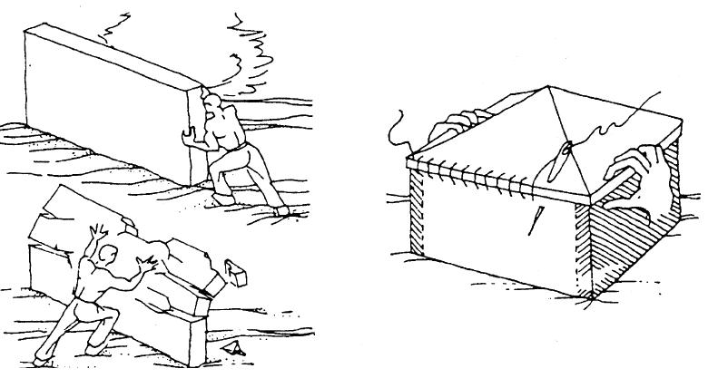

**Figure S3.** Box-type behavior: by tying all the construction elements together, the building behaves as a single unit.



**Figure S1.** Stress transfer mechanism from a loop-shaped stainless steel strap placed in tension to the masonry enclosed within it.