Supplementary data

STAT3 inhibitory activities of lignans isolated from the stems of Lindera obtusiloba Blume

Eun-Jae Park^{a,b}, Hee-Ju Lim^{a,b}, Hyung-Jin Limª, Bong-Sik Yun^{b}, Soyoung Leeª, Seung-Jae Leeª, Seung Woong Lee^{a,}

ª Functionality Biomaterial Research Center, Korea Research Institute of Bioscience and Biotechnology, Jeonbuk 56212, Republic of Korea
^{b}Division of Biotechnology and Advanced Institute of Environment and Bioscience, College of Environmental and Bioresource Sciences, Jeonbuk National University, Iksan-si, Republic of Korea

* Corresponding authors.
E-mail address: lswdoc@kribb.re.kr
Figure legends
Figure S1. 1H NMR spectrum of compound 1
Figure S2. 13C NMR spectrum of compound 1
Figure S3. 1H NMR spectrum of compound 2
Figure S4. 13C NMR spectrum of compound 2
Figure S5. 1H NMR spectrum of compound 3
Figure S6. 13C NMR spectrum of compound 3
Figure S7. 1H NMR spectrum of compound 4
Figure S8. 13C NMR spectrum of compound 4
Figure S9. 1H NMR spectrum of compound 5
Figure S10. 13C NMR spectrum of compound 5
Figure S11. 1H NMR spectrum of compound 6
Figure S12. 13C NMR spectrum of compound 6
Figure S13. 1H NMR spectrum of compound 7
Figure S14. 13C NMR spectrum of compound 7

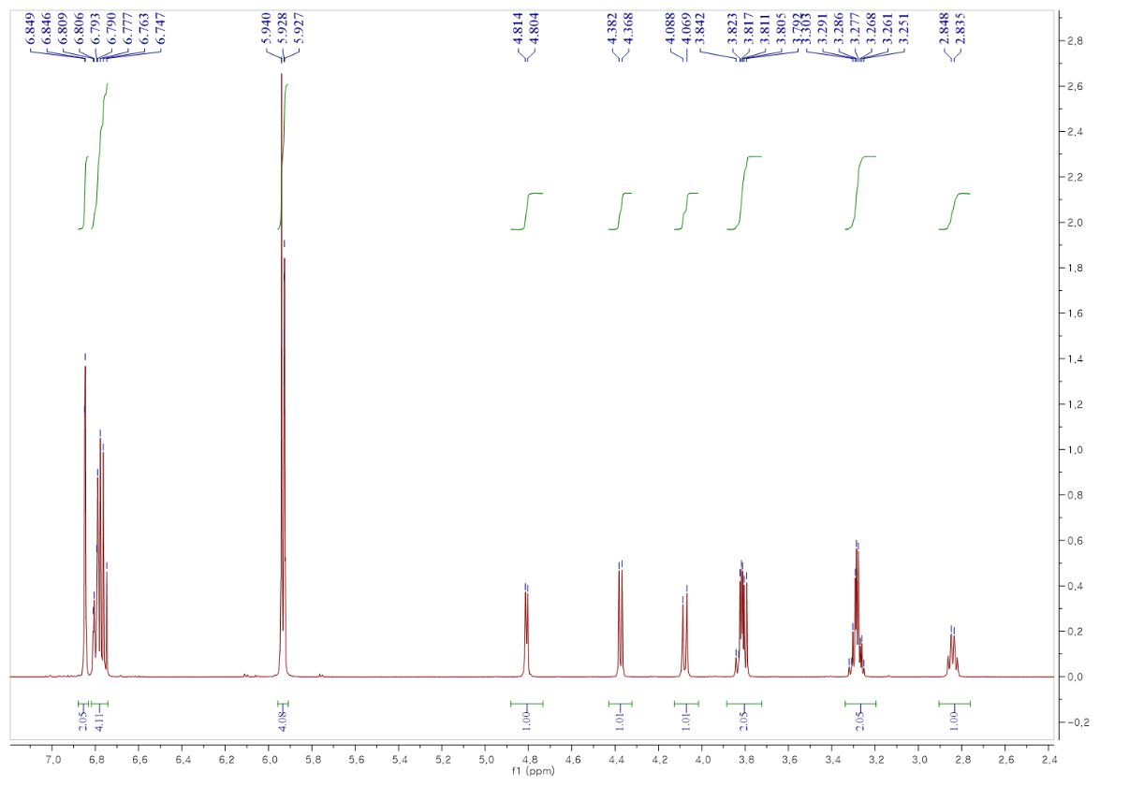
Figure S1. ¹H NMR spectrum of compound 1
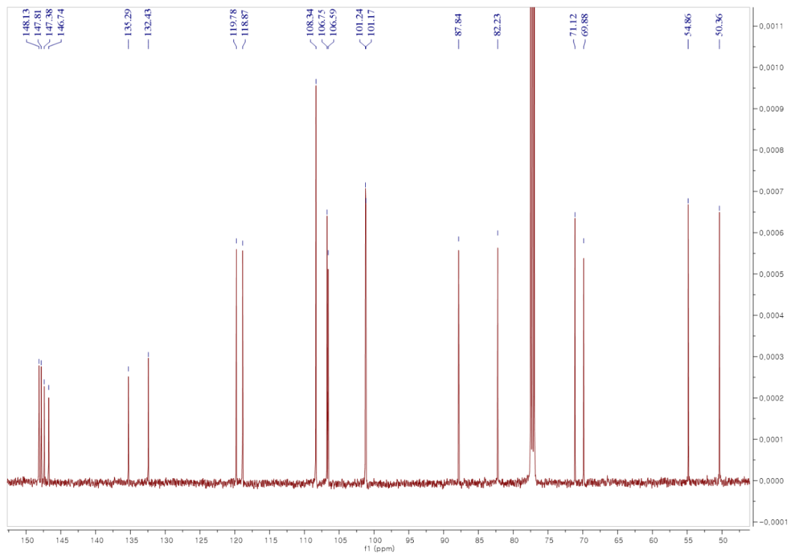
Figure S2. ¹³C NMR spectrum of compound 1
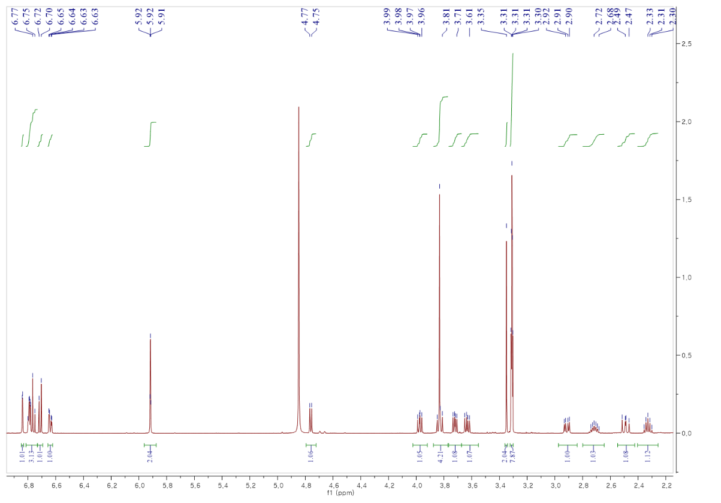
Figure S3. ¹H NMR spectrum of compound 2
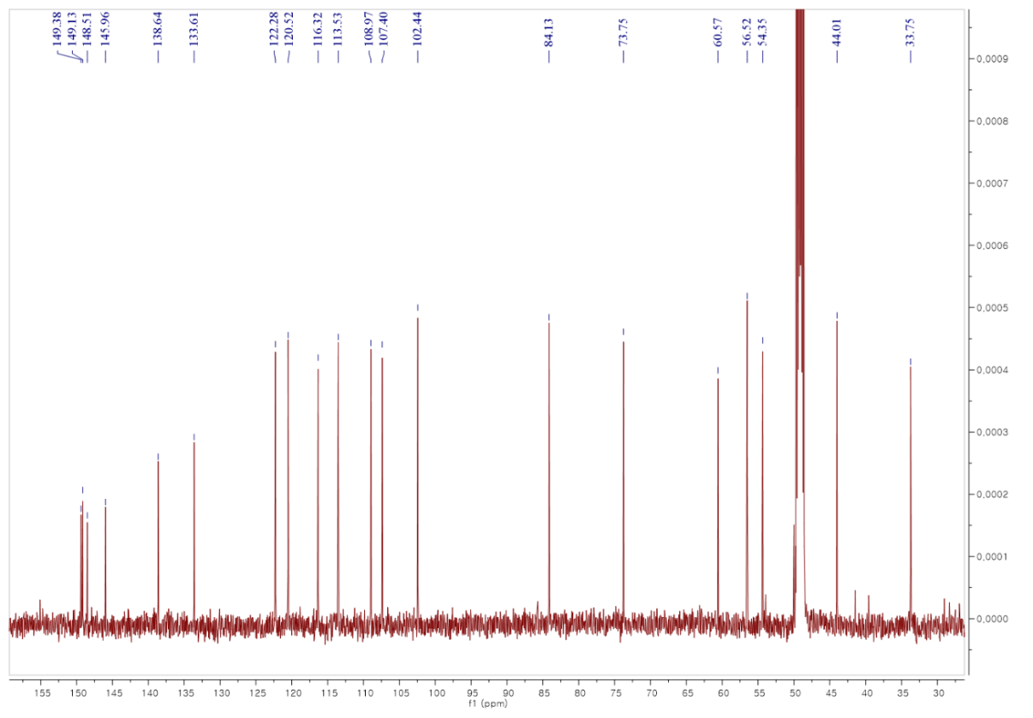
Figure S4. ¹³C NMR spectrum of compound 2
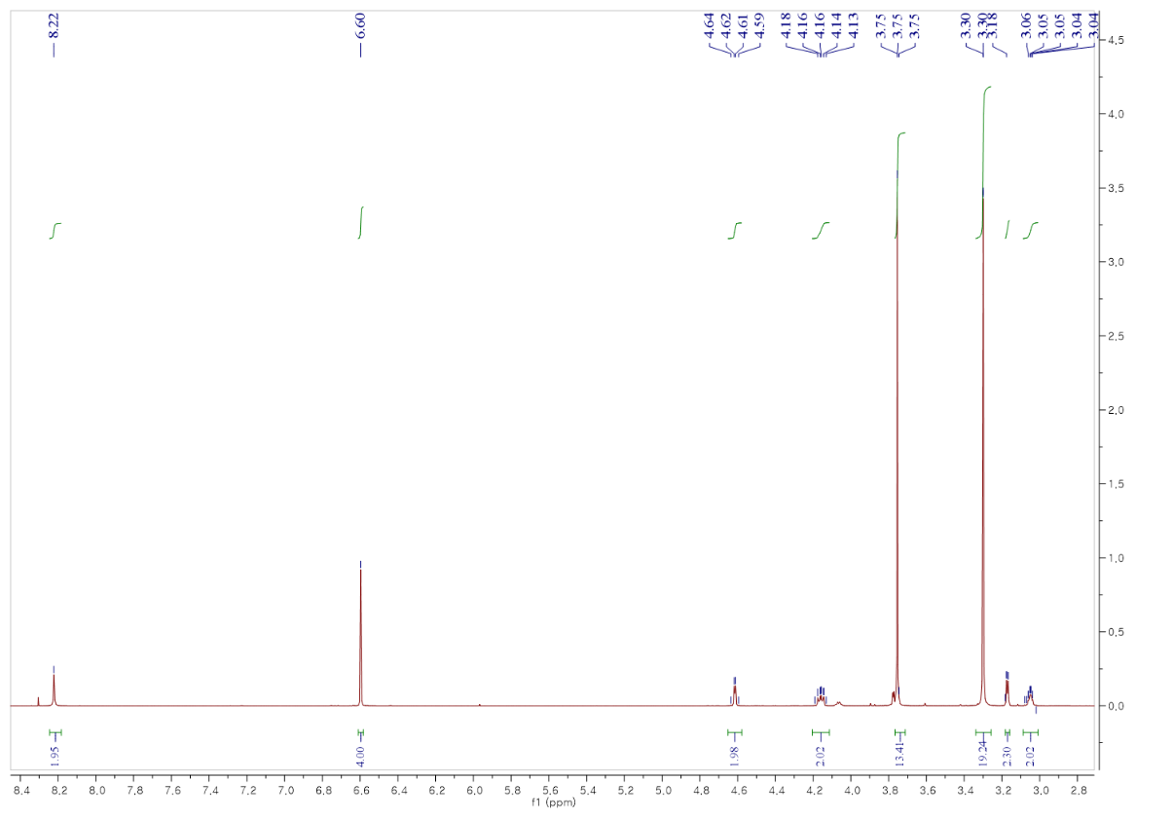
Figure S5. ¹H NMR spectrum of compound 3
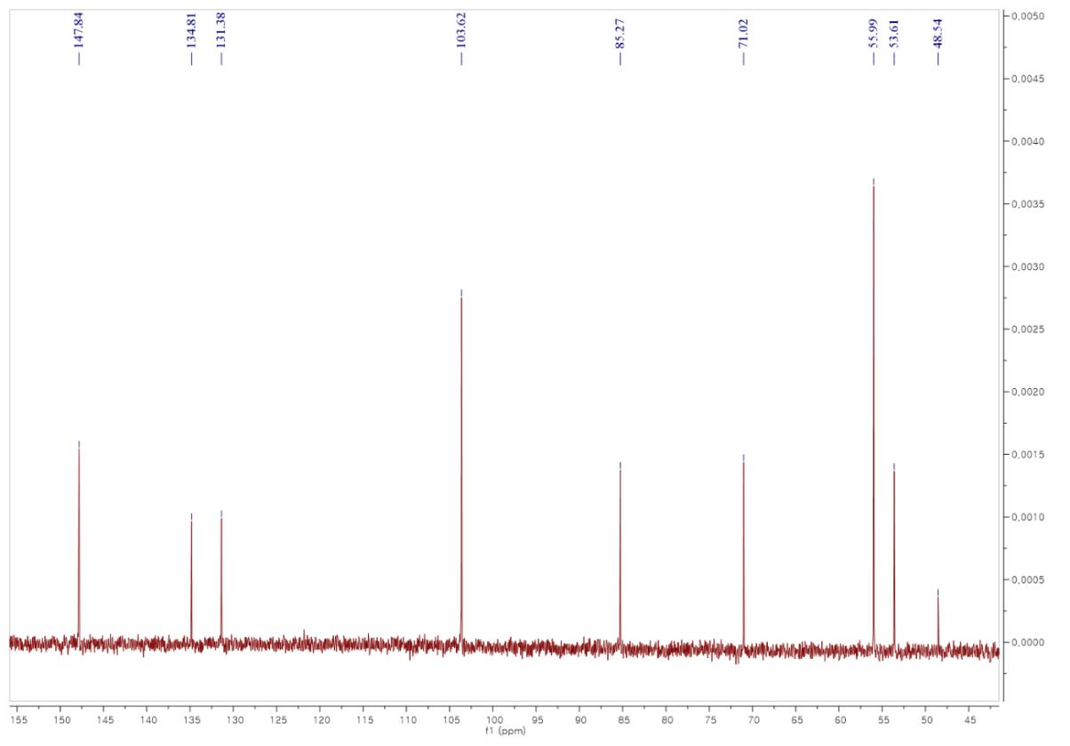
Figure S6. ¹³C NMR spectrum of compound 3
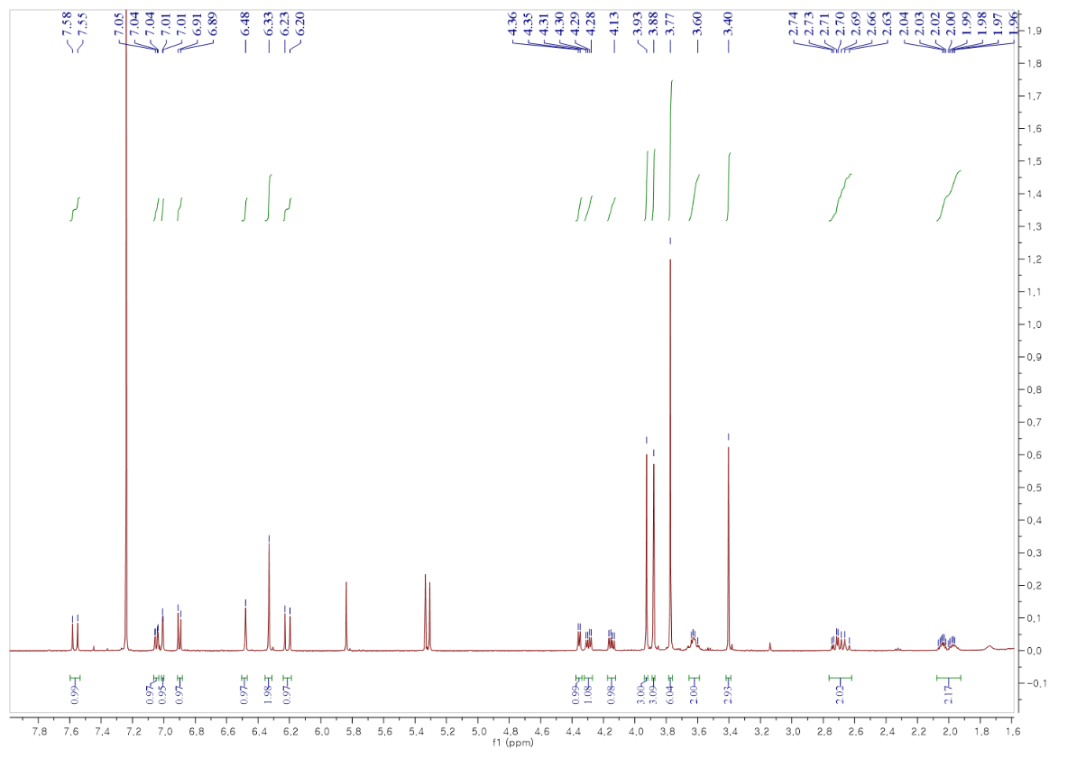
Figure S7. ¹H NMR spectrum of compound 4
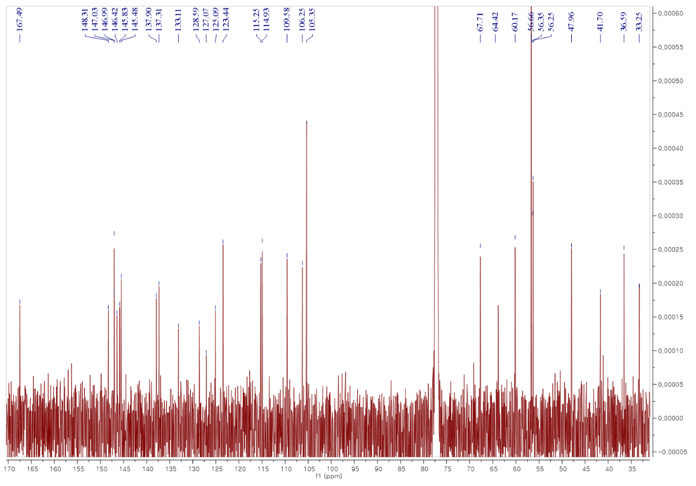
Figure S8. ¹³C NMR spectrum of compound 4

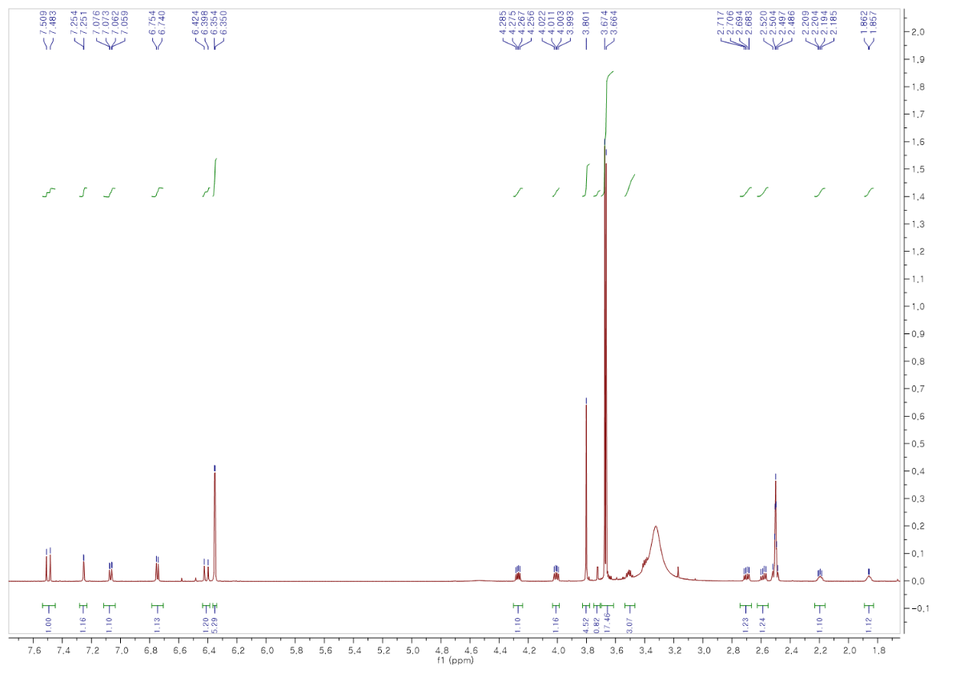
Figure S9. ¹H NMR spectrum of compound 5
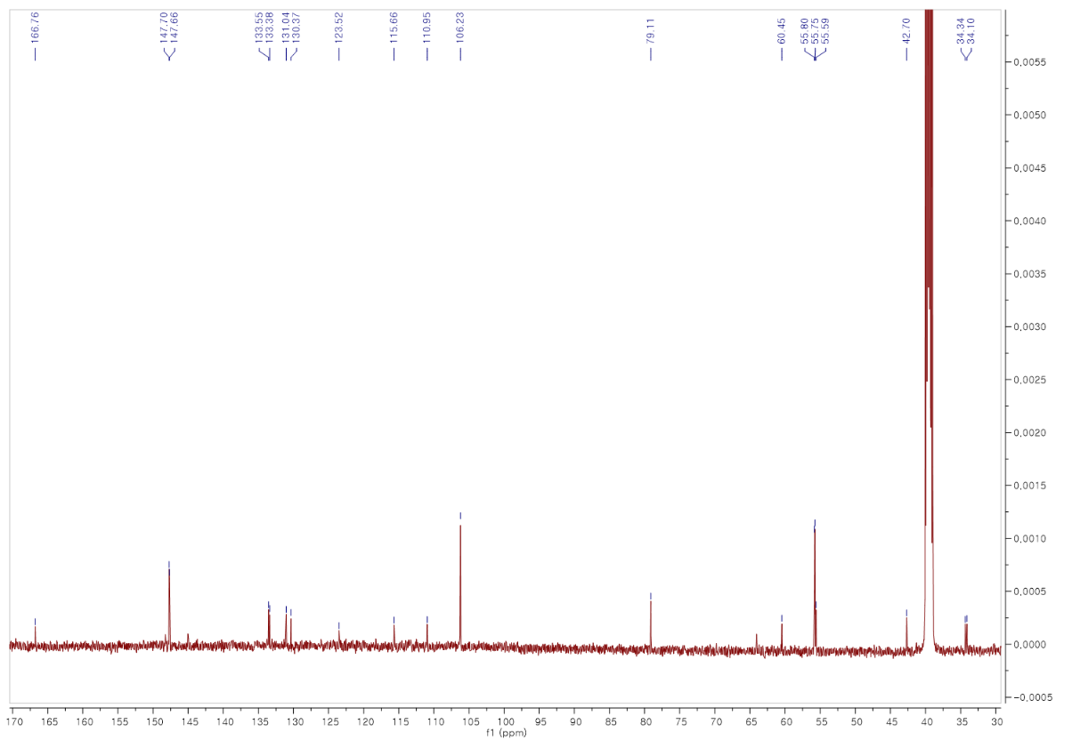
Figure S10. ¹³C NMR spectrum of compound 5

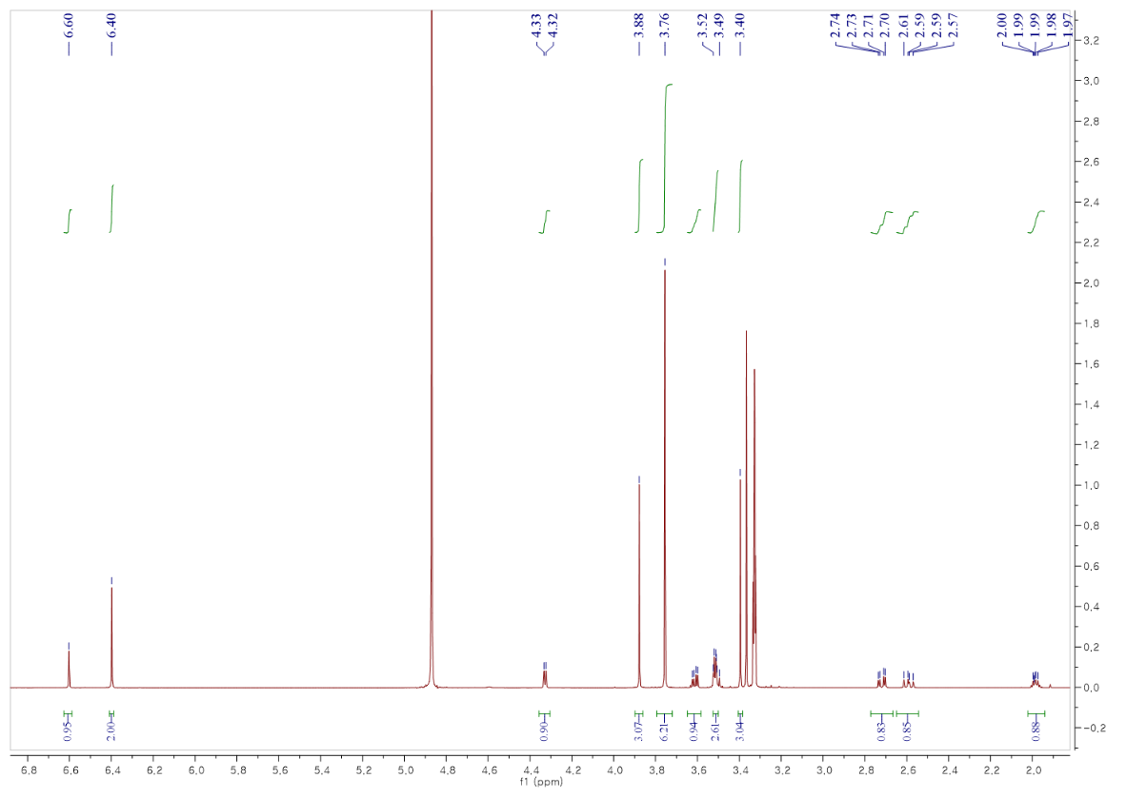
Figure S11. ¹H NMR spectrum of compound 6
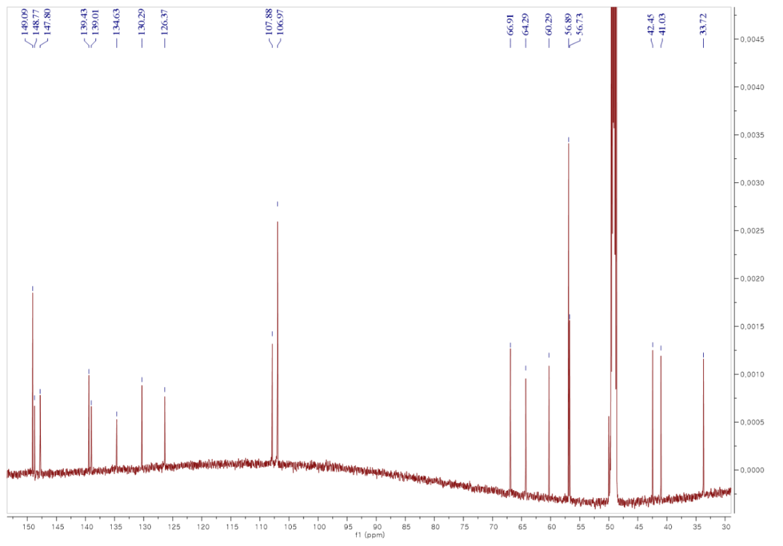
Figure S12. ¹³C NMR spectrum of compound 6
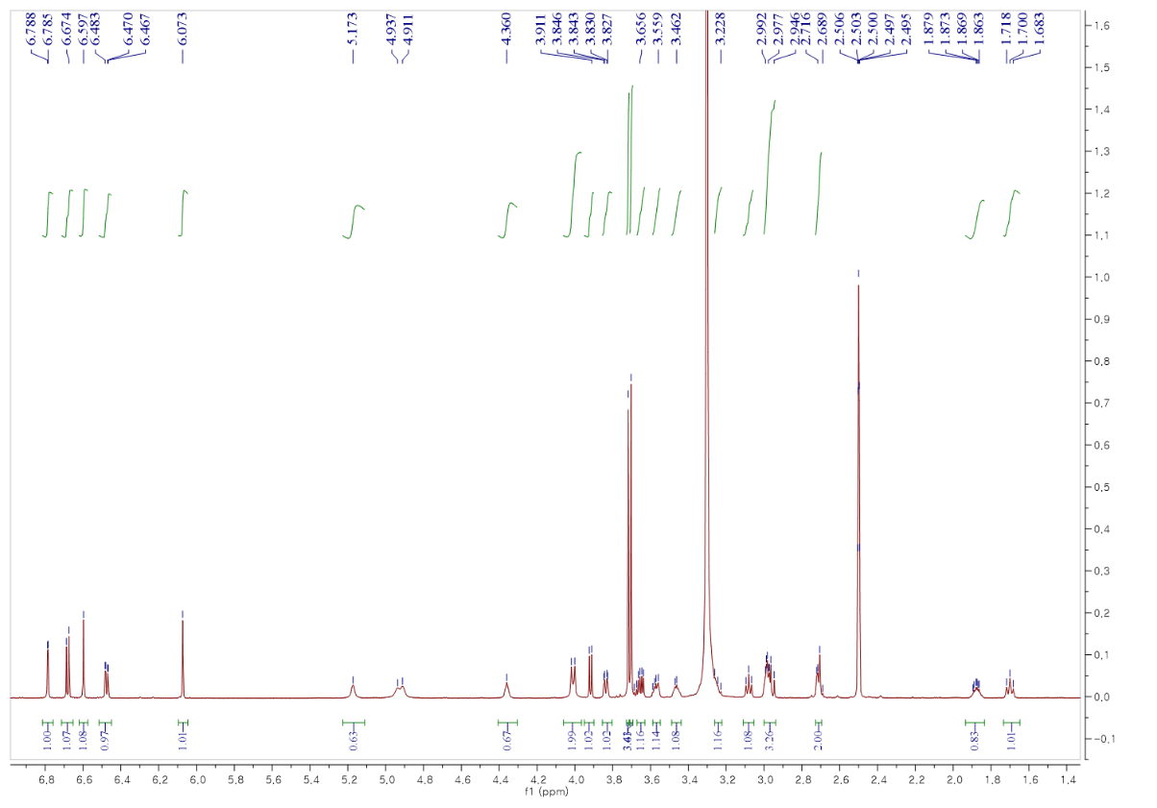
Figure S13. ¹H NMR spectrum of compound 7
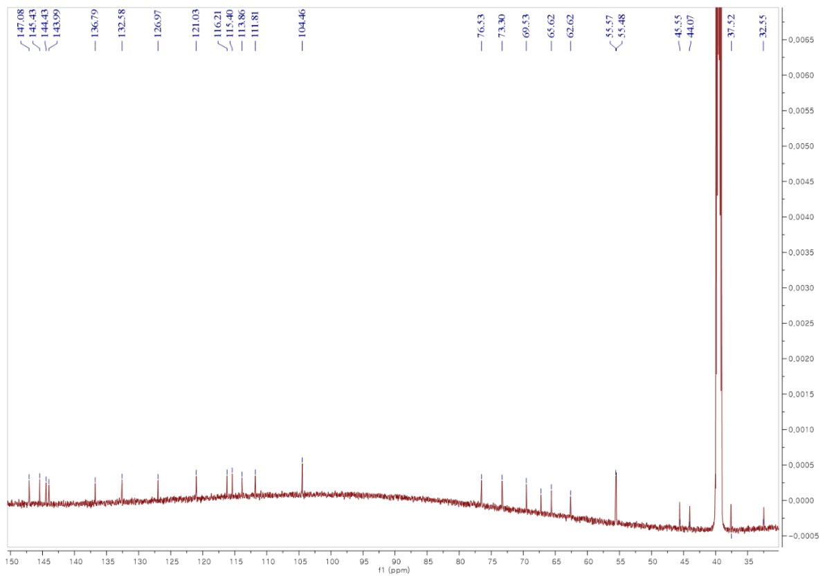
Figure S14. ¹³C NMR spectrum of compound 7

Authors for correspondence: Dr. Seung Woong Lee Tel: +82-63-570-5264 Fax: +82-63-570-5239 E-mail: lswdoc@kribb.re.kr

