Synthesis, Characterization, and Environmental Applications of Novel Per-Fluorinated Organic Polymers with Azo- and Azomethine-Based Linkers via Nucleophilic Aromatic Substitution
Suha S. Altarawneh¹*, Hani M. El-Kaderi², Alexander J. Richard², Osama M. Alakayleh¹, Ibtesam Y. Aljaafreh¹, Mansour H. Almatarneh³, Taher S. Ababneh⁴, Lo’ay A. Al-Momani⁵ and Rawan H. Aldalabeeh¹
¹Tafila Technical University, Tafila 66110, Jordan
²Department of Chemistry, Virginia Commonwealth University, Richmond, VA 23284, USA
³University of Jordan, Department of Chemistry, Amman, 11942, Jordan
⁴Department of Chemistry, Yarmouk University, Irbid 21163, Jordan
⁵Department of Chemistry, The Hashemite University, Zarqa 13133, Jordan
Title
Part 1:
SchemeS1: Proposed mechanism of the nucleophilic aromatic substitution reaction (NAS).
Table S1: Reported values of the chemical shift of ¹⁹F-NMR and different sites

Scheme S2: Proposed mechanism of the nucleophilic aromatic substitution reaction (NAS).

Figures S1-S4: ¹H- and ¹³C-NMR Spectra of the monomers.

Figures S5-S12: ¹H- and ¹³C-NMR Spectra of the polymers.
Figure S13: Proposed sites of zero and non-zero dipole moments of the polymers.
Figure S14: Solubility behavior of the polymers in THF and DMSO.
Part 2: optical properties of the polymers
Figure S15 UV–Vis absorption spectra ofmonomers and their fluorinated polymers.
Figure S16 Experimental determination of λonset and bandgap determination.
TableS2. λ max of monomers and polymers.
Part 3: BET surface area determination
Table S3: BET plots data of the polymers
References

Scheme S1: Proposed mechanism of the nucleophilic aromatic substitution reaction (NAS).

Table S1: Reported values of the chemical shift of ¹⁹F-NMR and different sites. [1]
Compound | Chemical Shift (ppm)
Benzene + Hexafluorobenzene | -163.2
Mono-fluorobenezne | -112.9
1,2-Difluorobenezne | -138.4
1,3-Difluorobenezne | -109.9
1,4-Difluorobenezne | -119.6
1,2,4-Triflourobenzne | -143.5  -133.5  -115.7
1,2,4,5-Tetrafluorobenezne | -139.7
Penta-fluorobenzene | -162.5  -154.2  -139.2

List of ¹H- and ¹³C-NMR Spectra of the monomers
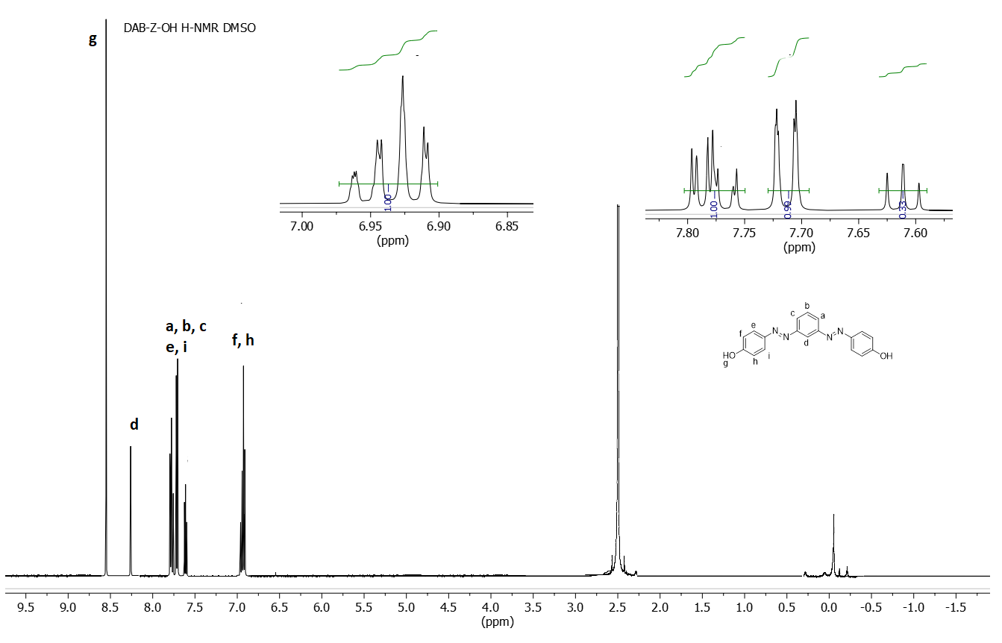
Figure S1: ¹H-NMR spectra of DAB-Z-OH
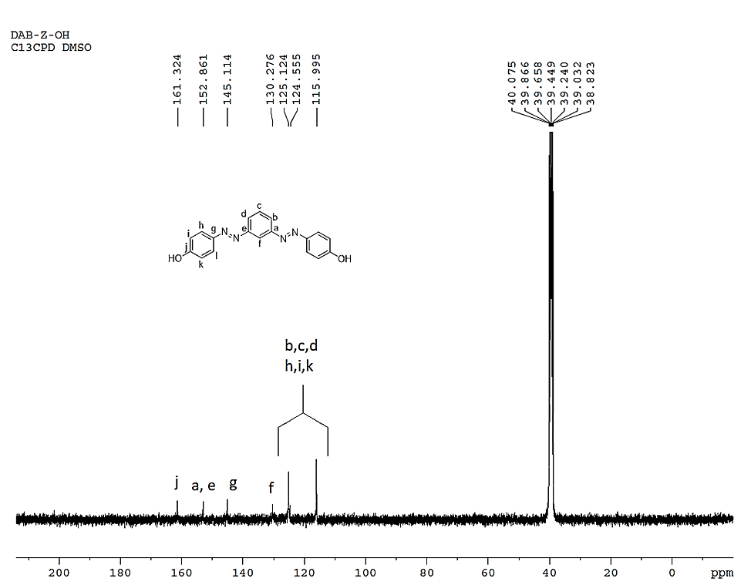
Figure S2: ¹³C-NMR spectra of DAB-Z-OH
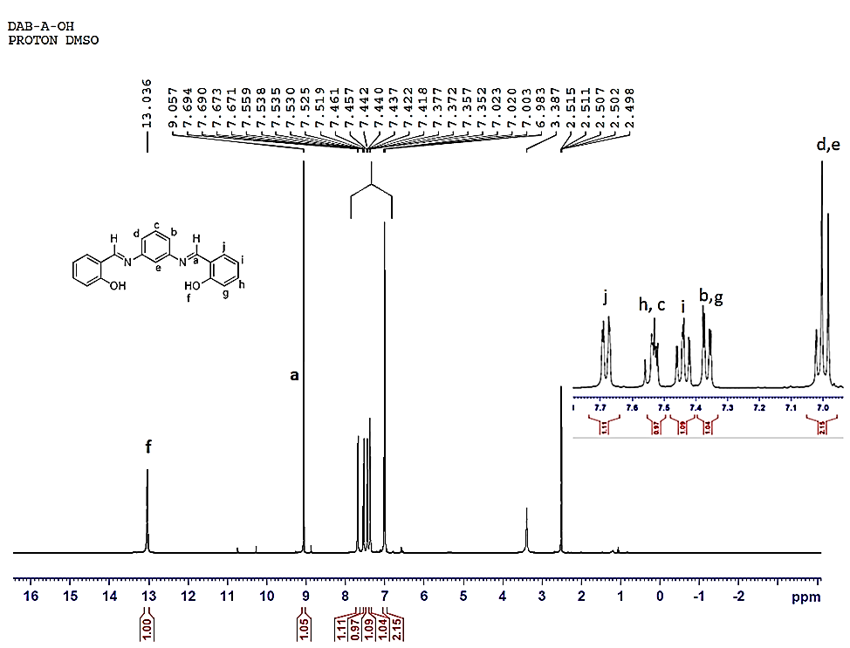
Figure S3: ¹H-NMR spectra of DAB-A-OH

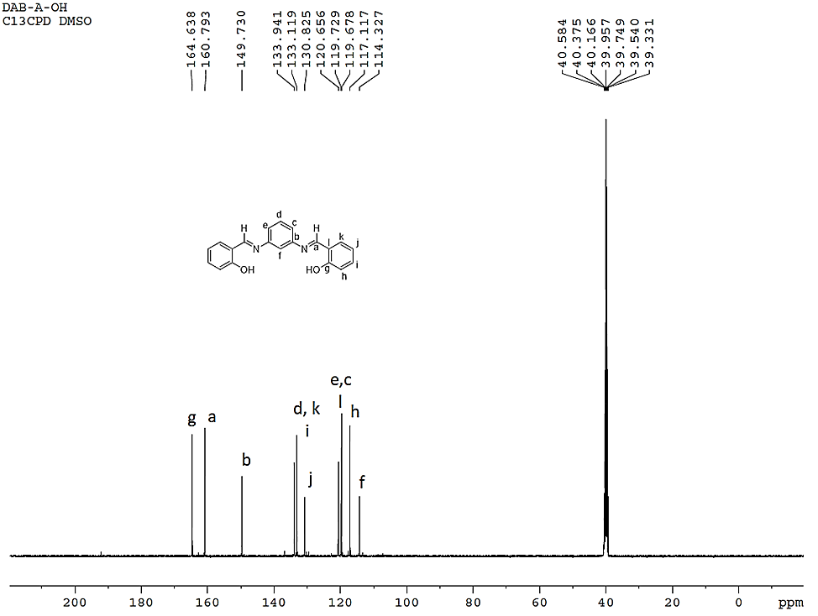
Figure S4 : ¹³C-NMR spectra of DAB-A-OH

¹H- and ¹³C-NMR Spectra of the Polymers

Figure S5 : ¹H-NMR spectra of DAB-A-1h

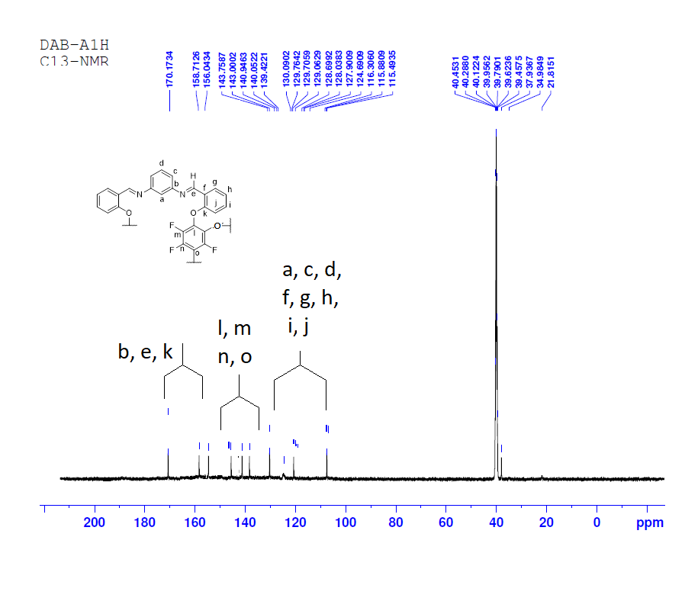Figure S6 : ¹³C-NMR spectra of DAB-A-1h

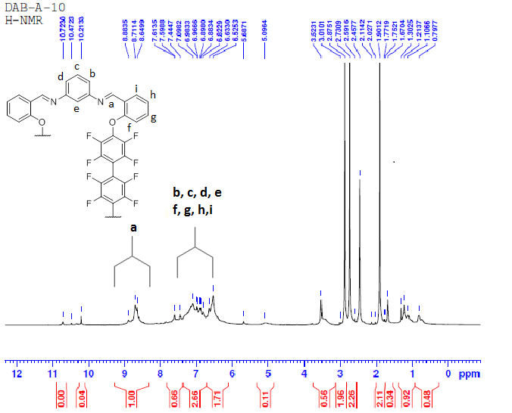

Figure S7 : ¹H-NMR spectra of DAB-A-1O

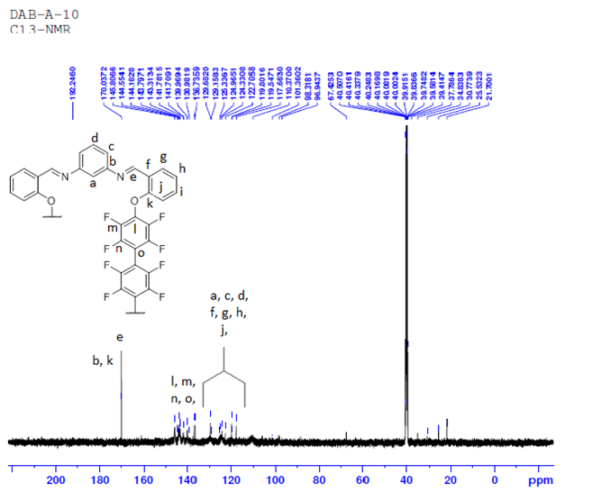
Figure S8 : ¹³C-NMR spectra of DAB-A-1O

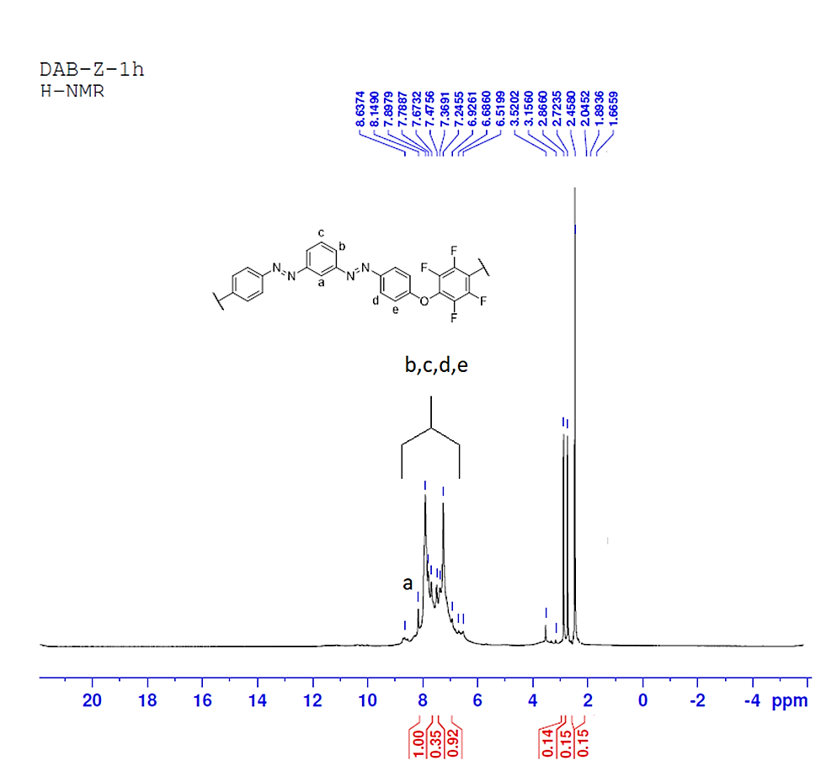
Figure S9 : ¹H-NMR spectra of DAB-Z-1h

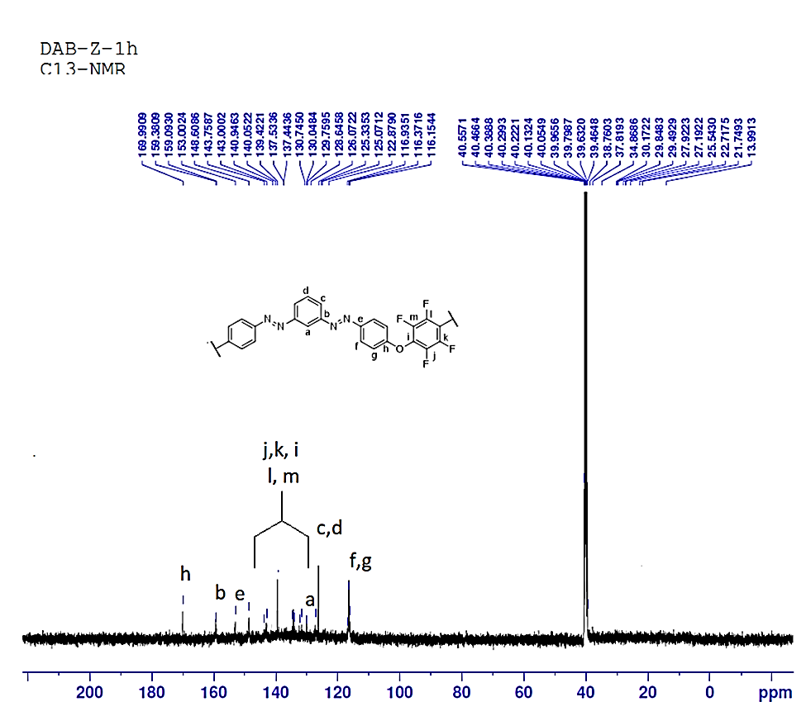
Figure S10 : ¹³C-NMR spectra of DAB-Z-1h

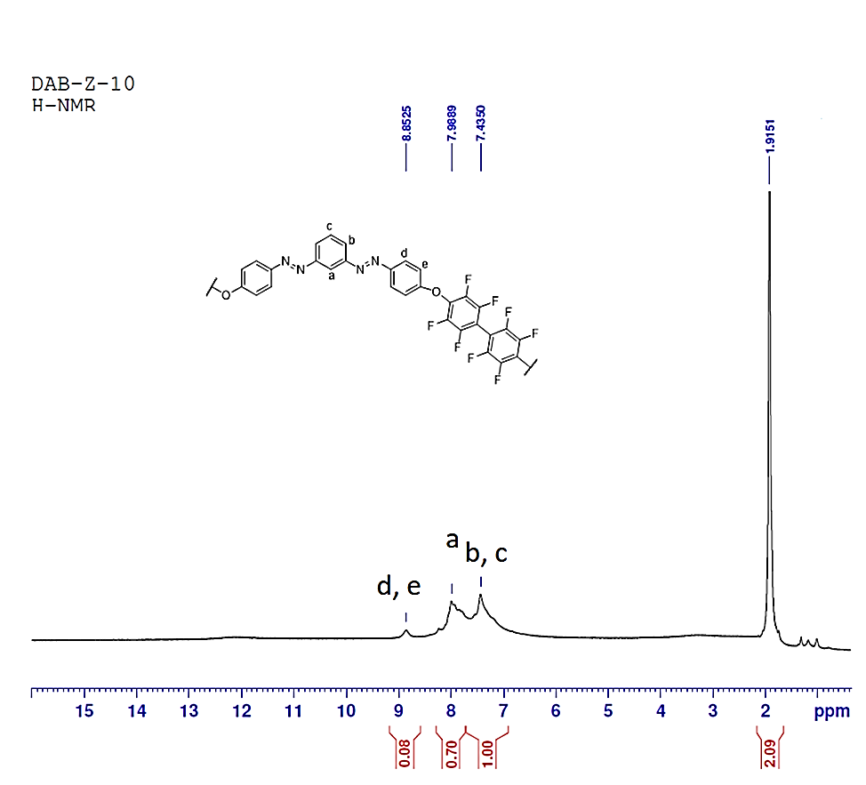
Figure S11 : ¹H-NMR spectra of DAB-Z-1O

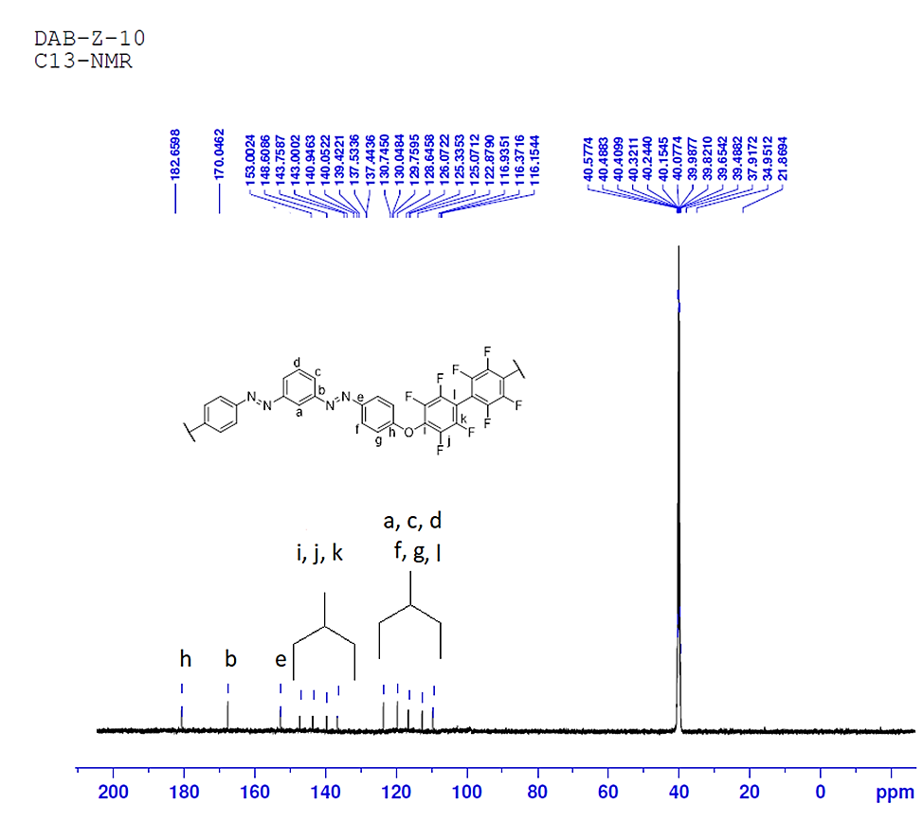
Figure S12 : ¹³C-NMR spectra of DAB-Z-1O

Figure S13: Proposed sites of zero and non-zero dipole moments of the polymers; (bold arrow create µ = 0, dashed arrow creates µ > 0).
Figure S14: Solubility behavior of the polymers in THF and DMSO. (Note: DAB-A-1h, DAB-Z-1h were completely insoluble in THF)

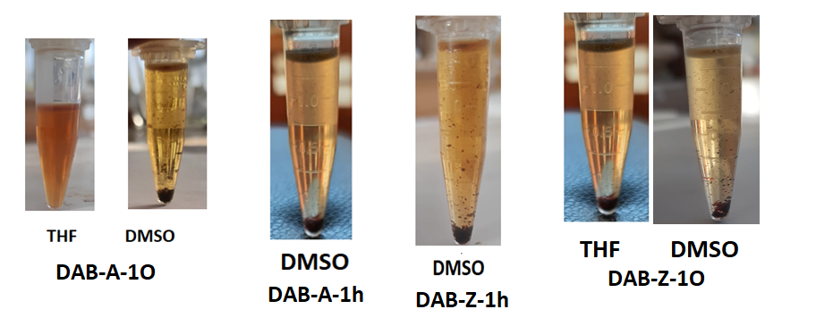
Part 2: Optical properties of the polymers
The degree of conjugation in the aromatic linkers (HFB and DFB) as well as in the resulting polymers (DAB-A-1h, DAB-A-1O, DAB-Z-1h, and DAB-Z-1O) was investigated by measuring their UV-Vis absorption spectra in DMSO. The maximum absorption wavelength (λ_{max}) is directly related to the degree of π-orbital overlap in conjugated systems. Thus, a comparison of the UV-Vis spectra of the linkers and the polymers provides information about the extent of π-π* transition in the extended conjugated systems.
Figure S15.A displays the absorption spectra of DAB-A-1h, DAB-A-1O, and DAB-A-OH. The absorption spectrum of DAB-A-OH exhibited two λ_{max} values at 350 and 276 nm, corresponding to the absorption of the azomethine (C=N) and phenyl groups, respectively. After the polymerization of DAB-A-OH with HFB and DFB, the λ_{max} shifted to 305 and 322 nm, respectively. This shift may be attributed to the incorporation of the fluorinated linkers and the modification of the chain planarity, leading to a hypsochromic effect [2].
Figure S15.B shows the UV-Vis spectra of DAB-Z-OH, DAB-Z-1h, and DAB-Z-1O. DAB-Z-OH exhibited two maxima at 366 and 440 nm in the absorption spectrum. The less intense maximum at 440 nm is indicative of the presence of azo-hydrazone-enamine tautomeric forms, which are formed due to interactions with DMSO [3]. Similarly, DAB-Z-1h and DAB-Z-1O, the azo-based polymers, exhibited hypsochromic shifts in their UV-Vis spectra to 334 and 342 nm, respectively. This shift was more significant than that observed in the azomethine-based polymers, possibly because of the presence of N=N and the higher fluorine content [4]. The hypsochromic shift observed in the absorption spectra could also be influenced by several other factors such as hydrogen bonding of the nitrogen sites, different chain conformations, and alterations in planarity.

Figure S15 UV–Vis absorption spectra of (A) DAB-A-OH and (B) DAB-Z-OH and their fluorinated polymers.
To investigate the impact of structural variations on the optical properties of the polymers, the bandgap (Eg) was determined using the Tauc relation applied to solutions of known concentrations or from transmittance spectra [2]. The Eg values were calculated by extrapolating the linear region of the UV-Vis spectra to x = λ, y = 0, as shown in Figure S16.A-B. The linear region in the UV-Vis spectra indicates the first sharp increase in absorption or the absorption onset. The λ values obtained from this region were then used in the Equation 1240/λ to calculate Eg. As a consequence of the polymerization, Eg values were found to increase, which can be attributed to the inclusion of fluorine groups in the polymer chains of all polymers.

Figure S16 Experimental determination of λ onset corresponding to the bandgap values of (A) DAB-A-OH and (B) DAB-Z-OH and their corresponding polymers.
TableS2. λ max of monomers and polymers.
Monomers/Polymers | λ maxª (nm) | λ_{onset}^{b} | Bandgap E_{g} (eV)
DAB-A-OH | 391 | 391 | 3.17
DAB-A-1O | 322 | 373 | 3.32
DAB-A-1h | 305 | 362 | 3.42
DAB-Z-OH | 366 | 588 | 2.10
DAB-Z-1O | 342 | 414 | 2.99
DAB-Z-1h | 334 | 421 | 2.94
ª λ_{max} determined from the UV–Vis absorption spectra. ^{b} λ _{onset}: wavelength at the first increase in absorbance.

Part 3: BET surface area calculations
The BET surface area of the polymers was determined by using Multi-point BET plot by using eq (1), where Xm is the monolayer capacity, P/P0 relative pressure, and C is constant. The plot of $\frac{1}{X\left[\left(\frac{p0}{p}\right)-1\right]} Vs (\frac{P}{P0})$ is performed by using, at minimum, three data points, in the P/P0 range 0.025 to 0.30, which should give a linear relation with a positive slope. It is well-known that at relative pressures higher than 0.5, there is the onset of capillary condensation, and at relatively low pressures only a monolayer gas adsorption occurs. gives liners plot with positive slope.
$$\frac{1}{X\left[\left(\frac{p0}{p}\right)-1\right]}=\frac{1}{XmC}+\left(\frac{C-1}{XmC}\right)*\left(\frac{P}{P0}\right) eq (1)$$

When the values of the slope and y-intercept is determined by using least squares regression, the monolayer capacity Xm can be calculated by applying eq (2).
$$Xm=\left(\frac{1}{slope \left(s\right)+intercept \left(i\right)}\right) eq (2)$$

Once Xm is determined, the total surface area SA can be calculated from eq (3), where Av is Avogadro's number (6.022 *10²³), Am is the cross sectional area of the adsorbate and equals 0.138 nm² for an absorbed argon molecule, and Mv is the molar volume, which equals 22414 mL as STP conditions.
$$SA (\frac{m^{2}}{g})=\left[\frac{Xm\frac{cc}{g}*Am \left({nm}^{2}\right)*Av}{22414 cc}\right] eq \left(3\right)$$
According to the above equations, the calculated Xm and SA values along with the slope, and intercepts of the plots are summarized in table S3.

Table S3. BET plots data of the polymers
Equation | y = a + b*x
Plot | DAB-A-1O | DAB-A-1h | DAB-Z-1h | DAB-Z-1O
Weight | No Weighting
Intercept (i) | -4.58E-09 | -2.795E-09 | -2.677E-09 | -1.678E-09
Slope (s) | 0.0129972 | 0.0091831 | 0.0075039 | 0.0048092
Xm=1/(s+i) | 76.93967565 | 108.895722 | 133.2640836 | 207.9348642
SA (surface area) | 285.2665312 | 403.7488409 | 494.0985588 | 770.9527876
Residual Sum of Squares | 3.61E-05 | 1.99E-05 | 1.12E-05 | 4.99E-06
Pearson's r | 0.994560004 | 0.99375191 | 0.994836658 | 0.994574501
R-Square (COD) | 0.989149602 | 0.987542859 | 0.989699976 | 0.989178439
Adj. R-Square | 0.986437003 | 0.984428574 | 0.98712497 | 0.986473049

[5-7]
References

1. Kaseman, D.C., et al., Chemical Analysis of Fluorobenzenes via Multinuclear Detection in the Strong Heteronuclear J-Coupling Regime. Applied Sciences, 2020. 10(11): p. 3836.
2. Altarawneh, S.S., et al., Synthesis, structures, and density functional theory computational study of thiophene-containing and fluorodecorated imine-linked polymers. Journal of Applied Polymer Science, 2017. 134(2).
3. Mohammadi, A. and J. Jabbari, Simple naked-eye colorimetric chemosensors based on Schiff-base for selective sensing of cyanide and fluoride ions. Canadian Journal of Chemistry, 2016. 94(7): p. 631-636.
4. Chng, S., et al., A study of diazonium couplings with aromatic nucleophiles both in solution and on a polymer surface. Applied Surface Science, 2017. 401: p. 181-189.
5. Bae, Y.-S., A.Ö. Yazaydın, and R.Q. Snurr, Evaluation of the BET Method for Determining Surface Areas of MOFs and Zeolites that Contain Ultra-Micropores. Langmuir, 2010. 26(8): p. 5475-5483.
6. Merukan Chola, N., et al., Sorption of Carbon Dioxide and Nitrogen on Porous Hyper-Cross-Linked Aromatic Polymers: Effect of Textural Properties, Composition, and Electrostatic Interactions. ACS Omega, 2023. 8(28): p. 24761-24772.
7. Shi, K., et al., Two-Dimensional Energy Histograms as Features for Machine Learning to Predict Adsorption in Diverse Nanoporous Materials. Journal of Chemical Theory and Computation, 2023. 19(14): p. 4568-4583.

