Supplementary Material

Table S1: Fermentation parameters, astaxanthin production and growth indicators. For each performed fermentation the pH, aeration rate, astaxanthin production, volumetric productivity (VP), glucose yield (Y_{P/S}), as well as the growth rate (µ) and biomass formation are stated. Runs 1 to 10 belong to the DoE setup, runs under control conditions are marked in grey. The runs marked in green are run with optimal setpoints. Growth rates given as – could not be calculated due to failures of the automatic sampling process.
Run # | Parameters |  |  |  | Astaxanthin |  |  |  | Growth
 | pH | aeration rate [vvm] | rDOS [%] | Initial OD_{600nm} | [mg L⁻¹] | [mg g⁻¹ CDW] | VP  [mg L⁻¹ h⁻¹] | Y_{P/S} [mg g⁻¹] | µ  [h⁻¹] | max. OD_{600 nm} | max. CDW [g L⁻¹]
1 | 7 | 0.5 | 30 | 3 | 1.79 | 0.22 | 0.02 | 0.04 | - | 52 | 13
2 | 6 | 0.75 | 15 | 5 | 0.66 | 0.15 | 0.05 | 0.02 | 0.10 | 21 | 5.25
3 | 8 | 0.25 | 45 | 1 | 8.19 | 0.86 | 0.33 | 0.2 | 0.15 | 38 | 9.5
4 | 8 | 0.75 | 45 | 5 | 7.47 | 0.92 | 0.23 | 0.19 | 0.21 | 37 | 9.25
5 | 8 | 0.25 | 15 | 5 | 9.84 | 1.19 | 0.10 | 0.25 | 0.21 | 41 | 10.25
6 | 6 | 0.25 | 45 | 5 | 0.33 | 0.06 | 0.01 | 0.01 | 0.13 | 28 | 7
7 | 7 | 0.5 | 30 | 3 | 4.45 | 0.76 | 0.22 | 0.11 | 0.24 | 32 | 8
8 | 6 | 0.25 | 15 | 1 | 0.41 | 0.04 | 0.02 | 0.01 | - | 49 | 12.25
9 | 8 | 0.75 | 15 | 1 | 6.49 | 0.88 | 0.16 | 0.16 | - | 34 | 8.5
10 | 6 | 0.75 | 45 | 1 | 0.00 | 0.00 | 0 | 0 | 0.14 | 17 | 4.25
11 | 7 | 0.15 | 30 | 1 | 2.38 | 0.24 | 0.05 | 0.06 | 0.25 | 52 | 12.9
12 | 7 | 0.25 | 30 | 1 | 5.53 | 0.61 | 0.12 | 0.14 | 0.26 | 53 | 13.4
13 | 7 | 0.35 | 30 | 1 | 2.14 | 0.24 | 0.04 | 0.05 | 0.22 | 46 | 11.5
14 | 7 | 0.5 | 30 | 1 | 0.93 | 0.11 | 0.02 | 0.02 | 0.20 | 42 | 10.7
15 | 7.5 | 0.25 | 30 | 1 | 6.07 | 0.67 | 0.13 | 0.15 | 0.26 | 47 | 11.8
16 | 8 | 0.25 | 30 | 1 | 7.12 | 0.81 | 0.15 | 0.18 | 0.21 | 50 | 12.6
17 | 8.5 | 0.25 | 30 | 1 | 5.91 | 0.82 | 0.12 | 0.15 | 0.15 | 35 | 8.7
18 | 6 | 0.25 | 30 | 1 | 0.04 | 0.08 | <0.01 | <0.01 | 0.12 | 11 | 2.7
19 | 6→8 | 0.25 | 30 | 1 | 4.18 | 0.57 | 0.09 | 0.10 | 0.21 | 41 | 10.3
20 | 8→6 | 0.25 | 30 | 1 | 0.52 | 0.12 | 0.01 | 0.01 | 0.23 | 47 | 11.7
21 | 8 | 0.25 | 30 | 1 | 7.42 | 0.89 | 0.15 | 0.19 | 0.24 | 57 | 14.3
22 | 8 | 0.25 | 30 | 1 | 8.28 | 0.92 | 0.17 | 0.21 | 0.22 | 54 | 13.5

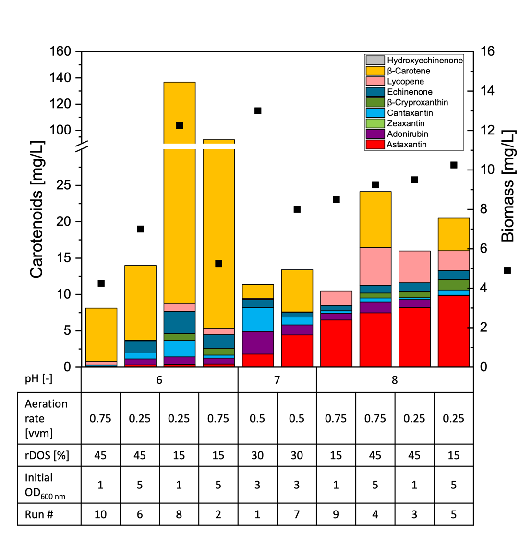
Figure S1: Carotenoid titers of C. glutamicum ASTA* at the time of maximum astaxanthin titer of each DOE run.

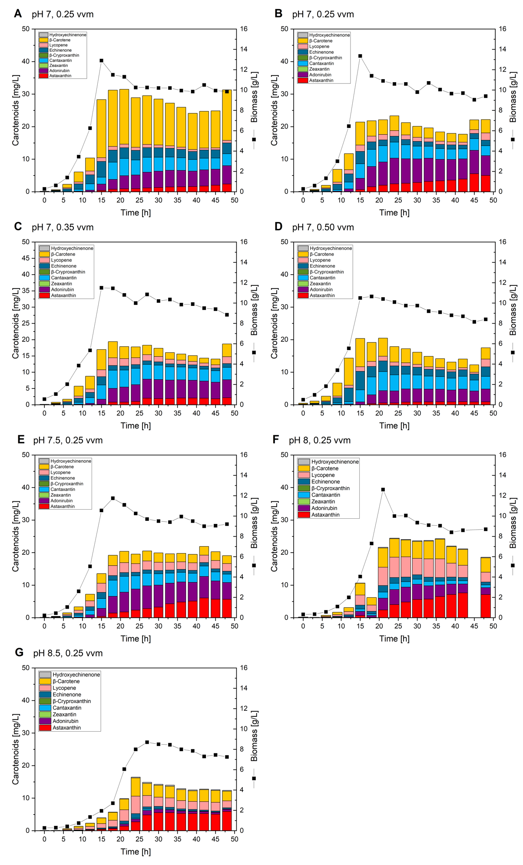
Figure S2: Carotenoid titers and biomass formation of C. glutamicum ASTA* during batch fermentations at different aeration rates and pH. Progression of carotenoid titers (bars) and biomass formation (black squares) over time during batch fermentations with C. glutamicum ASTA* grown in 2 L CGXII medium at pH 7 with an aeration rate of 0.15 vvm (A), 0.25 vvm (B), 0.35 vvm (C) and 0.5 vvm (D); or with an aeration rate of 0.25 vvm at pH 7.5 (E), pH 8 (F) or pH 8.5 (G). All fermentations were performed with an initial OD_{600 nm} of 1, at rDOS of 30 %.
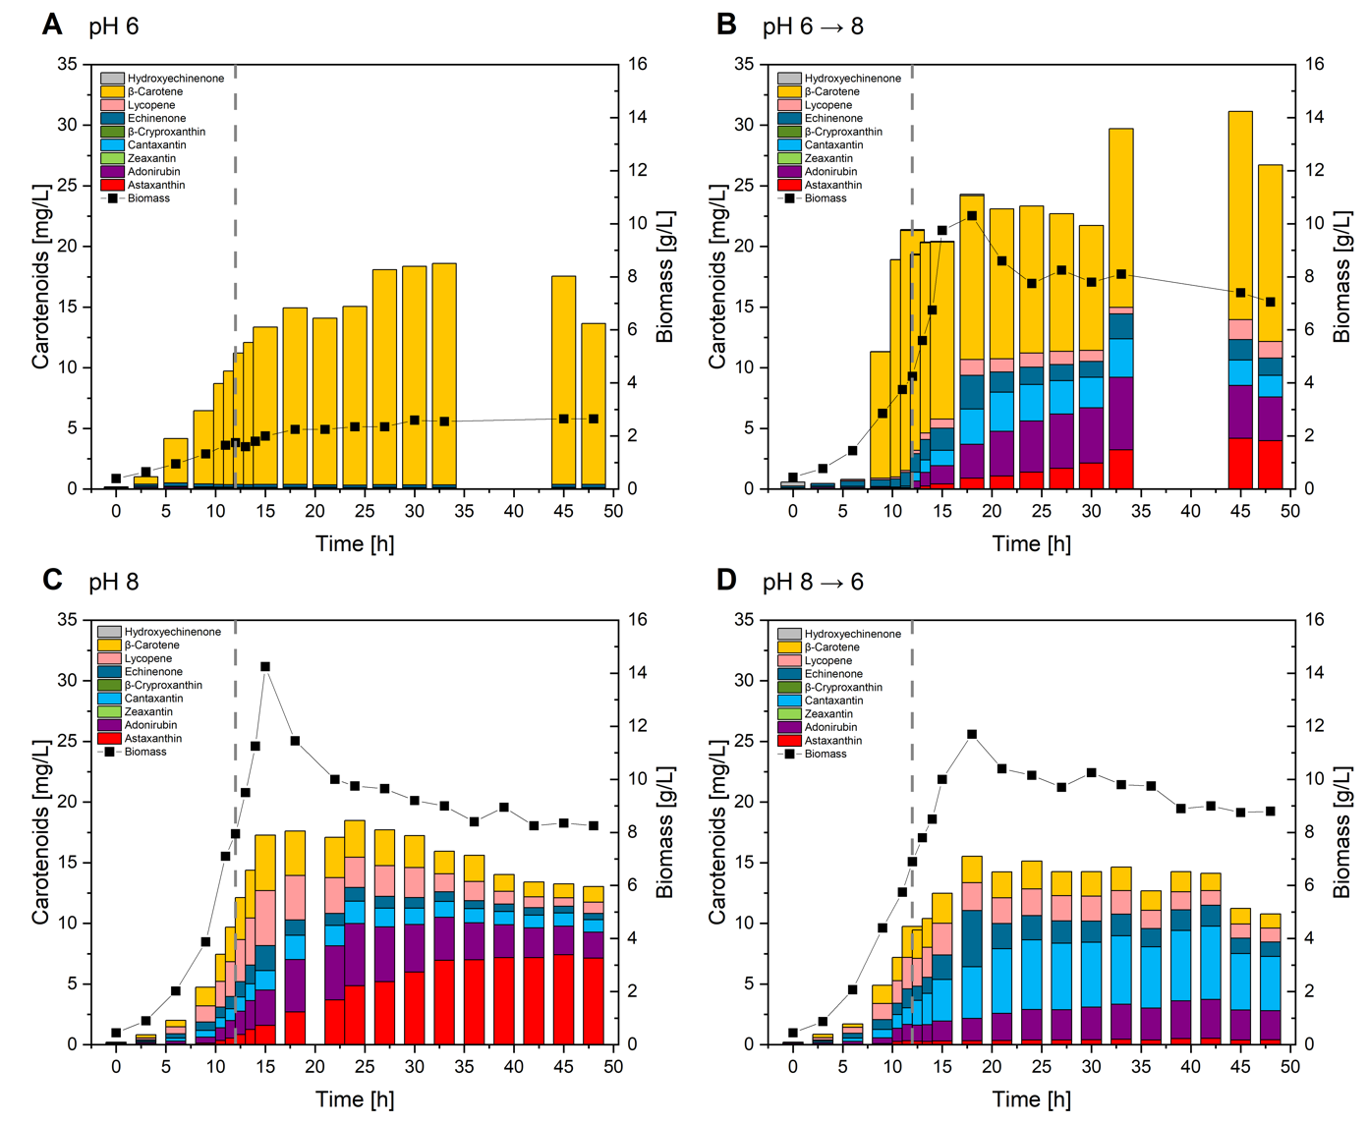
Figure S3: Carotenoid titers and biomass formation of C. glutamicum ASTA* during batch fermentations at different pH values and with pH-shifts. Progression of carotenoid titers (bars) and biomass formation (black squares) during 2 L batch fermentations in CGXII medium steady at pH 6 (A), pH 8 (C), or with a pH-shift after 12 h from pH 6 to pH 8 (B) or from pH 8 to pH 6 (D). The dashed grey line indicates a process time of 12 h.
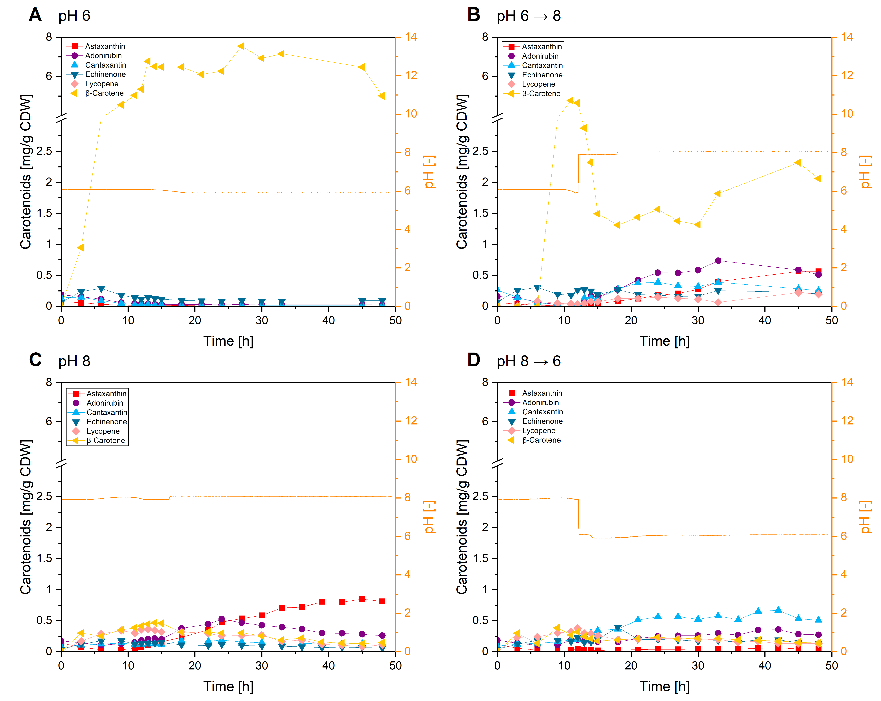
Figure S4: Cellular carotenoid contents of C. glutamicum ASTA* during batch fermentations at different pH values and with pH-shifts. Progression of cellular carotenoid contents and pH (orange line) during 2 L batch fermentations in CGXII medium steady at pH 6 (A), pH 8 (C), or with a pH-shift after 12 h from pH 6 to pH 8 (B)or from pH 8 to pH 6 (D).

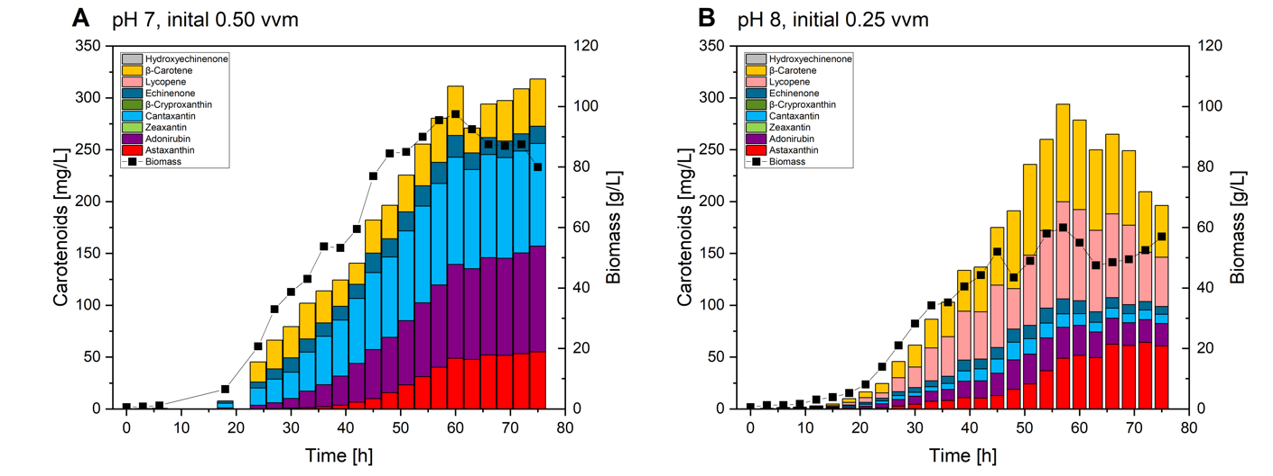
Figure S5: Carotenoid titers and biomass formation of C. glutamicum ASTA* during fed-batch fermentations. Progression of carotenoid titers (bars) and biomass formation (black squares) during fed-batch fermentations in 1 L HCDC medium with 1 L 600 g L⁻¹ glucose as feed. Cultivated at pH 7 with an initial aeration rate of 0.5 vvm (A), or at pH 8 with an initial aeration rate of 0.25 (B).

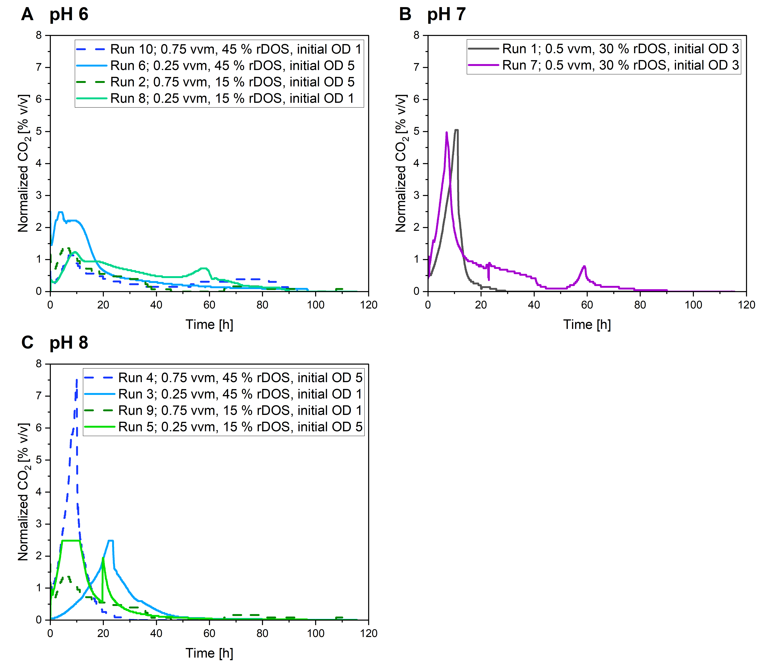
Figure S6: Off-gas CO₂ profiles of the batch DoE fermentation runs 1 – 10. The sets are grouped base on their pH setpoint pH 6 (A), pH 7 (B) and pH 8 (C). High rDOS is indicated by blue coloration and low rDOS by green coloration. High aeration rate is indicated by dashed lines, low aeration rate by continuous lines. All setpoints are given in the legend of each graph. The CO₂ values were normalized by multiplying them with the aeration rate of the separate fermentation runs. The sensors detection range was from 0 – 5% [v/v].

