Appendix
Further Analysis
Contents
General Information 4
Descriptive 4
Annual Scientific Production 5
Average Citations Per Year 6
Three Field Plot 7
Sources 8
Most Relevant Sources 8
Most Local Cited Sources 9
Core Sources by Bradford’s Law 10
Sources Local Impact by G-Index 11
Sources Local Impact by H-Index 12
Sources Local Impact by M-Index 13
Sources Local Impact by Total Citations 14
Local Impacts 14
Sources’ Production Over time 15
Authors 16
Most Local Cited Authors 16
Author Productivity through Lotka’s Law 16
Author’s Local Impact by H index 18
Author’s Local Impact by G index 19
Author’s Local Impact by M index 20
Author’s Local Impact by Total Citations 21
Documents 22
Most Global Cited Documents 22
Most Local Cited Documents 23
Most Local Cited References 24
Most Relevant Keywords Plus 25
Most Relevant Authors Keywords 27
Most Relevant Unigram words in Title 29
Most Relevant Bigram words in Title 31
Most Relevant Trigram words in Title 33
Most Relevant Unigram words in Abstract 35
Most Relevant Bigram words in Abstract 37
Most Relevant Trigram words in Abstract 39
Trend Topic of Author Keywords 42
Conceptual Structure 43
Co-Occurrence Network of Keyword Plus 43
Co-Occurrence Network of Author Keyword 44
Co-Occurrence Network of Unigram words in Title 44
Co-Occurrence Network of Bigram words in Title 45
Co-Occurrence Network of Trigram words in Title 45
Co-Occurrence Network of Unigram words in Abstract 46
Co-Occurrence Network of Bigram words in Abstract 46
Co-Occurrence Network of Trigram words in Abstract 47
Thematic Map 48
Thematic Map Keyword Plus 48
Thematic Network Keyword Plus 48
Thematic Map Authors Keyword 49
Thematic Network Authors Keyword 49
Thematic Map Unigram Word in title 50
Thematic Network Unigram Word in title 50
Thematic Map Bigram Word in title 51
Thematic Network Bigram Word in title 51
Thematic Map Trigram Word in title 52
Thematic Network Trigram Word in title 52
Thematic Map Unigram Word in Abstract 53
Thematic Network Unigram Word in Abstract 53
Thematic Map Bigram Word in Abstract 54
Thematic Network Bigram Word in Abstract 54
Thematic Map Trigram Word in Abstract 55
Thematic Network Trigram Word in Abstract 55
Correspondence Analysis 56
Multiple Correspondence Analysis of Keyword Plus 56
Correspondence Analysis of Keyword Plus 57
Multiple Correspondence Analysis of Authors Keywords 58
Correspondence Analysis of Authors Keywords 59
Co-citation Network 60
Co-Citation Network for Research Articles 60
Co-Citation Network for Authors 62
Co-Citation Network for Sources 64
Historiograph 66
Collaboration Network 67
University 67
Countries 69
Countries Collaboration Network 71

General Information

Descriptive
MAIN INFORMATION ABOUT DATA
Timespan | 2004:2023
Sources (Journals, Books, etc) | 1,125
Documents | 12,700
Annual Growth Rate % | 28.12
Document Average Age | 5.03
Average citations per doc | 22.51
References | 279,617

DOCUMENT CONTENTS
Keywords Plus (ID) | 13,707
Author's Keywords (DE) | 19,062

AUTHORS
Authors | 29,125
Authors of single-authored docs | 111

AUTHORS COLLABORATION
Single-authored docs | 148
Co-Authors per Doc | 4.89
International co-authorships % | 37.27

DOCUMENT TYPES
article | 12,165
article; book chapter | 2
article; data paper | 40
article; early access | 222
article; proceedings paper | 79
article; retracted publication | 3
correction | 1
editorial material | 10
editorial material; book chapter | 1
letter | 8
letter; early access | 1
meeting abstract | 6
review | 155
review; book chapter | 7

Annual Scientific Production

Year | Articles
2004 | 10
2005 | 36
2006 | 69
2007 | 112
2008 | 119
2009 | 186
2010 | 251
2011 | 296
2012 | 370
2013 | 484
2014 | 555
2015 | 675
2016 | 775
2017 | 872
2018 | 1,047
2019 | 1,223
2020 | 1,368
2021 | 1,536
2022 | 1,607
2023 | 1,109

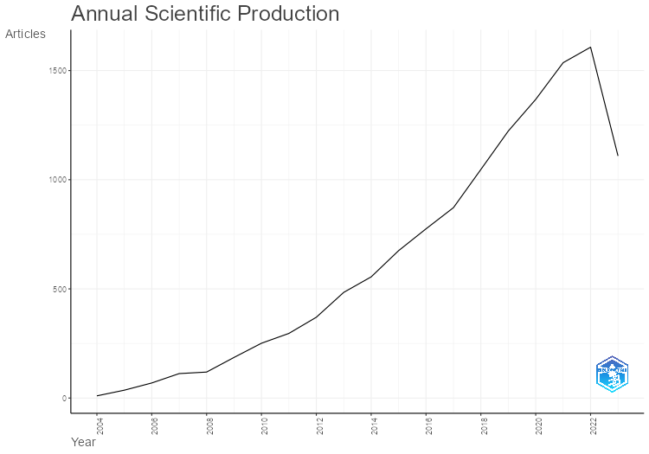

Average Citations Per Year
Year | MeanTCperArt | N | MeanTCperYear | CitableYears
2004 | 163.9 | 10 | 8.2 | 20
2005 | 139.33 | 36 | 7.33 | 19
2006 | 90.17 | 69 | 5.01 | 18
2007 | 87.99 | 112 | 5.18 | 17
2008 | 68.96 | 119 | 4.31 | 16
2009 | 71.96 | 186 | 4.8 | 15
2010 | 70.38 | 251 | 5.03 | 14
2011 | 91.74 | 296 | 7.06 | 13
2012 | 48.06 | 370 | 4 | 12
2013 | 42.54 | 484 | 3.87 | 11
2014 | 40.64 | 555 | 4.06 | 10
2015 | 33.34 | 675 | 3.7 | 9
2016 | 26.62 | 775 | 3.33 | 8
2017 | 25.59 | 872 | 3.66 | 7
2018 | 21.26 | 1047 | 3.54 | 6
2019 | 16.81 | 1223 | 3.36 | 5
2020 | 10.21 | 1368 | 2.55 | 4
2021 | 5.94 | 1536 | 1.98 | 3
2022 | 2.49 | 1607 | 1.25 | 2
2023 | 0.43 | 1109 | 0.43 | 1

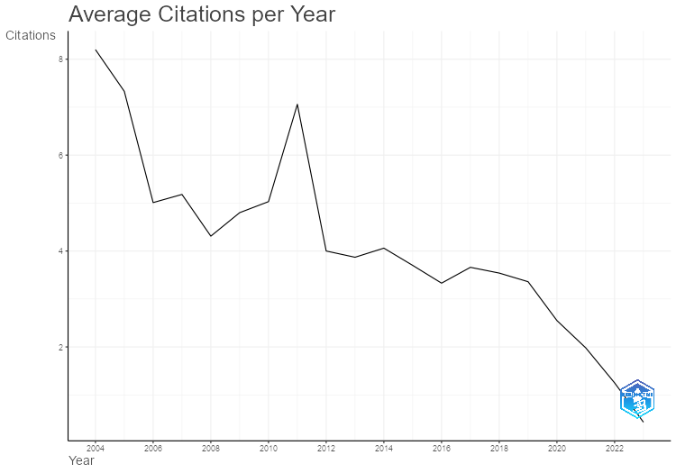

Three Field Plot
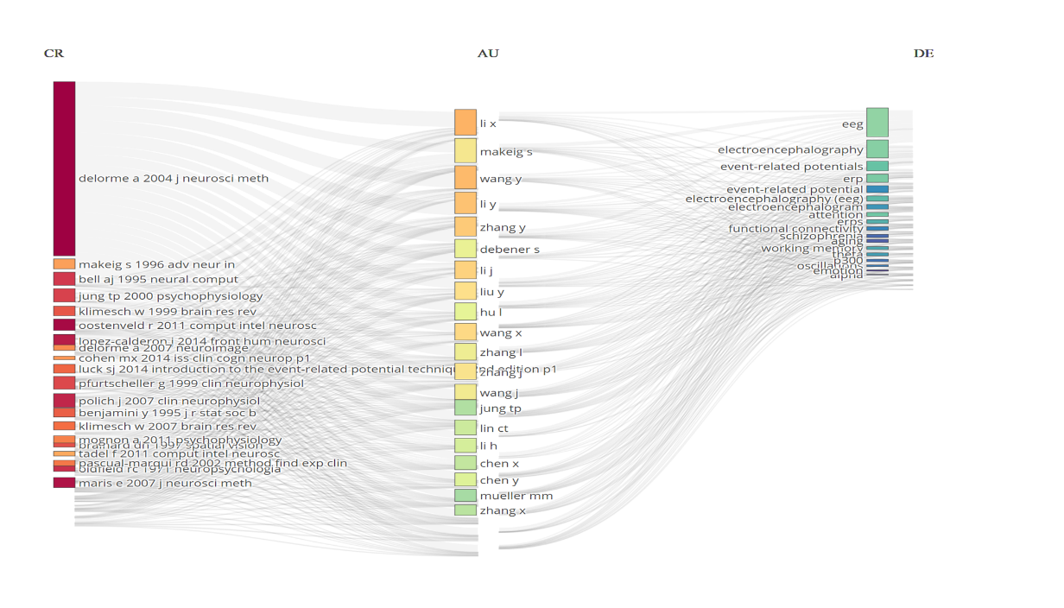
References
Left | References
Middle | Authors
Right | Keyword

Sources

Most Relevant Sources
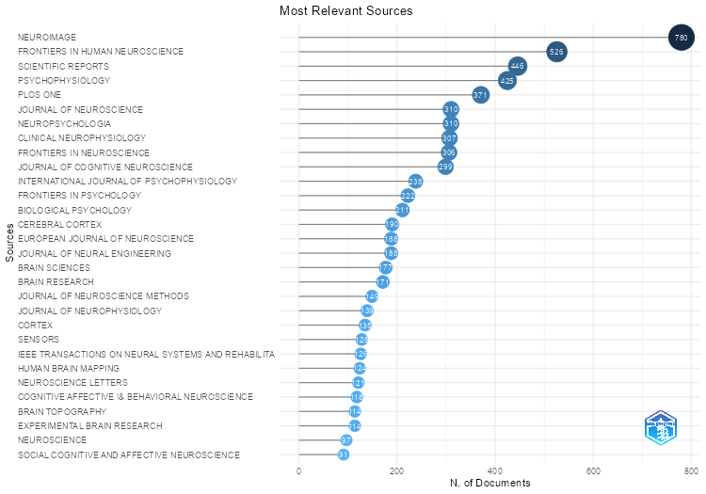

Most Local Cited Sources
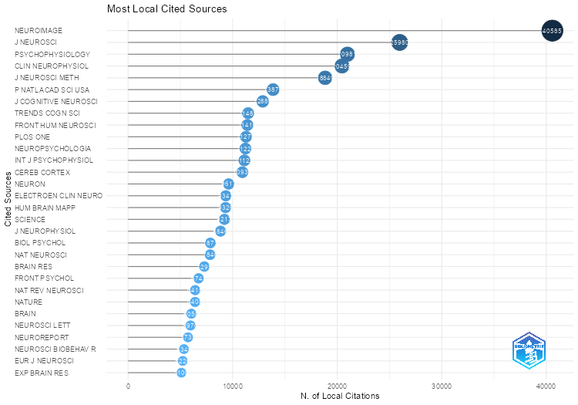

Core Sources by Bradford’s Law
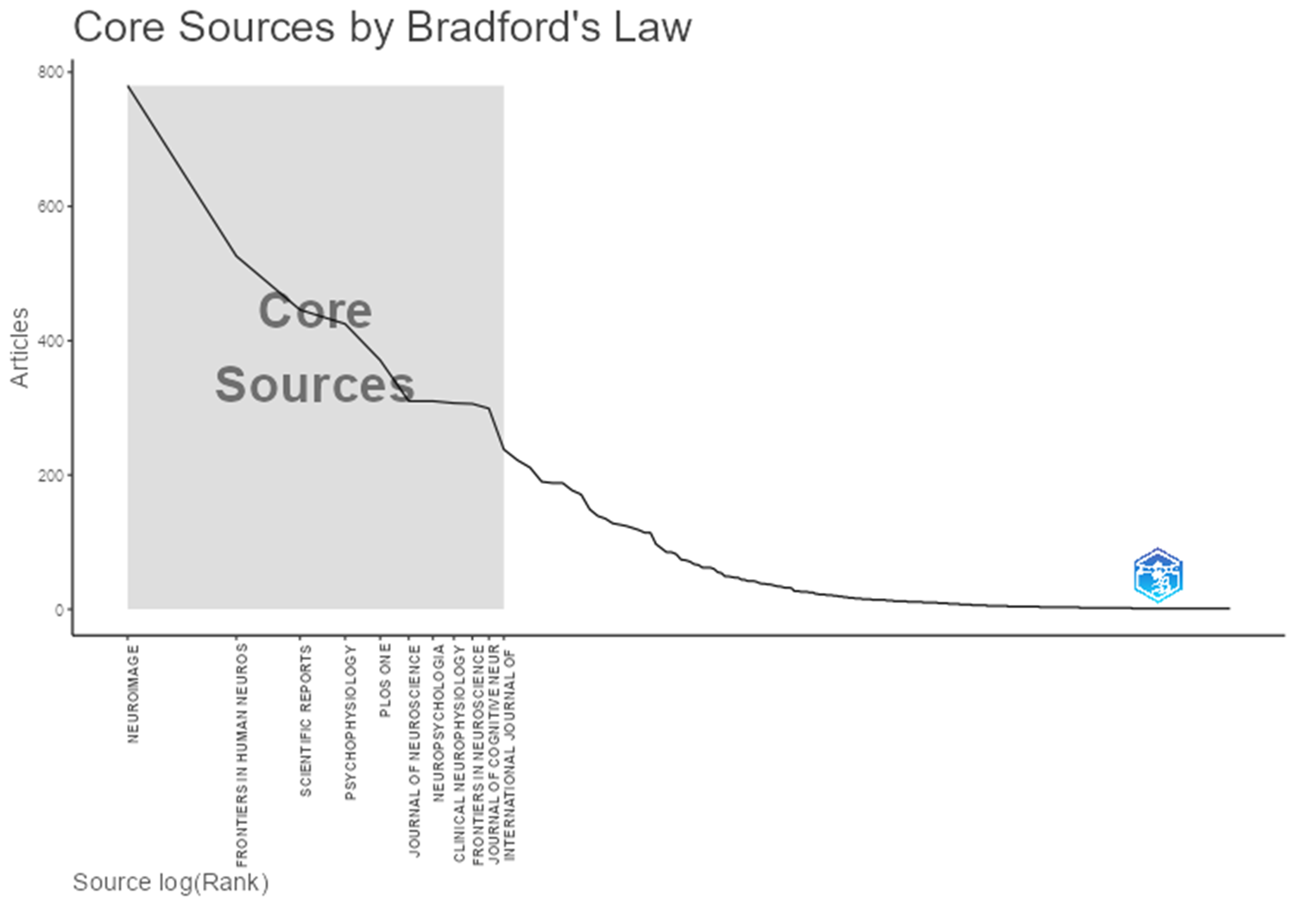

Sources Local Impact by G-Index
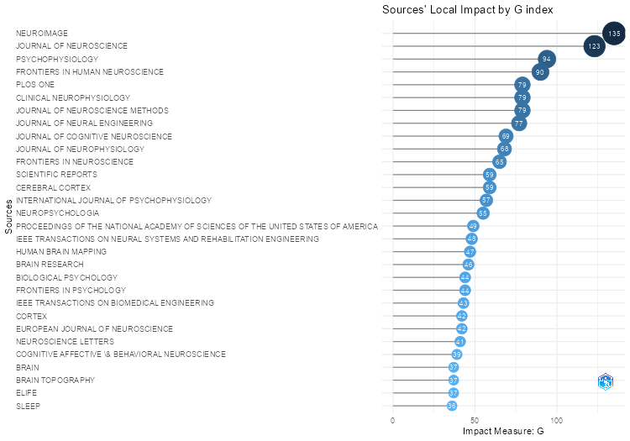

Sources Local Impact by H-Index
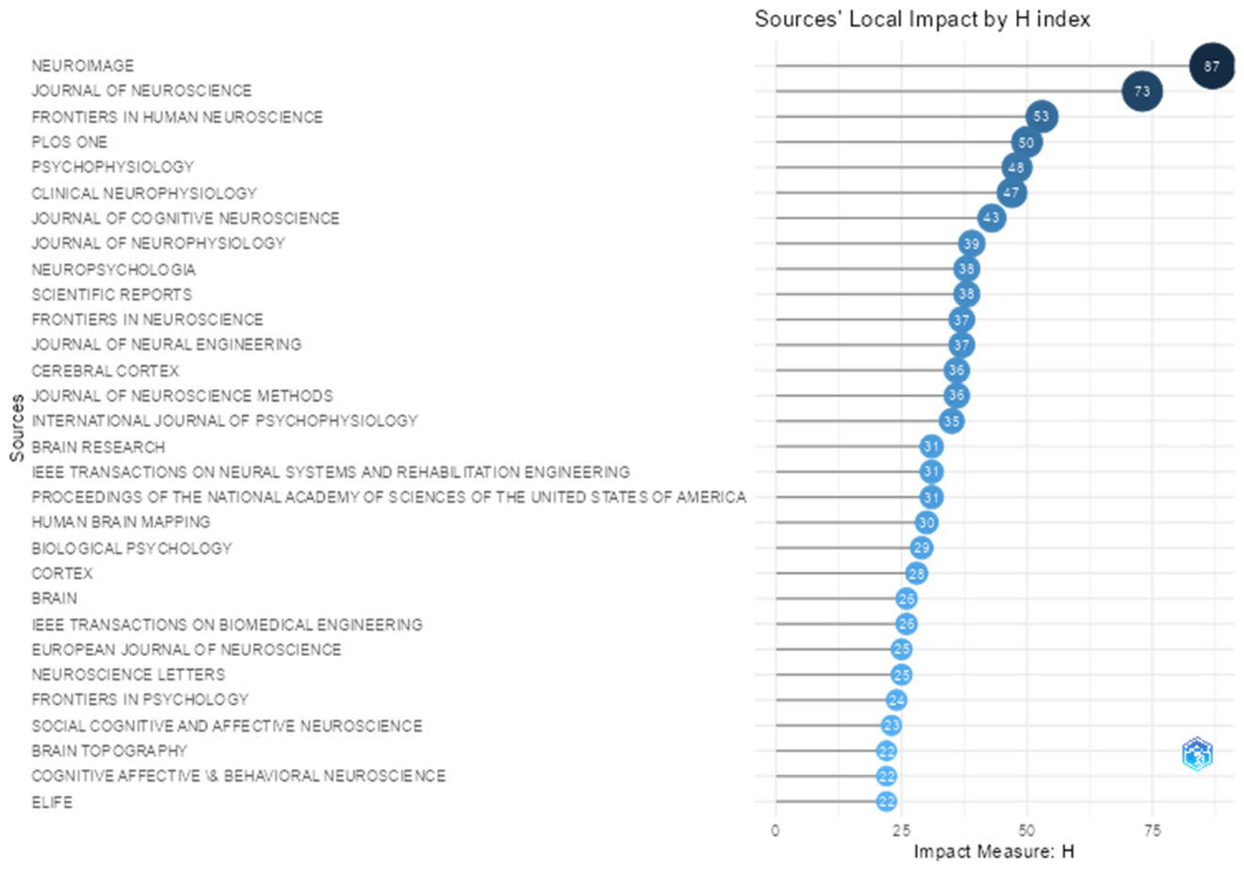

Sources Local Impact by M-Index
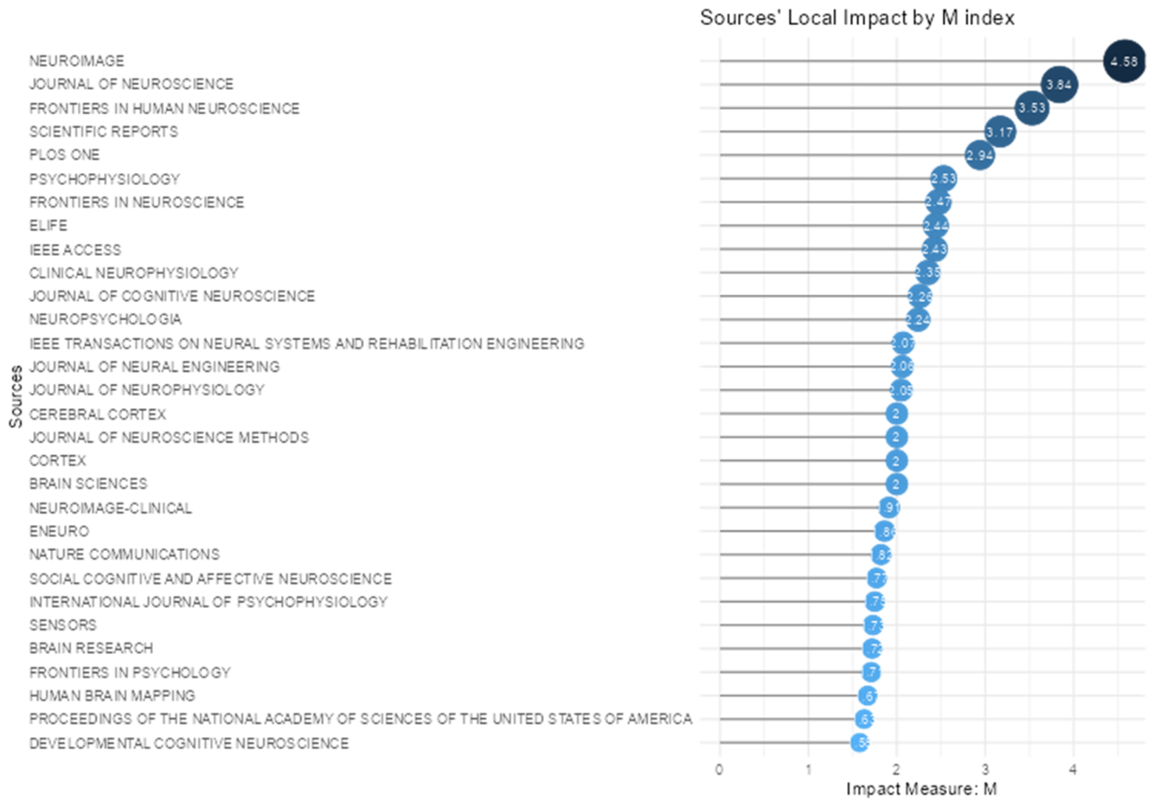

Sources Local Impact by Total Citations
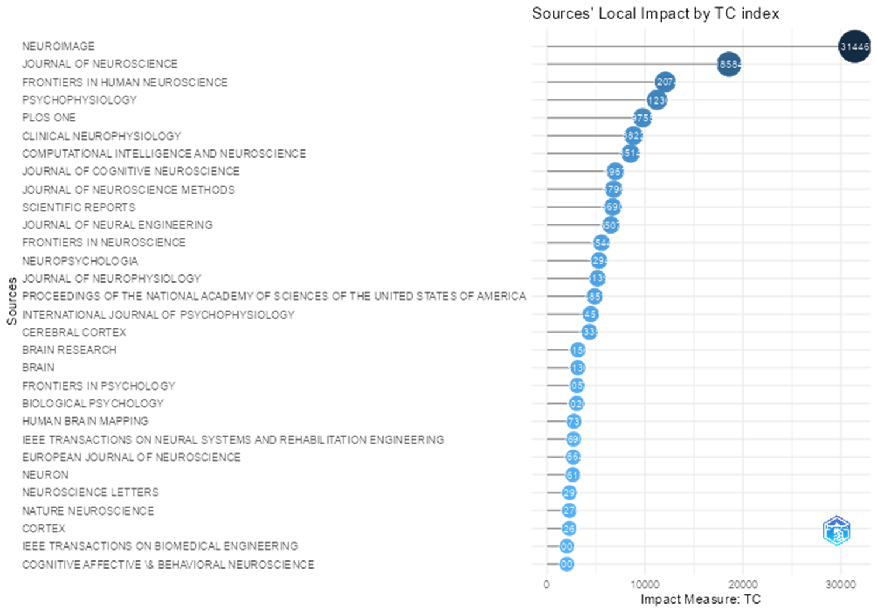

Local Impacts
Sources | Local Impact |  |  |  | Number Papers | Start Year
 | H Index | G Index | M Index | Total Citations
NEUROIMAGE | 87 | 135 | 4.578947 | 31446 | 780 | 2005
JOURNAL OF NEUROSCIENCE | 73 | 123 | 3.842105 | 18584 | 310 | 2005
FRONTIERS IN HUMAN NEUROSCIENCE | 53 | 90 | 3.533333 | 12074 | 526 | 2009
PLOS ONE | 50 | 79 | 2.941176 | 9755 | 371 | 2007
PSYCHOPHYSIOLOGY | 48 | 94 | 2.526316 | 11230 | 425 | 2005

Sources’ Production Over time
It shows top 20 journals and 10 top journal in the table.
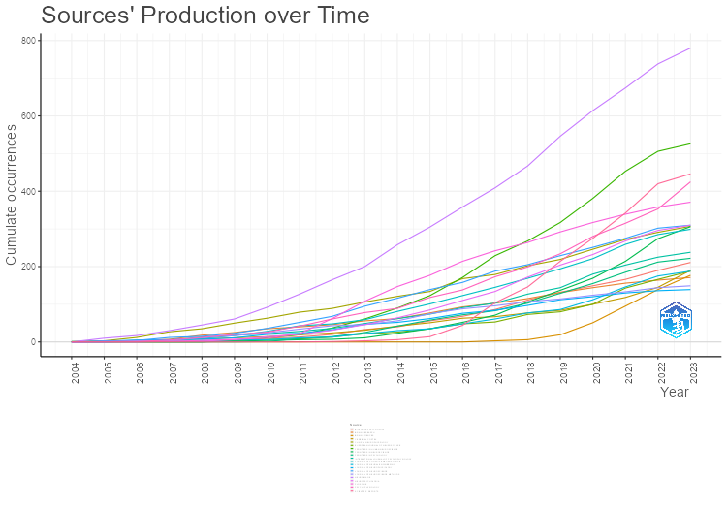
Year | Journal Names
 | NEUROIMAGE | FRONTIERS IN HUMAN NEUROSCIENCE | SCIENTIFIC REPORTS | PSYCHOPHYSIOLOGY | PLOS ONE | JOURNAL OF NEUROSCIENCE | NEUROPSYCHOLOGIA | CLINICAL NEUROPHYSIOLOGY | FRONTIERS IN NEUROSCIENCE | JOURNAL OF COGNITIVE NEUROSCIENCE
2004 | 0 | 0 | 0 | 0 | 0 | 0 | 0 | 1 | 0 | 0
2005 | 10 | 0 | 0 | 1 | 0 | 3 | 0 | 3 | 0 | 1
2006 | 17 | 0 | 0 | 1 | 0 | 4 | 0 | 12 | 0 | 2
2007 | 30 | 0 | 0 | 5 | 1 | 12 | 2 | 27 | 0 | 5
2008 | 45 | 0 | 0 | 12 | 4 | 15 | 2 | 35 | 0 | 9
2009 | 61 | 4 | 0 | 20 | 7 | 23 | 6 | 50 | 2 | 17
2010 | 92 | 11 | 0 | 26 | 10 | 36 | 14 | 63 | 4 | 28
2011 | 127 | 19 | 0 | 42 | 22 | 52 | 20 | 79 | 6 | 43
2012 | 165 | 37 | 1 | 61 | 62 | 68 | 31 | 89 | 7 | 48
2013 | 200 | 61 | 3 | 78 | 108 | 95 | 46 | 106 | 11 | 59
2014 | 258 | 90 | 6 | 89 | 147 | 116 | 64 | 121 | 23 | 81
2015 | 305 | 123 | 14 | 118 | 177 | 139 | 85 | 134 | 35 | 101
2016 | 358 | 171 | 44 | 138 | 214 | 158 | 110 | 168 | 52 | 123
2017 | 409 | 229 | 104 | 173 | 242 | 188 | 134 | 179 | 71 | 145
2018 | 467 | 268 | 146 | 199 | 264 | 205 | 172 | 202 | 106 | 169
2019 | 546 | 317 | 214 | 234 | 292 | 229 | 204 | 219 | 137 | 194
2020 | 614 | 381 | 275 | 280 | 317 | 251 | 232 | 246 | 169 | 221
2021 | 674 | 453 | 342 | 315 | 339 | 275 | 268 | 272 | 214 | 259
2022 | 738 | 506 | 420 | 353 | 358 | 302 | 296 | 291 | 274 | 285
2023 | 780 | 526 | 446 | 425 | 371 | 310 | 310 | 307 | 306 | 299

Authors

Most Local Cited Authors

Row | Author | University | LocalCitations
1 | Scott Makeig | University of California, San Diego | 3,427
2 | Arnaud Delorme | CNRS, UCSD, Paul Sabatier university | 2,151
3 | Stefan Debener | University of Oldenburg | 1,870
4 | Steven J Luck | University of California, Davis | 1,670
5 | Javier Lopez-Calderon | Universidad de Talca, United States | 1,228
6 | Julie Onton | University of Califormia, San Diego | 1,064
7 | Mike X Cohen | Radboud University Medical Centre | 788
8 | Daniel P. Ferris | University of Florida | 786
9 | Klaus Gramann | Technische Universität Berlin | 672
10 | Giandomenico (GD) Iannetti | University College London (UCL) | 667

Author Productivity through Lotka’s Law

N.Articles | N.Authors | Freq
1 | 19,416 | 66.7%
2 | 4,432 | 15.2%
3 | 1,879 | 6.5%
4 | 1,000 | 3.4%
5 | 580 | 2.0%
6 | 402 | 1.4%
7 | 292 | 1.0%
8 | 230 | 0.8%
9 | 175 | 0.6%
10 | 124 | 0.4%

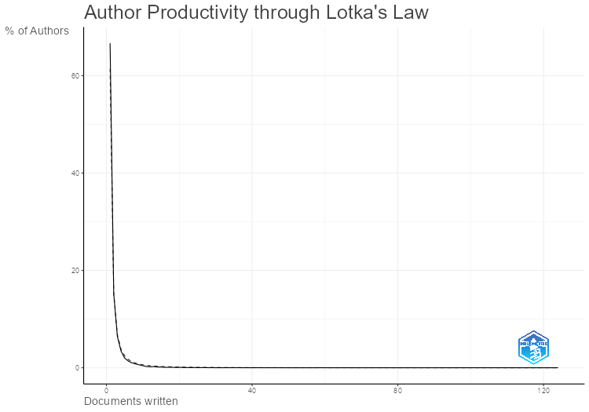

Author’s Local Impact by H index
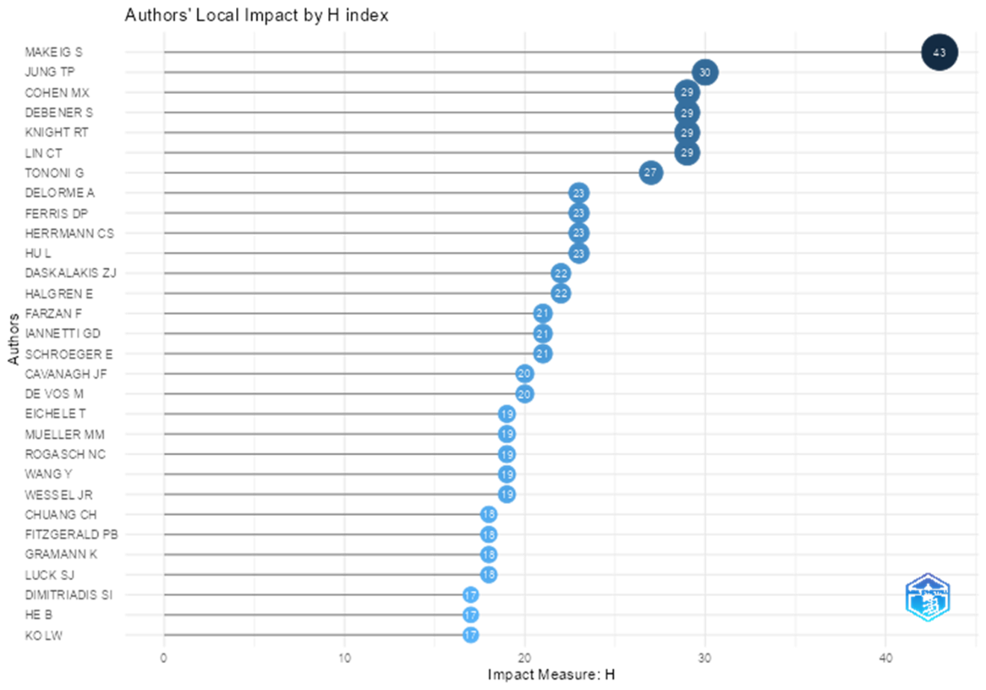

Author’s Local Impact by G index
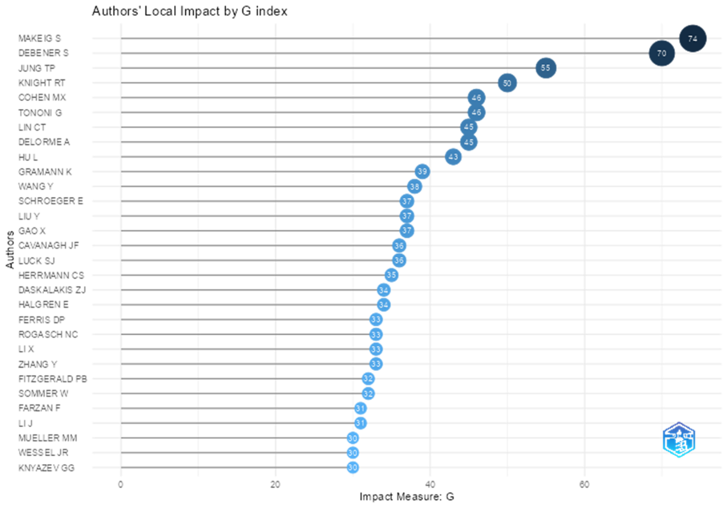

Author’s Local Impact by M index
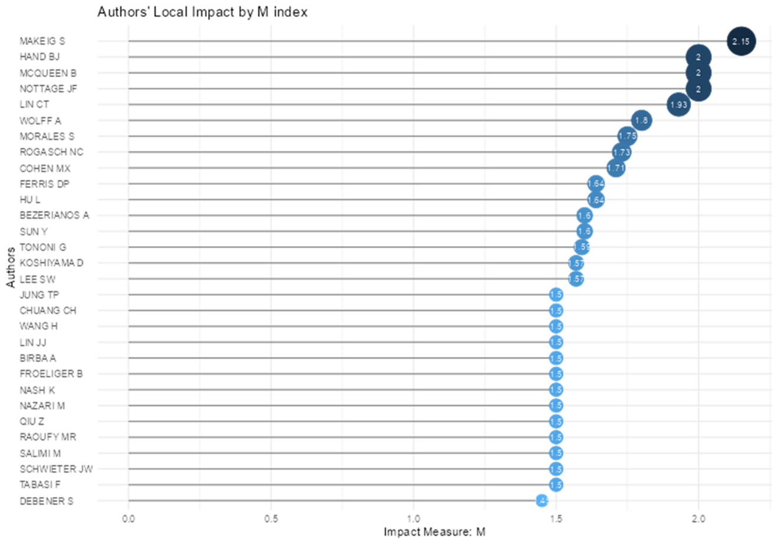

Author’s Local Impact by Total Citations

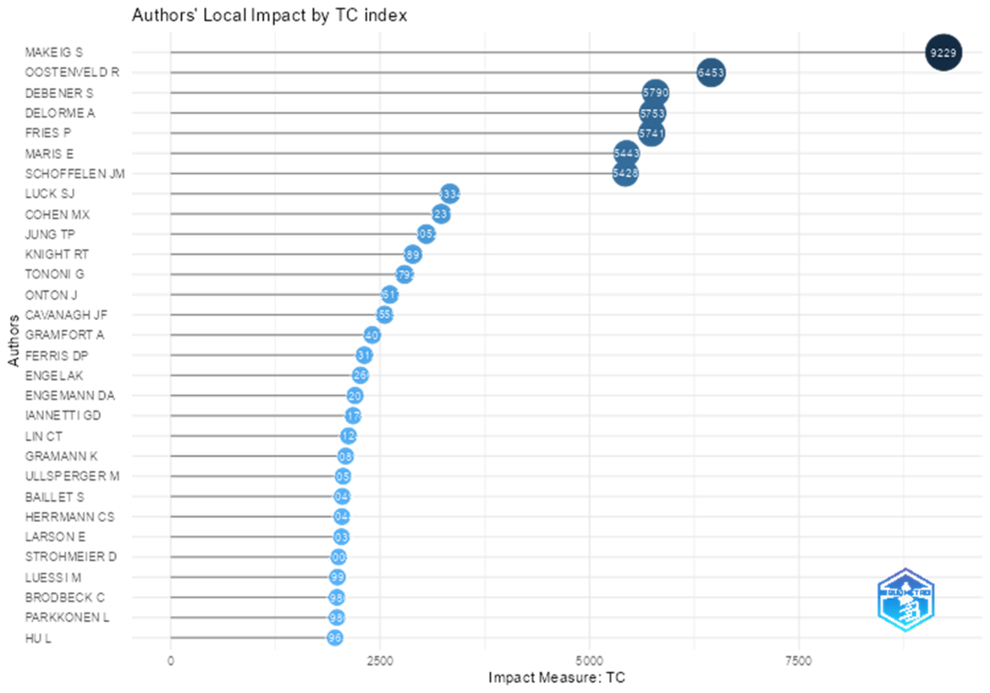

Sources | Local Impact |  |  |  | Number Papers | Start Year
 | H Index | G Index | M Index | Total Citations
Scott Makeig | 43 | 74 | 2.15 | 9229 | 74 | 2004
Tzyy-Ping Jung | 30 | 55 | 1.5 | 3052 | 59 | 2004
Mike X Cohen | 29 | 46 | 1.705882 | 3231 | 46 | 2007
Stefan Debener | 29 | 70 | 1.45 | 5790 | 70 | 2004
Robert Thomas Knight | 29 | 50 | 1.45 | 2891 | 50 | 2004
Chin-Teng Lin | 29 | 45 | 1.933333 | 2124 | 66 | 2009
Giulio Tononi | 27 | 46 | 1.588235 | 2792 | 46 | 2007
Arnaud Delorme | 23 | 45 | 1.15 | 5753 | 45 | 2004
Daniel P. Ferris | 23 | 33 | 1.642857 | 2312 | 33 | 2010
Christoph S Herrmann | 23 | 35 | 1.277778 | 2044 | 35 | 2006

Documents

Most Global Cited Documents
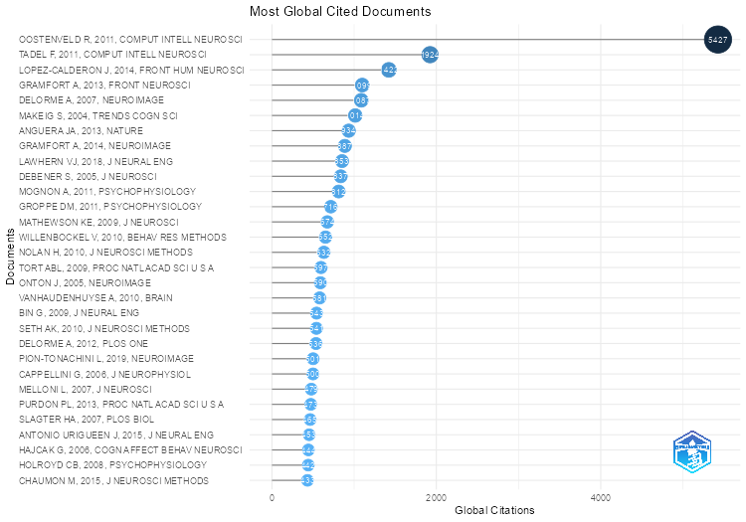

Most Local Cited Documents
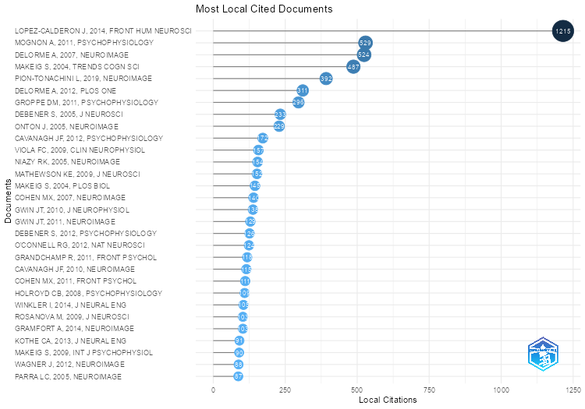

Most Local Cited References
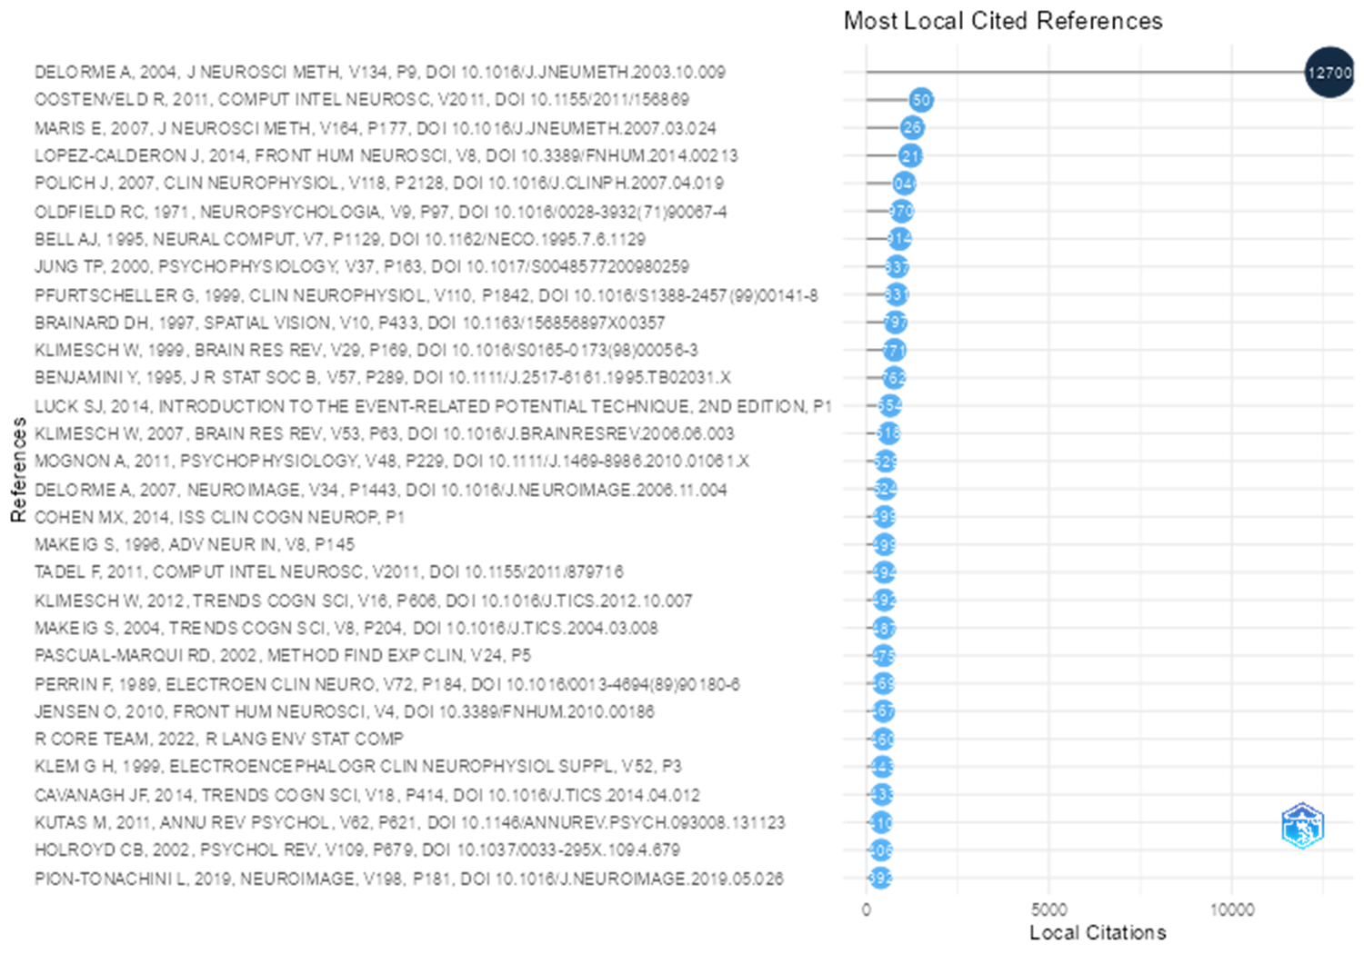

Most Relevant Keywords Plus
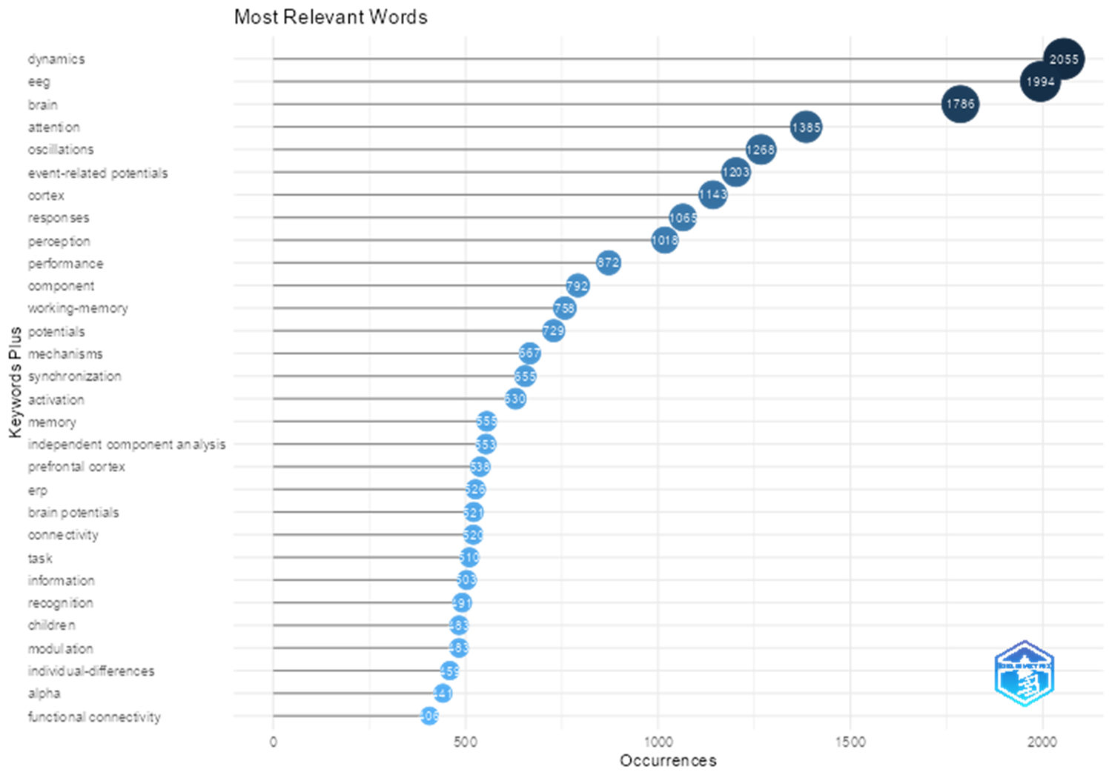

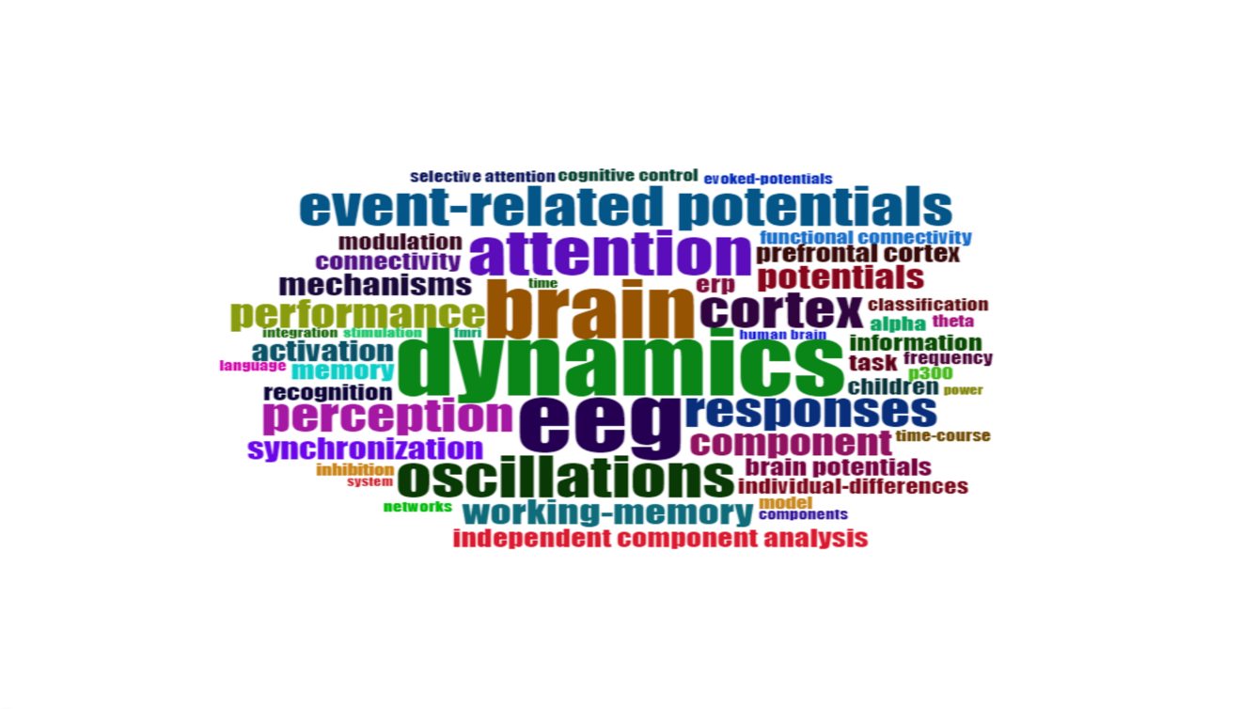
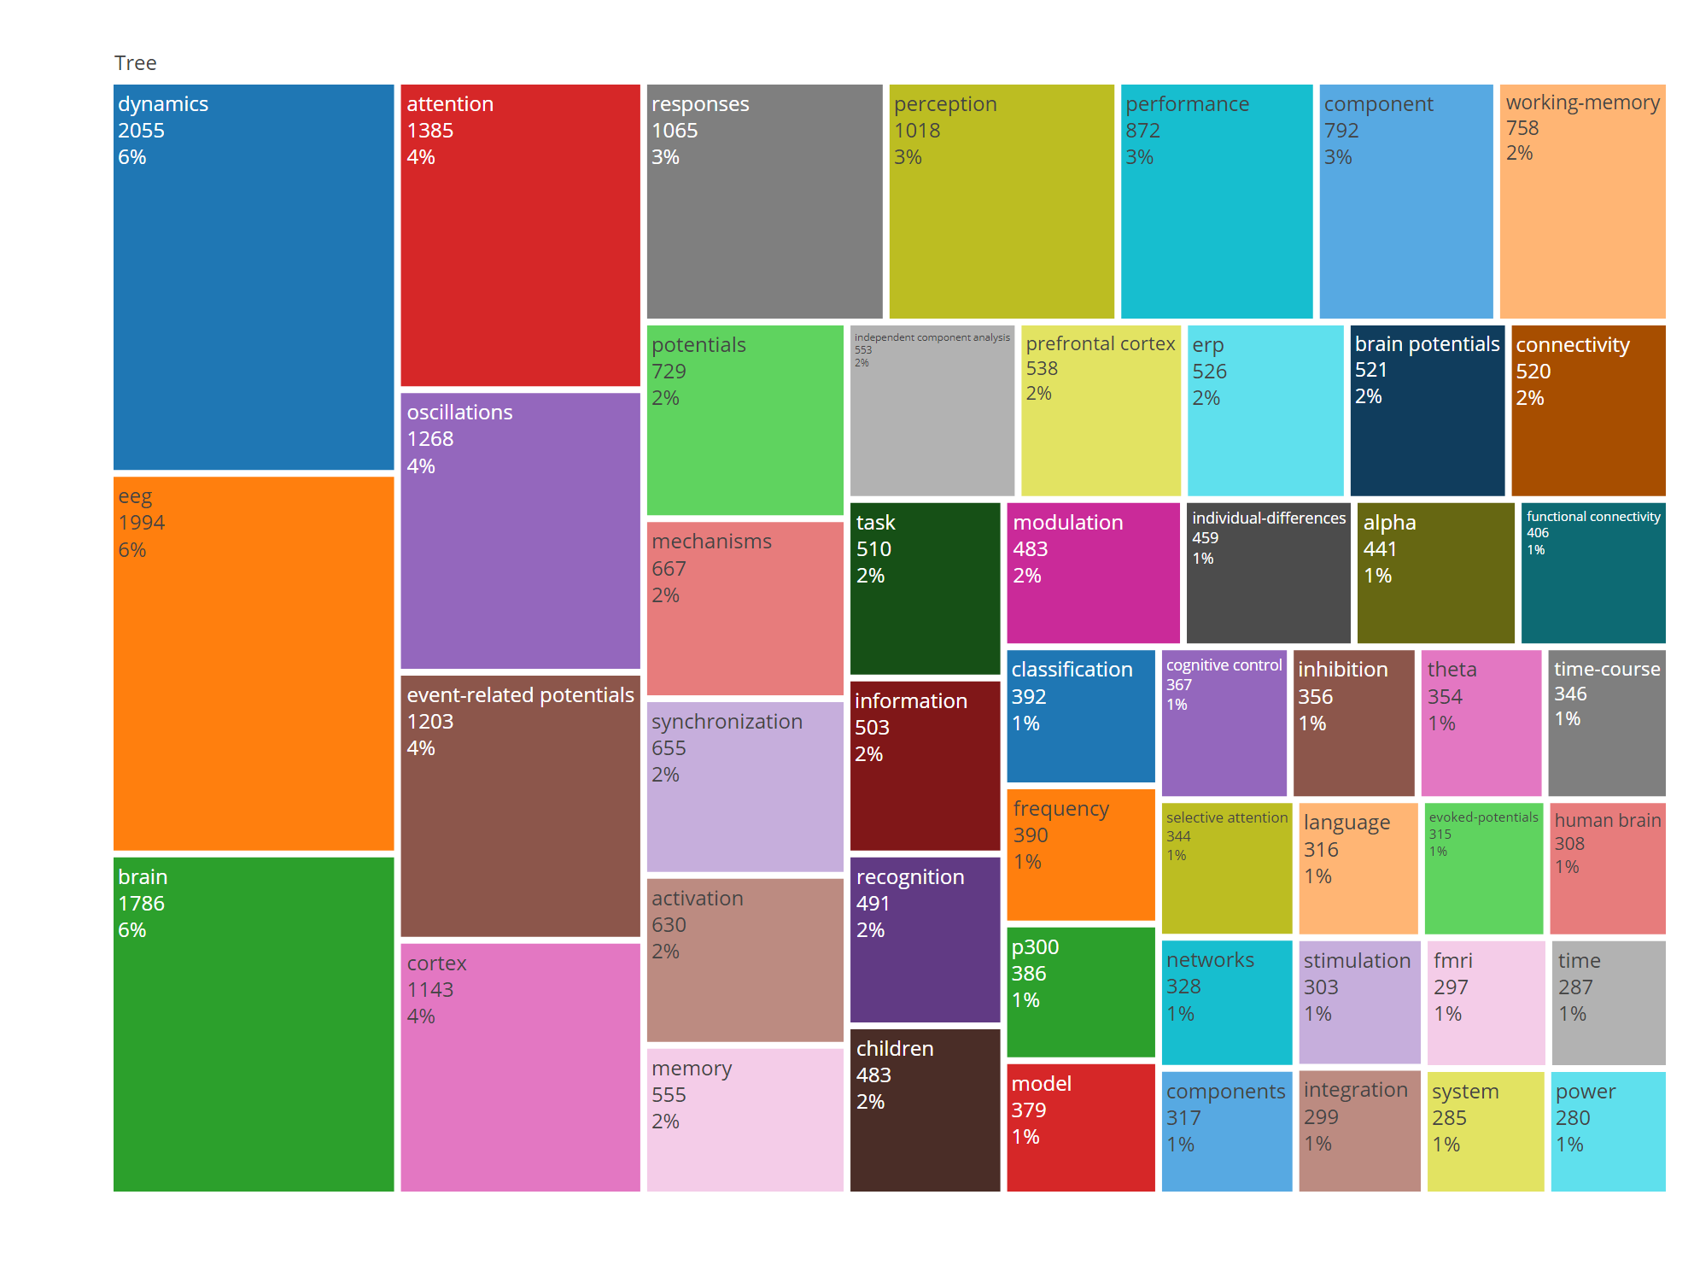

Most Relevant Authors Keywords
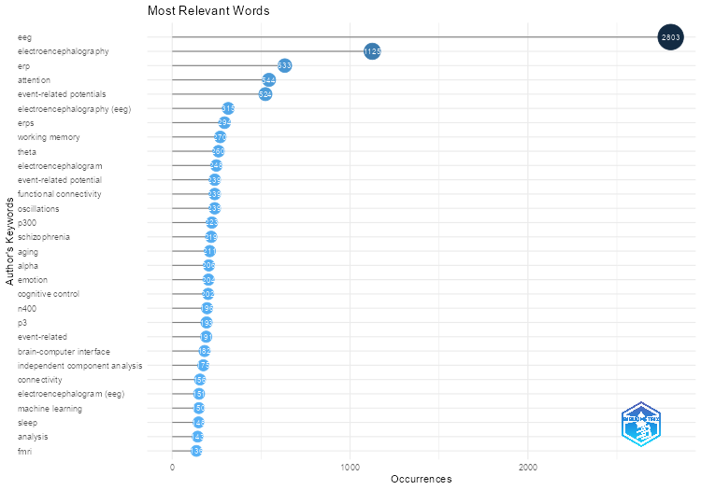
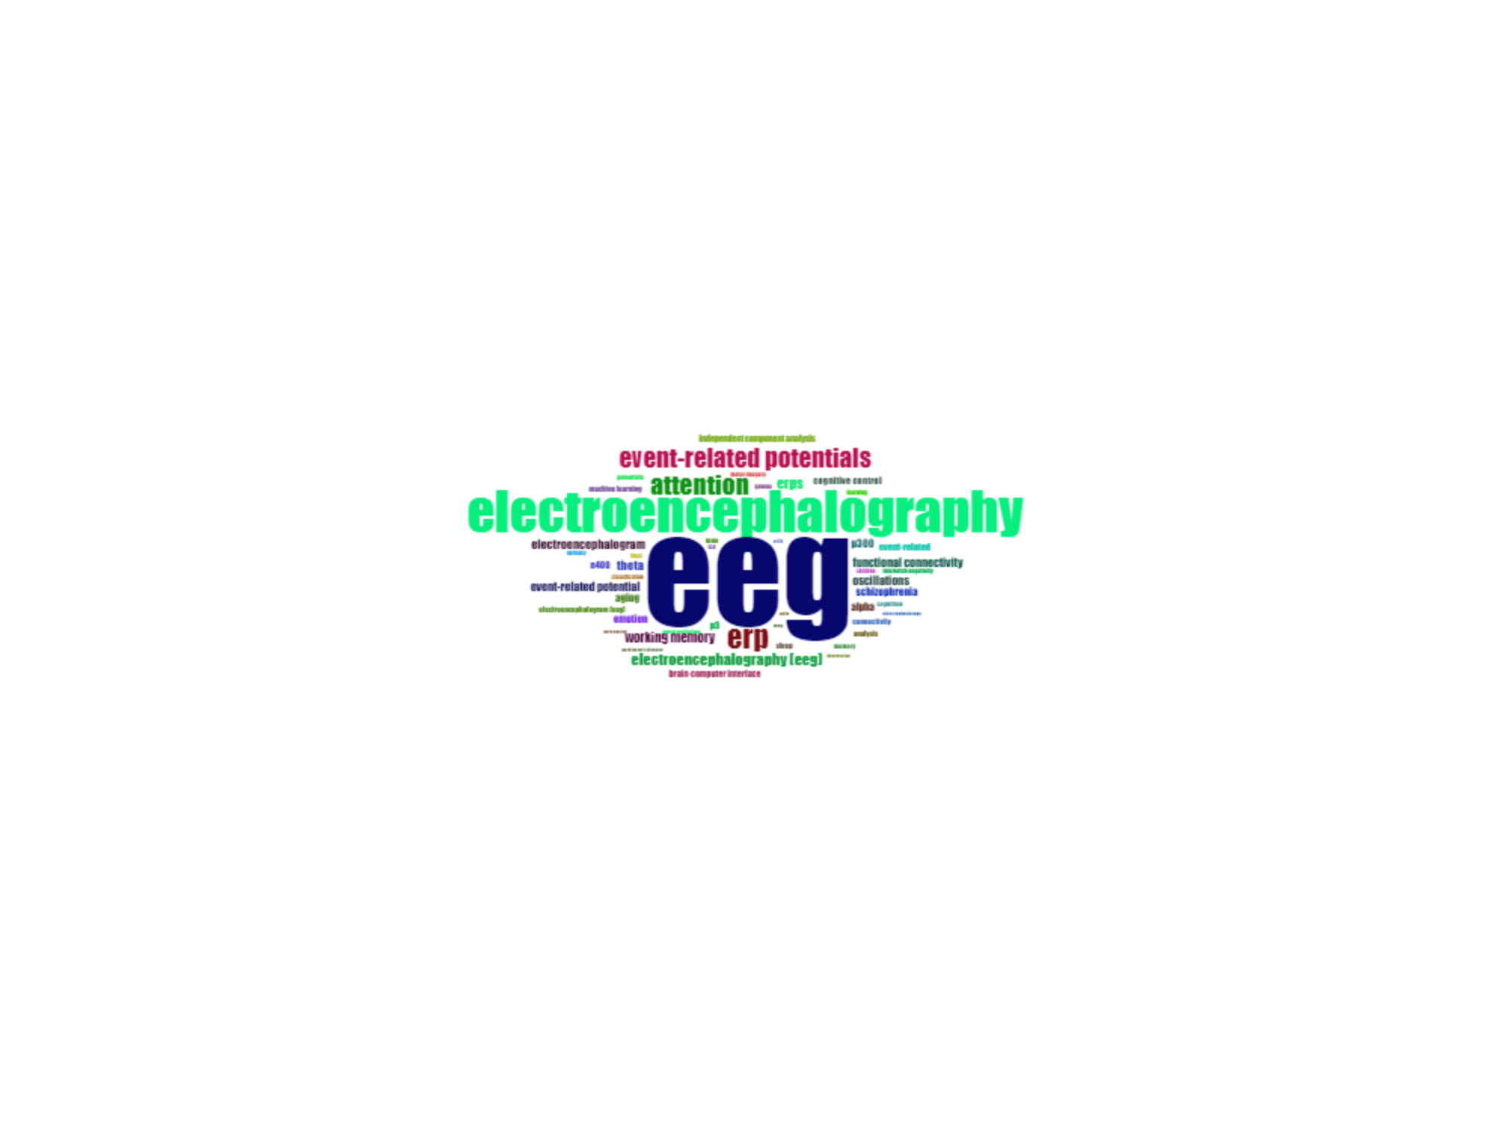
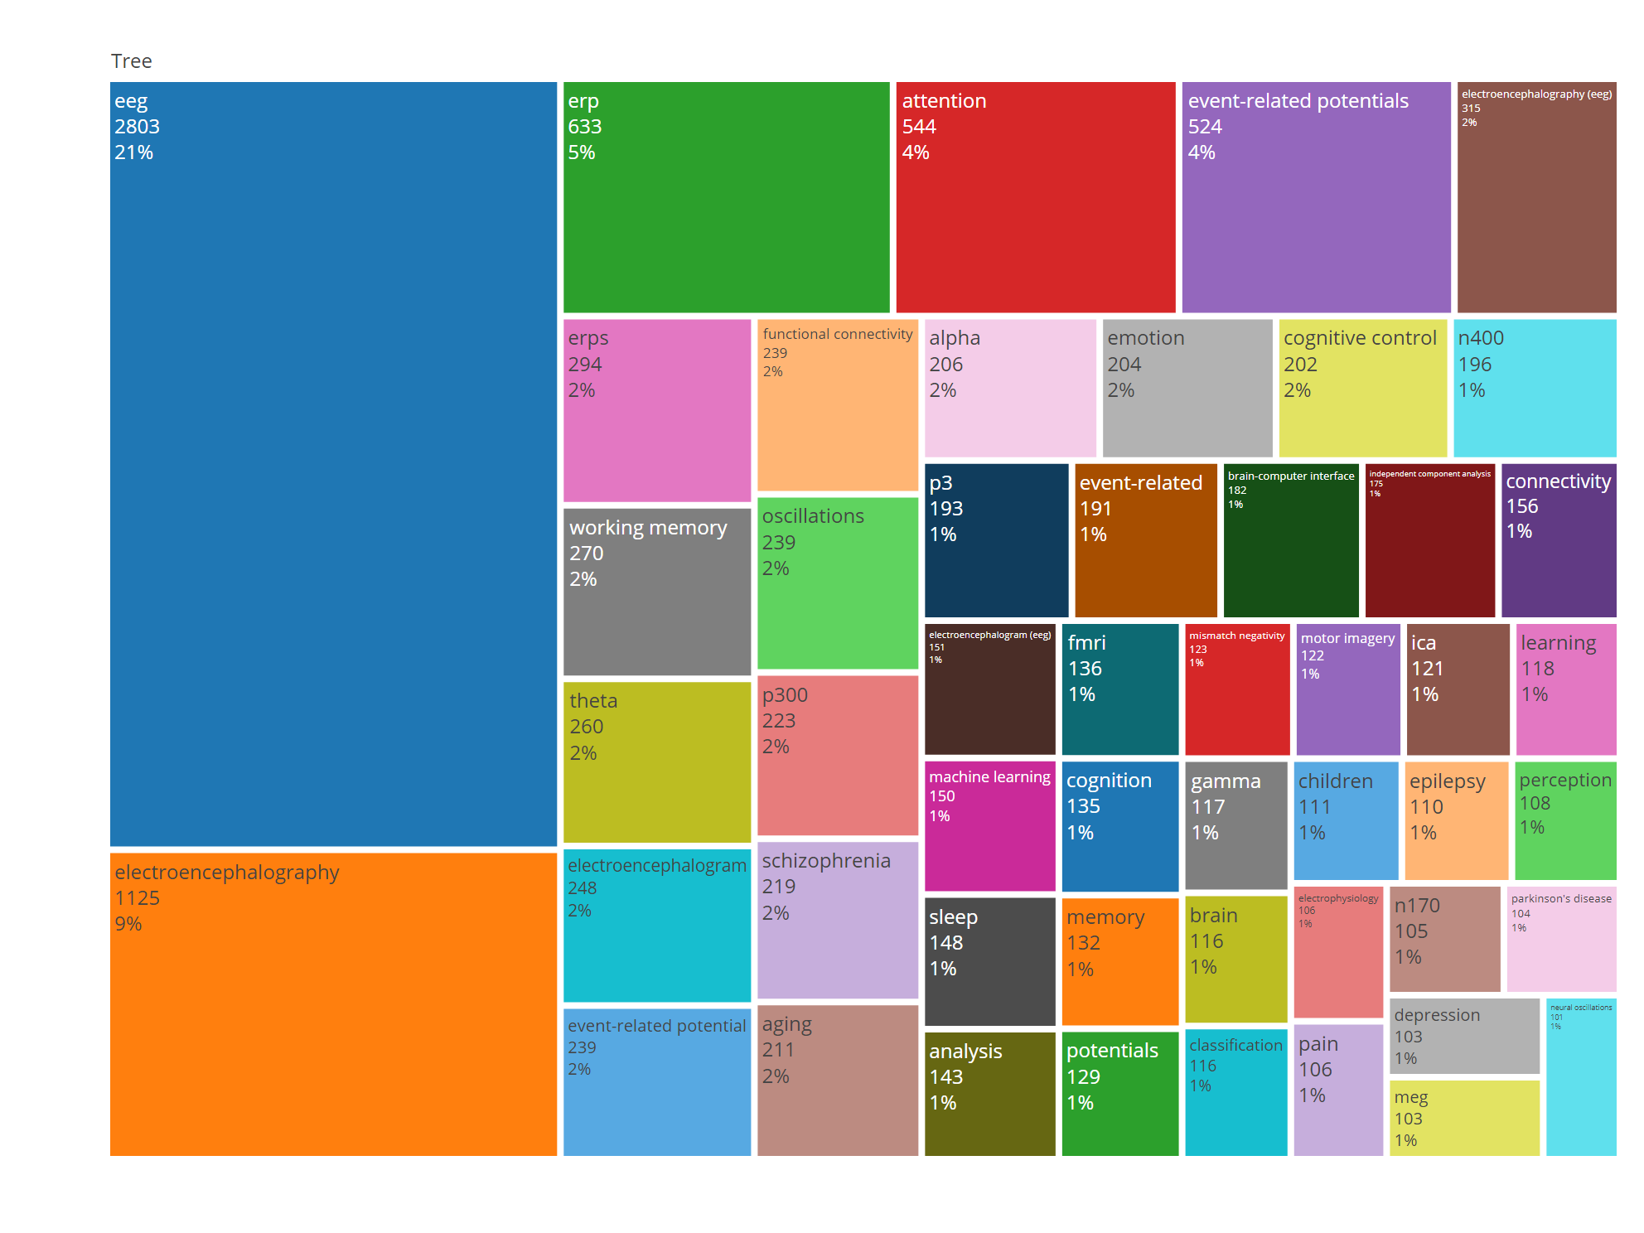

Most Relevant Unigram words in Title
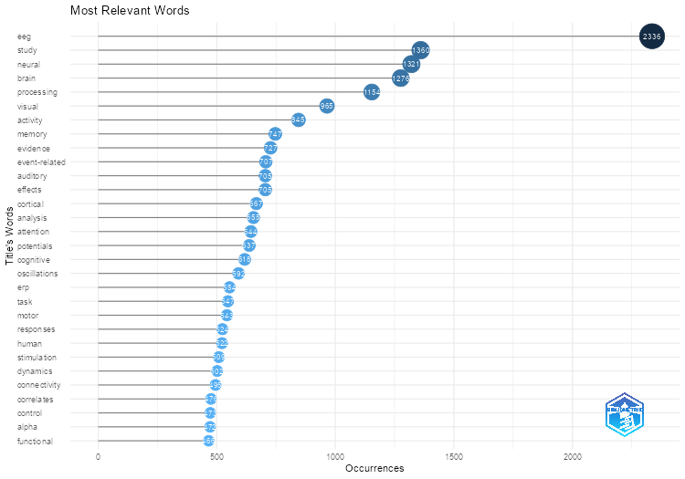
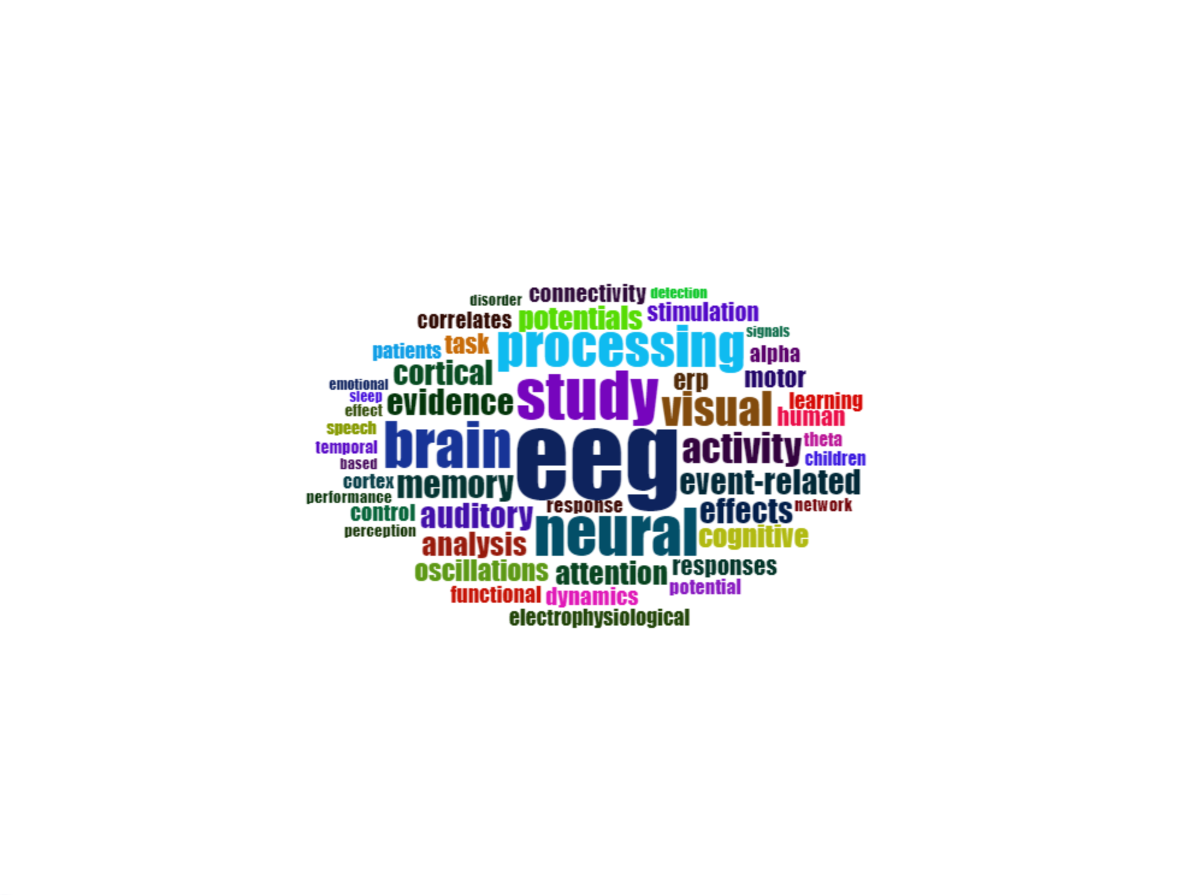
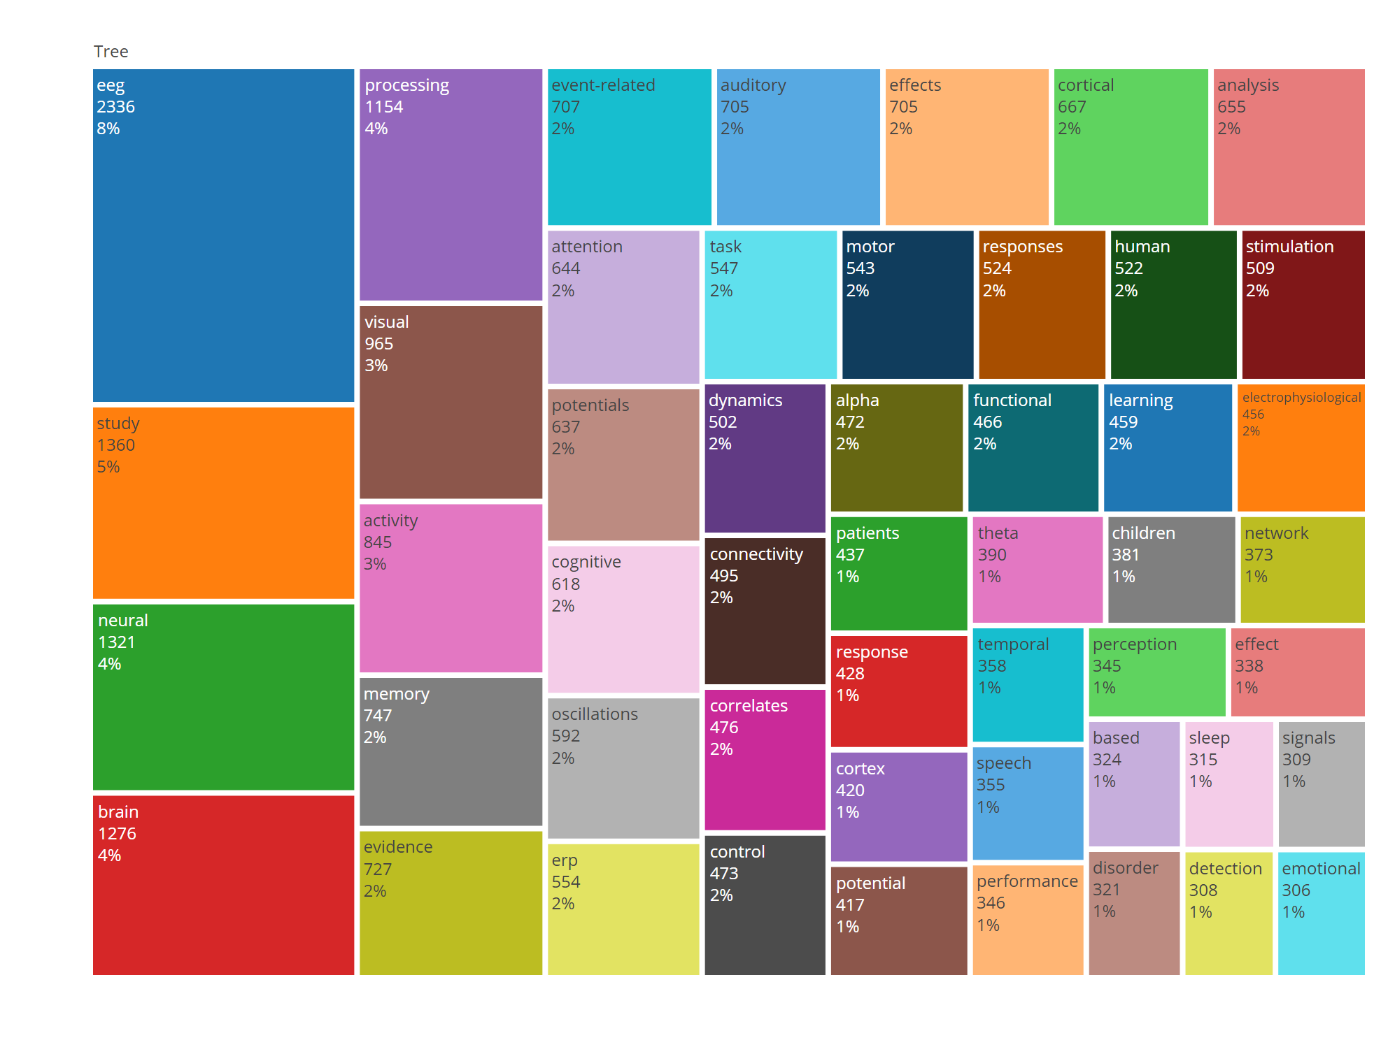

Most Relevant Bigram words in Title
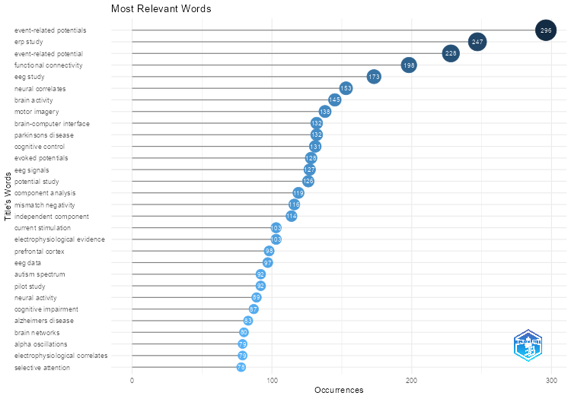
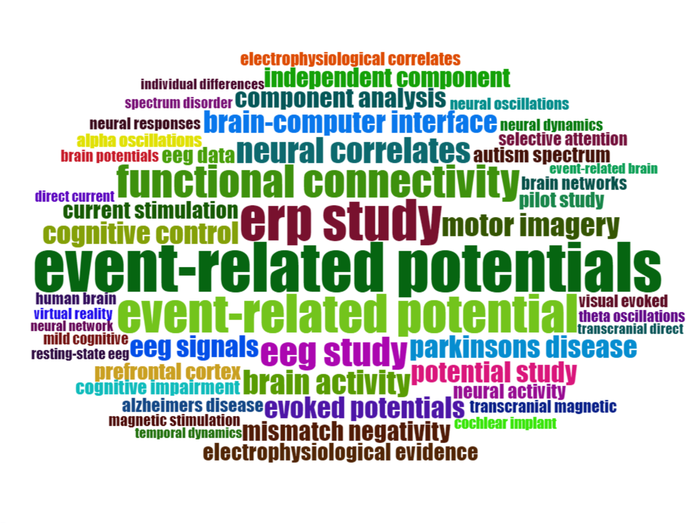
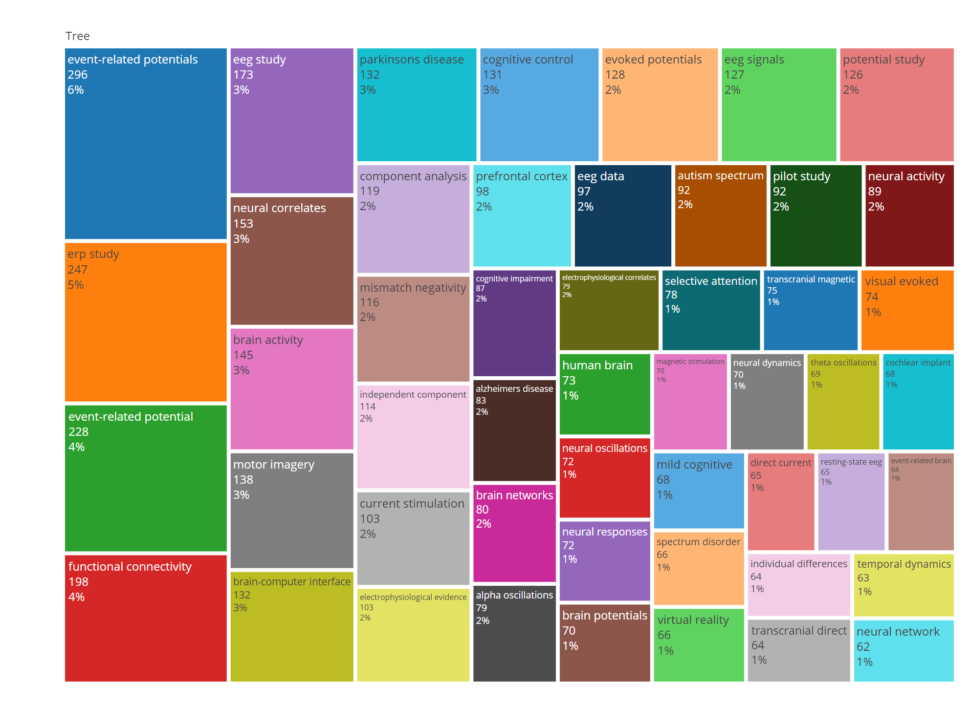

Most Relevant Trigram words in Title
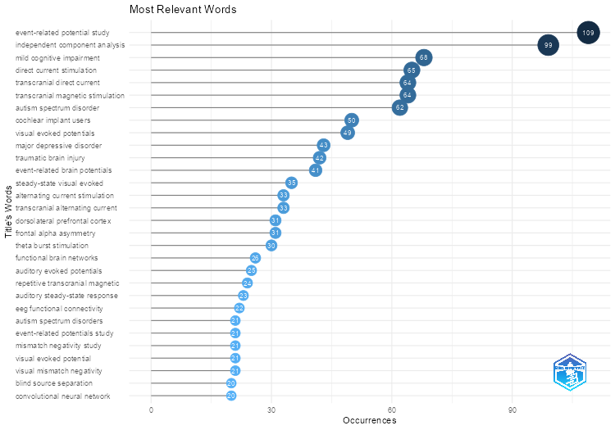
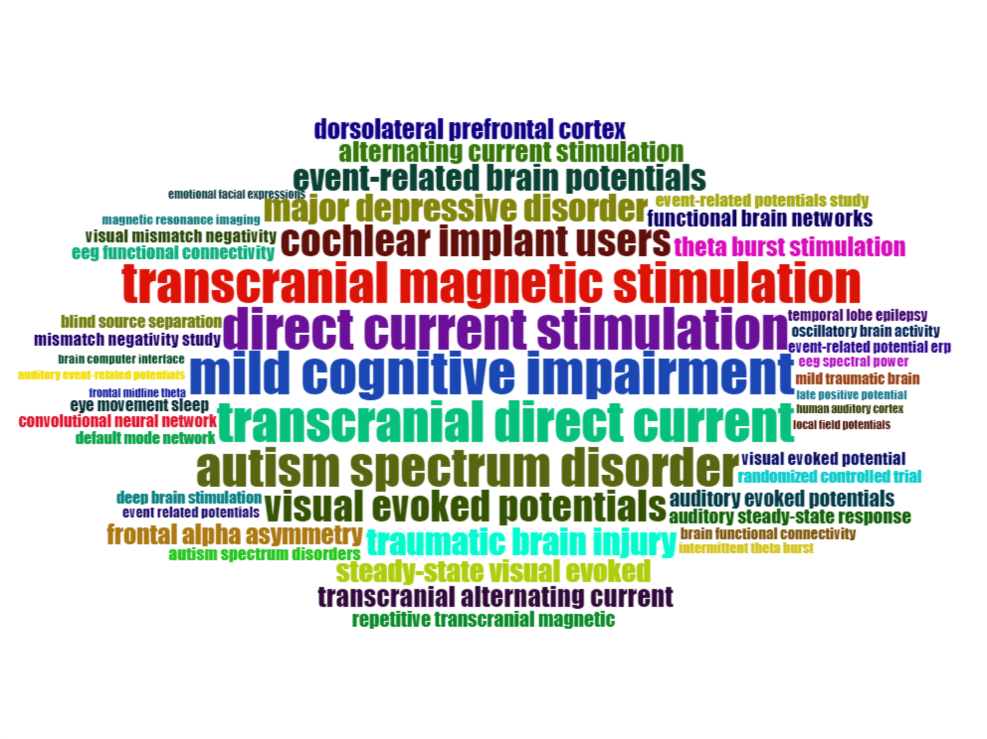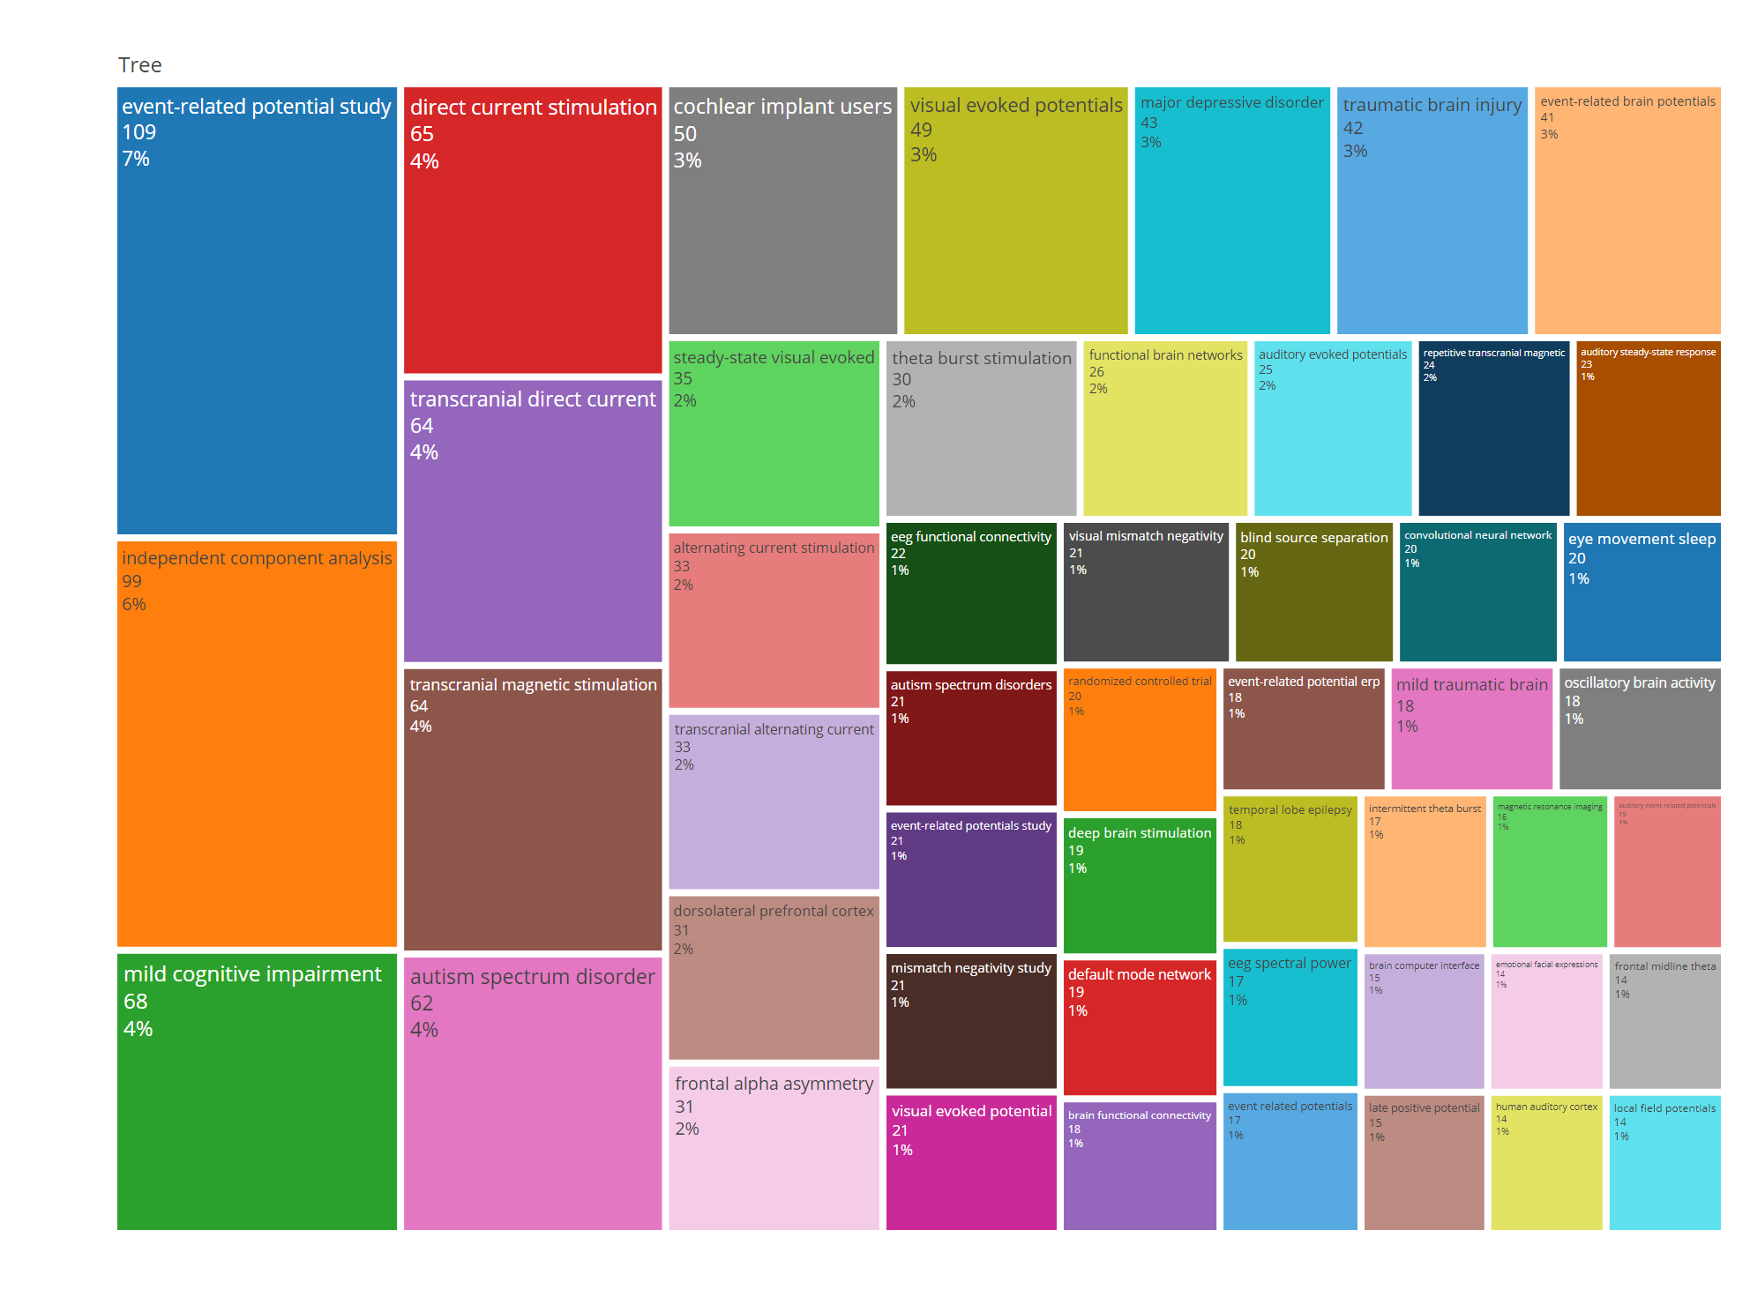

Most Relevant Unigram words in Abstract
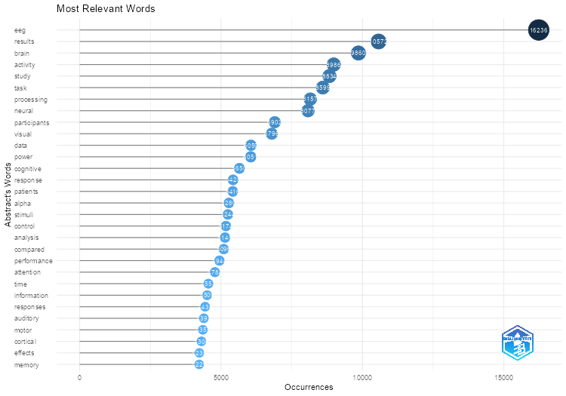
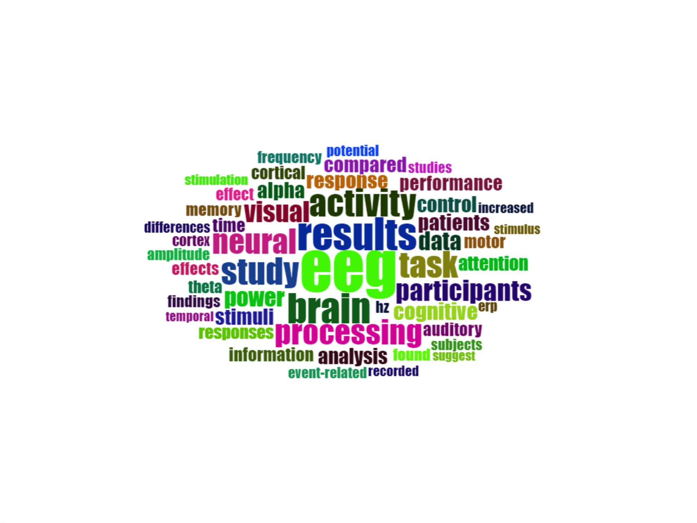
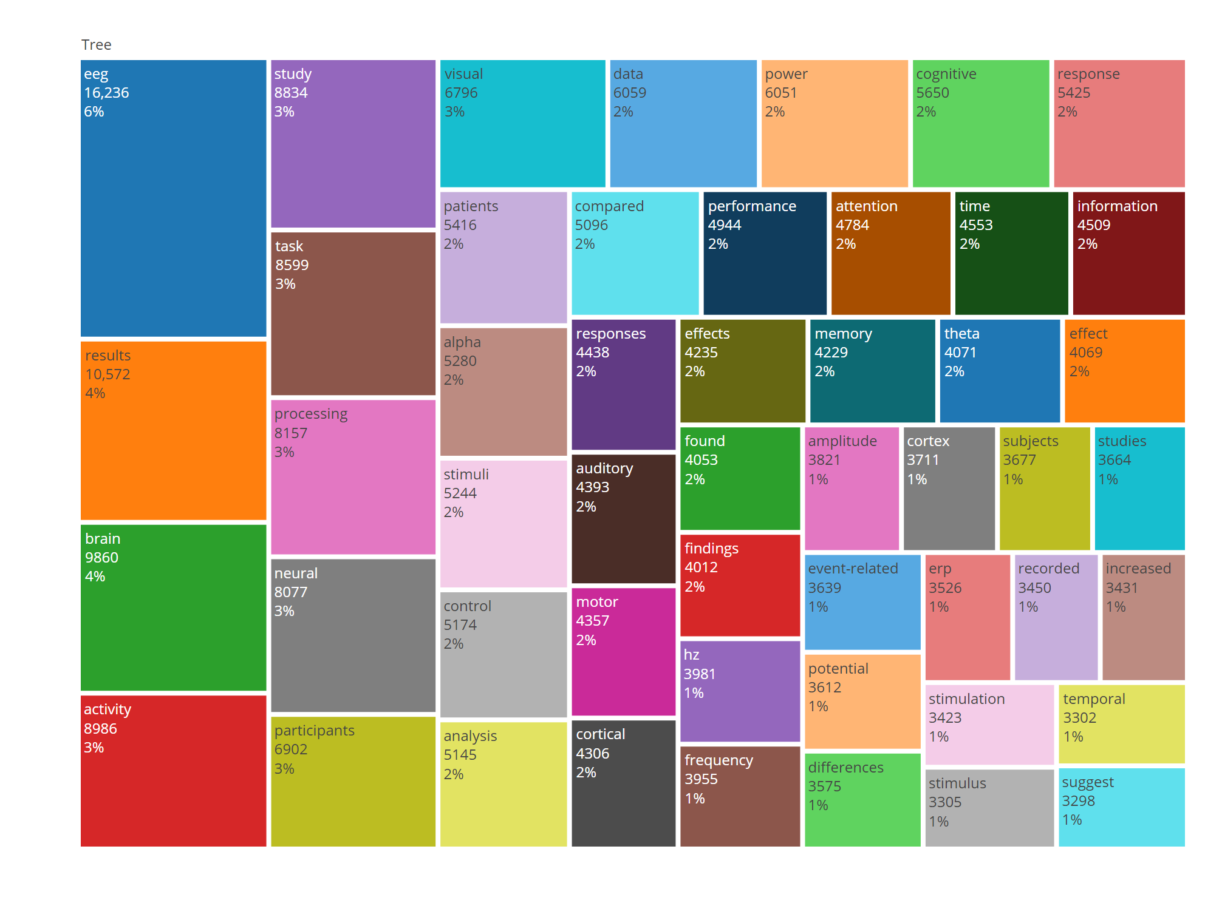

Most Relevant Bigram words in Abstract
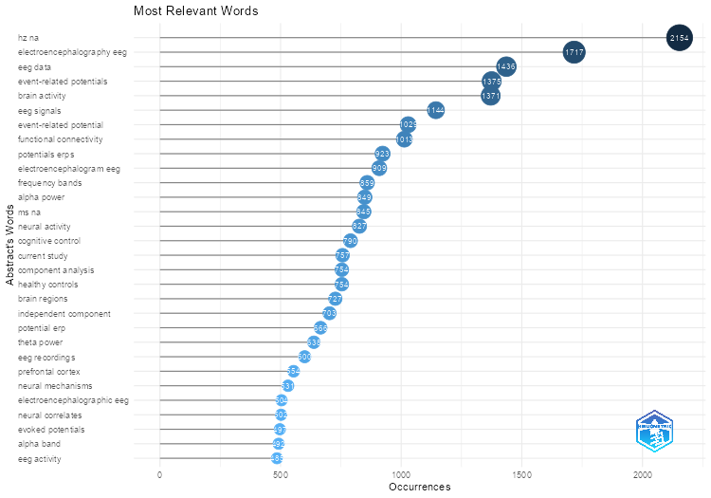
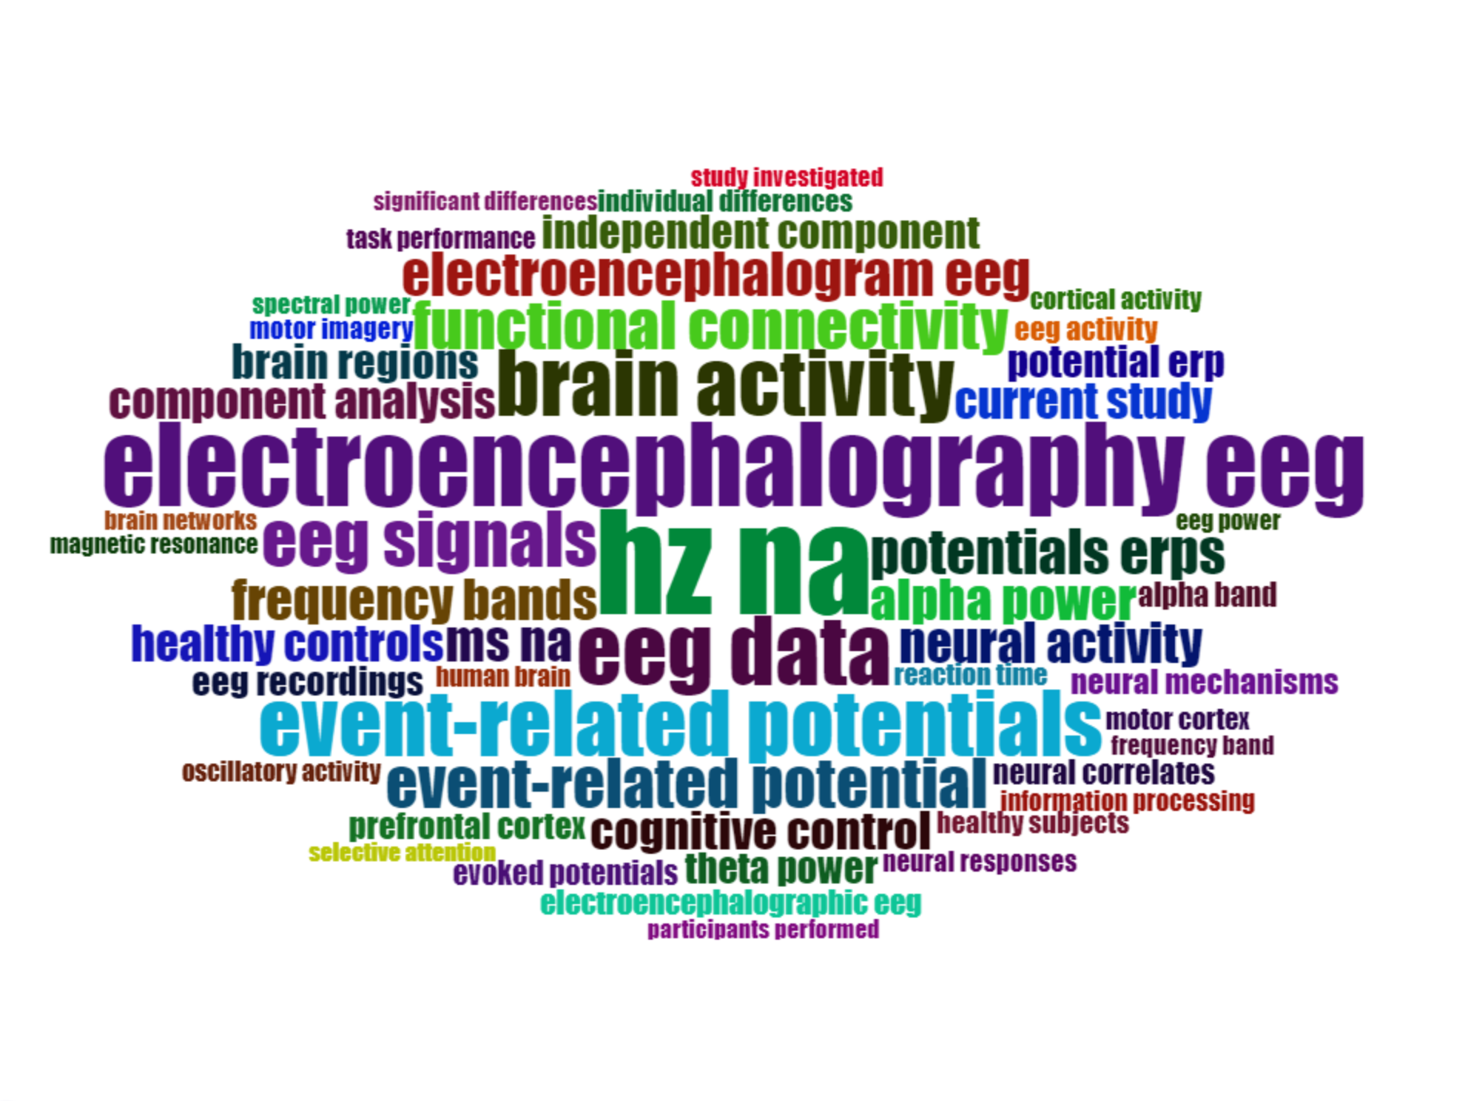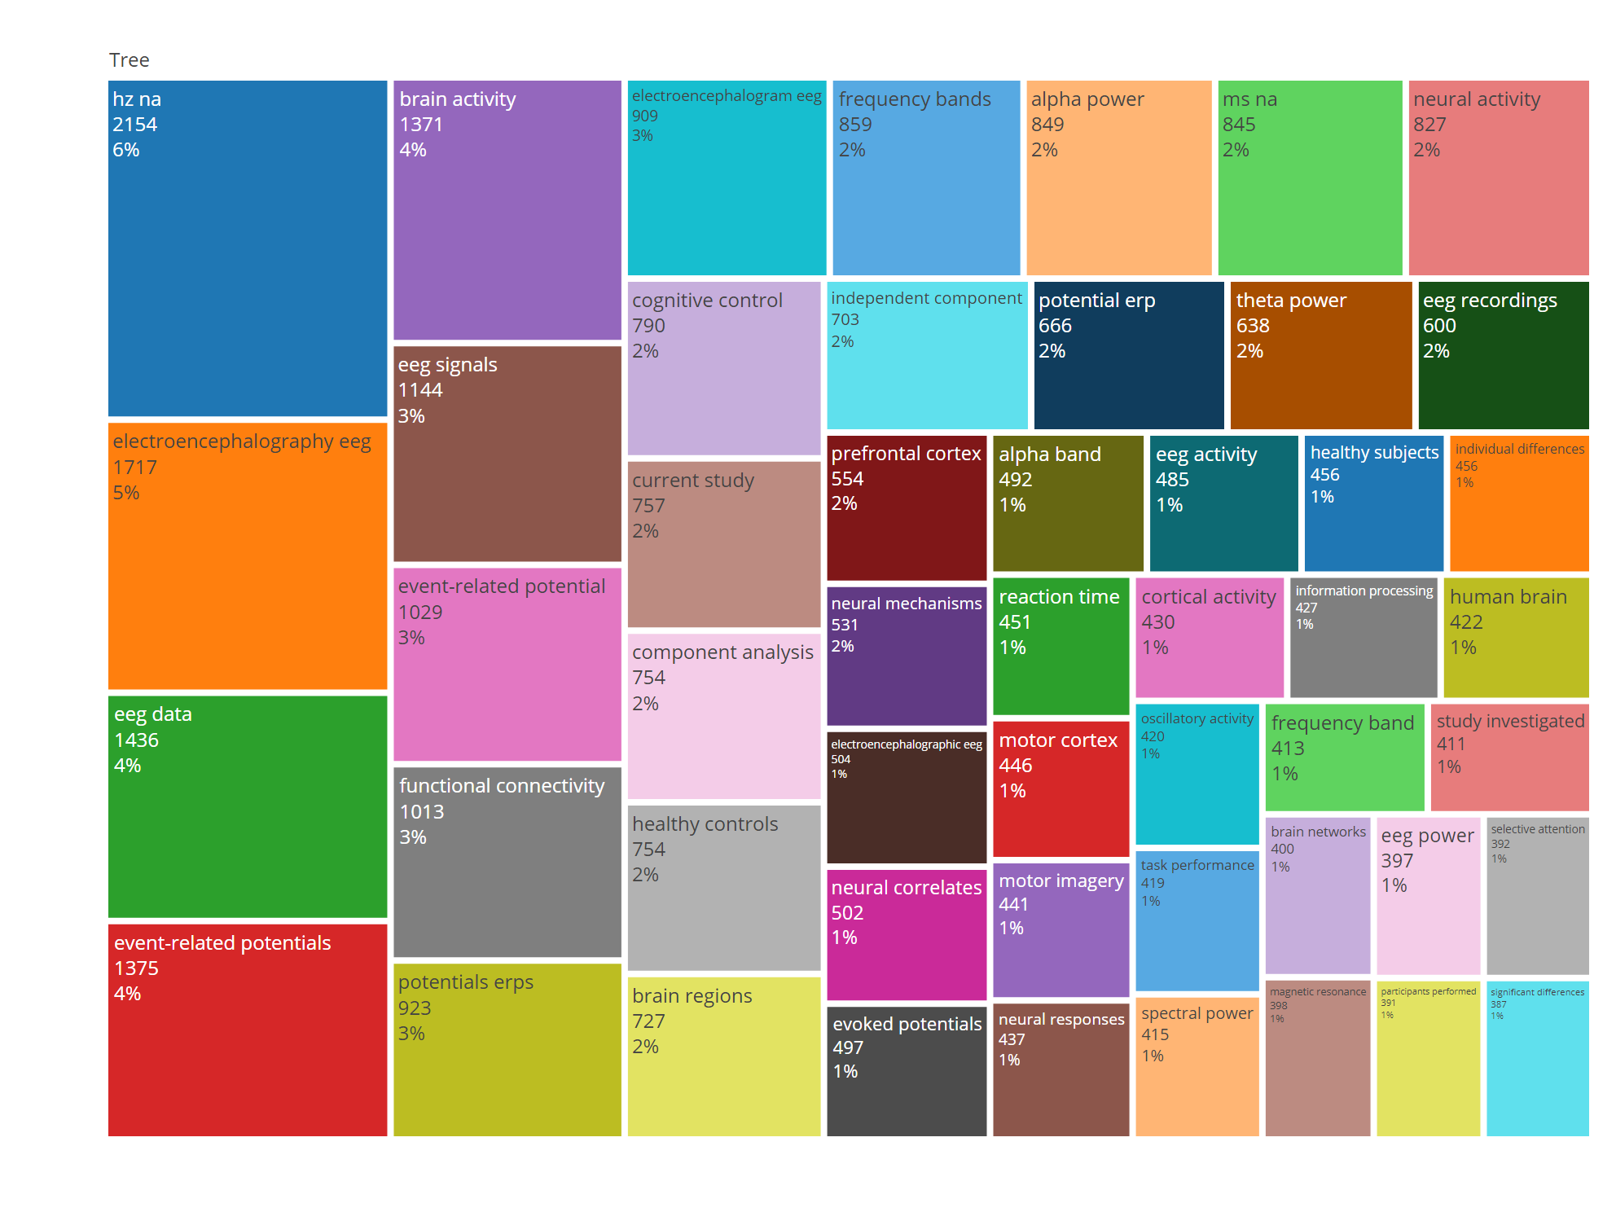

Most Relevant Trigram words in Abstract
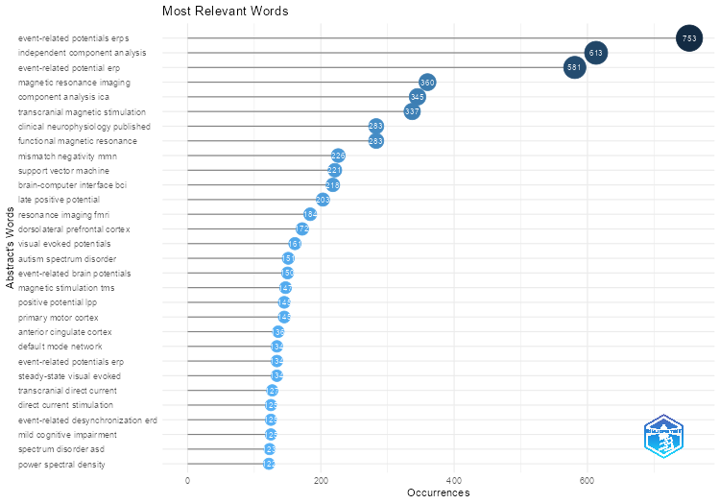
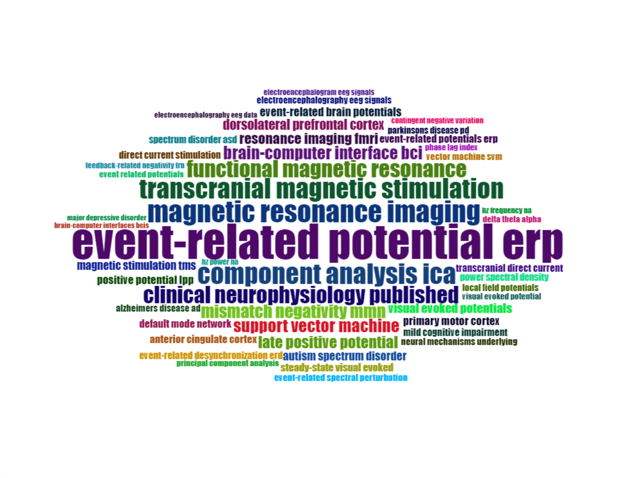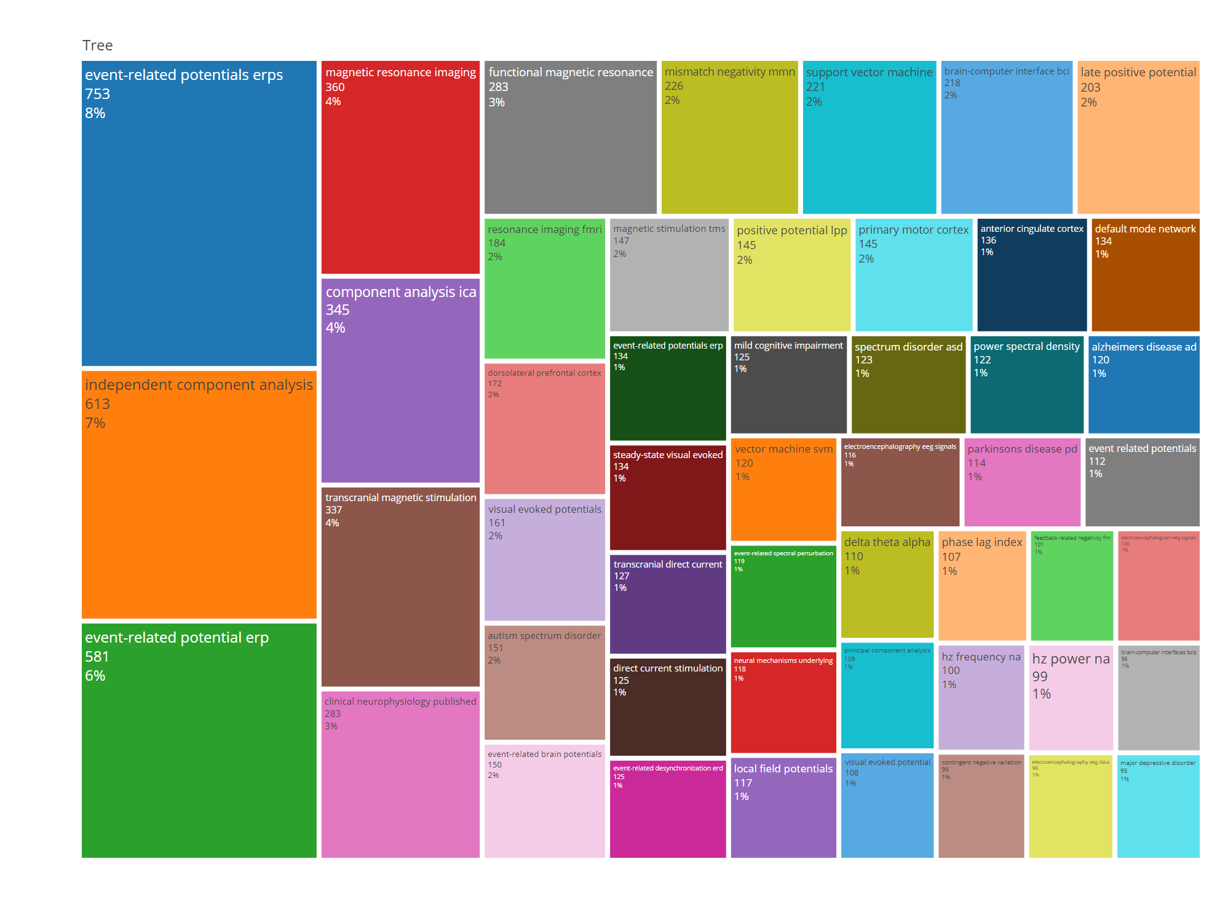

Rows | Keywords
 | Plus |  | Authors
 | Term | Freq | Term | Freq
1 | dynamics | 2,055 | eeg | 2,803
2 | eeg | 1,994 | electroencephalography | 1,125
3 | brain | 1,786 | erp | 633
4 | attention | 1,385 | attention | 544
5 | oscillations | 1,268 | event-related potentials | 524
6 | event-related potentials | 1,203 | electroencephalography (eeg) | 315
7 | cortex | 1,143 | erps | 294
8 | responses | 1,065 | working memory | 270
9 | perception | 1,018 | theta | 260
10 | performance | 872 | electroencephalogram | 248

Rows | Title
 | Unigram |  | Bigram |  | Trigram
 | Term | Freq | Term | Freq | Term | Freq
1 | eeg | 2,336 | event-related potentials | 296 | event-related potential study | 109
2 | study | 1,360 | erp study | 247 | independent component analysis | 99
3 | neural | 1,321 | event-related potential | 228 | mild cognitive impairment | 68
4 | brain | 1,276 | functional connectivity | 198 | direct current stimulation | 65
5 | processing | 1,154 | eeg study | 173 | transcranial direct current | 64
6 | visual | 965 | neural correlates | 153 | transcranial magnetic stimulation | 64
7 | activity | 845 | brain activity | 145 | autism spectrum disorder | 62
8 | memory | 747 | motor imagery | 138 | cochlear implant users | 50
9 | evidence | 727 | brain-computer interface | 132 | visual evoked potentials | 49
10 | event-related | 707 | parkinsons disease | 132 | major depressive disorder | 43

Rows | Abstract
 | Unigram |  | Bigram |  | Trigram
 | Term | Freq | Term | Freq | Term | Freq
1 | eeg | 16,236 | hz na | 2,154 | event-related potentials erps | 753
2 | results | 10,572 | electroencephalography eeg | 1,717 | independent component analysis | 613
3 | brain | 9,860 | eeg data | 1,436 | event-related potential erp | 581
4 | activity | 8,986 | event-related potentials | 1,375 | magnetic resonance imaging | 360
5 | study | 8,834 | brain activity | 1,371 | component analysis ica | 345
6 | task | 8,599 | eeg signals | 1,144 | transcranial magnetic stimulation | 337
7 | processing | 8,157 | event-related potential | 1,029 | clinical neurophysiology published | 283
8 | neural | 8,077 | functional connectivity | 1,013 | functional magnetic resonance | 283
9 | participants | 6,902 | potentials erps | 923 | mismatch negativity mmn | 226
10 | visual | 6,796 | electroencephalogram eeg | 909 | support vector machine | 221

The time trend of them are avaiable.

Trend Topic of Author Keywords
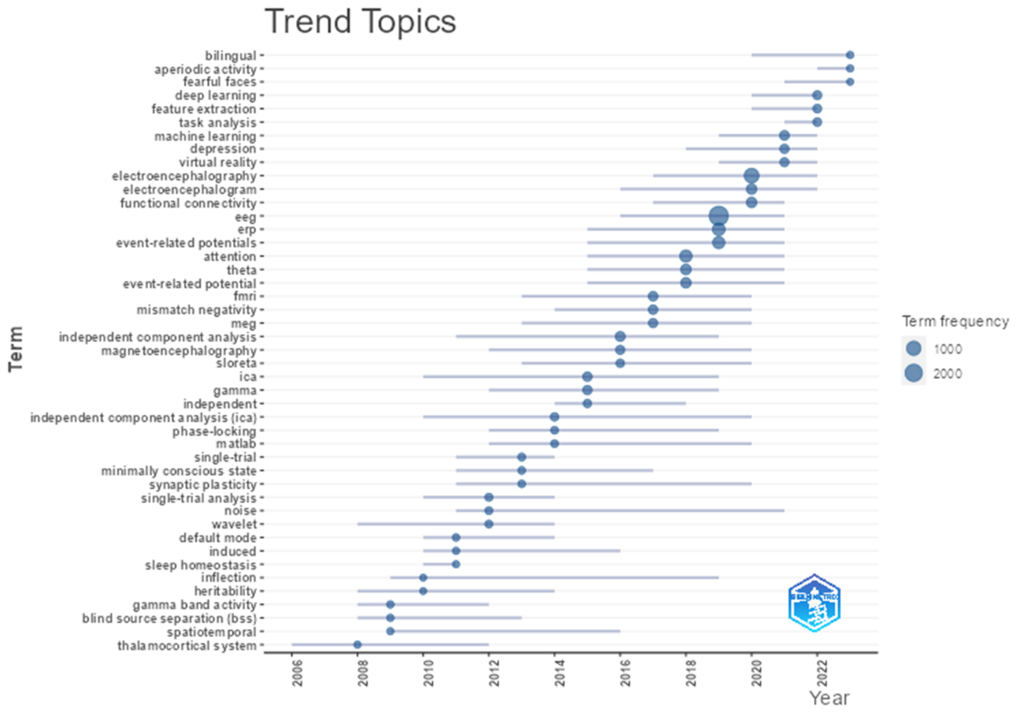

The Reference Publication Year Spectroscopy (RPYS) [1] are presented in the figure-1. The years before 1900 are omitted because the number of them is very neglect. The peak at 2004 is related to the [2] with about 32.4% of all 39,155 references in 2004. And the highest peaks is in 2012 and 2014 with 40,360 and 40,431 references, respectively. The decline in the graph shows after 2014.
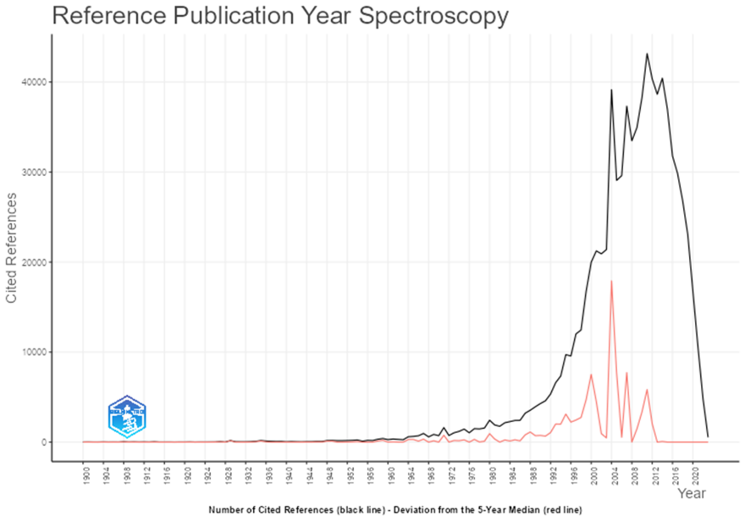

Conceptual Structure

Co-Occurrence Network of Keyword Plus
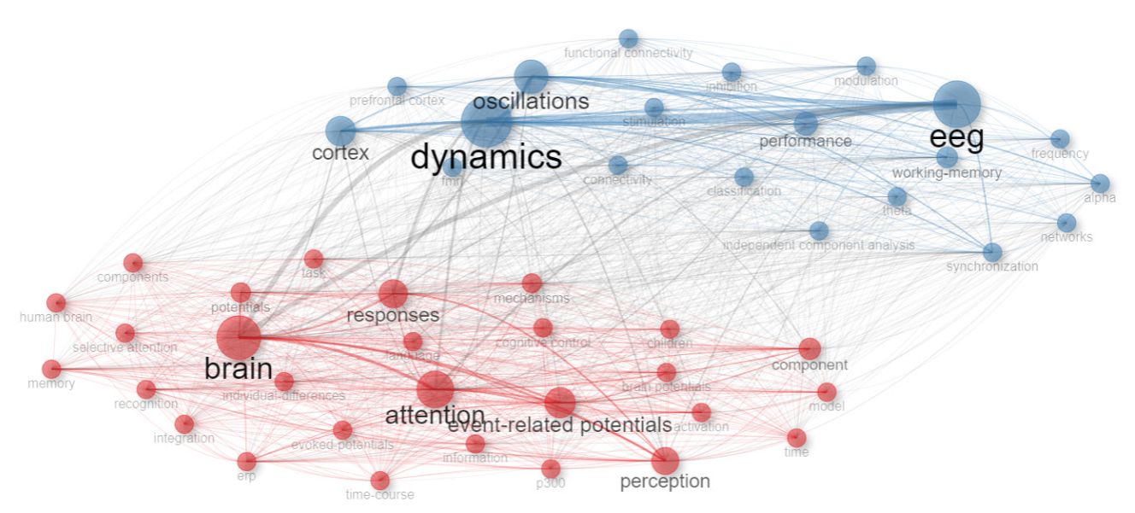

Co-Occurrence Network of Author Keyword
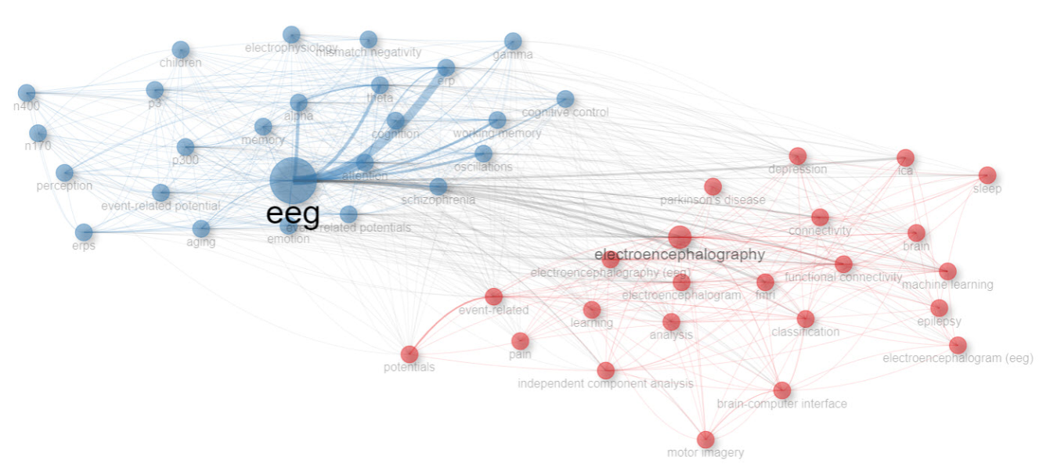

Co-Occurrence Network of Unigram words in Title
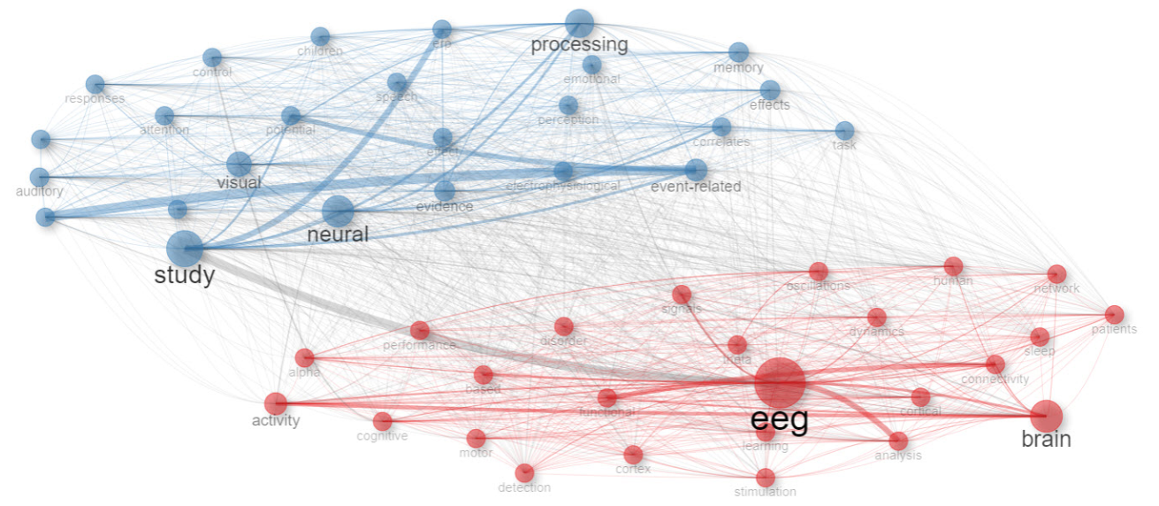

Co-Occurrence Network of Bigram words in Title
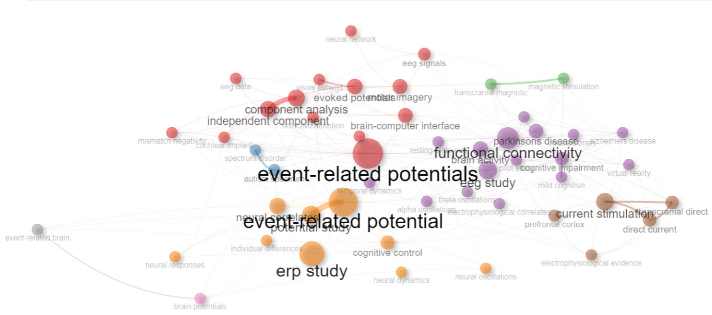

Co-Occurrence Network of Trigram words in Title
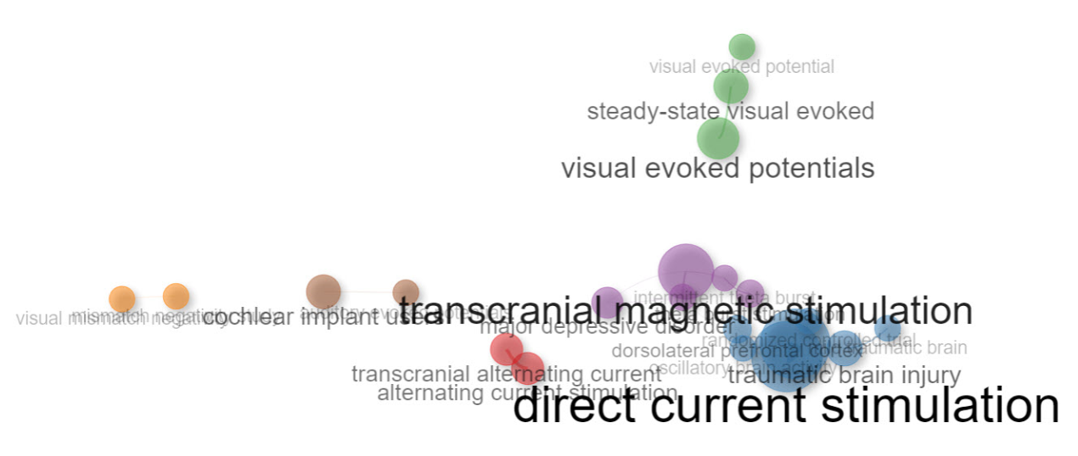

Co-Occurrence Network of Unigram words in Abstract
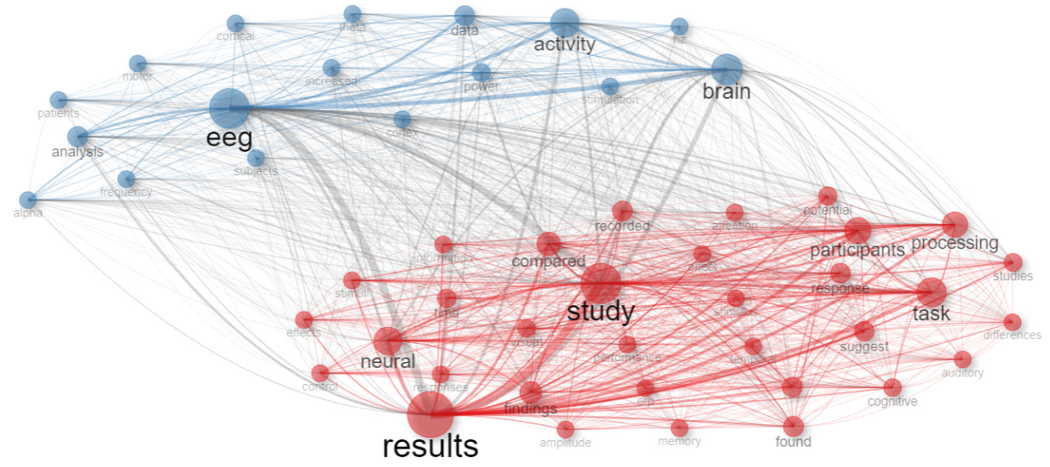

Co-Occurrence Network of Bigram words in Abstract
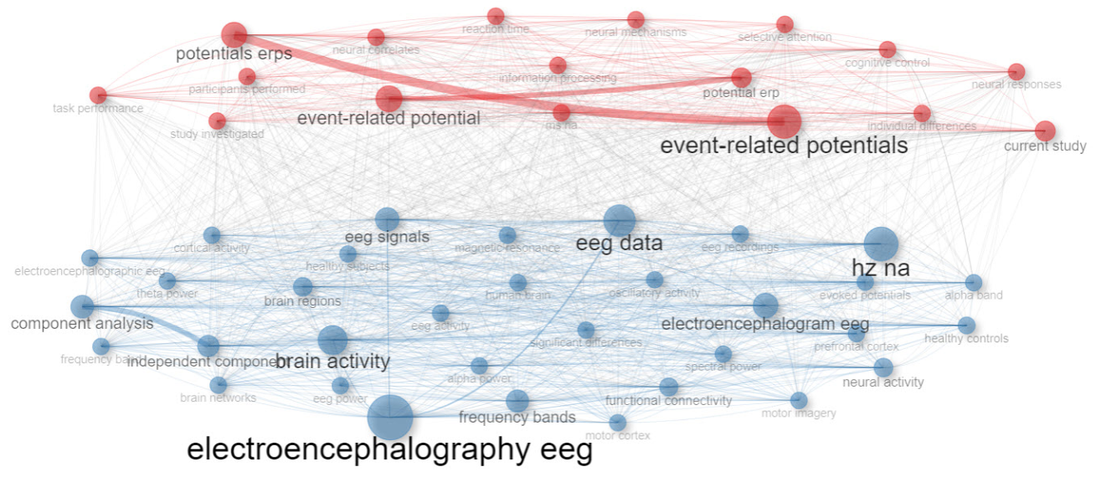

Co-Occurrence Network of Trigram words in Abstract
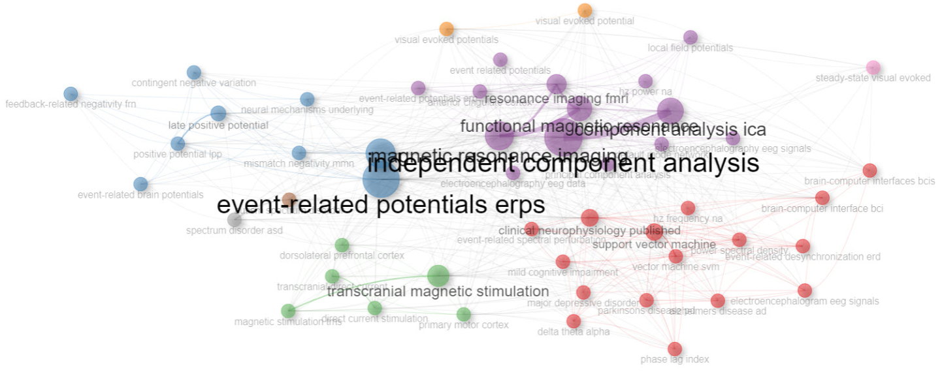
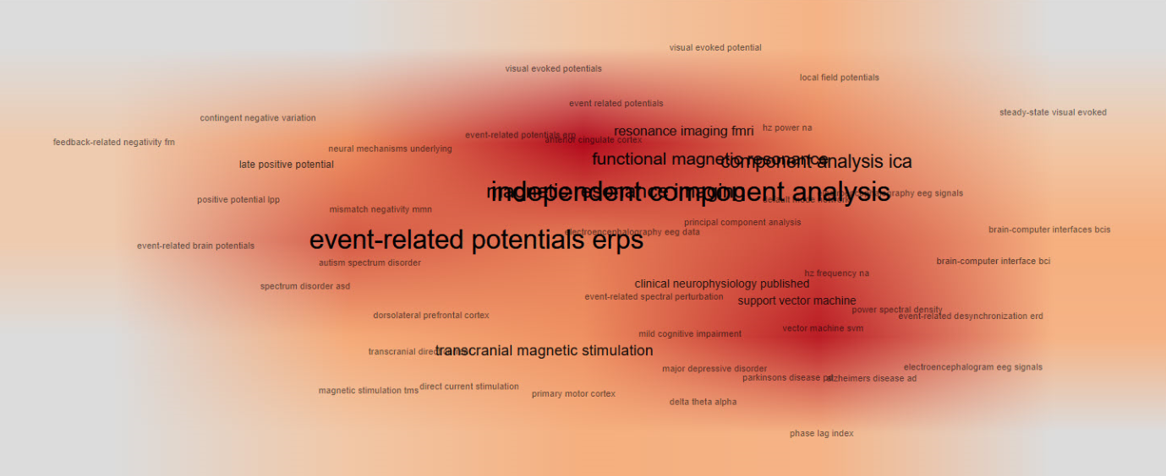

Thematic Map

Thematic Map Keyword Plus
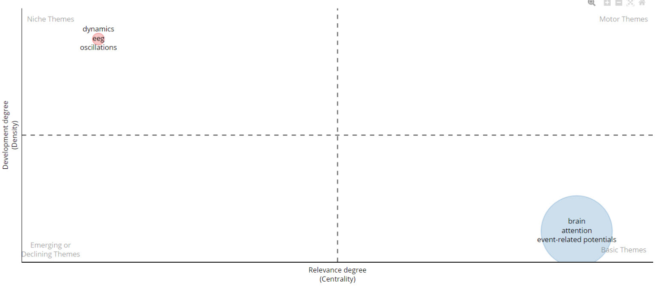

Thematic Network Keyword Plus
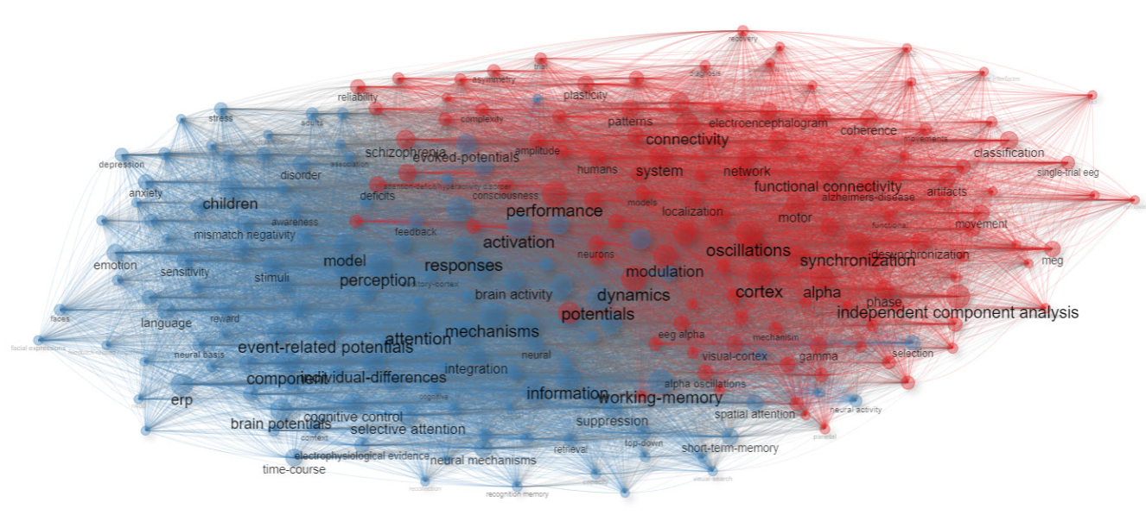

Thematic Map Authors Keyword
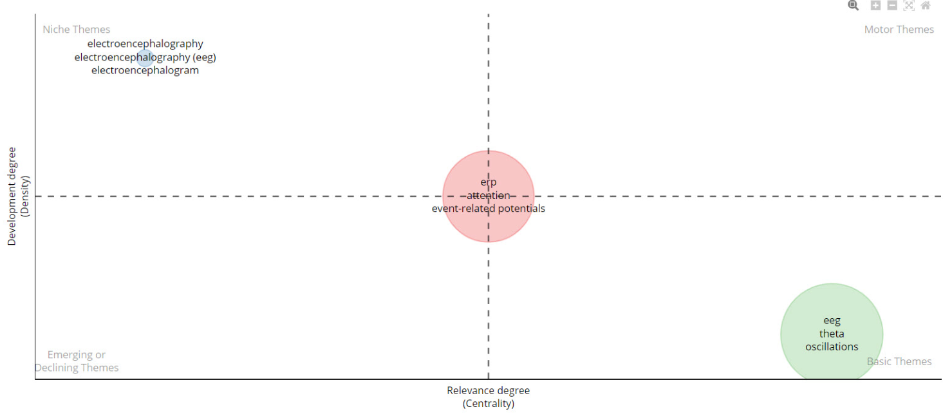

Thematic Network Authors Keyword
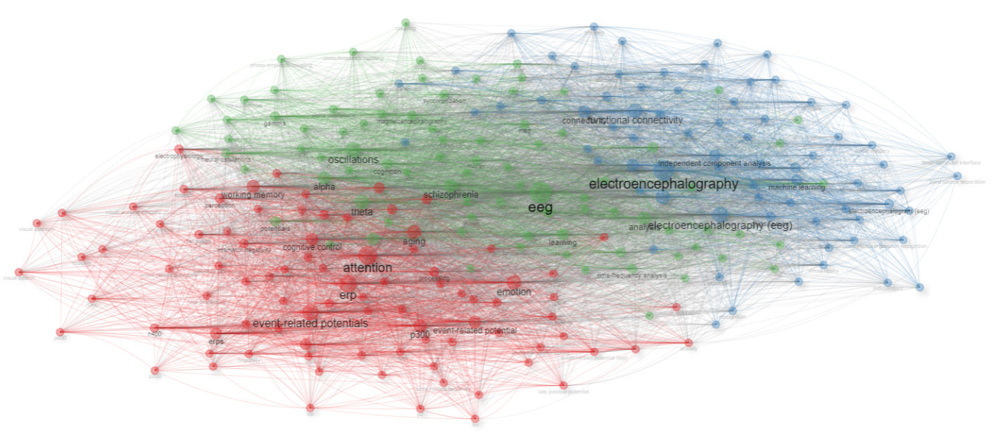

Thematic Map Unigram Word in title
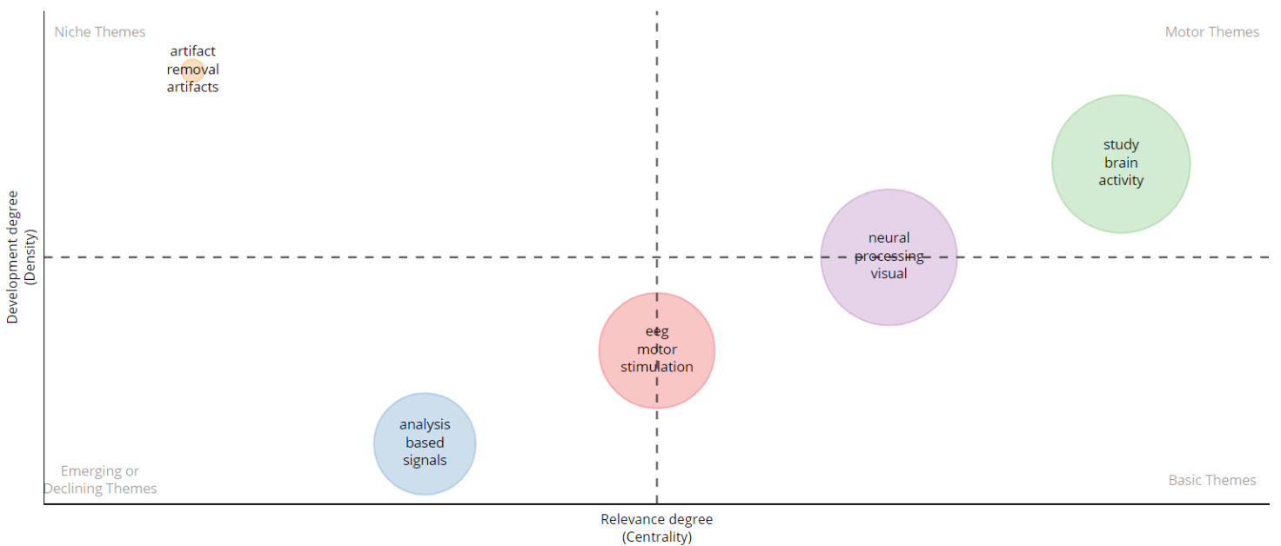

Thematic Network Unigram Word in title
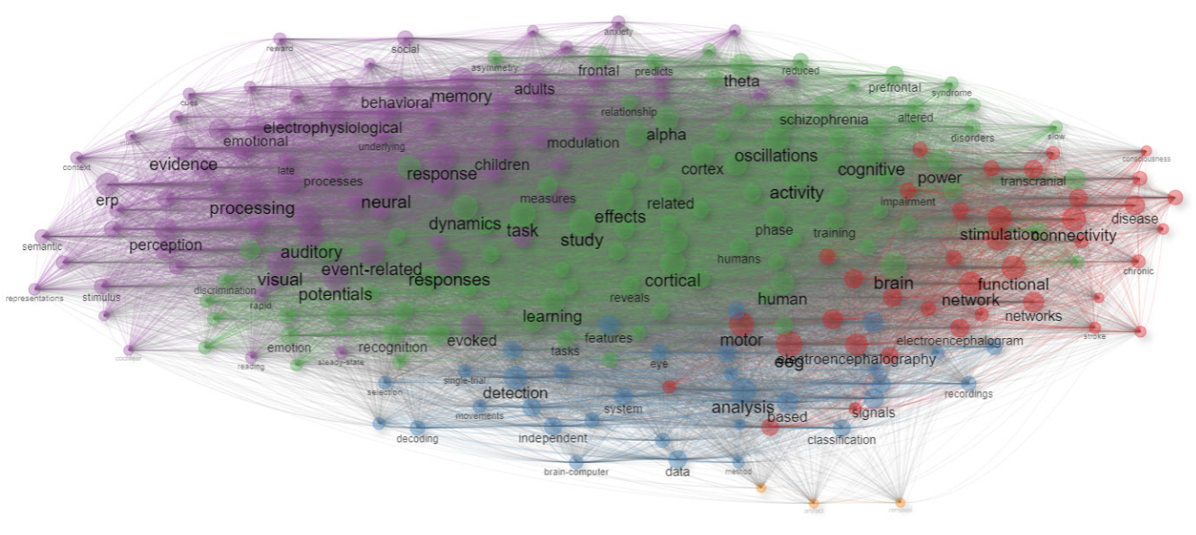

Thematic Map Bigram Word in title
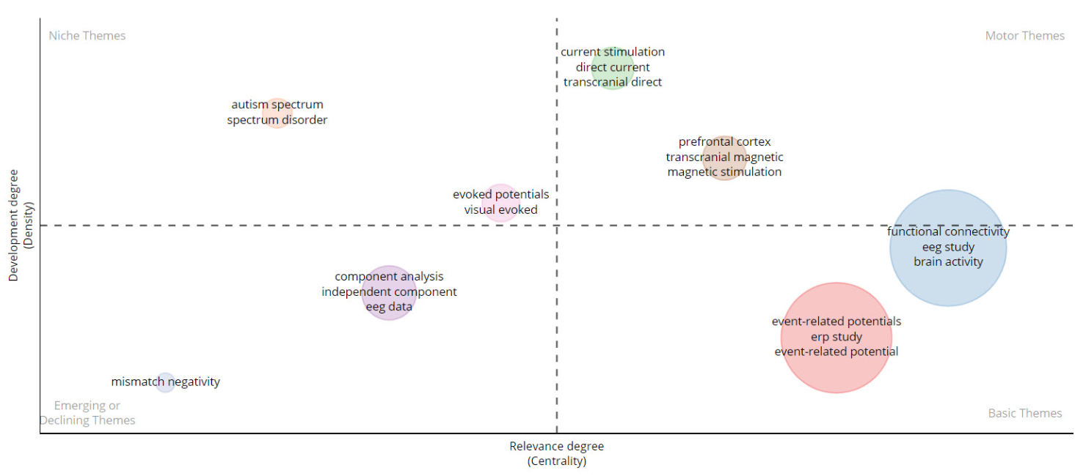

Thematic Network Bigram Word in title
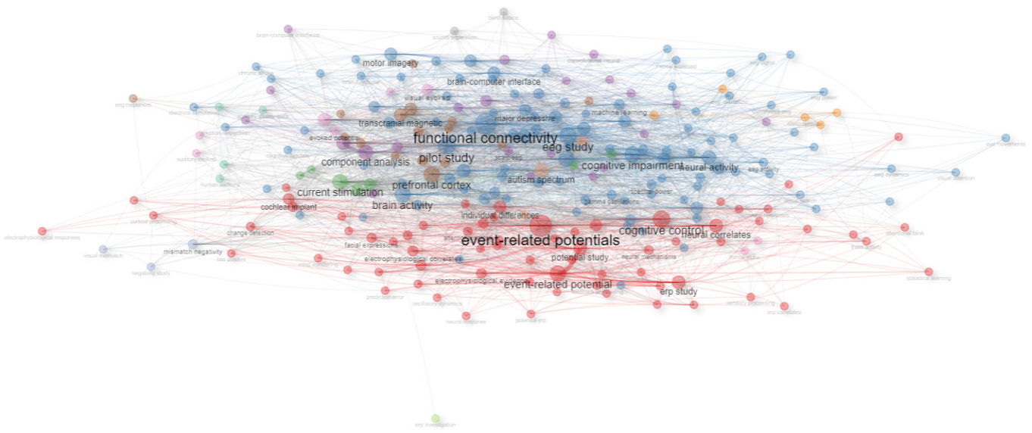

Thematic Map Trigram Word in title
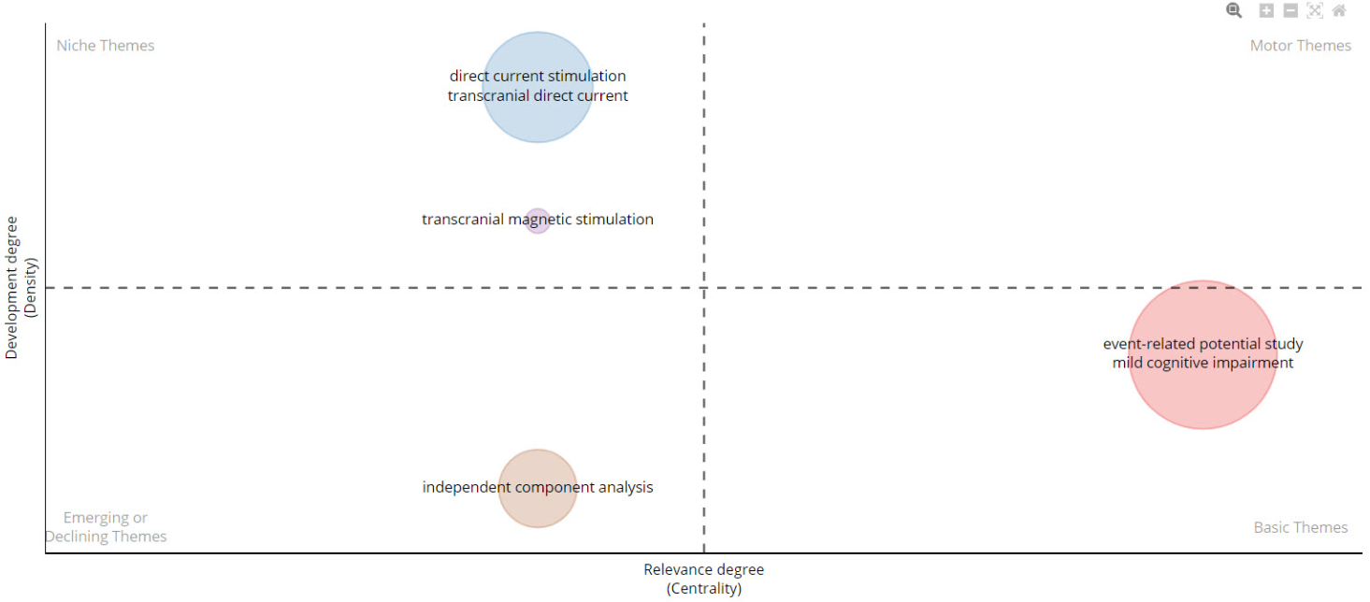

Thematic Network Trigram Word in title
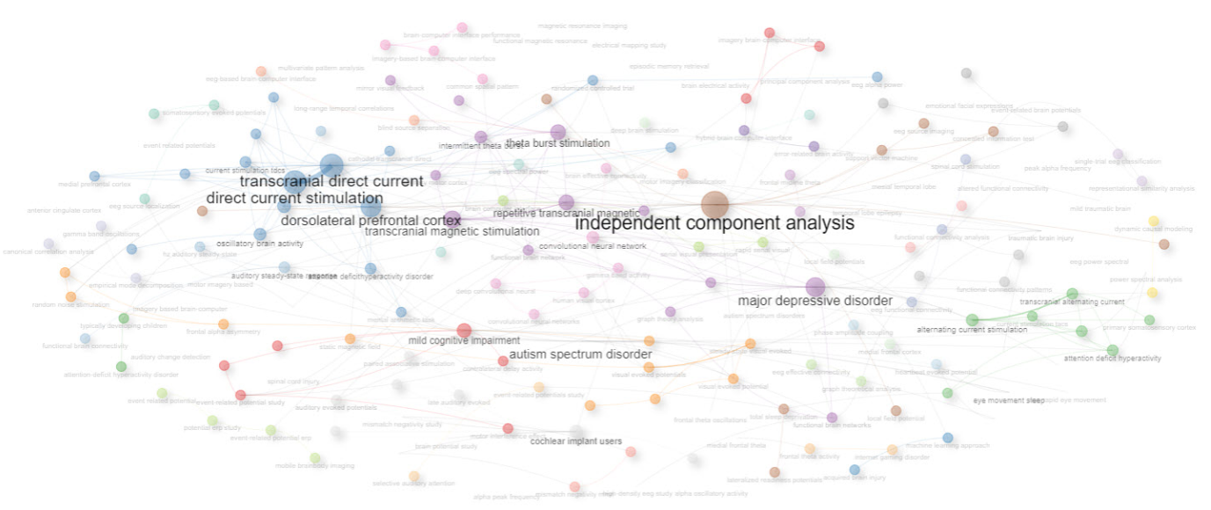

Thematic Map Unigram Word in Abstract
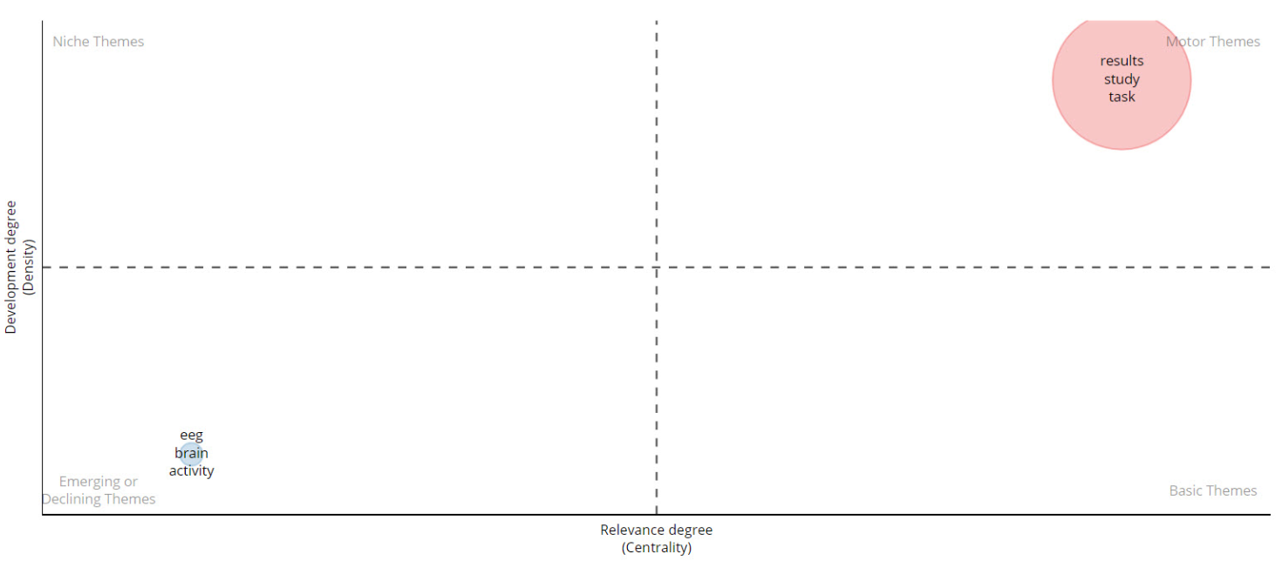

Thematic Network Unigram Word in Abstract
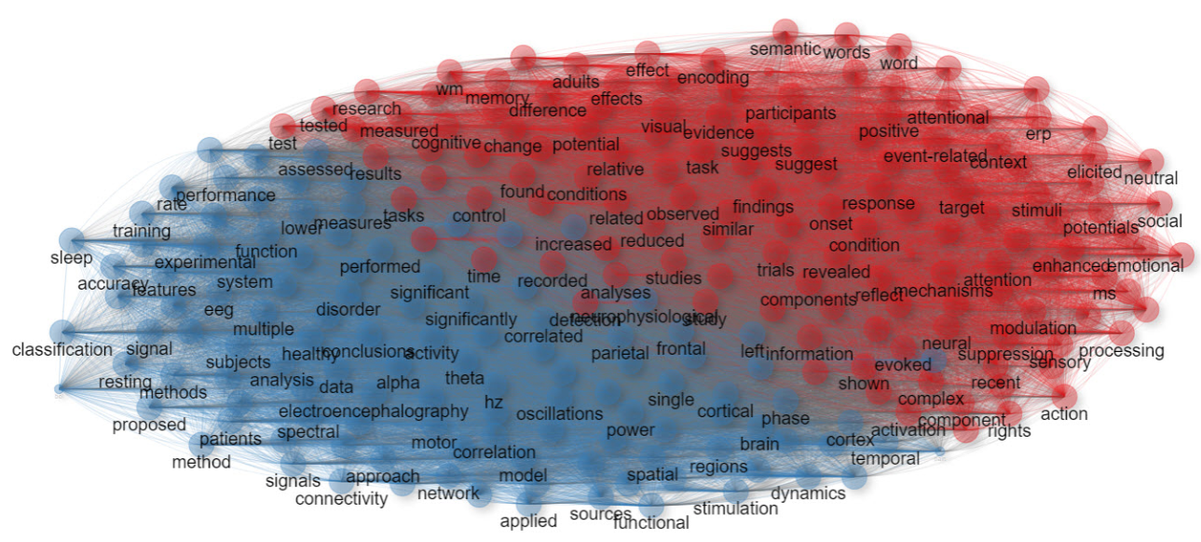

Thematic Map Bigram Word in Abstract
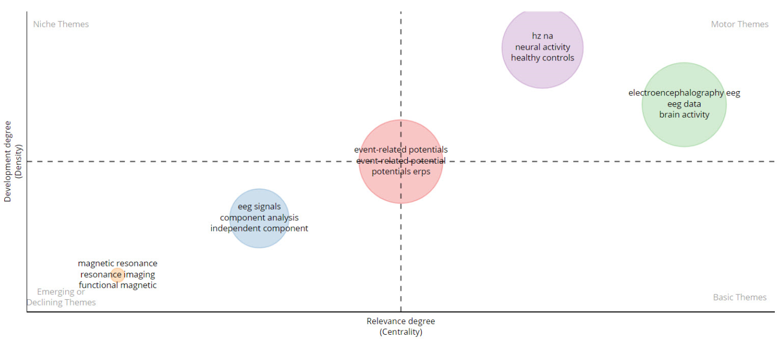

Thematic Network Bigram Word in Abstract
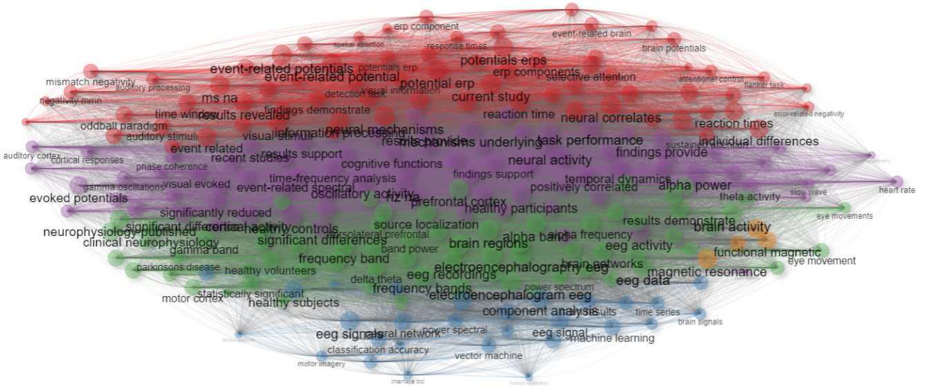

Thematic Map Trigram Word in Abstract
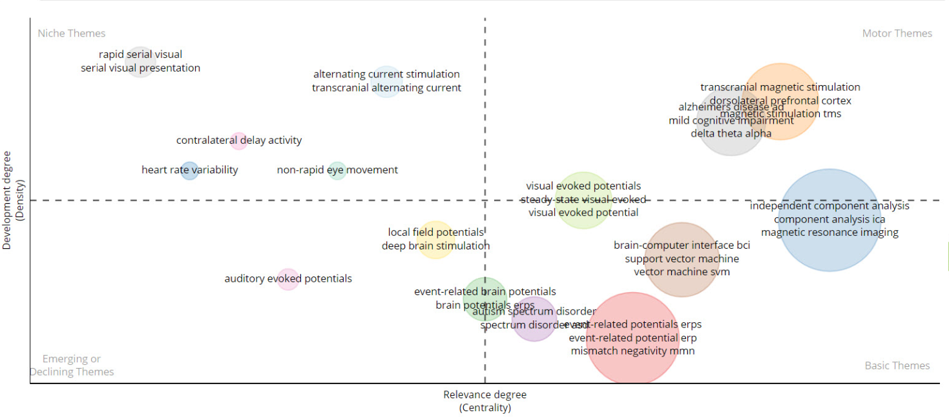

Thematic Network Trigram Word in Abstract
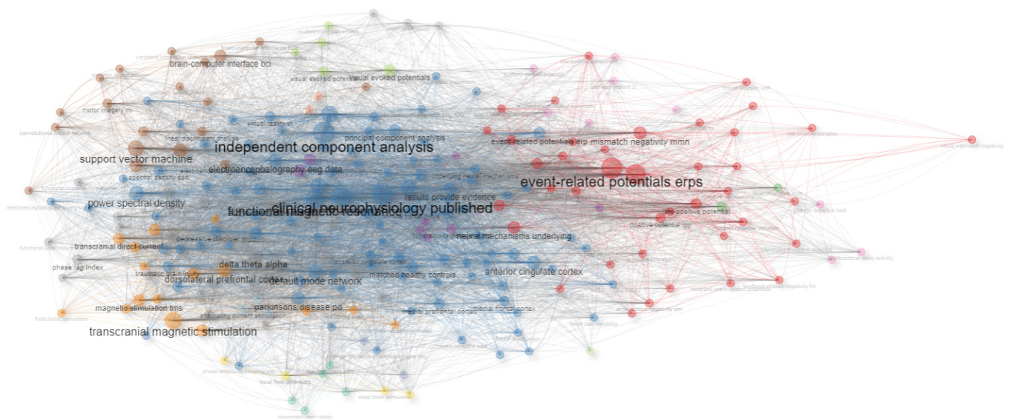

Correspondence Analysis

Multiple Correspondence Analysis of Keyword Plus
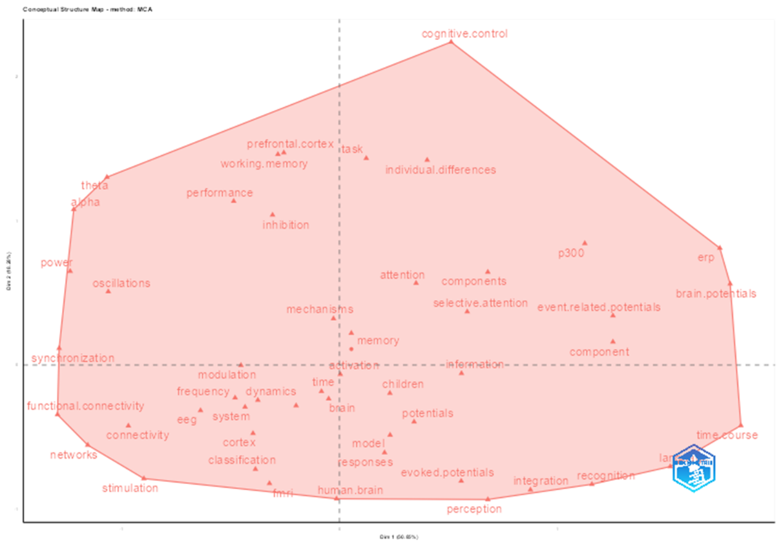
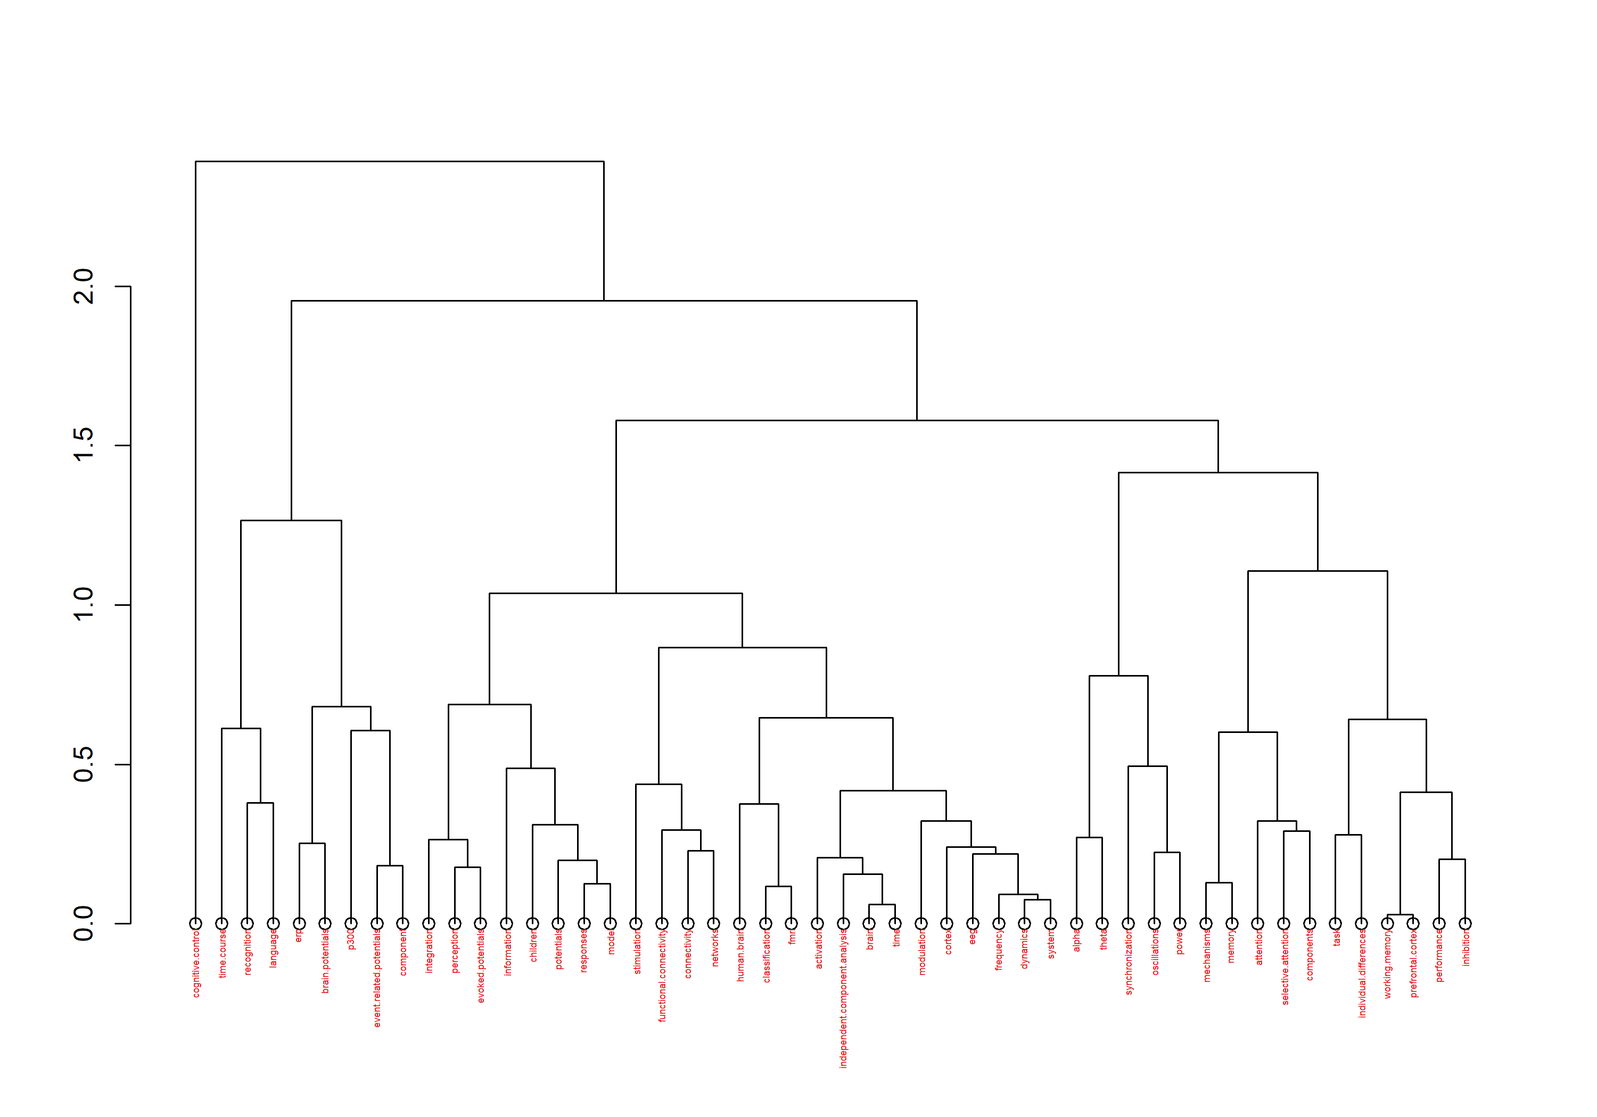

Correspondence Analysis of Keyword Plus
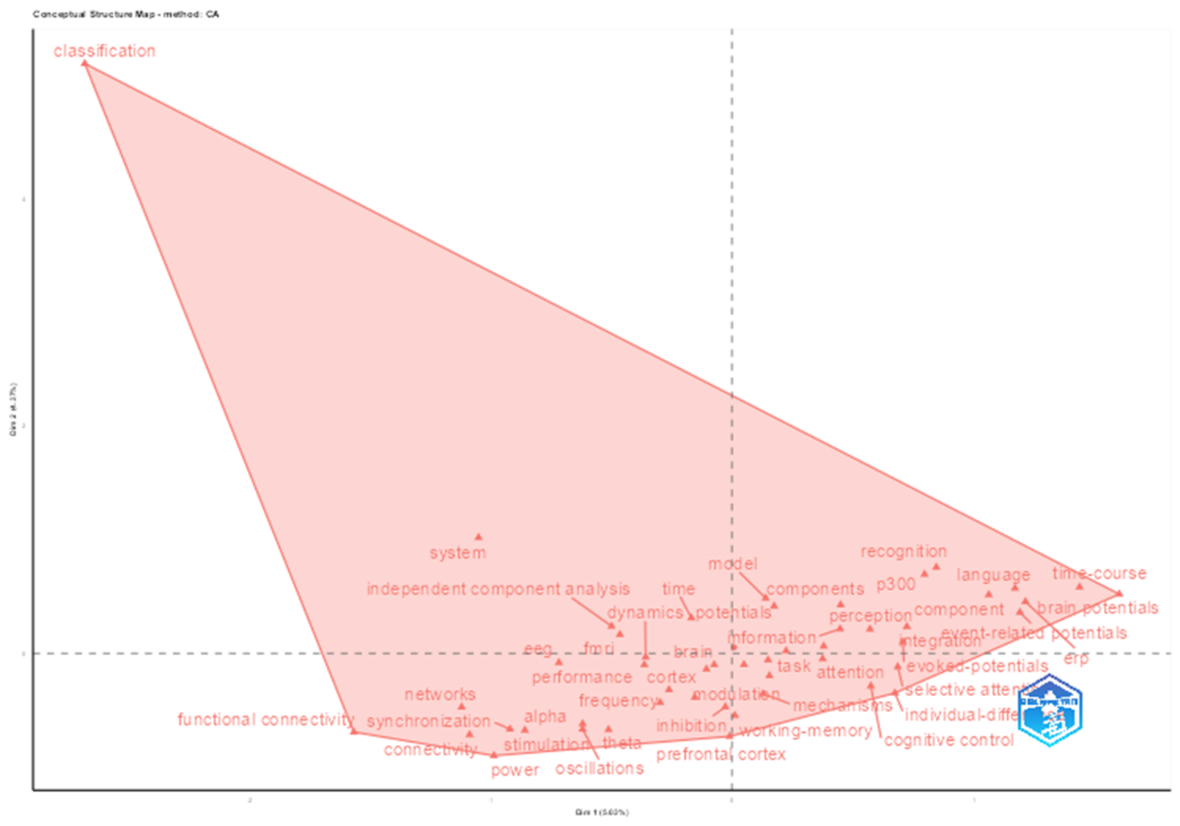
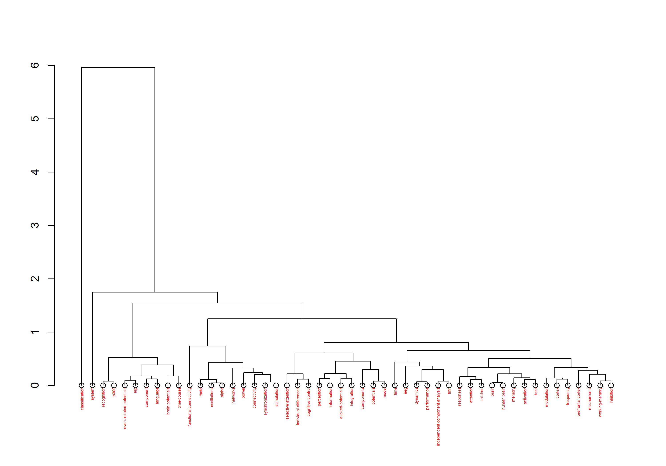

Multiple Correspondence Analysis of Authors Keywords
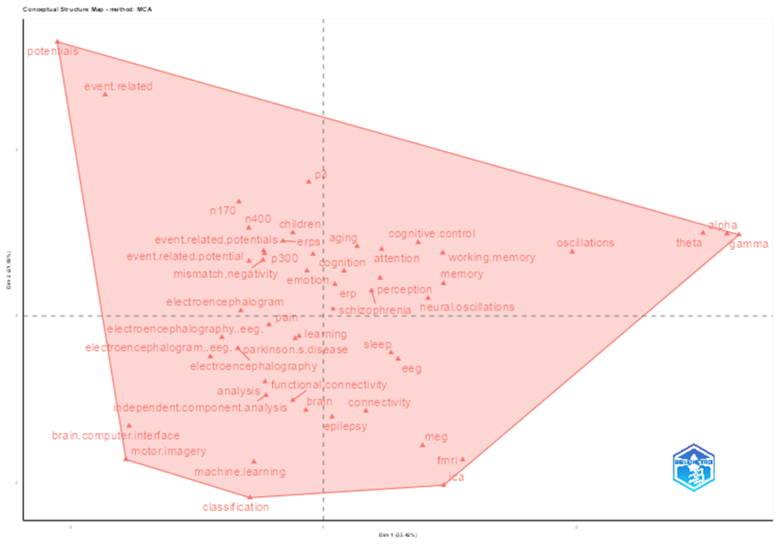
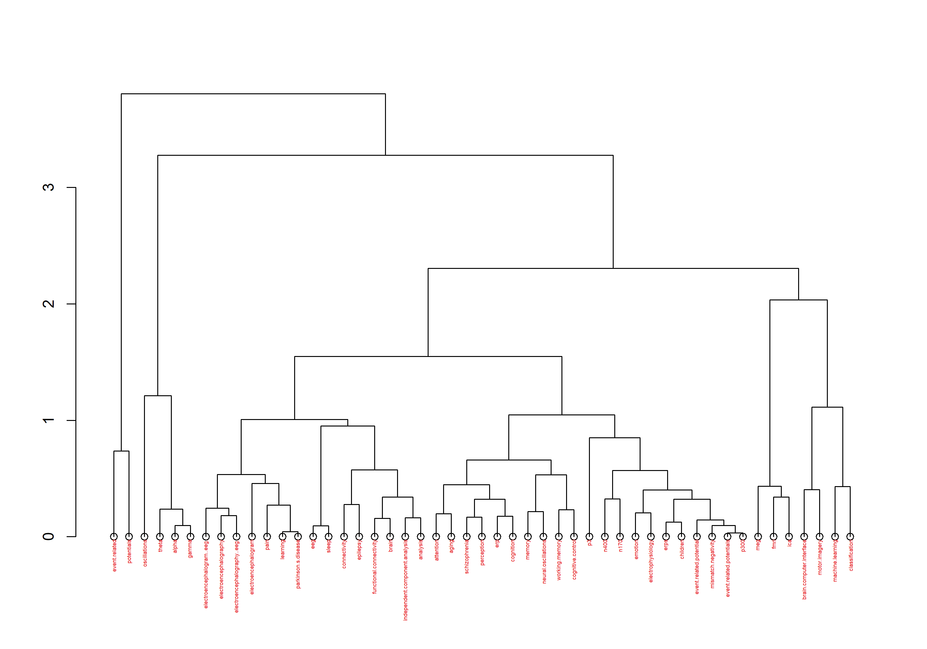

Correspondence Analysis of Authors Keywords
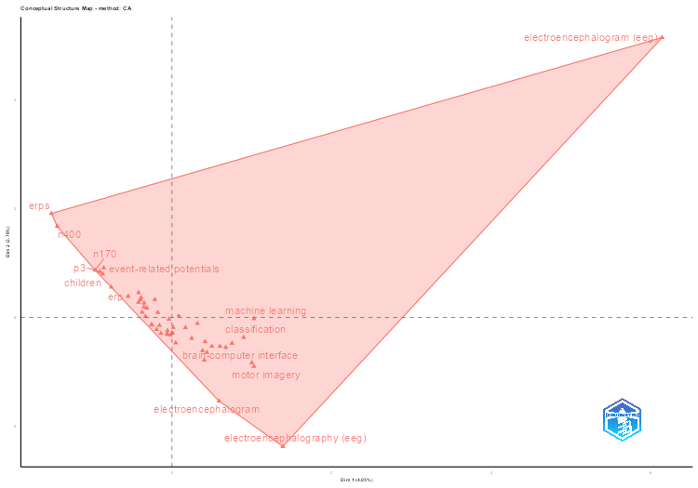
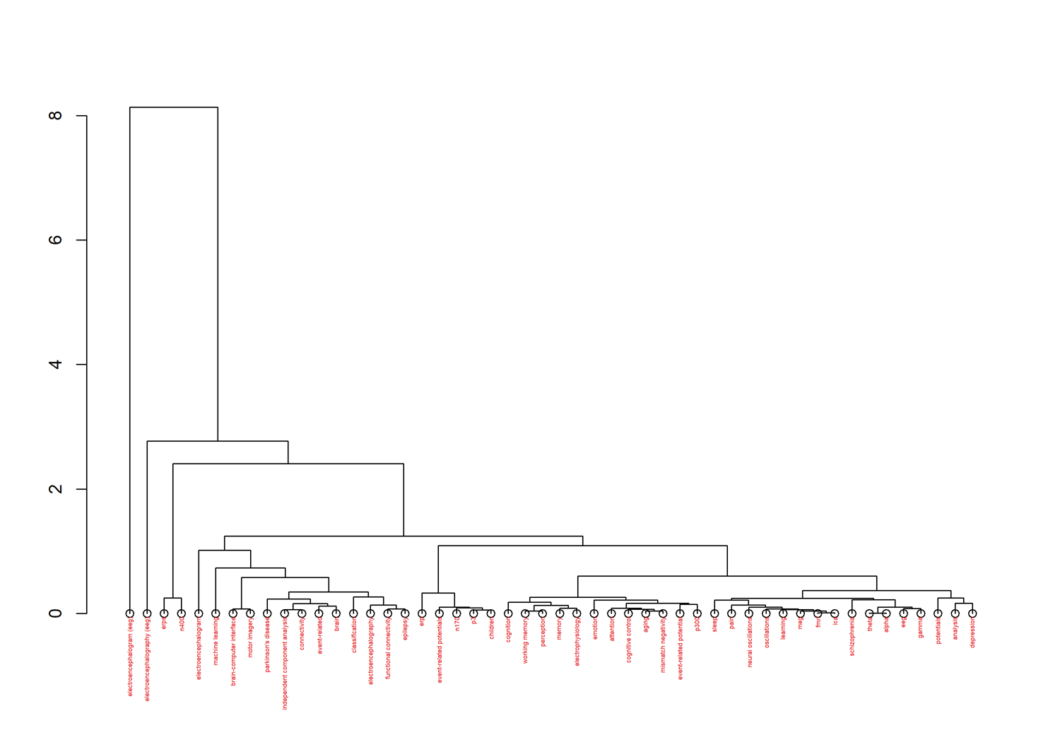

Co-citation Network

Co-Citation Network for Research Articles
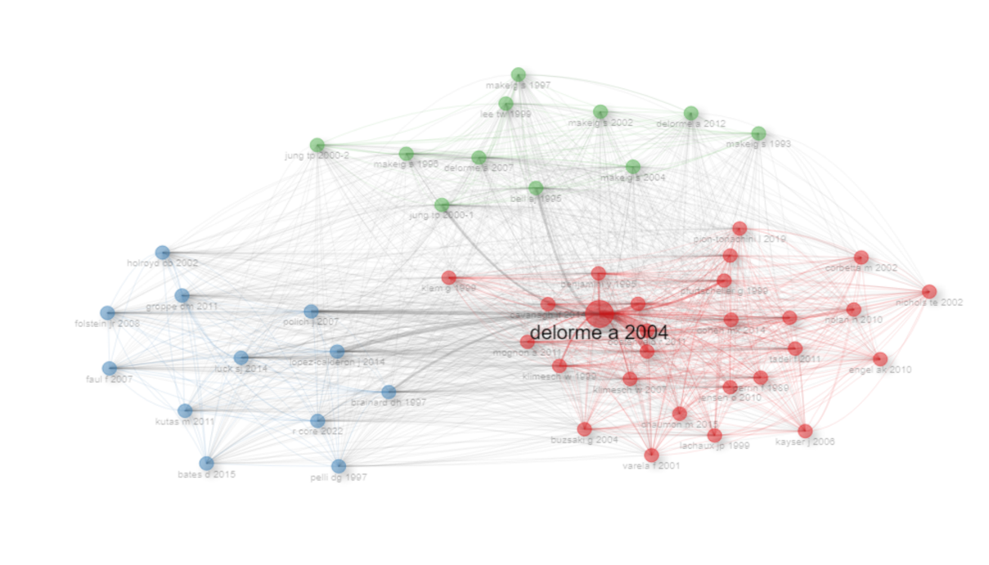
Node | Cluster | Betweenness | Closeness | PageRank
delorme a 2004 | 1 | 113.052 | 0.013 | 0.020
oostenveld r 2011 | 1 | 1.799 | 0.013 | 0.020
maris e 2007 | 1 | 1.872 | 0.013 | 0.020
oldfield rc 1971 | 1 | 1.072 | 0.013 | 0.020
pfurtscheller g 1999 | 1 | 0.902 | 0.013 | 0.020
klimesch w 1999 | 1 | 0.526 | 0.013 | 0.020
benjamini y 1995 | 1 | 0.531 | 0.013 | 0.020
klimesch w 2007 | 1 | 0.400 | 0.013 | 0.020
pascual-marqui rd 2002 | 1 | 0.179 | 0.013 | 0.020
mognon a 2011 | 1 | 0.436 | 0.013 | 0.020
cohen mx 2014 | 1 | 0.304 | 0.013 | 0.020
tadel f 2011 | 1 | 0.142 | 0.013 | 0.020
klimesch w 2012 | 1 | 0.203 | 0.013 | 0.020
perrin f 1989 | 1 | 0.229 | 0.013 | 0.020
jensen o 2010 | 1 | 0.158 | 0.013 | 0.020
klem g 1999 | 1 | 0.180 | 0.013 | 0.020
cavanagh jf 2014 | 1 | 0.226 | 0.013 | 0.020
pion-tonachini l 2019 | 1 | 0.214 | 0.013 | 0.020
lachaux jp 1999 | 1 | 0.067 | 0.013 | 0.020
buzsaki g 2004 | 1 | 0.072 | 0.013 | 0.020
engel ak 2010 | 1 | 0.094 | 0.013 | 0.020
kayser j 2006 | 1 | 0.084 | 0.013 | 0.020
nolan h 2010 | 1 | 0.163 | 0.013 | 0.020
corbetta m 2002 | 1 | 0.078 | 0.013 | 0.020
varela f 2001 | 1 | 0.081 | 0.013 | 0.020
nichols te 2002 | 1 | 0.064 | 0.013 | 0.020
chaumon m 2015 | 1 | 0.193 | 0.013 | 0.020
lopez-calderon j 2014 | 2 | 32.674 | 0.017 | 0.020
polich j 2007 | 2 | 34.353 | 0.017 | 0.020
brainard dh 1997 | 2 | 35.855 | 0.017 | 0.020
luck sj 2014 | 2 | 12.741 | 0.017 | 0.020
r core 2022 | 2 | 14.813 | 0.017 | 0.020
kutas m 2011 | 2 | 2.686 | 0.016 | 0.020
holroyd cb 2002 | 2 | 5.197 | 0.016 | 0.020
folstein jr 2008 | 2 | 4.397 | 0.017 | 0.020
faul f 2007 | 2 | 5.057 | 0.016 | 0.020
pelli dg 1997 | 2 | 5.944 | 0.016 | 0.020
groppe dm 2011 | 2 | 7.163 | 0.017 | 0.020
bates d 2015 | 2 | 5.864 | 0.016 | 0.020
bell aj 1995 | 3 | 43.574 | 0.017 | 0.020
jung tp 2000-1 | 3 | 33.959 | 0.017 | 0.020
delorme a 2007 | 3 | 17.733 | 0.017 | 0.020
makeig s 1996 | 3 | 14.911 | 0.017 | 0.020
makeig s 2004 | 3 | 24.668 | 0.017 | 0.020
makeig s 1993 | 3 | 13.419 | 0.016 | 0.020
lee tw 1999 | 3 | 7.507 | 0.017 | 0.020
jung tp 2000-2 | 3 | 5.037 | 0.017 | 0.020
makeig s 2002 | 3 | 9.994 | 0.017 | 0.020
makeig s 1997 | 3 | 4.495 | 0.017 | 0.020
delorme a 2012 | 3 | 12.638 | 0.017 | 0.020

Co-Citation Network for Authors
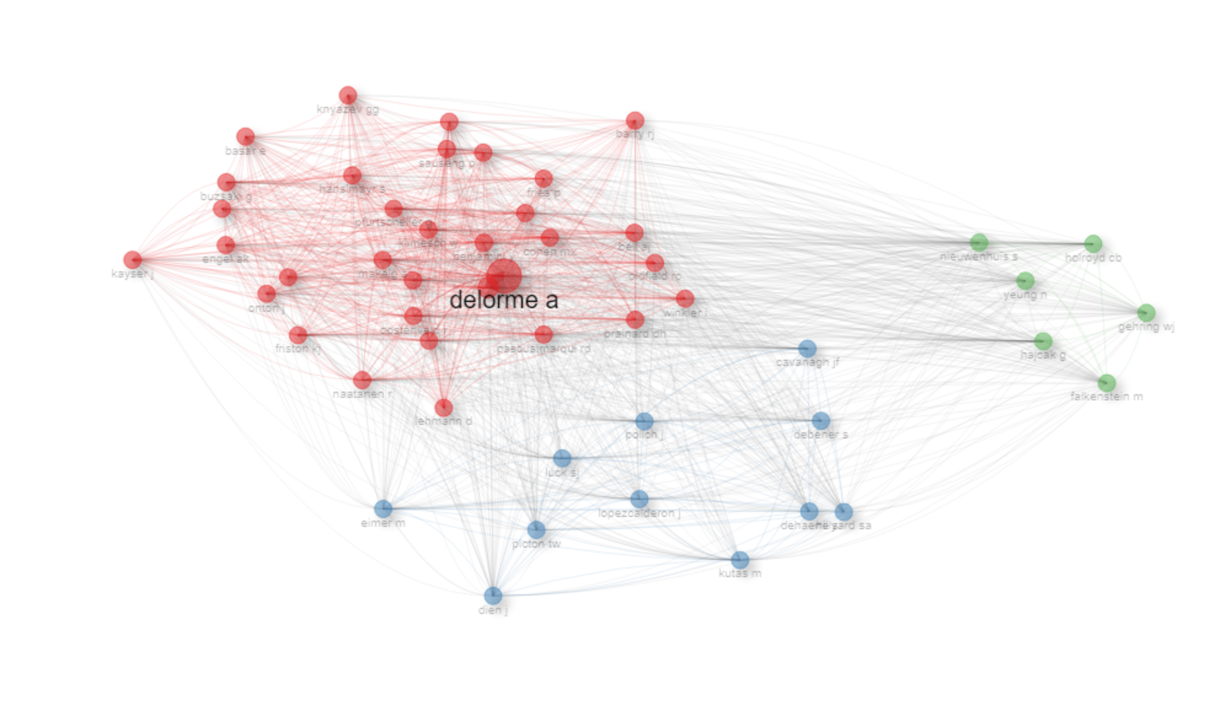
Node | Cluster | Betweenness | Closeness | PageRank
delorme a | 1 | 46.54 | 0.01 | 0.02
anonymous | 1 | 10.47 | 0.01 | 0.02
klimesch w | 1 | 0.61 | 0.01 | 0.02
pfurtscheller g | 1 | 0.23 | 0.01 | 0.02
makeig s | 1 | 1.17 | 0.01 | 0.02
oostenveld r | 1 | 0.71 | 0.01 | 0.02
cohen mx | 1 | 1.06 | 0.01 | 0.02
naatanen r | 1 | 0.48 | 0.01 | 0.02
jung tp | 1 | 0.75 | 0.01 | 0.02
maris e | 1 | 0.51 | 0.01 | 0.02
jensen o | 1 | 0.18 | 0.01 | 0.02
pascualmarqui rd | 1 | 0.13 | 0.01 | 0.02
friston kj | 1 | 0.20 | 0.01 | 0.02
benjamini y | 1 | 0.27 | 0.01 | 0.02
buzsaki g | 1 | 0.05 | 0.01 | 0.02
sauseng p | 1 | 0.17 | 0.01 | 0.02
oldfield rc | 1 | 0.43 | 0.01 | 0.02
bell aj | 1 | 0.42 | 0.01 | 0.02
babiloni c | 1 | 0.03 | 0.01 | 0.02
winkler i | 1 | 0.13 | 0.01 | 0.02
tallonbaudry c | 1 | 0.09 | 0.01 | 0.02
brainard dh | 1 | 0.34 | 0.01 | 0.02
fries p | 1 | 0.06 | 0.01 | 0.02
hanslmayr s | 1 | 0.10 | 0.01 | 0.02
stam cj | 1 | 0.01 | 0.01 | 0.02
onton j | 1 | 0.13 | 0.01 | 0.02
engel ak | 1 | 0.06 | 0.01 | 0.02
perrin f | 1 | 0.16 | 0.01 | 0.02
kayser j | 1 | 0.17 | 0.01 | 0.02
basar e | 1 | 0.04 | 0.01 | 0.02
barry rj | 1 | 0.05 | 0.01 | 0.02
knyazev gg | 1 | 0.02 | 0.01 | 0.02
lehmann d | 1 | 0.04 | 0.01 | 0.02
luck sj | 2 | 103.13 | 0.02 | 0.02
polich j | 2 | 95.38 | 0.02 | 0.02
kutas m | 2 | 14.24 | 0.02 | 0.02
lopezcalderon j | 2 | 33.02 | 0.02 | 0.02
cavanagh jf | 2 | 84.35 | 0.02 | 0.02
eimer m | 2 | 16.71 | 0.02 | 0.02
debener s | 2 | 49.67 | 0.02 | 0.02
picton tw | 2 | 25.94 | 0.02 | 0.02
dien j | 2 | 9.49 | 0.02 | 0.02
dehaene s | 2 | 17.21 | 0.02 | 0.02
hillyard sa | 2 | 16.38 | 0.02 | 0.02
hajcak g | 3 | 9.87 | 0.02 | 0.02
holroyd cb | 3 | 9.29 | 0.02 | 0.02
nieuwenhuis s | 3 | 17.39 | 0.02 | 0.02
yeung n | 3 | 14.11 | 0.02 | 0.02
falkenstein m | 3 | 7.75 | 0.02 | 0.02
gehring wj | 3 | 9.22 | 0.02 | 0.02

Co-Citation Network for Sources
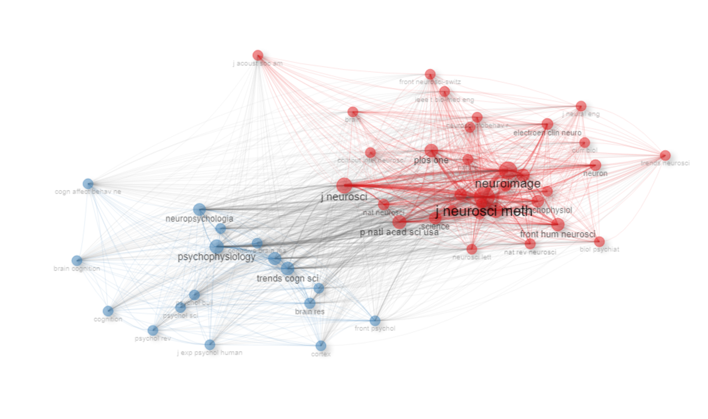
Node | Cluster | Betweenness | Closeness | PageRank
neuroimage | 1 | 14.94 | 0.01 | 0.02
j neurosci | 1 | 10.19 | 0.01 | 0.02
clin neurophysiol | 1 | 8.45 | 0.01 | 0.02
j neurosci meth | 1 | 21.80 | 0.01 | 0.02
p natl acad sci usa | 1 | 6.92 | 0.01 | 0.02
front hum neurosci | 1 | 7.30 | 0.01 | 0.02
plos one | 1 | 6.44 | 0.01 | 0.02
int j psychophysiol | 1 | 6.20 | 0.01 | 0.02
cereb cortex | 1 | 6.41 | 0.01 | 0.02
neuron | 1 | 3.53 | 0.01 | 0.02
electroen clin neuro | 1 | 3.90 | 0.01 | 0.02
hum brain mapp | 1 | 3.98 | 0.01 | 0.02
science | 1 | 5.54 | 0.01 | 0.02
j neurophysiol | 1 | 2.18 | 0.01 | 0.02
nat neurosci | 1 | 3.87 | 0.01 | 0.02
nat rev neurosci | 1 | 3.05 | 0.01 | 0.02
nature | 1 | 2.74 | 0.01 | 0.02
brain | 1 | 1.31 | 0.01 | 0.02
neurosci lett | 1 | 2.76 | 0.01 | 0.02
neurosci biobehav r | 1 | 2.79 | 0.01 | 0.02
eur j neurosci | 1 | 2.32 | 0.01 | 0.02
exp brain res | 1 | 1.59 | 0.01 | 0.02
sci rep-uk | 1 | 1.50 | 0.01 | 0.02
biol psychiat | 1 | 0.68 | 0.01 | 0.02
ieee t bio-med eng | 1 | 0.23 | 0.01 | 0.02
j neural eng | 1 | 0.13 | 0.01 | 0.02
curr biol | 1 | 1.26 | 0.01 | 0.02
front neurosci-switz | 1 | 0.67 | 0.01 | 0.02
brain topogr | 1 | 0.83 | 0.01 | 0.02
neuroscience | 1 | 0.78 | 0.01 | 0.02
comput intel neurosc | 1 | 0.80 | 0.01 | 0.02
trends neurosci | 1 | 0.75 | 0.01 | 0.02
j acoust soc am | 1 | 0.14 | 0.01 | 0.02
psychophysiology | 2 | 94.13 | 0.02 | 0.02
j cognitive neurosci | 2 | 66.38 | 0.02 | 0.02
trends cogn sci | 2 | 82.51 | 0.02 | 0.02
neuropsychologia | 2 | 61.93 | 0.02 | 0.02
biol psychol | 2 | 28.06 | 0.02 | 0.02
brain res | 2 | 44.04 | 0.02 | 0.02
front psychol | 2 | 33.60 | 0.02 | 0.02
neuroreport | 2 | 30.24 | 0.02 | 0.02
cognitive brain res | 2 | 18.17 | 0.02 | 0.02
psychol sci | 2 | 11.76 | 0.02 | 0.02
j exp psychol human | 2 | 6.77 | 0.02 | 0.02
psychol rev | 2 | 7.83 | 0.02 | 0.02
cortex | 2 | 11.86 | 0.02 | 0.02
brain cognition | 2 | 10.24 | 0.02 | 0.02
psychol bull | 2 | 8.85 | 0.02 | 0.02
cogn affect behav ne | 2 | 6.74 | 0.02 | 0.02
cognition | 2 | 4.89 | 0.02 | 0.02

Historiograph

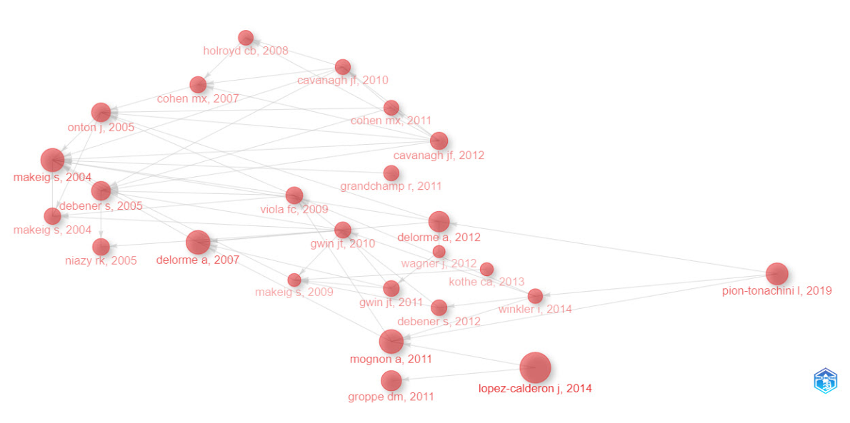

Collaboration Network

University
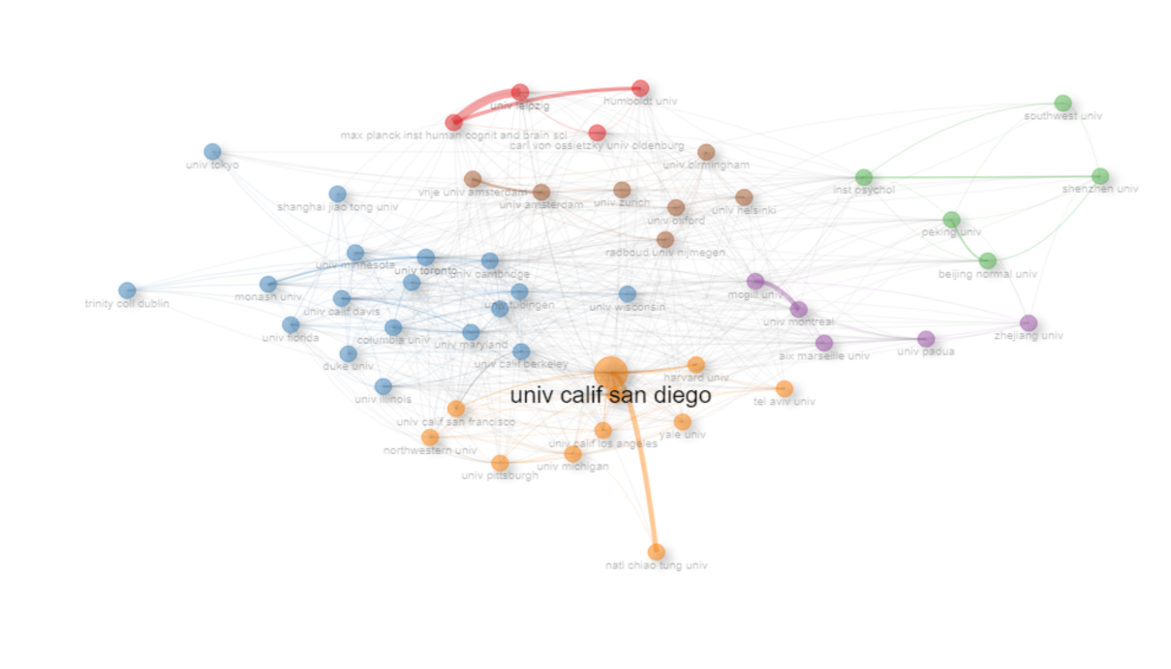
Node | Cluster | Betweenness | Closeness | PageRank
carl von ossietzky univ oldenburg | 1 | 8.847 | 0.013 | 0.021
univ leipzig | 1 | 15.266 | 0.012 | 0.034
humboldt univ | 1 | 7.208 | 0.012 | 0.022
max planck inst human cognit and brain sci | 1 | 9.405 | 0.012 | 0.028
univ toronto | 2 | 35.346 | 0.015 | 0.033
univ calif davis | 2 | 12.598 | 0.013 | 0.023
univ maryland | 2 | 24.910 | 0.014 | 0.027
univ cambridge | 2 | 46.970 | 0.015 | 0.026
univ wisconsin | 2 | 10.114 | 0.013 | 0.013
univ illinois | 2 | 5.910 | 0.013 | 0.015
univ tubingen | 2 | 11.923 | 0.014 | 0.018
monash univ | 2 | 6.788 | 0.013 | 0.018
univ minnesota | 2 | 7.962 | 0.013 | 0.013
univ british columbia | 2 | 9.327 | 0.013 | 0.014
trinity coll dublin | 2 | 0.938 | 0.011 | 0.012
univ calif berkeley | 2 | 13.283 | 0.014 | 0.023
columbia univ | 2 | 9.497 | 0.014 | 0.018
univ florida | 2 | 9.427 | 0.013 | 0.016
shanghai jiao tong univ | 2 | 5.139 | 0.011 | 0.011
vanderbilt univ | 2 | 10.402 | 0.014 | 0.016
univ tokyo | 2 | 0.274 | 0.011 | 0.006
duke univ | 2 | 1.686 | 0.013 | 0.010
beijing normal univ | 3 | 7.558 | 0.012 | 0.020
southwest univ | 3 | 1.238 | 0.011 | 0.011
inst psychol | 3 | 43.353 | 0.014 | 0.028
peking univ | 3 | 11.093 | 0.012 | 0.017
shenzhen univ | 3 | 4.932 | 0.011 | 0.017
univ padua | 4 | 3.976 | 0.012 | 0.012
mcgill univ | 4 | 30.761 | 0.014 | 0.028
aix marseille univ | 4 | 11.549 | 0.013 | 0.017
zhejiang univ | 4 | 3.795 | 0.011 | 0.009
univ montreal | 4 | 5.616 | 0.013 | 0.021
univ calif san diego | 5 | 105.113 | 0.016 | 0.059
harvard med sch | 5 | 41.910 | 0.015 | 0.035
univ pittsburgh | 5 | 3.296 | 0.013 | 0.019
northwestern univ | 5 | 4.533 | 0.013 | 0.013
tel aviv univ | 5 | 3.131 | 0.012 | 0.012
univ michigan | 5 | 12.938 | 0.013 | 0.019
univ calif los angeles | 5 | 12.529 | 0.013 | 0.025
univ calif san francisco | 5 | 19.122 | 0.013 | 0.030
natl chiao tung univ | 5 | 0.000 | 0.010 | 0.012
yale univ | 5 | 11.421 | 0.013 | 0.022
harvard univ | 5 | 16.480 | 0.013 | 0.022
univ zurich | 6 | 11.390 | 0.013 | 0.017
univ helsinki | 6 | 4.256 | 0.013 | 0.011
univ oxford | 6 | 15.102 | 0.013 | 0.017
radboud univ nijmegen | 6 | 46.328 | 0.015 | 0.027
univ amsterdam | 6 | 24.740 | 0.014 | 0.025
vrije univ amsterdam | 6 | 8.220 | 0.013 | 0.018
univ birmingham | 6 | 14.400 | 0.013 | 0.018

Countries
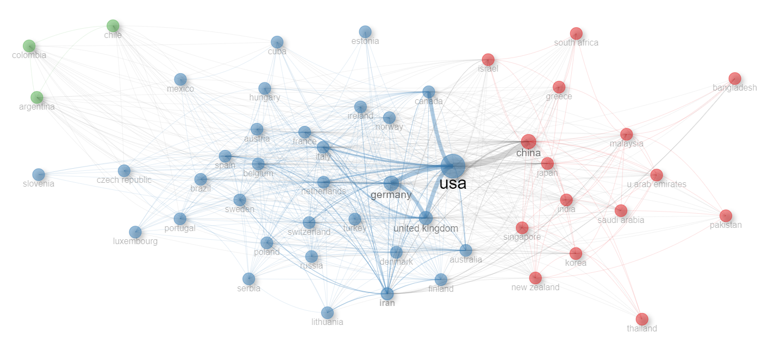
Node | Cluster | Betweenness | Closeness | PageRank
china | 1 | 17.307 | 0.017 | 0.058
japan | 1 | 3.671 | 0.016 | 0.016
korea | 1 | 0.214 | 0.014 | 0.010
israel | 1 | 0.079 | 0.014 | 0.011
india | 1 | 0.187 | 0.013 | 0.008
greece | 1 | 0.070 | 0.013 | 0.009
singapore | 1 | 1.463 | 0.015 | 0.012
new zealand | 1 | 0.653 | 0.013 | 0.008
malaysia | 1 | 1.194 | 0.013 | 0.007
u arab emirates | 1 | 0.287 | 0.012 | 0.006
thailand | 1 | 0.008 | 0.011 | 0.004
south africa | 1 | 0.015 | 0.012 | 0.006
saudi arabia | 1 | 0.349 | 0.013 | 0.006
pakistan | 1 | 0.073 | 0.011 | 0.004
bangladesh | 1 | 0.000 | 0.011 | 0.004
usa | 2 | 271.438 | 0.020 | 0.141
germany | 2 | 80.215 | 0.019 | 0.086
united kingdom | 2 | 103.458 | 0.020 | 0.089
canada | 2 | 3.747 | 0.017 | 0.043
italy | 2 | 19.488 | 0.019 | 0.051
france | 2 | 7.652 | 0.018 | 0.035
australia | 2 | 16.212 | 0.018 | 0.040
netherlands | 2 | 8.316 | 0.018 | 0.040
spain | 2 | 9.419 | 0.017 | 0.028
switzerland | 2 | 8.467 | 0.017 | 0.032
belgium | 2 | 3.633 | 0.017 | 0.025
finland | 2 | 2.329 | 0.015 | 0.018
denmark | 2 | 6.208 | 0.015 | 0.017
iran | 2 | 0.330 | 0.013 | 0.009
brazil | 2 | 0.884 | 0.014 | 0.011
norway | 2 | 0.692 | 0.014 | 0.013
hungary | 2 | 0.104 | 0.013 | 0.009
ireland | 2 | 0.976 | 0.015 | 0.014
poland | 2 | 0.804 | 0.014 | 0.009
austria | 2 | 0.748 | 0.015 | 0.014
portugal | 2 | 0.313 | 0.013 | 0.008
russia | 2 | 0.482 | 0.014 | 0.010
sweden | 2 | 1.122 | 0.016 | 0.015
turkey | 2 | 0.009 | 0.013 | 0.006
czech republic | 2 | 0.020 | 0.012 | 0.005
lithuania | 2 | 0.102 | 0.012 | 0.005
mexico | 2 | 0.023 | 0.012 | 0.004
slovenia | 2 | 0.000 | 0.011 | 0.004
estonia | 2 | 0.000 | 0.011 | 0.004
serbia | 2 | 0.284 | 0.012 | 0.005
cuba | 2 | 0.061 | 0.012 | 0.005
luxembourg | 2 | 0.002 | 0.012 | 0.004
chile | 3 | 0.265 | 0.013 | 0.014
argentina | 3 | 0.418 | 0.013 | 0.011
colombia | 3 | 0.212 | 0.013 | 0.008

Countries Collaboration Network
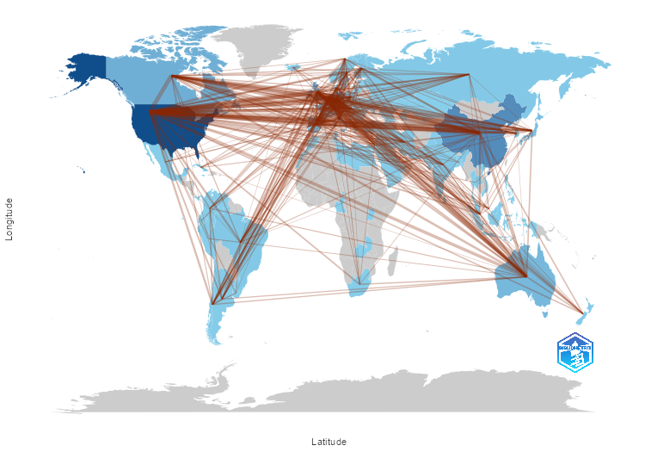

References
1. Marx, W., et al., Detecting the historical roots of research fields by reference publication year spectroscopy (RPYS). Journal of the Association for Information Science and Technology, 2014. 65(4): p. 751-764.
2. Delorme, A. and S. Makeig, EEGLAB: an open source toolbox for analysis of single-trial EEG dynamics including independent component analysis. Journal of neuroscience methods, 2004. 134(1): p. 9-21.

